**Chronic kidney disease-Prediction**

As a data scientist, the goal is to develop a predictive model that uses these parameters to accurately predict the Chronic kidney disease

Data set contain **399 rows × 28 columns** data.

It have categorical data in multiple column so we need to convert it into **INT** by using **get_dummies()** function from pandas.

With the use of GridSearchCV both Decision tree and Random forest predict with good accuracy.

**SVM Sreenshot:**

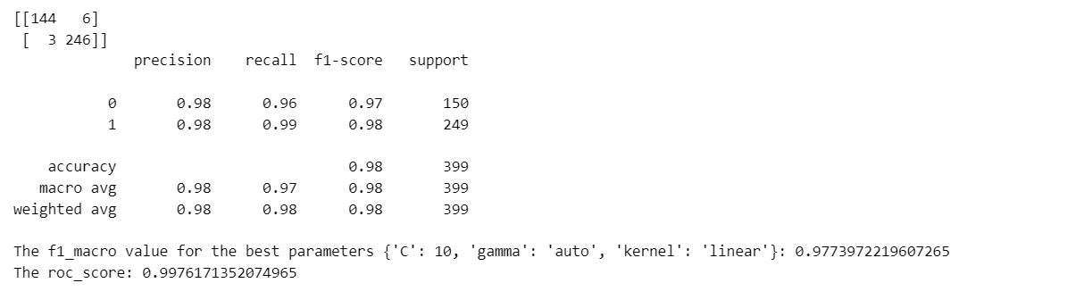

**Decision tree Screenshot:**

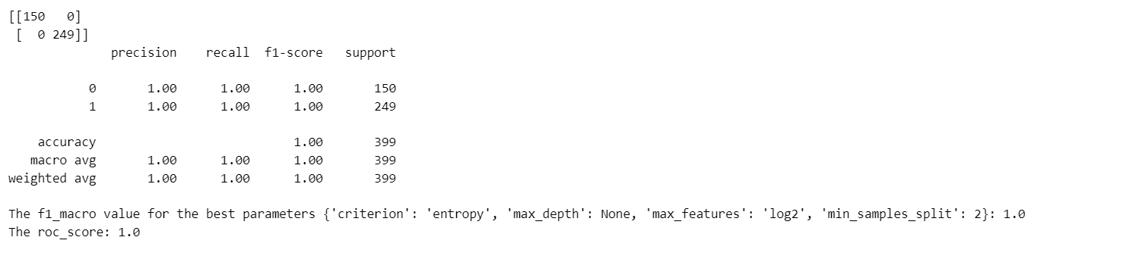

**Random Forest Screenshot:**

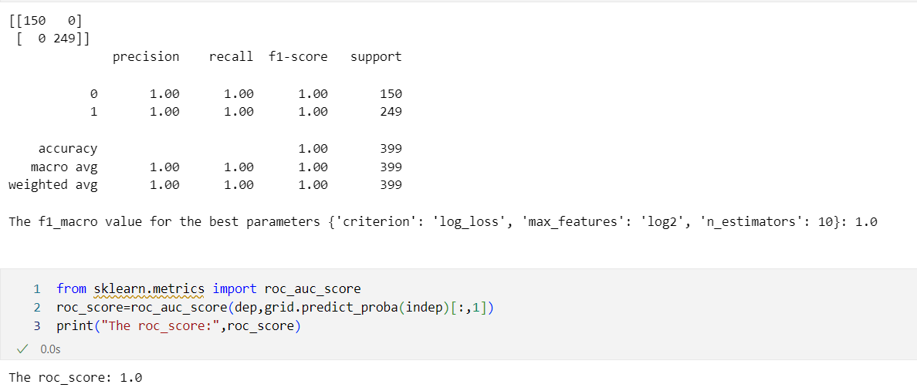

**KNN:**

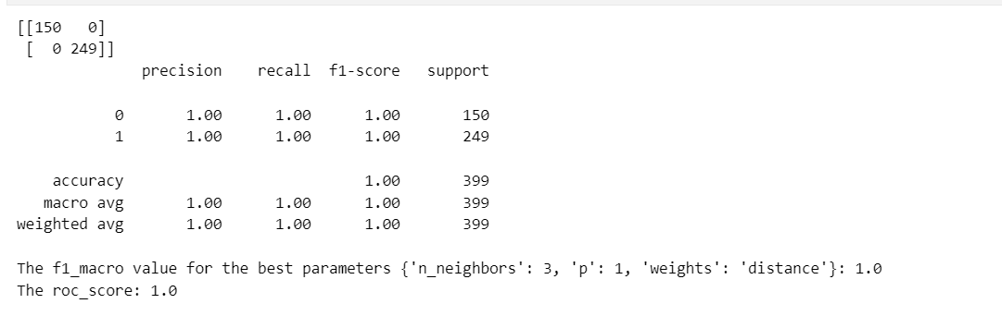

**LOGISTIC REGRESSION:**

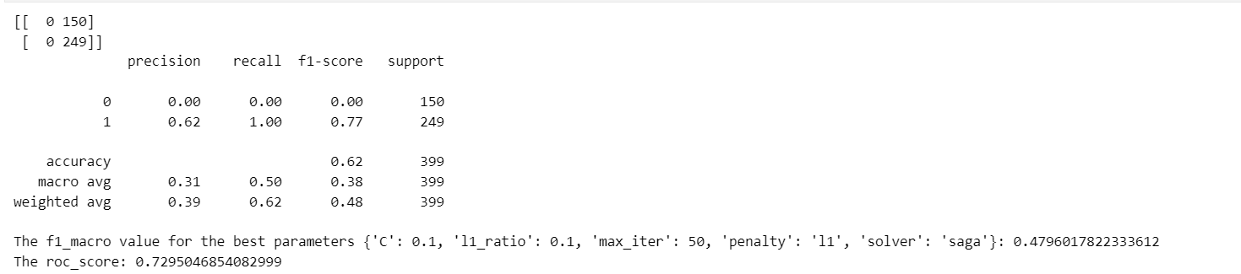

**Naive_bayes:**

**GaussianNB**

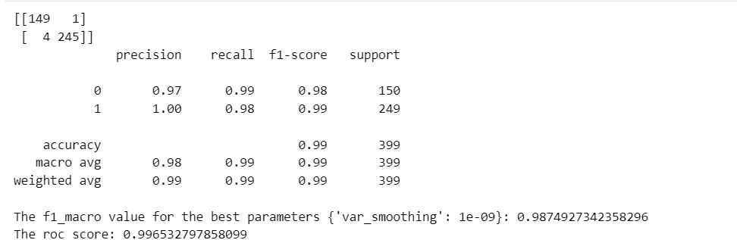

**BernoulliNB**

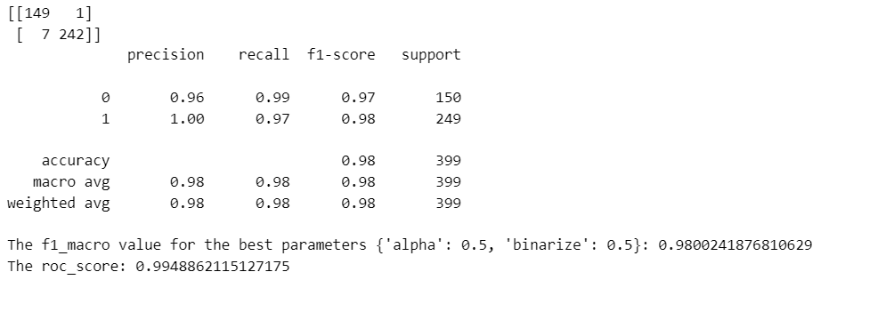

**MultinomialNB**

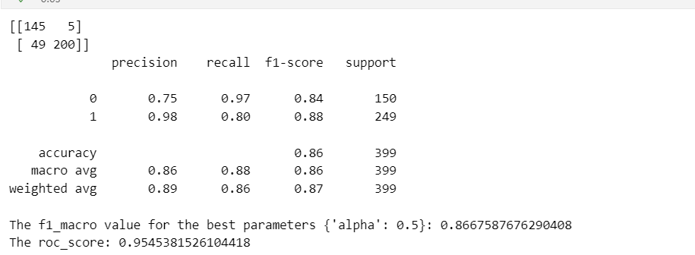

**CategoricalNB**

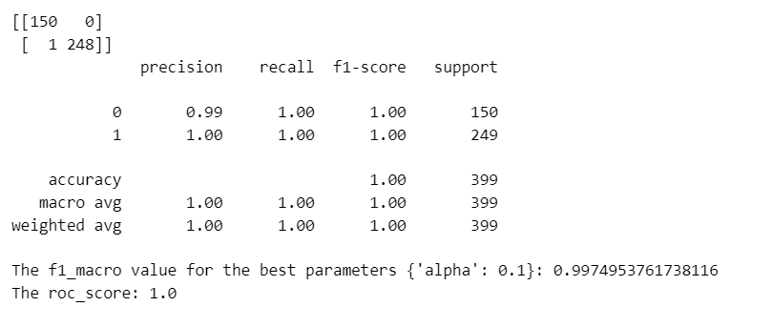

**ComplementNB**

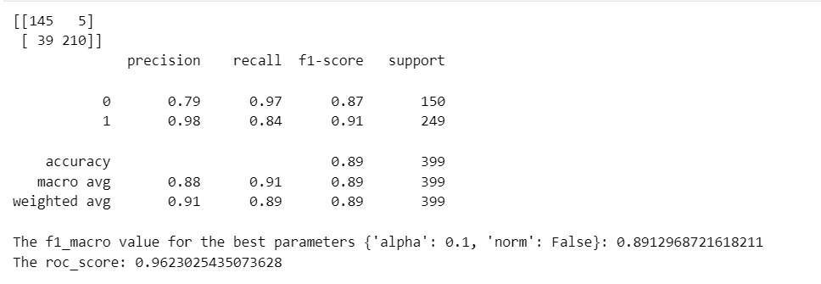

Both **DecisionTree,RandomForest** and **KNN** predict Chronic kidney disease with **100** percent accuracy and with **ROC_SCORE** as **1**

**DecisionTree** :{'criterion': 'gini', 'max_depth': 10, 'max_features': 'sqrt', 'min_samples_split': 2}

**RandomForest :**{'criterion': 'log_loss', 'max_features': 'log2', 'n_estimators': 100}

**KNN:**{'n_neighbors': 3, 'p': 1, 'weights': 'distance'}