UEP Feedback Form Design Document

UI Design:

Page 1

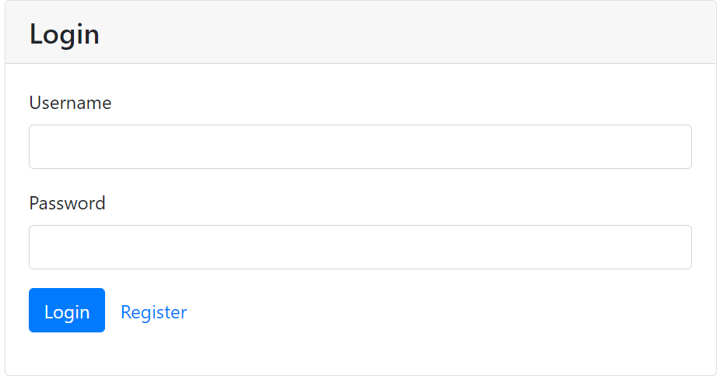

Once logged in feedback page gets displayed

Page 2:

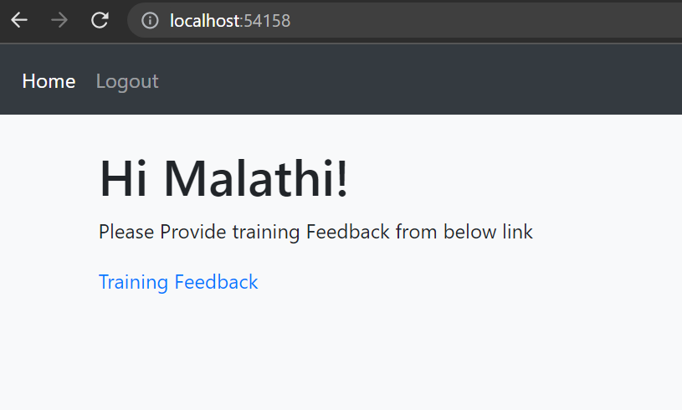

Database Design:

Employee Table:

|  |  |  |  |  |  |
| --- | --- | --- | --- | --- | --- |
| **PrimaryKey(EmpId)** | **EmpName** | **pwd** | **ProjecId** | **EmpEmail** | **Is Feedback taken(yes/no)** |
| 1 |  |  |  |  |  |
| 2 |  |  |  |  |  |
| 3 |  |  |  |  |  |

Question Category Table:

|  |  |
| --- | --- |
| **PrimaryKey(CategoryID)** | **Category Name** |
| 11 | General |
| 22 | Technology Fundamentals |
| 33 | Behavioral & Soft-skill  Fundamentals |
| 44 | Digital & Platformation  Fundamentals |
| 55 | Software Engineering  Fundamentals |

Question Table:

|  |  |  |  |  |
| --- | --- | --- | --- | --- |
| **PrimaryKey(QuestionId)** | **FK_ CategoryID** | **Questions Name** | **IsObjectiveType(yes/no)** | **AnswerId(CouserID/ Comment)** |
| 1 | 11 | To what extent the UEP helped you to become a better Fullstack Engineer? |  |  |
| 2 | 22 | Choose the most useful courses? |  |  |
| 3 | 33 | Choose the least useful courses? |  |  |
|  | 444 |  |  |  |

Course Table:

|  |  |
| --- | --- |
| **PrimaryKey(CCourseD)** | **Course Name** |
| 11 | Angular |
| 22 | WebAPI |
| 33 | CSS |
| 44 | HTML |
| 55 | MVC |

Response Table:

|  |  |  |  |  |
| --- | --- | --- | --- | --- |
| **PrimaryKey(ResultID)** | **EmployeeID** | **QuestionId** | **EmployeeAnswer** | **Empolyee Comments** |
| 11 |  |  |  |  |
| 22 |  |  |  |  |
| 33 |  |  |  |  |
| 44 |  |  |  |  |
| 55 |  |  |  |  |

* API Design:
* Web API

1. Create EF from SQL DataBase
2. Create Controller classes for each table

* Angular

1. Create components for login page, feedback pages
2. Create service components for each webApi controllers
3. Create models components (similar to db table fileds)