**AWS – Concepts**

1. Introduction to Cloud Computing Concepts and AWS (Amazon Web Services):
2. Introduction to EC2, EBS, EFS and Amazon FSX
3. Introduction to IAM (Identity and Access management), Cloud Watch, AMI (Amazon Machine Image)
4. Elastic Load Balancer and Auto Scaling, Route 53
5. VPC (Virtual Private Cloud)
6. S3 (Simple Storage Service)
7. Database Services
8. Cloud Formation and App Services
9. AWS Lambda, Elastic Beanstalk, AWS Ops work and API (Application Programming Interface) Gateway
10. SNS (Simple Notification Services)
11. SQS (Simple Queue Services)
12. SES (Amazon Simple Email Service)
13. **Cloud Computing**

Cloud Computing is sharing a Hardware/Software resource virtually over a network.

**Cloud Service Models:**

**IaaS – Infrastructure as a Service** Ex: AWS, Rackspace, MS Azure

**PasS – Platform as a Service** Ex: AWS Elastic Beanstalk, Heroku etc

**SaaS – Software as a Service** Ex: Google drive, Google docs, MS Office 365 etc

**Cloud deployment Models:**

* Public Cloud (AWS, MS Azure, Google platform, IBM blue mix etc)
* Private Cloud (HPE, VM ware, Redhat Open stack, Dell EMC etc)
* Hybrid Cloud

**Virtualization:**

Virtualization is a process of creating a virtual environment of something. It can be a Hardware or storage device or a network resources.

**Advantages of Virtualization:**

* Itsaves the space.
* It saves the operating cost.
* It enables the easy management of our data center.

**Types of Virtualization:**

* Hardware virtualization AWS*
* Application virtualization
* Server virtualization
* Network virtualization
* Desktop virtualization

**Hypervisor:**

Hypervisor is a hardware virtualization technique that allows to run multiple operating systems on a single host system at the same time.

It is also called as virtual machine manager.

**Types of Hypervisor:**

We have 2 types of Hypervisors.

**Type-1 Bare metal/native hypervisor: *AWS**

It runs directly on the hardware, there is no operating system between hardware and hypervisor. So, it is more efficient due to direct access to the hardware, CPU, memory network and physical storage. However, we should have a dedicated machine to run the instructions.

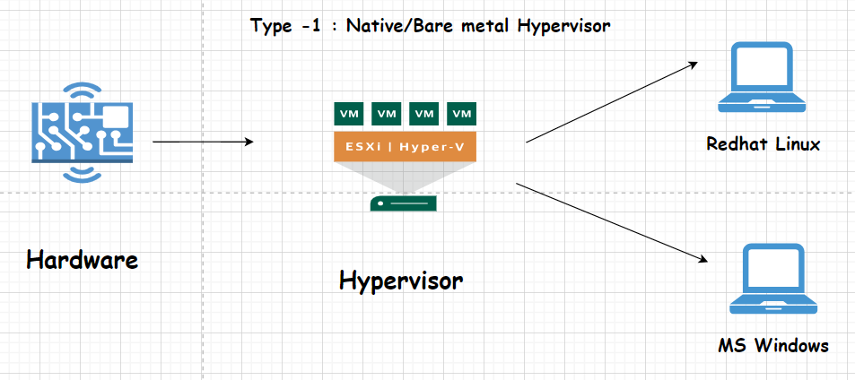

* **Xen – Hypervisor (Type-1) software used by AWS for virtualization.**

**Type-2 Hosted hypervisor:**

It doesn’t run over the hardware directly, it runs over the application as it has an Operating System.

It is easy to set up.

It is useful for the engineers & Security analysis to check the malware and newly deployed applications.

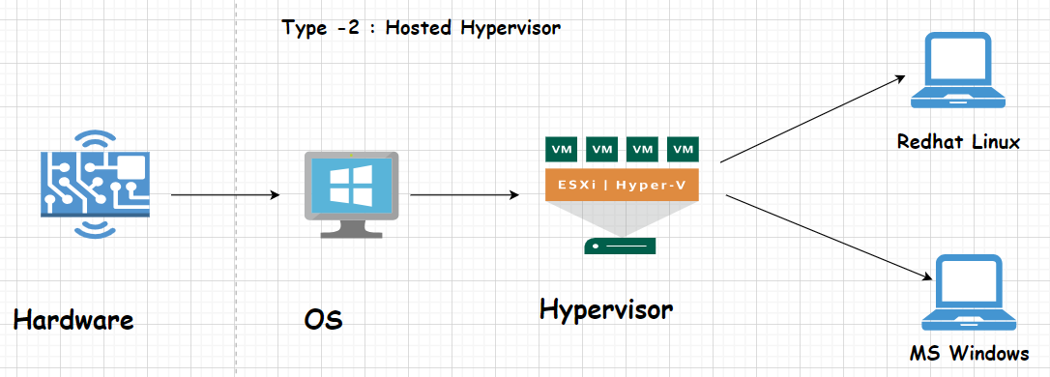

The below tables shows what are the services that are managed by the customer and the services managed by the CSP (Could Service Provider) in Onsite, IaaS, PaaS, SaaS.

In Onsite, customer has to manager everything as shown. But, in SaaS, CSP manages everything.

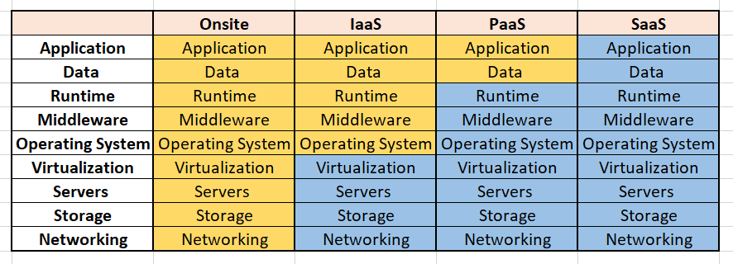

**\* Customer manages * CSP manages**

**1. IaaS (Infrastructure as a Service)**

**Description:**  
IaaS provides virtualized computing resources over the internet. It allows you to rent IT infrastructure like servers, storage, and networking on a pay-as-you-go basis. This means you don’t have to invest in physical hardware.

**Examples:**

* **Amazon EC2:** You can launch virtual servers and scale them up or down as needed.
* **Google Compute Engine:** Offers virtual machines and storage options for your applications.

**2. PaaS (Platform as a Service)**

**Description:**  
PaaS provides a platform that allows developers to build, deploy, and manage applications without worrying about the underlying infrastructure. It includes tools, middleware, and database management services, making it easier for developers to focus on writing code.

**Examples:**

* **Google App Engine:** A platform for building web applications without managing servers.
* **AWS Elastic Beanstalk:** Lets you deploy and manage applications in various languages without worrying about the underlying hardware.

**3. SaaS (Software as a Service)**

**Description:**  
SaaS delivers software applications over the internet on a subscription basis. Users access these applications through a web browser, eliminating the need to install or maintain software locally.

**Examples:**

* **Google Workspace (formerly G Suite):** Provides applications like Google Docs, Sheets, and Gmail online.
* **Salesforce:** A customer relationship management (CRM) tool that runs in the cloud.

**4. Onsite Cloud Services (Private Cloud)**

**Description:**  
Onsite cloud services refer to private cloud environments hosted on your own premises. This setup allows you to have dedicated resources for your organization, giving you more control over security and compliance.

**Examples:**

* **OpenStack:** An open-source software platform that allows you to create and manage your own private cloud.
* **VMware vSphere:** A virtualization platform that enables you to create a private cloud using your own hardware.

**Summary**

* **IaaS:** Rent virtual servers (e.g., EC2).
* **PaaS:** Develop applications without managing servers (e.g., Google App Engine).
* **SaaS:** Use software online (e.g., Google Workspace).
* **Onsite Cloud Services:** Build a private cloud with dedicated resources (e.g., Open Stack).

1. **Cloud Introduction to EC2, EBS, and EFS, FSX**

**EC2 (Elastic Compute Cloud):** Amazon EC2 (Elastic Compute Cloud) is a service that provides virtual servers in the cloud. Using amazon EC2 eliminates the need to invest in hardware upfront, allowing you to develop and deploy applications more quickly. Elasticity is a level at which a system is able to adapt to workload changes by provisioning and de-provisioning resources such that the resources meet the current demands as much as possible.

**Features of EC2:**

* Instances are virtual computing environments
* AMI (Amazon machine images) are preconfigured templates for your instances that package the bits you need for your server(including the operating system and additional software).
* Instance types are different configurations of CPU, memory and storage & networking capacity for your EC2 instances.
* Using key pairs, you can secure login information for your instances. (AWS stores the public key & you store the private key in a secured pace.)

**Instance Types:**

* General purpose, T2 Burstable, Memory optimized, Storage optimized, Accelerated Computing, Compute-optimized.

EC2 Created below in the AWS platform.

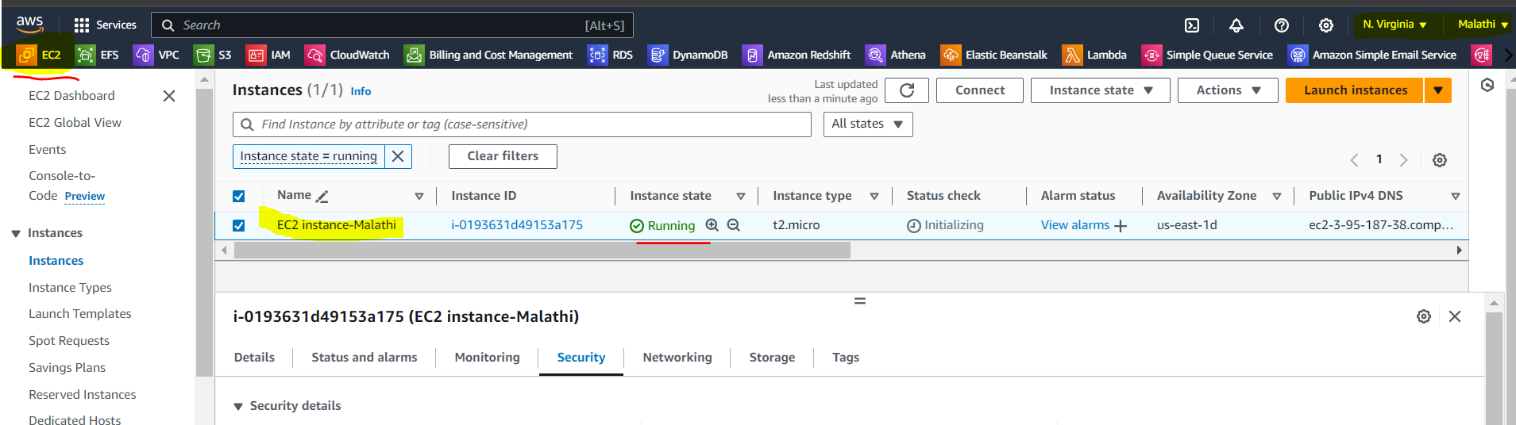

**EBS (Elastic Block Storage):** It is similar to RAM.Amazon EBS is a service from AWS that provides storage volumes with Amazon EC2instances. EBS provides storage volumes that function like virtual hard drives. These volumes can be attached to EC2 instances to store data. Unlike file storage systems, block storage divides data into blocks and stores them, which allows for efficient and flexible storage management.

One EBS can be attached to one EC2. No 2 EC2 instances can have the same EBS volume.

### Features of EBS:

### ****Flexible****: You can create EBS volumes of different sizes and performance characteristics based on your needs. For example, you might choose a volume optimized for high-speed access (SSD) or a volume optimized for cost-efficiency (HDD).

1. **Attach and Detach**: You can attach an EBS volume to an EC2 instance to use it. If you need to, you can detach it and attach it to another instance. This flexibility allows you to move data easily between instances.
2. **Snapshots**: EBS allows you to take snapshots of your volumes. These snapshots are backups that are stored in Amazon S3 (Simple Storage Service). You can use snapshots to restore data or create new EBS volumes.
3. **Performance Options**: EBS offers different performance options, such as General Purpose SSD, Provisioned IOPS SSD (for high-performance needs), and Cold HDD (for infrequent access).
4. **High Availability**: EBS volumes are automatically replicated within the Availability Zone (a data center location) to provide durability. They are designed to handle failures and ensure that your data is safe.

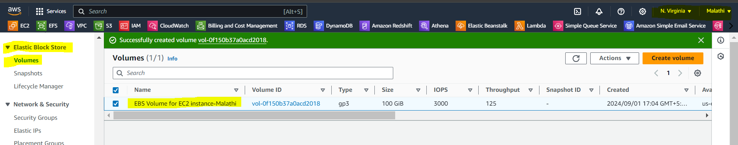

Click on the link below for more details on

Amazon EBS: <https://docs.aws.amazon.com/ebs/?icmpid=docs_homepage_storage>

**EFS (Elastic File Storage):** EFS is afile level storage service that provides a shared elastic file system with virtually limitless scalability. EFS is a highly available storage system that can be used by multiple servers at the same time.

It automatically scale up or scale down the storage depends on the work load (heavy/less workloads).

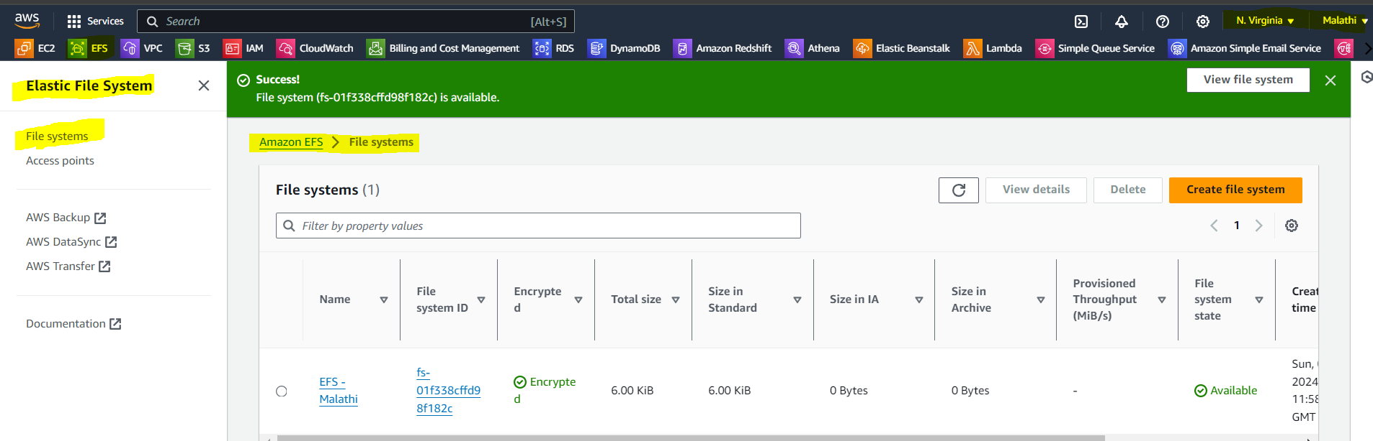

**Features:**

1. **Easy to Use**: You can quickly create and configure EFS through the AWS Management Console or APIs. It integrates easily with EC2 instances.
2. **Shared Access**: Multiple EC2 instances can access the same EFS file system simultaneously. This is useful for applications that need to share files among multiple instances.
3. **High Availability**: EFS is designed to be highly available and fault-tolerant. It replicates your data across multiple Availability Zones (data centers) within a region, which helps ensure your data is always accessible.
4. **Elastic**: EFS automatically adjusts its capacity as you add or remove files. There’s no need to provision storage ahead of time.
5. **Performance**: EFS provides high performance for a wide range of workloads, from small web apps to large data-intensive applications.

**How It Works:**

1. **Create a File System**: You start by creating an EFS file system through the AWS Management Console.
2. **Mount to EC2**: You then mount the EFS file system to your EC2 instances. This makes it appear as if it’s a local drive on those instances.
3. **Use It**: You can then store and access files on the EFS file system just like you would with any other file system. Multiple EC2 instances can read and write to the same file system concurrently.
4. **Manage**: EFS handles scaling and maintenance, so you don’t have to worry about the underlying infrastructure.

**When to Use EFS:**

* **Shared Storage**: When you need a shared file system that multiple EC2 instances can access simultaneously.
* **Dynamic Workloads**: For applications that need to scale storage automatically without manual intervention.
* **High Availability**: When you need durable storage with built-in redundancy.

**FSX (File server):** Amazon Fsx is fully managed third-party file system solution. It makes use of SSD storage to provide fast performance with low latency.

**Use cases of FSX :**

* File system that can establish permissions at the file or folder level and are accessible by multiple users.
* Application workloads that use the SMB protocol and require shared file storage provided by windows-based file systems (NTFS).
* It is compatible with the following compute services;
* Amazon elastic compute cloud, instances of amazon workspaces, instances of amazon app stream &VMWare cloud VMS running on AWS environments.
* Using FSX, we can launch and run high performing file systems with just a few clicks while avoiding tasks such as provisioning hardware, configuring software, or taking backups.
* It provides the option to choose 2 file systems. 1. FSX for windows file server. 2. FSX for luster.
* It is simple and fully managed.
* Highly available and durable.
* Secure and compliant.
* Fast Delivery.
* Pay only for the used resources.
* Easy integration with other AWS services.

1. **Introduction to IAM, Cloud watch, and AMI**

**IAM (Identity and Access Management):** AWS IAM is a web service that helps you securely control access to AWS resources. It is to control who is authenticated and authorized to use resources.

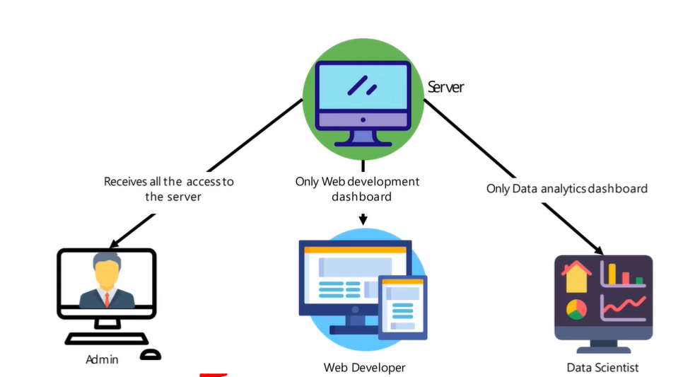

**Features of AMI:**

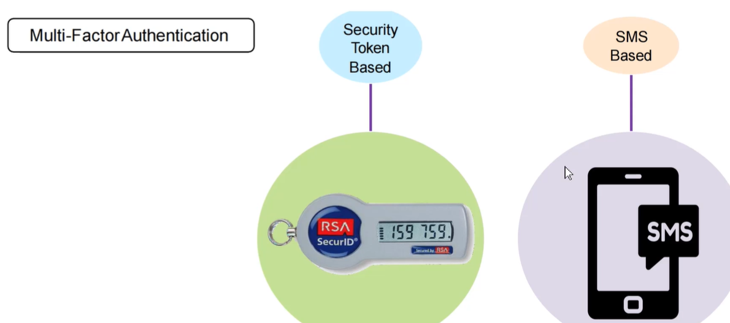

The roles and policies are created and attached to the users and groups based on the permissions requirements.

For more details, please visit the link: <https://aws.amazon.com/about-aws/whats-new/2024/06/aws-iam-access-analyzer-policy-checks/>

**CloudWatch:** Usingcloudwatch, we can create alarms on billing for the data usage in the AWS platform for all the services used.

* It monitors all the AWS resources provisioned and deployed.
* Sends notification if anything goes wrong.
* Events, Alarms, Logs and Metrics are fundamentals to cloudwatchmonitoring.
* Individual data points which are monitored, all actions are based on metrics. E.g. CPU utilization %.
* All AWS services send metrics to CouldWatch by default.

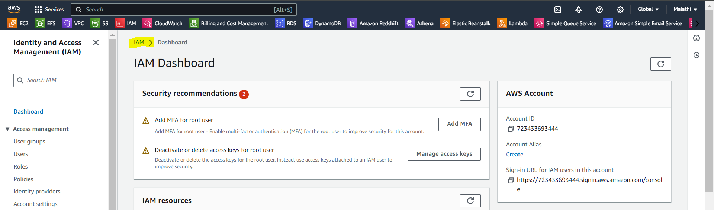

**AMI (Amazon Machine Image):** An Amazon Machine Image (AMI) is an image that provides the software that is required to set up and boot an Amazon EC2 instance. Each AMI also contains a block device mapping that specifies the block devices to attach to the instances that you launch. You must specify an AMI when you launch an instance. The AMI must be compatible with the instance type that you chose for your instance. You can use an AMI provided by AWS, a public AMI, an AMI that someone else shared with you, or an AMI that you purchased from the AWS Marketplace.

An AMI is specific to the following:

* Region
* Operating System
* Processor architecture
* Root device type
* Virtualization type

You can launch multiple instances from a single AMI when you require multiple instances with the same configuration.

1. **Elastic Load Balancer and Auto Scaling**

**ELB (Elastic Load Balancer) :** Load balancer is a service that uniformly distributes the traffic and workloads across multiple servers or a cluster of servers. Load balancer increases the availability and fault tolerance of an application.

* ELB scales itself as necessary to handle the load.
* Incoming traffic is distributed across EC2 instances in multiple availability zones.
* Load balancer is the single point of contact for the clients.

**Types of load balancer:** There are 3 types: Classic Load Balancer, Network Load Balancer, and Application Load Balancer.

**Classic Load Balancer:** It resembles the traditional load balancing, but virtual devices replace the physical hardware. It distributes the incoming application traffic across EC2 instances in multiple AZs and functions at Layer 7 of the OSI model. It routes the traffic to the healthy EC2 instances only and it is evenly distributed.

**Network Load Balancer:** This is used to handle the sudden and violent traffic. It functions at the 4th layer of the OSI model. It handles the millions of requests per second and maintains low latency. Ideal for load balancing the TCP traffic and supports elastic or static IP.

**Application Load Balancer:** This identifies the incoming traffic type and directs it to the specific resources. Functions at the 7th Layer of the OSI (Open System Interconnection) model.

**7 Layers of OSI Model:**

* 1. The Physical Layer.
* 2. The Data Link Layer.
* 3. The Network Layer.
* 4. The Transport Layer.
* 5. The Session Layer.
* 6. The Presentation Layer.
* 7. The Application Layer.

**Auto Scaling:** Auto scaling is the process of scaling up and scaling down the instances based on the load. AWS Auto scaling monitors your applications and adjusts the capacity automatically to ensure consistent, predictable performance at the lowest possible cost. It is simple to set up application scaling for multiple resources across multiple services using AWS auto scaling in minutes.

* Scaling is the process of adding/removing capacity/resources as needed.
* Scale out is adding the capacity/resources.
* Scale in is removing the capacity/resources.
* Types: Vertical and Horizontal
* Auto scaling is scaling out/in automatically without any manual intervention.
* It helps ensure that the correct number of EC2 instances are available to handle the load.
* Multi-AZ instances provide high availability solutions.
* Auto scaling can dynamically increase or decrease capacity as needed.
* Load Balancer automatically registers instances in the group.
* Heath Checks: EC2 instances only: EC2 status are considered.
* EC2 and ELB Health Checks: An instance is considered unhealthy if either of the health checks fail.

**Route 53:** Route 53 is the highly available and scalable Domain Name System provided by AWS.

Example: In [www.amazon.com](http://www.amazon.com) 🡪 com: Top level domain name, amazon 🡪 Domain name, Domain name system is an Internet service that translates the domain names into IP addresses. Also, the endings like .com, .in, .gov, .ord etc represent different domains.

Hosting a Website:

* Start up and server/host where the web service will run(IP address of the server is 10.20.30.60)
* Get a domain name from the DNS (Domain Name Server) providers such as Go daddy, Freenom, etc.
* Link the domain name with the IP address from the above using domain service/system.
* Network latency is an amount of time taken to deliver some amount of data over the network.
* If an application is hosted on EC2 instances in multiple regions, user latency can be reduced by serving requests from the region where
* Network latency is the lowest
* We have to create latency resource record set for the amazon EC2 resource in each region that hosts the application latency record sets can be created for both ELB and EC2 instances.
* Latency on the internet can be changed over time due to changes in routing or any other factor.
* Geo location routing can be used to send the traffic to resources based on the geographical location of users. For example, all queries from Europe can be routed to the IP address: 10.30.50.70
* Geo location works by mapping IP addresses, irrespective of regions, to locations.

1. **VPC (Virtual Private Cloud):** A **Virtual Private Cloud (VPC)** is like having your own private network within a cloud provider (like AWS or Google Cloud), where you can safely run your applications and store data.

It’s like setting up a secure office network, but in the cloud. You control how your resources (like virtual servers, databases, etc.) connect to each other and the internet. You can also decide which parts of your network are accessible from the outside world and which parts are kept private.

For example:

* **Public-facing resources** (like a website) can be accessed by users via the internet.
* **Private resources** (like databases) can be hidden and only accessible to your application servers, making everything more secure.

**Components of VPC:**

* Network Interfaces
* Route Tables
* Internet Gateway
* Network Address Translation(NAT) Gateway
* Security Groups and NACL

Network Interface:

* Interface between computer and internet network.
* Network IO (Input/Output) happens via network interface cards.
* Network interfaces contain – Elastic IP, Public IP, Private IP, Security Groups
* It can be created to an instance, attached to an instance, detached from an instance, re-attached to another instance.
* Network interfaces can have additional secondary IP address attached to it.
* IP address can be assigned to n/w interfaces attached to a running to stopped instance.

Route Tables:

* Route Table tells a machine/network where the traffic is directed.
* Directions are defined by “routes” in Route Tables.
* Each subnet must be associated with a route.
* All the VPCs come with an implicit router and a main route table which can be modified.

Internet Gateway and NAT Gateway:

* An internet gateway is a horizontally scaled, redundant and highly available VPC component that allows communication between instances in your VPC and internet.
* Purpose of an Internet gateway:
* It can be created to an instance, attached to an instance, detached from an instance, re-attached to another instance.
* Internet cannot initiate any connection to the instance via NAT.
* NAT devices enable instances in the Private Subnet to connect to the internet and brings responses back to the instances.
* NAT devices are created in public subnet.

Security Groups and NACL :

* A security group acts as a virtual firewall for your instance to control inbound and outbound traffic.