PART B

(PART B : TO BE COMPLETED BY STUDENTS)

***(Students must submit the soft copy as per following segments within two hours of the practical. The soft copy must be uploaded on the Blackboard or emailed to the concerned lab in charge faculties at the end of the practical in case there is no Black board access available)***

| Roll No. C056 | Name: Malav Mehta |
| --- | --- |
| Class : B | Batch : EB2 |
| Date of Experiment: 2/1/24 | Date of Submission |
| Grade : |  |

# Documentation written by student:





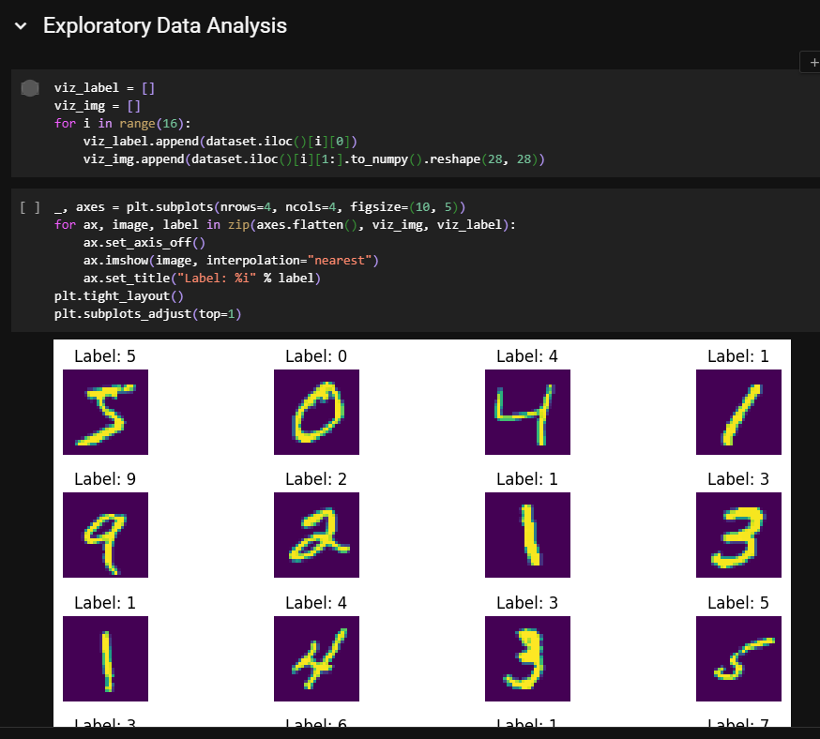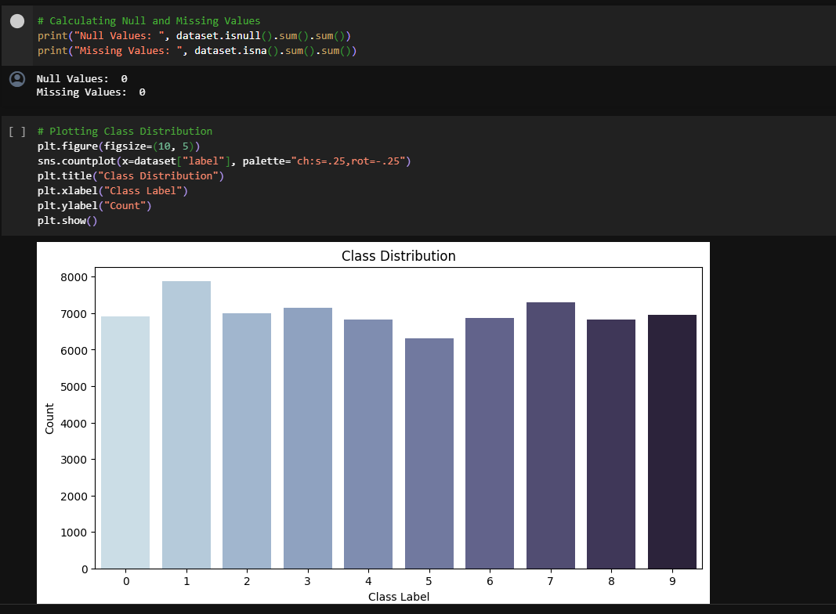



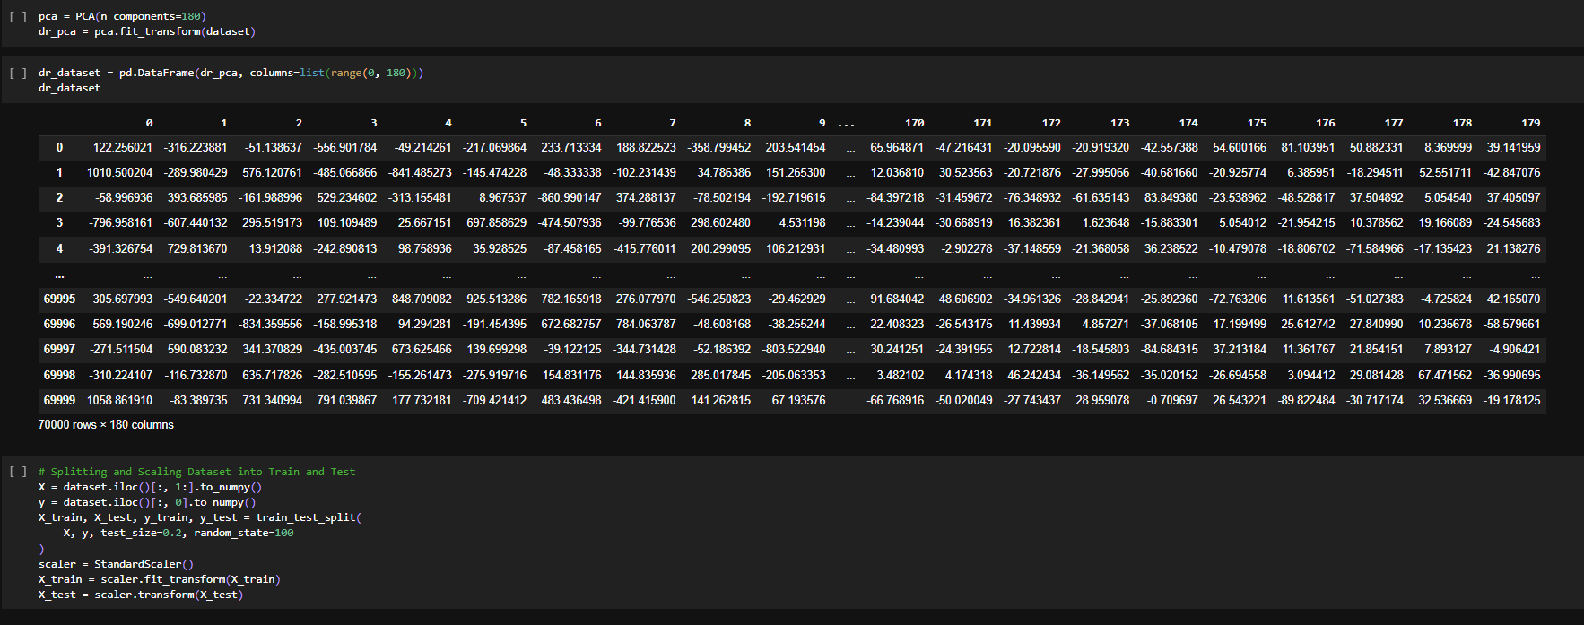





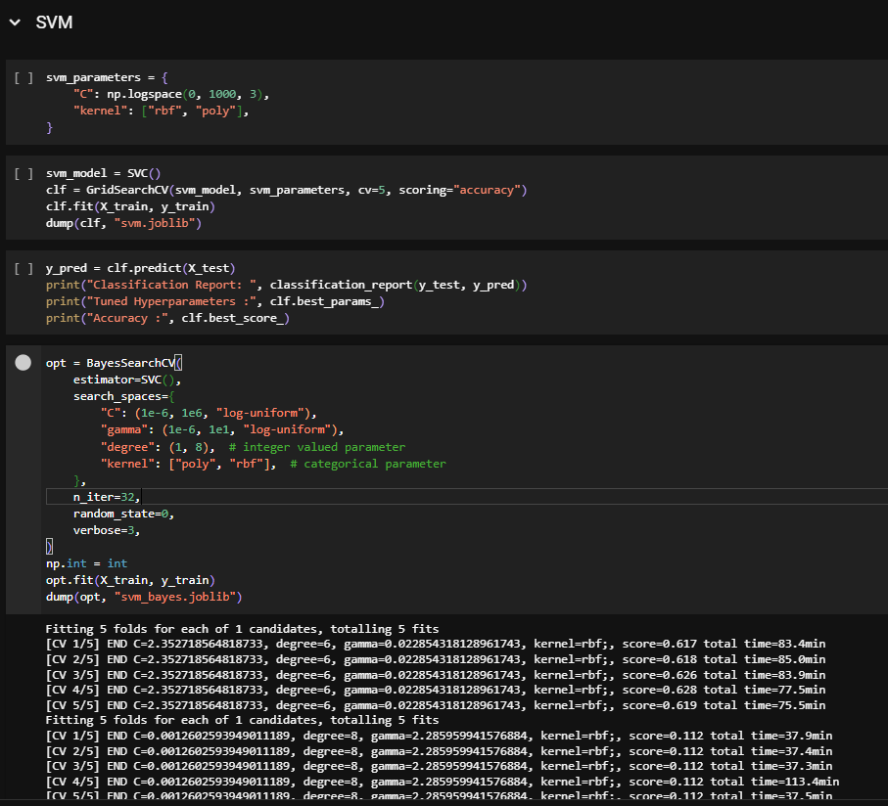

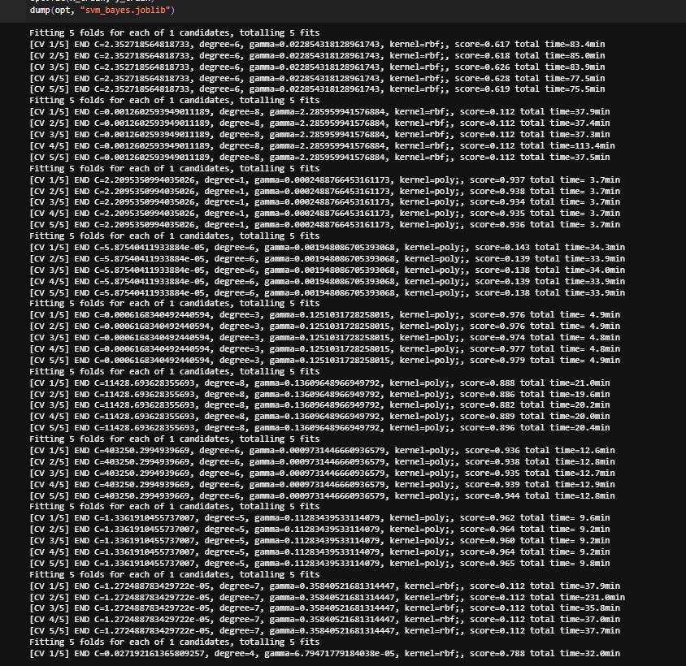

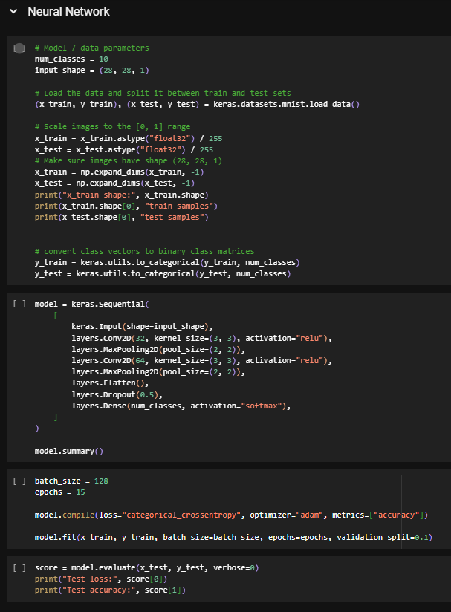

# Observations and learning:

***ANS:-***

Exciting new insights into the appropriateness of several machine learning models for picture classification tasks, such as handwritten digit identification, were obtained through evaluation. While logistic regression and other simpler linear algorithms managed a respectable 91.86% validation accuracy, they were unable to identify the visual patterns present in the dataset and necessitated extensive searches for hyperparameters. Similar to this, K-Nearest Neighbours, decision trees, and support vector machines all achieved respectable accuracy levels of 86–96%, but only after extensive computational research to determine the proper parameters. Conversely, without requiring the same amount of fine tuning, the deep Convolutional Neural Network architecture was able to learn robust features well during training. When given enough training data, the CNN model produced results with 98.40% accuracy quite rapidly, proving the deep learning's advantages in terms of both speed and performance for computer vision tasks.

# Conclusion:

*This analysis of machine learning techniques for classifying handwritten digits concluded by highlighting the benefits of deep convolutional neural networks for image recognition applications. Simpler linear and tree-based models might have successfully captured the visual patterns in the pixel data, but they only reached modest accuracy levels with substantial hyperparameter adjustment. However, the CNN architecture consistently outperformed the alternatives and trained effectively without the need for similar tuning thanks to its hierarchical feature design. These trials demonstrated how crucial it is to choose the right model class and architecture for the problem space as opposed to trying to brute force accuracy gains using only parameter searches. Deep neural networks (DLNs) hold great potential for computer vision applications as they can immediately learn robust spatial representations from pixel inputs.*