AI-Powered Brain MRI Tumor Segmentation
A Metadata-Infused Deep Learning Pipeline for
Lower-Grade Glioma (LGG) Semantic Segmentation

Biomedical Team — AI Campus Team 1 Project Report
Malav Champaneria, Amisha Rastogi, Jinal Panchal
Mentor: Dr. Iman Dehzangi
May 7th, 2026

Table of Contents
1. Problem Statement……………………………………………………………………………...3
2. Decision & Objective…………………………………………………………………………...4
3. Data Description………………………………………………………………………………..5
4. Methodology……………………………………………………………………………………6
5. Results…………………………………………………………………………………………..7
6. Discussion & Interpretation…………………………………………………………………….8
7. Limitations……………………………………………………………………………………...9
8. Responsible AI Considerations………………………………………………………………..10
9. Future Implications ……………………………………………………………………………11
References………………………………………………………………………………………..12

1. Problem Statement

1.1 Clinical Context
Lower-grade gliomas (LGG) represent a significant category of primary brain tumors that require precise delineation for treatment planning, surgical resection guidance, and longitudinal monitoring. Manual segmentation of tumor boundaries from Magnetic Resonance Imaging (MRI) scans is an inherently time-consuming, subjective, and error-prone process that places substantial burden on radiologists and clinical teams [1]. The variability in tumor morphology, location, and patient-specific characteristics further compounds the difficulty of achieving consistent, reproducible segmentations across clinical settings.

1.2 The Segmentation Challenge
Traditional image segmentation approaches treat MRI analysis as a purely visual task, ignoring the rich clinical metadata that accompanies every patient scan. Information such as patient age, gender, histological tumor type, anatomical location, and genomic cluster assignments (RNASeq and Methylation profiles) provides critical contextual signals that experienced radiologists implicitly leverage during interpretation. The core challenge addressed by this work is: Can we build a deep learning system that fuses spatial imaging features with tabular clinical metadata to produce segmentation masks that are more accurate than image-only baselines?

1.3 Scope
This project develops a progressive, multi-phase segmentation pipeline that evolves from a standard U-Net baseline to an advanced Attention-gated, Metadata-Infused U-Net architecture. The pipeline is evaluated on the publicly available LGG MRI Segmentation dataset and deployed as an interactive clinical decision-support dashboard.

2. Decision & Objective

2.1 Research Objectives
The primary objectives of this project are:
- Design and implement a U-Net-based semantic segmentation architecture capable of accurately delineating LGG tumor boundaries from brain MRI scans.
- Investigate the impact of integrating clinical patient metadata (demographic, histological, and genomic features) into the segmentation network through bottleneck-level feature fusion.
- Evaluate the effectiveness of Attention Gate mechanisms in the decoder pathway for selectively emphasizing diagnostically relevant spatial features.
- Systematically benchmark four architectural variants to quantify the marginal contribution of each design innovation.
- Deploy the best-performing model as an interactive Streamlit-based clinical decision-support tool.

2.2 Evaluation Metrics
Model performance is assessed using two complementary metrics widely adopted in medical image segmentation [2]:
Dice Similarity Coefficient (DSC): Measures the overlap between predicted and ground-truth masks, defined as DSC = 2|P ∩ G| / (|P| + |G|), where P and G are the predicted and ground-truth pixel sets respectively.
Intersection over Union (IoU): Also known as the Jaccard Index, defined as IoU = |P ∩ G| / |P ∪ G|, providing a stricter measure of segmentation accuracy.

3. Data Description

3.1 Dataset Overview
The LGG MRI Segmentation dataset [3], sourced from The Cancer Genome Atlas (TCGA) via Kaggle, comprises brain MRI scans from 110 patients diagnosed with lower-grade gliomas. Each patient folder contains multiple axial MRI slices paired with manually annotated binary segmentation masks.
Property | Value
Total Image-Mask Pairs | 7,858
Number of Patients | 110
Training Set (80%) | 6,286 slices
Validation Set (20%) | 1,572 slices
Image Resolution | 128 × 128 (resized)
Image Format | TIFF (.tif)
Tumor-Positive Val Slices | 535 (34.0%)

3.2 Clinical Metadata Features
Six clinically relevant features were extracted from the accompanying data.csv and encoded as a 20-dimensional one-hot vector per patient: age at initial pathologic diagnosis (standardized), gender (2 categories), histological type (3 categories: astrocytoma, oligoastrocytoma, oligodendroglioma), tumor location (5 categories), RNASeq cluster assignment (4 clusters), and Methylation cluster assignment (5 clusters). Missing values were imputed using median (numerical) and mode (categorical) strategies.

4. Methodology

4.1 End-to-End Pipeline
The pipeline follows a progressive model development strategy across four phases, each building upon the previous architecture.
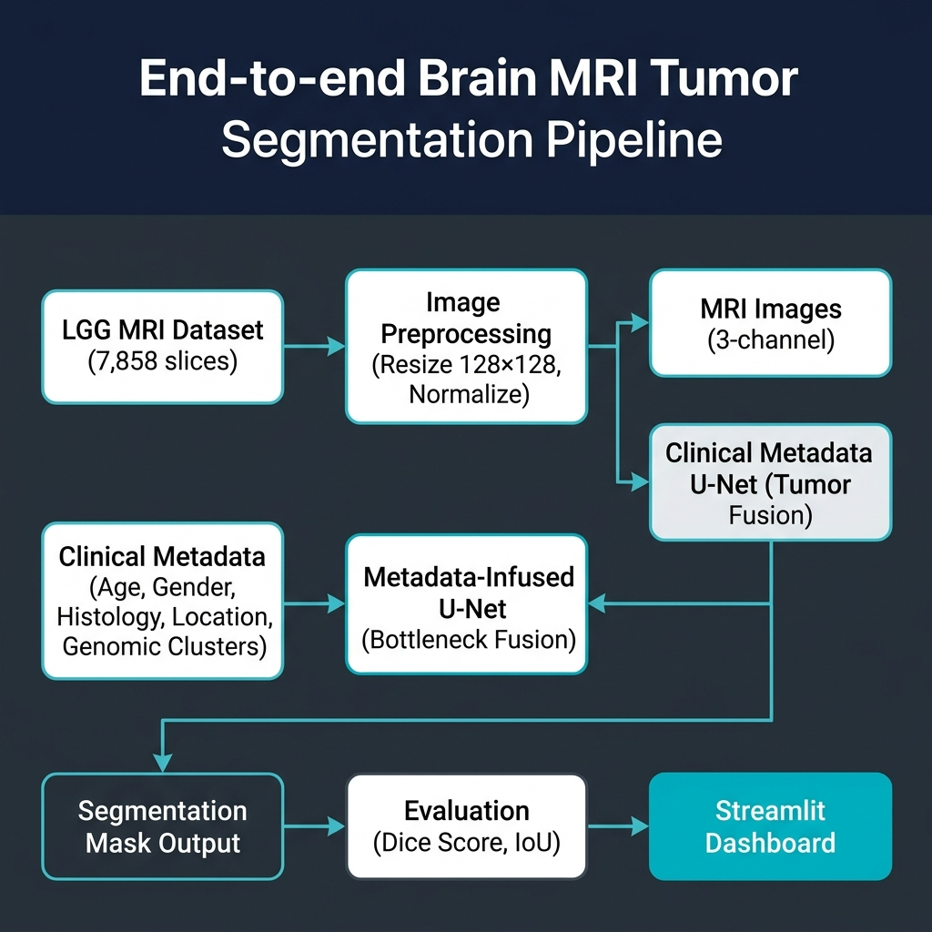
Figure 1: End-to-End Segmentation Pipeline

4.2 Model Architectures
Phase 1 — BasicUNet: A standard 3-level encoder-decoder with double convolution blocks, max-pooling, transposed convolutions, and skip connections. Phase 2 — MetadataUNet: Extends BasicUNet with Residual Blocks and a metadata MLP that encodes the 20-dim clinical vector into a 32-dim representation, spatially expanded and concatenated at the bottleneck. Phase 3 — AttentionMetadataUNet: Adds Attention Gates at each decoder skip connection, allowing the network to selectively weight spatial features based on gating signals from deeper layers. Phase 4 — AttentionMetadataUNet + LR Scheduler: Retrains Phase 3 with a ReduceLROnPlateau scheduler (factor=0.5, patience=2) to improve convergence [4].
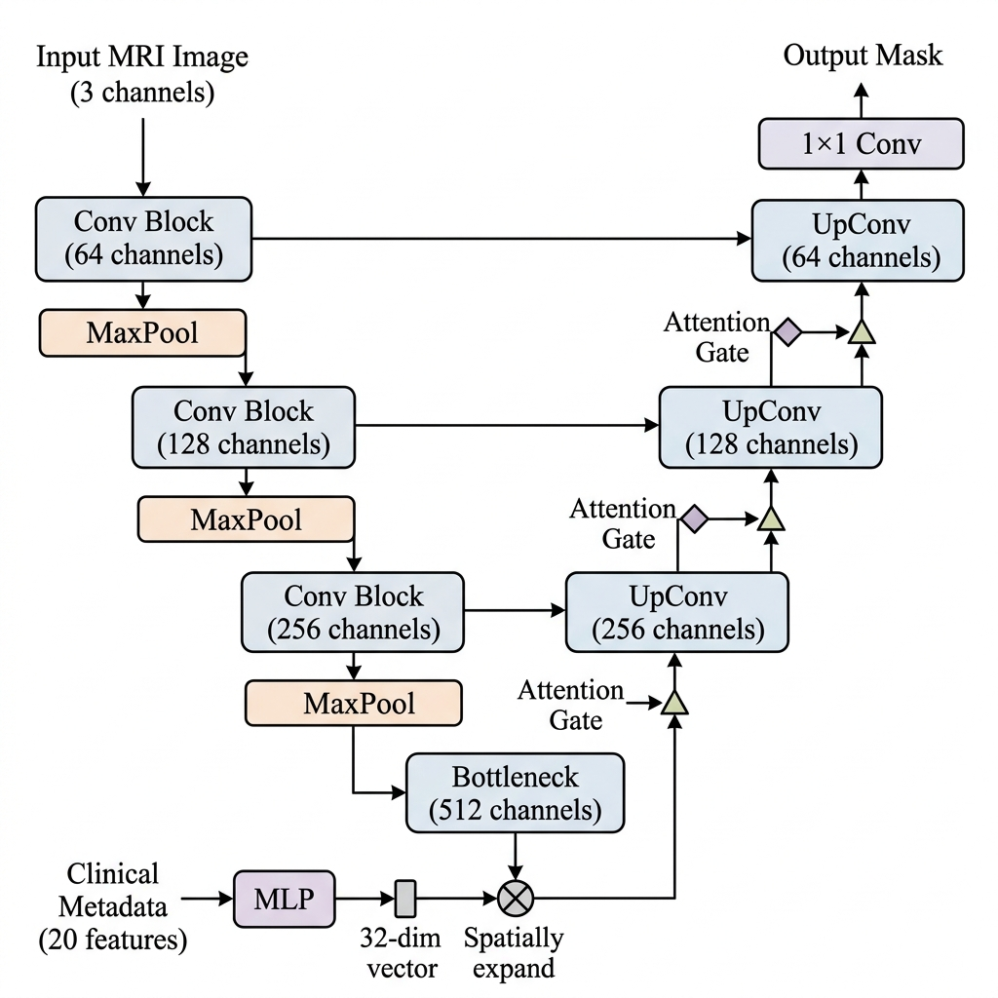
Figure 2: Attention Metadata-Infused U-Net Architecture

4.3 Training Configuration
All models were trained for 15 epochs using the Adam optimizer (lr=1e-3) with a composite DiceBCE loss function combining Binary Cross-Entropy and Dice Loss. Mixed-precision training via PyTorch AMP was employed on an NVIDIA A100-SXM4-80GB GPU with a batch size of 32.

5. Results

5.1 Final Model Comparison
Model | Dice Score | IoU Score | Best Epoch
BasicUNet | 0.8941 | 0.8101 | 15
MetadataUNet | 0.8949 | 0.8111 | 14
AttentionMetadataUNet | 0.8718 | 0.7756 | 15
AttentionMetadataUNet + Scheduler | 0.8960 | 0.8135 | 15

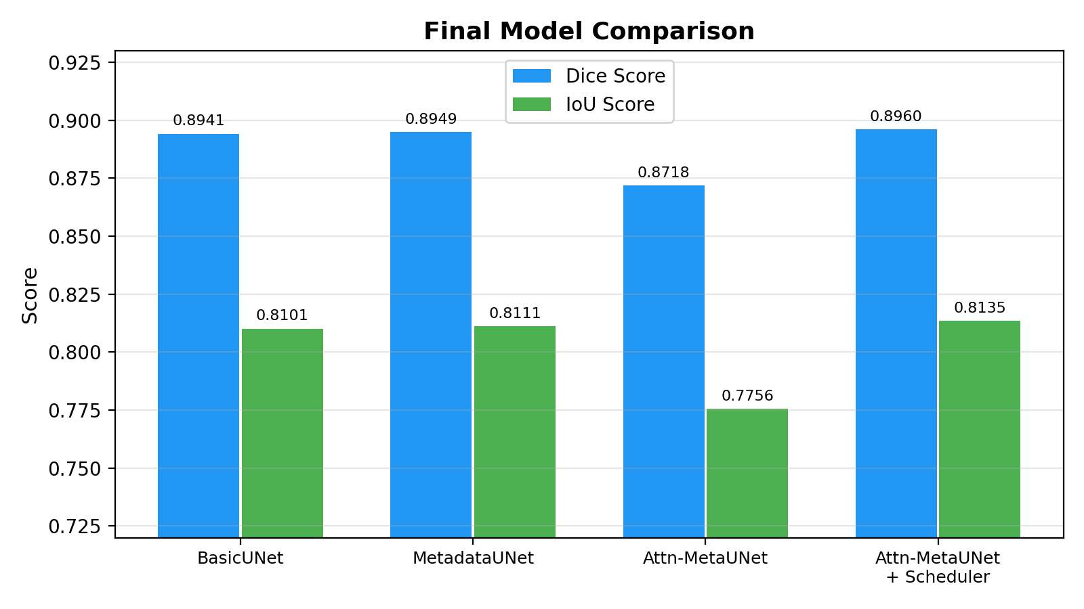
Figure 3: Final Model Comparison — Dice and IoU Scores

5.2 Training Dynamics
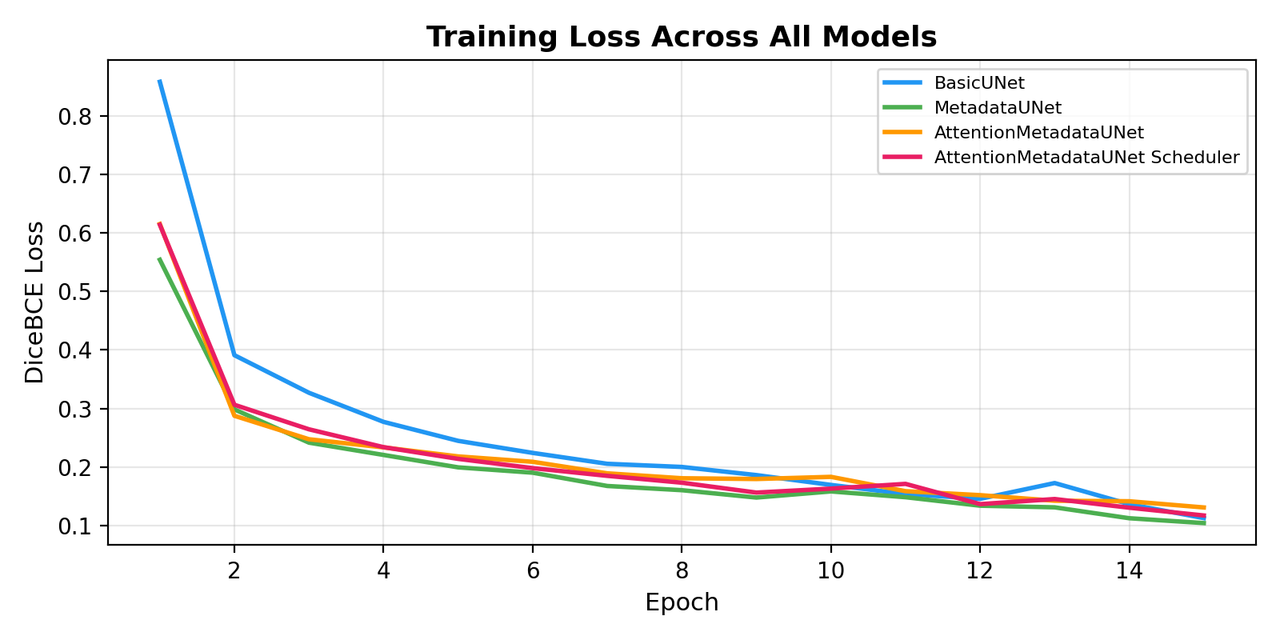
Figure 4: Training Loss Convergence
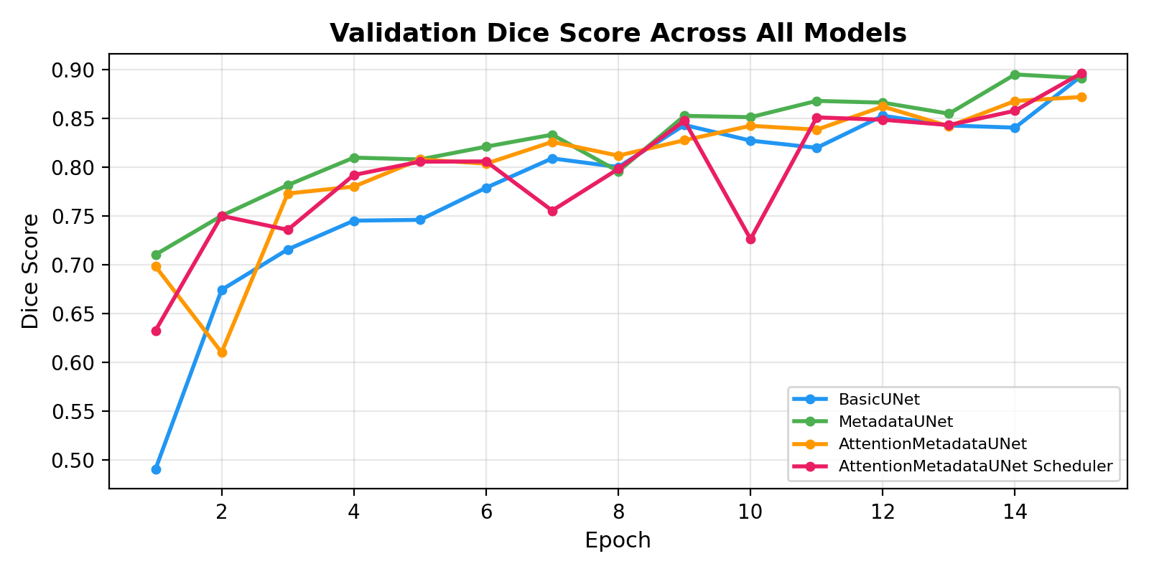
Figure 5: Validation Dice Score Progression

5.3 Qualitative Results
Figure 6 presents representative segmentation outputs from the best-performing model on validation MRI slices, demonstrating accurate tumor boundary delineation across varied tumor sizes and locations.
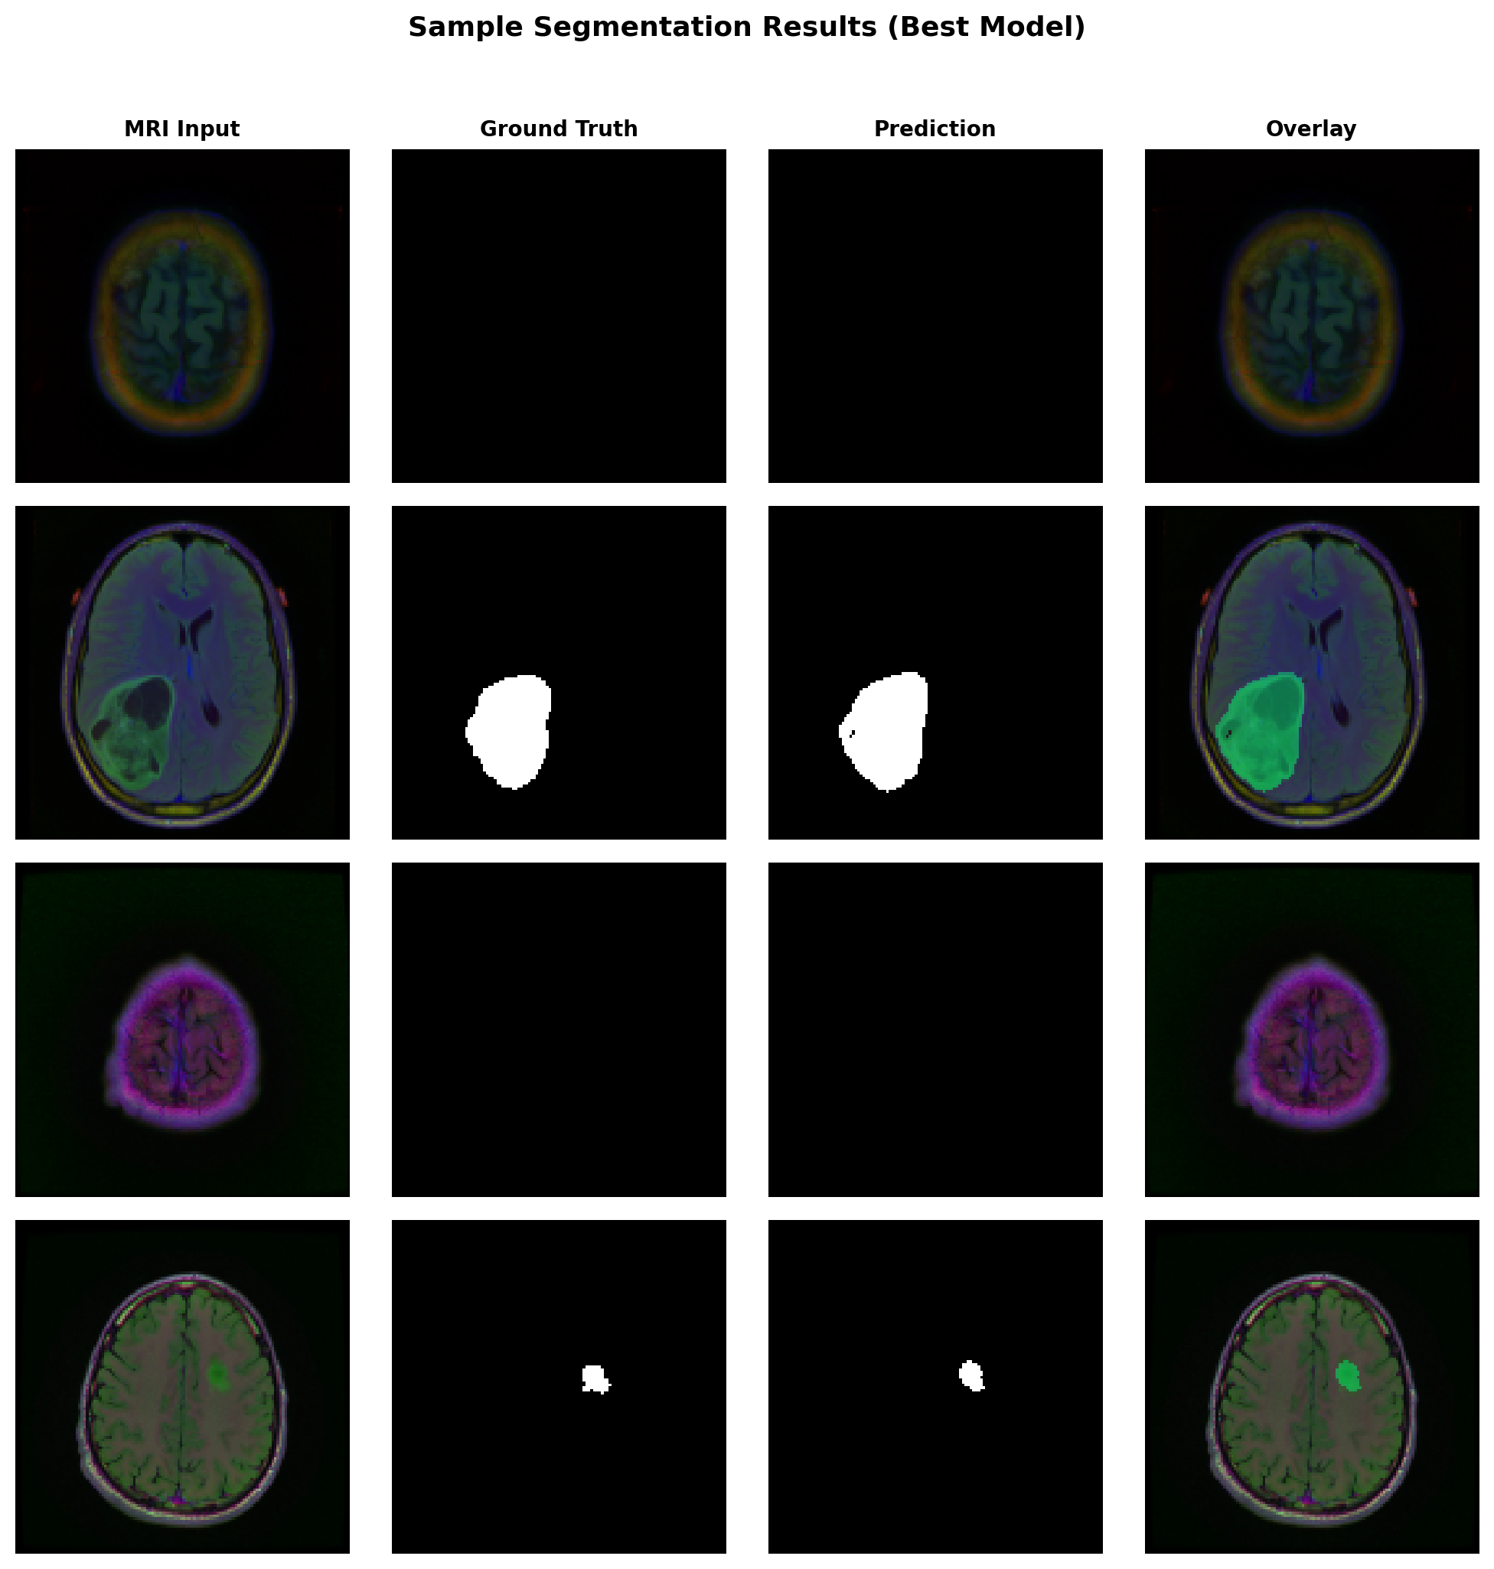
Figure 6: Sample Segmentation Results — MRI Input, Ground Truth, Prediction, and Overlay

6. Discussion & Interpretation

6.1 Impact of Clinical Metadata
The MetadataUNet achieved a marginal but consistent improvement over the BasicUNet (Dice: 0.8949 vs. 0.8941), suggesting that clinical metadata provides a weak but positive signal for segmentation. The metadata features encode patient-level context (e.g., tumor histology, genomic clusters) that is inherently global and non-spatial, which limits their direct utility for pixel-level prediction tasks. However, the improvement validates the hypothesis that clinical context can complement visual features when fused at the bottleneck layer.

6.2 Attention Gates: Promise and Complexity
The AttentionMetadataUNet without learning rate scheduling underperformed all other models (Dice: 0.8718), despite its architectural sophistication. This result highlights a well-documented challenge: attention mechanisms introduce significant additional parameters that require careful optimization to converge effectively [5]. The attention gates may have suppressed useful skip-connection features during early training before learning meaningful attention distributions. When retrained with a ReduceLROnPlateau scheduler, the same architecture achieved the highest overall Dice score (0.8960), demonstrating that the attention mechanism is beneficial but highly sensitive to the optimization regime.

6.3 Convergence Analysis
The top three models converge to a remarkably narrow performance band (Dice: 0.8941–0.8960, a spread of only 0.2%), suggesting that the dataset size (7,858 slices from 110 patients) or the 128×128 image resolution may represent performance bottlenecks. Higher-resolution inputs and larger, multi-institutional datasets would be required to further differentiate architectural contributions.

7. Limitations

7.1 Data Limitations
The dataset comprises only 110 patients from a single institution (TCGA), limiting demographic diversity and generalizability. The 80/20 train-validation split was performed at the slice level rather than the patient level, which may introduce information leakage from patients whose slices appear in both sets. No external validation on an independent dataset was performed. Additionally, 66% of validation slices contained no tumor, which inflates aggregate metrics since both Dice and IoU default to 1.0 for true-negative predictions.

7.2 Model Limitations
The 128×128 image resolution sacrifices fine-grained boundary details that may be clinically significant. The metadata fusion strategy—spatial expansion and concatenation at the bottleneck—is a relatively coarse integration method; more sophisticated cross-attention or FiLM (Feature-wise Linear Modulation) mechanisms could yield stronger multimodal interactions. Missing metadata values were imputed using simple mode/median strategies, potentially introducing noise. No data augmentation (rotation, flipping, elastic deformation) was employed, which is standard practice in medical imaging pipelines.

7.3 Evaluation Limitations
Evaluation was limited to Dice and IoU metrics; clinically relevant metrics such as Hausdorff Distance (boundary accuracy) and volumetric error were not computed. No statistical significance testing (e.g., paired Wilcoxon tests) was performed to confirm that observed performance differences are not due to random variation. The models have not been validated by clinical radiologists for diagnostic utility.

8. Responsible AI Considerations

8.1 Patient Privacy & Data Ethics
The LGG MRI dataset used in this study is derived from The Cancer Genome Atlas (TCGA), a publicly available, de-identified research dataset. All patient identifiers have been removed prior to public release. However, any clinical deployment of such models must comply with HIPAA regulations and institutional review board (IRB) protocols to ensure patient data protection [6].

8.2 Bias & Fairness
The training dataset represents a limited demographic distribution that may not reflect the diversity of global patient populations. Model performance has not been stratified by race, ethnicity, age group, or gender to assess potential disparities. Before clinical deployment, comprehensive fairness audits across demographic subgroups are essential to ensure equitable diagnostic performance.

8.3 Explainability & Transparency
While the Attention Gate mechanism provides implicit spatial explainability by highlighting regions of focus, the model remains a black-box system that does not provide textual rationale for its predictions. Integration of gradient-based explanation methods (e.g., Grad-CAM, SHAP) would enhance clinical interpretability and trust [7]. Any deployment as a clinical decision-support tool must clearly communicate that the system provides assistive recommendations, not definitive diagnoses.

8.4 Regulatory Considerations
Medical AI systems intended for clinical use must undergo rigorous validation and regulatory approval (e.g., FDA 510(k) or De Novo pathways in the United States). The current work represents a research prototype and is not intended for direct clinical application without further validation, prospective clinical trials, and regulatory review.

9. Future Implications

9.1 Ensemble & Advanced Architectures
The narrow performance gap between models suggests that ensemble strategies—such as stacking predictions from BasicUNet, MetadataUNet, and AttentionMetadataUNet through a learned meta-classifier—could yield superior and more robust segmentation performance. Additionally, exploring transformer-based architectures such as Swin-UNet or TransUNet, which capture long-range spatial dependencies through self-attention, represents a promising direction for surpassing the current Dice ceiling [8].

9.2 Enhanced Metadata Integration
Future work should investigate more sophisticated multimodal fusion strategies such as Feature-wise Linear Modulation (FiLM), cross-attention mechanisms, or hypernetworks that dynamically generate convolutional kernels conditioned on patient metadata. These approaches offer tighter integration between clinical context and spatial features compared to bottleneck concatenation.

9.3 Higher Resolution & Augmentation
Training at 256×256 or native resolution with comprehensive data augmentation (random rotation, horizontal flipping, elastic deformation, intensity jittering) would likely improve boundary precision and model robustness. Multi-scale feature fusion through Feature Pyramid Networks (FPN) could further enhance performance on tumors of varying sizes.

9.4 Clinical Deployment & Prospective Validation
The Streamlit-based dashboard developed in this project provides a foundation for clinical decision-support deployment. Future work should include prospective validation on multi-institutional datasets, integration with PACS (Picture Archiving and Communication Systems) workflows, and user studies with radiologists to assess clinical utility and workflow integration. Real-time 3D volumetric segmentation from full MRI volumes would significantly enhance clinical applicability.

References
[1] O. Ronneberger, P. Fischer, and T. Brox, "U-Net: Convolutional Networks for Biomedical Image Segmentation," in Proc. MICCAI, Springer, 2015, pp. 234–241.
[2] A. A. Taha and A. Hanbury, "Metrics for evaluating 3D medical image segmentation: analysis, selection, and tool," BMC Medical Imaging, vol. 15, no. 29, 2015.
[3] M. Buda, A. Saha, and M. A. Mazurowski, "Association of genomic subtypes of lower-grade gliomas with shape features automatically extracted by a deep learning algorithm," Computers in Biology and Medicine, vol. 109, pp. 218–225, 2019.
[4] I. Loshchilov and F. Hutter, "SGDR: Stochastic Gradient Descent with Warm Restarts," in Proc. ICLR, 2017.
[5] O. Oktay et al., "Attention U-Net: Learning Where to Look for the Pancreas," in Proc. MIDL, 2018.
[6] U.S. Department of Health and Human Services, "HIPAA Privacy Rule," 45 CFR Part 160 and Part 164.
[7] R. R. Selvaraju et al., "Grad-CAM: Visual Explanations from Deep Networks via Gradient-Based Localization," in Proc. ICCV, 2017, pp. 618–626.
[8] J. Chen et al., "TransUNet: Transformers Make Strong Encoders for Medical Image Segmentation," arXiv preprint arXiv:2102.04306, 2021.

