SQL ASSIGNMENT SOLUTIONS

-- Q1. Basic Filtering – High-Value Products
-- Find all event records where the base_price is greater than 1,000.
-- Display:
-- - event_id
-- - store_id
-- - product_code
-- - base_price
-- - promo_type
-- Concepts:
-- SELECT, WHERE, comparison operators.

select event_id,store_id,product_code,base_price,promo_type from fact_events where base_price>1000;
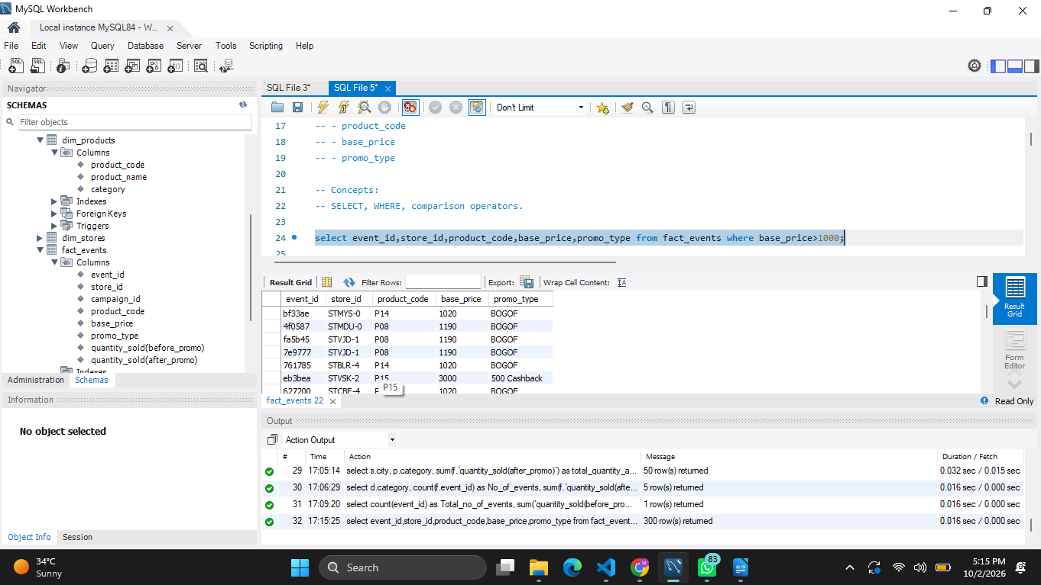

-- ------------------------------------------------------------
-- Q2. Sorting Promotional Events
-- Display all events where quantity sold after the promotion was greater than 100.
-- Display:
-- - event_id
-- - product_code
-- - promo_type
-- - quantity_sold(before_promo)
-- - quantity_sold(after_promo)
-- Sort by quantity_sold(after_promo) in descending order.
-- Concepts:
-- WHERE, ORDER BY, DESC.

select event_id,
product_code,
promo_type,
`quantity_sold(before_promo)`,
`quantity_sold(after_promo)`
from fact_events
where `quantity_sold(after_promo)`>100
order by `quantity_sold(after_promo)` desc;
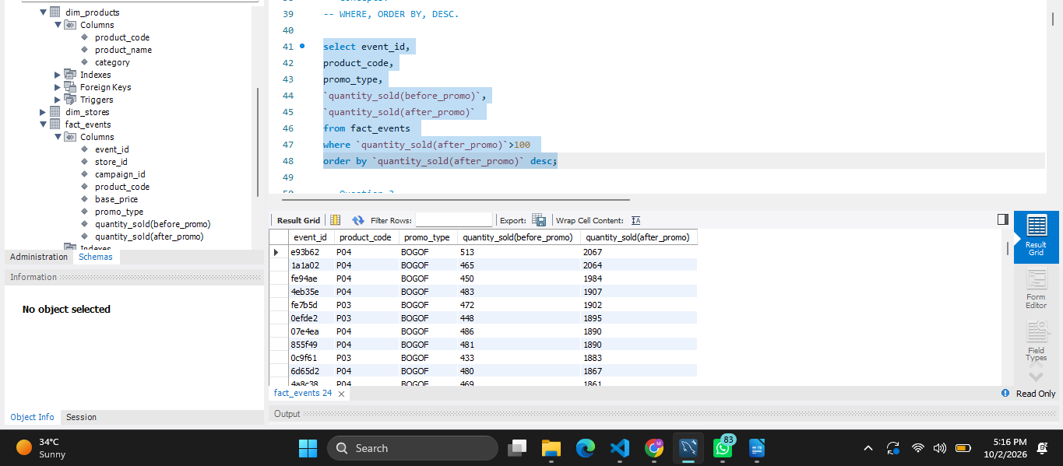
-- ------------------------------------------------------------

-- Q3. DISTINCT Promotion Types
-- Find all unique promotion types used in the dataset.
-- Display only the unique promo_type values.
-- Concepts:
-- DISTINCT.

select distinct promo_type from fact_events;
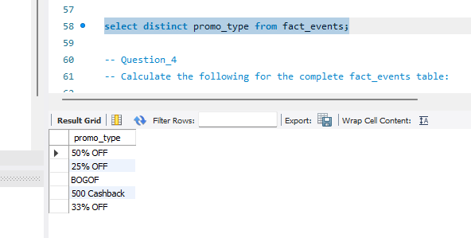
-- ------------------------------------------------------------

-- Q4. Basic Aggregation
-- Calculate the following for the complete fact_events table:
-- - Total number of events
-- - Total quantity sold before promotion
-- - Total quantity sold after promotion
-- - Average base price
-- - Maximum base price
-- - Minimum base price
-- Return all metrics in one row.
-- Concepts:
-- COUNT, SUM, AVG, MAX, MIN

select count(event_id) as Total_no_of_events,
sum(`quantity_sold(before_promo)`) as Total_quantity_before_promotion,
sum(`quantity_sold(after_promo)`) as Total_quantity_after_promotion,
avg(base_price) as Avg_base_price,
max(base_price) as max_price,
min(base_price) as min_price
from fact_events;
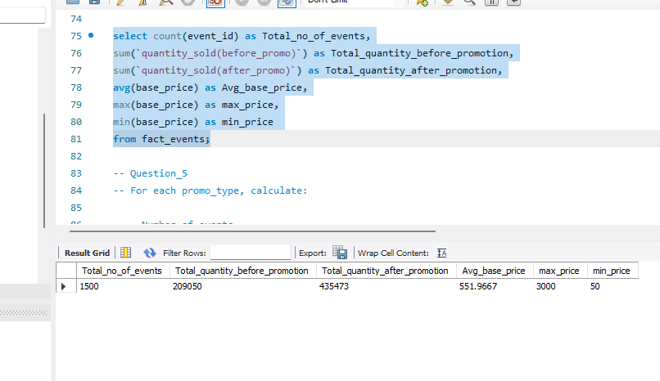
-- -------------------------------------------------------------------------------
-- Q5. Sales Volume by Promotion Type
-- For each promo_type, calculate:
-- - Number of events
-- - Total quantity sold before promotion
-- - Total quantity sold after promotion
-- Sort by total quantity sold after promotion in descending order.
-- Concepts:
-- GROUP BY, COUNT, SUM, ORDER BY.

select promo_type,
count(*) as No_of_events,
sum(`quantity_sold(before_promo)`) as Total_quantity_before_promo,
sum(`quantity_sold(after_promo)`) as Total_quantity_after_promo
from fact_events group by promo_type order by Total_quantity_after_promo desc;
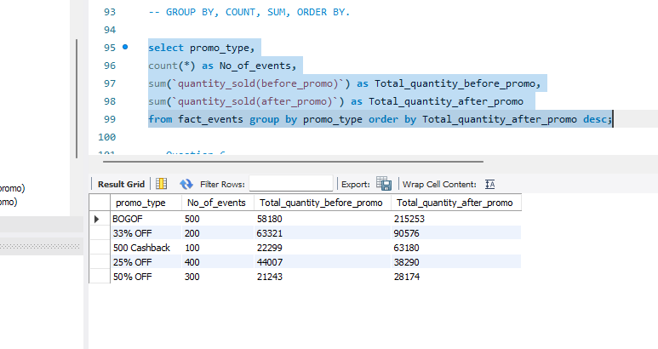
-- ------------------------------------------------------------

-- Q6. Promotion Uplift
-- For every promotion type, calculate:
-- - Total quantity before promotion
-- - Total quantity after promotion
-- - Quantity increase/decrease
-- Use:
-- Quantity Change = After Promo Quantity - Before Promo Quantity
-- Display:
-- - promo_type
-- - total_before
-- - total_after
-- - quantity_change
-- Sort by quantity_change descending.
-- Concepts:
-- GROUP BY, SUM, arithmetic calculations, aliases.

select promo_type,
sum(`quantity_sold(before_promo)`) as total_before,
sum(`quantity_sold(after_promo)`) as total_after,
sum(`quantity_sold(after_promo)`)-sum(`quantity_sold(before_promo)`) as quantity_change
from fact_events
group by promo_type
order by quantity_change desc;
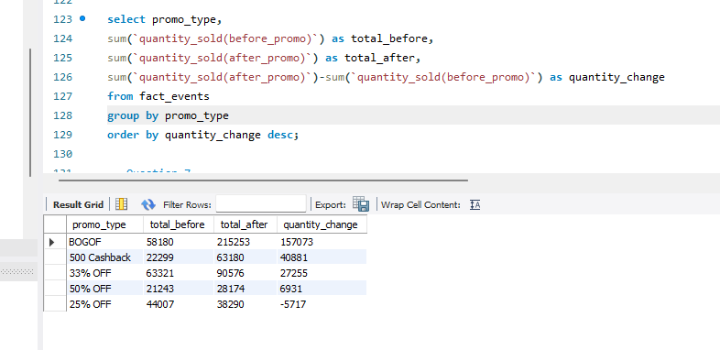
-- ------------------------------------------------------------

-- Q7. Product Performance
-- Using fact_events and dim_products, calculate total quantity sold after promotion for every product.
-- Display:
-- - product_code
-- - product_name
-- - category
-- - total quantity after promotion
-- Sort by total quantity after promotion descending.
-- Concepts:
-- INNER JOIN, GROUP BY, SUM, ORDER BY.

select d.product_code,
d.product_name,
d.category,
sum(f.`quantity_sold(after_promo)`) as Total_quantity_after_promo
from fact_events f inner join dim_products d
on f.product_code=d.product_code
group by d.product_code
order by Total_quantity_after_promo desc ;
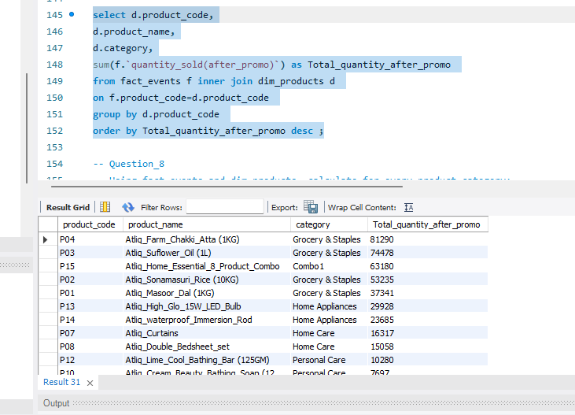
-- ------------------------------------------------------------

-- Q8. Category-Level Performance
-- Using fact_events and dim_products, calculate for every product category:
-- - Number of events
-- - Total quantity before promotion
-- - Total quantity after promotion
-- - Quantity change
-- Sort categories by total quantity after promotion descending.
-- Concepts:
-- JOIN, GROUP BY, SUM, COUNT, arithmetic calculations.

select d.category,
count(f.event_id) as No_of_events,
sum(f.`quantity_sold(after_promo)`) as Total_quantity_before_promo,
sum(f.`quantity_sold(before_promo)`) as Total_quantity_after_promo
from fact_events f join dim_products d
on f.product_code=d.product_code
group by d.category
order by Total_quantity_after_promo desc;
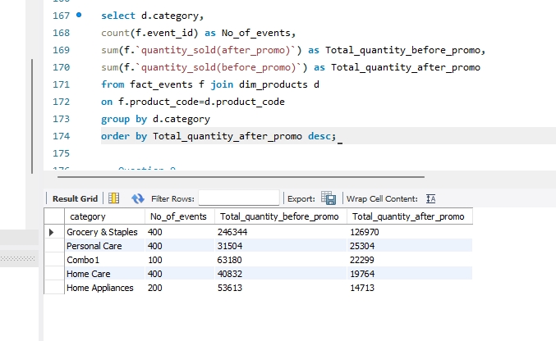

-- ------------------------------------------------------------

-- Q9. Store Performance
-- Using fact_events and dim_stores, calculate for every city:

-- - Number of promotional events
-- - Total quantity before promotion
-- - Total quantity after promotion

-- Display:
-- - city
-- - event_count
-- - total_before
-- - total_after
-- Sort cities by total_after descending.
-- Concepts:
-- JOIN, GROUP BY, aggregation, ORDER BY.

select d.city,
count(*) as event_count,
sum(f.`quantity_sold(before_promo)`) as total_before,
sum(f.`quantity_sold(after_promo)`) as total_after
from fact_events f join dim_stores d
on f.store_id=d.store_id
group by d.city
order by total_after desc;
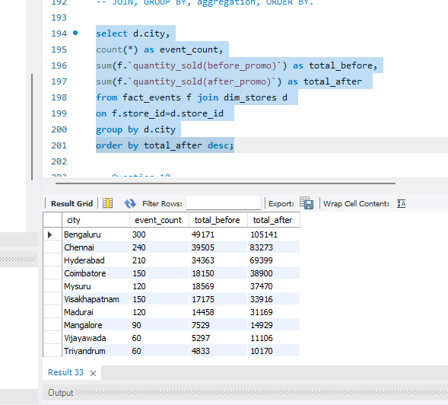
-- ------------------------------------------------------------

-- Q10. Campaign Performance
-- Using fact_events and dim_campaigns, calculate for each campaign:
-- - Campaign name
-- - Start date
-- - End date
-- - Number of events
-- - Total quantity before promotion
-- - Total quantity after promotion
-- Sort by total quantity after promotion descending.
-- Concepts:
-- JOIN, GROUP BY, date columns, aggregation.

select d.campaign_name,
d.start_date,
d.end_date,
count(*) as event_count,
sum(f.`quantity_sold(before_promo)`) as total_before,
sum(f.`quantity_sold(after_promo)`) as total_after
from fact_events f join dim_campaigns d
on f.campaign_id=d.campaign_id
group by d.campaign_id
order by total_after desc;
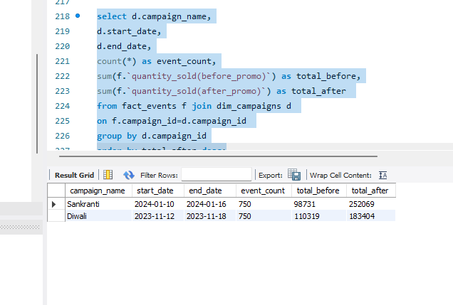

-- ------------------------------------------------------------

-- Q11. Product Category with HAVING
-- Find product categories where the total quantity sold after promotion is greater than 1,000.
-- Display:
-- - category
-- - total quantity after promotion
-- - average base price
-- Sort by total quantity after promotion descending.
-- Concepts:
-- JOIN, GROUP BY, HAVING, AVG, SUM.

select d.category,
sum(f.`quantity_sold(after_promo)`) as total_after,
avg(f.base_price) as Avg_base_price
from fact_events f join dim_products d
on f.product_code=d.product_code
group by d.category
having total_after>1000
order by total_after desc;
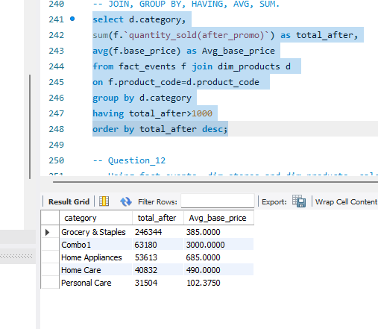
-- ------------------------------------------------------------

-- Q12. Store + Category Analysis
-- Using fact_events, dim_stores and dim_products, calculate total quantity sold after promotion for every combination of:
-- - City
-- - Product category
-- Display:
-- - city
-- - category
-- - total quantity after promotion
-- Sort first by city and then by total quantity descending.
-- Concepts:
-- Multiple JOINs, GROUP BY, ORDER BY.

select s.city,
p.category,
sum(f.`quantity_sold(after_promo)`) as total_quantity_after_promo
from fact_events f join dim_stores s
on f.store_id=s.store_id
join dim_products p
on f.product_code=p.product_code
group by s.city,p.category
order by s.city,total_quantity_after_promo desc;
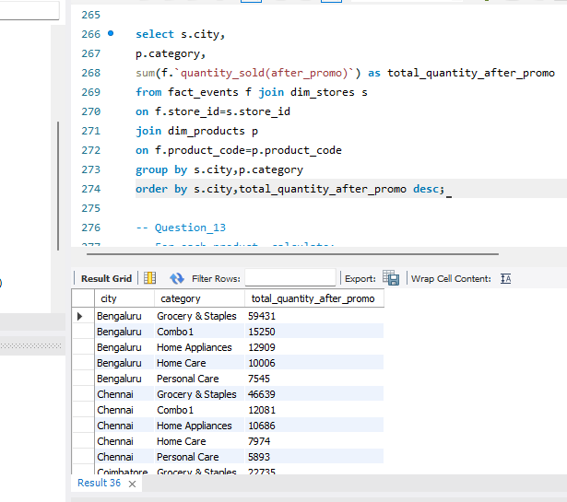
-- ------------------------------------------------------------

-- Q13. Promotion Effectiveness by Product
-- For each product, calculate:
-- - Product name
-- - Category
-- - Total quantity before promotion
-- - Total quantity after promotion
-- - Quantity change
-- - Percentage change
-- Use:
-- Percentage Change =
-- ((After Promo - Before Promo) / Before Promo) * 100
-- Handle division by zero appropriately.
-- Sort by percentage change descending.
-- Concepts:
-- JOIN, GROUP BY, arithmetic calculations, NULLIF, percentage calculations.

select d.product_name,
d.category,
sum(f.`quantity_sold(after_promo)`) as total_after,
sum(f.`quantity_sold(before_promo)`) as total_before,
sum(f.`quantity_sold(after_promo)`)-sum(f.`quantity_sold(before_promo)`) as quantity_change,
(sum(f.`quantity_sold(after_promo)`)-sum(f.`quantity_sold(before_promo)`))*100/nullif(sum(f.`quantity_sold(before_promo)`),0) as percentage_change
from dim_products d join fact_events f on d.product_code=f.product_code
group by d.product_code
order by percentage_change desc;
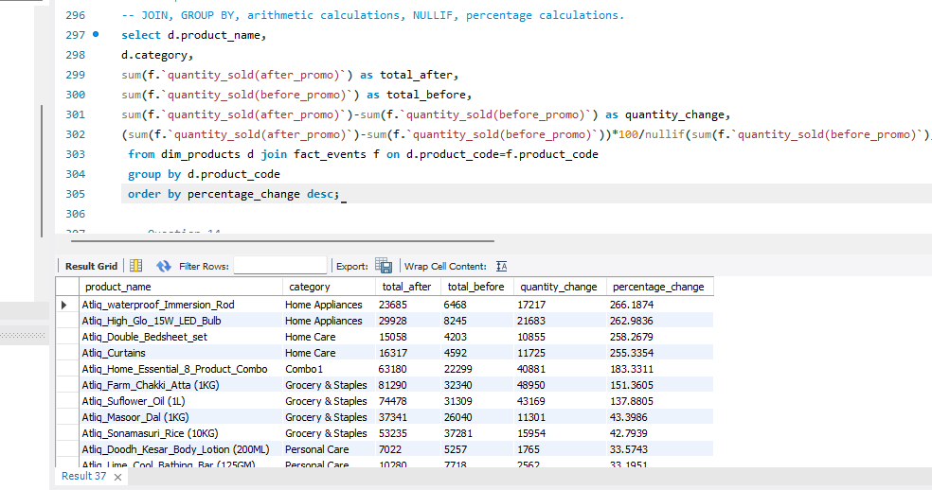
-- ------------------------------------------------------------

-- Q14. Campaign and Promotion Type Analysis
-- For each campaign and promo_type combination, calculate:
-- - Number of events
-- - Total quantity before promotion
-- - Total quantity after promotion
-- - Quantity change
-- Display:
-- - campaign_name
-- - promo_type
-- - event_count
-- - total_before
-- - total_after
-- - quantity_change
-- Sort by campaign_name and quantity_change descending.
-- Concepts:
-- Multiple GROUP BY columns, JOIN, aggregation, ORDER BY.

select d.campaign_name,
f.promo_type,count(*) as event_count,
sum(f.`quantity_sold(after_promo)`) as total_after,
sum(f.`quantity_sold(before_promo)`) as total_before,
sum(f.`quantity_sold(after_promo)`)-sum(f.`quantity_sold(before_promo)`) as quantity_change
from dim_campaigns d join fact_events f
on d.campaign_id=f.campaign_id
group by d.campaign_id,f.promo_type
order by d.campaign_name,quantity_change desc;
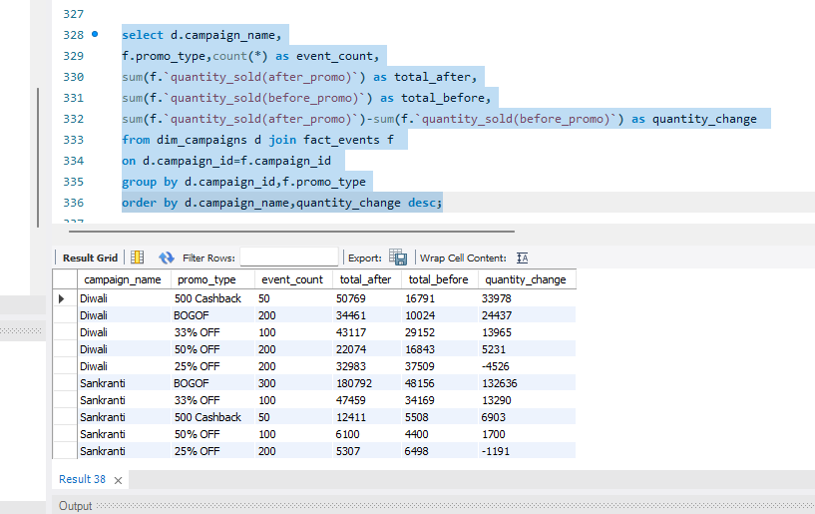
-- ------------------------------------------------------------

-- Q15. Product Revenue Before and After Promotion
-- For each product, calculate:
-- 1. Revenue before promotion =
-- base_price × quantity_sold(before_promo)
-- 2. Revenue after promotion =
-- base_price × quantity_sold(after_promo)
-- 3. Revenue difference =
-- Revenue after - Revenue before
-- Display:
-- - product_name
-- - category
-- - revenue_before
-- - revenue_after
-- - revenue_difference
-- Sort by revenue_difference descending.
-- Concepts:
-- JOIN, GROUP BY, SUM, arithmetic calculations, aliases.

select d.product_name,d.category,
sum(f.base_price*f.`quantity_sold(before_promo)`) as revenue_before,
sum(f.base_price*f.`quantity_sold(after_promo)`) as revenue_after,
sum(f.base_price*(f.`quantity_sold(after_promo)`-f.`quantity_sold(before_promo)`)) as revenue_diff
from dim_products d join fact_events f on d.product_code=f.product_code
group by d.product_code
order by revenue_diff desc;
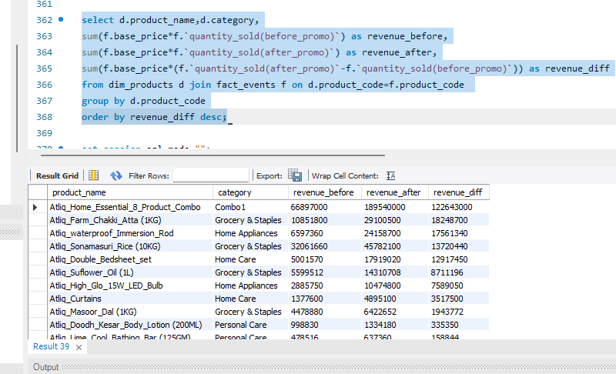
-- ------------------------------------------------------------

-- Q16. Classify Promotion Performance
-- For every promotion type, calculate total quantity before and after promotion.
-- Then classify the promotion using CASE:
-- - Percentage change >= 50% → "High Impact"
-- - Percentage change >= 20% → "Medium Impact"
-- - Percentage change < 20% → "Low Impact"
-- Display:
-- - promo_type
-- - total_before
-- - total_after
-- - percentage_change
-- - performance_category
-- Sort by percentage_change descending.
-- Concepts:
-- GROUP BY, CASE, arithmetic calculations, NULLIF, aliases.

select promo_type,
total_after,
total_before,
percentage_change,
case
when percentage_change>=50 then 'High Impact'
when percentage_change>=20 then 'Medium Impact'
when percentage_change<20 then 'Low Impact'
end as performance_category from(
select promo_type,
sum(`quantity_sold(after_promo)`) as total_after,
sum(`quantity_sold(before_promo)`) as total_before,
(sum(`quantity_sold(after_promo)`)-sum(`quantity_sold(before_promo)`))*100/nullif(sum(`quantity_sold(before_promo)`),0) as percentage_change
from fact_events group by promo_type
) as new_table order by percentage_change desc;
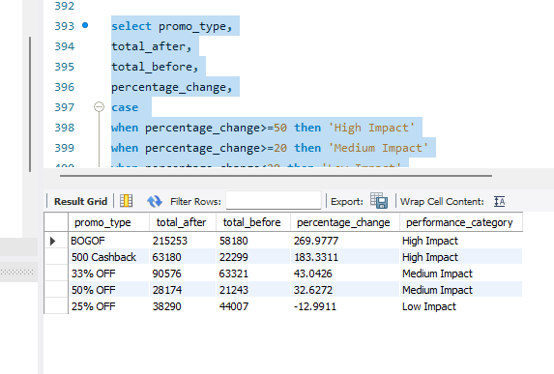
-- ------------------------------------------------------------

-- Q17. Top Products Within Each Category
-- Using a CTE:
-- 1. Calculate total quantity sold after promotion for every product.
-- 2. Rank products within each category based on total quantity sold after promotion.
-- 3. Return only the top 2 products from every category.
-- Display:
-- - category
-- - product_name
-- - total_quantity_after
-- - category_rank
-- Concepts:
-- CTE, JOIN, GROUP BY, DENSE_RANK/ROW_NUMBER,
-- PARTITION BY, window functions.

with ranked_products as (
select d.product_name,
d.category,
sum(`quantity_sold(after_promo)`) as total_product_after_promo,
dense_rank()over(partition by d.category order by sum(`quantity_sold(after_promo)`) desc ) as category_rank
from fact_events f join dim_products d
on d.product_code=f.product_code
group by d.product_code
)
select product_name,category,total_product_after_promo,category_rank from ranked_products where category_rank<=2 order by category,category_rank;
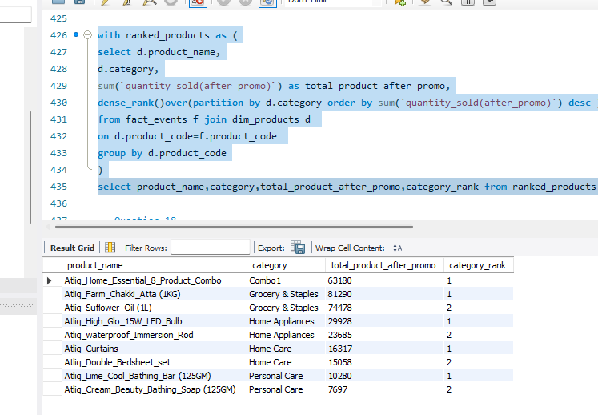

-- ------------------------------------------------------------

-- Q18. Best-Performing Stores Within Each City
-- Calculate total quantity sold after promotion for each store.
-- Join dim_stores to obtain the city.
-- Then rank stores within each city based on total quantity sold after promotion.
-- Return the top 2 stores from each city.
-- Display:
-- - city
-- - store_id
-- - total_quantity_after
-- - city_rank
-- Concepts:
-- JOIN, CTE, GROUP BY, window functions,
-- PARTITION BY, RANK/DENSE_RANK.

with ranked_outcome as (
select d.store_id,
sum(f.`quantity_sold(after_promo)`) as total_quantity_after_promo,
d.city,
dense_rank()over(partition by d.city order by SUM(f.`quantity_sold(after_promo)`) DESC) as ranked
from dim_stores d join fact_events f
on d.store_id=f.store_id group by d.store_id
)
select store_id,
total_quantity_after_promo,
city,
ranked
from ranked_outcome where ranked<=2;
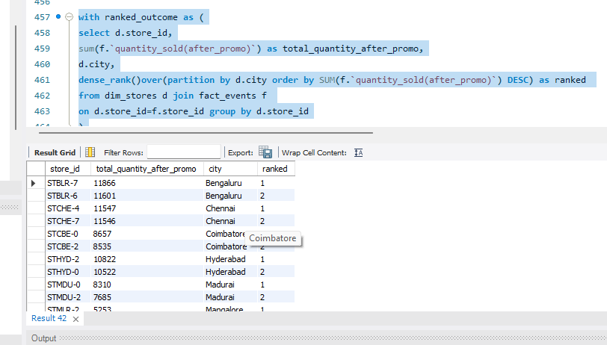
-- ------------------------------------------------------------
-- Q19. Campaign-Level Product Performance
-- For every campaign and product:
-- Calculate:
-- - Total quantity before promotion
-- - Total quantity after promotion
-- - Quantity change
-- - Percentage change
-- Then rank products within each campaign based on percentage change.
-- Return the top 3 products for every campaign.
-- Display:
-- - campaign_name
-- - product_name
-- - total_before
-- - total_after
-- - quantity_change
-- - percentage_change
-- - campaign_rank
-- Concepts:
-- Multiple JOINs, CTE, GROUP BY, arithmetic calculations,
-- NULLIF, window functions, PARTITION BY, ranking.

with ranked_outcome as (
select
c.campaign_name,
c.campaign_id,
d.product_name,
sum(f.`quantity_sold(before_promo)`) as total_quantity_before_promo,
sum(f.`quantity_sold(after_promo)`) as total_quantity_after_promo,
dense_rank()over(partition by f.campaign_id order by (sum(f.`quantity_sold(after_promo)`)-sum(f.`quantity_sold(before_promo)`))*100/nullif(sum(f.`quantity_sold(before_promo)`),0) desc) as ranked_items
from dim_products d join fact_events f
on d.product_code=f.product_code
join dim_campaigns c
on f.campaign_id=c.campaign_id
group by f.campaign_id,d.product_code
)
select campaign_name,product_name,total_quantity_before_promo,total_quantity_after_promo,
total_quantity_after_promo - total_quantity_before_promo AS quantity_change,
(total_quantity_after_promo - total_quantity_before_promo) * 100.0/ NULLIF(total_quantity_before_promo, 0) AS percentage_change,
ranked_items
from ranked_outcome
WHERE ranked_items <= 3;
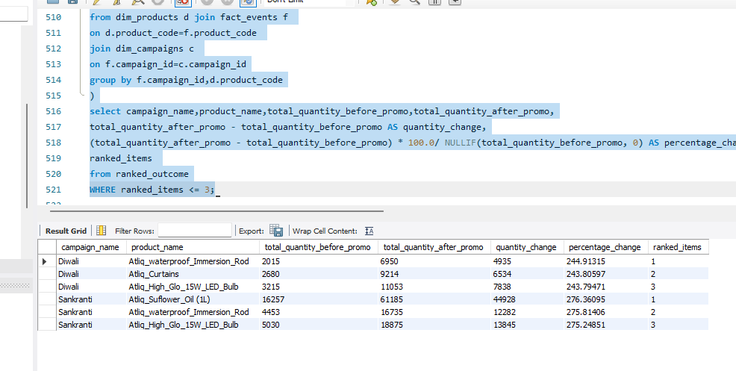
-- ------------------------------------------------------------

-- Q20. Complete Promotional Performance Analysis
-- Create a complete analytical report at the product-category level.

-- For every product, calculate:

-- - Product name
-- - Category
-- - Number of promotional events
-- - Total quantity before promotion
-- - Total quantity after promotion
-- - Quantity change
-- - Percentage change
-- - Revenue before promotion
-- - Revenue after promotion
-- - Revenue change
-- - Average base price
-- - Product rank within its category
-- Use:
-- Quantity Change =
-- Total After - Total Before
-- Percentage Change =
-- ((Total After - Total Before) / Total Before) * 100
-- Revenue Before =
-- SUM(base_price × quantity_before)
-- Revenue After =
-- SUM(base_price × quantity_after)
-- Revenue Change =
-- Revenue After - Revenue Before
-- Then:
-- 1. Rank products within each category by Revenue Change.
-- 2. Return only the top 2 products from each category.
-- 3. Use appropriate handling for division by zero.

with temp as (
select d.product_name,
d.category,
COUNT(f.event_id) AS Number_of_promotional_events,
sum(f.`quantity_sold(before_promo)`) as Total_quantity_before_promo,
sum(f.`quantity_sold(after_promo)`) as Total_quantity_after_promo,
avg(f.base_price) as Avg_base_price,
sum(f.base_price*f.`quantity_sold(before_promo)`) as Revenue_before,
sum(f.base_price*f.`quantity_sold(after_promo)`) as Revenue_after,
sum(f.base_price*f.`quantity_sold(after_promo)`)-sum(f.base_price*f.`quantity_sold(before_promo)`) as Revenue_change
from fact_events f join dim_products d
on d.product_code=f.product_code
group by d.product_code
) ,ranked_products as(
select product_name,
category,
Total_quantity_before_promo,
Total_quantity_after_promo,
Total_quantity_after_promo-Total_quantity_before_promo as Quantity_change,
(Total_quantity_after_promo-Total_quantity_before_promo)*100/nullif(Total_quantity_before_promo,0) as Percentage_change,
Revenue_before,
Revenue_after,
Revenue_change,
dense_rank()over(partition by category order by Revenue_change desc) as ranked,
Avg_base_price
from temp
)
select * from ranked_products where ranked<=2;
