9 May 2022

**Digital Marketing**

* **What is digital marketing (spamming)?**
  + Marketing using digital or electronic devices and the internet.
* **Points to check before posting something on the internet for marketing.**
  + Target audience
  + Strategy
  + Audience interaction
  + Content about post
* **Channels of digital marketing.**
  + SEO (Search Engine Optimization) (putting efforts manually (not paid))
    - Showing your website as a top website using keywords searched by any user.
    - It works organically (without paying to search engines ).
  + SEM (Search Engine Marketing)(Paid efforts)
    - Showing Web results using a paid label or Ad label.
  + Social Media Optimization
    - Redirect the users to your websites using social media
    - Use social media profile to represent your business
    - Post everything as scheduled.
  + Social Media Marketing
    - Posting on social media using a sponsored label(paid)
  + Email marketing
    - Sending Mails to existing audiences and new audiences for interaction (marketing through EMails).
  + Content Marketing
    - Process of making valuable and relevant content to attract and engage with an audience
  + Affiliate Marketing
    - Selling products online by taking a commission from dealers.
  + Influencer Marketing
    - This is a process of promoting and selling products with influencer and attract the target audience
* **Benefits of Digital Marketing.**
  + Low requirements for entering the digital marketing
  + Real-time activity reports.
  + It can be measurable, meaning you can retrieve information about your post like how many people in your audience got a checked post,how much impression you’re getting with that post, which age-group is more attached to it etc.
  + Any time you can run your advertisement or post.
  + We can reach customers globally , at any place ,with offline marketing we can not gross globally it’ll be very costly and hard.
  + We can select the targeting audience categories like age-groups,sex ratio, a particular place, etc
* **SEO (Search Engine Optimization)**
  + In 1991 the first website was created and SEO was founded
  + After that, too many websites were created
  + Structure and accessibility needed to access those website’s content
  + First Search engine: YAHOO
  + After that in 1996 larry page & brin build ‘Back Rub’ named a search engine which is now known as ‘GOOGLE’
  + SEO is a process to increase the number and quality of users to websites by an algorithm using keywords.
  + **Types of SEO**
    - On page SEO (relate to the content on the Website(editing on Webpage))
    - Off Page SEO(make the relationship strong of our website with another website (backlinks))
    - Technical SEO(Non-content Elements on a website (page speed))
* **On Page SEO:-**
  + You can control almost 100% of the elements of a website.
  + One time Setup: Step by step process, basic design, etc
  + Once in a while: some internal edits, headings, blog
  + On-page SEO based on Ranking factors.
  + SEO is an ongoing process which means if you’ll be in the No1 position SEO should be done.
* **Factors of on page SEO:-**
  + A website should be crawlable(check Bots, Robots, etc)
  + User-friendly URL
  + Well targeted contents
  + Keyword optimization
  + Website optimization
  + HTTPs
  + Image optimization
  + Readability & UX
  + Click through rate
  + Mobile friendly
  + Quality outbound links (where the referral link going through )
  + Website structure

Today’s learning:-

~learn about Basics of Digital Marketing.

~learn about SEO,

~on page SEO,

~Create a note on it.

10 May 2022

**Working of Search Engine**

* **Elements of Search Engine:-**
  + Website
  + Crawler (Search Engine)
  + Search Engine Local Server
  + Search Engine Main Server
  + User
* **Process of Search engine.**
  + Crawler Scan the source code of websites.
  + Whole data stored in the Local Server of the search engine.
  + After that indexer categories the website and sets it category wise in the main server of the Search engine.
  + User requests ( Search ) the keyword and that keyword goes through a ranking algorithm.
  + After that all the data matches the keyword is shown to the user priority wise.
* **Crawling:-**
  + Crawler crawl all the available Websites is called crawling.
* **Crawler:-**
  + Scan the Website **Word by Word** if it finds any back link then the crawler follows the link and goes to that particular website then checks it.
  + This process is a very time taking process.to overcome this situation just go to **GSC** (Google Search console) and submit your website.
  + All the crawled information will be stored in Local Server. There is no structure available in Local Server.
* **Ranking algorithm:-**
  + Provides rank to the website based on searched keywords by the user.
* **Indexing:-**
  + After crawling, indexer categories your website and set website category wise align of website is called indexing
* **Keywords for on-page**
  + Title Tag ( Page Title)
  + Description
  + H1 tag ( for giving structure to website ) (giving information about content )
  + Formatted text ( formatting text (bold,italic,underline) )
  + Outgoing links (links for other pages mentioned in website)
  + URL -> ( domain,subdomain,folder name or page name)
  + Alt tag ( graphics )
  + Content.
* **Types of keyword**
  + Primary keywords.( should be at starting point )
    - Should be at starting point
    - Primary keyword can be used in :-
      * Title tag
      * Description
      * H1 Tag ( indirect ranking factor )
  + Secondary keywords.
* **Title tag**
  + Title tag found in head section in HTML code.
  + Length 50-60 characters.
* **Keywords:-**
  + Keywords should be in the first 25 to 40 % of titles.
* **Action word in title**
  + Get
  + Take
  + Boost
  + Learn
  + Go
  + Make
* **Description:-**
  + 155 to 160 character summary for describing content of webpage.
  + **Elements**
    - Keywords
    - Legible & readable copy
    - Treat like advertisement of your website
    - Length 155 to 160 characters.
    - Consider using rich snippets.

**Example**

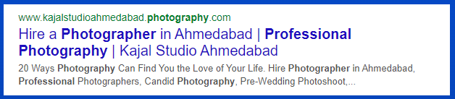

Today’s learning:-

-search engine working

-crawling

-indexing

-types of keywords

-made an example of website result

11 May 2022

* **Factors to be noted for a good website:-**
  + Websites should be mobile-friendly.
  + Not every user browses on a laptop or PC.
  + During testing of websites for mobile check, elements are not too close to the other one and not too far from the other one.
  + Check the applied CSS is working properly or not in other devices.
  + Don’t use too many H1 Tags.
  + Check your website in the **Screaming Frog** tool for finding H1 tags.
* **Why H1 Tag is important:-**
  + H1 tag content is the most visible content on webpages.
  + H1 gives information to crawlers about web pages.
  + Keywords used in H1 are more visible than other contents.
  + H1 Tag gives structure to your webpage.
* **Canonical tags**
  + If your webpage has similar content under different URLs, canonical tag specifies which URL is main
  + Gives the crawler a hint that which content has more priority.
  + You should use only one canonical tag.
  + Use canonical tag in head tag only.
* **Robots.txt:**
  + This file tells the crawler to go on some pages of the website and not to go on some pages.
  + If you want to hide some pages from crawlers simply apply the robots.txt file in Html code.
* **Sitemaps:-**
  + Makes crawling & indexing easy for crawlers.
  + Sitemaps are hierarchical forms of your website.
  + It shows which page is connected with the other page.
  + Site maps can be in two ways.
  + Simple way and hierarchical way.
  + In a simple way crawler will go to another page through inlinks. It is a very complex and time consuming process. In this process maybe some pages remain crawling.
  + Hierarchical way is easier than the simple way it shows hierarchically where to go next
  + **XMLSitemaps:-**
    - XML Sitemaps are basically written for search engine spiders.
    - Using XML sitemap a search engine spiders can easily and quickly extract all important pieces of information about your site
  + **HTML Sitemap:-**
    - HTML site map helps lost users to find a particular page on your website
* **Domain Authority:-**
  + Developed by MOZ.
  + Domain authority does not relate with google.
  + DA provides ranking score
  + More ranking score, more ranking ability.
  + DA Based on link authority.valid for whole domain.
* **How MOZ calculate Domain authority:**
  + Based on link profiles ( Availability of link, strong links )
* **Page authority:-**
  + Page authority also based on **link profiles** only for a single page
  + Developed by MOZ
  + Page authority considers the same factors as Domain Authority.
  + Also called page ranking ability
  + For improving page authority: try external links from other higher authority websites.

1. **Make a Report on the current website of Secret mindtech**
2. **Make a project on a new website with SEO**

Today’s learning:-

~Factors for a good website.

~Importance of H1 Tag.

~Canonical Tags

~Robots file

~SiteMap.

~DA & PA in SEO.

12 May 2022

* **Redirect:-**
  + Sending users and search engines to different URLs.
  + Types of redirect
    - 301 Redirect (permanently Moved)
    - 302 Redirect
* **Need of redirection:-**
  + If your page is down or under construction (changing content of page ).
* **301 Redirection - Permanent moved content.**
  + URL moved permanently to another URL.
  + Crawlers and users don’t know about another URL so if any one Enters first URL the crawler and user will be automatically redirected to another URL.
  + It’ll pass between 90-99% of link equity to the redirected page.
  + With the use of 310 redirection, your page will not lose any popularity or value.
* **302 Redirection - Temporarily moved URL**
  + 302 redirection indicates that a URl temporarily moved to another URL.
  + Search engines will not pass page ranking to the 2nd URL immediately.
  + In this case the 2nd URL shall not be indexed.
  + 302 redirection is used for recurring temporary content.
* **SEO friendly URL:-**
  + Permalink
    - It is customizable.
    - Focus on permalink because permalink can be used at many places.
  + Make Fewer folders.
  + Use keywords in URLs.
  + Don’t use special characters.
  + Connect URL to page title (not exactly same but there should be some connections.)
  + Avoid automatic numeric labels.
  + SEO friendly URLs improve user experience.
  + URLs’ character should be in lower case only.
  + URLs help in backlinking.
* **Alt text in SEO:-**
  + Alt Text known as “Alternative text” or ”Alt attribute” or “Alt-Description”.
  + In some cases if the image is not loading on the browser alt text will represent the text about image.
  + It’ll help the crawler to clear the Description properly about the image.
  + Try to focus on Describing the image as it is.
  + Keep optimum length
  + Use primary keywords in Alt Text (Don't use over Keywords).
  + Avoid keyword stuffing
  + Don't use “Image of” or “photo of”.
* **SSL certificates:-**
  + On 6 August,2014, Google said that the Website with an SSL certificate (https://) will get more advantage in the Search Engine Result Pages **(SERPs).**
  + If your website is SSL certified then the user will feel more secure and fee free to make any transaction or give details about themselves.
  + This is indirect factor to rank of website
  + SSL Certificate will be more effective to rank higher .
* **Types of SSL certificate:-**
  + Single domain SSL Certificate
    - Not work on any subdomain.
    - Only for the main domain.
  + Multi domain SSL Certificate
    - Applicable for multiple domains.
  + Wildcard SSL Certificate
    - Cover all domain on single root domain
  + Organisation SSL Certificate
    - Works as a single domain, authenticating details of organisation.
  + Extended SSL Certificate
    - Big websites use this type of Certificate
* **Searcher’s Intent**
  + Searcher’s intent is needed to increase the ranking of a website.
  + Type of searches
    - Informational (detailed information about query) ( more important for SEO)
    - Navigational (search page direct )
    - Transactional ( for buying something )
    - Commercial ( for selling something )
    - Local searches ( nearby searches )
* **Query & Keyword:-**
  + Query is for Users
  + Keyword is for marketer
  + User searches query
  + Marketers use keywords to rank websites.
  + Query can be use for derive keywords from GSC (Google Search Console).

Today’s learning:-

~Redirection

~Types of Redirection

~ SEO-friendly URLs

~Alt Text

~SSL certificate

~Searcher’s Intent

~Query & Keyword

~Tool: SEO-Quake

13 May 2022

* **Link Building & link Earning:-**
  + During 1995 - 2000 google considered link building and link earning same.
  + Link Building (Banned )
    - Creating links theself like paid links, fake links, resi broker link etc.
    - Building links
    - Article submission
    - Spam emails
    - Reciprocal linking
  + Link Earning
    - Post anything on internet and people like that , then it gaining backlinks automatically is called link earning
    - Content curation
    - Guest blogging
    - Personalised email outreach
    - Building partnership
* **Value of link:-**
  + The more the links, the higher the value
  + If a more valued page gives external links then that page will have more value.
  + 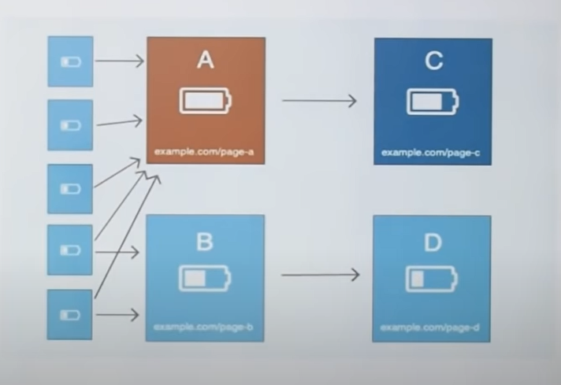
  + Main content link ~> more value
    - Top part ~> more value
    - Middle part ~> Moderate value
    - Lover part ~> less value
  + Side bar link ~> less value than main content
  + Footer link ~> very less value than all of the above
  + If more values page give you back links then your page will be at first position and if that backlink will be removed after some time, your page will be on first page for some time
* **Multiple keyword in single page:-**
  + We can optimise our page for multiple keyword
  + This will very helpful for growing
  + If we use single page keyword, the page complexity will increase
  + If we are using multiple keyword in single page all keywords should be relevance to that content
* **E-A-T in SEO (Expertise, Authority, Trust):-**
  + **Expertise:**
    - Search engines will check the bio and background of the author with the presence of particular data .
  + **Authority:**
    - Links given in blog posts for confirmation of numeric data, those links will give Google a signal that the given numeric data is true.
  + **Trust:-**
    - The search engine will check the interaction with your blog post
* **Pogo Sticking:-**
  + If a user does not stay on a web page or user go back to SERP or user clicks on external links and redirects to another page this activity is known as **POGO STICKING.**
  + User search for query , user will get many search results on SERP.
  + Then user will click on first result link
  + Then it’ll go back to SERP.
* **Bounce Rate:-**
  + If any user comes on your website and gets some information and does not go deep and not go to any external links and go back to SERP then it'll be known as **Bounce Rate.**
* **Meta tags:-**
  + Keyword tags:
    - Google does not use the keywords meta tag in web ranking.
  + Revisit after:
    - This tag commands robots to return to a page after a specific time period.
  + Cache-control:
    - This tag allows web publishers to define how often a page is cached
  + Geo Meta tag:-
    - Google does not use geo meta tags for ranking.
  + Expiration date:
    - This tag tells the crawler when this page will expire.
* **Different links to avoid:-**
  + Spam links on comments
  + Non relevant reciprocal link exchange (two different page link with each other)
  + Automation tools (scrapebox and xrumer)
  + Buying links from fiverr (freelancing)
  + Link velocity (Speed of making links)

Today’s learning:-

~Link Building & Link Earning

~Values of links

~Multiple keywords

~E-A-T in SEO

~Keyword ideas.

~Pogo Sticking

~Bounce Rate

~Meta tags

~Links to avoid

Today’s work:-

~Point out negative points of Website

16 May 2022

Today’s Work:-

~Make a report on negative points of the Website

~Learn about different SEO tools & Extension.

17 May 2022

* **Social Media Optimization:-**
  + It is use to catalyst to grow our business.
  + It count efforts on YT,FB,twitter, Instagram and other platform
  + Non paid campaign
  + Mostly on page kind activities
    - Optimization of profile
    - Page assets
  + Focus on brand image (should be same on every platform)
  + Focus on elements algorithm,understand the algorithm
  + Person working on SMO must understand dynamic nature of social media platforms
* **Social Media Marketing**
  + Almost paid campaigns on social media.
  + Social media advertisement.
  + Content understanding is required
  + Content calendar (schedule)
  + Advertising skills required
  + Campaign are created according to the object
  + Power of retargeting
* **Affiliate marketing**
  + Affiliate marketing is the process of earning a commission by promoting other people’s product
  + 3 basic components
    - Vender
    - Affiliate network
    - Affiliates
  + Two types of affiliate networks and standalone
    - **In India**
      * Flipkart
      * Amazon associate
      * vCommission
      * BIGROCK affiliate
    - **Outside India**
      * ClickBank
      * Ci affiliate
      * Jvzoo
* **Content Marketing**
  + CM is a strategic marketing approach focused on creating and distribute valuable relevant and consistent content to attract an audience
    - Type of content marketing
      * Blogging
      * Video
      * Podcast
      * Infographics
      * Email
      * Visual content
      * Ebooks

Today’s learning:-

~Social Media Optimization

~Social Media Marketing

~Affiliate Marketing

~Content Marketing

~Influencer Marketing

~Google ADs

~Google Keyword Planner

18 May 2022

[keyword planning](https://docs.google.com/spreadsheets/d/1F5yK8fOq7nML_raq3ZOYOiFxYyJCkWME1l7QIWTe4Yo/edit?usp=sharing)

Today’s work:-

~Keywords Planning and sorting.

19 May 2022

Today’s work:-

~Leave

20 May 2022

Today’s work:-

~Keyword Planning

~Compare Keywords

~

23 May 2022

**SERP Home page**

* URL
  + <https://www.secretmindtech.com>
* Title
  + Secret MindTech | IT Company | India
* Description
  + Secret MindTech is India's leading IT company for developing mobile apps, web design, and digital marketing. Utilise new technologies to improve client service.
* **SERP Result for Home page.**

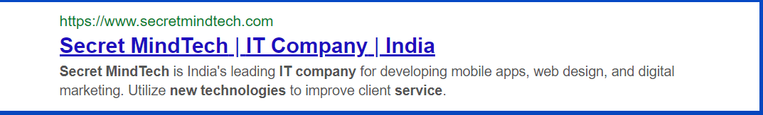

**SERP Service page**

* URL
  + <https://www.secretmindtech.com>/service/
* Title
  + Services - Secret MindTech | India
* Description
  + Secret MindTech is the best software company, which provides better customer service with the right team of experienced Employees and experts to fully meet your requirements. Some of the most successful services are offered by Secret MindTech.
* **Home page description.**

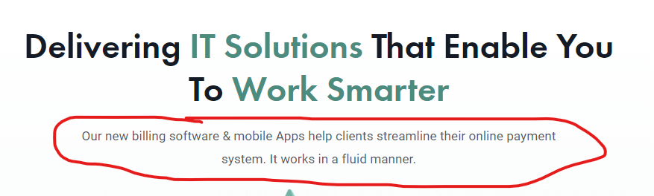

* At Secret MindTech, we provide the best IT solutions which allow you to work smarter. Here we provide the best customer services and IT solutions to make your work easy and effective with an Experienced Employee team.

The Services we offer.

* **Service Page description.**

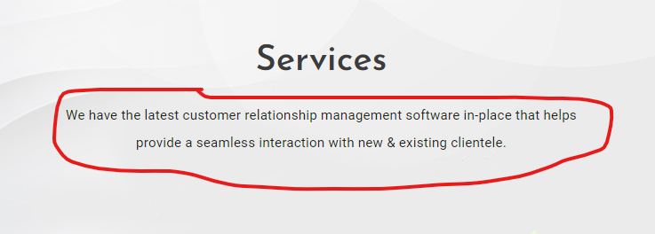

* + Secret MindTech is the best software company, which provides better customer service with the right team of experienced Employees and experts to fully meet your requirements. Some of the most successful services are offered by Secret MindTech.

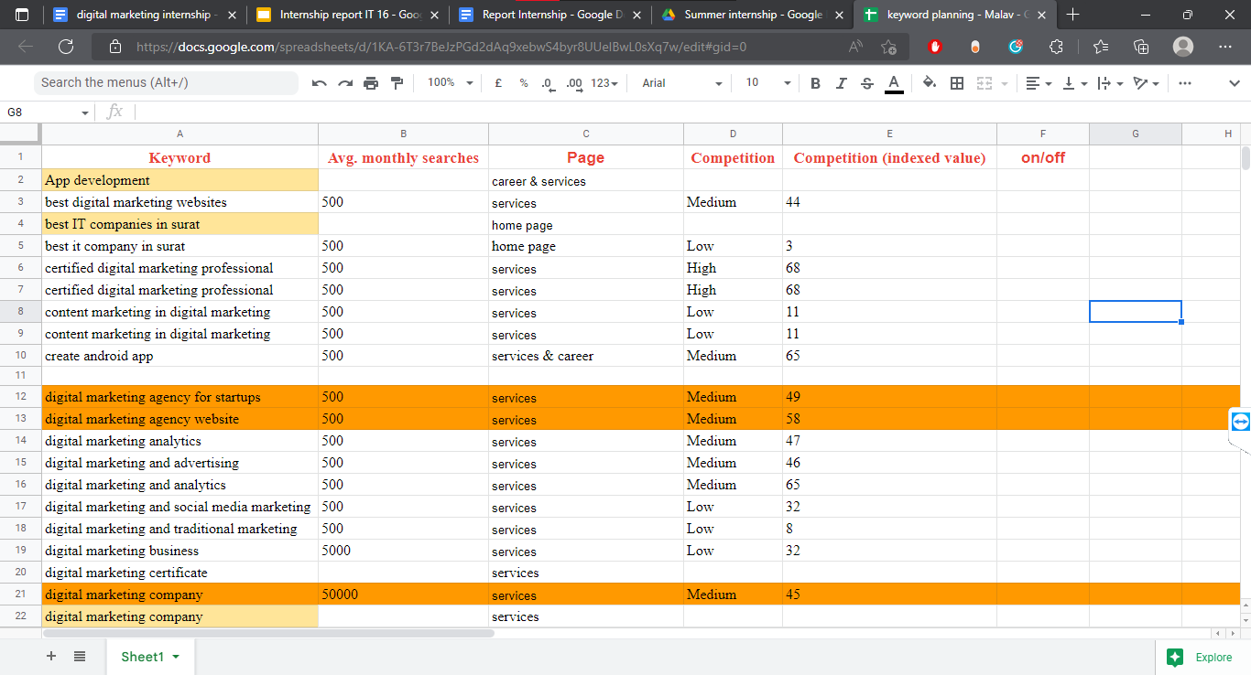

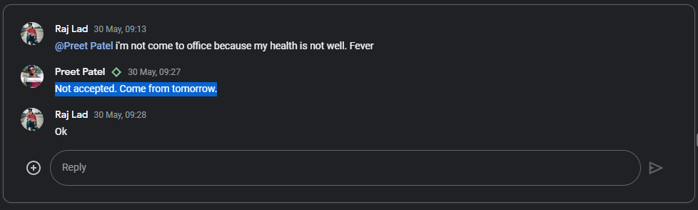

Today’s work:-

~sorting keyword page-wise.

~made a title tag.

~made a note on negative points of a new website.

~made SERP example.

~write description

~find blogs.

~design title for homepage & service page.

24 May 2022

* **Digital Marketing.**
  + At Secret MindTech, we are leading in providing the best services in digital marketing. Take your company to the next level through our digital marketing services. We are here to help you with advertising, analysis, and optimization! We are also working for organic and viral growth for your business. Hence take your business to the next level with our new digital marketing strategies. Let’s start working together, which is owned by you and driven by us. This means beginning with a plan and ending with outcomes.
* **Web development**
  + In this digital age, if you're thinking of exploring your company on an online platform, we're going to do it in real time with Web Development. We create ideas on the Internet. Our purpose is to be the creator of your success. Secret MindTech’s web experts deliver success for each solution. We are committed to creativity. We are not your average design company.
* **Mobile app development.**
  + Secret MindTech is the best mobile app development company in India. We design technology for today’s mobile generation. An app is a tool for a successful business. Let us help you put your ideas in the Mobile App “We do what we love for people who love what we do”.  
    Let us start your own chapter in this exciting app development journey with us.
* **UI/UX Developer:-** 
  + We provide UI design, UX design, and front-end development for awesome projects. As UI/UX designers, it will be our responsibility to deliver the best user experience and ensure customer satisfaction and loyalty. We will come up with ideas using a variety of methods and the latest technology. Our team has more than three years of experience in user interface design, UX design, and front-end development.

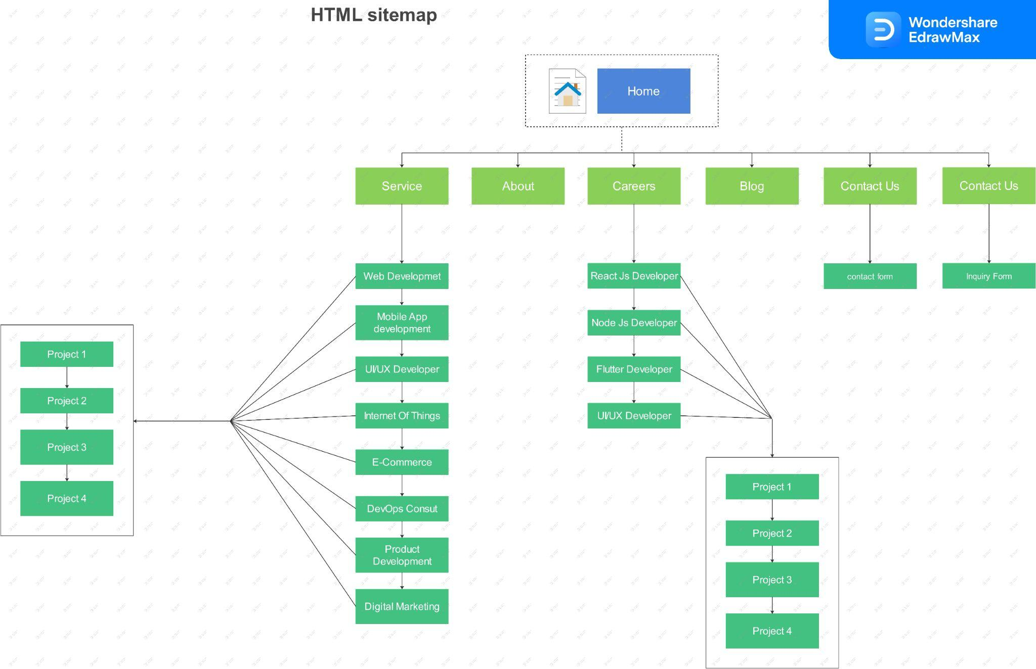

Today’s work:-

~Wrote Description

1. Web Development
2. Mobile App Development
3. Digital Marketing
4. ~~Product Development~~

~Create HTML Sitemap

~Discover Blogs.

25 May 2022

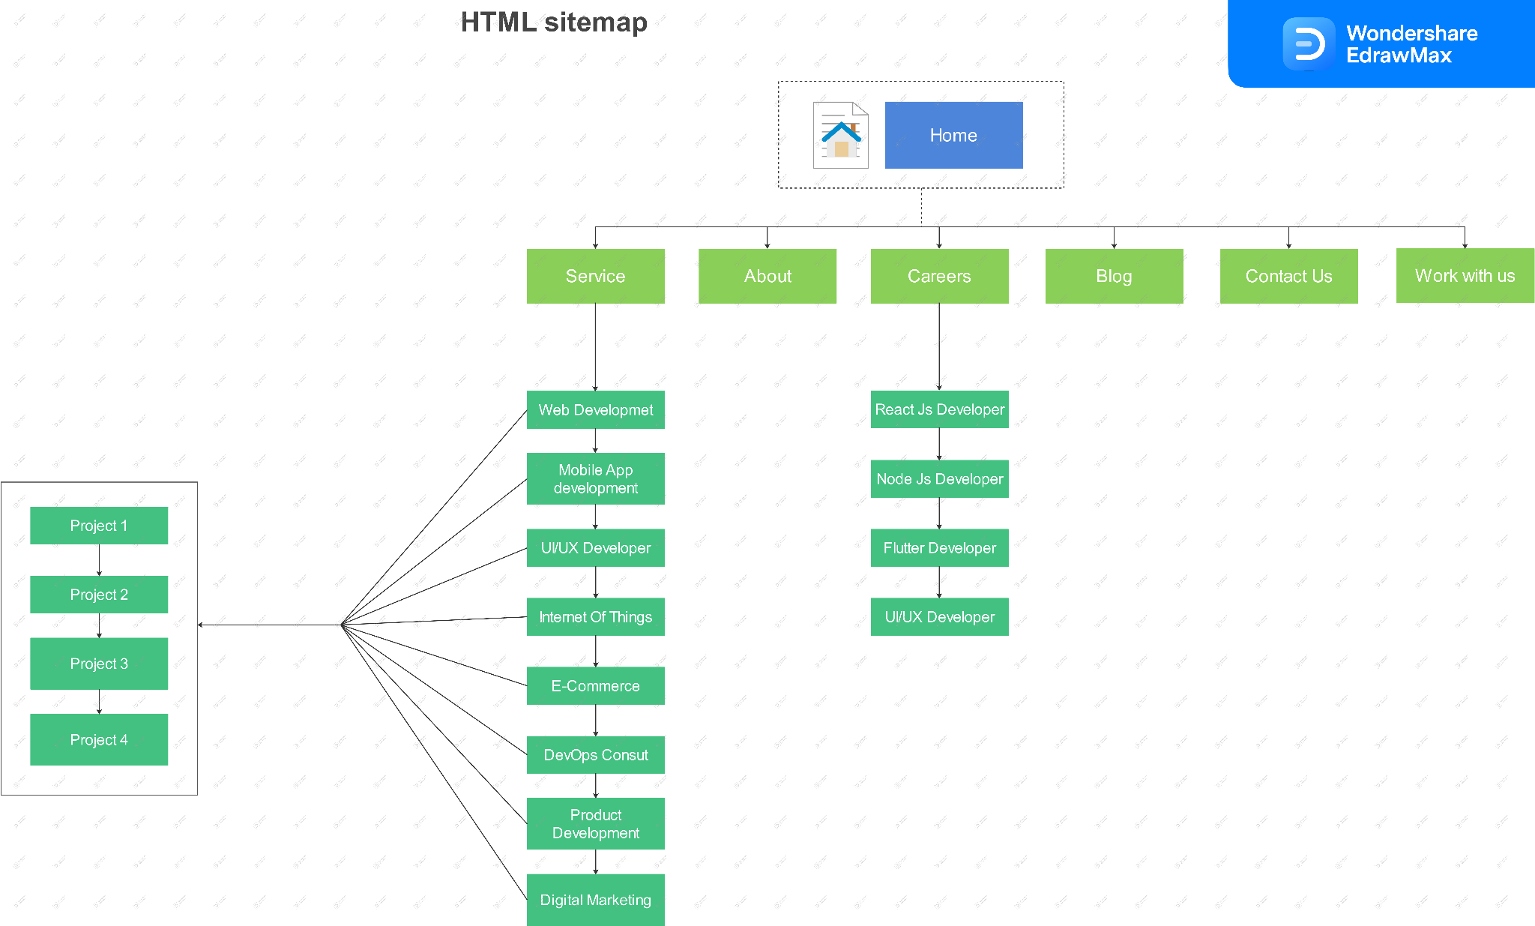

**Pending**

* **E-commerce :**
  + Secret MindTech is also a leading E-commerce platform for everyone. We are selling only the best things online. We are providing guaranteed sales on every posting. We make online selling superbly easy. We are helping buyers and sellers to attain their goals. We will not let you down. We are gonna be your trusted E-commerce platform. Here every product is special. We are combining quality and reliability in one. There are endless possibilities with E-commerce. we bring the good cart to life. If you can’t beat E-commerce, join E-commerce. We don’t make E-commerce, We make E-commerce better & successful, lets's start today!
* **DevOps Consulting** 
  + Our DevOps consulting service provides speed and expertise to make a professional product. The DevOps service provides support to the programmers in speeding the process of development and also gives full control of automation and testing during making the product. It also aids the improvement in statistics and making of good quality products at a faster rate. The main factor of DevOps is improvement in contentment, productivity, workplace culture, etc . The factors are the duty of DevOps consulting firms.
* **Internet of Things:-** 
  + The rapid expansion of devices provides information more quickly by connecting unconnected devices. Secret MindTech's Internet of Things (IoT) offers new ways to increase efficiency, interact with customers, and expand new business with better knowledge. We are able to connect new and existing devices, protect devices and data from loss, and explore partner solutions to enhance the workspace and connect devices in large areas.
  + In the past few years, IoT is a very important technology. Nowadays we can connect daily objects - cars, baby monitors, kitchen appliances, etc. to the Internet by embedded devices, seamless communication is possible between people, processes, and things.
  + It means low-cost computing, the cloud, big data, analytics, and mobile techs. In this Hyperconnected world, digital systems can record, monitor, and adjust each and every interaction between connected things.
  + **Technologies used in making IoT Possible.**
    - Accessing low cost and low power sensor technology
    - Connectivity
    - Cloud computing system
    - Machine learning and analytics
    - Converse artificial intelligence (AI)

**Internet of Things :-** The Internet of Things(Iot) is the ability to have devices communicate with one another via the internet or other networks, remotely tracking information to provide feedback to assist with commonly done using sensors connecting to a back-to-base system.The rapid expansion of devices provides information more quickly by connecting unconnected devices. Secret MindTech's Internet of Things (IdT) offers new ways to increase efficiency, interact with customers, and expand new business with better knowledge. We are able to connect new and existing devices, protect devices and data from loss, and explore partner solutions to enhance workspace and connect devices in large areas.

Some common day-to-day examples are :-

* Detection of gas level and dust.
* Assistance with the control of temperature and humidity levels.
* Different applications in the automotive, aviation, and nautical sectors.

The things that make up the Iot can be anything from wearable fitness trackers tto an autonomous vehicle.

* **Product Development:-**
  + Product development is the complete process of taking an idea from concept to delivering it outside of the mind. Technically product development is similar to the build phase of the product life cycle. Product development is much more than “how” a product build. It is the “what”,” why”, and ”when”. Secret MindTech Provides you with the best product based on your idea.
  + Bring your idea and get the best product not only as you want but much more than that.
  + Phrases of product development
    - Strategize: Defines goals and initiatives
    - Ideate: Brainstorm and capture the ideas
    - Plan: Refine the ideas based on strategic goals, estimated product value, and capacity
    - Showcase: Show roadmaps and go to market plans with stakeholders
    - Build: Deliver new functionality via agile development
    - Launch: Bring those exciting new capabilities to market
    - Analyze: Assess realized product value by tracking customer usage and love.

**About us**

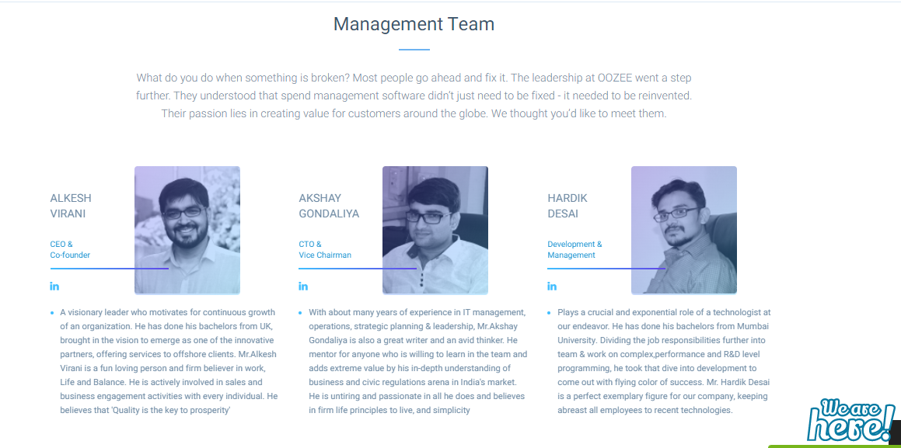

* **OOZEE tech**

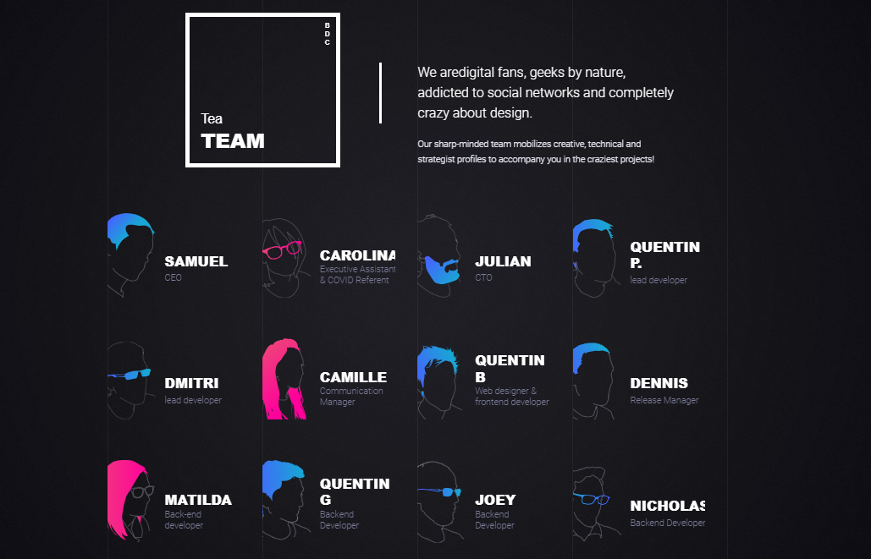

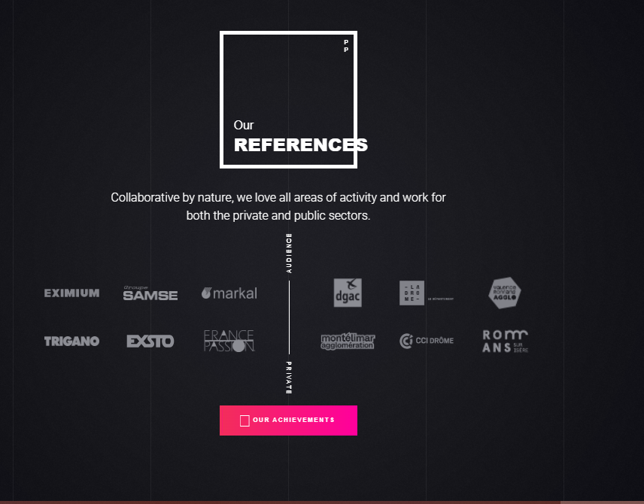

* **6Tematik.fr**

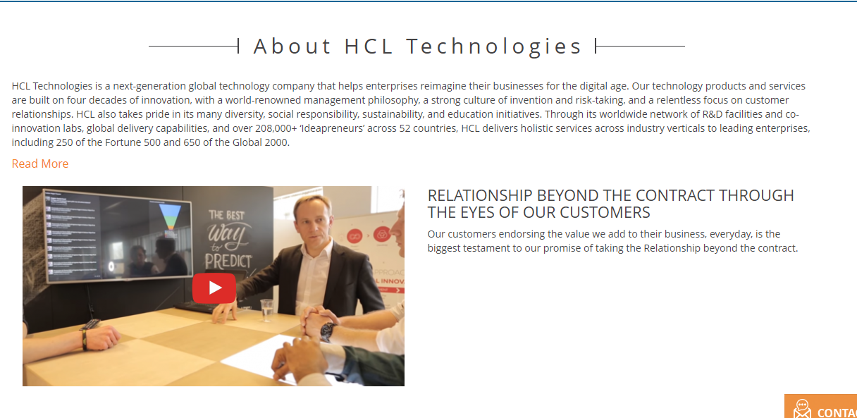

* **HCL Tech**
* **About Us**
  + A small intro about the company
  + Vision / mission
  + Company founder’s story
  + Employee details (Years of experience, specialty, etc.)
  + Skills/awards or clients' views about our work.

Today’s work:-

~Write Description

1. DevOps consulting
2. E-commerce
3. Internet Of Things
4. Product Development

~SERP for Service page.

~About Us Section planning.

~Wrote Blog on DM(SEO).

26 May 2022

Yesterday’s work:-

~Wrote blog on UI/UX Development.

~Planed pending Blog Topics.

27 May 2022

Today’s work:-

~Wrote Blogs

1. Product Development.
2. E-Commerce.
3. Graphic Design.

30 May 2022

**ALT tags:-**

* 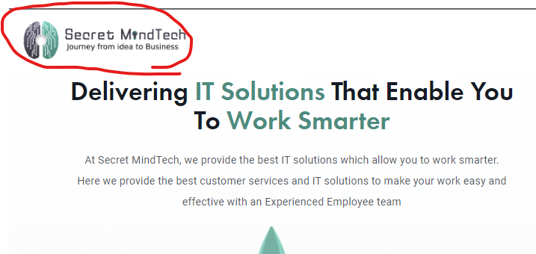
  + IT company logo
  + Logo Secret MindTech
* 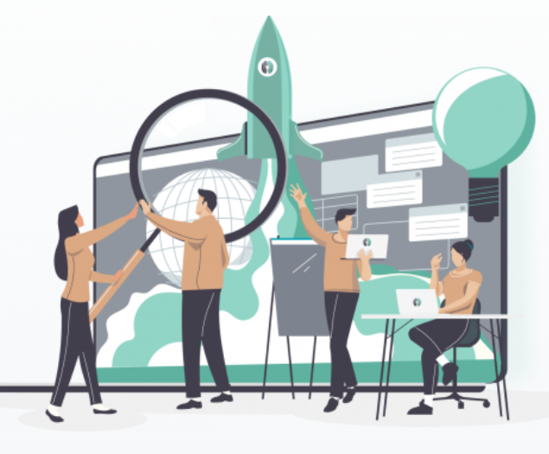
  + IT Team.
  + Team Work
  + Tech Team
* 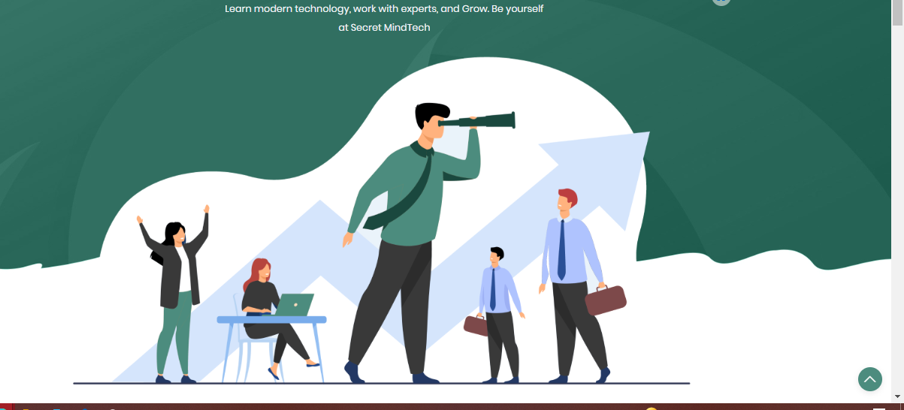
  + Search for jobs
  + Employee requirements
  + Career advise.
* **Meta Data (Meta info)**

<!-- Primary Meta Tags -->

<**title**>Secret MindTech | IT Company | India </**title**>

<**meta** name="title" content="Secret MindTech | IT Company | India ">

<**meta** name="description" content="Secret MindTech is India's leading IT company for developing mobile apps, web design, and digital marketing. Utilize new technologies to improve client service.">

<!-- Open Graph / Facebook -->

<**meta** property="og:type" content="website">

<**meta** property="og:url" content="https://www.secretmindtech.com/">

<**meta** property="og:title" content="Secret MindTech | IT Company | India ">

<**meta** property="og:description" content="Secret MindTech is India's leading IT company for developing mobile apps, web design, and digital marketing. Utilize new technologies to improve client service.">

<**meta** property="og:image" content="">

<!-- Twitter -->

<**meta** property="twitter:card" content="summary_large_image">

<**meta** property="twitter:url" content="https://www.secretmindtech.com/">

<**meta** property="twitter:title" content="Secret MindTech | IT Company | India ">

<**meta** property="twitter:description" content="Secret MindTech is India's leading IT company for developing mobile apps, web design, and digital marketing. Utilize new technologies to improve client service.">

<**meta** property="twitter:image" content="">

Today’s work:-

~Create an excel sheet for backlink websites.

~ALT Tag for the images.

~Generate Meta tag

~create Accounts for backlinks.