**Secret MindTech**

**Surat**

An internship report submitted to



**UKA TARSADIA UNIVERSITY**

Final Year Student of

**Diploma**

in

**Information Technology**

**By**

Pancholi Malav Avnishkumar

202002100710016

**Guided by**

Mr. Preet A. Patel

Company HR

Ms. Jayshree H. Patil

Assistant Professor

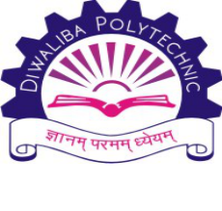

**Department of Computer Engineering & Information Technology**

**Diwaliba Polytechnic**

**Mahuva, Surat, Gujarat**

**July 2022**

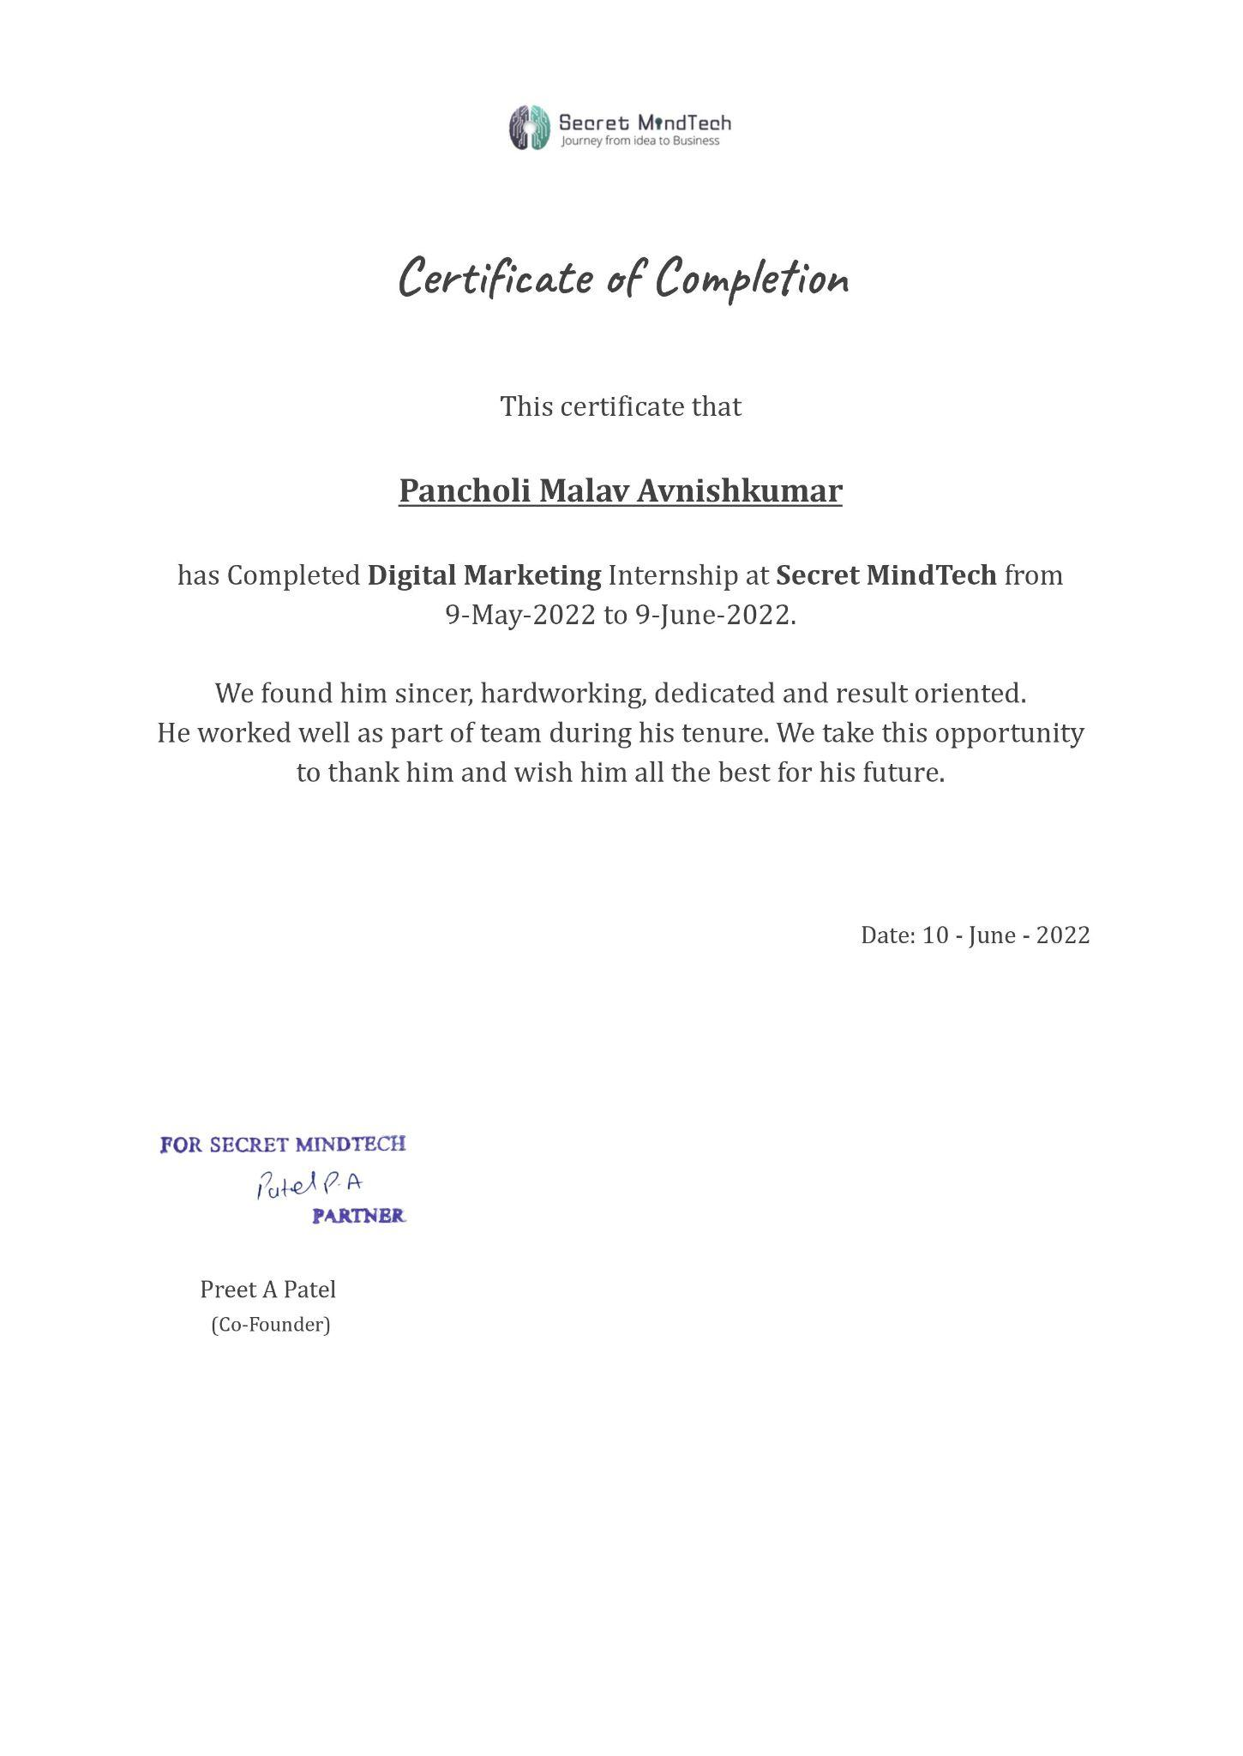

**EVALUATION BY EXTERNAL GUIDE**

|  |  |  |  |
| --- | --- | --- | --- |
| **Information about external supervisor/mentor/guide of Intern student** | | | |
| **Name** |  | **Contact No** |  |
| **Name of Organization** |  | **Email Address:** | |
| **Job Title/Designation** |  |

|  |  |  |  |  |  |
| --- | --- | --- | --- | --- | --- |
| **Intern Student details** | | | | | |
| **Enrollment No** | **Name of the student** | **Course/Semester** | **Project Title/Internship Name** | **Start date** | **End date** |
|  |  |  |  |  |  |

|  |  |  |  |  |  |  |
| --- | --- | --- | --- | --- | --- | --- |
| **Intern/Student Evaluation/Assessment Criteria** | | | | | | |
| **Sr. No** | **Evaluation criteria** | **Excellent**  **(5)** | **Very Good (4)** | **Satisfactory**  **(3)** | **Needs Improvement (2)** | **Unsatisfactory**  **(1)** |
| 1 | Punctuality |  |  |  |  |  |
| 2 | Behaved in a professionalmanner |  |  |  |  |  |
| 3 | Effectively performed  Given Assignments |  |  |  |  |  |
| 4 | Oral communication skills |  |  |  |  |  |
| 5 | Written communication skills |  |  |  |  |  |
| 6 | Ability to work with others |  |  |  |  |  |
| 7 | Ability to adapt to a variety of tasks |  |  |  |  |  |
| 8 | Reliability |  |  |  |  |  |
| 9 | Dependability |  |  |  |  |  |
| 10 | Attention to accuracy and details |  |  |  |  |  |
| 11 | Willingness to ask for help and guidance |  |  |  |  |  |
| 12 | Demonstrated critical thinkingand problem solving skills |  |  |  |  |  |
| 13 | Quality of work |  |  |  |  |  |
| 14 | Seemed interested and in andenthusiastic about the internship experience |  |  |  |  |  |
| 15 | Analytical thinking |  |  |  |  |  |

**Qualitative review/Assessment**:

|  |  |
| --- | --- |
| **Sr. No** | **Qualitative Assessment Criteria** |
| 1 | Comment about the approach of Intern/students towards problem solving |
| 2 | Suggestions for making internship program more effective and value added |
| 3 | Specific observation(s) which will help to improve the quality of intern/student |

|  |  |
| --- | --- |
| **Signature of Supervisor/Guide/Mentor** | **Date** |
|  |  |

**EVALUATION BY INTERNAL GUIDE**

|  |  |  |  |
| --- | --- | --- | --- |
| **Information about internal supervisor/mentor/guide of Intern student** | | | |
| **Name** |  | **Contact No** |  |
| **Designation** |  | **Email Address:** | |
| **Department** |  |

|  |  |  |  |  |  |
| --- | --- | --- | --- | --- | --- |
| **Intern Student details** | | | | | |
| **Enrollment No** | **Name of the student** | **Course/Semester** | **Project Title / Internship Name** | **Start date** | **End date** |
|  |  |  |  |  |  |

|  |  |  |  |  |  |  |
| --- | --- | --- | --- | --- | --- | --- |
| **Intern/Student Evaluation/Assessment Criteria** | | | | | | |
| **Sr. No** | **Evaluation criteria** | **Excellent**  **(5)** | **Very Good (4)** | **Satisfactory**  **(3)** | **Needs Improvement (2)** | **Unsatisfactory**  **(1)** |
| 1 | Punctuality |  |  |  |  |  |
| 2 | Behaved in a professional manner |  |  |  |  |  |
| 3 | Effectively performed  Given Assignments |  |  |  |  |  |
| 4 | Oral communication skills |  |  |  |  |  |
| 5 | Written communication skills |  |  |  |  |  |
| 6 | Ability to work with others |  |  |  |  |  |
| 7 | Ability to adapt to a variety of tasks |  |  |  |  |  |
| 8 | Reliability |  |  |  |  |  |
| 9 | Dependability |  |  |  |  |  |
| 10 | Attention to accuracy and details |  |  |  |  |  |
| 11 | Willingness to ask for help and guidance |  |  |  |  |  |
| 12 | Demonstrated critical thinking and problem solving skills |  |  |  |  |  |
| 13 | Quality of work |  |  |  |  |  |
| 14 | Seemed interested and in and enthusiastic about the internship experience |  |  |  |  |  |
| 15 | Analytical thinking |  |  |  |  |  |

**Qualitative review/Assessment**:

|  |  |
| --- | --- |
| **Sr. No** | **Qualitative Assessment Criteria** |
| 1 | Specific improvement observed in the student during your visit |
| 2 | Details of future collaboration discussed during your meeting with HR and Industry’s guide |
| 3 | Specific comments/suggestions |

|  |  |
| --- | --- |
| **Signature of Supervisor/Guide/Mentor** | **Date** |
|  |  |

**Industry Feedback Form**

**Dear Sir / Madam,**

Many final year students of our Department are undergoing internship training at your organization. We are thankful to you for providing them training with your prestigious Organization.

We shall very much appreciate and be grateful to you if you can spare some of your valuable time to fill up this feedback form. It will help us to improve the Institute further and make better employees in the future.

Tick ‘√’ the number that best describes your level of satisfaction at each question:

1 – Far from satisfied

2 – Not satisfied

3 – Satisfied

4 – Happy

5 – Very happy

|  |  |  |  |  |  |  |  |  |  |  |  |  |  |  |  |  |  |  |
| --- | --- | --- | --- | --- | --- | --- | --- | --- | --- | --- | --- | --- | --- | --- | --- | --- | --- | --- |
|  | **How satisfied are you with the student work performance in each of these areas:** | | | | | | | **1** | | | **2** | | **3** | | **4** | | **5** | |
|  | General communication skills | | | | | | |  | | |  | |  | |  | |  | |
|  | Developing practical solutions to work place problems | | | | | | |  | | |  | |  | |  | |  | |
|  | Working as part of a team | | | | | | |  | | |  | |  | |  | |  | |
|  | Creative in response to workplace challenges | | | | | | |  | | |  | |  | |  | |  | |
|  | Their planning and organization skills | | | | | | |  | | |  | |  | |  | |  | |
|  | Self-motivated and taking on the appropriate level of responsibility | | | | | | |  | | |  | |  | |  | |  | |
|  | Open to new ideas and learning new techniques | | | | | | |  | | |  | |  | |  | |  | |
|  | Using technology and workplace equipment | | | | | | |  | | |  | |  | |  | |  | |
|  | Ability to contribute to the goal of the organization | | | | | | |  | | |  | |  | |  | |  | |
|  | Technical knowledge/skill | | | | | | |  | | |  | |  | |  | |  | |
|  | Ability to manage/leadership qualities | | | | | | |  | | |  | |  | |  | |  | |
|  | Innovativeness, creativity | | | | | | |  | | |  | |  | |  | |  | |
|  | Relationship with seniors /peers/subordinates | | | | | | |  | | |  | |  | |  | |  | |
|  | Involvement in social activities | | | | | | |  | | |  | |  | |  | |  | |
|  | Ability to take up extra responsibility | | | | | | |  | | |  | |  | |  | |  | |
| **On a scale of 1 to 10 how do you rate your overall satisfaction with UTU students?** | | | | | | | | | | | | | | | | | |
|  | |  |  |  |  |  |  | | |  | |  | | | |  | |
| If you were dissatisfied with any aspect, please comment further: | | | | | | | | | | | | | | | | | |
| How could our programs be improved? What specific comments do you have regarding the curriculum? | | | | | | | | | | | | | | | | | |
| Any other comment(s): | | | | | | | | | | | | | | | | | |
| Would you like to recruit / train UTU student? | | | | | | | | | Yes □ | | | | | No □ | | | |
| Would you refer us to other organization(s)? | | | | | | | | | Yes □ | | | | | No □ | | | |
| Please feel free to speak in confidence with our TPO/ staff about any aspects of the program or student’s performance. If you would like staff to contact you to discuss any issues, please provide your contact number.  Phone: | | | | | | | | | | | | | | | | | |

Name: ______________________________________________________________

Position: ____________________________________________________________

Company/organization: _________________________________________________

Date and Signature: __________________________

**ACKNOWLEDGEMENT**

Bearing in mind previously I am using this opportunity to express my deepest gratitude and special thanks to the HR of Secret MindTech who in spite of being extraordinarily busy with his duties, took time out to hear, guide, and keep me on the correct path and allowing me to carry out my work at their esteemed organization and extending during the training.

I sincerely thank Mr. Preet Patel, HR and Partner to participate in meaningful decisions and provide necessary guidance and organize all facilities to make life easier. I choose this time to thank him for his contribution.

I perceive this opportunity as an important stage in my career development. I will strive to make the best use of the skills and knowledge I have acquired and will continue to work to improve them, in order to reach my desired career goals.

Sincerely,

Malav Pancholi

Place: Diwaliba Polytechnic, Mahuva.

Date:

**ABOUT COMPANY**

Vision:-

The vision at secret mind tech, is of a highly trained and efficient team for development and services, ready for anything that may occur, quick to respond to customer needs and concerns, and to resolve any problem.

Mission:-

At secret mind tech every person in our company is a member of the team and a team player, with the mutual goal of fulfilling the expectations and needs, that they perform to their fullest capacity and potential. our objective is to ensure that the highest quality customer service is made available, client satisfaction is our primary concern and focus, reached through innovative and cost-effective services.

Products:-

1. Mafia Game
2. Ticktac Game

Turnover:-

Confidential.

Partners:-

1. TrueBlue Technologies
2. Florex
3. Finideas
4. Nityam Solar Energy
5. Me BookKeeper

Customers:-

Secret MindTech has around 2600 Satisfied clients and 463+ companies.

**ABOUT INTERNSHIP AREA**

Basics of Area:-

We have done the internship in the group. we are 4 members in the group: Malav Pancholi, Kashish Rajyaguru, Harsh Patel, and Raj Lad. we have done an internship in Digital Marketing (SEO)

Correlate This Area with Your Subject:-

Digital marketing is important because it connects a business with its customers when they are online, & is effective in all industries. It connects businesses with ideal customers when they are on Google through SEO & PPC, on social media with social media marketing, & through email with email marketing

Future Aspects of This Area:-

In today’s world of the internet, Digital Marketing is the only one and most guaranteed way of marketing, which is popularly being the most preferred space for marketing communications and related interactions.

The future of marketing is way beyond traditional marketing and now, marketing is majorly based on the Digital Sphere. The scope of Digital Marketing provides some of the most powerful techniques of marketing where traditional modes of marketing fail.

**CONTACT DETAILS**

**EXTERNAL GUIDE**

|  |  |
| --- | --- |
| **NAME** | **Preet A Patel** |
| **DESIGNATION** | **HR & Co-Founder** |
| **MOBILE** | **7990145876** |
| **EMAIL** | **preet@secretmindtech.com** |

**INTERNAL GUIDE**

|  |  |
| --- | --- |
| **NAME** | **Jayshree H Patil** |
| **DESIGNATION** | **Assistant Professor** |
| **MOBILE** | **8320427738** |
| **EMAIL** | **jayshree.patil@utu.ac.in** |

**STUDENT**

|  |  |
| --- | --- |
| **NAME** | **Pancholi Malav Avnishkumar** |
| **MOBILE** | **8780363156** |
| **EMAIL** | **pancholimalav6@gmail.com** |

**LEARNING OUTPUT**

**Week 1 Learning:**

In the first week, we learned about digital marketing. The simple concept of digital marketing. “SEO”: On-page SEO/OFF page SEO, Overview of search engine work, Google search console, On-page SEO factors, How to check mobile Responsive Website & Canonicalization issue, sitemap. Types Of sitemap: XML/HTML, Redirection:301/302, SEO friendly URLs, ALT text in SEO, SSL Certificate in SEO & Types of SSL Certificates and also made a short Note on Each & every topic That we have learned in the first week.

* **What is digital marketing (spamming)?**
  + Marketing using digital or electronic devices and the internet.
* **Points to check before posting something on the internet for marketing.**
  + Target audience
  + Strategy
  + Audience interaction
  + Content about post
* **Channels of digital marketing.**
  + SEO (Search Engine Optimization) (putting efforts manually (not paid))
    - Showing your website as a top website using keywords searched by any user.
    - It works organically (without paying to search engines ).
  + SEM (Search Engine Marketing)(Paid efforts)
    - Showing Web results using a paid label or Ad label.
  + Social Media Optimization
    - Redirect the users to your websites using social media
    - Use social media profile to represent your business
    - Post everything as scheduled.
  + Social Media Marketing
    - Posting on social media using a sponsored label(paid)
  + Email marketing
    - Sending Mails to existing audiences and new audiences for interaction (marketing through EMails).
  + Content Marketing
    - Process of making valuable and relevant content to attract and engage with an audience
  + Affiliate Marketing
    - Selling products online by taking a commission from dealers.
  + Influencer Marketing
    - This is a process of promoting and selling products with influencers and attracting the target audience
* **Benefits of Digital Marketing.**
  + Low requirements for entering digital marketing
  + Real-time activity reports.
  + It can be measurable, meaning you can retrieve information about your post like how many people in your audience got a checked post,how much impression you’re getting with that post, which age-group is more attached to it etc.
  + Any time you can run your advertisement or post.
  + We can reach customers globally , at any place ,with offline marketing we can not gross globally it’ll be very costly and hard.
  + We can select the targeting audience categories like age-groups,sex ratio, a particular place, etc
* **SEO (Search Engine Optimization)**
  + In 1991 the first website was created and SEO was founded
  + After that, too many websites were created
  + Structure and accessibility needed to access those website’s content
  + First Search engine: YAHOO
  + After that in 1996 larry page & brin build ‘Back Rub’ named a search engine which is now known as ‘GOOGLE’
  + SEO is a process to increase the number and quality of users to websites by an algorithm using keywords.
  + **Types of SEO**
    - On page SEO (relate to the content on the Website(editing on Webpage))
    - Off Page SEO(make the relationship strong of our website with another website (backlinks))
* **On Page SEO:-**
  + You can control almost 100% of the elements of a website.
  + One time Setup: Step by step process, basic design, etc
  + Once in a while: some internal edits, headings, blog
  + On-page SEO based on Ranking factors.
  + SEO is an ongoing process which means if you’ll be in the No1 position SEO should be done.
* **Factors of on page SEO:-**
  + A website should be crawlable(check Bots, Robots, etc)
  + User-friendly URL
  + Well targeted contents
  + Keyword optimization
  + Website optimization
  + HTTPs
  + Image optimization
  + Readability & UX
  + Click through rate
  + Mobile friendly
  + Quality outbound links (where the referral link going through )
  + Website structure
* **Working of Search Engine**
* **Elements of Search Engine:-**
  + Website
  + Crawler (Search Engine)
  + Search Engine Local Server
  + Search Engine Main Server
  + User
* **Process of Search engine.**
  + Crawler Scan the source code of websites.
  + Whole data stored in the Local Server of the search engine.
  + After that indexer categories the website and sets it category wise in the main server of the Search engine.
  + User requests ( Search ) the keyword and that keyword goes through a ranking algorithm.
  + After that all the data matches the keyword is shown to the user priority wise.
* **Crawling:-**
  + Crawler crawl all the available Websites is called crawling.
* **Crawler:-**
  + Scan the Website **Word by Word** if it finds any back link then the crawler follows the link and goes to that particular website then checks it.
  + This process is a very time taking process.to overcome this situation just go to **GSC** (Google Search console) and submit your website.
  + All the crawled information will be stored in Local Server. There is no structure available in Local Server.
* **Ranking algorithm:-**
  + Provides rank to the website based on searched keywords by the user.
* **Indexing:-**
  + After crawling, indexer categories your website and set website category wise align of website is called indexing
* **Keywords for on-page**
  + Title Tag ( Page Title)
  + Description
  + H1 tag ( for giving structure to website ) (giving information about content )
  + Formatted text ( formatting text (bold,italic,underline) )
  + Outgoing links (links for other pages mentioned in website)
  + URL -> ( domain,subdomain,folder name or page name)
  + Alt tag ( graphics )
  + Content.
* **Types of keyword**
  + Primary keywords.( should be at starting point )
    - Should be at starting point
    - Primary keyword can be used in :-
      * Title tag
      * Description
      * H1 Tag ( indirect ranking factor )
  + Secondary keywords.
* **Title tag**
  + Title tag found in head section in HTML code.
  + Length 50-60 characters.
* **Keywords:-**
  + Keywords should be in the first 25 to 40 % of titles.
* **Action word in title**
  + Get
  + Take
  + Boost
  + Learn
  + Go
  + Make
* **Description:-**
  + 155 to 160 character summary for describing content of webpage.
  + **Elements**
    - Keywords
    - Legible & readable copy
    - Treat like advertisement of your website
    - Length 155 to 160 characters.
    - Consider using rich snippets.



~:fig:1:Example:~

* **Factors to be noted for a good website:-**
  + Websites should be mobile-friendly.
  + Not every user browses on a laptop or PC.
  + During testing of websites for mobile check, elements are not too close to the other one and not too far from the other one.
  + Check the applied CSS is working properly or not in other devices.
  + Don’t use too many H1 Tags.
  + Check your website in the **Screaming Frog** tool for finding H1 tags.
* **Why H1 Tag is important:-**
  + H1 tag content is the most visible content on webpages.
  + H1 gives information to crawlers about web pages.
  + Keywords used in H1 are more visible than other contents.
  + H1 Tag gives structure to your webpage.
* **Canonical tags**
  + If your webpage has similar content under different URLs, the canonical tag specifies which URL is the main
  + Gives the crawler a hint that which content has more priority.
  + You should use only one canonical tag.
  + Use the canonical tag in head tag only.
* **Robots.txt:**
  + This file tells the crawler to go on some pages of the website and not to go on some pages.
  + If you want to hide some pages from crawlers simply apply the robots.txt file in Html code.
* **Sitemaps:-**
  + Makes crawling & indexing easy for crawlers.
  + Sitemaps are hierarchical forms of your website.
  + It shows which page is connected with the other page.
  + Site maps can be in two ways.
  + Simple way and hierarchical way.
  + In a simple way crawler will go to another page through inlinks. It is a very complex and time consuming process. In this process maybe some pages remain crawling.
  + Hierarchical way is easier than the simple way it shows hierarchically where to go next
  + **XMLSitemaps:-**
    - XML Sitemaps are basically written for search engine spiders.
    - Using XML sitemap a search engine spiders can easily and quickly extract all important pieces of information about your site
  + **HTML Sitemap:-**
    - HTML site map helps lost users to find a particular page on your website

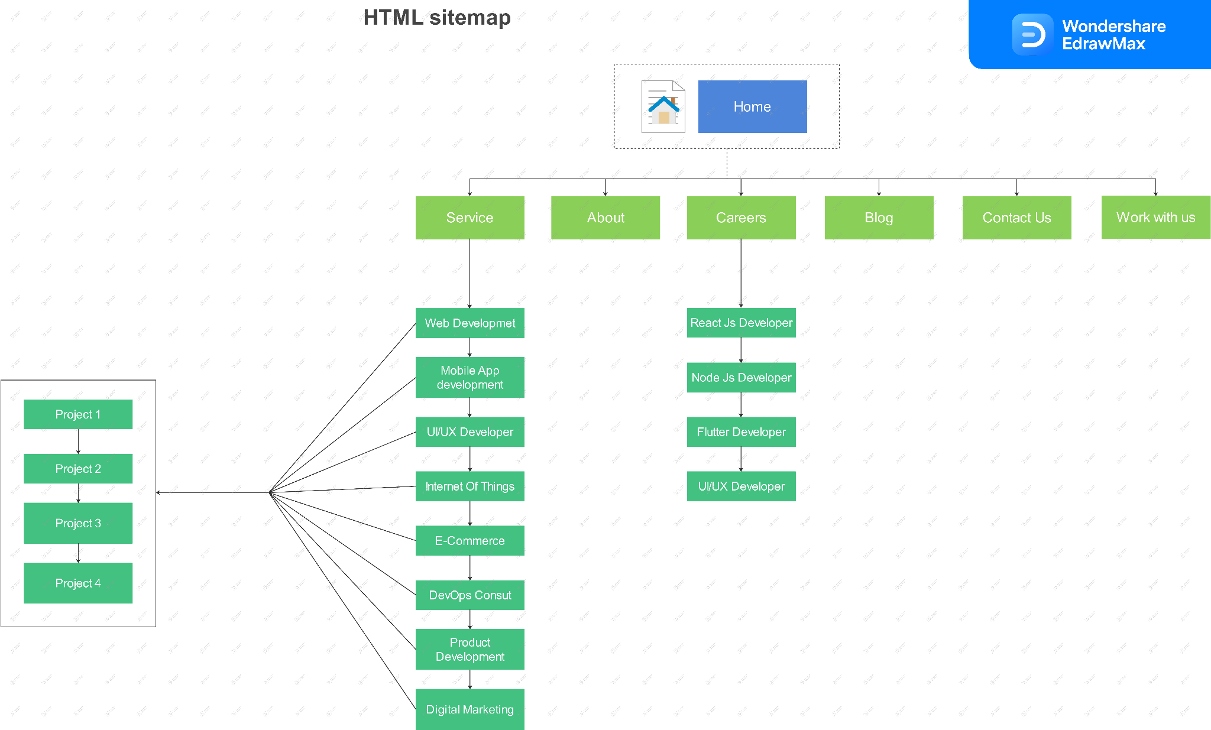

~:fig:2: HTML sitemap:~

* **Domain Authority:-**
  + Developed by MOZ.
  + Domain authority does not relate with google.
  + DA provides ranking score
  + More ranking score, more ranking ability.
  + DA Based on link authority.valid for whole domain.
* **How MOZ calculate Domain authority:**
  + Based on link profiles ( Availability of link, strong links )
* **Page authority:-**
  + Page authority also based on **link profiles** only for a single page
  + Developed by MOZ
  + Page authority considers the same factors as Domain Authority.
  + Also called page ranking ability
  + For improving page authority: try external links from other higher authority websites.
* **Redirect:-**
  + Sending users and search engines to different URLs.
  + Types of redirect
    - 301 Redirect (permanently Moved)
    - 302 Redirect
* **Need of redirection:-**
  + If your page is down or under construction (changing content of page ).
* **301 Redirection - Permanent moved content.**
  + URL moved permanently to another URL.
  + Crawlers and users don’t know about another URL so if any one Enters first URL the crawler and user will be automatically redirected to another URL.
  + It’ll pass between 90-99% of link equity to the redirected page.
  + With the use of 310 redirection, your page will not lose any popularity or value.
* **302 Redirection - Temporarily moved URL**
  + 302 redirection indicates that a URl temporarily moved to another URL.
  + Search engines will not pass page ranking to the 2nd URL immediately.
  + In this case the 2nd URL shall not be indexed.
  + 302 redirection is used for recurring temporary content.
* **SEO friendly URL:-**
  + Permalink
    - It is customizable.
    - Focus on permalink because permalink can be used at many places.
  + Make Fewer folders.
  + Use keywords in URLs.
  + Don’t use special characters.
  + Connect URL to page title (not exactly same but there should be some connections.)
  + Avoid automatic numeric labels.
  + SEO friendly URLs improve user experience.
  + URLs’ character should be in lower case only.
  + URLs help in backlinking.
* **Alt text in SEO:-**
  + Alt Text known as “Alternative text” or ”Alt attribute” or “Alt-Description”.
  + In some cases if the image is not loading on the browser alt text will represent the text about image.
  + It’ll help the crawler to clear the Description properly about the image.
  + Try to focus on Describing the image as it is.
  + Keep optimum length
  + Use primary keywords in Alt Text (Don't use over Keywords).
  + Avoid keyword stuffing
  + Don't use “Image of” or “photo of”.
* **SSL certificates:-**
  + On 6 August 2014, Google said that the Website with an SSL certificate (https://) will get more advantage in the Search Engine Result Pages **(SERPs).**
  + If your website is SSL certified then the user will feel more secure and feel free to make any transaction or give details about themselves.
  + This is indirect factor to rank of website
  + SSL Certificate will be more effective to rank higher .
* **Types of SSL certificate:-**
  + Single domain SSL Certificate
    - Not work on any subdomain.
    - Only for the main domain.
  + Multi domain SSL Certificate
    - Applicable for multiple domains.
  + Wildcard SSL Certificate
    - Cover all domain on single root domain
  + Organisation SSL Certificate
    - Works as a single domain, authenticating details of organisation.
  + Extended SSL Certificate
    - Big websites use this type of Certificate

**Practicals:**

1. **Make a project on a new website with SEO**

**Week 2 Learning:**

In the second week I have learned about Searcher’s Intent, Difference Between Keyword & Query, Understanding SEOquake, Multiple Keywords in a single post & Google’s E-A-T Algorithm, What is POGO sticking in SEO?, POGO sticking Vs Bounce Rate, Meta tags to ignore in SEO, Different kinds of Links to avoid, What is SEM?, Email Marketing, SMO(Search Media Optimization)/SMM(Search Media Marketing), Affiliate Marketing and also made a short Note on each & every topic That I have learned in this week also done Keyword planning and sorting & Also made An Excel sheet of keywords Using different tools.

* **Searcher’s Intent**
  + Searcher’s intent is needed to increase the ranking of a website.
  + Type of searches
    - Informational (detailed information about query) ( more important for SEO)
    - Navigational (search page direct )
    - Transactional ( for buying something )
    - Commercial ( for selling something )
    - Local searches ( nearby searches )
* **Query & Keyword:-**
  + Query is for Users
  + Keyword is for marketer
  + User searches query
  + Marketers use keywords to rank websites.
  + Query can be used to derive keywords from GSC (Google Search Console).

* **Link Building & link Earning:-**
  + During 1995 - 2000 google considered link building and link earning same.
  + Link Building (Banned )
    - Creating links theself like paid links, fake links, resi broker link etc.
    - Building links
    - Article submission
    - Spam emails
    - Reciprocal linking
  + Link Earning
    - Post anything on internet and people like that , then it gaining backlinks automatically is called link earning
    - Content curation
    - Guest blogging
    - Personalised email outreach
    - Building partnership
* **Value of link:-**
  + The more the links, the higher the value
  + If a more valued page gives external links then that page will have more value.

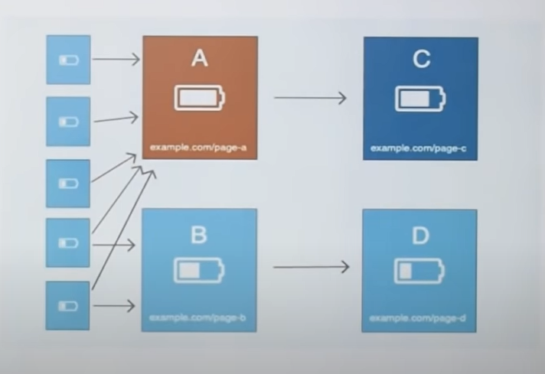

~:fig:3:value of links:~

* + Main content link ~> more value
    - Top part ~> more value
    - Middle part ~> Moderate value
    - Lover part ~> less value
  + Side bar link ~> less value than main content
  + Footer link ~> very less value than all of the above
  + If more values page give you back links then your page will be at first position and if that backlink will be removed after some time, your page will be on first page for some time
* **Multiple keyword in single page:-**
  + We can optimise our page for multiple keyword
  + This will very helpful for growing
  + If we use single page keyword, the page complexity will increase
  + If we are using multiple keyword in single page all keywords should be relevance to that content
* **E-A-T in SEO (Expertise, Authority, Trust):-**
  + **Expertise:**
    - Search engines will check the bio and background of the author with the presence of particular data.
  + **Authority:**
    - Links given in blog posts for confirmation of numeric data, those links will give Google a signal that the given numeric data is true.
  + **Trust:-**
    - The search engine will check the interaction with your blog post
* **Bounce Rate:-**
  + If any user comes on your website and gets some information and does not go deep and not go to any external links and go back to SERP then it'll be known as **Bounce Rate.**
* **Meta tags:-**
  + Keyword tags:
    - Google does not use the keywords meta tag in web ranking.
  + Revisit after
    - This tag commands robots to return to a page after a specific time period.
  + Cache-control:
    - This tag allows web publishers to define how often a page is cached
  + Geo Meta tag:-
    - Google does not use geo meta tags for ranking.
  + Expiration date:
    - This tag tells the crawler when this page will expire.
* **Different links to avoid:-**
  + Spam links on comments
  + Nonrelevant reciprocal link exchange (two different page link with each other)
  + Automation tools (scrapebox and xrumer)
  + Buying links from fiverr (freelancing)
  + Link velocity (Speed of making links)
* **Social Media Optimization:-**
  + It is used as a catalyst to grow our business.
  + It count efforts on YT,FB,twitter, Instagram and other platform
  + Non paid campaign
  + Mostly on page kind activities
    - Optimization of profile
    - Page assets
  + Focus on brand image (should be same on every platform)
  + Focus on elements algorithm,understand the algorithm
  + Person working on SMO must understand dynamic nature of social media platforms
* **Social Media Marketing**
  + Almost paid campaigns on social media.
  + Social media advertisement.
  + Content understanding is required
  + Content calendar (schedule)
  + Advertising skills required
  + Campaign are created according to the object
  + Power of retargeting
* **Affiliate marketing**
  + Affiliate marketing is the process of earning a commission by promoting other people’s product
  + 3 basic components
    - Vender
    - Affiliate network
    - Affiliates
  + Two types of affiliate networks and standalone
    - **In India**
      * Flipkart
      * Amazon associate
      * vCommission
      * BIGROCK affiliate
    - **Outside India**
      * ClickBank
      * Ci affiliate
      * Jvzoo

**Practicals:**

**Keyword planning & sorting**

**Make a Report on the current website of Secret mindtech**

**Week 3 Learning:**

In the Third week I have Completed Keyword planning and sorting & started working on the website of Secret MindTech to Improve SEO rate of the website. In order to improve the SEO Firstly we have Listed out all the negative points of the website which we have already done in second week and started Designing title Tag and Description of Service page & Home page also found content for those pages, made description about Web designing , Mobile app development, Digital marketing for service page, SERP for service page, About us section planning.

**Keyword planning & sorting:**

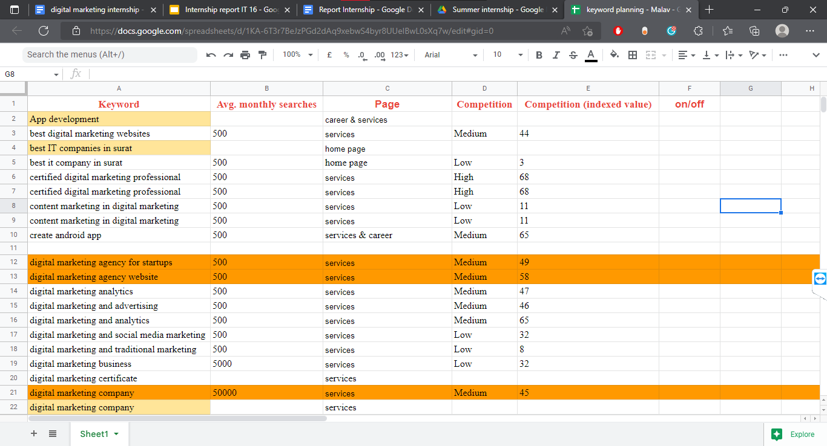

~:fig:4: keywords planning:~

**Negative points of the website:**

1. Description is missing
2. Title is missing
3. Keywords are missing
4. Website does not have any structure
5. Heading Tag is missing.
6. No Keyword in details
7. Redirecting button over specified

# 

~:fig:5: current website:~

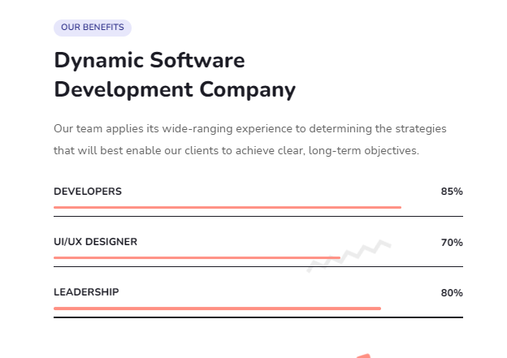

~:fig:6: current website details:~

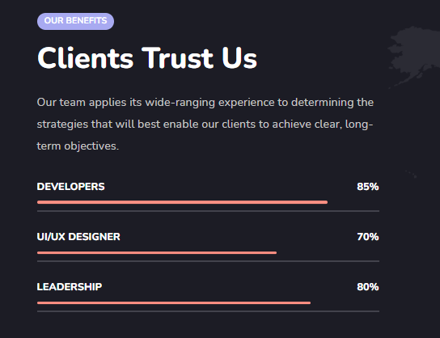

~:fig:7: current website details:~

8. Same detail specified in 2 different pages

9. This is mobile friendly website but taking longer time for loading (missing AMP)

10. Some keywords are used in about us section

11. Contact us button not working

12. Proper ALT Text not used (34 image pending)

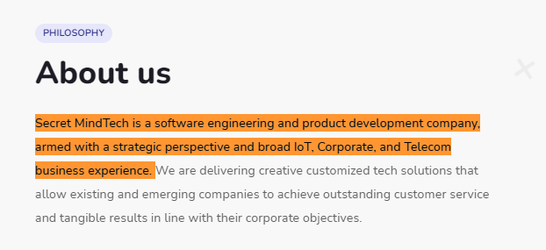

~:fig:8: current website about us part:~

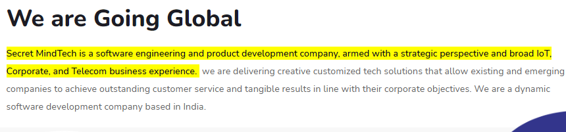

~:fig:9: current website details:~

13. Same Content.



~:fig:10: current website:~

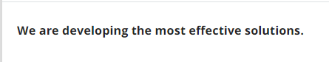

**This is better**

~:fig:5: current website:~

14. Grammar Mistake

15. Lack of backlink (only 2)

16. Lack of Keywords (Only 4 (India))

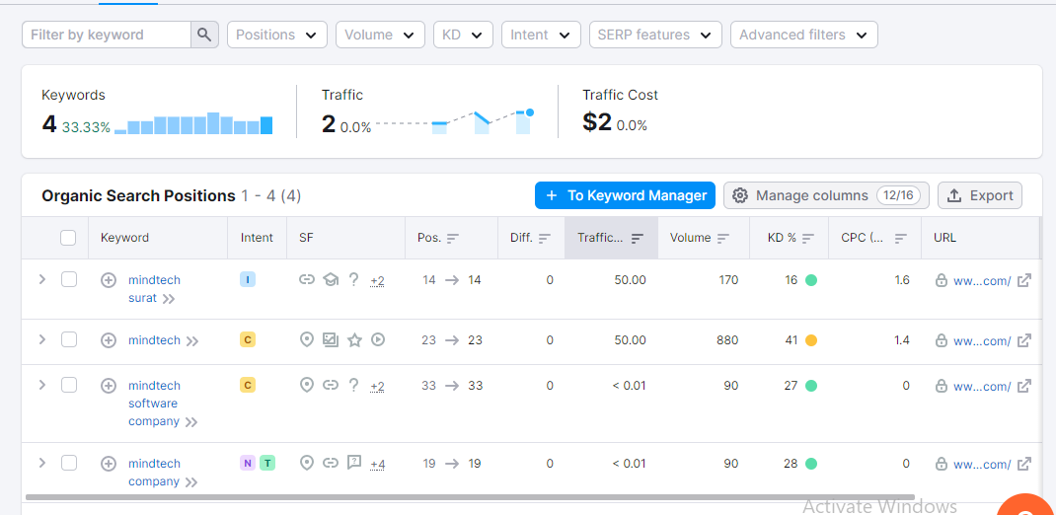

17. There are only 4 keywords available on this website.

18. Meta description Missing (Describe your website).

19. social links mentioned in very small icons and at the end of the website.

20. Less text.

21. Open graph object Missing.

* + **Open** Graph objects are basically just URLs referring to pages that have the appropriate OG meta tags set.

22.Website does not have proper meta tags.

* + <meta> tags always go inside the <head> element, and are typically used to specify character set, page description, keywords, author of the document, and viewport settings.

23. Website does not have a page on Twitter.

24. Wrong keyword used.

25. This website has only an XML site map.

26. HTML sitemap is missing.

**SERP Home page**

* URL
  + <https://www.secretmindtech.com>
* Title
  + Secret MindTech | IT Company | India
* Description
  + Secret MindTech is India's leading IT company for developing mobile apps, web design, and digital marketing. Utilise new technologies to improve client service.
* **SERP Result for Home page.**

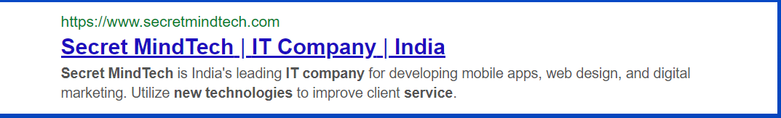

**SERP Service page**

* URL
  + <https://www.secretmindtech.com>/service/
* Title
  + Services - Secret MindTech | India
* Description
  + Secret MindTech is the best software company, which provides better customer service with the right team of experienced Employees and experts to fully meet your requirements. Some of the most successful services are offered by Secret MindTech.
* **Home page description.**

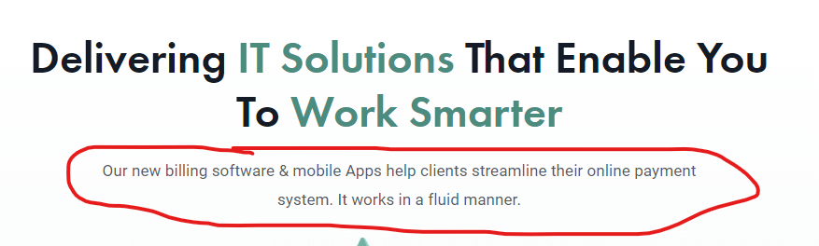

* At Secret MindTech, we provide the best IT solutions which allow you to work smarter. Here we provide the best customer services and IT solutions to make your work easy and effective with an Experienced Employee team.

The Services we offer.

* **Service Page description.**

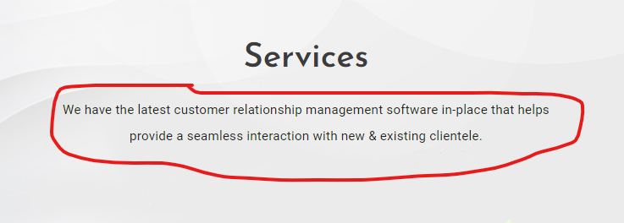

* + Secret MindTech is the best software company, which provides better customer service with the right team of experienced Employees and experts to fully meet your requirements. Some of the most successful services are offered by Secret MindTech.

**Contant Writing:**

* **Digital Marketing.**
  + At Secret MindTech, we are leading in providing the best services in digital marketing. Take your company to the next level through our digital marketing services. We are here to help you with advertising, analysis, and optimization! We are also working for organic and viral growth for your business. Hence take your business to the next level with our new digital marketing strategies. Let’s start working together, which is owned by you and driven by us. This means beginning with a plan and ending with outcomes.
* **Web development**
  + In this digital age, if you're thinking of exploring your company on an online platform, we're going to do it in real time with Web Development. We create ideas on the Internet. Our purpose is to be the creator of your success. Secret MindTech’s web experts deliver success for each solution. We are committed to creativity. We are not your average design company.
* **Mobile app development.**
  + Secret MindTech is the best mobile app development company in India. We design technology for today’s mobile generation. An app is a tool for a successful business. Let us help you put your ideas in the Mobile App “We do what we love for people who love what we do”.  
    Let us start your own chapter in this exciting app development journey with us.

**Week 4 Learning:** completed content making about E-commerce,DevOps Consulting**,**UI/UX Developer**,**Blog Making for the blog section of the Website. i wrote a blog on : Web designing/What is software & Software engineering?/Do You Know What Is Requirement Engineering?/What is the software development life cycle?/Do you know what POP & OOP is?

* **E-commerce :**
  + Secret MindTech is also a leading E-commerce platform for everyone. We are selling only the best things online. We are providing guaranteed sales on every posting. We make online selling superbly easy. We are helping buyers and sellers to attain their goals. We will not let you down. We are gonna be your trusted E-commerce platform. Here every product is special. We are combining quality and reliability in one. There are endless possibilities with E-commerce. we bring the good cart to life. If you can’t beat E-commerce, join E-commerce. We don’t make E-commerce, We make E-commerce better & successful, let's start today!
* **DevOps Consulting** 
  + Our DevOps consulting service provides speed and expertise to make a professional product. The DevOps service provides support to the programmers in speeding the process of development and also gives full control of automation and testing during making the product. It also aids the improvement in statistics and making of good quality products at a faster rate. The main factor of DevOps is improvement in contentment, productivity, workplace culture, etc . The factors are the duty of DevOps consulting firms.
* **UI/UX Developer:-** 
  + We provide UI design, UX design, and front-end development for awesome projects. As UI/UX designers, it will be our responsibility to deliver the best user experience and ensure customer satisfaction and loyalty. We will come up with ideas using a variety of methods and the latest technology. Our team has more than three years of experience in user interface design, UX design, and front-end development.
* **Internet of Things:-** 
  + The Internet of Things(Iot) is the ability to have devices communicate with one another via the internet or other networks, remotely tracking information to provide feedback to assist with commonly done using sensors connecting to a back-to-base system.The rapid expansion of devices provides information more quickly by connecting unconnected devices. Secret MindTech's Internet of Things (IdT) offers new ways to increase efficiency, interact with customers, and expand new business with better knowledge. We are able to connect new and existing devices, protect devices and data from loss, and explore partner solutions to enhance workspace and connect devices in large areas.
* **Product Development:-**
  + Product development is the complete process of taking an idea from concept to delivering it outside of the mind. Technically product development is similar to the build phase of the product life cycle. Product development is much more than “how” a product build. It is the “what”,” why”, and ”when”. Secret MindTech Provides you with the best product based on your idea.
  + Bring your idea and get the best product not only as you want but much more than that.
  + Phrases of product development
  + Strategize: Defines goals and initiatives
  + Ideate: Brainstorm and capture the ideas
  + Plan: Refine the ideas based on strategic goals, estimated product value, and capacity
  + Showcase: Show roadmaps and go to market plans with stakeholders
  + Build: Deliver new functionality via agile development
  + Launch: Bring those exciting new capabilities to market
  + Analyze: Assess realized product value by tracking customer usage and love.
* **About Us**
  + A small intro about the company
  + Vision / mission
  + Company founder’s story
  + Employee details (Years of experience, specialty, etc.)
  + Skills/awards or clients' views about our work.

**Blogs: Here is one of my blogs:**

Blog 2 : Do you know What JAVA programming is?

This blog is about the basics of java programming for you. So you can easily understand what java programming is? So let’s start with what programming languages are? And Types of programming languages.

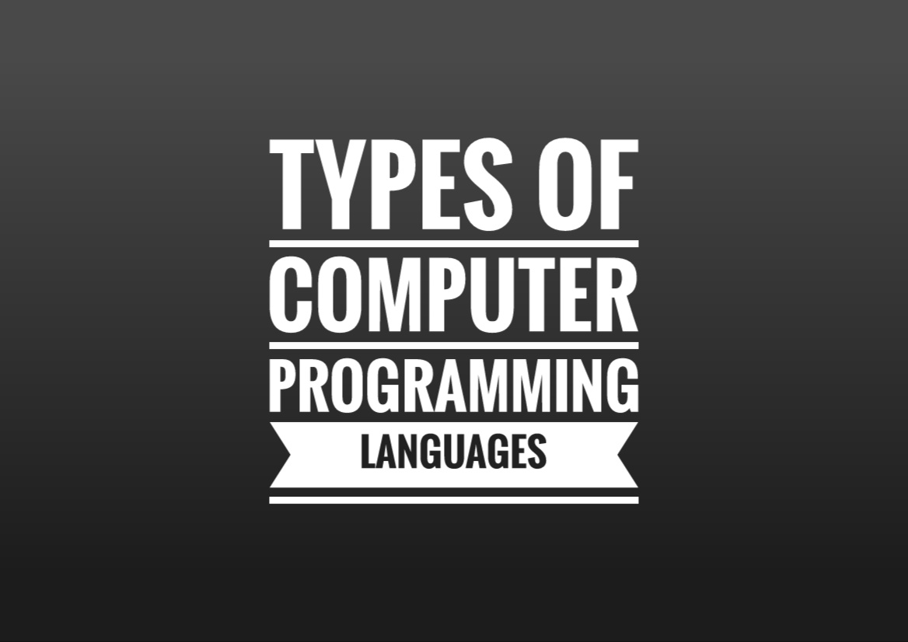

What are programming languages?

As we know , we need a specific language to communicate with a person right? Similarly programmers need a language to communicate with computers and those languages are called [**programming languages**](https://en.wikipedia.org/wiki/Programming_language).

**Types of programming languages:**

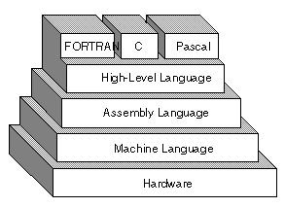

**There are mainly two types of programming languages :**

1. [**Object oriented programming**](https://www.tutorialspoint.com/human_computer_interface/object_oriented_programming.htm)
2. [**Procedural oriented programming**](https://en.wikipedia.org/wiki/Procedural_programming)

# Object oriented programming

Object oriented programming is a programming paradigm based upon

[objects](https://www.techopedia.com/definition/24339/java-object#:~:text=A%20Java%20object%20is%20a,are%20also%20known%20as%20classes.) (having both data and methods).

A programming language which is based on an object is called object oriented programming language.

OOP is an approach to problem solving where all computations are carried out using objects.

An object is a component of a program that knows how to perform certain actions and how to interact with other elements of the program.

Objects are the basic units of object oriented programming.

A method in OOP like a procedure in POP(Procedure Oriented programming)

The key difference here is that the method is a part of an object.

In OOP you organize your code by creating objects, and then you can give those objects properties and you can make them do certain things.

OOP is used to **manage increasing complexity**.

# Procedural oriented programming

Procedural oriented programming language is a programming language which is based upon procedure is called procedural oriented programming language.

For example,

C , FORTRAN , [PASCAL](https://en.wikipedia.org/wiki/Blaise_Pascal) , [FORTON](https://en.wikipedia.org/wiki/Fortran)

Procedure programming uses a list of instructions to tell the computer what to do step-by-step. Procedure programming releases on -you guessed it- procedures,also known as routines or subroutines. A procedure contains a series of computational steps to be carried out. Procedure programming is also referred to as imperative programming. Procedure programming languages are also known as top-down languages.

Procedure programming is intuitive in the sense that it is very similar to how you would expect a program to work. If you want a computer to do something, you should provide step-by-step instructions on how to do it. Therefore no surprise that most early programming languages are all Procedure. Examples of Procedural languages include [Fortran](https://en.wikipedia.org/wiki/Fortran#:~:text=Fortran%20(%2F%CB%88f%C9%94%CB%90rt,numeric%20computation%20and%20scientific%20computing.) , [COBOL](https://www.microfocus.com/en-us/what-is/cobol#:~:text=COBOL%20stands%20for%20Common%20Business,which%20the%20computer%20can%20understand.) and [C](https://en.wikipedia.org/wiki/C_(programming_language)), which have been around since the 1960s and 70s.

**Now you know what programming languages are and what are the main two types of programming languages. Now you're gonna know about JAVA programming.JAVA is an Object Oriented programming language, and very similar to C++.**

JAVA is a simplified language.JAVA Technology consists of:

A Programming Language

A Development Environment

An Application Environment

Two types of [application](https://www.besanttechnologies.com/types-java-applications) can be created using JAVA:

* Application : Standalone JAVA programs, using JAVA runtime Environment(JRE), executed without use of web browser
* JAVA Applets : They run under the JAVA enabled web browser.

[**HISTORY OF JAVA**](https://www.javatpoint.com/history-of-java)**:**

* **JAVA** was createdat [**Sun Microsystem**](https://en.wikipedia.org/wiki/Sun_Microsystems) **in 1991**.
* It took 18 months to develop the first working version.
* This language was initially called **“Oak”**, but it was renamed **“JAVA” in 1995.**
* Oak was **first used in television set-top boxes** designed to provide video on demand services.
* Oak was unsuccessful So in 1995 Sun **changed the name to JAVA** and modified the language to take advantage of the growing world wide web.

[**JAVA FEATURES**](https://www.tutorialspoint.com/What-are-the-major-features-of-Java-programming)**:**

* Features of a language are nothing but the set of services or facilities provided by language vendors to the industry programmers.
* Some important features of JAVA are:

1. Simple
2. Sequre
3. Portable
4. Object oriented
5. Robust
6. Multi threaded
7. Architectural Neutral
8. High performance
9. Distributed
10. Dynamic
11. Interpreted
12. Platform Independent

**JAVA PROGRAMMING** [**STRUCTURE**](https://www.javatpoint.com/structure-of-java-program)**:**

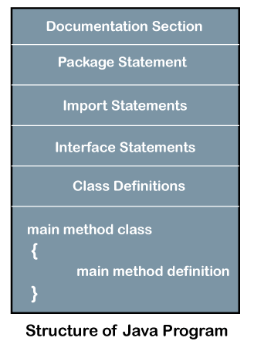

**JAVA program structure contains the following elements:**

* Documentation section
* Package Declaration
* Import Statements
* Class Definition
* Interface Section
* Class variables and variables
* Main method class
* Methods and Behaviors

**JAVA is a simplified language. I hope you understand what JAVA programming is? It was such a basic concept of OOP/POP & JAVA you can learn and experience JAVA programs with** [**SecretMindTech**](http://staging.secretmindtech.com/)**.So contact us on our website** [**Secret MindTech**](http://staging.secretmindtech.com/) **to work with us on JAVA programming**.

**Week 5 Learning:**

In the last week we have found various social media platforms for social media optimization Learned how actual social media optimization is & sorted the list of various social media platforms for an organic marketing and Started making accounts on those various platforms, At last, we learned about social media marketing Which is paid, not Organic & completed the theory content.

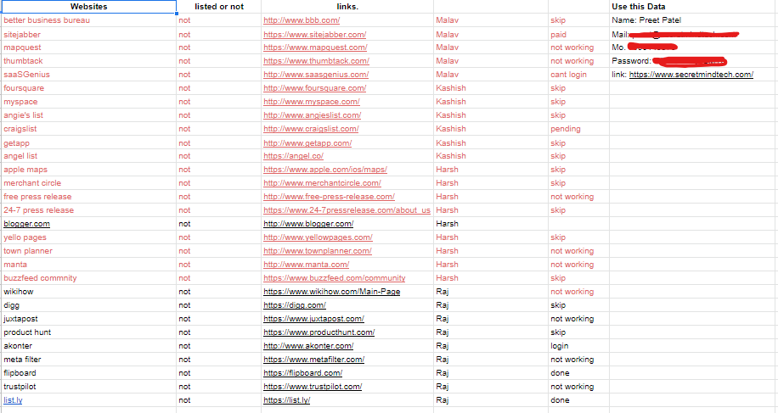

**SUMMARY OF INTERNSHIP**

We have learned many things in this internship and mainly got the experience which is so helpful for us nowadays. We have done our internship in digital marketing.In this amount of time we have learned from the basics of digital marketing like what is actual digital marketing in simple words.What are its types? How does it work? We learned all the basic things about digital marketing in the first week and then we started learning about Search Engine Optimization then Search Engine marketing and so on.In this period of time we have done some practicals also which was related to what we learned.Learning theory and doing it practically to understand the theory properly was our daily routine and that was the best pattern for learning.That internship was the best experience of all of us.