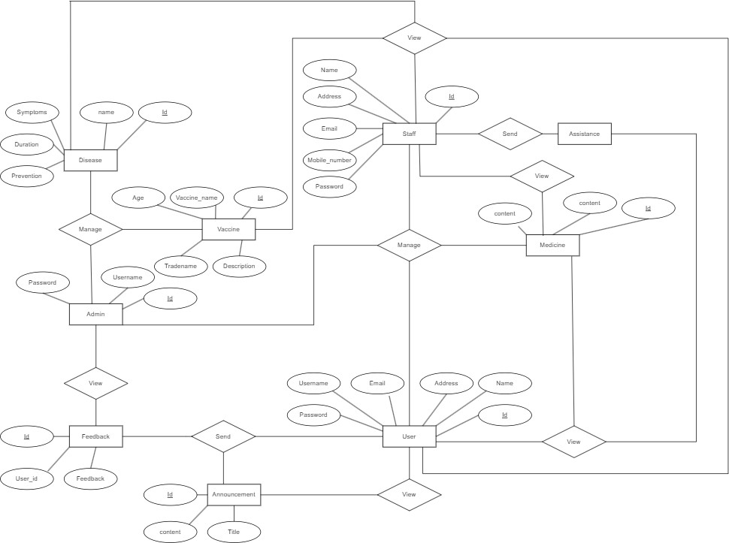
29/09/2024, 21:02 Untitled Diagram.drawio

