**PROJECT PROPOSAL**

**TITLE:** EXPENSE TRACKER

**TEAM MEMBERS**:

MALAVIKA P PILLAI- AM.EN.U4CSE16038

LAKSHMI ANAND- AM.EN.U4CSE16037

POOJA JAYAKUMAR PILLAI- AM.EN.U4CSE16049

SOURAV. S- AM.EN.U4CSE16059

**INTRODUCTION:**

The main purpose of this application is to track all the expenses made by a user. The user can generate report of his expenses based on the transaction date of the expenses or category of items.

We are developing a web application named as “Expense Tracker” and this application is used to manage the application user‘s daily expenses in a more efficient and manageable way. By using this application we can reduce the manual calculations for their daily expenses and keep the track of the expenditure. In this application, user can provide his income to calculate his total expenses per day and these results will stored for unique user.

**SCOPE:**

Expense Tracker application which will keep a track of Income-Expense of a user on a day to day basis. This application takes Income from user and divides in daily expense allowed. If you exceed that days expense it will cut if from your income and give new daily expense allowed amount, and if that days expense is less it will add it in savings. Expense tracking application will generate report at the end of the month.

**FUNCTIONAL REQUIREMENTS:**

* The application should provide password-based secure access to the user.
* Design a dashboard or home screen providing an easy and simple view of everything in one place.
* The user should be allowed to add income to different categories.
* The user should be allowed to add his/her expenses against different categories such as food,clothing etc.
* The user may add/remove new/old categories of income and expenses.
* The application will allow users to set their monthly budget to monitor and control spending.
* An application should provide the facility to set alerts on budgets regarding expenses (electricity bill).
* The application will provide different reports regarding expenses,income and savings on the daily,weekly,monthly or yearly basis for better control over the money.
* The application will also allow users to view category-wise spending for a day/month/year

**USECASE:**

* Login for every user.
* Add transaction to add details on income or expense.
* Income
* Expense
* Generate Report about the status of savings and expenses.
* Maintain events to monitor the activities.
* Weekly view on expenditures and balance.

**USECASE DIAGRAM:**

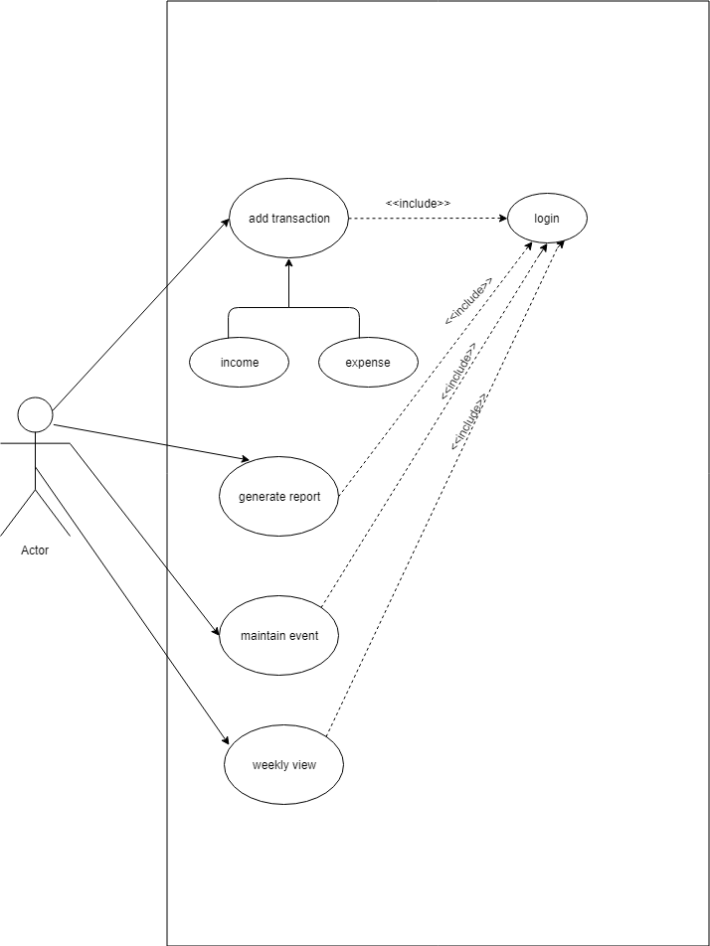

**USECASE DESCRIPTION:**

* In this web application each user has a login through which only they can track their expenses.
* We have an add transaction class that is used to add or remove expense and income details according to different categories.
* A generate report class that generates the updated reports according to the user’s wish(daily,weekly,monthly).
* A maintain event bar to monitor the expenses and check for budget warning.
* A weekly view for tracking the weekly earning and spending.

**USER INTERFACE:**

In this web application,we have a login page for every user.After logging in we get the dashboard where income,expenses and balance are displayed.We have an edit profile button and a category button for adding/removing the income,expense and their different categories like food,transportation,health etc.We have a remainder button which can send notification as mail.A report button is also present in the dashboard to show daily,weekly or monthly report.