|  |
| --- |
| **Name: Malavika A**  **Roll No:16**  **Batch: RMCA B**  **Date: 6/05/2022** |

**ADVANCED DATABASE MANAGEMENT STYSTEM LAB**

**Experiment No.: 6**

**Aim**

To familiarize with join or cartesian product

**Questions**

1.Give name of customers having living city BOMBAY and branch city NAGPUR

2.Give names of customers having the same living city as their branch city

3.Give names of customers who are borrowers as well as depositors and having city

NAGPUR.

4.Give names of borrowers having deposit amount greater than 1000 and loan amount greater

than 2000.

5.Give names of depositors having the same branch as the branch of Sunil

6.Give names of borrowers having loan amount greater than the loan amount of Pramod

7.Give the name of the customer living in the city where branch of depositor Sunil is located.

8.Give branch city and living city of Pramod

9.Give branch city of Sunil and branch city of Anil

10.Give the living city of Anil and the living city of Sunil

# Procedure

# 

SELECT D1.CNAME,D1.BNAME,C1.CNAME,C1.CITY,B1.CITY,B1.BNAME FROM DEPOSIT D1,CUSTOMER C1,BRANCH B1 WHERE C1.CITY = 'BOMBAY' AND B1.CITY = 'NAGPUR' AND D1.CNAME = C1.CNAME AND D1.BNAME = B1.BNAME;

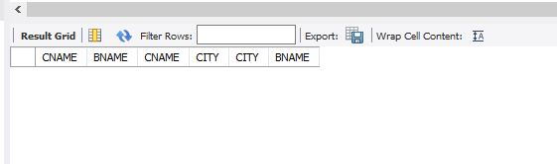

SELECT DISTINCT(CUSTOMER.CNAME), BRANCH.CITY FROM BRANCH, CUSTOMER WHERE BRANCH.CITY = CUSTOMER.CITY;

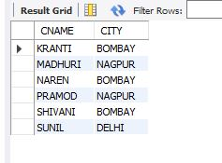

SELECT BR1.CNAME, BR1.AMOUNT, D1.CNAME, D1.AMOUNT FROM BORROW BR1,DEPOSIT D1 WHERE D1.CNAME = BR1.CNAME AND D1.AMOUNT >1000 AND BR1.AMOUNT > 2000;

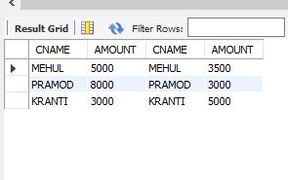

SELECT D1.CNAME FROM DEPOSIT D1 WHERE D1.BNAME IN (SELECT D2.BNAME FROM DEPOSIT D2 WHERE D2.CNAME = 'SUNIL');

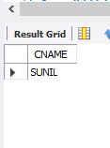

SELECT BR1.CNAME,BR1.AMOUNT FROM BORROW BR1 WHERE BR1.AMOUNT > ALL (SELECT BR2.AMOUNT FROM BORROW BR2 WHERE BR2.CNAME = 'PRAMOD');

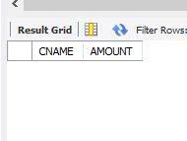

SELECT C.CNAME FROM CUSTOMER C WHERE C.CITY IN (SELECT B.CITY FROM BRANCH B WHERE B.BNAME IN (SELECT D.BNAME FROM DEPOSIT D WHERE D.CNAME='SUNIL'));

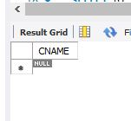

SELECT B1.CITY , C1.CITY FROM BRANCH B1,CUSTOMER C1, DEPOSIT D1 WHERE C1.CNAME = 'PRAMOD' AND C1.CNAME = D1.CNAME AND D1.BNAME =B1.BNAME;

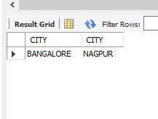

SELECT B1.CITY FROM DEPOSIT D1, BRANCH B1 WHERE D1.BNAME =B1.BNAME AND D1.CNAME IN ('SUNIL' ,'ANIL');

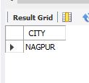

SELECT C1.CNAME, C1.CITY FROM CUSTOMER C1 WHERE C1.CNAME ='ANIL' OR C1.CNAME = 'SUNIL';

