|  |
| --- |
| **Name: Malavika A**  **Roll No:16**  **Batch: RMCA B**  **Date: 10/06/2022** |

**ADVANCED DATABASE MANAGEMENT STYSTEM LAB**

**Experiment No.:**

**Aim**

Create  a student table with fields id,name,subject1,subject2,subject3 and total,percentage. For each entry of row, update total marks and percentage using triggers in SQL

# Procedure

step 1: start

step 2: create table student

step 3: create trigger on student table

step 4: insert records

step 5: select the table to see if the triggers has been executed

step 6: stop

Syntax:

create trigger [trigger_name]

[before or after]

{insert or update or delete}

on [table_name]

[for each row]

[trigger_body]

1. create database student

use student

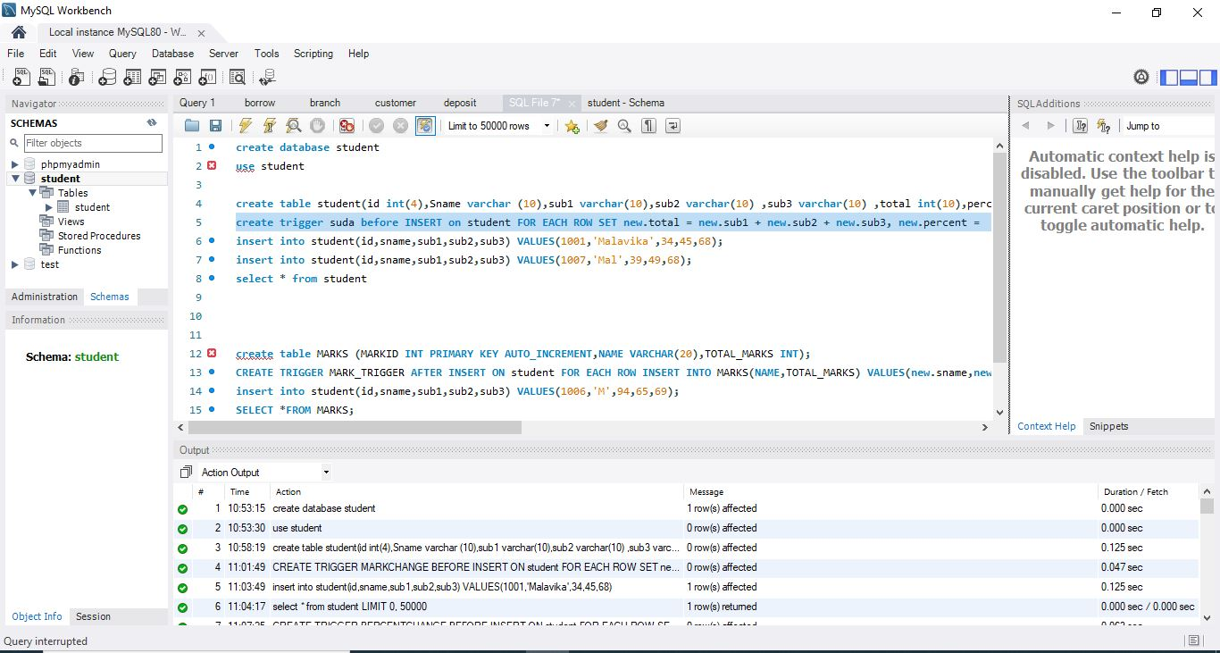

1. create table student(id int(4),Sname varchar (10),sub1 varchar(10),sub2 varchar(10) ,sub3 varchar(10) ,total int(10),percent int(3))



1. create trigger suda before INSERT on student FOR EACH ROW SET new.total = new.sub1 + new.sub2 + new.sub3, new.percent = new.total/300*100;

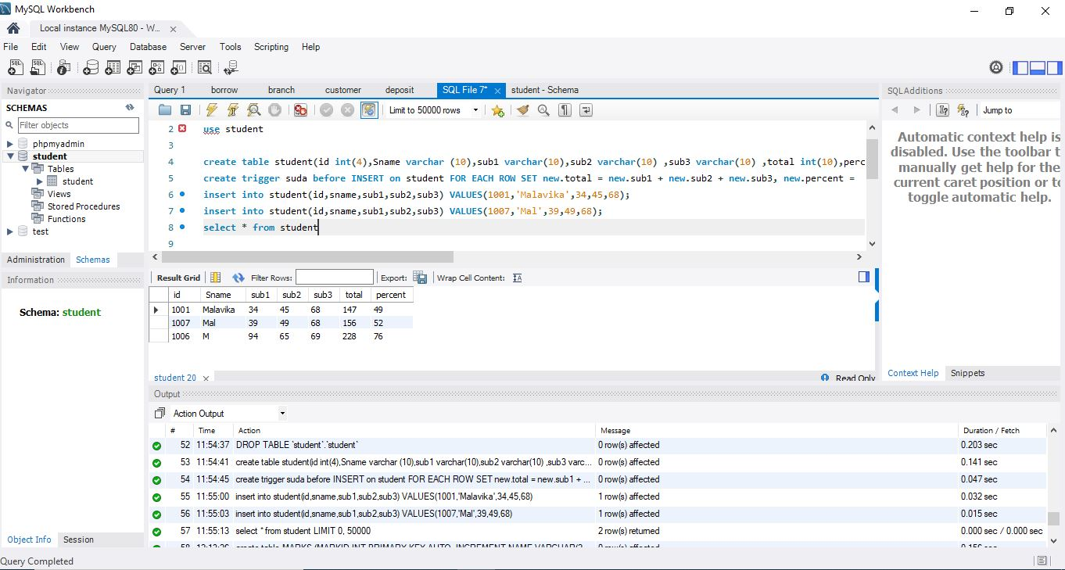

1. insert into student(id,sname,sub1,sub2,sub3) VALUES(1001,'Malavika',34,45,68);



1. insert into student(id,sname,sub1,sub2,sub3) VALUES(1007,'Mal',39,49,68);



1. select * from student

