|  |
| --- |
| **Name: MALAVIKA A**  **Roll No: 16**  **Batch: RMCA B**  **Date: 27-09-2022** |

**MOBILE APPLICATION DEVELEPOMENT LAB**

Android lab cycle: 3

**Experiment No.:** 1

**Aim**

Design a page with intent

**Procedure**

**activity_main.xml**

<?xml version="1.0" encoding="utf-8"?>

<androidx.constraintlayout.widget.ConstraintLayout xmlns:android="http://schemas.android.com/apk/res/android"

xmlns:app="http://schemas.android.com/apk/res-auto"

xmlns:tools="http://schemas.android.com/tools"

android:layout_width="match_parent"

android:layout_height="match_parent"

tools:context=".MainActivity">

<TextView

android:layout_width="wrap_content"

android:layout_height="wrap_content"

android:text="Main Activity"

app:layout_constraintBottom_toBottomOf="parent"

app:layout_constraintEnd_toEndOf="parent"

app:layout_constraintHorizontal_bias="0.498"

app:layout_constraintStart_toStartOf="parent"

app:layout_constraintTop_toTopOf="parent"

app:layout_constraintVertical_bias="0.449" />

<Button

android:id="@+id/button1"

android:layout_width="166dp"

android:layout_height="61dp"

android:text="Go to second Activity"

tools:layout_editor_absoluteX="132dp"

tools:layout_editor_absoluteY="441dp" />

</androidx.constraintlayout.widget.ConstraintLayout>

**activity_secondactivity.xml**

<?xml version="1.0" encoding="utf-8"?>  
<androidx.constraintlayout.widget.ConstraintLayout xmlns:android="http://schemas.android.com/apk/res/android"  
 xmlns:app="http://schemas.android.com/apk/res-auto"  
 xmlns:tools="http://schemas.android.com/tools"  
 android:layout_width="match_parent"  
 android:layout_height="match_parent"  
 tools:context=".secondactivity">  
  
 <TextView  
 android:id="@+id/textView"  
 android:layout_width="wrap_content"  
 android:layout_height="wrap_content"  
 android:text="Second Activity"  
 tools:layout_editor_absoluteX="173dp"  
 tools:layout_editor_absoluteY="319dp" />  
</androidx.constraintlayout.widget.ConstraintLayout>

**Main_Activity.java**

package com.example.intend;  
  
import androidx.appcompat.app.AppCompatActivity;  
  
import android.content.Intent;  
import android.os.Bundle;  
import android.view.View;  
import android.widget.Button;  
  
public class MainActivity extends AppCompatActivity {  
 Button b1obj;  
  
 @Override  
 protected void onCreate(Bundle savedInstanceState) {  
 super.onCreate(savedInstanceState);  
 setContentView(R.layout.*activity_main*);  
 b1obj=findViewById(R.id.*button1*);  
 b1obj.setOnClickListener(new View.OnClickListener() {  
 @Override  
 public void onClick(View v) {  
 Intent i= new Intent(MainActivity.this, secondactivity.class);  
 startActivity(i);  
 }  
 });  
 }  
}

OUTPUT

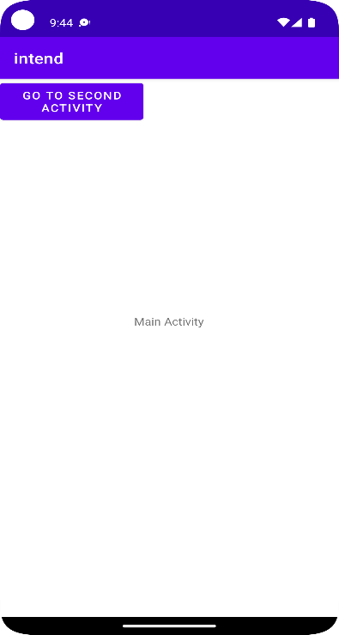

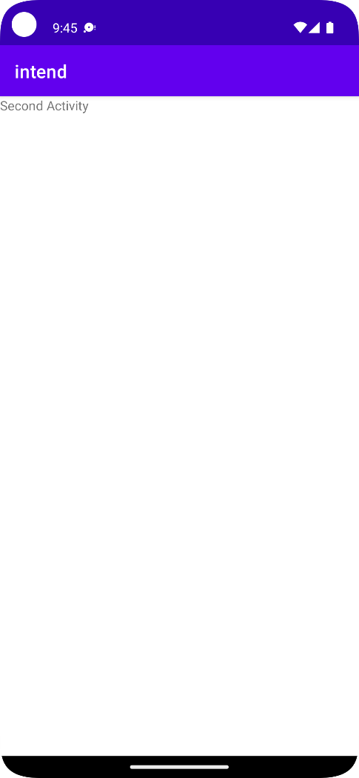

|  |
| --- |
| **Name: MALAVIKA A**  **Roll No: 16**  **Batch: RMCA B**  **Date: 11-10-2022** |

**MOBILE APPLICATION DEVELEPOMENT LAB**

Android lab cycle:3

**Experiment No.:** 2

**Aim**

**Procedure**

**activity_main.xml**

**Main_Activity.java**

**OUTPUT**

|  |
| --- |
| **Name: MALAVIKA A**  **Roll No: 16**  **Batch: RMCA B**  **Date: 30-8-2022** |

**MOBILE APPLICATION DEVELEPOMENT LAB**

Android lab cycle:2

**Experiment No.:** 3

**Aim**

**Procedure**

**activity_main.xml**

**activity_main.xml**

OUTPUT

|  |
| --- |
| **Name: MALAVIKA A**  **Roll No: 16**  **Batch: RMCA B**  **Date: 20-09-2022** |

**MOBILE APPLICATION DEVELEPOMENT LAB**

Android lab cycle:2

**Experiment No.:** 2

**Aim**

**Procedure**

**activity_main.xml**

**OUTPUT**

|  |
| --- |
| **Name: MALAVIKA A**  **Roll No: 16**  **Batch: RMCA B**  **Date: 20-09-2022** |

**MOBILE APPLICATION DEVELEPOMENT LAB**

Android lab cycle:2

**Experiment No.:** 2

**Aim**

**Procedure**

**activity_main.xml**

**Main_Activity.java**

**OUTPUT**