

|  |
| --- |
| **Name: MALAVIKA A**  **Roll No: 16**  **Batch: RMCA B**  **Date: 12-09-2022** |

**DATA SCIENCE LAB**

**Experiment No.: 1**

**Aim**

Zscores

**Procedure**

1. **Zscore(data)**

import pandas as pd

import numpy as np

import scipy.stats as stats

data = np.array([6, 7, 7, 12, 13, 13, 15, 16, 19, 22])

stats.zscore(data)

**OUTPUT**

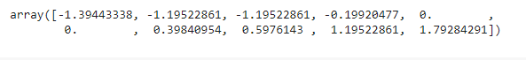

1. **Zscore(axis)**

import pandas as pd

import numpy as np

import scipy.stats as stats

data = np.array([[5, 6, 7, 7, 8],

                 [8, 8, 8, 9, 9],

                 [2, 2, 4, 4, 5]])

stats.zscore(data, axis=1)

**OUTPUT**

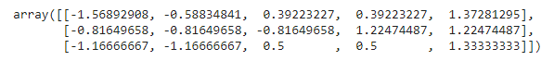

1. **Apply()**

import pandas as pd

import numpy as np

import scipy.stats as stats

data = pd.DataFrame(np.random.randint(0, 10, size=(5, 3)), columns=['A', 'B', 'C'])

data.apply(stats.zscore)

**OUTPUT**

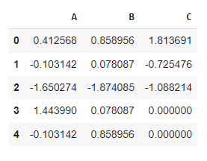

1. **Scaler.transform()**

from sklearn.preprocessing import MinMaxScaler

data = [[-1, 2], [-0.5, 6], [0, 10], [1, 18]]

scaler = MinMaxScaler()

print(scaler.fit(data))

MinMaxScaler()

print(scaler.data_max_)

print(scaler.transform(data))

print(scaler.transform([[2, 2]]))

**OUTPUT**

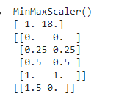

1. **RandomForestClassifier()**

import numpy as np

from scipy.stats import randint

from sklearn.experimental import enable_halving_search_cv  # noqa

from sklearn.model_selection import HalvingRandomSearchCV

from sklearn.ensemble import RandomForestClassifier

from sklearn.datasets import make_classification

rng = np.random.RandomState(0)

X, y = make_classification(n_samples=700, random_state=rng)

clf = RandomForestClassifier(n_estimators=10, random_state=rng)

param_dist = {

    "max_depth": [3, None],

    "max_features": randint(1, 11),

    "min_samples_split": randint(2, 11),

    "bootstrap": [True, False],

    "criterion": ["gini", "entropy"],

}

rsh = HalvingRandomSearchCV(

    estimator=clf, param_distributions=param_dist, factor=2, random_state=rng

)

rsh.fit(X, y)

rsh.best_params_

**OUTPUT**

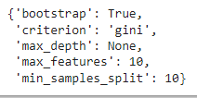

1. **SelfTrainingClassifier**

import numpy as np

from sklearn import datasets

from sklearn.semi_supervised import SelfTrainingClassifier

from sklearn.svm import SVC

rng = np.random.RandomState(42)

iris = datasets.load_iris()

random_unlabeled_points = rng.rand(iris.target.shape[0]) < 0.3

iris.target[random_unlabeled_points] = -1

svc = SVC(probability=True, gamma="auto")

self_training_model = SelfTrainingClassifier(svc)

self_training_model.fit(iris.data, iris.target)

**OUTPUT**



1. **suptitle**

from sklearn.ensemble import RandomForestRegressor

from sklearn.datasets import fetch_california_housing

from sklearn.inspection import plot_partial_dependence

X, y = fetch_california_housing(return_X_y=True, as_frame=True)

features = ["MedInc", "AveOccup", "HouseAge", "AveRooms"]

est = RandomForestRegressor(n_estimators=10)

est.fit(X, y)

display = plot_partial_dependence(

    est,

    X,

    features,

    kind="individual",

    subsample=50,

    n_jobs=3,

    grid_resolution=20,

    random_state=0,

)

display.figure_.suptitle(

    "Partial dependence of house value on non-location features\n"

    "for the California housing dataset, with BayesianRidge"

)

display.figure_.subplots_adjust(hspace=0.3)

**OUTPUT**

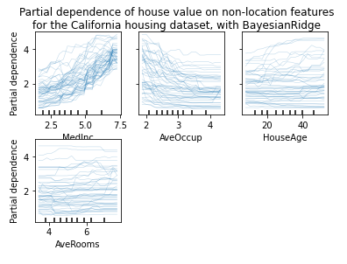

1. **load_iris**

from sklearn.datasets import load_iris

from sklearn.preprocessing import MinMaxScaler

import numpy as np

X, y = load_iris(return_X_y=True)

print(X.shape)

**OUTPUT**



1. **x_scaled.min**

from sklearn.datasets import load_iris

from sklearn.preprocessing import MinMaxScaler

import numpy as np

X_scaled.min(axis=0)

**OUTPUT**



1. **x_scaled.max**

from sklearn.datasets import load_iris

from sklearn.preprocessing import MinMaxScaler

import numpy as np

X_scaled.max(axis=0)

**OUTPUT**



1. **Train_test_split**

from sklearn.model_selection import train_test_split

X_train, X_test, y_train, y_test = train_test_split(

    X, y, test_size=0.2, random_state=42, stratify = y)

**OUTPUT**



1. **KNeighborsClassifier**

from sklearn.neighbors import KNeighborsClassifier

model=KNeighborsClassifier(n_neighbors=5,metric='minkowski')

model.fit(X_train, y_train)

y_pred=model.predict(X_test)

model.score(X_test, y_test)

**OUTPUT**



1. **MinMaxScaler**

import matplotlib.pyplot as plt

from sklearn.preprocessing import MinMaxScaler

fig, axes = plt.subplots(1,2)

axes[0].scatter(X[:,0], X[:,1], c=y)

axes[0].set_title("Original data")

axes[1].scatter(X_scaled[:,0], X_scaled[:,1], c=y)

axes[1].set_title("MinMax scaled data")

plt.show()

**OUTPUT**

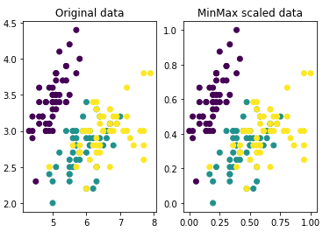

1. **Euclidean distance**

from math import sqrt

def euclidean_distance(row1, row2):

  distance = 0.0

  for i in range(len(row1)-1):

    distance += (row1[i] - row2[i])**2

  return sqrt(distance)

dataset = [[2.7810836,2.550537003,0],

  [1.465489372,2.362125076,0],

  [3.396561688,4.400293529,0],

  [1.38807019,1.850220317,0],

  [3.06407232,3.005305973,0],

  [7.627531214,2.759262235,1],

  [5.332441248,2.088626775,1],

  [6.922596716,1.77106367,1],

  [8.675418651,-0.242068655,1],

  [7.673756466,3.508563011,1]]

row0 = dataset[0]

for row in dataset:

  distance = euclidean_distance(row0, row)

  print(distance)

**OUTPUT**

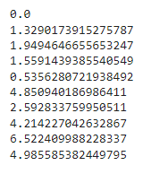

1. **Neighbors**

from math import sqrt

def euclidean_distance(row1, row2):

  distance = 0.0

  for i in range(len(row1)-1):

    distance += (row1[i] - row2[i])**2

  return sqrt(distance)

def get_neighbors(train, test_row, num_neighbors):

  distances = list()

  for train_row in train:

    dist = euclidean_distance(test_row, train_row)

    distances.append((train_row, dist))

  distances.sort(key=lambda tup: tup[1])

  neighbors = list()

  for i in range(num_neighbors):

    neighbors.append(distances[i][0])

  return neighbors

dataset = [[2.7810836,2.550537003,0],

  [1.465489372,2.362125076,0],

  [3.396561688,4.400293529,0],

  [1.38807019,1.850220317,0],

  [3.06407232,3.005305973,0],

  [7.627531214,2.759262235,1],

  [5.332441248,2.088626775,1],

  [6.922596716,1.77106367,1],

  [8.675418651,-0.242068655,1],

  [7.673756466,3.508563011,1]]

neighbors = get_neighbors(dataset, dataset[0], 3)

for neighbor in neighbors:

  print(neighbor)

**OUTPUT**

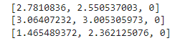

1. **Expected ,got**

from math import sqrt

def euclidean_distance(row1, row2):

  distance = 0.0

  for i in range(len(row1)-1):

    distance += (row1[i] - row2[i])**2

  return sqrt(distance)

def get_neighbors(train, test_row, num_neighbors):

  distances = list()

  for train_row in train:

    dist = euclidean_distance(test_row, train_row)

    distances.append((train_row, dist))

  distances.sort(key=lambda tup: tup[1])

  neighbors = list()

  for i in range(num_neighbors):

    neighbors.append(distances[i][0])

  return neighbors

def predict_classification(train, test_row, num_neighbors):

  neighbors = get_neighbors(train, test_row, num_neighbors)

  output_values = [row[-1] for row in neighbors]

  prediction = max(set(output_values), key=output_values.count)

  return prediction

dataset = [[2.7810836,2.550537003,0],

  [1.465489372,2.362125076,0],

  [3.396561688,4.400293529,0],

  [1.38807019,1.850220317,0],

  [3.06407232,3.005305973,0],

  [7.627531214,2.759262235,1],

  [5.332441248,2.088626775,1],

  [6.922596716,1.77106367,1],

  [8.675418651,-0.242068655,1],

  [7.673756466,3.508563011,1]]

prediction = predict_classification(dataset, dataset[0], 3)

print('Expected %d, Got %d.' % (dataset[0][-1], prediction))

**OUTPUT**



1. **Iris MinMaxScaler**

from sklearn.datasets import load_iris

from sklearn.preprocessing import MinMaxScaler

import numpy as np

X, y = load_iris(return_X_y=True)

print(X.shape)

scaler = MinMaxScaler()

scaler.fit(X)

X_scaled = scaler.transform(X)

X_scaled

**OUTPUT**

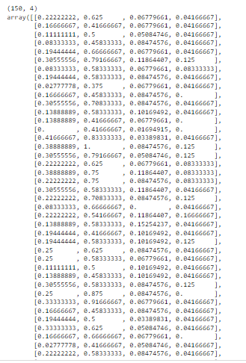



|  |
| --- |
| **Name: MALAVIKA A**  **Roll No: 16**  **Batch: RMCA B**  **Date: 13-10-2022** |

**DATA SCIENCE LAB**

**Experiment No.:**

**Aim**

Decision Tree

**Procedure**

import matplotlib.pyplot as plt

from sklearn.tree import DecisionTreeClassifier

from sklearn.model_selection import train_test_split

from sklearn.metrics import accuracy_score

import pandas as pd

import numpy as np

from sklearn import tree

from sklearn.datasets import load_iris

data = load_iris()

df = pd.DataFrame(data.data, columns=data.feature_names)

df['target'] = data.target

X_train, X_test, Y_train, Y_test = train_test_split(df[data.feature_names], df['target'], random_state=0)

clf = DecisionTreeClassifier(max_depth=2,

                             random_state=0)

clf.fit(X_train, Y_train)

fn = ['sepal length (cm)', 'sepal width (cm)', 'petal length (cm)', 'petal width (cm)']

cn = ['setosa', 'versicolor', 'virginica']

tree.plot_tree(clf,

               feature_names=fn,

               class_names=cn,

               filled=True

               )

y_pred = clf.predict(X_test)

print("Train data accuracy:",accuracy_score(y_true = Y_train, y_pred=clf.predict(X_train)))

print("Test data accuracy:",accuracy_score(y_true = Y_test, y_pred=y_pred))

plt.show()

**Output**

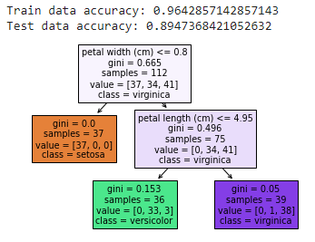



|  |
| --- |
| **Name: MALAVIKA A**  **Roll No: 16**  **Batch: RMCA B**  **Date: 13-10-2022** |

**DATA SCIENCE LAB**

**Experiment No.:**

**Aim**

Decisi

**Procedure**

import matplotlib.pyplot as plt

from sklearn.datasets import load_iris

from sklearn.datasets import load_breast_cancer

from sklearn.tree import DecisionTreeClassifier

from sklearn.ensemble import RandomForestClassifier

from sklearn.model_selection import train_test_split

import pandas as pd

import numpy as np

from sklearn import tree

import pandas as pd

from sklearn.datasets import load_iris

data = load_iris()

df = pd.DataFrame(data.data, columns=data.feature_names)

df['target'] = data.target

X_train, X_test, Y_train, Y_test = train_test_split(df[data.feature_names], df['target'], random_state=0)

clf = DecisionTreeClassifier(max_depth = 2,

                             random_state = 0)

clf.fit(X_train, Y_train)

clf.predict(X_test)

tree.plot_tree(clf);

fn=['sepal length (cm)','sepal width (cm)','petal length (cm)','petal width (cm)']

cn=['setosa', 'versicolor', 'virginica']

fig, axes = plt.subplots(nrows = 1,ncols = 1,figsize = (2,2), dpi= 300)

tree.plot_tree(clf,

               feature_names = fn,

               class_names=cn,

               filled = True);

fig.savefig('imagename.png')

**Output**

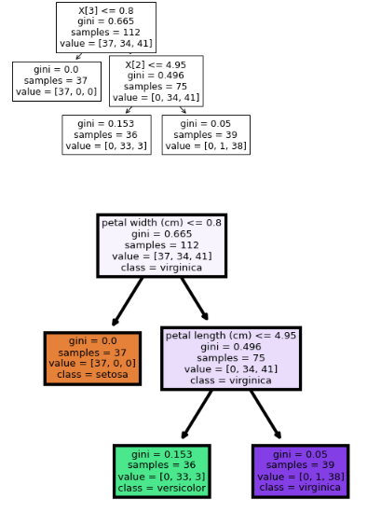



|  |
| --- |
| **Name: MALAVIKA A**  **Roll No: 16**  **Batch: RMCA B**  **Date: 17-10-2022** |

**DATA SCIENCE LAB**

**Experiment No.:**

**Aim**

Golf-dataset

**Procedure**

import pandas as pd

import io

from sklearn.model_selection import train_test_split

df1 = pd.read_csv('/content/golf-dataset.csv')

print(df1)

**Output**

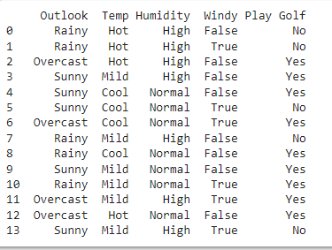

import pandas as pd

import io

from sklearn.model_selection import train_test_split

df1 = pd.read_csv('/content/golf-dataset.csv')

df1.head(10)

**Output**

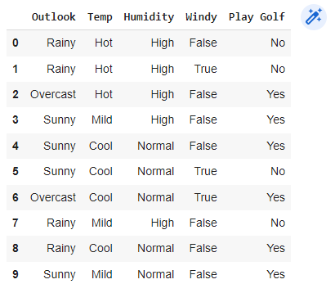

import pandas as pd

import io

from sklearn.model_selection import train_test_split

df1 = pd.read_csv('/content/golf-dataset.csv')

X = df1.iloc[:, [0,1,2, 3]].values

y = df1.iloc[:, -1].values

print(X)

print(y)

**Output**

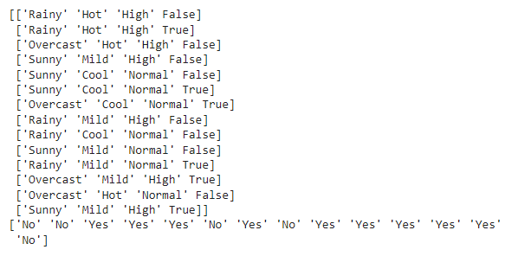

import io

from sklearn.model_selection import train_test_split

df1 = pd.read_csv('/content/golf-dataset.csv')

X_train, X_test, y_train, y_test = train_test_split( X, y, test_size = 0.2, random_state=42)

print(X_test)

**Output**

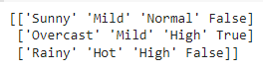

import io

from sklearn.model_selection import train_test_split

df1 = pd.read_csv('/content/golf-dataset.csv')

df1['Outlook'].replace(['Rainy'],[0], inplace=True)

df1['Outlook'].replace(['Overcast'],[1], inplace=True)

print(df1)

**Output**

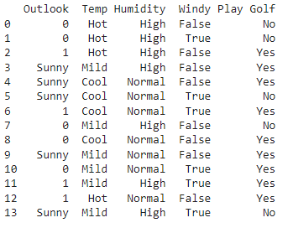

import pandas as pd

import numpy as np

from sklearn import preprocessing

data= pd.read_csv('golf-dataset.csv')

label_encoder = preprocessing.LabelEncoder()

data['Outlook']= label_encoder.fit_transform(data['Outlook'])

data['Temp']= label_encoder.fit_transform(data['Temp'])

data['Humidity']= label_encoder.fit_transform(data['Humidity'])

data['Windy']= label_encoder.fit_transform(data['Windy'])

data['Play Golf']= label_encoder.fit_transform(data['Play Golf'])

data

**Output**

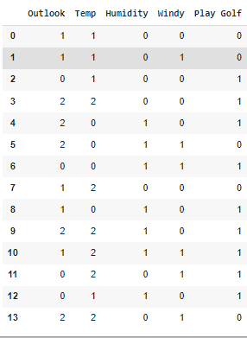

X=data.drop('Play Golf', axis=1)

Y=data['Play Golf']

Y

**Output**

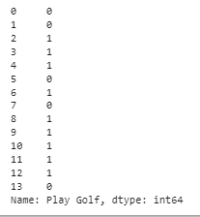

from sklearn.model_selection import train_test_split

X_train, X_test, y_train, y_test = train_test_split(X, Y, test_size=0.1, random_state=42)

from sklearn.naive_bayes import GaussianNB

gnb = GaussianNB()

gnb.fit(X_train, y_train)

y_pred = gnb.predict(X_test)

from sklearn import metrics

print("Gaussian Naive Bayes model accuracy(in %):", metrics.accuracy_score(y_test, y_pred)*100)

**Output**



from sklearn import metrics

confusion_matrix = metrics.confusion_matrix(Y, Y)

confusion_matrix

**Output**



**Output**

**Output**

**Output**

**Output**



|  |
| --- |
| **Name: MALAVIKA A**  **Roll No: 16**  **Batch: RMCA B**  **Date: 27-10-2022** |

**DATA SCIENCE LAB**

**Experiment No.:**

**Aim**

Linear Regression Implementation

**Procedure**

import matplotlib.pyplot as plt

import numpy as np

from sklearn import datasets, linear_model, metrics

boston = datasets.load_boston(return_X_y=False)

X = boston.data

y = boston.target

from sklearn.model_selection import train_test_split

X_train, X_test, y_train, y_test = train_test_split(X, y, test_size=0.4,

                          random_state=1)

reg = linear_model.LinearRegression()

reg.fit(X_train, y_train)

print('Coefficients: ', reg.coef_)

print('Variance score: {}'.format(reg.score(X_test, y_test)))

plt.style.use('fivethirtyeight')

plt.scatter(reg.predict(X_train), reg.predict(X_train) - y_train,

      color = "green", s = 10, label = 'Train data')

plt.scatter(reg.predict(X_test), reg.predict(X_test) - y_test,

      color = "blue", s = 10, label = 'Test data')

plt.hlines(y = 0, xmin = 0, xmax = 50, linewidth = 2)

plt.legend(loc = 'upper right')

plt.title("Residual errors")

plt.show()

**Output**

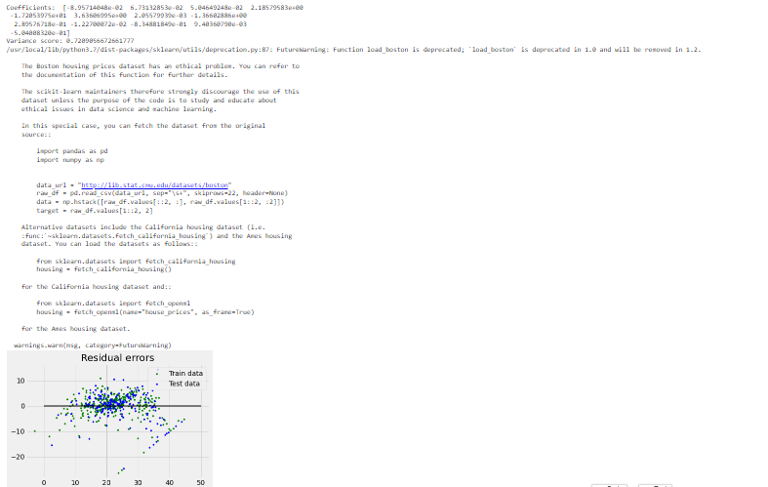



|  |
| --- |
| **Name: MALAVIKA A**  **Roll No: 16**  **Batch: RMCA B**  **Date: 13-10-2022** |

**DATA SCIENCE LAB**

**Experiment No.:**

**Aim**

**Procedure**

**Output**