AIM: Define a class ‘product’ with data members pcode, pname and price. Create 3 objects of the class and find the product having the lowest price.

PROCEDURE:

class Product{

String pcode,pname;

double price;

void details(){

System.out.println("PRODUCT DETAILS:");

System.out.println("PCode:"+pcode);

System.out.println("PName:"+pname);

System.out.println("Price:"+price);

}

}

public class ProductDetails{

public static void main(String args[]){

Product p1=new Product();

p1.pcode="PD22";

p1.pname="SENSOR";

p1.price=25000;

System.out.println("/nProduct 1:");

p1.details();

Product p2=new Product();

p2.pcode="PD33";

p2.pname="TELEVISION";

p2.price=50000;

System.out.println("\nProduct 2:");

p2.details();

Product p3=new Product();

p2.pcode="PD55";

p2.pname="KEYBOARD";

p2.price=2500;

System.out.println("\nProduct 3:");

p3.details();

if(p1.price<p2.price && p1.price<p3.price){

System.out.println("\nProduct with lowest price is:");

p1.details();

}

else if(p2.price<p3.price){

System.out.println("\nProduct with lowest price is:");

p2.details();

}

else{

System.out.println("\nProduct with lowest price is:\n");

p3.details();

}

}

}

OUTPUT

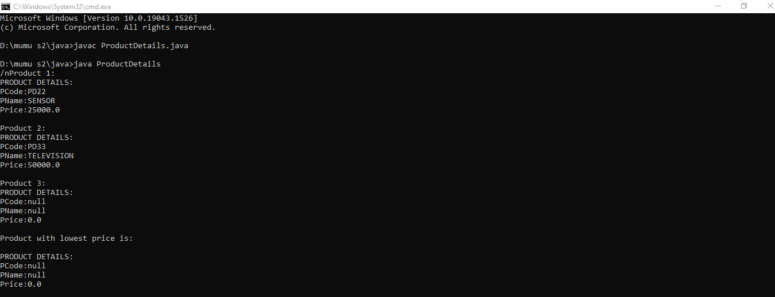

AIM: Define a class ‘Student’ with data members studentid, studentname and marks of 3 subjects . Create 3 objects of the class and find the total mark and average of 3 students.

PROCEDURE:

class Student{

int studentid, mark1, mark2, mark3,total,avg;

String studentname;

Student(){

studentid=102;

studentname="mal";

mark1=67;

mark2=68;

mark3=69;

}

Student(int rollno, String name, int m1, int m2, int m3){

studentid=rollno;

studentname=name;

mark1=m1;

mark2=m2;

mark3=m3;

}

Student( int mk1, int mk2, int mk3){

studentid=111;

studentname="Jimin";

mark1=mk1;

mark2=mk2;

mark3=mk3;

}

void display(){

int total,avg;

System.out.println("Student ID::"+studentid);

System.out.println("Student Name::"+studentname);

System.out.println("Mark1::"+mark1);

System.out.println("Mark2::"+mark2);

System.out.println("Mark3::"+mark3);

total=mark1+mark2+mark3;

avg=total/3;

}

}

public class StudentDetails{

public static void main(String args[]){

System.out.println("---Student 1---");

Student s1=new Student();

s1.display();

System.out.println("---Student 2---");

Student s2=new Student(2,"harry",99,98,97);

s2.display();

System.out.println("---Student 3---");

Student s3=new Student(89,88,87);

s3.display();

}

}

OUTPUT

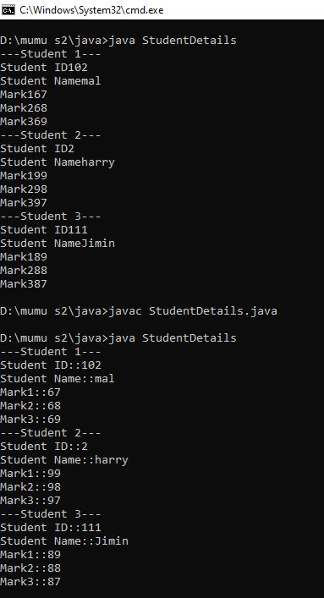

AIM: Create a class ‘vehicle’ with any data members and initialize with array of objects.

PROCEDURE:

class Vehicle{

int vno;

String vmodel;

String vowner;

int vweight;

Vehicle(){}

Vehicle(int regno, String mo, String ow, int vw){

vno=regno;

vmodel=mo;

vowner=ow;

vweight=vw;

}

void display(){

System.out.println("Vehicle Number::"+vno);

System.out.println("Vehicle Model::"+vmodel);

System.out.println("vehicle Owner::"+vowner);

System.out.println("Vehicle weight::"+vweight);

}

}

public class VehicleDetails{

public static void main(String args[]){

Vehicle[] v=new Vehicle[3];

v[0]=new Vehicle(12345,"Swift","Ramesh",567);

v[1]=new Vehicle(12345,"I10","suresh",588);

v[2]=new Vehicle(12345,"Toyota","kali",678);

System.out.println("---Vehicle 1---");

v[0].display();

System.out.println("---Vehicle 2---");

v[1].display();

System.out.println("---Vehicle 3---");

v[2].display();

}

}

OUTPUT

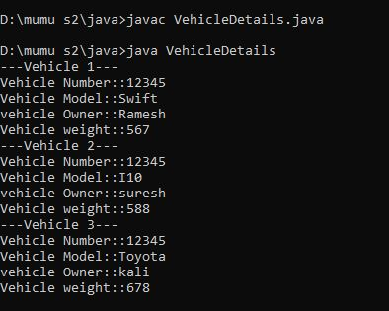

AIM:To demonstrate the use of scanner class.

PROCEDURE:

import java.util.Scanner;

public class FileText{

public static void main(String args[]){

String name;

System.out.println("enter your name::");

Scanner n=new Scanner(System.in);

name=n.nextLine();

System.out.println(name);

}

}

OUTPUT

