AIM: To read 2 matrices from the console and perform matrix addition.

PROCEDURE:

import java.util.Scanner;

public class MatrixAddition

{

public static void main(String[] args)

{

int p, q, m, n;

Scanner sc = new Scanner(System.in);

System.out.print("Enter the number of rows in the first matrix:");

p = sc.nextInt();

System.out.print("Enter the number of columns in the first matrix:");

q = sc.nextInt();

System.out.print("Enter the number of rows in the second matrix:");

m = sc.nextInt();

System.out.print("Enter the number of columns in the second matrix:");

n = sc.nextInt();

if (p == m && q == n)

{

int a[][] = new int[p][q];

int b[][] = new int[m][n];

int c[][] = new int[m][n];

System.out.println("Enter all the elements of first matrix:");

for (int i = 0; i < p; i++)

{

for (int j = 0; j < q; j++)

{

a[i][j] = sc.nextInt();

}

}

System.out.println("");

System.out.println("Enter all the elements of second matrix:");

for (int i = 0; i < m; i++)

{

for (int j = 0; j < n; j++)

{

b[i][j] = sc.nextInt();

}

}

System.out.println("");

System.out.println("First Matrix:");

for (int i = 0; i < p; i++)

{

for (int j = 0; j < q; j++)

{

System.out.print(a[i][j]+" ");

}

System.out.println("");

}

System.out.println("Second Matrix:");

for (int i = 0; i < m; i++)

{

for (int j = 0; j < n; j++)

{

System.out.print(b[i][j]+" ");

}

System.out.println("");

}

for (int i = 0; i < p; i++)

{

for (int j = 0; j < n; j++)

{

for (int k = 0; k < q; k++)

{

c[i][j] = a[i][j] + b[i][j];

}

}

}

System.out.println("Matrix after addition:");

for (int i = 0; i < p; i++)

{

for (int j = 0; j < n; j++)

{

System.out.print(c[i][j]+" ");

}

System.out.println("");

}

}

else

{

System.out.println("Addition not possible");

System.out.println("Try Again");

}

}

}

OUTPUT

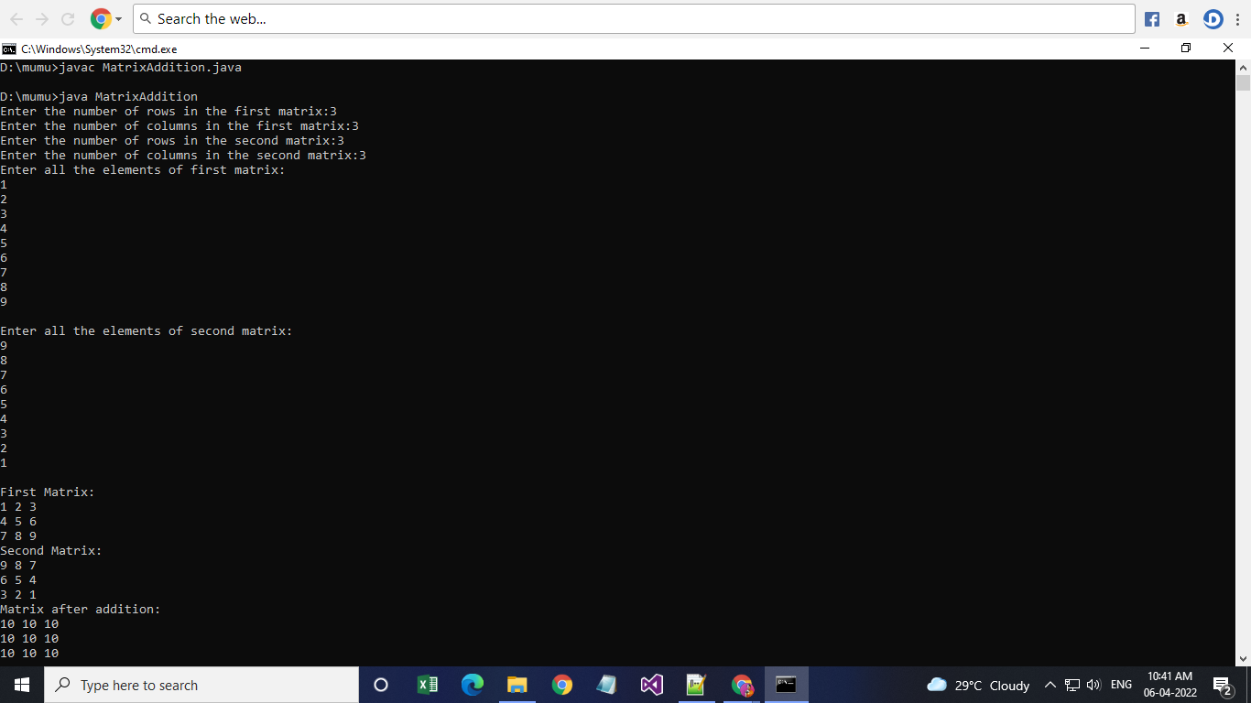

AIM: To add complex numbers

PROCEDURE:

class Complex {

double real, img;

Complex(int r, int i) {

real = r;

img = i;

}

Complex addComp(Complex C1, Complex C2) {

Complex sum = new Complex(0, 0);

sum.real = C1.real + C2.real;

sum.img = C1.img + C2.img;

return sum;

}

}

class ComplexMain {

public static void main(String[] args) {

Complex C1 = new Complex(2, 3);

Complex C2 = new Complex(5, 6);

Complex C3 = new Complex(0, 0);

System.out.println("Complex number 1 : " + C1.real + " + " + C1.img + "i");

System.out.println("Complex number 2 : " + C2.real + " + " + C2.img + "i");

C3 = C3.addComp(C1, C2);

System.out.println("Sum of complex numbers : " + C3.real + " + " + C3.img + "i");

}

}

OUTPUT

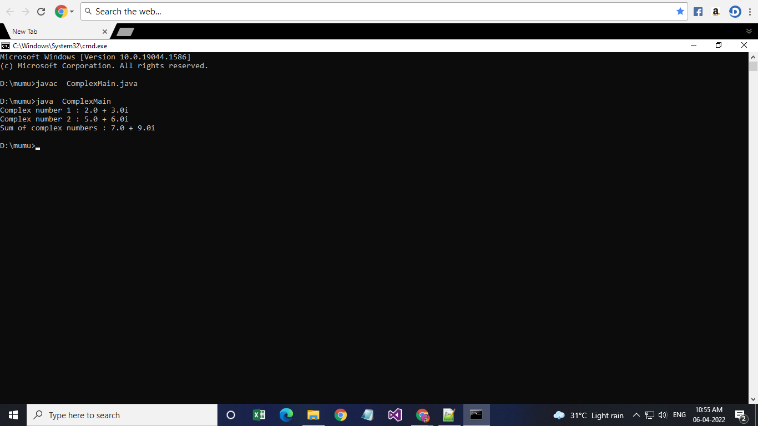

AIM: To read a matrix from the console and check whether it is symmetric or not.

PROCEDURE:

import java.util.\*;

public class Matsy {

public static void main(String[] args) {

Scanner s=new Scanner(System.in);

int r,c;

System.out.println("enter no of rows and columns");

r=s.nextInt();

c=s.nextInt();

int a[][]=new int[r][c];

int b[][]=new int[r][c];

System.out.println("enter the matrix elements");

for(int i=0;i<r;i++) {

for(int j=0;j<c;j++)

{

a[i][j]=s.nextInt();

}

}

if(r==c) {

for(int i=0;i<r;i++)

{

for(int j=0;j<c;j++) {

b[i][j]=a[j][i];

}

}

}

int x=0;

for(int i=0;i<r;i++)

for(int j=0;j<c;j++)

if(a[i][j]==b[i][j])

x=1;

if(x==1)

System.out.println("yes");

else

System.out.println("No");

}

}

OUTPUT

