UML DIAGRAMS

CLASS DIAGRAM

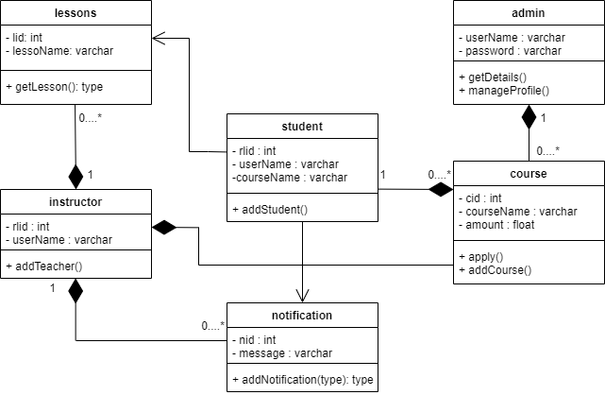

OBJECT DIAGRAM

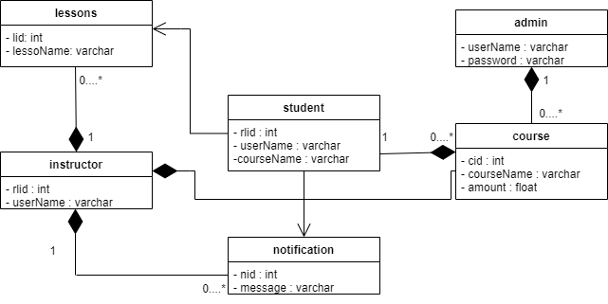

USE CASE DIAGRAM

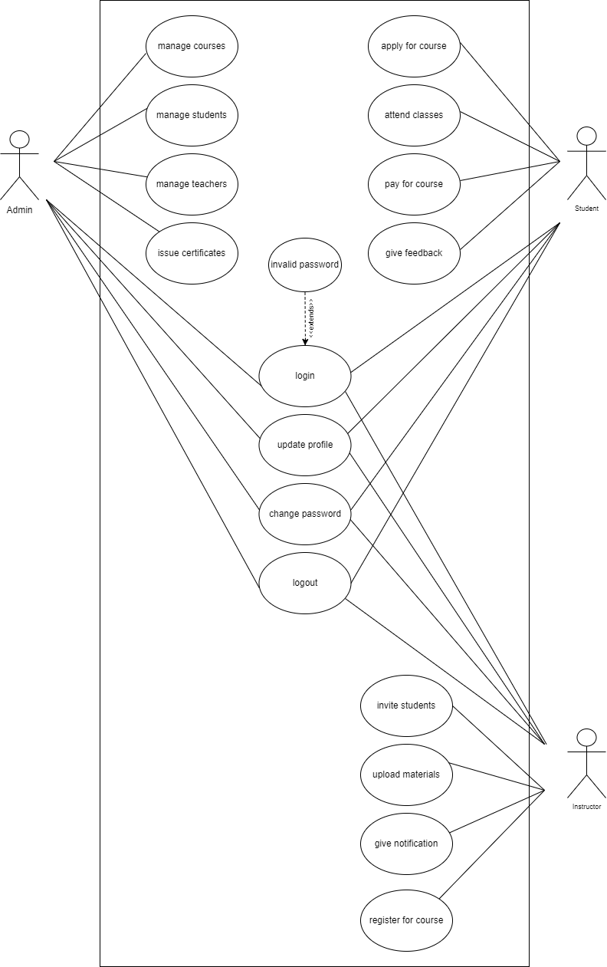

SEQUENCE DIAGRAM

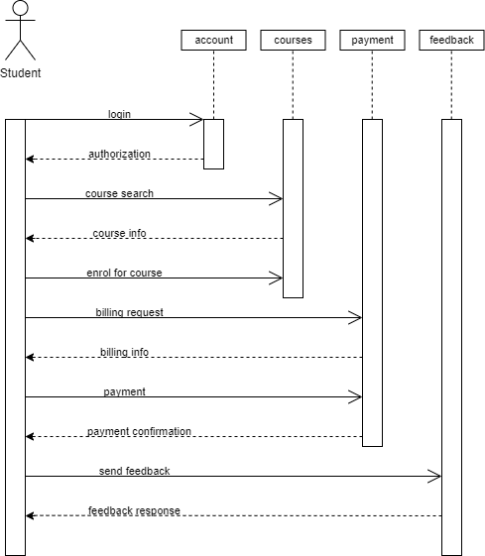

ACTIVITY DIAGRAM

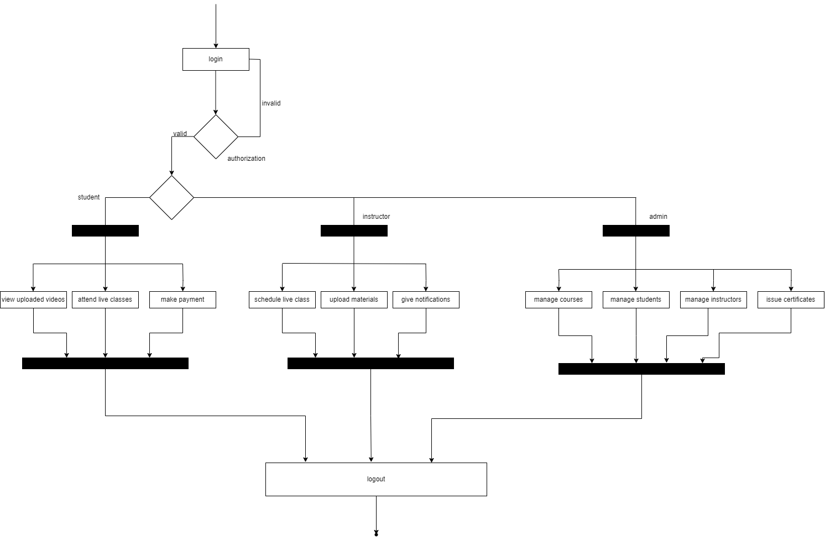

STATE CHART DIAGRAM

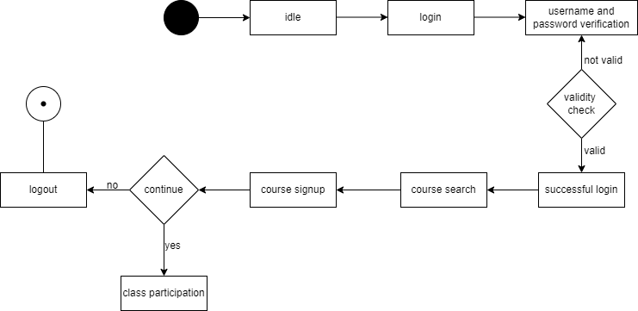

DEPLOYMENT DIAGRAM

