**Name: Malavika A**

**Roll No: 16**

**Batch: RMCA B**

**Date: 24/03/2022**

**NETWORKING & SYSTEM ADMINISTRATION LAB**

**Experiment No.: 3**

**Aim**

Familiarization of the linux commands.

**Procedure**

1. pwd

The [pwd](https://www.javatpoint.com/linux-pwd) command is used to display the location of the current working directory.

Syntax:

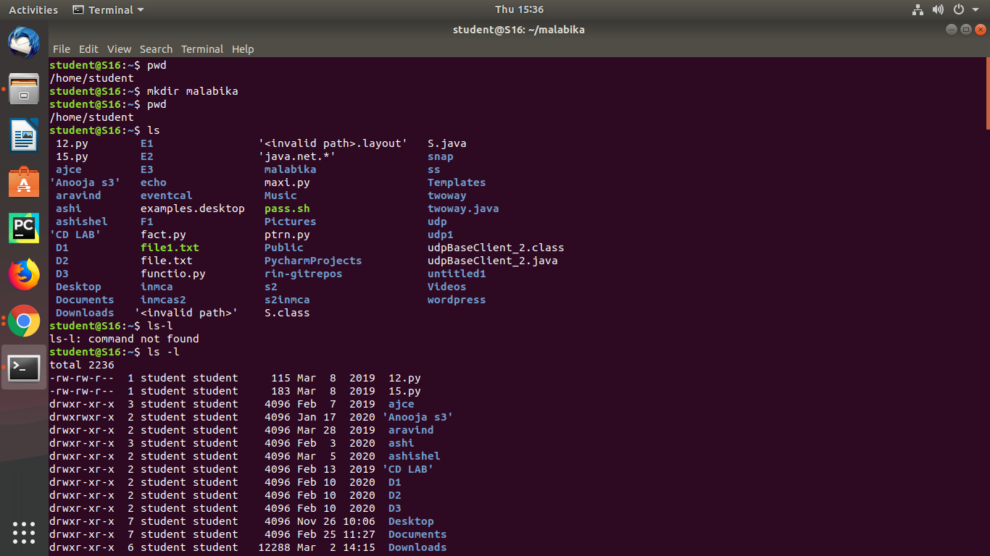

Output:



1. mkdir

The [mkdir](https://www.javatpoint.com/linux-mkdir) command is used to create a new directory under any directory.

 Syntax:

Output:



1. ls

The [ls](https://www.javatpoint.com/linux-ls) command is used to display a list of content of a directory.

Syntax:



Output:



* ls –l

This command is used to shows file or directory, size, modified date and time, file or folder name and owner of the file, and its permission.

Syntax:



Output:



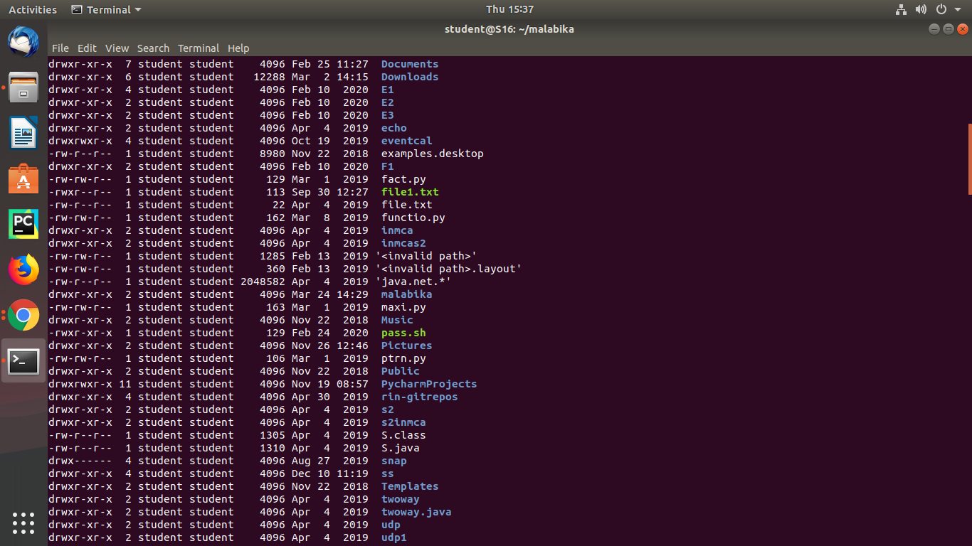

* ls –a

This command is used to list all files including hidden files.

Syntax:

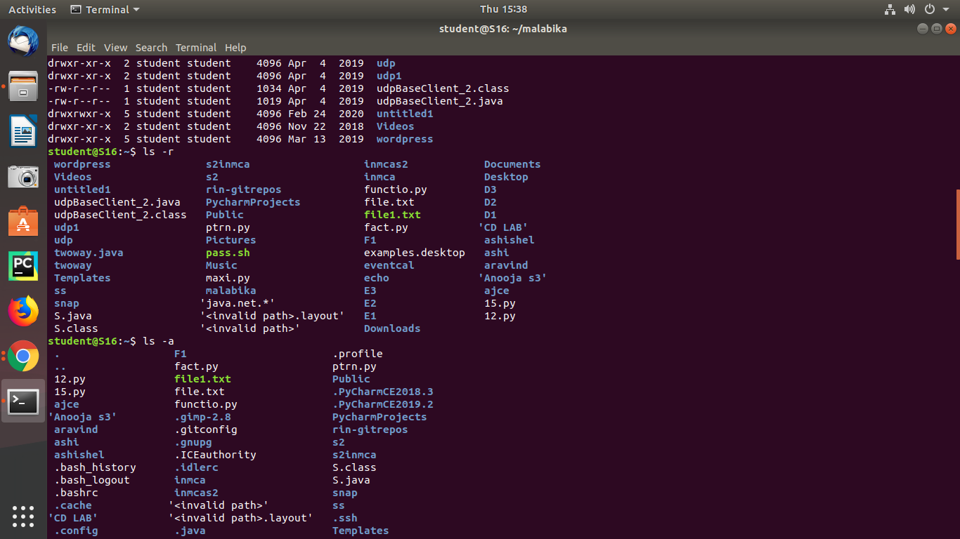

Output:



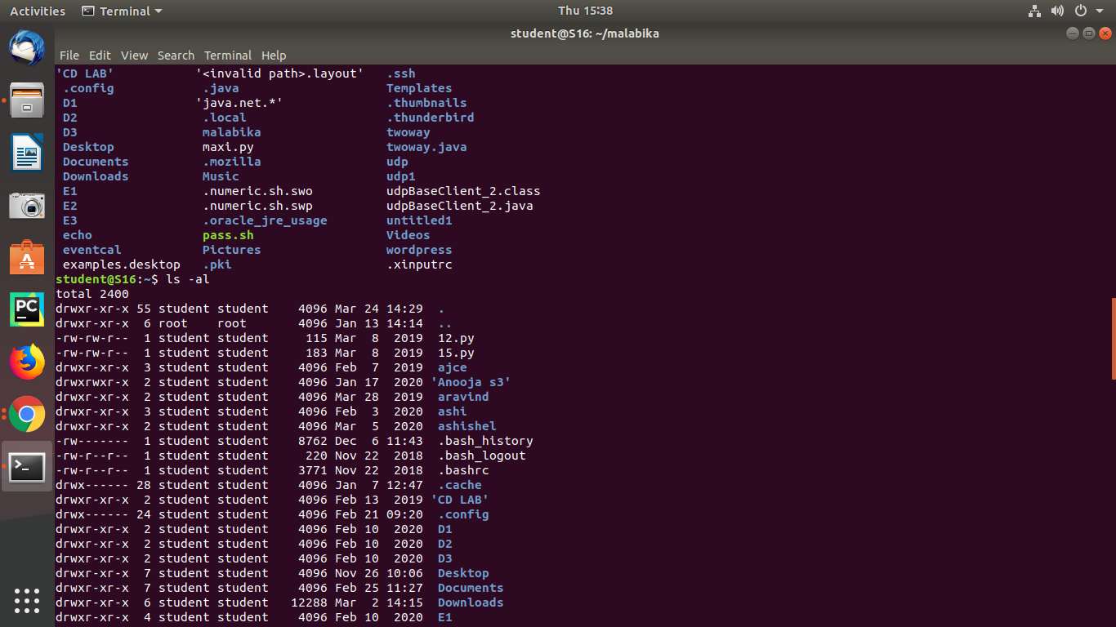

* ls –r

This command is used to display files and directories in reverse order.

Syntax:



Output:



* ls –al

This command is used to give permission.

Syntax:



Output:



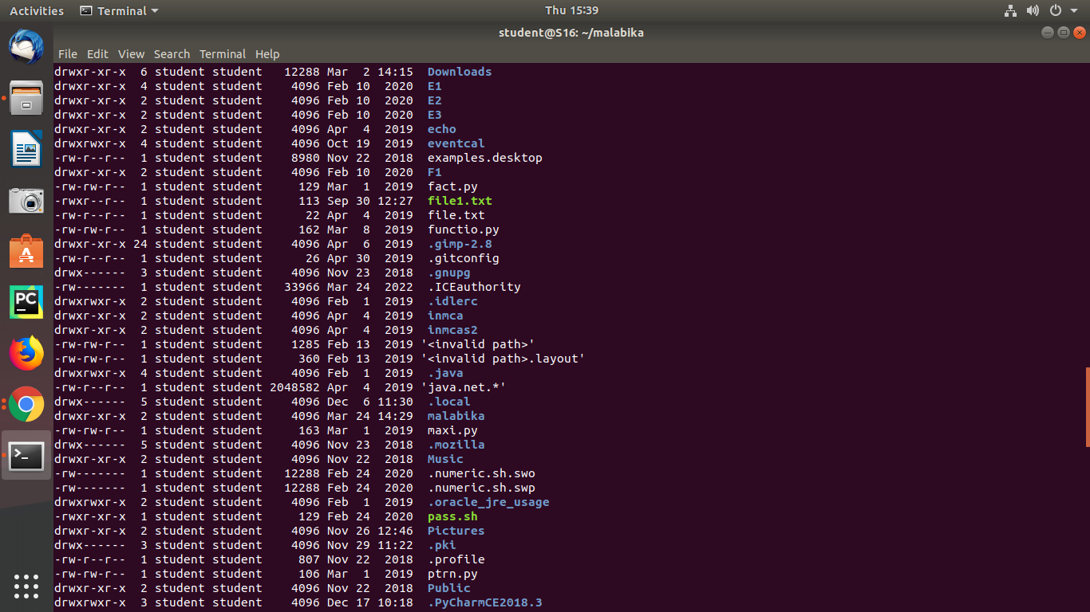

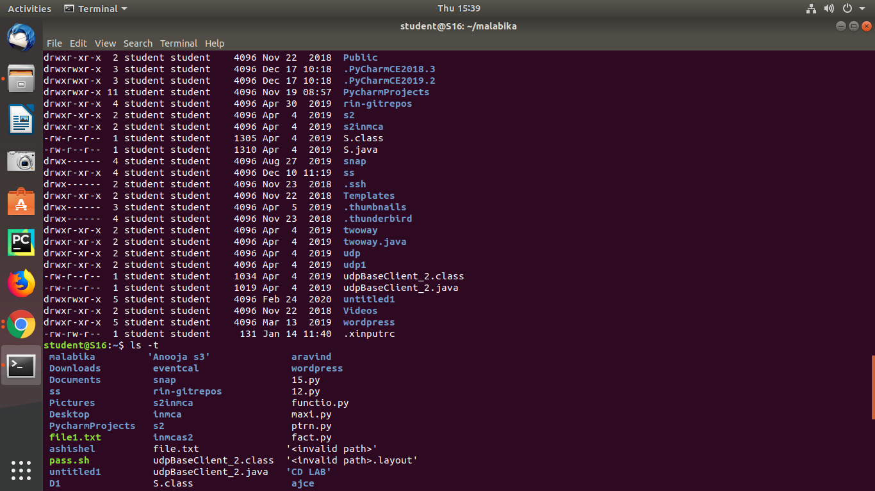

* ls –t

This command is used to display files in the last modified order.

Syntax:



Output:



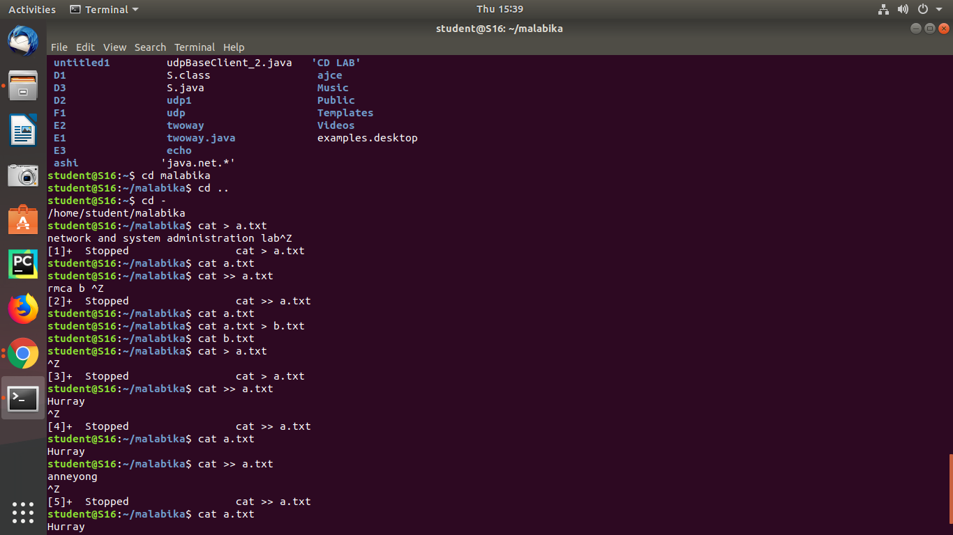

1. cd

The [cd](https://www.javatpoint.com/linux-cd) command is used to change the current directory.

Syntax:



Output:



1. cat

The [cat](https://www.javatpoint.com/linux-cat) command is a multi-purpose utility in the Linux system. It can be used to create a file, display content of the file, copy the content of one file to another file, and more.

Syntax:











Output:

















