**Name: Malavika A**

**Roll No: 16**

**Batch: RMCA B**

**Date:5/05/2022**

**NETWORKING & SYSTEM ADMINISTRATION LAB**

**Experiment No.: 8**

1.Write a shell script to print the basic details.

PROCEDURE

#!/bin/bash

echo "Enter your Name:"

read name

echo "Enter your Address:"

read address

echo "Enter your phone Number:"

read phone

echo "Enter age:"

read age

echo "Enter gender:"

read gender

echo "Enter your Email:"

read email

echo "DETAILS"

echo "__________________"

echo "Name:"$name

echo "Address:"$address

echo "Address:"$phone

echo "Age:"$age

echo "Gender:"$gender

echo "Email:"$email

**OUTPUT**

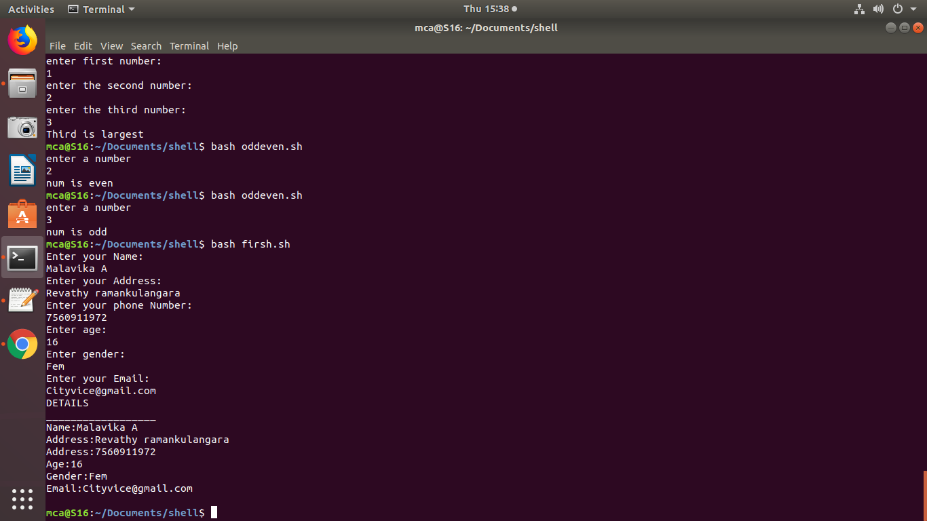

2. Write a shell script to find the sum of two numbers.

PROCEDURE

#!/bin/bash

echo "Enter first number:"

read num1

echo "enter second number:"

read num2

sum=$(($num1+$num2))

echo "sum is "$sum

if [ $sum -ge 0 ]

then

echo "greater than Zero"

else

echo "less than zero"

fi

**OUTPUT**

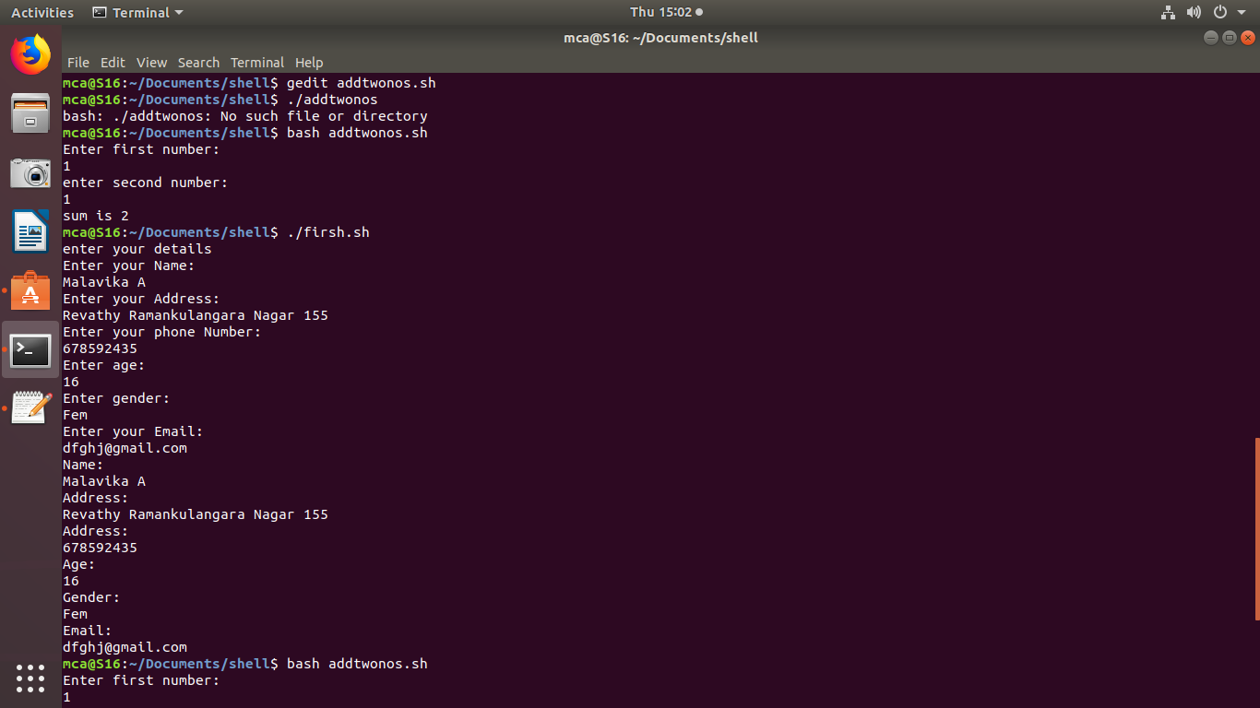

3. Write a shell script to find the largest of two numbers.

PROCEDURE

#!/bin/bash

echo "enter first number:"

read first

echo "enter the second number:"

read second

if [ $first -gt $second ]

then

echo "first is largest"

else

echo "second is largest"

fi

**OUTPUT**

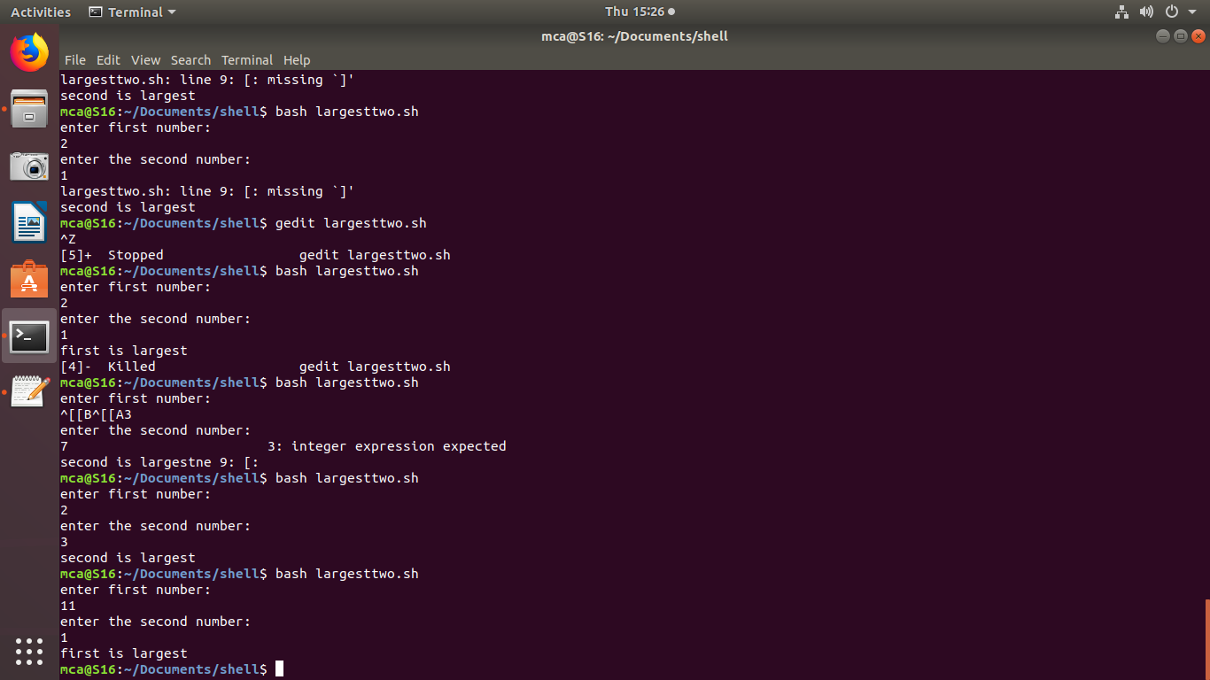

4. Write a shell script to find the largest of three numbers.

PROCEDURE

#!/bin/bash

echo "enter first number:"

read first

echo "enter the second number:"

read second

echo "enter the third number:"

read third

if [ $first -gt $second -a $first -gt $third ]

then

echo "first is largest"

elif [ $second -gt $third ]

then

echo "second is largest"

else

echo "Third is largest"

fi

**OUTPUT**

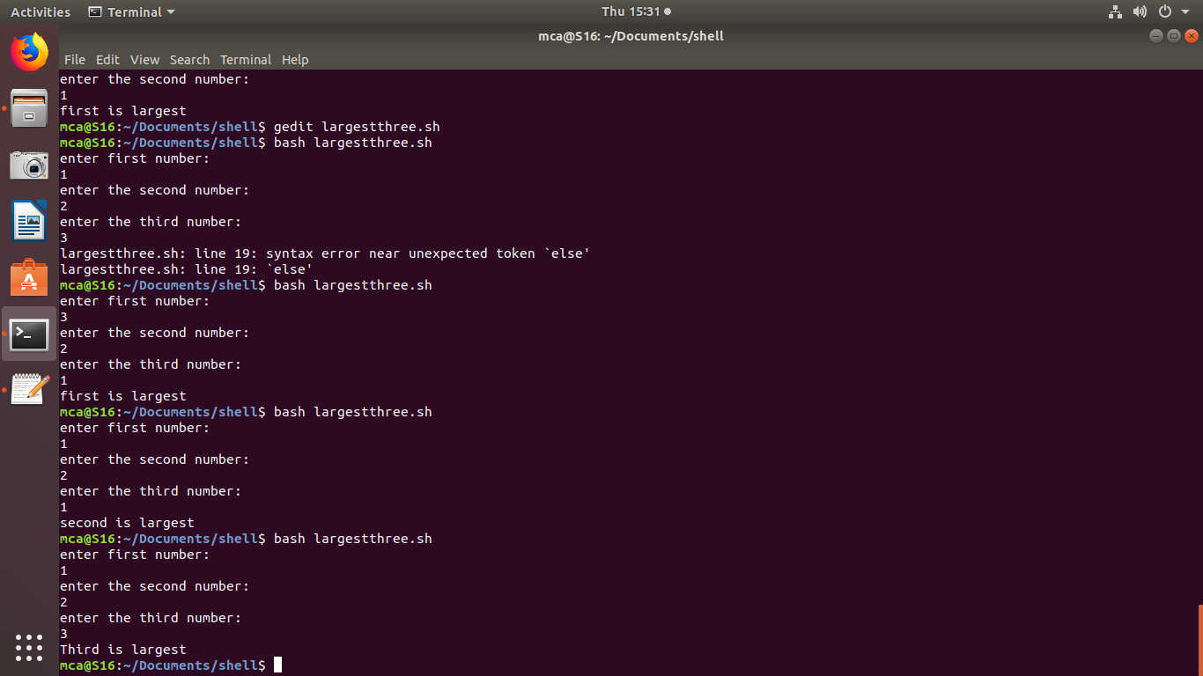

5. Write a shell script to find odd and even numbers.

PROCEDURE

#!/bin/bash

echo "enter a number"

read num

n=$(($num%2))

if [ $n -eq 0 ]

then

echo "num is even"

else

echo "num is odd"

fi

**OUTPUT**

