**Name: Malavika A**

**Roll No: 16**

**Batch: RMCA B**

**Date: 23/05/2022**

**NETWORKING & SYSTEM ADMINISTRATION LAB**

**Experiment No.: 20**

**Aim**

Steps for Installing Docker

**Procedure**

1. **Open the terminal on Ubuntu.**
2. **Remove any Docker files that are running in the system, using the following command:**

**Syntax:**

$ sudo apt-get remove docker docker-engine docker.io

After entering the above command, you will need to enter the password of the root and press enter.

**Output:**

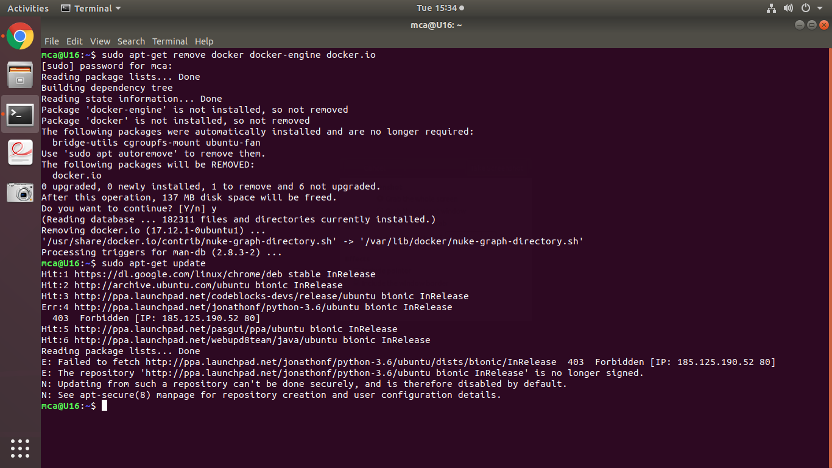

1. **Check if the system is up-to-date using the following command:**

**Syntax:**

$ sudo apt-get update

**Output:**



1. **Install Docker using the following command:**

**Syntax:**

$ sudo apt install docker.io

**Output**

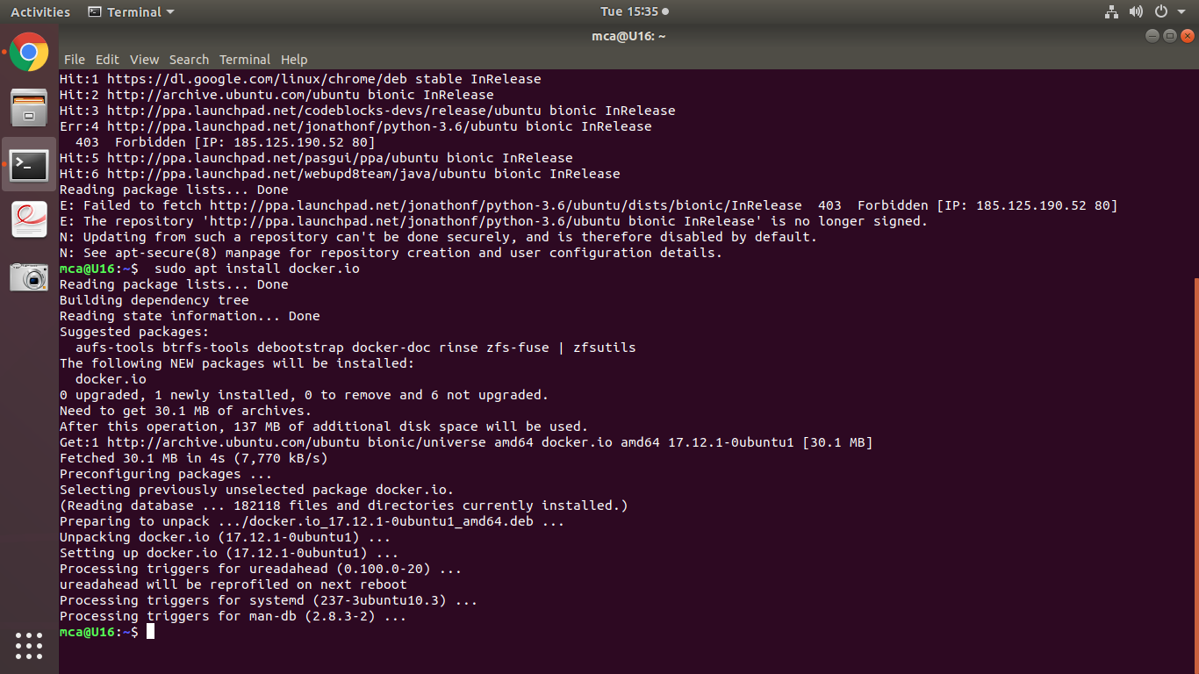

You’ll then get a prompt asking you to choose between y/n - choose y

1. **Install all the dependency packages using the following command:**

**Syntax:**

$ sudo snap install docker

**Output:**

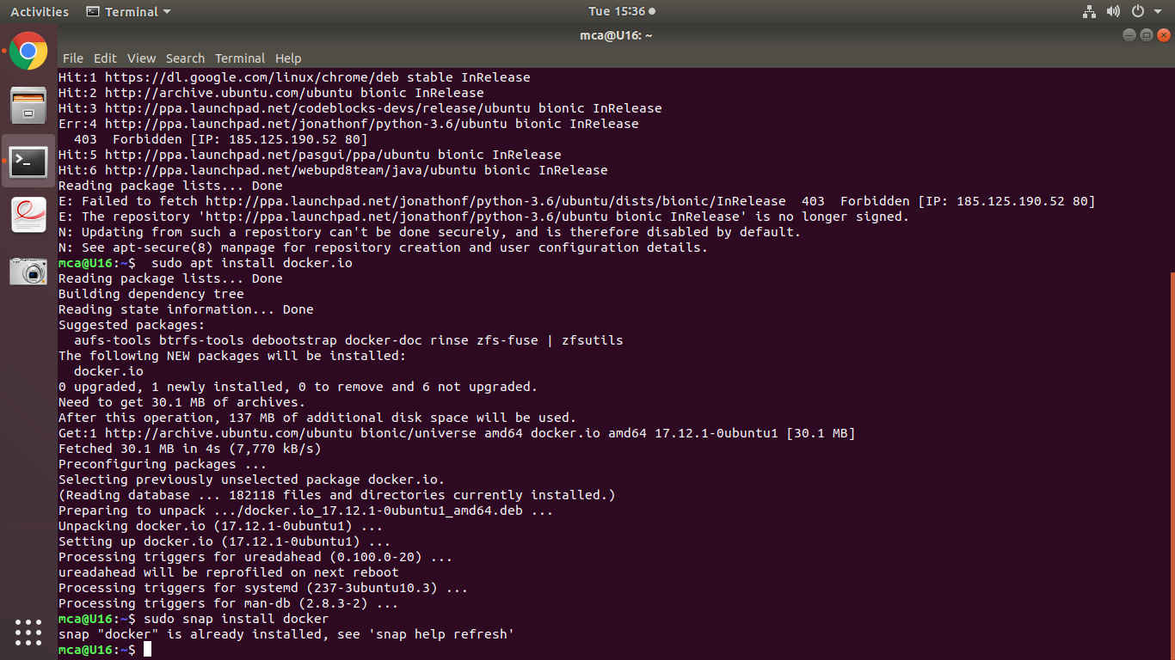

1. **Before testing Docker, check the version installed using the following command:**

**Syntax:**

$ docker –version

**Output:**

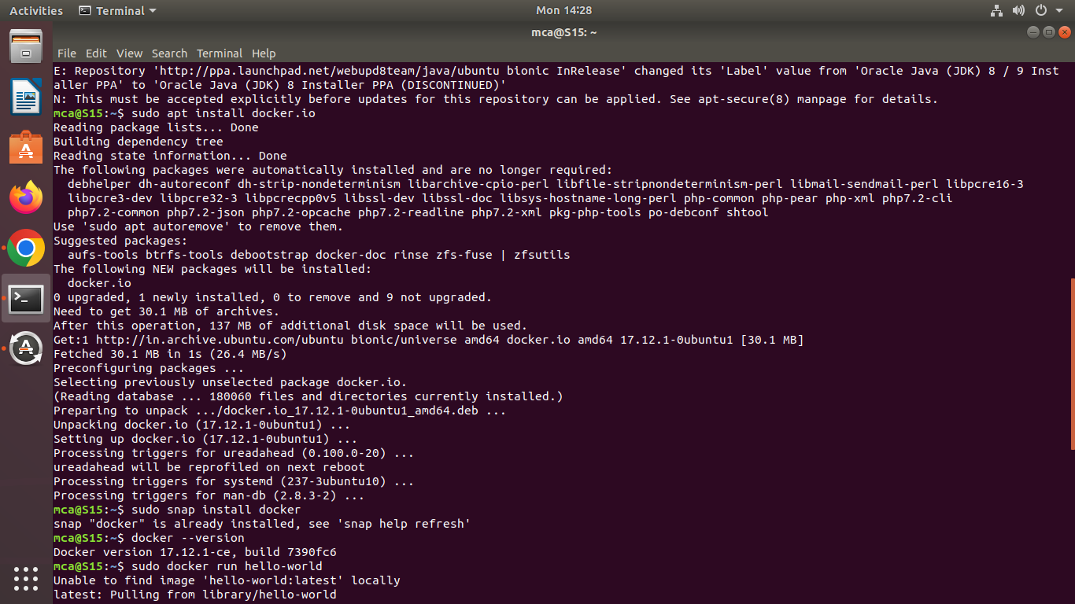

1. **Pull an image from the Docker hub using the following command:**

**Syntax:**

$ sudo docker run hello-world

**Output:**

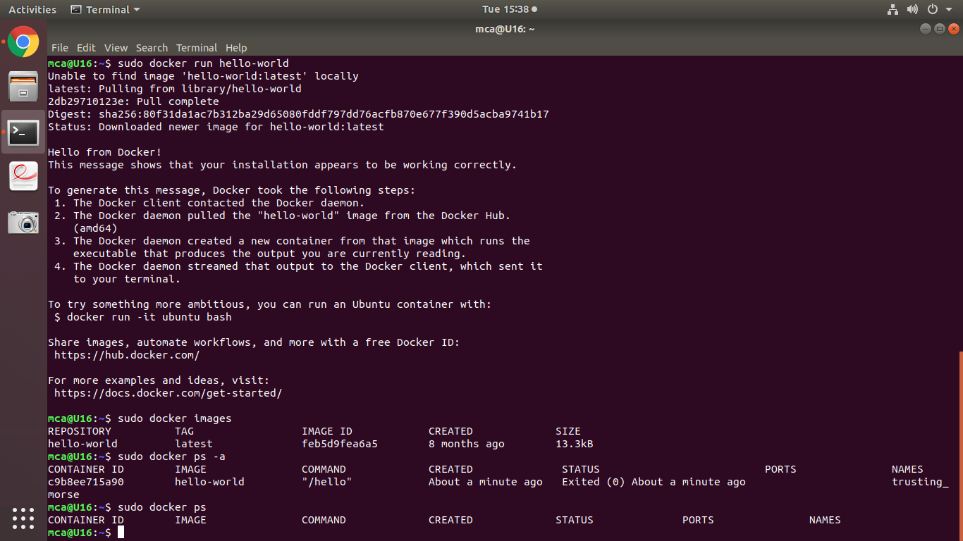

Here, hello-world is the docker image present on the Docker hub.

1. **Check if the docker image has been pulled and is present in your system using the following command:**

**Syntax:**

$ sudo docker images

**Output:**



1. **To display all the containers pulled, use the following command:**

**Syntax:**

$ sudo docker ps –a

**Output:**



1. **To check for containers in a running state, use the following command:**

**Syntax:**

$ sudo docker ps

**Output:**

