**Name: Malavika A**

**Roll No: 16**

**Batch: RMCA B**

**Date:9/05/2022**

**NETWORKING & SYSTEM ADMINISTRATION LAB**

**Experiment No.: 9**

1. Write a shell sript program to print the current date and calendar.

PROCEDURE

#!/bin/bash

today=$(date)

echo "Date:$today"

echo "Calendar"

cal

OUTPUT

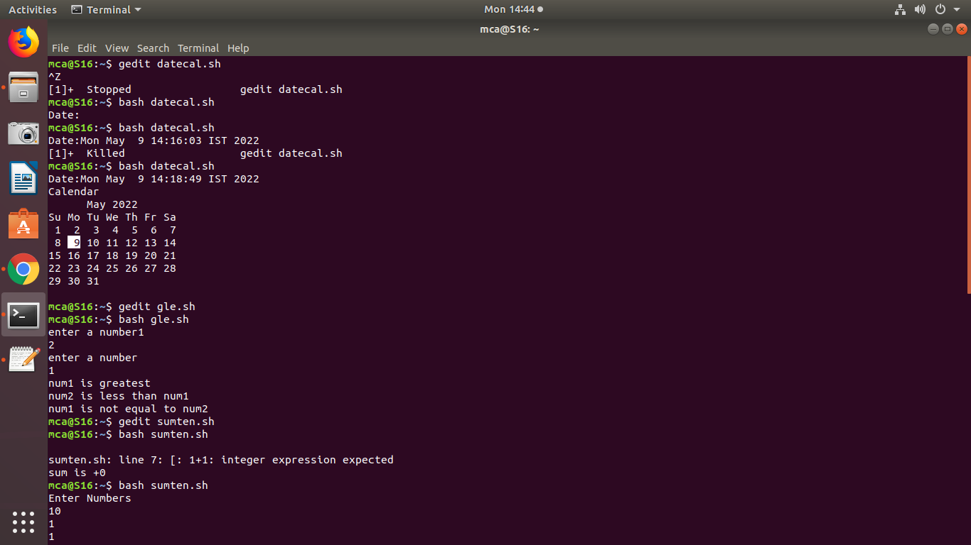

1. Write a shell script to the sum of 10 numbers.

PROCEDURE

#!/bin/bash

sum=0

for((i=1;i<=10;i++))

do

sum=$(($sum + i))

done

echo $sum

OUTPUT

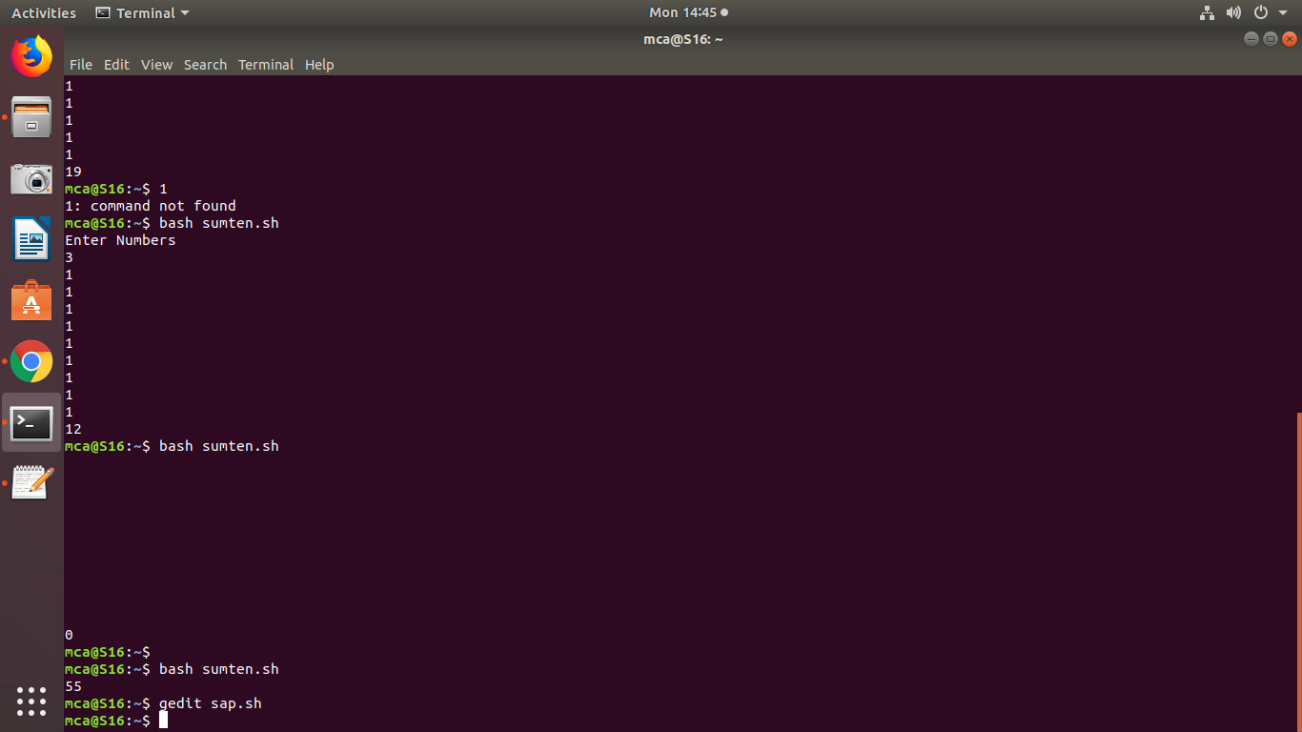

1. Write a shell script to check whether a number is greater tha, less than or equal to the other number.

PROCEDURE

#!/bin/bash

echo "enter a number1"

read num1

echo "enter a number"

read num2

if [ $num1 -gt $num2 ]

then

echo "num1 is greatest"

else

echo "num2 is greatest"

fi

if [ $num1 -lt $num2 ]

then

echo "num1 is less than num2"

else

echo "num2 is less than num1"

fi

if [ $num1 -eq $num2 ]

then

echo "num1 is equal to num2"

else

echo "num1 is not equal to num2"

fi

OUTPUT



1. Write a shell script program to find sum, average and product of 4 numbers.

PROCEDURE

#!/bin/bash

echo "first number:"

read n1

echo "second number:"

read n2

echo "third number:"

read n3

echo "fourth number:"

read n4

sum=$(($n1+$n2+$n3+$n4))

echo "Sum:: $sum"

avg=$(echo $sum / 4 | bc -l)

echo "Average::$avg"

product=$(echo "$n1 * $n2 * $n3 * $n4" | bc -l)

echo "Product::$product"

OUTPUT

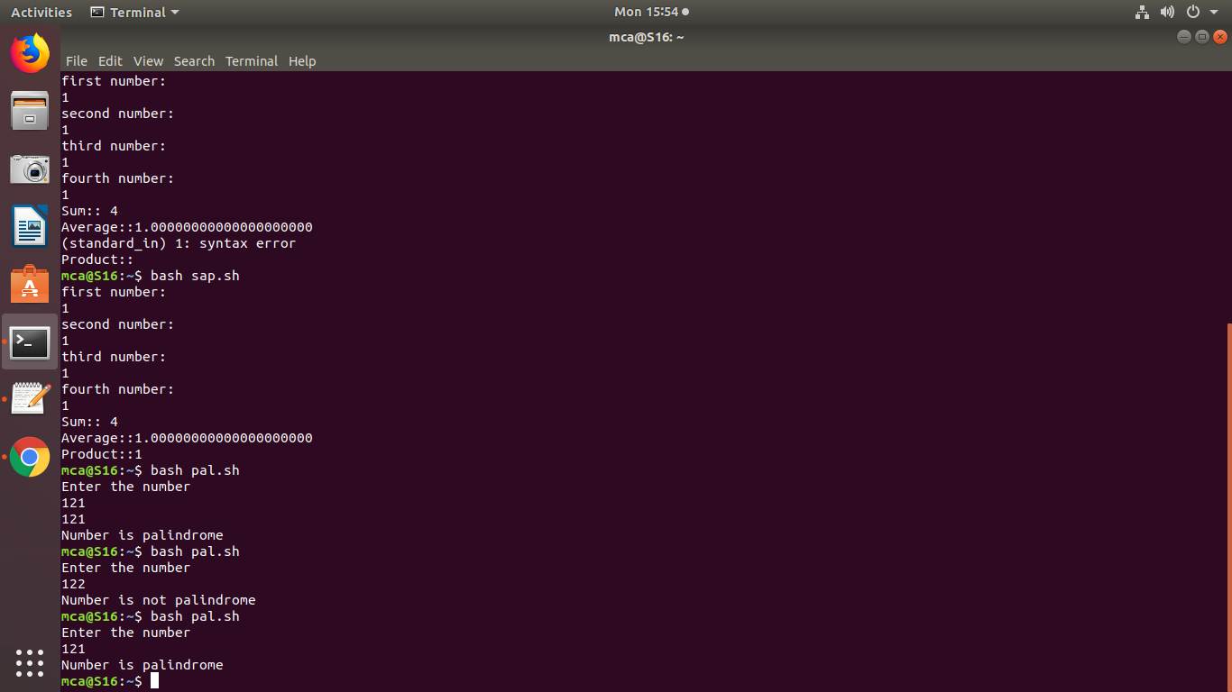

1. Write a shell script program to find factorial of a number.

PROCEDURE

#!/bin/bash

echo "Enter a number"

read num

fact=1

n=$num;

while [ $num -ge 1 ]

do

fact=`expr $fact \* $num`

num=`expr $num - 1`

done

echo "Factorial of $n is $fact"

OUTPUT

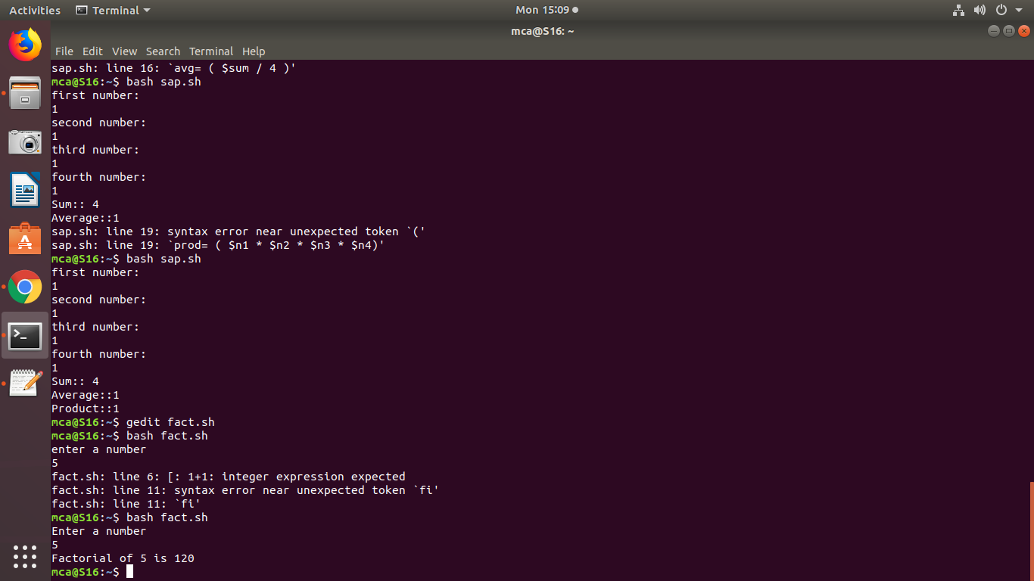

1. Write a shell script program to find leap year.

PROCEDURE

#!/bin/bash

echo "enter the year :"

read y

a=`expr $y % 4`

b=`expr $y % 100`

c=`expr $y % 400`

if [ $a -eq 0 -a $b -ne 0 -o $c -eq 0 ]

then

echo "$y is leap year"

else

echo "$y is not leap year"

fi

OUTPUT

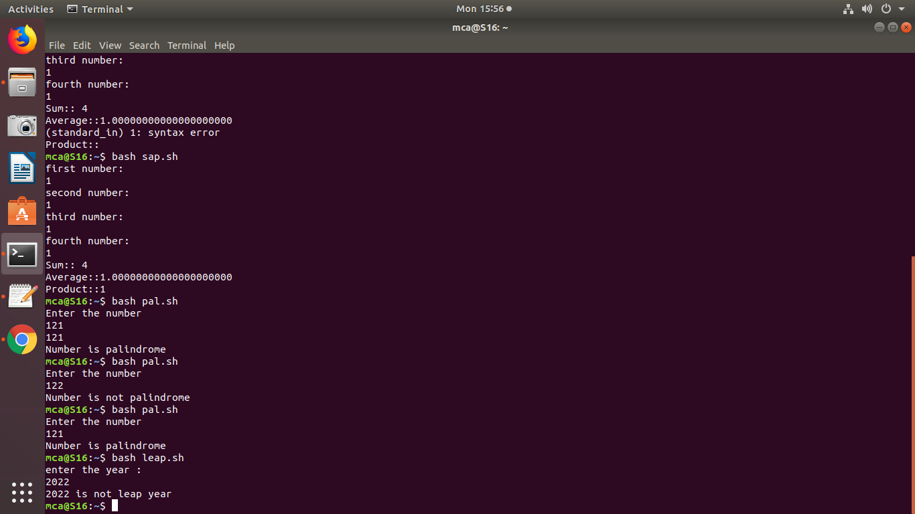

1. Write a shell script to check if a given number is palindrome or not.

PROCEDURE

#!/bin/bash

echo "Enter the number"

read n

number=$n

reverse=0

while [ $n -gt 0 ]

do

a=`expr $n % 10 `

n=`expr $n / 10 `

reverse=`expr $reverse \* 10 + $a`

done

if [ $number -eq $reverse ]

then

echo "Number is palindrome"

else

echo "Number is not palindrome"

fi

OUTPUT

