**Name: Malavika A**

**Roll No: 16**

**Batch: RMCA B**

**Date:26/03/2021**

**NETWORKING & SYSTEM ADMINISTRATION LAB**

**Experiment No.: 3**

**Aim**

Familiarization of Linux commands.

**Procedure**

1. –n

This command is used to displays line numbers in contents.

Syntax:

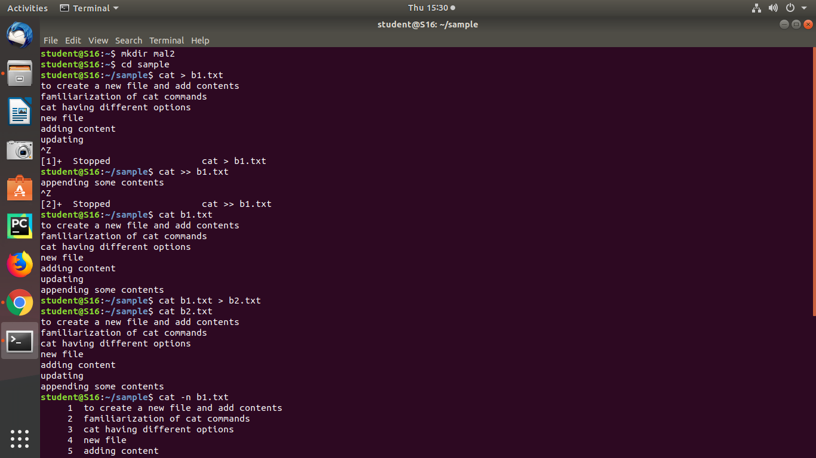

Output:

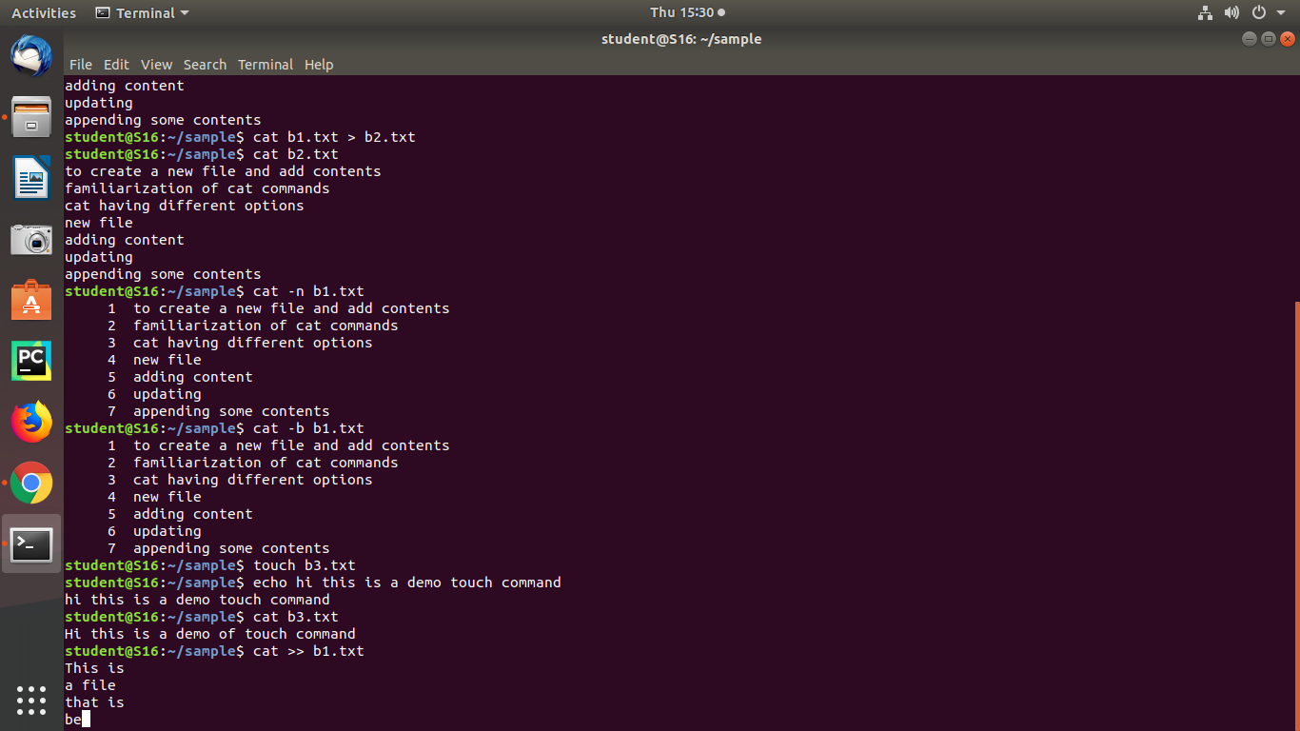



1. –b

This command is used to removes the empty lines.

Syntax:



Output:



1. touch

This command is used to create an empty file.

Syntax:



Output:



1. head, head -4

This head command is used to display the first ten line of contents and head -4 which displays the first four lines of contents.

Syntax:

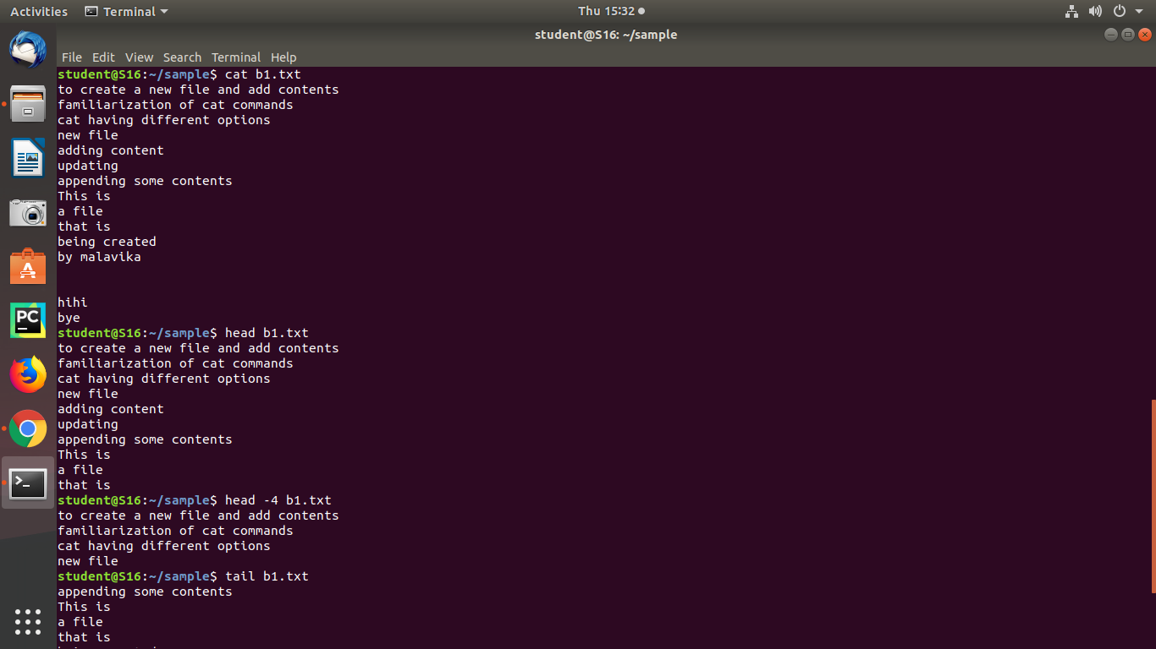



Output:



1. tail, -3

This tail command is used to displays the last ten lines of contents and tail -3 which displays the last 3 lines of contents.

Syntax:

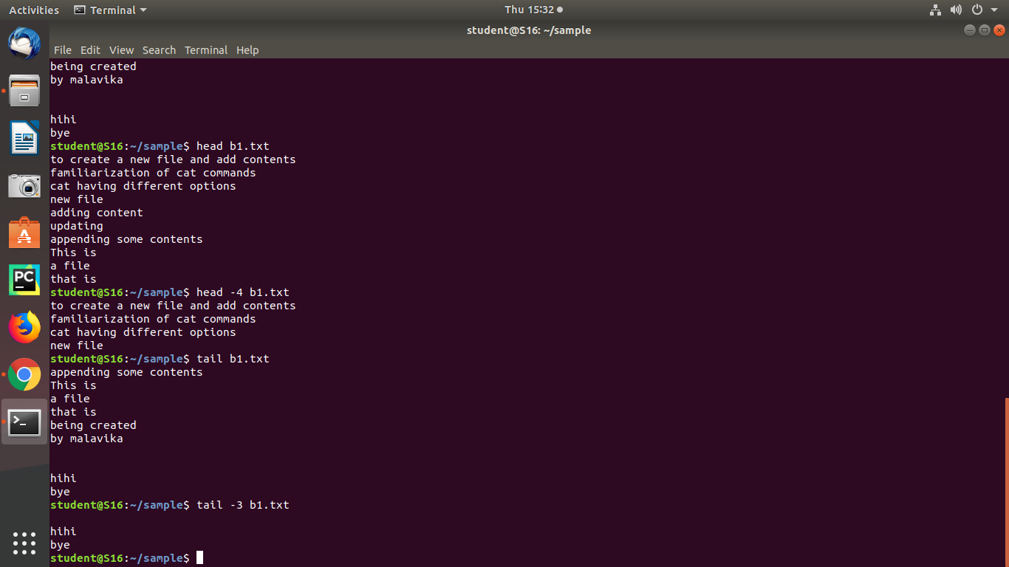



Output:

