**Name: Malavika A**

**Roll No: 16**

**Batch: RMCA B**

**Date:26/03/2021**

**NETWORKING & SYSTEM ADMINISTRATION LAB**

**Experiment No.: 3**

**Aim**

Familiarization of Linux commands.

**Procedure**

1. cut f2, cut f1

This cut f2 command is used to display the second column contents and f1 which displays the first column contents.

Syntax:

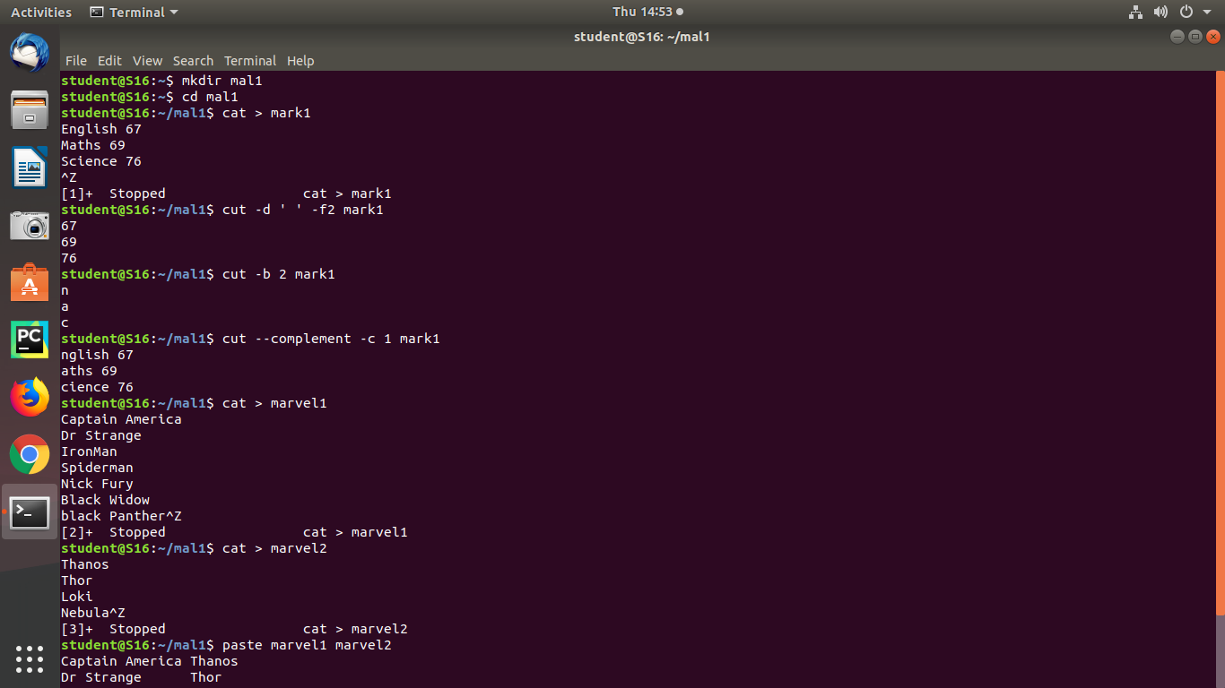

Output:



1. cut ‘ ‘

This command is used cut the spaces.

Syntax:



Output:



1. **cut –b 2**

This command is used to displays the second letters.

Syntax:



Output:



1. **cut –complement –c 1**

This command is used to displays the contents except the first letter .

Syntax:



Output:



1. **Paste**

This command is used to paste one file contents to another.

Syntax:

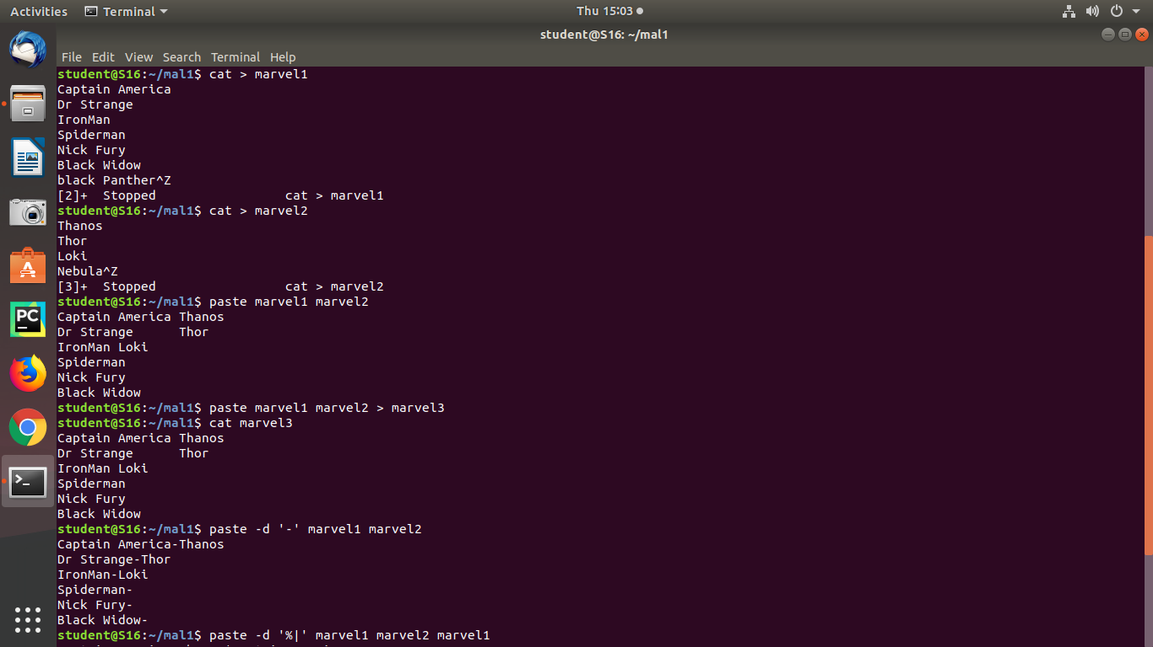



Output:



1. **Paste –d ‘-‘ file1 file2, Paste –d ‘%‘ file1 file2**

This command is used to displays ‘–‘ and ‘%’ in between the contents.

Syntax:

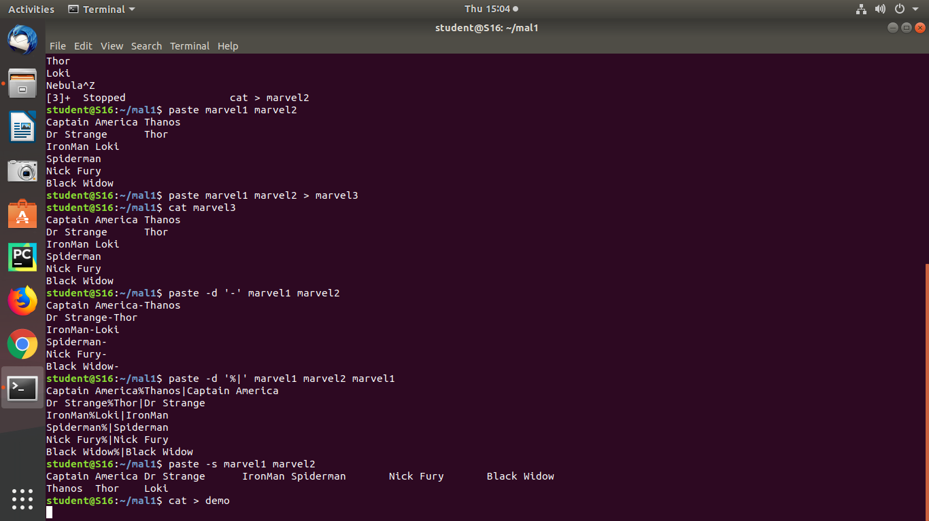



Output:



1. **Paste –s file1 file2**

This command is used to displays the contents as single line.

Syntax:

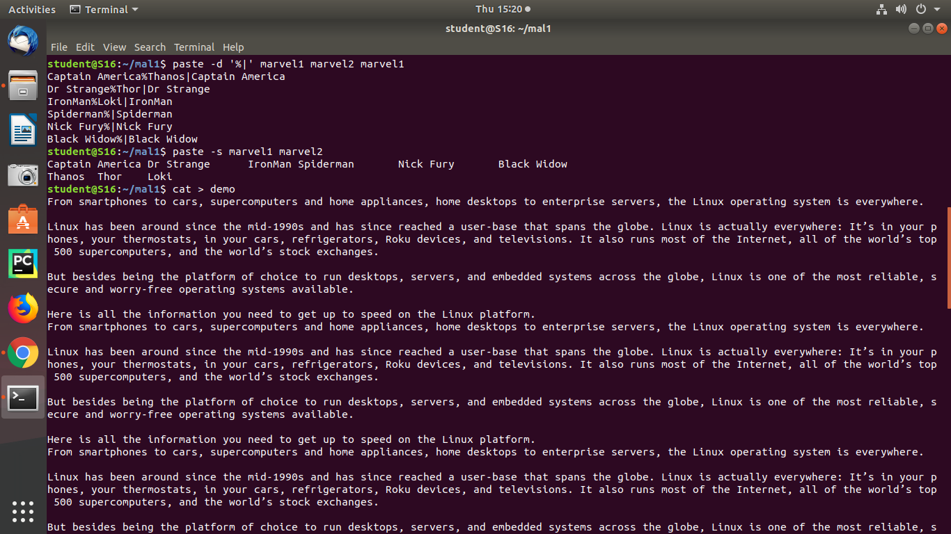

Output:



1. **More, more -3 filename,+3 filename**

This more command displays the output one screenful at a time ,more -3 command which displays the first 3 lines of contents and +3 displays the lines excepts the first three lines.

Syntax:

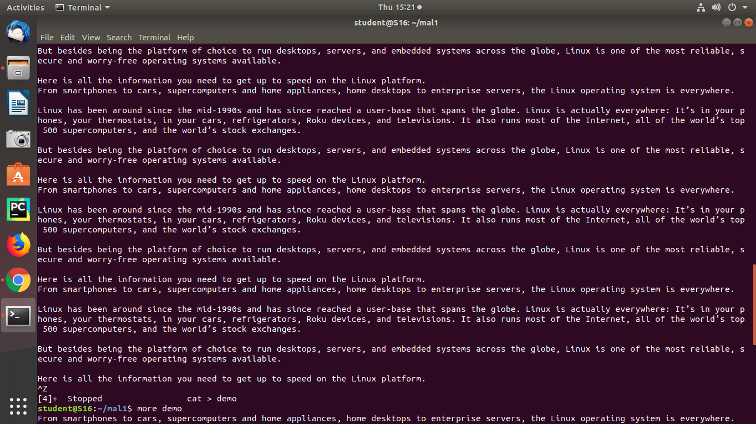

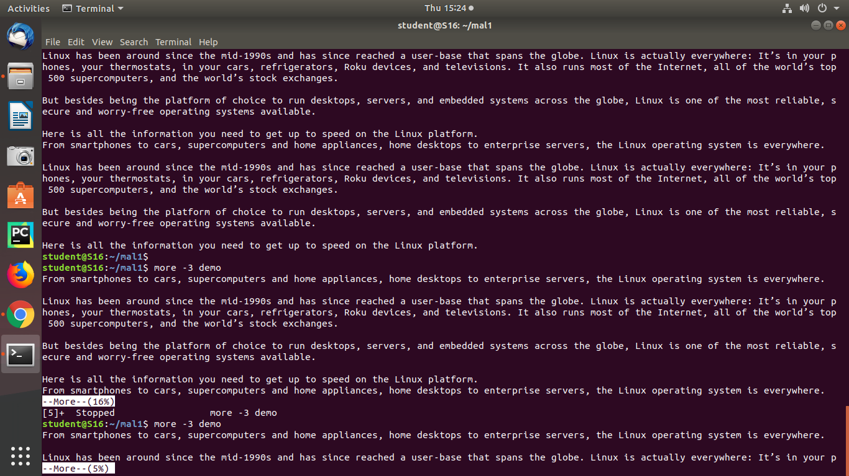

Output:

