

University Of Leicester

Computer Science Department

MSc. Web Applications and Services

**HiPerVison Projects on Shelton Vision's Textile Inspection Systems: Backend web-based interface**

**Malavika Reghunathan Nair**

**08 December 2014**

**A report submitted in fulfilment of the requirements for Course CO7501- Individual Project, Department of Computer Science, University of Leicester.**

**Supervised by: Dr. Reiko Heckel**

## Summary:

This project involves working on the Shelton WebSPECTOR surface inspection system which is currently used in various industries to inspect materials for defects. The system uses a combination of vision hardware (lights, cameras and electronics) and software. There are two primary software platforms. The first is the front-end (written in C#) where the operator interface, defect analysis and system co-ordination is done. The second is the back-end (written in C++) where the image processing and defect detection is carried out.

The outline aim of the project is to explore the possibilities of using existing web technologies and services to provide a web-based interface to allow engineers to interrogate the back-end remotely to troubleshoot any faults in identifying defects and adjust parameters.

**List of Acronyms:**

HTTP Hyper Text Transfer Protocol

XML eXtensible Markup Language

REST REpresentational State Transfer

SOAP Simple Object Access Protocol

URI Uniform Resource Identifier

URL Uniform Resource Locator

CGI Common Gateway Script

MIME Multi-Purpose Internet Mail Extensions

AJAX Asynchronous JavaScript + XML

IDE   Integrated development environment

JAX-RS Java API for RESTful Services

PHPHypertext Preprocessor

JSON JavaScript Object Notation

SV Shelton Machines Ltd

**Table of Contents:**

1. Introduction

1.1 Overall aim of the project

1.2 Objectives

1.3 Schedule

1.4 Report Structure

1.5 Reflective Analysis

1. Literature Review

2.1 Introduction

2. 1.1 Web Service API

2.2 SOAP, REST and JSON

2.2.1 Advantages of REST over SOAP

2.2.2 Languages supporting REST

2.3 JAVA API for RESTful web service

2.3.1 JAX-RS with Jersey

2.4 ASP.NET Web API for a REST Service

2. 5 Client-Side scripting techniques

2.6 Conclusion

3. System Architecture

1. Environment Set up

4.1 System and Hardware

4.2 Setting up the Database

1. 4.2.1 SQL Server 2005 Installation Instructions

4.2.2 SQL Management Studio Installation Instructions

4.2.3 Setting up a test database

4.3 Setting up the Java Environment

4.4 Setting up the ASP.NET Environment

4.5 Obstacles faced during set up

5. Implementation of REST Service using Java

6. Implementation of REST Service using ASP.NET

7. Consuming Java RESTful Web Service by JQuery Client

8. Consuming ASP.NET RESTful Web Service JQuery Client

9. Project Management

10. Analysis of Results

10.1 Comparison

10.2 Improvement and Future Work

**List of Figures:**

Figure1: High-Level Architecture

Figure 1.3a: Gantt chart excerpt

Figure 2: Web Technology

Figure 3: Communication between a user and web-based database

Figure 4: RESTful WebService

Figure 5: Test Database Specification

Figure 6:Java RESTful Service Code snippet

Figure 7: Code snippet of the Java method to retrieve the DataSource created in WebLogic

Figure 8: Code snippet of the method which performs the SQL query to the database

Figure 9: REST Service Package

Figure 10: Code snippet for converting the database ResultSet to JSON Object

Figure 11: Code snippet of the html page for the client

Figure 12: Code snippet of JQuery + Ajax consuming the REST service

Figure 13: code snippet of Web Application deployment descriptor (web.xml)

Figure 14: code snippet of Web application deployment descriptor elements (weblogic.xml)

Figure 15: Client Package

Figure 16: The client home page

Figure 17: Client page after processing the request

**List of Tables:**

Table 1: REST Vs SOAP

Table2: Organisation of architecture components in the folder structure

**Chapter 1**

1. **Introduction**
   1. **Overall aim of the project**

‘Shelton Vision’ (SV) a company that works on textile inspection systems currently has a desktop based application for their engineers to access and write information from and to a product database. The database holds information viz. material images, process graphs and other displays.

The company’s current vision is to have a back-end web based interface to allow its engineers to interrogate the backend remotely to troubleshoot any faults in identifying defects and adjust parameters.

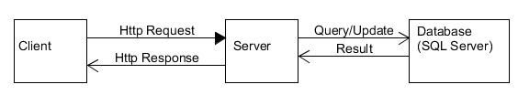

Figure 1: High-Level Architecture

The aim of this project is to do a feasibility study of current web technologies available in the market and then decide on the best technology to implement a web application to replace the existing desktop based application. Upon discussion with SV, for study purposes only a few core functionalities of the application are taken into consideration at this stage.

A comparative analysis will be done on the implemented solutions.

* 1. **Objectives**

The project assesses the feasibility of implementing a Web-based interface for the engineers to access the information linked to a product database. The information the engineer sees is a mixture of material images, process graphs and other displays. The existing system works under the Microsoft Windows XP operating system and a MS SQL database. It has been developed over 15 years with a mixture of Visual Basic 6, C and assembler libraries, SQL procedures, and WiT(visual programming package).

The project is supervised in cooperation with SV, who provides the requirements and technical support.

The **main objective** of this project is to:

* Review available technologies
* Create a web service API for client-service interactions
* Create a client side prototype exploiting the API

After discussing with SV, the **scenarios** to be implemented have been decided as follows:

1. Live streaming of images in its original size at client side. Images are of size 4MB stored at a location both client and server can access. Image paths are stored in the database.
2. Update parameters in the database on a button push at client side. On successful update, display a message at client side which is send from server.
3. Display graph at client side from a list of vector data. The vector data being stored in the database.

**1.3 Schedule**

A Gantt chart was prepared to manage the allocation time of the project tasks. The schedule starts from June 1st 2014 and each column represents end of week. There were regular meetings with the supervisor and SV to discuss on the progress and for technical support. It helped to decide on how to go about the solution. Sufficient time was allocated to do the background research of available technologies and to set up the environment.

Below is the embedded Gantt chart file.



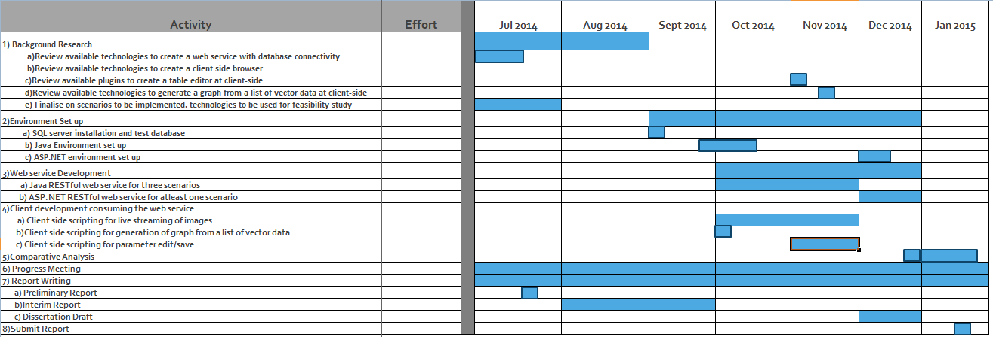

Figure 1.3a: Gantt chart excerpt

**1.4 Report Structure**

The following is the structure of the report.

* Chapter 2 describes the background research on client-server architecture, basics of web technology, specifications used for web services, technologies available for client-side scripting and a brief description of a framework that can be used to build web services.
* Chapter 3 describes the system architecture and describes the various layers of a 3-Tier architecture
* Chapter 4 describes the setting up of environment essential to perform a client-server task. Basically, the IDE, database, Operating system, Server etc and the obstacles faced during the progress
* Chapter 5 describes the implementation of a RESTful web service API using JAX-RS Jersey framework
* Chapter 6 describes the implementation of RESTful web service API using ASP.NET
* Chapter 7 describes how a JAX-RS web service is being consumed by a jQuery client using Ajax call
* Chapter 8 describes how a ASP .NET web service is being consumed by a jQuery client using Ajax call
* Chapter 9 describes the project management methods employed in this project
* Chapter 10 does a comparative analysis of the web application implemented using Java and .NET platforms.

**1.5 Reflective Analysis**

According to the initial plan, a web service API which is able to communicate to C++ applications was a requirement. But it was later decided to replace C++ application with a database as the C++ application is still not developed.

**Chapter 2**

1. **Literature Review**
   1. **Introduction**

The web is a distributed, dynamic and large information repository [3]. Communication over the web or internet can be broken down to two interested parties: *Clients and Servers*. The machine providing services are servers. Clients are the machine used to connect to those services [10]. *Services* are self-contained modules-deployed over standard middleware platforms- that can be described, published, located, orchestrated and programmed using technologies over a network [4].

A web browser is the web client which acts on behalf of the user. The browser contacts the web server and sends a request for the information and receives the information and displays it on the user’s computer [10]. Fig 2.1a shows how a basic web technology works.

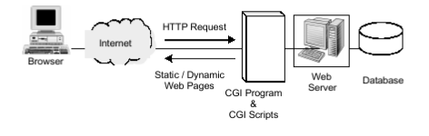

Figure 2: Web Technology [10]

The figure 2.1b illustrates the steps for a web page to access the database. A web browser cannot directly access a database. Most of the cases, browsers are a program running on the web server which acts as an intermediary to the database [10].

When the user hits a URL or clicks a submit button on the web page, the browser sends the request to the web server, which passes it to the Common Gateway Script (CGI). The CGI loads a library which sends the SQL commands to the SQL database server. The database server then executes the query and sends the result to the CGI script. The CGI script generates an HTML document and writes it to the web server. The web server sends the HTML page back to the remote user [10].

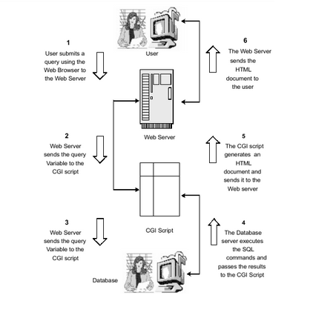

Figure 3: Communication between a user and web-based database [10]

A web service is a mode of communication between two machines over a network. The main goal of web service is to exchange information among applications in a standard way [9]. Two most widely used approaches for web service development are SOAP and REST (Representational State Transfer).REST has been accepted widely as a simpler alternative to SOAP and WSDL based web services [8].

* + 1. **Web service API**

A web service is a piece of software, or a system that provides access to its services via an address on the World Wide Web. This address is called URI, or URL. Web service sends the information in a transferrable format that the other application or client can understand or parse [20].

Most often-used types of web service:

* SOAP
* XML-RPC
* JSON-RPC
* REST

Web service can send the information to the client in any of the transferrable format, the most common being XML and JSON. The method of converting the data to a particular format is called ‘data serialisation’.

A web service can be categorised as ‘RESTful’ if it conforms to the constraints or the set of rules insisting by a REST architecture. RESTful APIs do not require XML-based web service protocols (SOAP & WSDL).

The main benefit of having an API-centric web application is that it can be used anywhere and it helps to build functionalities which can be used by any device, be it a browser, mobile phone, tablet or even desktop.

* 1. **SOAP, REST and JSON**

SOAP, REST and JSON are three specifications of web services.

**SOAP** defines a communication protocol for web services. WSDL enables service providers to describe their applications. UDDI offers a registry service that allows advertisement and discovery of web services [3]. XML is used to define Simple Object Access Protocol (SOAP).

**REST** (Representational Stat Transfer) defines a set of architectural principles by which you can design Web services that focus on a system's resources, including how resource states are addressed and transferred over HTTP by a wide range of clients written in different languages [8].REST is an architecture style for defining networked applications.

**JSON** (JavaScript Object Notation)is an open standard format that uses a non-strict subset of JavaScript. Information is exchanged using data objects in the form of attribute-value pair. The MIME type for JSON text data is “application/json”.

JSON is much simpler than XML and is a better data exchange format.

JSON Sample:

{

“id”: 1,

“name”: “Dave”,

“city”: “London”

“gender” : { “type” : “male”

},

“phone number” :{ “type” : “work”,

“number” : “000 007 131”

}

}

We could use a combination of web service specifications in order to obtain a better performance.

**2.2.1 Advantages of REST over SOAP**

Web services performance is an important factor. SOAP communications causes network traffic, higher latency and processing delays. To overcome this limitations the RESTful architecture is used. REST is a lightweight, easy and better alternative for the SOAP [9]. Table 1 illustrates a comparison of SOAP and REST.

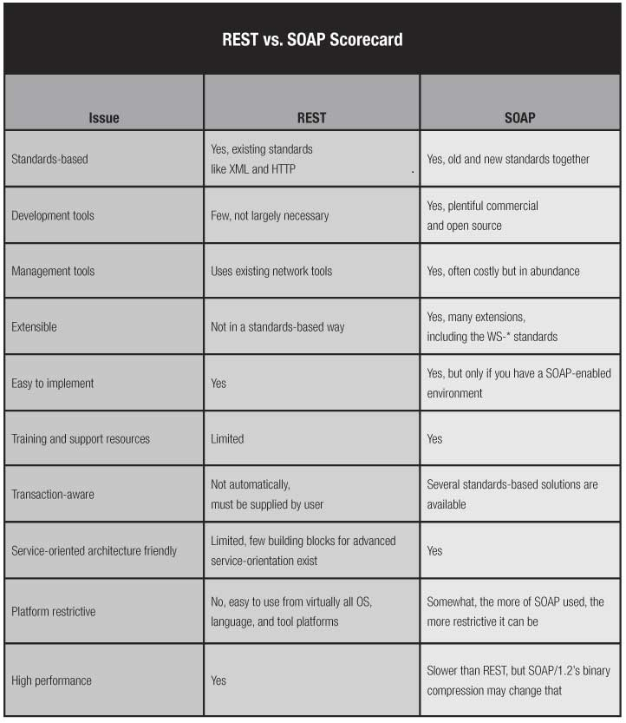

Table 1: REST Vs SOAP [11]

**2.2.2 RESTful Web Services**

RESTful web services have the advantage of being simple, lightweight and fast [22]. Basically, web services are viewed as resources and can be identified by their URLs or URIs. A Uniform Resource Identifier, or URI, in a RESTful web service is a hyperlink to a resource, and it's the only means for clients and servers to exchange representations. These representations are negotiated between clients and servers through the communication protocol at runtime— through HTTP [21].

Resources may be accessed in various formats such as HTML, plain text, XML, PDF, JPEG, and JSON among others [22]. They are commonly represented using JSON rather than XML because it is more compact than XML and it can be used with almost all programming languages including JavaScript [5]. JAX-RS uses annotations to simplify RESTful web service development. By adding annotations, we can define resources and can define the operations or actions to be performed on those resources.

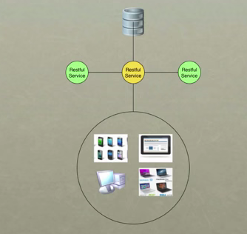

Figure 4: RESTful Web Service

With the delineated roles for resources and representations, we can now map our CRUD actions to the HTTP methods POST, GET, PUT , and DELETE as follows [21]:

Data action HTTP protocol equivalent

CREATE POST

RETRIEVE GET

UPDATE PUT

DELETE DELETE

Following constraints define a RESTful system:

* It must be a client-server system
* It has to be stateless— there should be no need for the service to keep users' sessions; in other words, each request should be independent of others
* It has to support a caching system— the network infrastructure should support cache at different levels
* It has to be uniformly accessible— each resource must have a unique address and a valid point of access
* It has to be layered— it must support scalability
* It should provide code on demand— although this is an optional constraint, applications can be extendable at runtime by allowing the downloading of code on demand, for example, Java Applets [21].

REST services can be accessed in different programming languages – C#, Java, Python, PHP, Ruby etc.

According to Shelton Vision, in the next steps of this project, this web service should be able to communicate with a C++ application in the backend. Their existing system works under the Microsoft windows XP operating system.

Given the time scale of the project, two native frameworks are selected to develop the web service API – **Java and C#.**

**2.3 JAVA API for Restful web service**

Java API for RESTful Web Services (JAX-RS) is defined in JSR 311 (<https://jcp.org/en/jsr/detail?id=311> ) [22].

**2.3.1 JAX-RS with Jersey**

“Jersey RESTful Web Services framework is an open source, production quality JAX-RS reference implementation for building RESTful Web Services in Java” [6].Jersey produces and consumes RESTful web services. In Jersey framework, the following methods are used which are defined in the HTTP/1.1 protocol.

* @GET is used to retrieve data or perform a query on a resource. The data returned from the web service is a representation of the requested resource [7]. This is the most-used, read only , public access method
* @POST is used to create a new resource. The web service may respond with data or status indicating success or failure [7].
* @PUT is used to update existing resources or data [7]. But it can also be used for inserting or adding data.
* @DELETE is used to remove a resource or data [7].
* @HEAD used to return meta-data of the resource

**Sample code:**

@Path("/manage/display")

**public** **class** Rest_Service {

@Path("/graph/”)

@GET // HTTP verb required to access this method

@Produces(MediaType.*Application_JSON*)

**public** Response returnVectorData () **throws** Exception {

// code goes here

}

}

For the sample code above, let’s assume the location of this service is at http://restjava.com. A request to retrieve the list of vector data uses the GET method with the URI <http://restjava.com/manage/display/graph/>. The return type of the service is ‘JSON’ .So the service will respond with the details in JSON representation.

* 1. **ASP.NET Web API for a REST Service (in progress....)**

ASP.NET is a free web framework for building great web sites and applications.

<http://msdn.microsoft.com/en-us/library/jj823172(v=vs.110).aspx>

Two technologies are available- WCF and ASP.NET Web API.

Windows Communication Foundation (WCF) is a framework for building service-oriented applications. Using WCF, you can send data as asynchronous messages from one service endpoint to another. A service endpoint can be part of a continuously available service hosted by IIS, or it can be a service hosted in an application. An endpoint can be a client of a service that requests data from a service endpoint. The messages can be as simple as a single character or word sent as XML, or as complex as a stream of binary data

[ASP.NET Web API](http://www.asp.net/web-api) is a framework that makes it easy to build HTTP services that reach a broad range of clients, including browsers and mobile devices. ASP.NET Web API is an ideal platform for building RESTful applications on the .NET Framework. Uses basic protocol and formats such as HTTP, WebSockets, SSL, JQuery, JSON, and XML. Ships with .NET framework but is open-source and is also available out-of-band as independent download.

The following table describes the major features of each technology.

|  |  |
| --- | --- |
| **WCF** | **ASP.NET Web API** |
| Enables building services that support multiple transport protocols (HTTP, TCP, UDP, and custom transports) and allows switching between them. | HTTP only. First-class programming model for HTTP. More suitable for access from various browsers, mobile devices etc enabling wide reach. |
| Enables building services that support multiple encodings (Text, MTOM, and Binary) of the same message type and allows switching between them. | Enables building Web APIs that support wide variety of media types including XML, JSON etc. |
| Supports building services with WS-* standards like Reliable Messaging, Transactions, Message Security. | Uses basic protocol and formats such as HTTP, WebSockets, SSL, JQuery, JSON, and XML. There is no support for higher level protocols such as Reliable Messaging or Transactions. |
| Supports Request-Reply, One Way, and Duplex message exchange patterns. | HTTP is request/response but additional patterns can be supported through [SignalR](https://github.com/SignalR/SignalR)and WebSockets integration. |
| WCF SOAP services can be described in WSDL allowing automated tools to generate client proxies even for services with complex schemas. | There is a variety of ways to describe a Web API ranging from auto-generated HTML help page describing snippets to structured metadata for OData integrated APIs. |
| Ships with the .NET framework. | Ships with .NET framework but is open-source and is also available out-of-band as independent download. |

<http://blogs.msdn.com/b/webdev/archive/2013/07/19/writing-web-api-client-code-for-multiple-platforms-using-portable-libraries.aspx>

The Microsoft ASP.NET Web API Client Libraries make it easy to write .NET clients that interact with RESTful HTTP services. Unfortunately, until recently the Web API client libraries did not support all platforms. Because of this limitation, developers had to maintain different code, depending on the target platform.

The new release of Microsoft ASP.NET Web API Client Libraries now comes with support for building portable libraries that target .NET 4.5, Windows Store and Windows Phone 8 applications. This support is built on the recently released portable HttpClient and the portable library support in Json.NET. Developers can now build a single portable library that can be used to consume Web APIs from Windows Phone and Windows Store apps as well as from middle-tier logic running on .NET 4.5

<http://msdn.microsoft.com/en-us/magazine/dn342871.aspx>

A typical Web service is laid out as depicted in **Figure 1**.

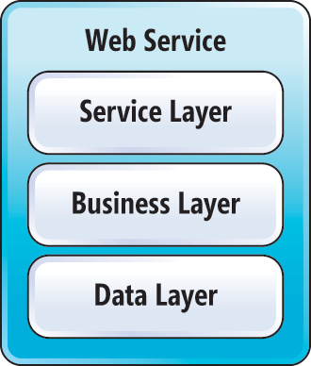  
**Figure 1 A Typical Web Service Layout**

The service layer is where you define your Web service interface. This is the only layer with which the client needs to interact to consume your Web service.

The business layer is usually heavy with business logic, obviously. This is where the meat of your Web service implementation resides, keeping your service layer light and focusing on client/server contracts and communication.

The data layer is meant to encapsulate your data access and provide abstracted data models for manipulation at the business layer.

If you like working with the .NET Framework and WCF and are in need of deploying your .NET Web services in an environment other than Windows, ServiceStack is an ideal option. Due to the similarity of ServiceStack and WCF, the transition from one to the other requires little adjustment in terms of development environment and tools. You get to continue writing C# code inside Visual Studio.

ServiceStack is an open source, cross-platform Mono Web service framework, and it’s gaining popularity. Web services built with ServiceStack can run in a Windows environment with .NET code or in a Linux environment with Mono support. The OSes supported by Mono include:

* Linux
* Mac OS X, iOS
* Sun Solaris
* BSD
* Microsoft Windows
* Nintendo Wii
* Sony PlayStation 3

<https://servicestack.net/features>

Brings .NET to exciting platforms. See <https://servicestack.net/pricing> for prices (Business version $999/per developer)

<http://stackoverflow.com/questions/9699083/servicestack-vs-asp-net-web-api>

ServiceStack is a .NET 3.5 framework that runs on ASP.NET and HttpListener hosts and can be hosted on either .NET or Mono (trivia: [www.servicestack.net](http://www.servicestack.net/) is powered by CentOS/Mono). This allows your ServiceStack web services to be hosted on either:

### Windows with .NET 3.5 & 4.0

* IIS 5/6/7 (uses IHttpHandler)
* VS.NET WebDevServer
* [Console App](https://github.com/ServiceStack/ServiceStack.Examples/tree/master/src/StarterTemplates/ConsoleAppHost) or Windows GUI
* [Windows Service](https://github.com/ServiceStack/ServiceStack.Examples/tree/master/src/StarterTemplates/WinServiceAppHost)

### Linux/OSX with Mono

* Apache + mod_mono
* Nginx + MonoFastCGI
* XSP
* Console App

-----------

Web APi- free to use ,need VS licence for commercial use.

High level of support, both from community and by Microsoft

Supports REST(RESTish by default) , doesn’t support SOAP

Self host in an OWIN application (i.e. runs anywhere).

<http://owin.org/>

OWIN defines a standard interface between .NET web servers and web applications. The goal of the OWIN interface is to decouple server and application, encourage the development of simple modules for .NET web development, and, by being an open standard, stimulate the open source ecosystem of .NET web development tools.

<http://www.asp.net/web-api/overview/hosting-aspnet-web-api/use-owin-to-self-host-web-api>

Can host ASP.NET Web API outside of IIS using OWIN( ie.runs everywhere).

[Open Web Interface for .NET](http://owin.org/) (OWIN) defines an abstraction between .NET web servers and web applications. OWIN decouples the web application from the server, which makes OWIN ideal for self-hosting a web application in your own process, outside of IIS.

<http://channel9.msdn.com/Series/Building-Web-Apps-with-ASP-NET-Jump-Start/Building-Web-Apps-with-ASPNET-Jump-Start-08-Real-time-Communication-with-SignalR>

SignalR, and an incredibly simple real-time web for .NET

Allows server-to-client push and RPC

Built async to scale to 1000’s of connections

Scale out with service bus, SQL server & Redis

Opensource on GitHub

To match real-time, need to do polling so frequently, thereby putting server in adverse load.(lot of web traffic)

SignalR is a .NET framework that implements Websockets with a fallback for old browsers.

* 1. **Client-Side scripting techniques**

There are various client side scripting techniques available today of which jQuery, is a very popular one with a good community. Some of the popular sites using jQuery include Google (code search), Twitter, Dell Inc., CBS News, Slashdot and others.

**jQuery** is a free, open-source and cross-platform JavaScript library used to simplify the client-side scripting of HTML. It has become very popular today and mostly used to develop dynamic web pages. Using jQuery library eliminates cross-browser incompatibilities.

The library provides a general-purpose abstraction layer for common web scripting [15] by taking a lot of common tasks and wrapping them into methods that can be invoked by a single line of code. In addition the framework comes with various plug-ins that are constantly being developed to add new features [15].

The use of JQuery has several advantages over several other JavaScript libraries. Some of them are listed below:

* Ease of use: This is one of the primary advantages of using JQuery. As mentioned above, the level of abstraction that the framework provides means that a task may be performed more easily with lesser lines of code than when using most alternatives.
* Library Size: The large library that JQuery provide allows performing more functions in comparison to other JavaScripts. In addition a compressed version of the library is only around 90 k, which is very small.
* Documentation and Tutorials: JQuery’s dedicated website provides ample information, tutorial and examples to demonstrate the use of the library. In addition it has got a large developer community [17].
* Ajax support: The jQuery library has a full suite of Ajax capabilities that can access by making use of the provided APIs. Actions can be performed on pages without requiring the entire page to be reloaded. [16]

However with these come certain disadvantages as well. They are listed below:

* Limited Functionality: Since jQuery is a framework that provides an abstraction over JavaScript, there may be inevitable cases where the raw JavaScript might have to be used depending on the customization required for example on a webpage.
* jQuery javaScript file: The jQuery file is required to run jQuery commands. Though the size of the file is relatively small, it is still an overhead on the client computer and as well as the web server in certain cases [17].

It can be summarized that the advantages of using the jQuery library clearly out-weighs its disadvantages and hence is clearly a potential candidate for use in this project.

**Sending Data with Ajax**

The jQuery function ‘jQuery.ajax()’ performs an asynchronous HTTP (Ajax) request [16]. Underneath all the hype and trappings, Ajax is just a means of loading data from the server to the web browser or client without a visible page refresh [15].

Example:

HTML defining the content area of a page [16]:

*<div id="dictionary">*

*</div>*

Now, suppose we want to insert another HTML document into this without a page refresh, it can be accomplished by jQuery as follows [16]:

*$(document).ready(function(){*

*$('#letter-a a').click(function(event) {*

*event.preventDefault();*

*$('#dictionary').load('a.html');*

*});*

*});*

The .load () method does all the heavy lifting for us. The target location for the HTML snippet is specified by using a normal jQuery selector, and then pass the URL of the file to be loaded as a parameter to the method. Now, when the first link is clicked, the file is loaded and placed inside <div id="dictionary">. The browser will render the new HTML as soon as it is inserted. As soon as the new HTML snippet is inserted, any CSS rules for the main document will get applied its new elements as well [16].

**Highcharts**

Scenario ii described in chapter 1 can be achieved by using a plugin to display the graph from a list of vector data. There are great jQuery chart plugins available in the net.

Highcharts is a charting library written in pure JavaScript, offering an easy way of adding interactive charts to a web site or web application[19]. Highcharts currently supports line, spline, area, areaspline, column, bar, pie, scatter, angular gauges, arearange, areasplinerange, columnrange, bubble, box plot, error bars, funnel, waterfall and polar chart types [19].

**DataTables**

Scenarios iii described in chapter 1 can be achieved by using a plugin to control an HTML table. DataTables is one of such plugin which is very popular in web development world.

DataTables is a plug-in for the jQuery Javascript library. It is a highly flexible tool, based upon the foundations of progressive enhancement, and will add advanced interaction controls to any HTML table [23].

* 1. **Conclusion**

Based on the background research, it was decided to create a REST service in a Java environment as well as in ASP.NET environment with client-side in JQuery and do a comparative analysis.

**Chapter 3**

1. **System Architecture**

Client Tier

(Holds presentation logic – jQuery, HighCharts,DataTables)

Application Server Tier

(Holds Buisiness logic – REStful web service using Java / C#)

Database Tier

(Holds application data – SQL Server)

Figure 3a: 3-Tier Deployment of the application

**Chapter 4**

1. **Environment Set Up**
   1. **System and Hardware**

The system and its hardware details used for this project are as below:

Operating System: Windows 7 Home Premium

Hardware: 4.00GB RAM, 32-bit (x86)

* 1. **Setting up the Database**

The relevant files and configuration details required for setting up the SQL Server 2005 and SQL management Studio installation instructions recommended by SV are explained in the subsections.

1. **4.2.1** **SQL Server 2005 Installation Instructions**

Steps:

1. Install the dot net framework 2.0 file dotnetfx.exe
2. Run the SQLEXPR32.EXE install file
3. For the name field put Developer, company Shelton Machines Ltd.
4. Untick 'hide advanced configuration options' and click next
5. For the feature selection, click on the plus next to Database services, and add the replication option. This is done by left clicking and selecting 'will be installed on local hard drive'
6. Add the connectivitiy components under the client components option. Then click next.
7. The named instance should be SQLExpress
8. On the next screen put a tick in the SQL server and SQL browser start service s and click next
9. IN the authentication mode screen, click on 'mixed mode' and set the password
10. Click next through collation settings
11. For Configuration options put a tick in 'add user to SQL server administrator role' and click next
12. Click next through error and Usage report settings
13. Once installed click on Start>Microsoft SQL server 2005>Configuration tools > SQL server surface area configuration.
14. Click on Surface area configuration for services and connections (near the bottom of the screen)
15. Click on remote connections and select 'Local and remote connections' and 'Using both TCP/IP and named connections'
16. Click apply and ok.
17. Select database Engine > service, then click on Stop and then Start,
18. Click OK and exit the surface area configuration program.
19. Start the windows firewall.(from control panel)
20. Click on exceptions, and Add Program...
21. Click on Browse and select “[c:\program](/C:/program)files\MicrosoftSQL server\MSSQL.1\MSSQL\Binn\sqlservr.exe
22. click Open and then OK
23. Click on add program again and browse to “[c:\program](/C:/program)files\MicrosoftSQL server\90\shared\sqlbrowser.exe”
24. Click open and then ok
25. **4.2.2 SQL Management Studio Installation Instructions**

Steps:

1. Run the .exe install file SQLServer2005_SSMSEE.msi
2. Run through the installation steps and when installation is complete connect to the desired database.

Server Name: MALU-PC\SQLEXPRESS

Authentication: SQL Server Authentication

Login: SA

Password: **********

**4.2.3 Setting up a test database**

A test database ‘TestDB’ was created using SQL server 2005 with three test tables ‘Images’ , ‘VectorData’ and ‘Parameters’ whose specifications are shown in figure5a, 5b and 5c.

For testing purpose of the project, the images are of size 4MB and are stored in the C drive of the machine.

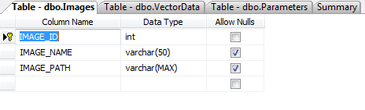

Figure 4.2.3a : Specification for table ‘Images’

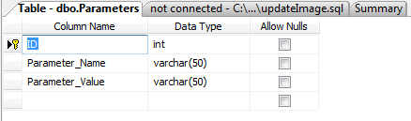

Figure 4.2.3b: Specification for table ‘Parameters’

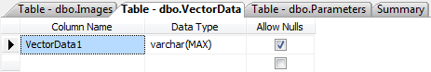’

Figure 4.2.3c: Specification for table ‘VectorData’

* 1. **Setting up Java Environment**

Using Eclipse IDE for development of Java RESTful service simplifies the task significantly and offers several tools. With a new Dynamic Web Project created in the eclipse IDE, it is possible to create both service and client in the same package through a web design view. Still the coding needs to be done manually. Any Java EE container can be used as server but her **Oracle WebLogic** has been chosen as it is very easy to use once installed and configured. Also it has a very good GUI.

For this project, a web application is developed in **Eclipse 3.7**, **Oracle Enterprise Pack for Eclipse (OEPE) 12 c**, and deploy the application to the Java application Server ,**Oracle WebLogic Server 12 c**.

“Oracle WebLogic Server 12c  is the industry's best application server for building and deploying enterprise [Java EE](http://www.oracle.com/technetwork/java/javaee/overview/index.html) applications with support for new features for lowering cost of operations, improving performance, enhancing scalability and supporting the [Oracle Applications](http://www.oracle.com/us/products/applications/index.html?ssSourceSiteId=otnen) portfolio “[12].

Downloaded the Free Oracle WebLogic Server 12c (12.1.1),

‘wls1213_dev.zip’ from <http://www.oracle.com/technetwork/middleware/fusion-middleware/downloads/index.html>.

Installed Oracle WebLogic 12c to a directory C:/Oracle and created a WebLogic Server domain as base_domain. Also need to install JDK 7.0 (atleast JDK 6.0 is required)

Downloaded the Jersey 1.8 ZIP bundle ‘jersey-archive-1.18.zip’ from <https://jersey.java.net/download.html> and placed it to the directory C:/Oracle.It contains the Jersey JARs and core dependencies.

Download the Microsoft JDBC driver 4.0 for SQL server ‘sqljdbc4.jar’ from

<http://www.microsoft.com/en-us/download/details.aspx?displaylang=en&id=11774>,

a Type 4 JDBC driver that provides database connectivity through the standard JDBC application program interfaces (APIs) available in Java Platform. Placed this jar file to the directory ‘C:\Oracle\Middleware\wlserver_12.1\server\lib’ and add the following to the CLASSPATH declaration in the bin/ commEnv batch file:

*C:\Oracle\Middleware\wlserver_12.1\server\lib\sqljdbc4.jar*

In order to connect the server with the database, a data source needs to be created. MS SQL data source with the name ‘SqlDataSource’ is created from the oracle WebLogic Administration console and a successful connection is established to the database. Figure 4.3a shows the properties of the created JDBC datasource and figure 4.3b shows the created datasource in the admin console.

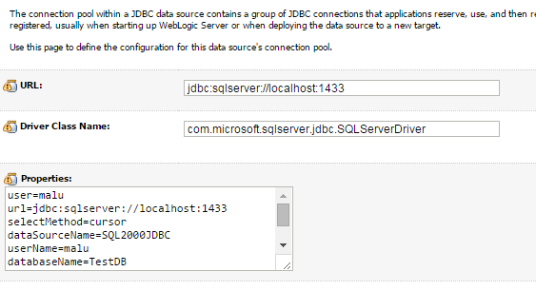

Figure 4.3a JDBC DataSource properties

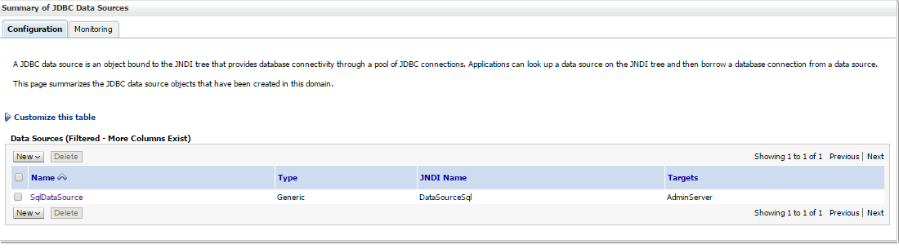

Figure 4.3b Summary of JDBC datasource created

* 1. **Setting up ASP.NET environment**

**[in progress....]**

* 1. **Obstacles faced during set up**

**Problem**: Installation of MSSQL 2005 in Windows 8 (x64) Operating System unsuccessful.

**Solution**: After discussing with SV, ordered Windows 7 Home Premium OS online as it was not physically available to purchase. Following the installation of Windows 7, MS SQL 2005 was successfully installed.

**Chapter 5**

1. **Implementation of REST Service using Java**

This section describes the steps followed to create the JAX-RS web service using the environment set up in section 4.3 of chapter 4.

Selected **File|New|Other** and in the **New** wizard, selected **Web|Dynamic Web Project** . In the **New Dynamic Web Project** wizard ((Figure 5a), specified project name as **‘com.sheltonmachines.service’** and a new target runtime is configured for **Oracle Weblogic Server 12c (12.1.1).** A new dynamic web project gets created with necessary libraries.

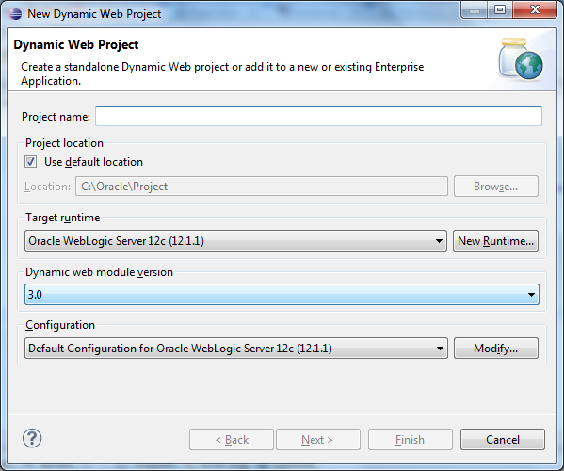

Figure 5a. New Dynamic web project wizard

Copied the Jersey JARs and sqljdbc4.jar explained in section 4.3 of chapter 4 to the web content library of the project at the below location :

C:\Oracle\Project\com.sheltonmachines.service\WebContent\WEB-INF\lib

The project gets created and the JAR files get added to the project as shown in Figure 5b.JAX-RS Servlet and the Servlet mapping get configured in web.xml, as shown in Figure 5c.

A RESTful web service resource is created using a root resource class. A root resource class is a POJO, annotated with the @PATH annotation and consisting of at least one method annotated with the @PATH annotation or request method designator such as @GET , @PUT , @POST , or @DELETE . Selected **File | New | Other** and in the New wizard select **Java | Class**. In New Java Class specified the Source folder ( com.sheltonmachines.service/src), specified a new Package name for better organization and maintainability (com.sheltonmachines.service.manage), and specify a class name ( manage_display ) in the Name field as shown in the figure 5d. Figure 5e shows a code snippet of the resource class( manage_display ). As seen in line 41, the HTTP verb “POST” is used to invoke the service method.

To separate the RESTful service from SQL Logic and JSON object mapping, the code handling database queries are done in a separate package (com.sheltonmachines.service.dao) and the code to convert the data into JSON format are done in a separate package(com.sheltonmachines.service.util).

The advantage of this is that if the REST service needs changing, there is no risk of breaking the SQL connection and logging packages. The structure of the packages is shown in figure 5f.

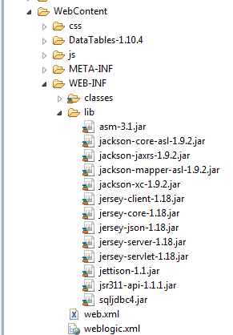

Figure5b. After adding the Jersey JARs and sqljdbc4.jar to the web content library

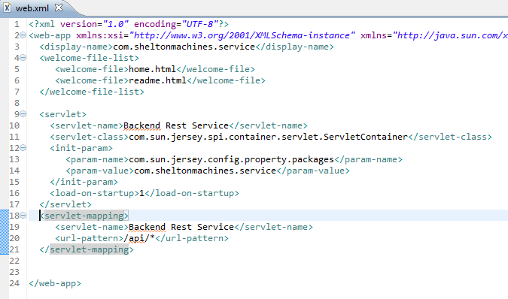

Figure 5c. Web.xml file

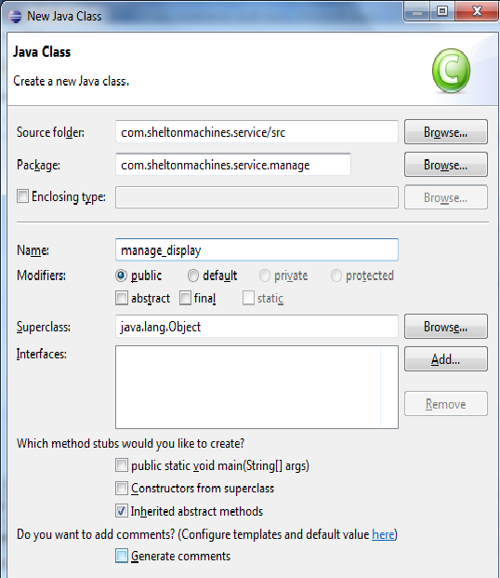

Figure 5d. Creating root resource class.

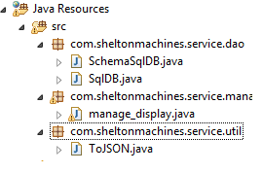

Figure 5f: REST Service Package structure

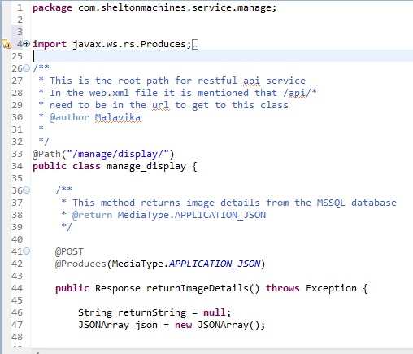

Figure 5e:Code snippet of resource class

The method retrieves the SQLDataSource of WebLogic which was created as explained in section 3.3 and returns a connection. The code snippet is showed in Figure 7. The method response is the image path to the client as a JSON object. Code snippet of the method doing the SQL queries is shown in Figure 8.

The service is then published to the WebLogic server. The service can be tested by entering the endpoint URL in the browser (for GET methods) or by using a client application. It can also be tested by using REST console apps available for each browser.

The result set of the database query is converted to JSON object using a separate class as mentioned before. The code snippet for the same is shown in figure 10.

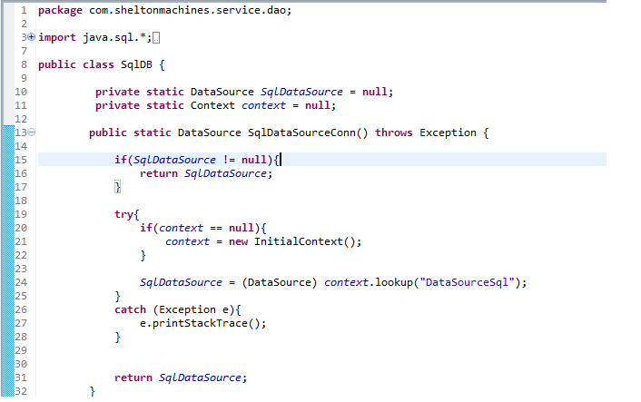

Figure 7: Code snippet of the Java method to retrieve the DataSource created in WebLogic

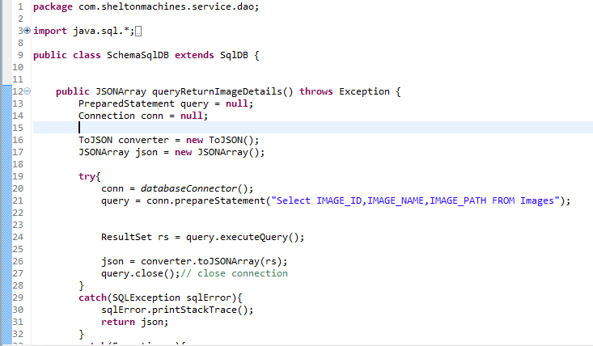

Figure 8: Code snippet of the method which performs the SQL query to the database

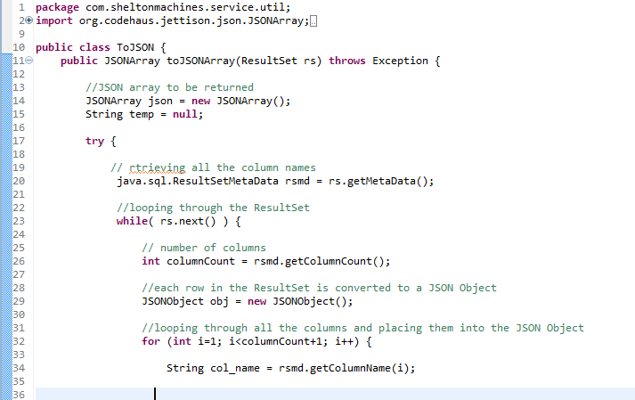

Figure 10: Code snippet for converting the database ResultSet to JSON Object

**Chapter 6**

1. **Implementation of REST Service using ASP.NET**

[in progress]

**Chapter 7**

1. **Consuming Java RESTful Web Service by JQuery Client**

The client written in JQuery will consume the Jersey-based RESTful web service created in chapter 4.

**Scenario i)** Live streaming of images in its original size at client side. Images are of size 4MB stored at a location both client and server can access. Image paths are stored in the database.

The RESTful web service implemented in chapter 4 returns the image details as a JSON Object. Here the client makes Ajax calls using JQuery library. The code snippet is shown in figure 12. Specify the REST service URL in the Ajax call and the request is send to the server. The server then responds with the image details. On success of the Ajax call, the images are displayed in the browser.

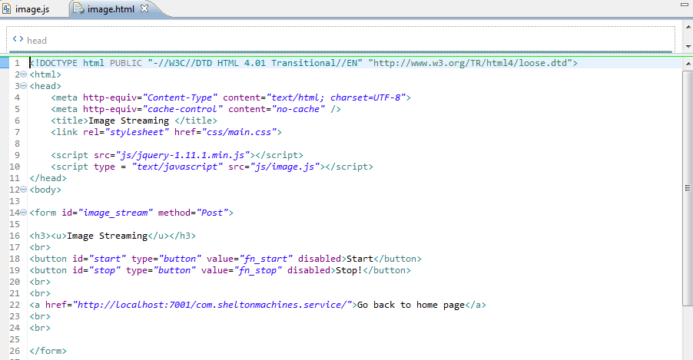

Figure 11: Code snippet for image.html

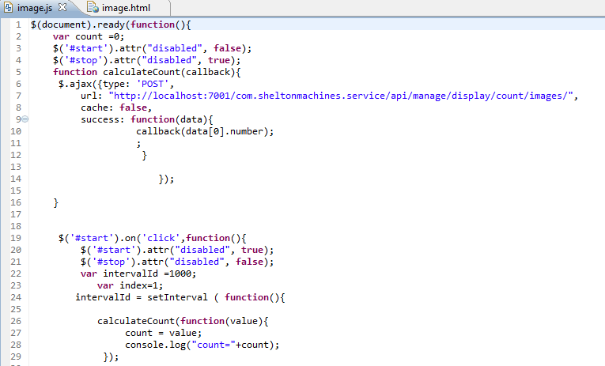

Figure 12: Code snippet of image.js, the javascript file consuming the RESTful web service

When an empty ‘Dynamic Web Project’ is created in Eclipse IDE for Java EE, a template for web application deployment descriptor (web.xml) gets generated in the WEB-INF directory of the web application project. It provides the configuration and deployment information for the web components of a specific web application (eg: servlets, servlet mappings, URL mapping) .When we hit the client URL , the starting point will be this web.xml. It acts a gateway to the application.

The servlet needs to be configured manually. A servlet can have multiple servlet-mapping. The web.xml for this project is shown in figure 13. When a request comes for a particular URL pattern, the servlet container matches the servlet-name with the url-pattern, finds the corresponding servlet-path and pass the control to the service.

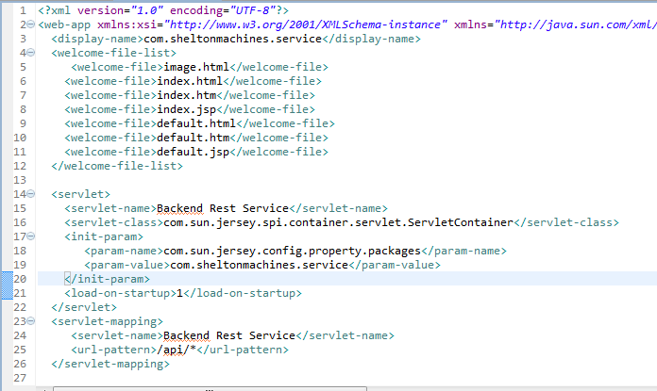

Figure 13: Code snippet of Web Application deployment descriptor (web.xml)

Web application deployment descriptor elements for all the application in a user domain are defined in weblogic.xml file which also resides in WEB-INF directory of the web application (figure 14). Lines 9 to 11 in figure 14 shows virtual directory mapping.

“Use the *virtual-directory-mapping* element to specify document roots other than the default document root of the Web application for certain kinds of requests, such as image requests” [13]. It can be used to include images from another location other than the physical directory that is mapped to application’s root virtual directory. If we specify a directory name, it gets mapped to a physical directory on a local or remote server.

The Client package structure is shown in figure 15. All JavaScript files are in a seperate folder. Table 2 shows the components and how they are organised in the folder structure.

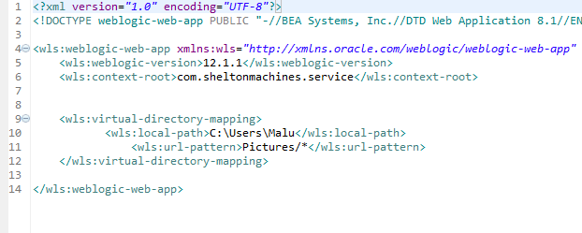

Figure 14: code snippet of Web application deployment descriptor elements (weblogic.xml)

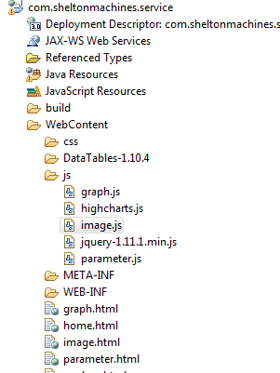

Figure 15: Client Package

|  |  |  |  |
| --- | --- | --- | --- |
| **Tier** | **Layers** | **Technology used** | **File Locations** |
| Client Tier | Presentation Layer | HTML  Javascript  Javascript libraries- jQuery, HighCharts,DataTables | /Webcontent  /WebContent/css  /WebContent/js |
| Application Server Tier | Business Layer  Application Layer | JAX-RS  Java | /src/com.sheltonmachines.service.manage  /src/com.sheltonmachines.service.util |
| Database Tier | Data Access Layer | Java  SQL | /src/com.sheltonmachines.service.dao |

Table2: Organisation of architecture components in the folder structure

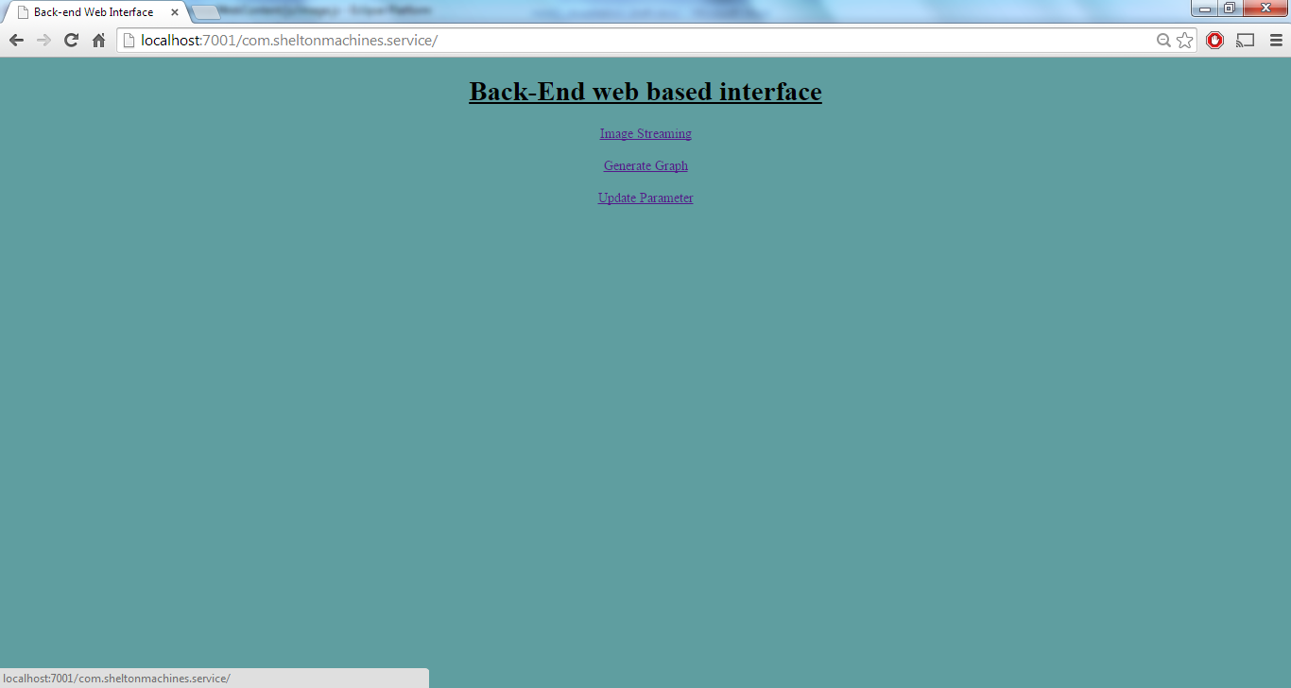

Client home page

Please find the client page for image streaming in figure 16. The client-server works as explained below:

1) The user pushes ‘Start’ button to start the image streaming. On clicking, the ‘start’ button will get disabled and ‘Stop’ button will get enabled.

2) The server will then pick up the first image file path from the database and sends it to the client which then displays on its browser.

3) The server will send the next image file path after a delay. This step will continue until the user clicks ‘Stop’ button or the server reaches the end of the image list. This would result in a ‘live’ changing of images and would look similar to streaming.

4) Meanwhile, the server keeps checking the database every 1500 milliseconds whether a change has been occurred or not. If any change occurs, it will get reflected at the client side without a refresh.

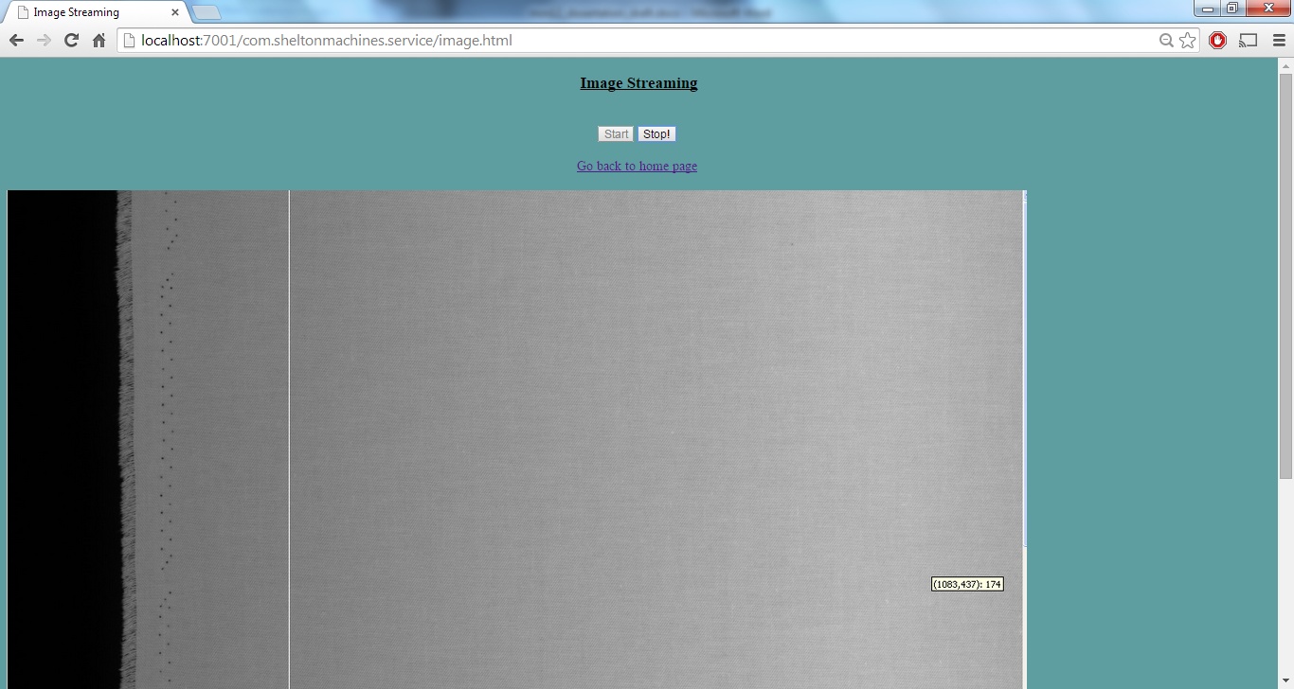

Figure 15: Client page for image streaming

**Scenario ii)** Update parameters in the database on a button push at client side. On successful update, display a message at client side which is send from the server.

The following table plug-in for JQuery Javascript library is added for the implementation of parameter table.

* Data Tables V1.10.4 - <http://www.datatables.net/download/>

When the user clicks on ‘Get Parameters’ button, the client make an Ajax call to the server and then the server return all the parameters in the database which are then displayed on the browser as shown in figure 18.

The parameters can be sorted, filtered, edited and can be saved back to the database. When the user clicks on ‘Save’ button, the details of the edited row is send back to the server and then the server updates the database accordingly.

The html code snippet is shown in figure 16 and the JavaScript code is shown in figure 17.

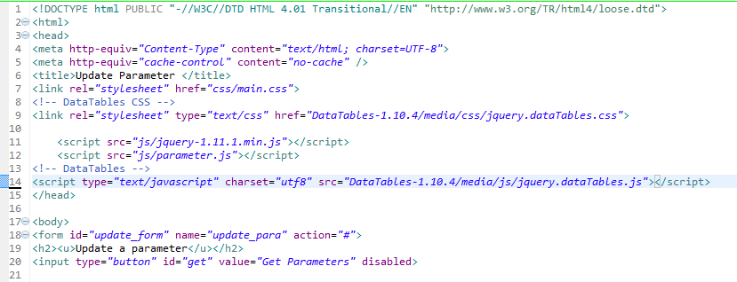

Figure 16: Code snippet for parameter.html

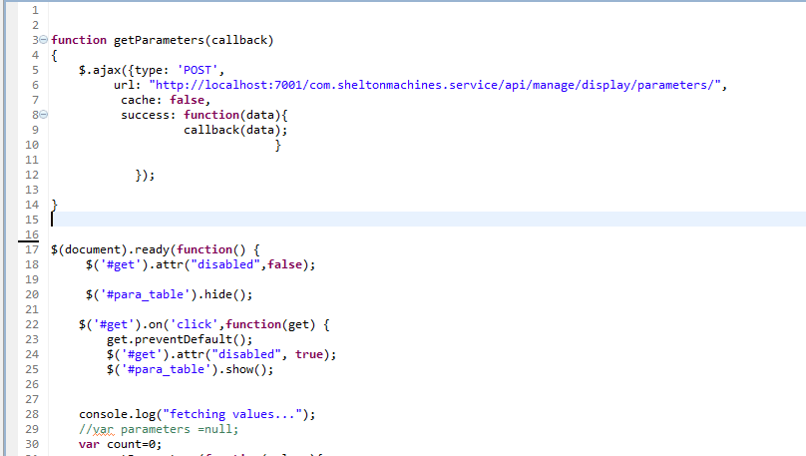

Figure 17: code snippet for parameter.js

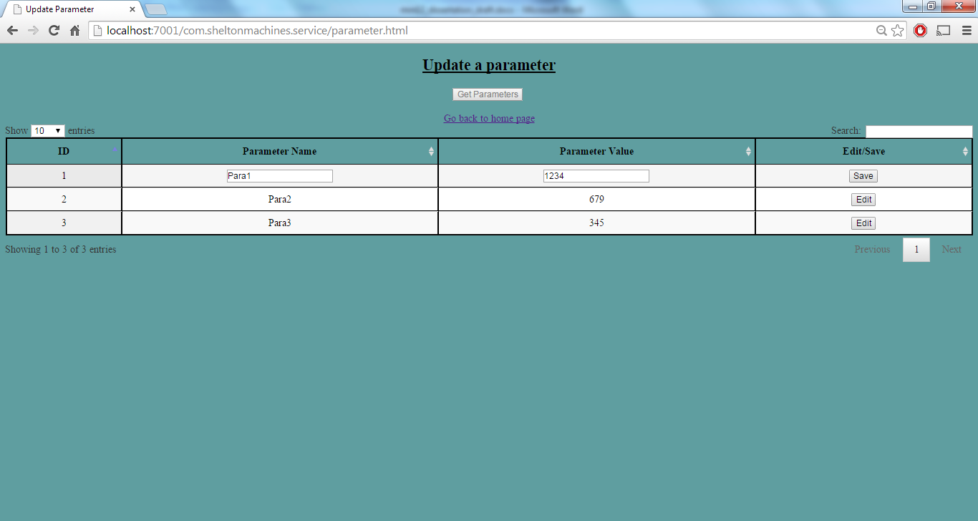

Figure 18: Client Page for Parameter Update

**Scenario iii)** Display graph at client side from a list of vector data

To achieve this, a JavaScript charting library called Highcharts v4.0.4 downloaded from the below link have been used.

* Highcharts V4.0.4 - <http://www.highcharts.com/download>

The html code snippet is shown in figure 19 and the JavaScript code is shown in figure 20. The resulting client page is shown in figure 21.

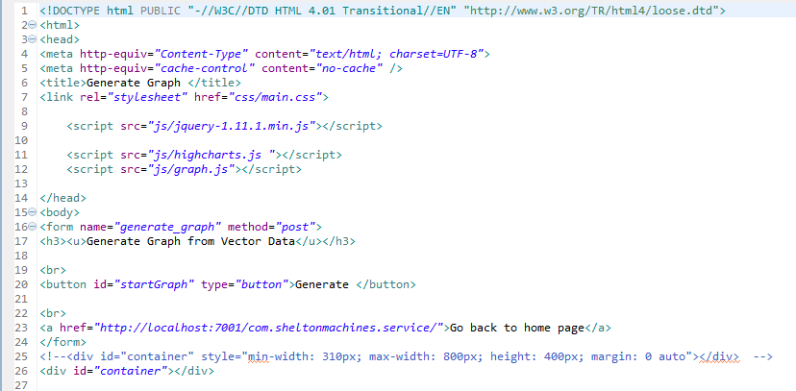

Figure 19: Code snippet for graph.html

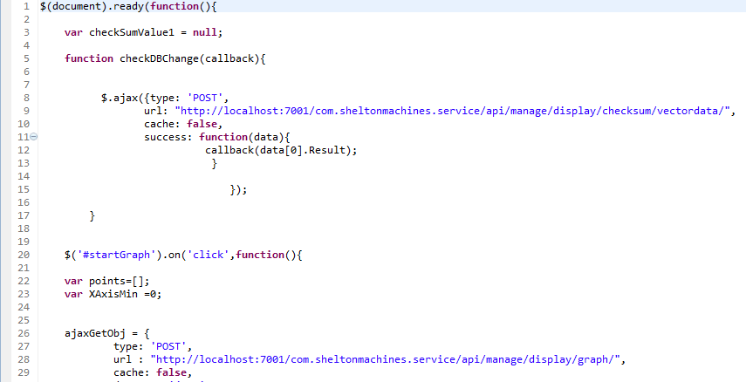

Figure 20: Code snippet for graph.js

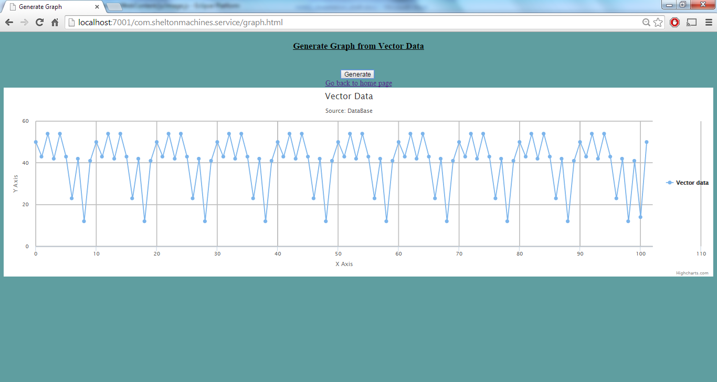

Figure 21: Client page for graph display

**Chapter 8**

1. **Consuming ASP.NET RESTful Web Service by JQuery Client**

In progress..

**Chapter 9**

1. **Project Management**

In progress....

**Chapter 10**

1. **Evaluation of the solution**

There are two subsections for this chapter:

1. Comparative Analysis of the solutions
2. Improvements and future work

Having implemented the web services in Java and C#, this section of the report shall compare the results against each other and draw conclusions on which framework performs better under the given circumstances.

The client is written in the same language. So the comparison lies at examining the performance of the jQuery client while accessing the Java and C# RESTful services.

Given the time scale of the project, only the image streaming scenario is taken into consideration for the comparison purpose.

**Comparative analysis of the solutions:**

**Browser Support:**

|  |  |  |  |  |
| --- | --- | --- | --- | --- |
|  | **IE** | **Google Chrome** | **Mozilla FireFox** | **Opera** |
| **Java REST** | **✓** | **✓** | **✓** |  |
| **.Net REST** |  |  |  |  |

Table 3: Browser compatability

Google chrome is more relaxed about javascript, expecially when downloading an XML/JSON payload.

Fiddler- HTTP debugging proxy

By restful approach, repository for each controller is being cached.

**Look and Feel:**

|  |  |  |  |
| --- | --- | --- | --- |
|  | **Background** | **CSS** | **UI Elements** |
| **Java REST** |  |  |  |
| **.Net REST** |  |  |  |

Table 4: A comparison on look and feel outcomes

**Device Support:**

|  |  |  |  |
| --- | --- | --- | --- |
|  | **Windows OS** | **Mac-iOS** | **Ubuntu-Linux OS** |
| **Java REST** | **✓** |  |  |
| **.Net REST** |  |  |  |

Table 5: Devices supported

**Response time against amount of data:**

A graph with log of time (in milliseconds on Y axis) and the image size in X axis

**Response time against database change:**

A graph with log of time (in milliseconds on Y axis) and time at which database is changed

**Security Records:**

In progress....

**Other factors:**

|  |  |  |
| --- | --- | --- |
|  | **Java REST** | **.Net REST** |
| **Effort of cost** |  |  |
| **Learning effort** |  | **Started on 09/12/14** |
| **Maintainability** |  |  |
| **Proprietary products** |  |  |

Table 6:

**References:**

[1] “JQuery UI 1.8. The User Interface Library for JQuery”,by Dan Wellman

[2]”Apache CXF Web Service Development-Develop and deploy SOAP and RESTful web services”, by Naveen Balani and Rajeev Hathi,PACKT PUBLISHING, BIRMINGHAM-MUMBAI

[3]”Foundations for Efficient Web service Selection”by Qi Yu, Athman Bouguettaya, SPRINGER US, 2010

[4]”Web Services & SOA Principles and Technology”, by Michael.P.Papazoglou, SECOND EDITION,PEARSON

[5]Part 1: Introduction to Jersey—a Standard, Open Source REST Implementation [online], Accessed date [27/09/2014]

Available at: <http://www.oracle.com/technetwork/articles/javaee/jersey-part1-159891.html>

[6] “RESTful Web Services with Jersey” by [Scott Leberknight](http://www.slideshare.net/scottleber?utm_campaign=profiletracking&utm_medium=sssite&utm_source=ssslideview), Software Developer at Near Infinity Corporation, Jun 07, 2014

[7] RESTful Web Services[online], [Accessed date: [27/09/2014]

Available at: <http://www.oracle.com/technetwork/articles/javase/index-137171.html>

[8] RESTfulWeb services: The basics [online], [Accessed date: 14/07/2014]

Abailable at: <http://www.ibm.com/developerworks/webservices/library/ws-restful/>

[9] Web Services based on SOAP and REST Principles [online], [Accessed date: 25/09/2014]

Available at : <http://www.ijsrp.org/research-paper-0513/ijsrp-p17115.pdf>

[10] “Introduction to Client Server Computing” by Yadav, Subash Chandra, Singh, Sanjay Kumar, New Age International, 2009

[11] “REST vs SOAP”, By [Dion Hinchcliffe](http://webservices.sys-con.com/author/5664hinchcliffe.htm) ,April 2005[Accessed date: 19/07/2014]

Available at: <http://zgia.net/?p=30>

## [12] Oracle WebLogic Server [online], [Accessed date: 27/09/2014]

Available at: <http://www.oracle.com/technetwork/middleware/weblogic/overview/index.html>

## [13] virtual-directory-mapping [online], [Accessed date: 29/09/2014]

Available at: <http://docs.oracle.com/cd/E11035_01/wls100/webapp/weblogic_xml.html#wp1039396>

[14] “ Programming PHP”, 3rd edition, By Kevin Tatroe, Peter MacIntyre, RasmusLerdorf (Page: 1)

[15] “Learning JQuery”, By Jonathan Chaffer, Karl Swedberg

[16] Category: Ajax [online], [Accessed date: [29/09/2014]

Available at: <http://api.jquery.com/category/ajax/>

[17]”jQuery:Advantages and Disadvantages” [online], [Accessed date: [29/09/2014]

Available at: <http://www.jscripters.com/jquery-disadvantages-and-advantages/>

[18] “Get Started with ASP.NET” [online], [Accessed date: [29/09/2014]

Available at: <http://www.asp.net/get-started>

[19] What is Highcharts? [online], [Accessed date: 27/10/2014]

Available at: <http://www.highcharts.com/products/highcharts>

[20] <https://ffeathers.wordpress.com/2014/02/16/api-types/> [07/12/14]

[21] “RESTful Java Web Services : Master Core REST Concepts and Create RESTful Web Services in Java” *by*Sandoval, Jose; Packt Publishing, Niovember 2009

[22] Java EE development with Eclipse, by Deepak Vohra, Packt Publishing,December 2012

[23]DataTables Table plug-in for jQuery [online], [Accessed Date: 08/09/14]

Available at: <http://datatables.net/>