**18CA314-Cryptography and Network Security**

**ASSIGNMENT-1**

**2. Find the multiplicative inverse of all the elements in Z5 and Z11**

**Ans:** Multiplicative Inverse of:

Z5->

|  |  |  |  |  |
| --- | --- | --- | --- | --- |
| a | 1 | 2 | 3 | 4 |
| a-1 | 1 | 3 | 2 | 4 |

Z11->

|  |  |  |  |  |  |  |  |  |  |  |
| --- | --- | --- | --- | --- | --- | --- | --- | --- | --- | --- |
| a | 1 | 2 | 3 | 4 | 5 | 6 | 7 | 8 | 9 | 10 |
| a-1 | 1 | 6 | 4 | 3 | 9 | 2 | 8 | 7 | 5 | 10 |

**3. Determine the gcd of 56245 and 43159**

**Ans:** 56245=43159*1+13086

43159=13086*3+3901

13086=3901*3+1383

3901=1383*2+1135

1383=1135*1+248

1135=248*4+143

248=143*1+105

143=105*1+38

105=38*2+29

38=29*1+9

29=9*3+2

9=2*4+1

2=**1**\*2+0

Therefore, gcd(56245,43159)=1.

**4. Compute phi(n) for 34 and 210**

**Ans:** According to Euler’s product formula

Phi(34)=34*(1-(1/3))

=81*2/3

=54.

Phi(210)=210*(1-(1/2))

=1024*1/2

=512.

**5. Compute 3100 mod(31319)**

**Ans:** Here e=100 =>26+25+22

30 mod 31319=3

32 mod 31319=9

34 mod 31319=81

38 mod 31319=6561

316 mod 31319=14418

332 mod 31319=21979

364 mod 31319=12185

3100 mod(31319)=12185*21979*81 mod 31319

=5346*81 mod 31319

=25879.

**PART-B**

1. Write a program to implement Extended Euclidean Algorithm and find multiplicative inverse for following values.

**Source code**

#include<iostream>

using namespace std;

int Exteuc(int a, int b, int *x, int *y)

{

if (a == 0)

{

*x = 0, *y = 1;

return b;

}

int x1, y1;

int gcd = Exteuc(b%a, a, &x1, &y1);

*x = y1 - (b/a) * x1;

*y = x1;

return gcd;

}

int main()

{

int a, m;

cin>>a>>m;

int x, y;

int g = Exteuc(a, m, &x, &y);

if (g != 1)

cout << "\n Inverse does not exist. ";

else

{

int res = (x%m + m) % m;

cout << "\nMultiplicative inverse of( "<<a<<","<<m<<") is "<< res;

}

return 0;

}

(a) 53947-1 mod 56211

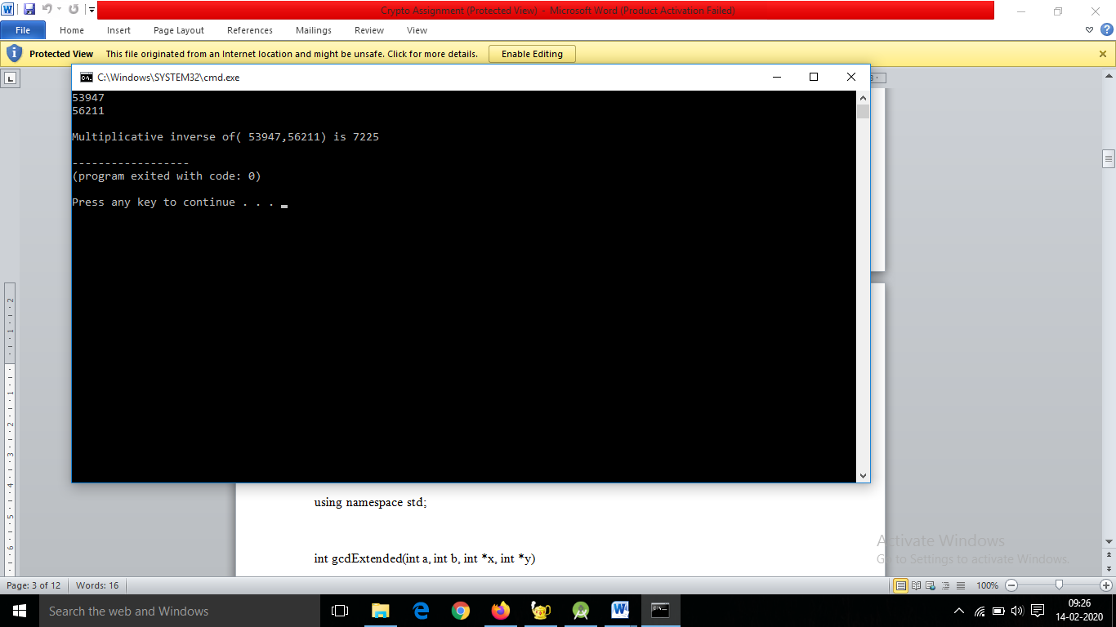

(b) 19385-1 mod 431592.

