Date : 04-08-2021

Session : Basic Introduction of stuents / Introduction to basic html /Software setup

Task given : Create github account and upload code with various versons & Basic html controls

My Task : Today , I have learn basic introduction with html & git version control system for upload code

With various versions using gitbash & github desktop both.

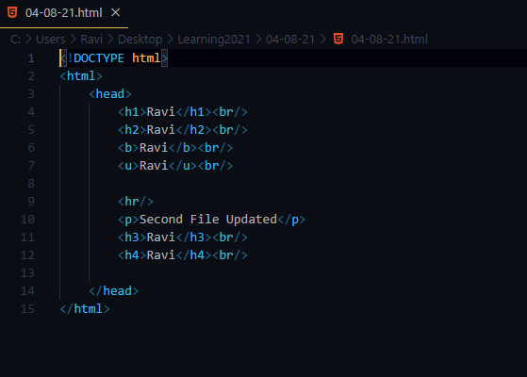

-> GitBash

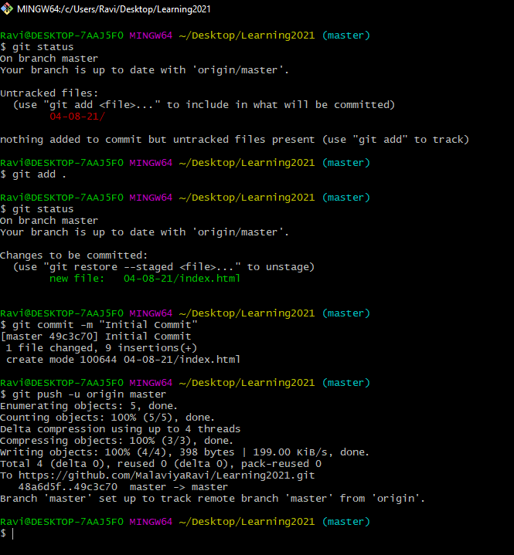

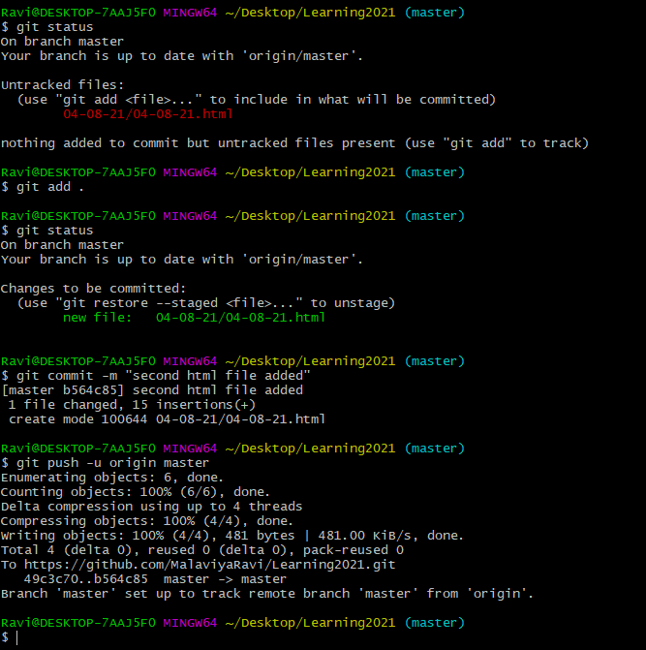

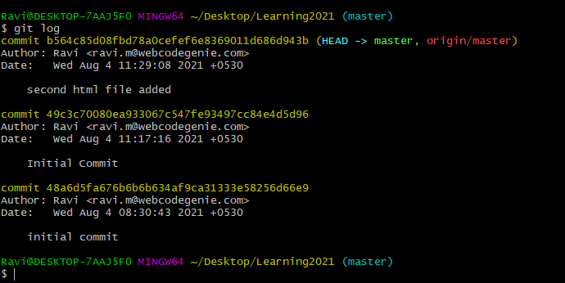

->Github Desktop

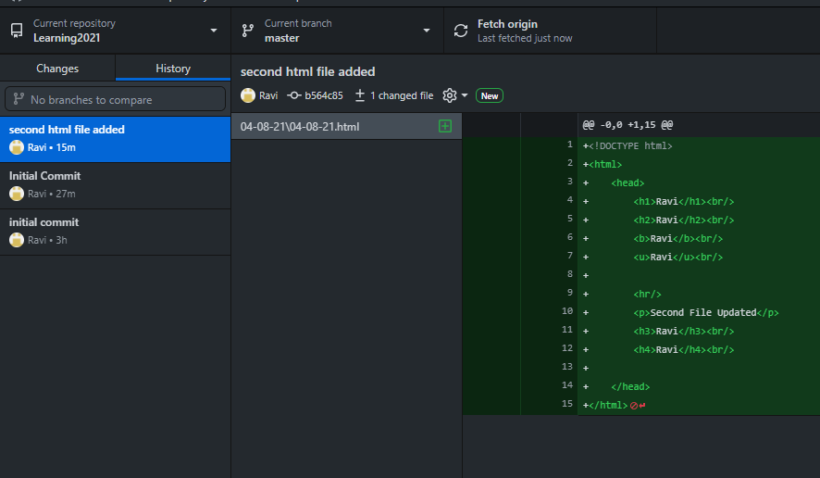

Output :

