Date : 09-08-2021

Session : Table, Frameset, iframe, List Tags(Final Session On Html5)

Task given : Create html layout using table & from tag of perticuler images

My Task : I have Completed today’s task using form & table tag.

**Output :**

Table1:

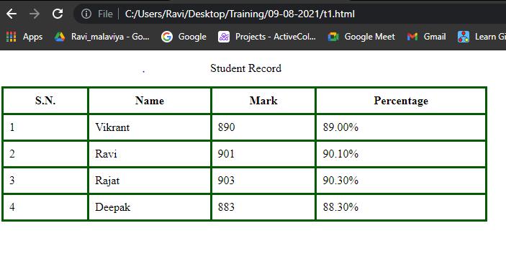

Table 2:

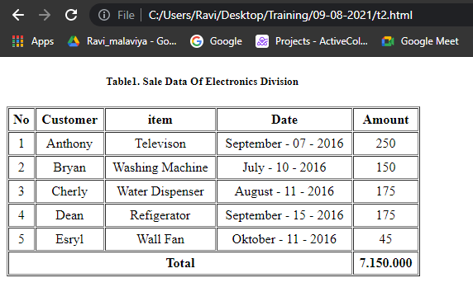

Table 3:

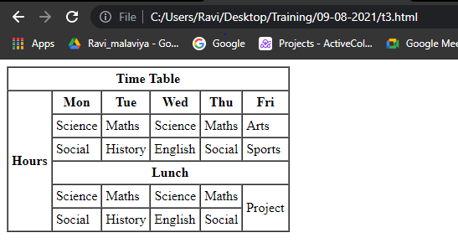

Table 4:

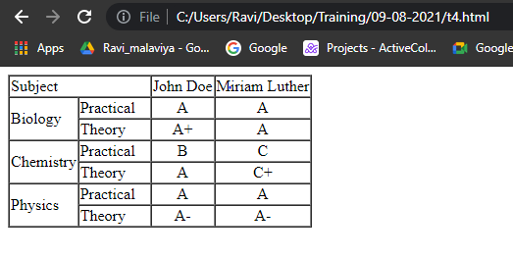

Table 5:

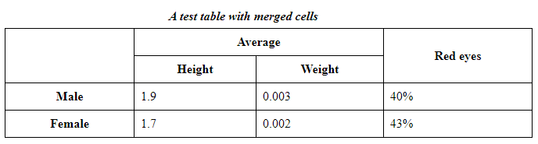

Form 1:

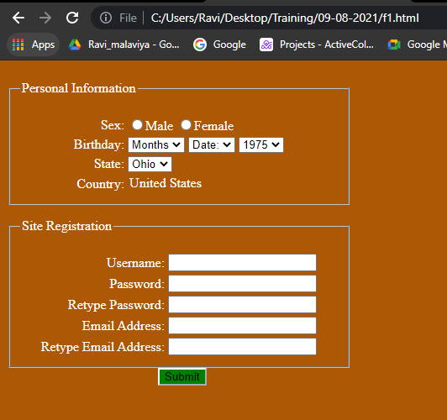

Form 2 :

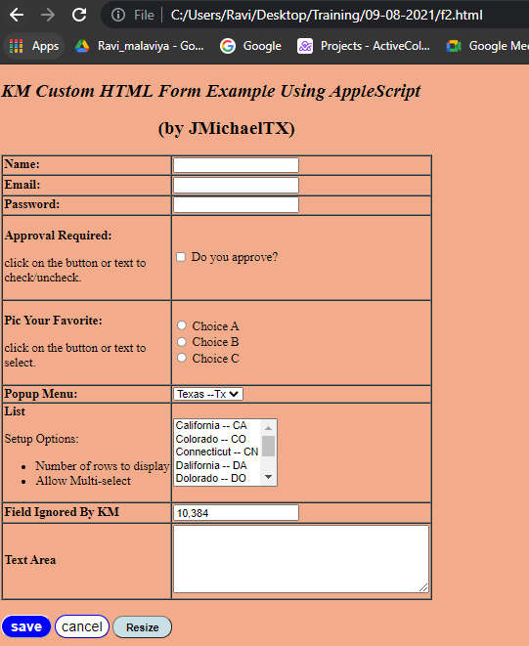

Form 3 :

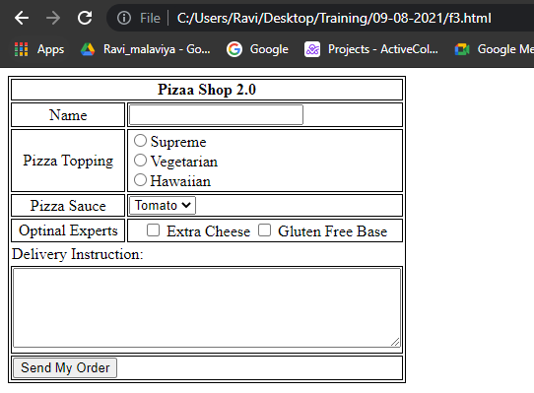

Table 6:

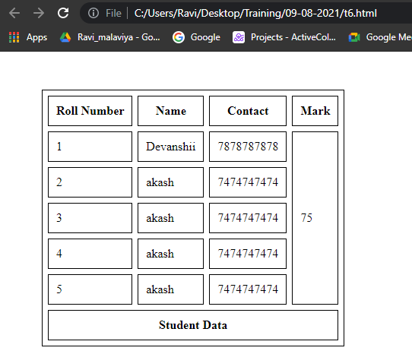

ListTask-1:

