Date : 20-08-2021

Session : Introduction to Jquery(Basics)

Task given :

1. Learn Jquery
2. Perform Practical
3. Explore Websites
4. Try To Understand Jquery Plugin

My Task :

|  |  |  |  |
| --- | --- | --- | --- |
| **No.** | **Task Details** | **Start Time** | **End Time** |
| 1 | Session | 09.30 AM | 11.30 AM |
| 2 | PPT Revision | 11.30 AM | 01:00 PM |
| 3 | Change event demo | 01.00 AM | 01.30 PM |
| 4 | Break | 01.30 PM | 02.00 PM |
| 5 | Dom Jquery | 02.00 PM | 02.30 PM |
| 6 | Event Delegations | 02.30 PM | 03.00 PM |
| 7 | Events In Jquery | 03.00 PM | 03.30 PM |
| 8 | Jquery Animate Function | 03.30 PM | 04.00 PM |
| 9 | Jquery Css | 04.00 PM | 04.15 PM |
| 10 | Jquery Effect | 04.15 PM | 04.20 PM |
| 11 | Explore Jquery In Depth | 04.20 PM | 05.45 PM |
| 12 | Try to Understand website source code  - <https://threebestrated.in/pizza-outlets-in-surat-gj>  - <https://webcodegenie.com/>  - <https://www.infoline.com/shree-jalaram-kharadi-furniture-works>  - <https://www.havmor.com/>  - <http://www.amul.com/index.php> | 05.45 PM | 06.50 PM |
| 10 | PMS, GIT, & Report | 06.50PM | 07.00 PM |

OUTPUT :

Change event Demo

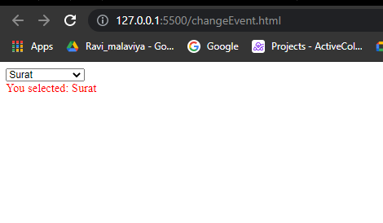

Dom Manipulation Jquery

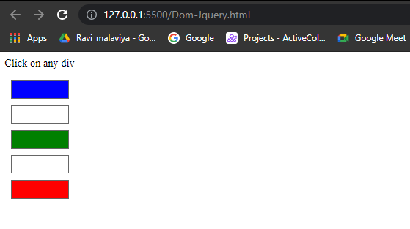

Event Delegations

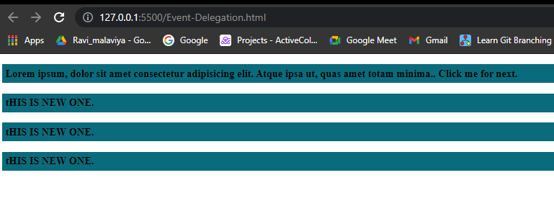

Events In Jquery

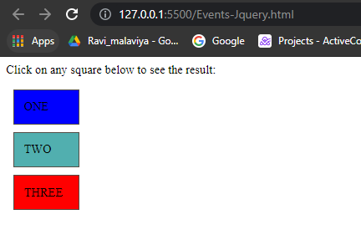

Jquery Animate Function

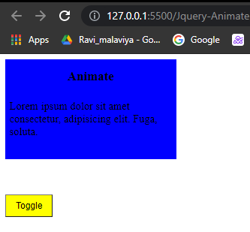

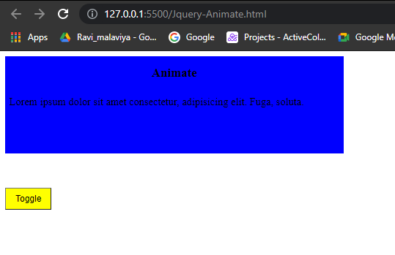

Jquery Css

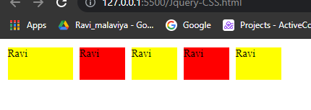

Jquery Effect

