Date : 27-08-2021

Session : - No Morning Session

Task given :

1. Jquery Cheatsheet read and implement it.
2. Work on given project of Jquery plugin.

My Task :

|  |  |  |  |
| --- | --- | --- | --- |
| **No.** | **Task Details** | **Start Time** | **End Time** |
| 1 | Working on Jquery Plugin project | 09.30 AM | 01.30 PM |
| 2 | Lunch Break | 1.30 PM | 2.20 PM |
| 3 | Jquery Cheatsheet | 2.20 PM | 6.30 PM |
| 4 | PMS, GIT, & Report | 06.30PM | 07.00PM |

OUTPUT :

Jquery Manipulation

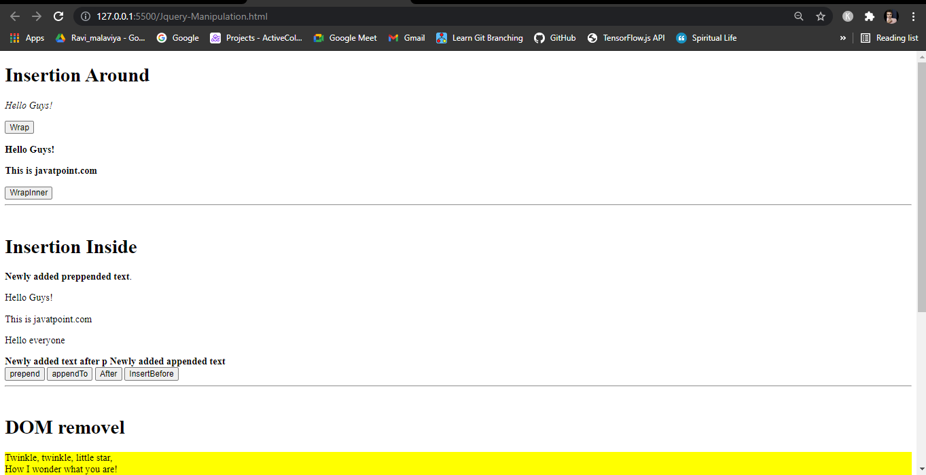

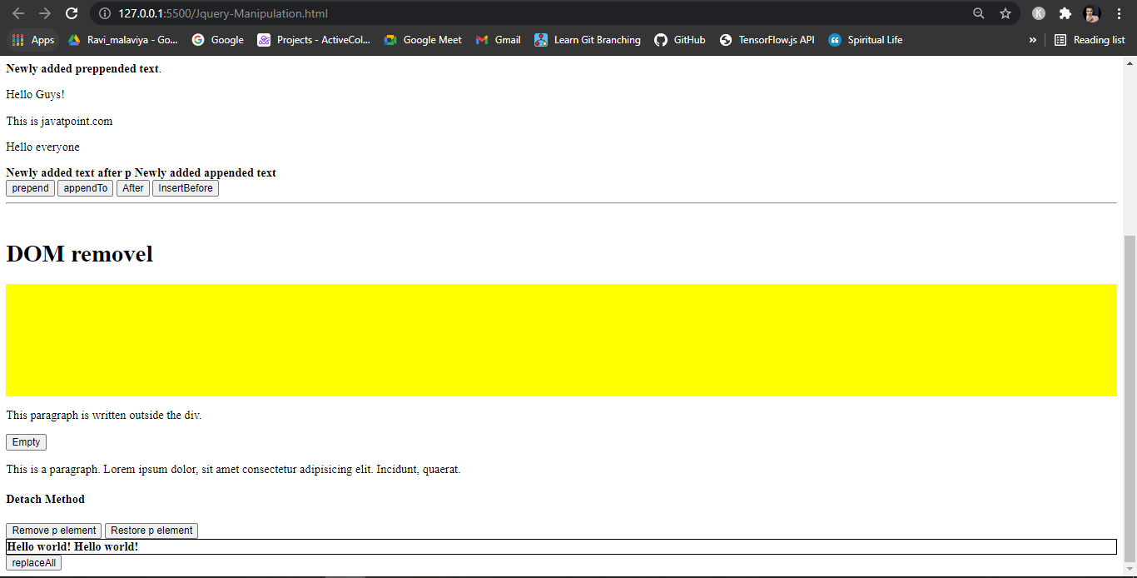

Jquery Traversal

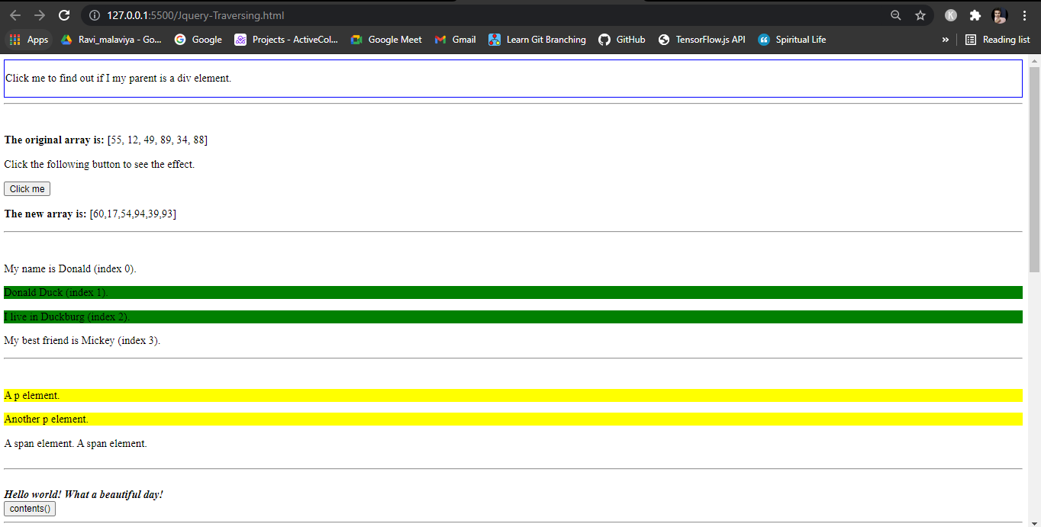

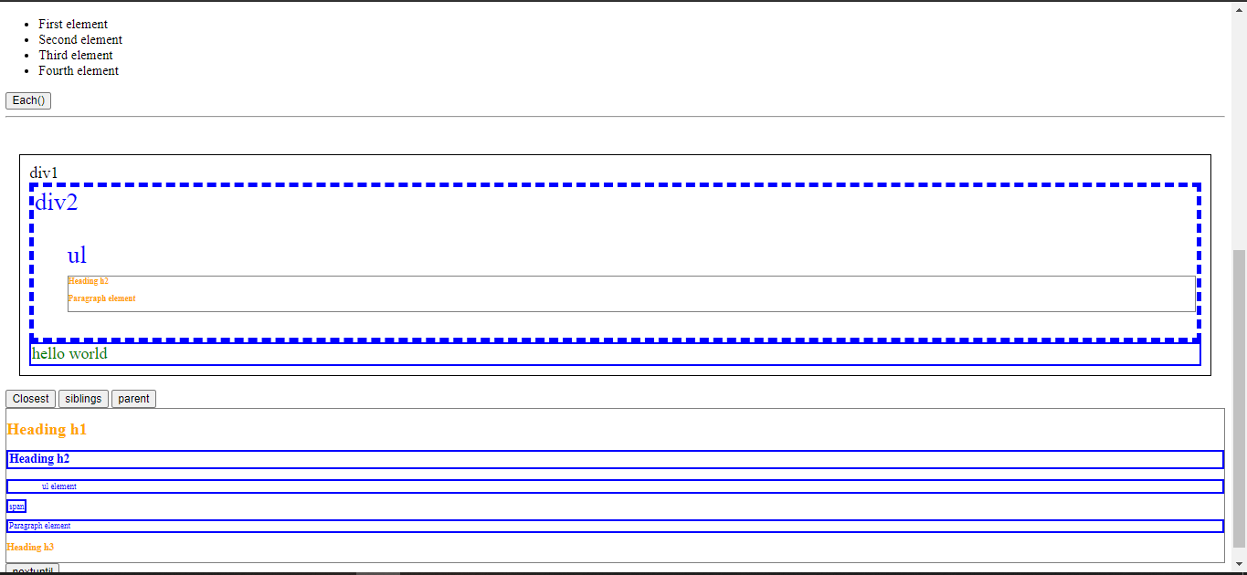

Jquery Plugin Project

