Date : 31-08-2021

Session : - Error Talks And Introduce new Jquery plugin

Task given :

1. Implement new Jquery Jquery plugin.
2. Read about jquery AJAX

My Task :

|  |  |  |  |
| --- | --- | --- | --- |
| **No.** | **Task Details** | **Start Time** | **End Time** |
| 1 | Session | 09.30 AM | 10.20 AM |
| 2 | Working on Jquery Plugin project | 10.20 AM | 10.50 AM |
| 3 | Implement new jquery plugin | 10.50 AM | 01.30 PM |
| 4 | Read About Jquery AJAX | 02.30 PM | 06.00 PM |
| 4 | PMS, GIT, & Report | 06.30PM | 07.00PM |

OUTPUT :

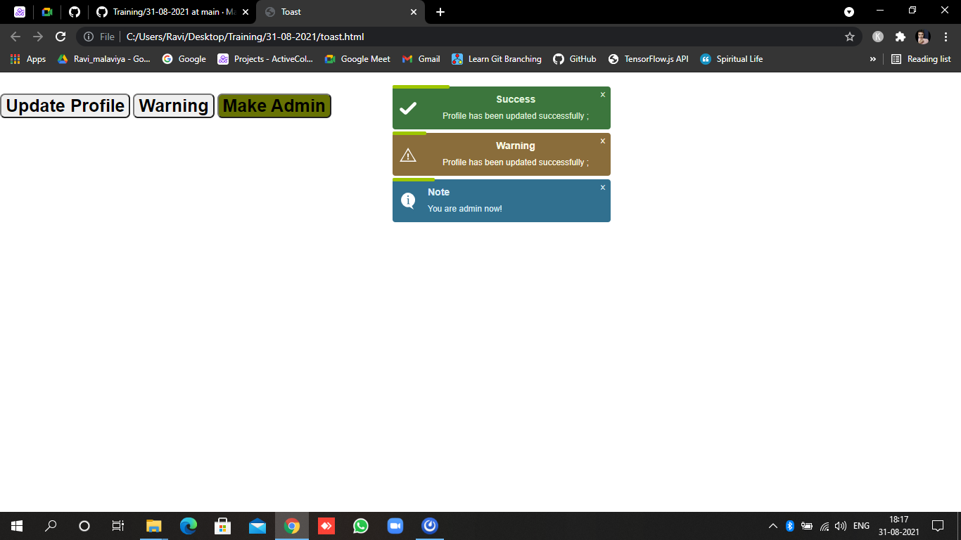

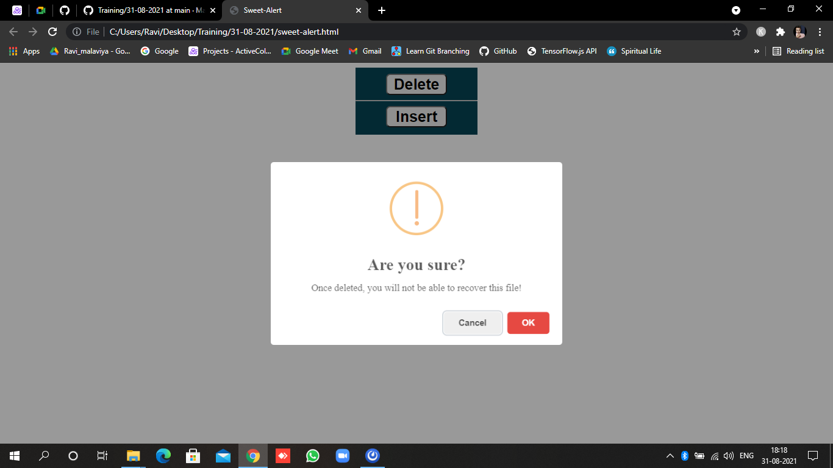

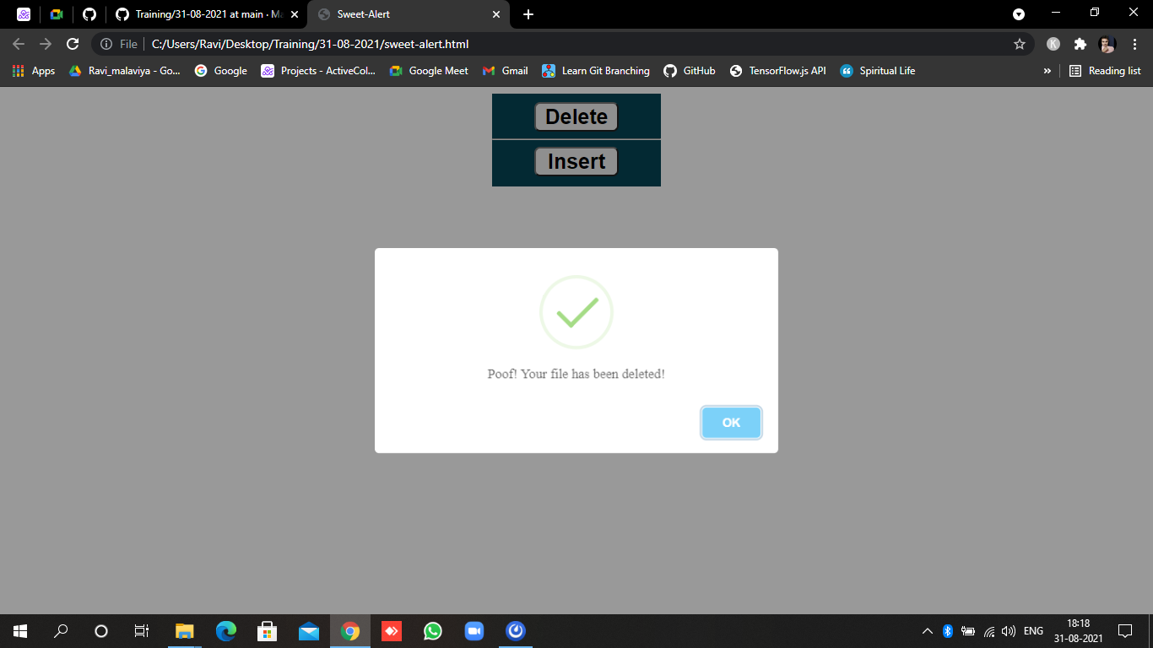

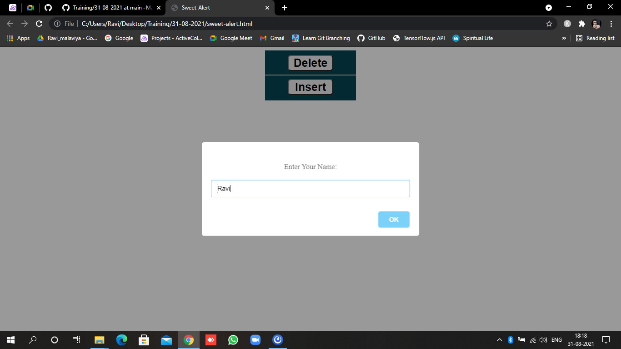

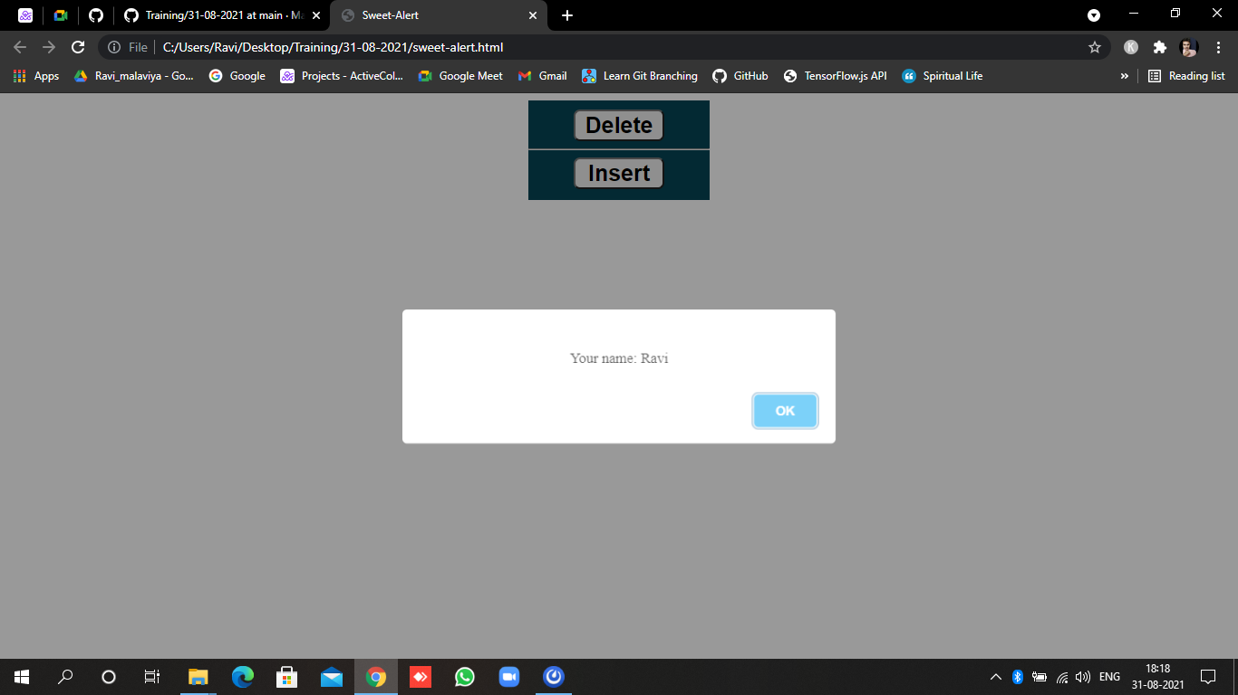

Chart.js

