Date : 11-08-2021

Session : Learn about various properties like display, float, clear, etc.. & CSS3 Advance stuffs.

Task given : Modify given template and integrate various navigation pages.

My Task :I have integrated about-us page & contact-us page and modified blog page.

**Output :**home page

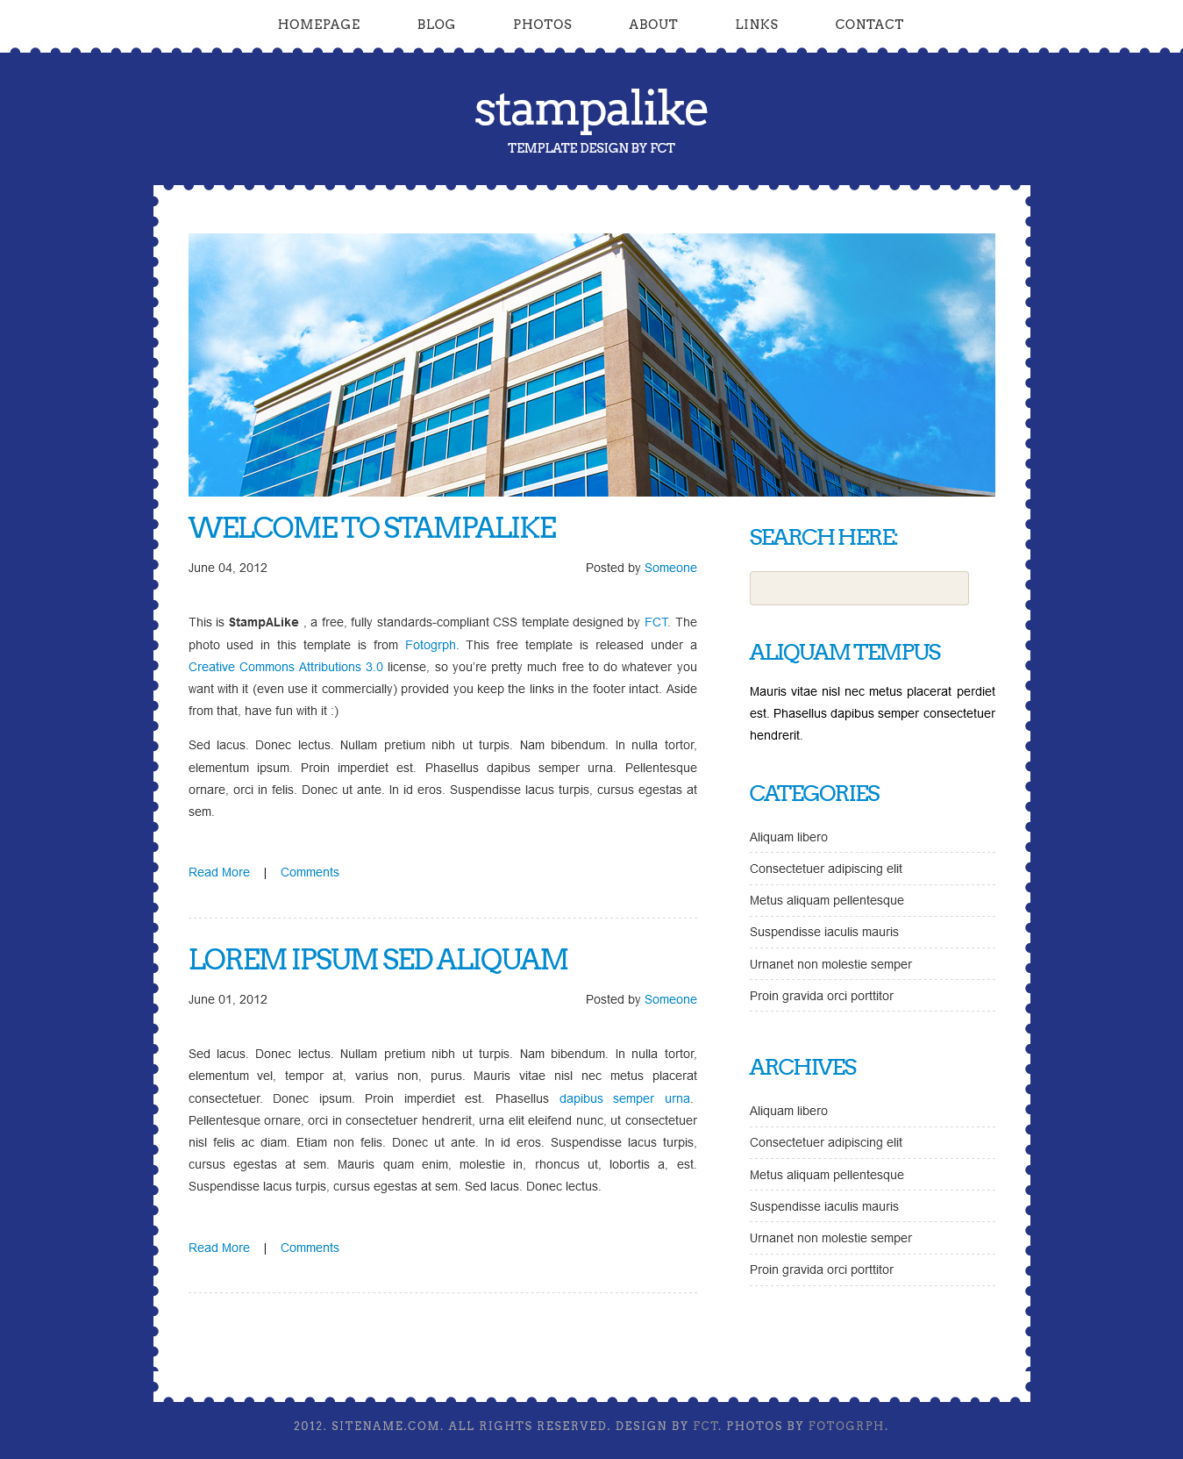

About page

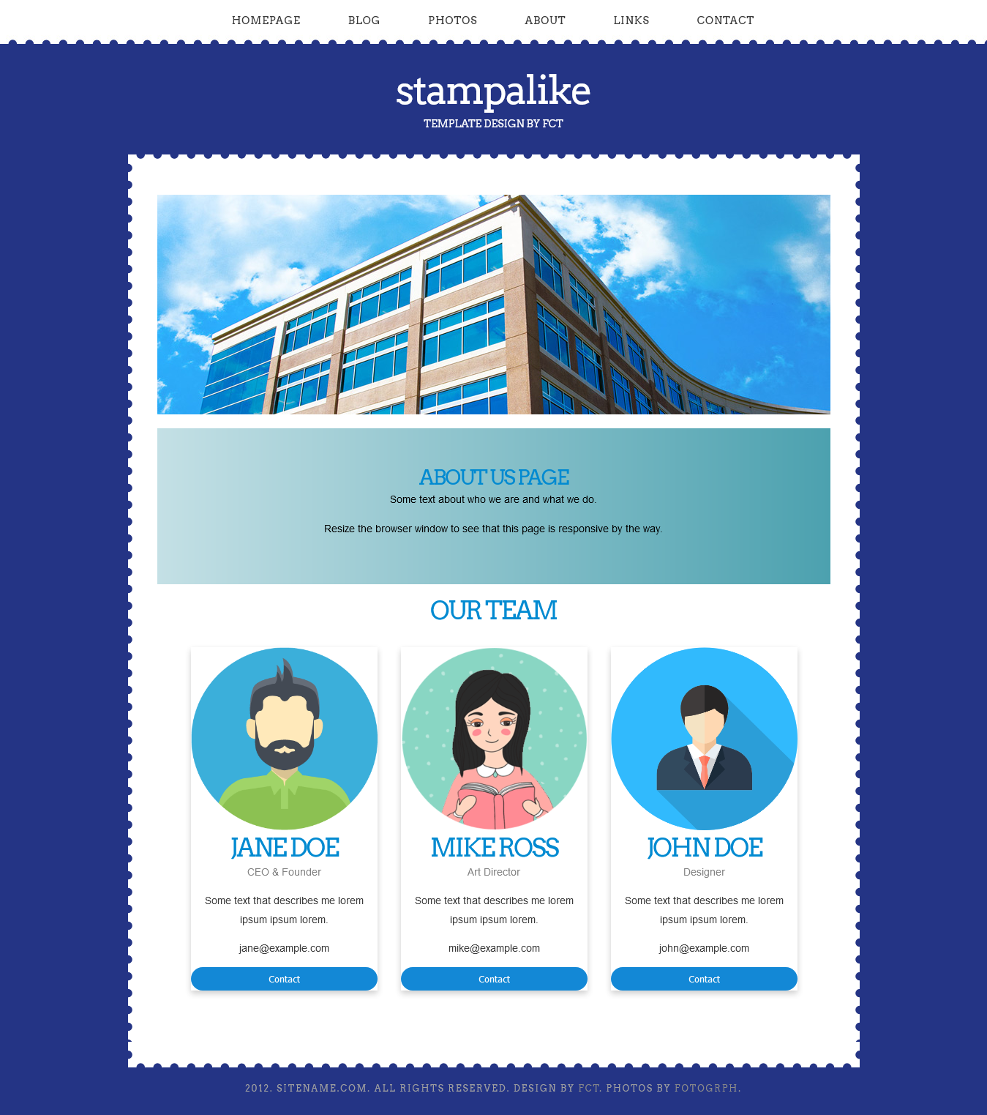

Blog page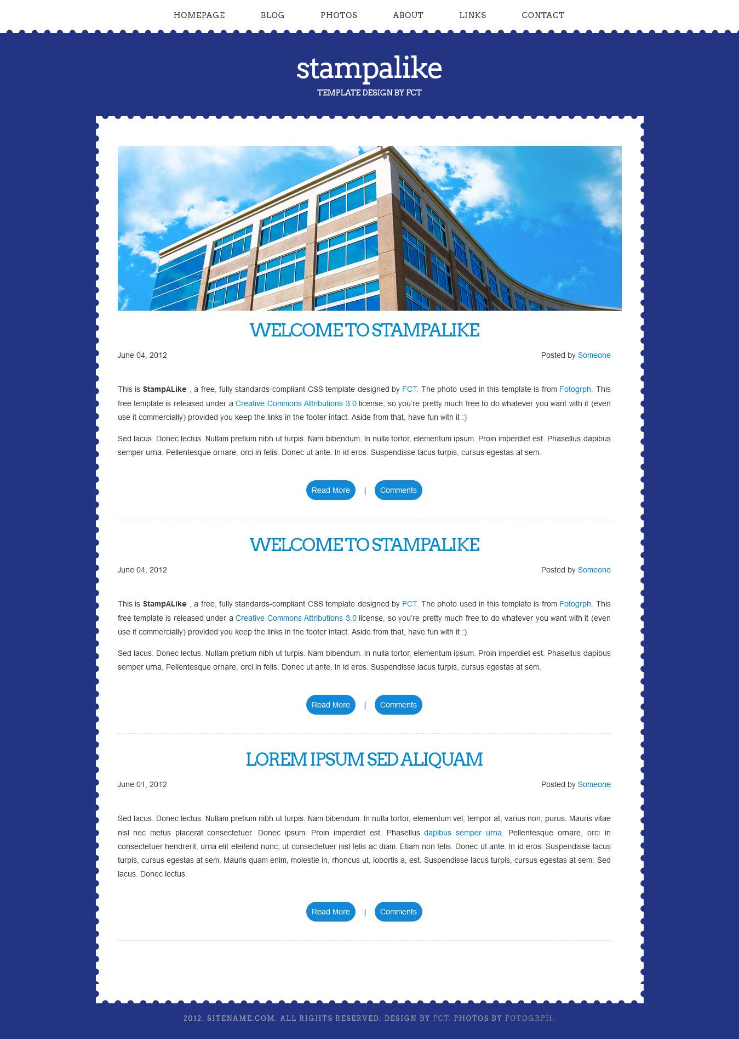

Contact us page

