Date : 18-08-2021

Session : Explain About SessionStorage & LocalStorage

Task given :

1. Read PPT
2. Counter Project
3. Todo app without localstorage
4. Todo app with localstorage

My Task :

|  |  |  |  |
| --- | --- | --- | --- |
| **No.** | **Task Details** | **Start Time** | **End Time** |
| 1 | Session | 10.00 AM | 11.30 AM |
| 2 | PPT Revision | 11.30 PM | 12.30 PM |
| 3 | Counter Project | 12.30 PM | 1.00 PM |
| 4 | Todo App Complete - Simple | 1.00 PM | 2.15 PM |
| 5 | Break | 2.15 PM | 3.00 PM |
| 6 | Todo App localStorage Bug Solve | 3.00 PM | 3.30 PM |
| 7 | Working On CRUD Using localStorage | 3.30 PM | 6.30 PM |
| 8 | Task Github Upload & Report Done | 6.30 PM | 7.00 PM |

.

OUTPUT :

Counter –

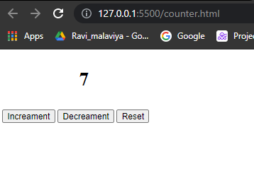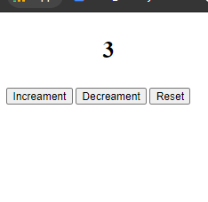

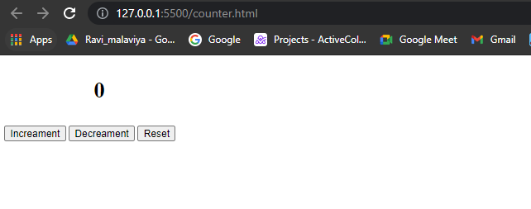

2. Simple Todo

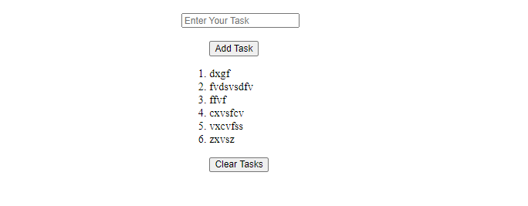

After Clear Tasks

3. Local Storage Todo App

-Initial State

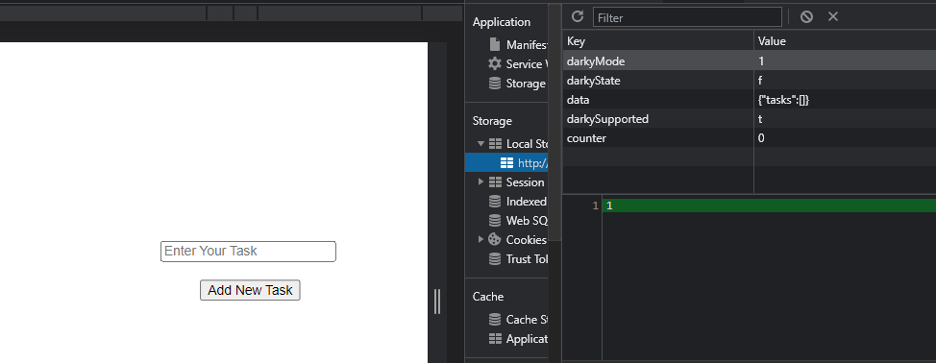

2. After Adding Task

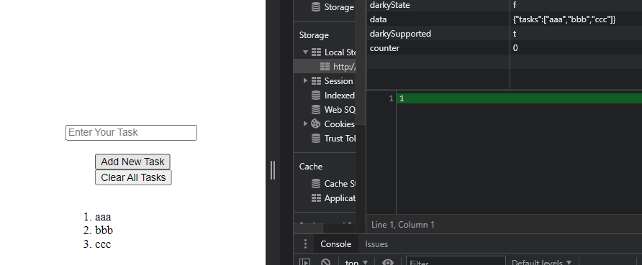

3. After Clear All Task.

