Date : 19-08-2021

Session : Explain addEventListener & Timer Funtions

Task given :

1. Image Change Using Event(Image Slider)
2. Events on html tags(div, p..)
3. Color picker
4. Form input tag’s events
5. Countdown
6. Stop event propagation

My Task :

|  |  |  |  |
| --- | --- | --- | --- |
| **No.** | **Task Details** | **Start Time** | **End Time** |
| 1 | Session | 09.30 AM | 10.30 AM |
| 2 | PPT Revision | 10.30 AM | 11.00 AM |
| 3 | Image Change Using Event(Image Slider) | 11.30 AM | 12.30 PM |
| 4 | Events on html tags(div, p..) | 12.30 PM | 1.00 PM |
| 5 | Color picker | 1.15 PM | 1.45 PM |
| 6 | Form input tag’s events | 1.45 PM | 3.00 PM |
| 7 | Countdown | 3.00 PM | 4.30 PM |
| 8 | Stop event propagation | 4.30 PM | 5.00 PM |
| 9 | Explore Jquery | 5.00 PM | 6.30 PM |
| 10 | Code Upload & Report | 6.30 PM | 7.00 PM |

OUTPUT :

Image Change Using Event(Image Slider)

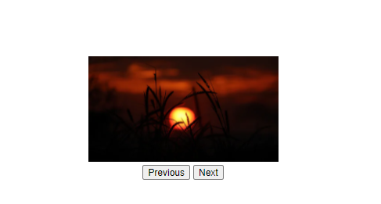

Events on html tags(div, p..)

-mouseover

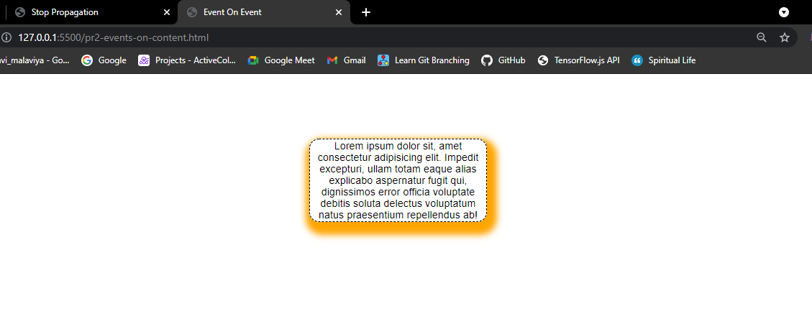

-mouseout

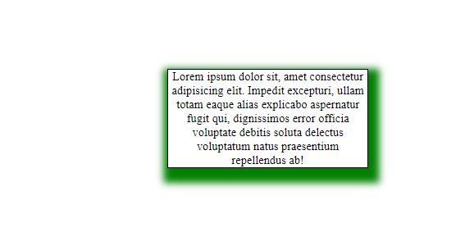

Color picker

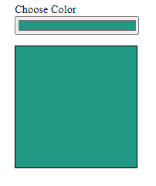 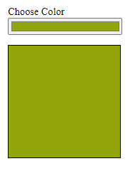 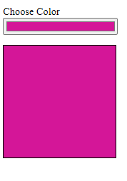

Form tag’s events

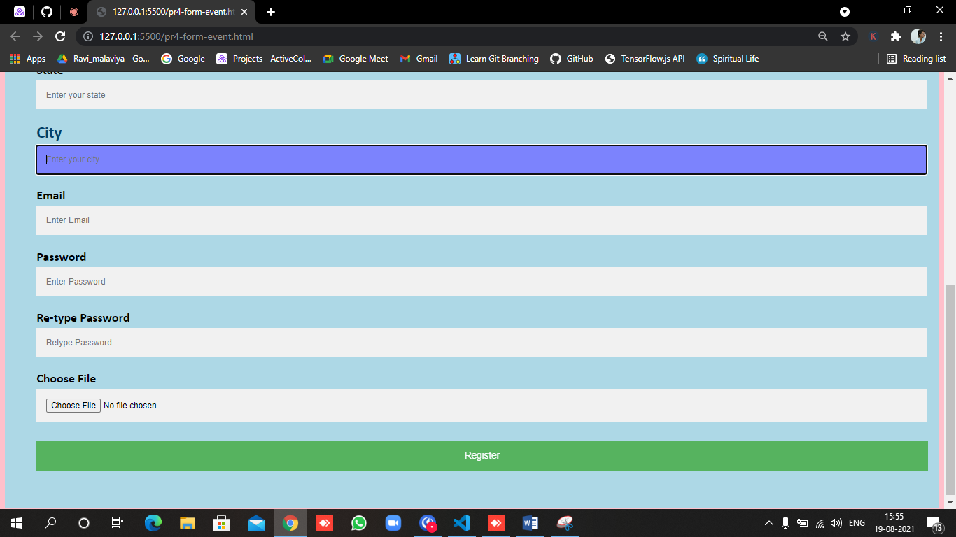

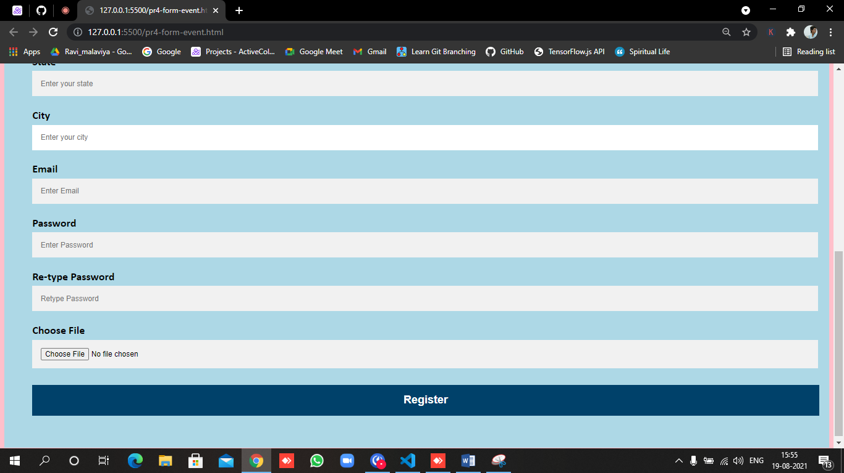

Countdown

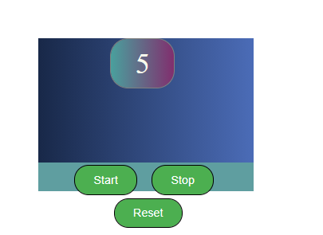

Stop event propagation

-before propagation

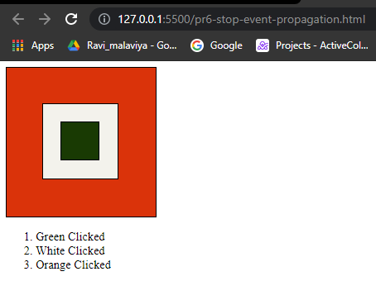

After stop propagation from white div(div2)

