Date : 26-08-2021

Session : - No Morning Session

Task given :

1. Jquery Cheatsheet read and implement it.
2. Work on given project of Jquery plugin.

My Task :

|  |  |  |  |
| --- | --- | --- | --- |
| **No.** | **Task Details** | **Start Time** | **End Time** |
| 1 | Jquery Cheatsheet read and implement it. | 10.00 AM | 4.20 PM |
| 2 | Lunch Break | 1.00 PM | 2.00 PM |
| 3 | Session | 4.20 PM | 5.30 PM |
| 4 | Working on jqery plugin project(Continue…) | 05.30 PM | 06.40 PM |
| 5 | PMS, GIT, & Report | 06.40PM | 07.00PM |

OUTPUT :

CSS Attribute

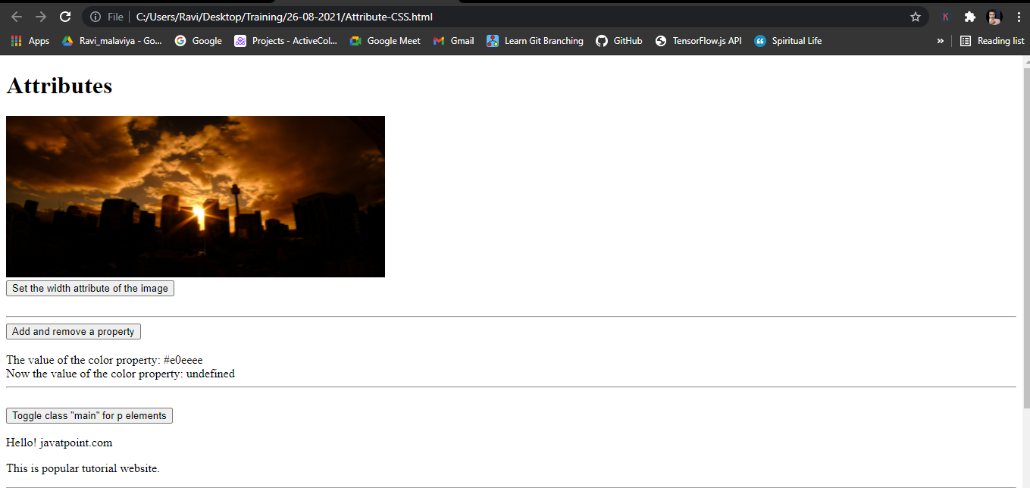

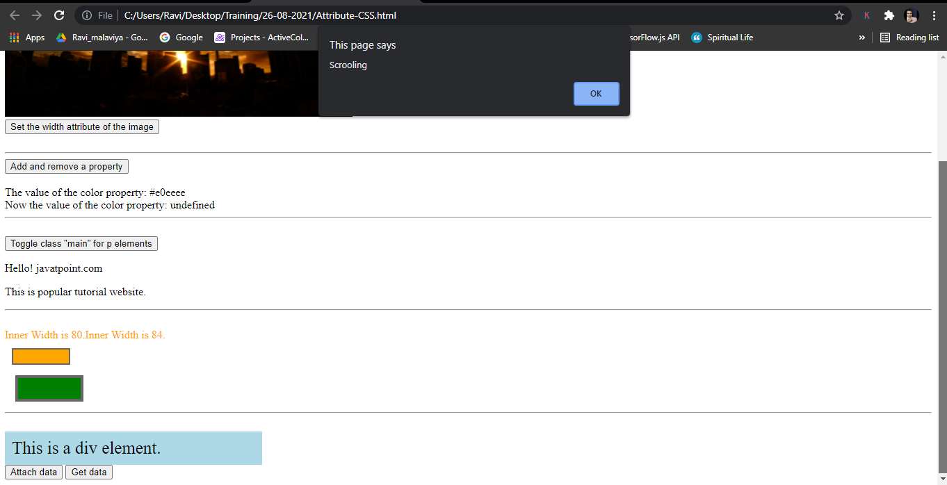

Jquery Selector

