DevOps Cloud Assignment
Implementation Documentation

By: Malav Shah
Email ID: shahmalav1999@gmail.com
Contact Details: +91 8355817127
Cloud Platform: Amazon Web Services (AWS) | Region: ap-south-1 (Mumbai)
Repository: https://github.com/Malavshah999/devops-assignment-case1.git

1. Assignment Overview
This assignment covers two infrastructure cases, both deployed on Amazon Web Services (AWS) in the ap-south-1 (Mumbai) region. The goal was to design, implement, secure, and document a production-grade cloud infrastructure demonstrating DevOps best practices.

Case | Objective | Key Services Used
Case 1 | Serverless Dockerized Service with JWT Auth | ECS Fargate, ALB, CloudFront, ECR, VPC
Case 2 | Secure Public Bucket Storage via CDN only | S3, CloudFront OAC, IAM, Bucket Policies

2. Pre-requisites

Tool | Version | Purpose
Git | 2.44+ | Version control for all code
Node.js | v20.x LTS | Runtime for Express application
Docker Desktop | 4.29+ | Build and run containers locally
AWS CLI | v2 | Interact with AWS from terminal

3. Case 1 — Serverless Dockerized Service

3.1 Architecture Overview
The application is designed so that the container running the actual code is NEVER directly reachable from the internet. All traffic must flow through the CDN and Load Balancer layers.

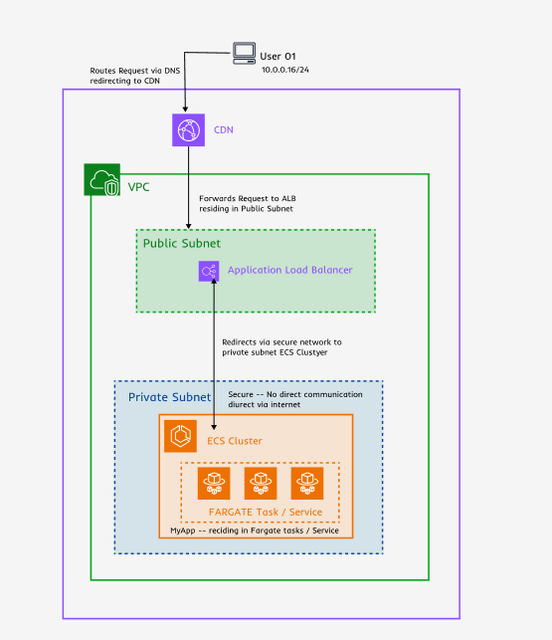

Fig (3.1 Figma chart of Architecture overview)

Layer | Component | Subnet Type | Purpose
Edge | CloudFront CDN | Global Edge | CDN caching, HTTPS termination, DDoS protection
Public | Application Load Balancer (ALB) | Public Subnet | Routes traffic, health checks, SSL offload
Private | ECS Fargate Container | Private Subnet | Runs the Express.js application

3.2 Application Code
A Node.js Express application was built with the following features:

Endpoint | Method | Auth Required | Description
/health | GET | No | Health check for ALB
/login | POST | No | Accepts username+password, returns JWT token
/items | GET | Yes (Bearer JWT) | Protected list — returns items only with valid token

Authentication Flow
- User sends /login with { username: 'admin', password: 'password123' }
- Server validates credentials against hardcoded mock user store
- On success, server signs a JWT token with a secret key (1 hour expiry)
- Client includes token in subsequent requests: Authorization: Bearer <token>
- authMiddleware verifies token on every protected route
- Invalid/missing token returns 401 Unauthorized

3.3 Docker Configuration
The application was containerized using a multi-security-layer Dockerfile:

3.4 AWS Infrastructure Setup
Step 1 — VPC and Network Configuration
A dedicated Virtual Private Cloud (VPC) was created to isolate all resources:

Resource | CIDR / Config | Purpose
VPC (devops-vpc) | 10.0.0.0/16 | Isolated network for all resources
Private Subnet | 10.0.1.0/24 — ap-south-1a | ECS Fargate tasks run here — no direct internet
Public Subnet | 10.0.2.0/24 — ap-south-1b | ALB and NAT Gateway live here
Internet Gateway | Attached to VPC | Allows public subnets to reach internet
NAT Gateway | In Public Subnet | Allows private subnet to pull ECR images outbound
Route Table (Public) | 0.0.0.0/0 -> IGW | Routes internet traffic for public subnets
Route Table (Private) | 0.0.0.0/0 -> NAT GW | Routes outbound traffic through NAT for private subnet

Step 2 — Amazon ECR (Container Registry)
Amazon Elastic Container Registry was created to store Docker images:
- Repository name: devops-case1
- Region: ap-south-1
- URI: 417492524162.dkr.ecr.ap-south-1.amazonaws.com/devops-case1
- Images tagged as :latest on every CI/CD pipeline run

Step 3 — ECS Fargate Cluster and Service

ECS Component | Configuration
Cluster Name | my-cluster
Service Name | my-service
Launch Type | FARGATE (serverless — no EC2 instances to manage)
Task CPU | 256 (.25 vCPU)
Task Memory | 512 MB
Container Port | 3000
Network Mode | awsvpc (each task gets its own ENI)
Subnet | Private subnet (10.0.1.0/24)
Public IP | DISABLED — container is not internet-accessible
Desired Count | 1 running task
Execution Role | ecsTaskExecutionRole with AmazonECSTaskExecutionRolePolicy

Step 4 — Application Load Balancer

ALB Setting | Value
Name | devops-alb
Scheme | Internet-facing
Subnets | Both public subnets (two AZs for HA)
Listener HTTP (80) | Forward to Target Group devops-tg
Target Group Protocol | HTTP on port 3000
Target Type | IP (required for Fargate awsvpc mode)
Health Check Path | /health
Health Check Interval | 30 seconds
Healthy Threshold | 2 consecutive successes

Step 5 — Security Groups

Security Group | Inbound Rule | Purpose
devops-alb-sg (ALB) | HTTP 80 from 0.0.0.0/0 | Allow web traffic to reach ALB
devops-alb-sg (ALB) | HTTPS 443 from 0.0.0.0/0 | Allow secure traffic to reach ALB
devops-ecs-sg (ECS) | TCP 3000 from devops-alb-sg only | Only ALB can reach containers — not public internet

3.5 CI/CD Pipeline
A GitHub Actions workflow was implemented to fully automate the build and deployment process on every code push.
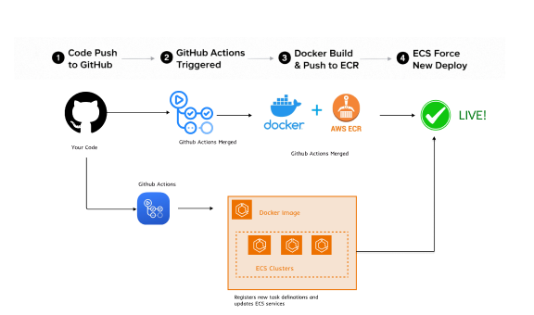
Pipeline Stage | Action | Tool
Trigger | Any push to main branch | GitHub Actions
Checkout | Pull latest code from repository | actions/checkout@v4
Docker Hub Auth | Check-in to docker hub via variables stored in repo | docker/login-action@v3
AWS Auth | Authenticate using IAM access keys from secrets | aws-actions/configure-aws-credentials@v4
ECR Login | Authenticate Docker to push to ECR | aws-actions/amazon-ecr-login@v2
Docker Build | Build image from Dockerfile in ./app | docker build command
Docker Push | Push image tagged :latest to ECR repository | docker push command
ECS Deploy | Force new deployment service — ECS pulls latest image | aws ecs update-service --force-new-deployment

GitHub Actions Secrets Configured
- AWS_ACCESS_KEY_ID — IAM user access key for CI/CD deployments
- AWS_SECRET_ACCESS_KEY — IAM user secret key
- DOCKERHUB_USERNAME — Docker Hub username (malavsh)
- DOCKERHUB_TOKEN — Docker Hub personal access token

IAM Permissions Issue Resolved
During setup, the IAM user MalavTest encountered permission errors because it lacked the necessary policies. This was resolved by:
Logging in with the root AWS account
Checking for and removing any permissions boundary on the user
Attaching the following managed policies:
AmazonEC2ContainerRegistryFullAccess,
AmazonECS_FullAccess,
AmazonVPCFullAccess,
ElasticLoadBalancingFullAccess,
CloudFrontFullAccess,
AmazonS3FullAccess,
SecretsManagerReadWrite,
CloudWatchFullAccess

3.6 CloudFront Configuration

CloudFront Setting | Value
Origin | ALB DNS name
Cache Behavior - /health | Cache enabled (static response)
Cache Behavior - /login | No cache (dynamic, auth endpoint)
Cache Behavior - /items | No cache (dynamic, protected data)

4. Case 2 — Secure Public Bucket Storage

4.1 Architecture Overview
The objective was to serve static content (HTML, CSS, images) to the public WITHOUT ever allowing direct access to the S3 bucket URL. All access must go through CloudFront using Origin Access Control.
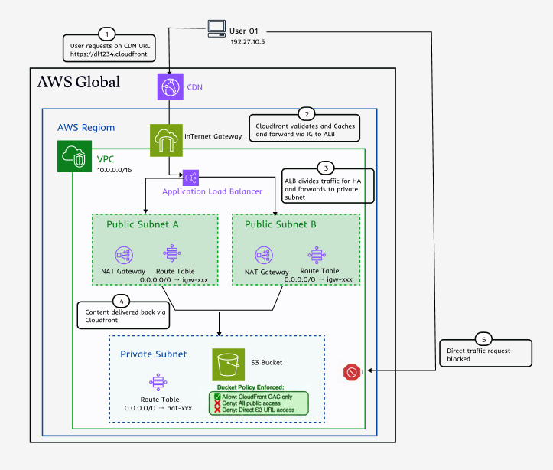

4.2 S3 Bucket Configuration
- Bucket name: devops-case2-static-ms
- Region: ap-south-1
- All public access: BLOCKED (BlockPublicAcls, IgnorePublicAcls, BlockPublicPolicy, RestrictPublicBuckets all set to true)
- Server-side encryption: SSE-S3 enabled (AES-256)
- Versioning: Enabled for object recovery
- Access logging: Enabled, logs sent to separate logging bucket

Sample Static Content Uploaded
- index.html — Main landing page
- style.css — Stylesheet
- logo.png — Sample image asset

4.3 CloudFront OAC Setup
Origin Access Control (OAC) is the modern, secure method for CloudFront to authenticate with S3. It uses AWS Signature Version 4 signing, which is more secure than the older Origin Access Identity (OAI).

4.4 Security Controls Implemented

Security Control | Implementation | Benefit
Bucket Policies | Only CloudFront OAC principal allowed in bucket policy | Prevents any direct S3 access
Public Access Block | All 4 public access block settings enabled | No accidental public exposure
Encryption at Rest | SSE-S3 (AES-256) enabled by default | Data encrypted on disk
Versioning | Object versioning enabled | Recovery from accidental deletion
Access Logging | S3 server access logs to separate bucket | Audit trail of all requests

5. Security Implementation Summary

5.1 Case 1 Security Controls

Security Measure | How Implemented | Threat Mitigated
Private Network Isolation | ECS tasks in private subnet, no public IP | Direct container exposure
JWT Authentication | jsonwebtoken library, 1-hour expiry, Bearer token | Unauthorized API access
Non-root Container | Custom user created in Dockerfile, USER appuser | Container escape privilege escalation
Minimal Base Image | node:20-alpine (small attack surface) | Unpatched OS vulnerabilities
Security Groups | ECS only accepts traffic from ALB SG on port 3000 | Port scanning, direct access
Environment Secrets | JWT_SECRET via environment variable, not hardcoded | Secret exposure in source code

5.2 Case 2 Security Controls

Security Measure | How Implemented | Threat Mitigated
Bucket Public Access Block | All 4 block settings enabled in S3 | Accidental public exposure
OAC Authentication | CloudFront signs all S3 requests with SigV4 | Unauthorized S3 access
Restrictive Bucket Policy | Only CloudFront service principal allowed | Direct bucket URL access
Encryption at Rest | SSE-S3 AES-256 server-side encryption | Data breach from storage access
HTTPS Enforcement | CloudFront viewer policy: redirect HTTP to HTTPS | Man-in-the-middle attacks
Access Logging | S3 access logs to dedicated logging bucket | Audit trail, anomaly detection

6. Cost Estimate

6.1 Monthly Cost at Low Traffic

AWS Service | Configuration | Est. Monthly Cost
ECS Fargate | 0.25 vCPU, 0.5GB RAM, 1 task 24/7 | ~$8 - $12
Application Load Balancer | 1 ALB, minimal LCU usage | ~$16 - $18
NAT Gateway | 1 NAT GW + data processing | ~$32 - $35
Amazon ECR | 1GB image storage | ~$0.10
CloudFront (Case 1) | 10GB transfer/month | ~$0.85
S3 (Case 2) | 1GB storage + requests | ~$0.05
CloudFront (Case 2) | 10GB transfer/month | ~$0.85
TOTAL |  | ~$60 - $70 / month

Cost Optimization Recommendations
- Use VPC Endpoints for ECR to eliminate NAT Gateway data transfer costs — saves ~$15-20/month at scale
- Switch ECS to Fargate Spot for non-critical workloads — up to 70% cost reduction
- Set CloudFront cache TTLs to maximize cache hit ratio and reduce origin requests
- Use S3 Intelligent-Tiering for Case 2 content if access patterns vary
- Delete NAT Gateway after assignment to avoid ongoing charges (~$32/month)

7. Problems Encountered and Solutions

Problem | Root Cause | Solution Applied
PowerShell script error on npm | Windows blocks PS scripts by default | Set-ExecutionPolicy RemoteSigned as Admin
VPC not appearing in ALB dropdown | Missing Internet Gateway and route tables | Created IGW, attached to VPC, added public route table
ECR AccessDeniedException | IAM user had no ECR permissions | Attached AmazonEC2ContainerRegistryFullAccess policy
AttachUserPolicy AccessDenied | Permissions boundary on IAM user | Logged in as root and removed boundary
ECS ClusterNotFoundException in CI/CD | ECS cluster not created before pipeline ran | Created cluster via aws ecs create-cluster
ECS ServiceNotFoundException | ECS service not created before pipeline ran | Created service via aws ecs create-service
runningCount 0 — tasks not starting | Private subnet could not reach ECR to pull image | Created NAT Gateway in public subnet, added route

PowerShell Execution Policy Fix
On a fresh Windows machine, npm commands were blocked by default PowerShell security policy. This was resolved by running the following command as Administrator:
Set-ExecutionPolicy -Scope CurrentUser -ExecutionPolicy RemoteSigned
This allows locally created scripts to run while requiring downloaded scripts to be signed — a safe middle ground for development.

Missed creating a NAT Gateway
ECS Fargate tasks in private subnets cannot pull Docker images from ECR without internet access. The error encountered was:
ResourceInitializationError: unable to pull registry auth: dial tcp 13.234.8.23:443: i/o timeout
Solution: A NAT Gateway was created in the public subnet and a route was added to the private subnet route table pointing all outbound traffic (0.0.0.0/0) through the NAT Gateway. This allows the private container to pull images from ECR without being directly exposed to the internet.

End of Documentation
DevOps Cloud Infrastructure Assignment — Malav

