Different Paths to Profitability
How Business Models Shape Financial Performance in Big Tech
Data Models Class Project
December 2025

By:
Malay Patel
Aditya Agarwal

Section 1: Executive Summary
FAANG firms are often compared using metrics such as ROE or profit margins, but these comparisons are misleading because the firms operate under very different business models. Some rely on high margins, others on scale and efficiency, and others on a mix of operating and financial choices. Treating profitability as a single outcome ignores these differences.
This project examines whether different business models rely on different financial drivers to generate ROE, and whether these relationships changed after COVID. Using firm-level data from 2015 to 2024, we combine strategic visual analysis with a sequence of regression models based on the DuPont framework. The results show that firms follow distinct paths to profitability, and no single metric explains success across all companies.

Section 2: Business Context and Motivation
Although FAANG firms are often grouped together, their business models differ significantly. Apple relies on premium pricing, Amazon operates on high volume with thin margins, Meta and Google depend on advertising revenue, and Microsoft focuses on enterprise software and cloud services. These differences affect cost structures, capital allocation, and how profits are generated, making direct profitability comparisons unreliable.
Traditional profitability analysis often focuses on single metrics such as ROE or profit margins. However, ROE can change due to margins, efficiency, leverage, or financial actions like share buybacks. Without separating these components, it is difficult to tell whether high returns reflect strong operations or accounting effects.
This project treats profitability as the outcome of strategic tradeoffs rather than a single score. Firms choose between margin expansion, operational efficiency, growth, and stability based on their business model. COVID provides a useful breakpoint to test whether these tradeoffs changed after 2020, allowing us to study shifts in how firms generate returns rather than just changes in performance levels.

Section 3: Data & Feature Engineering

3.1 Dataset Description
We use firm-year financial data for five large tech firms: Apple (AAPL), Amazon (AMZN), Google (GOOG), Meta (META), and Microsoft (MSFT). The sample covers fiscal years 2015–2024, giving 10 yearly observations per firm (50 total rows). All variables are constructed from financial statement items and then used consistently across the visuals and regressions.

3.2 Core Variables and Formulas
The project focuses on ROE as the outcome and three drivers that match the DuPont logic. We work with the following ratios:
- Net Profit Margin (NPM) = Net Income / Revenue: This measures how much profit is generated per $1 of sales.
- Asset Turnover (AT) = Revenue / Total Assets: This measures how efficiently assets generate revenue.
- Equity-to-Asset Ratio (EAR) = Stockholders' Equity / Total Assets: This captures capital structure in a simple way (higher value means more equity funding relative to assets).
- Return on Equity (ROE) = Net Income / Stockholders' Equity: This is the main performance outcome and reflects how much profit is generated per $1 of equity.

3.3 Derived Variables
We create PostCOVID, a dummy variable equal to 1 for FY ≥ 2020 and 0 otherwise. This is used later in the regression to test whether the relationships changed after 2020. We also create a BusinessModel label (Apple = high margin/low turnover, Amazon = low margin/high turnover, Meta/Google = advertising, Microsoft = enterprise). This label is used only for interpretation and discussion, not as a main regression input.
We also compute RevenueGrowth as:
$$Revenue Growth_{i} =\frac{Revenue_{t}-Revenue_{t-1}}{Revenue_{t-1} }$$
Since the first year for each firm has no prior year, those observations are missing growth by construction. Revenue growth is not used in Models 1 to 4, so it is treated as descriptive context only.

3.4 Risk / Stability Measures
To add a stability angle, we compute ROE volatility by firm using the standard deviation of ROE over the sample period. We also compute the coefficient of variation (CV = SD / Mean) as a scaled volatility measure. This is only used for the risk-return plot and is not a core driver in the regressions.

Section 4: Strategic Descriptive Analysis & Visualizations

4.1 Summary Statistics Overview
The summary statistics show clear differences in profitability, efficiency, and capital structure across firms and over time. Average ROE varies widely across companies, indicating that shareholder returns are not uniform within the FAANG group. Some firms consistently operate with higher profitability, while others exhibit lower but more stable returns. Net Profit Margin and Asset Turnover also show substantial dispersion, suggesting that firms rely on different operational approaches rather than a single dominant strategy.
Variation across years is also visible, particularly around the 2020 period. While all firms experienced changes in performance over time, the magnitude and direction of these changes differ by company. This suggests that firm-specific characteristics play a larger role than industry-wide effects alone. Overall, the summary statistics indicate that simple comparisons of averages are insufficient to explain performance differences and motivate a closer examination of strategic tradeoffs using visual and regression-based analysis.

4.2 Strategic Positioning: Asset Turnover vs Net Profit Margin

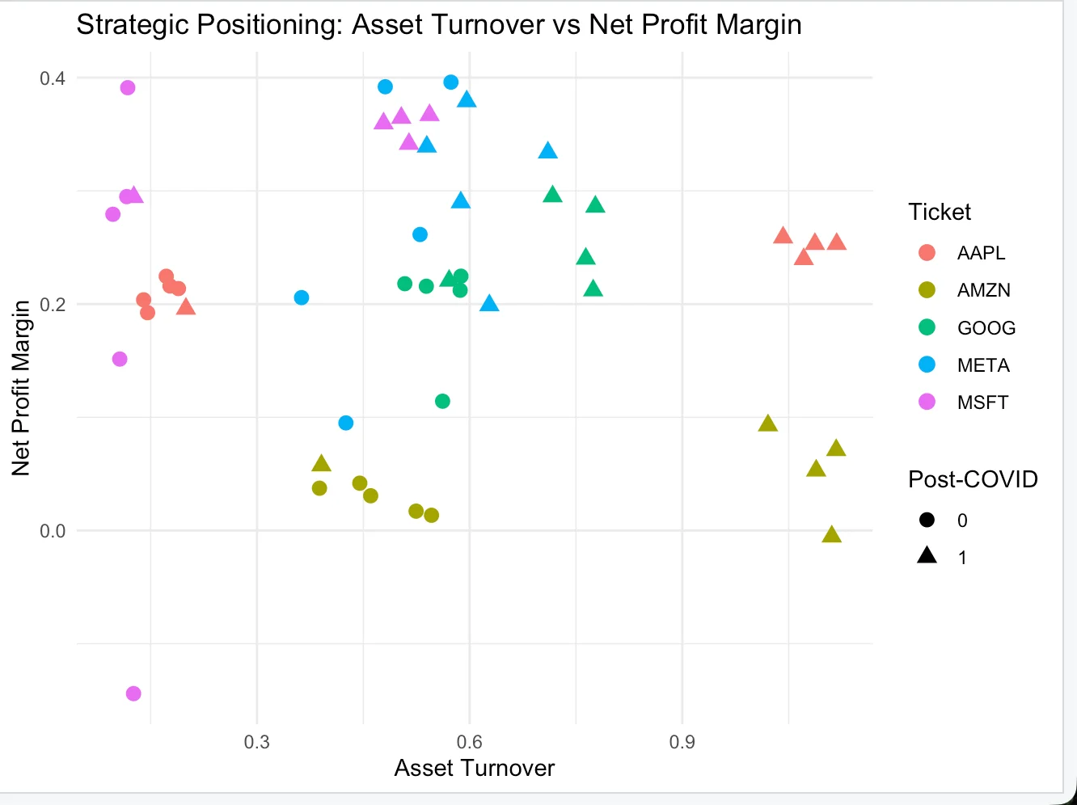

This figure plots each firm-year by asset turnover and net profit margin to show how firms position themselves operationally. A clear separation appears across companies. Amazon consistently operates at high asset turnover with very low margins, while Apple remains at lower turnover but higher margins. Meta and Microsoft cluster at higher margins with moderate turnover, and Google sits between margin and efficiency.
There is no single region where firms achieve both very high margins and very high turnover. Instead, firms occupy distinct areas of the plot, reflecting different operating strategies rather than a common performance frontier. The post-COVID observations largely fall within the same regions as earlier years, indicating that firms did not change their core operating positions after 2020.
This visualization shows that firms rely on different combinations of margin and efficiency to generate returns. These differences motivate examining whether the same financial drivers translate into ROE differently across firms in the regression analysis that follows.

4.3 Return on Equity Over Time

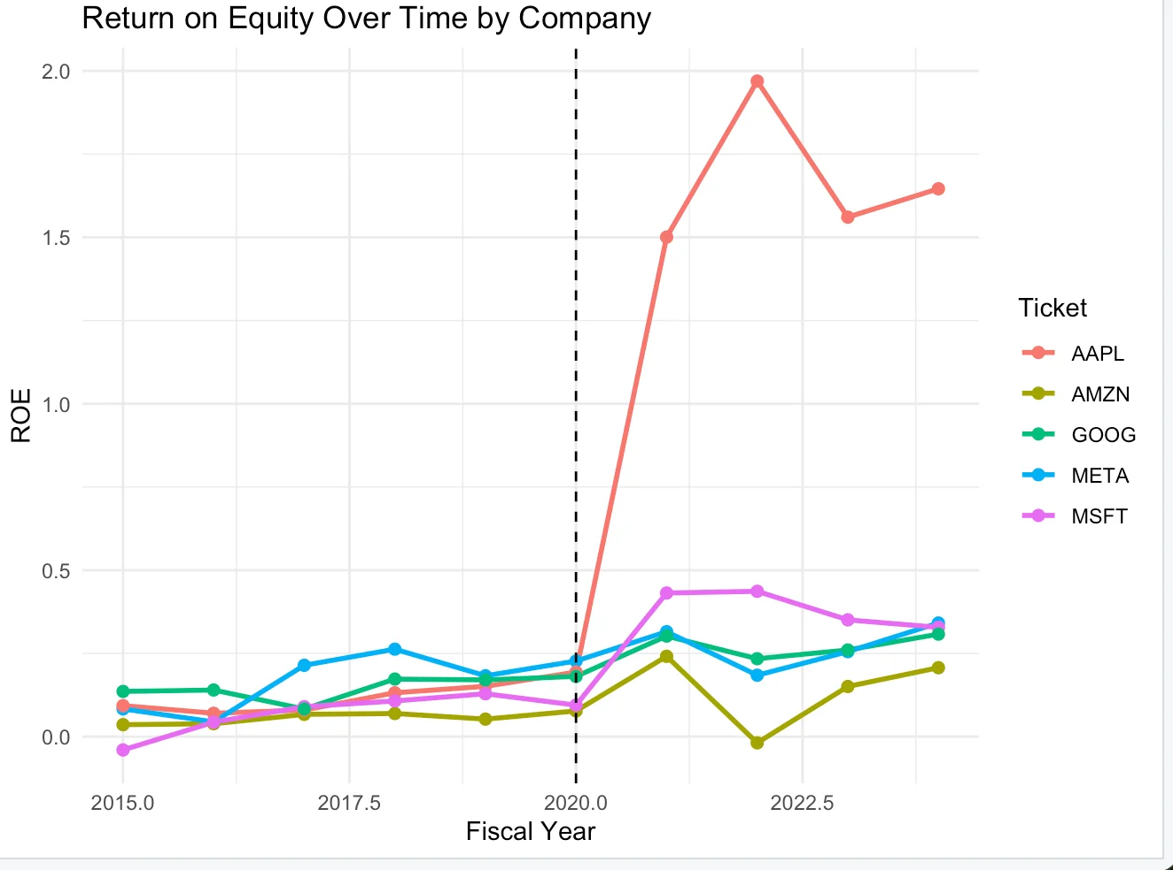

This figure tracks ROE for each firm from 2015 to 2024, with the dashed line marking the start of the COVID period in 2020. Apple shows a sharp increase in ROE beginning in 2021, rising well above the other firms. This change coincides with large equity reductions from share buybacks, which mechanically increase ROE rather than reflecting a sudden change in operating performance.
Google, Meta, and Microsoft display more stable ROE patterns over time, generally ranging between 0.1 and 0.4. Their trajectories show moderate variation but no structural break comparable to Apple’s. Amazon consistently records the lowest ROE across the entire period, reflecting its reinvestment-focused strategy and relatively thin margins.
The key takeaway from this visualization is persistence rather than convergence. Firms do not move toward a common ROE level over time. Instead, each company maintains a distinct profitability profile, reinforcing the idea that ROE reflects firm-specific operating and capital structure choices rather than a single industry benchmark.

4.4 Asset Turnover and ROE Relationship

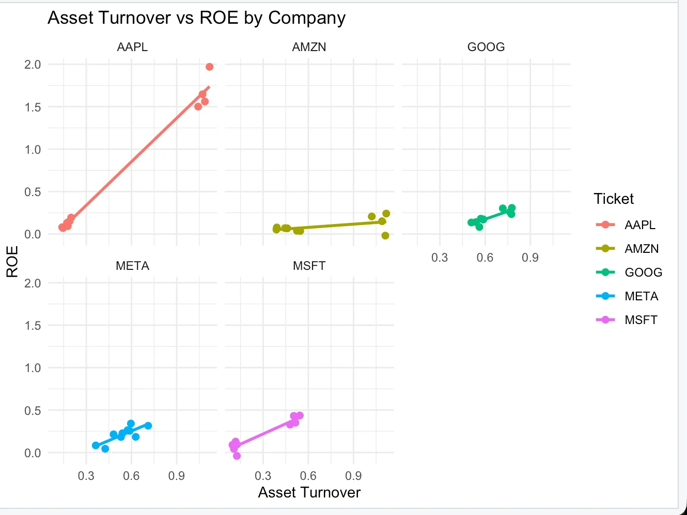

This visualization shows the relationship between asset turnover and return on equity for each company separately.
For Apple, there is a very strong positive relationship, where higher asset turnover is closely associated with much higher ROE.
This suggests that Apple converts operational efficiency directly into shareholder returns. Amazon shows a much flatter relationship, indicating that changes in asset turnover have a weaker effect on ROE, which aligns with its low-margin, reinvestment-heavy strategy.
Google, Meta, and Microsoft show moderate positive relationships, where improvements in efficiency lead to higher ROE but not as sharply as Apple.
Overall, the plot highlights that asset turnover does not affect ROE uniformly across companies, reinforcing the idea that different business models rely on different drivers of profitability.

4.5 Risk-Return Profile

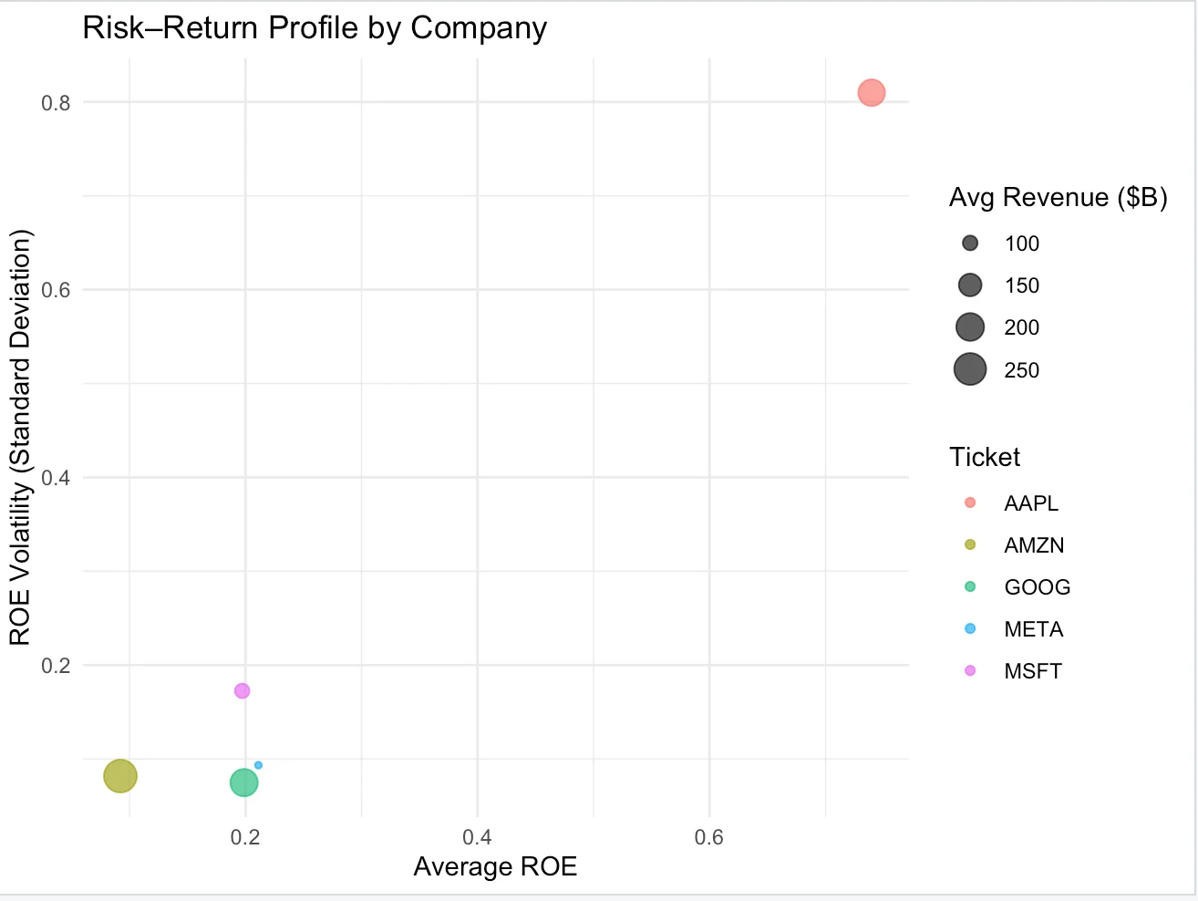

This visualization compares the average ROE of each company with the variability of ROE over time.
Apple stands out with the highest average ROE, but it also shows the highest volatility. This volatility is largely driven by changes in equity from share buybacks rather than operating instability, so it should be interpreted with caution.
Google and Microsoft show more moderate ROE levels with lower volatility, indicating more stable return patterns over the sample period. Amazon shows both low average ROE and relatively low volatility, reflecting its reinvestment-focused strategy.
Overall, this plot provides a supporting view of return consistency, but due to the short time period and accounting effects, it is not used as a primary driver of conclusions in this project

Section 5: Regression Analysis

5.1 Baseline ROE Model
We begin with a baseline regression that explains Return on Equity using the core components of the DuPont framework:
$$ROE=β_{0}+β_{1}(\text{Net Profit Margin})+β_{2}(\text{Asset Turnover})+β_{3}(\text{Equity-to-Asset Ratio})+ε$$

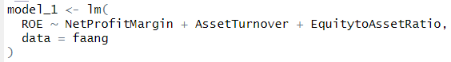
This model captures profitability, operational efficiency, and capital structure. All three variables are positive and statistically significant. The model explains a large share of the variation in ROE (R² = 0.80), indicating that these components together form a strong baseline explanation for shareholder returns across firms. This model establishes that ROE is mechanically linked to margins, efficiency, and leverage, but it assumes that all firms translate these drivers into returns in the same way.

5.2 Controlling for Company Differences
The baseline model treats all firms as structurally identical. This is unlikely to hold for companies with very different business models. To account for firm-specific differences, company indicator variables are added:
$$ROE=β_{0}+β_{1}(\text{Margin})+β_{2}(\text{Turnover})+β_{3}(\text{Leverage})+γ(\text{Company})+ε$$

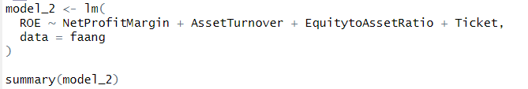
Including company indicators substantially increases explanatory power (R² = 0.926). Asset Turnover and Equity-to-Asset Ratio remain highly significant, while Net Profit Margin becomes only marginally significant.
Amazon's indicator is large, negative, and statistically significant. This implies that Amazon consistently generates lower ROE than the reference firm even after controlling for margins, efficiency, and leverage. The indicators for the other firms are not statistically significant, suggesting that their ROE levels are largely explained by operating fundamentals rather than firm identity alone.
This result confirms that firm structure matters, with Amazon standing out as structurally different from the rest.

5.3 Interaction Effects and Business Model Differences
The previous model controls for firm differences but still assumes that financial drivers affect ROE in the same way for all firms. This assumption is relaxed by introducing interaction terms between company indicators and the key operating variables:
$$ROE=β_{0}+β_{1}(\text{Margin})+β_{2}(\text{Turnover})+β_{3}(\text{Leverage})+δ(\text{Margin}×\text{Company})+θ(\text{Turnover}×\text{Company})+ε$$
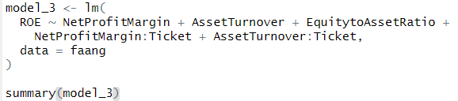
This specification fits the data extremely well (R² = 0.991) and explains nearly all variation in ROE. The interaction terms show that the relationship between operating variables and ROE differs sharply across firms.
Asset turnover contributes much less to ROE for Amazon than for the baseline firm, confirming that efficiency alone does not translate into shareholder returns for Amazon's business model. In contrast, profit margin interactions are positive and statistically significant across firms, indicating that improvements in margins have a larger payoff for ROE.
This model provides the core insight of the project: companies achieve profitability through different mechanisms, rather than following a single universal formula.

5.4 Temporal Effects (Pre- vs Post-COVID)
This model tests whether profitability drivers changed after COVID by introducing a Post-COVID indicator and interaction terms:
$$ROE=β_{0}+β_{1}(\text{Margin})+β_{2}(\text{Turnover})+β_{3}(\text{Leverage})+β_{4}(\text{PostCOVID})+β_{5}(\text{Margin}×\text{PostCOVID})+β_{6}(\text{Turnover}×\text{PostCOVID})+γ(\text{Company})+ε$$
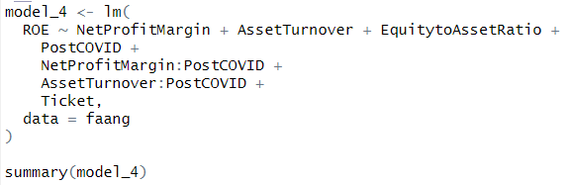
The Post-COVID indicator itself is not statistically significant, indicating no uniform shift in ROE levels after 2020 once fundamentals are controlled for. Asset Turnover and Equity-to-Asset Ratio remain strongly significant, showing that efficiency and capital structure continue to matter.
The interaction between Net Profit Margin and Post-COVID is positive and marginally significant, suggesting that margins became more important in explaining ROE after COVID. The interaction with Asset Turnover is not significant, indicating no meaningful change in the role of efficiency.
Overall, the results suggest a modest shift rather than a structural break. Profitability discipline appears to have gained importance after COVID, while the role of efficiency remained largely unchanged.

Section 6: Structural Change & COVID Analysis
Model 4 checks whether the link between ROE and its operating drivers changed after 2020. We do not treat COVID as a direct “cause” of ROE. Instead, we test whether margins or efficiency became important in explaining ROE after 2020.

No overall post-COVID shift in ROE levels
The PostCOVID term is not statistically significant (p- value = 0.189). After controlling for margin, asset turnover, capital structure, and firm fixed effects, ROE does not jump up or down just because the year is post-2020. Any change in ROE during this period is better explained by changes in fundamentals, not a pure time dummy.

Margins became more important after 2020 (weak but noticeable)
The interaction NetProfitMargin × PostCOVID is positive (0.669) and marginally significant (p-value = 0.069). Interpreting this in “percentage points”: if profit margin rises by 10 points (for example 20% to 30%), the pre-COVID effect from the main margin term is about +2.6 ROE points (0.264 × 0.10). Post-COVID, the added margin effect is about +6.7 ROE points (0.669 × 0.10). So the same margin improvement is associated with a larger ROE change after 2020. This supports the idea that margin discipline mattered more in the later period, but the evidence is not strong enough to overstate it.

Efficiency did not change after 2020
AssetTurnover × PostCOVID is near zero and not significant (p-value = 0.951). So, we do not see evidence that the payoff to efficiency shifted after 2020.

What this means
The core drivers (asset turnover and equity-to-asset ratio) still explain most ROE differences, and COVID does not create a new “baseline.” The one change we see is a mild shift toward margins being more tied to ROE after 2020, while the efficiency relationship stays basically the same.

Section 7: Dynamic Effects & Diagnostics

Model Progression and Explanatory Power
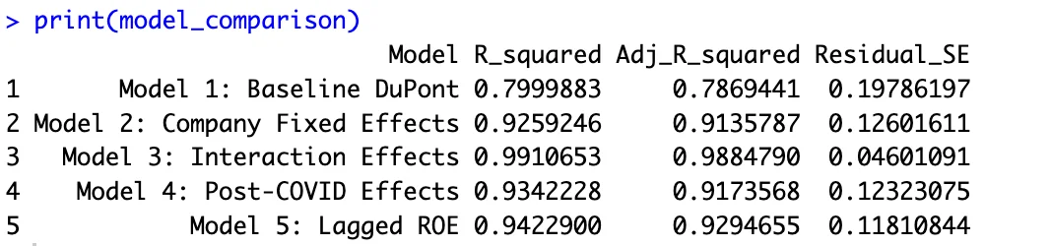
Table 7.1: Model Comparison Across Specifications
The sequence of models shows a clear improvement in explanatory power as structure is added.
Model 1, which includes only margin, asset turnover, and leverage, explains about 80% of ROE variation. This confirms that the DuPont components provide a strong baseline for understanding profitability.
Adding company indicators in Model 2 increases R-squared to 0.926 and substantially reduces the residual standard error. This indicates that firm-specific characteristics matter beyond operating ratios alone.
Model 3 introduces interaction terms between operating drivers and firms. This model achieves the highest fit (R-squared = 0.991) and the lowest residual error. The improvement is not mechanical. It reflects the fact that margins and efficiency translate into ROE differently across business models.
Model 4 trades some firm-specific detail for time-based analysis. The fit remains strong (R-squared = 0.934), showing that post-COVID effects exist but are secondary to firm heterogeneity.
Model 5 adds lagged ROE to test persistence. The improvement in fit is modest. This suggests that while profitability carries over across years, momentum alone does not dominate current operating fundamentals.

Profitability Persistence
Lagged ROE is positive and statistically significant. A 10 percentage point increase in last year’s ROE is associated with about a 1.8 percentage point increase in current ROE. This indicates persistence, but the effect is limited.
Compared to more stable industries, this level of persistence is low. In large tech firms, current margins, efficiency, and capital structure explain more variation in ROE than past performance alone.

Residual Diagnostics
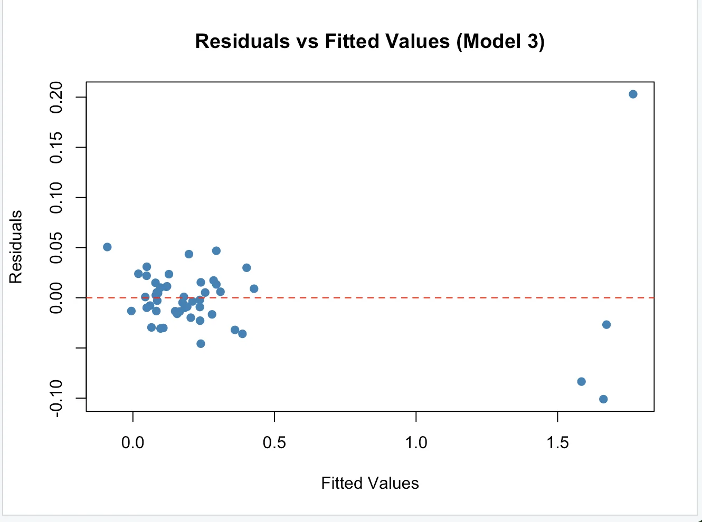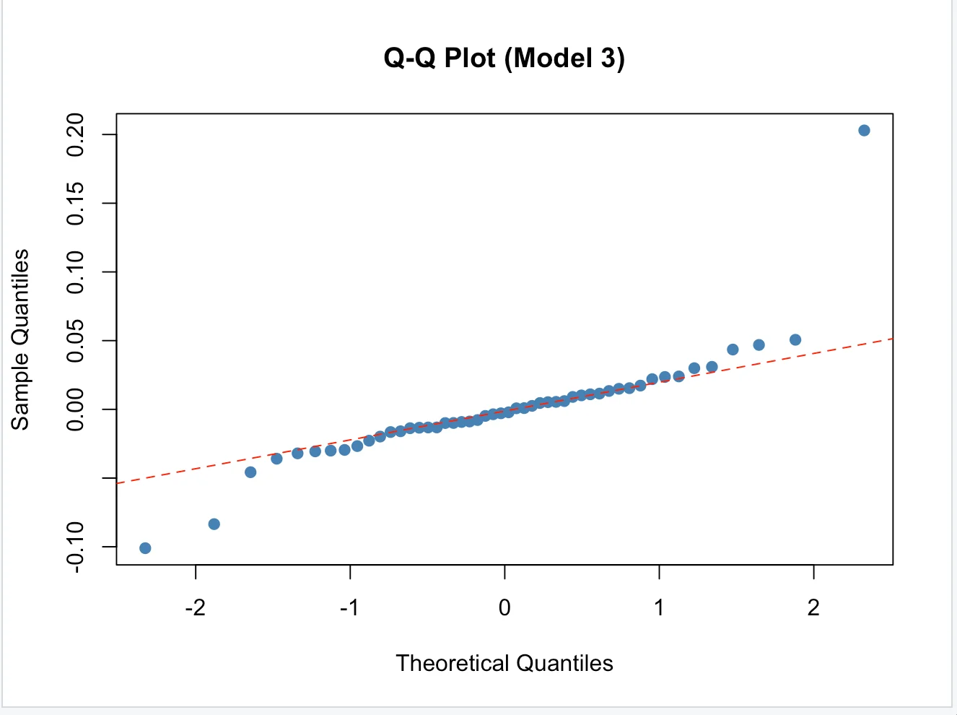
Residual diagnostics for Model 3 show no major violations of regression assumptions. Residuals are centered around zero and show no clear pattern against fitted values. There is no visible heteroskedasticity or nonlinearity.
A small number of Apple observations from 2021–2023 stand out as outliers. In these years, ROE is underpredicted by the model. This is consistent with Apple’s aggressive share buybacks, which reduce equity and mechanically inflate ROE. The model captures operating fundamentals but not financial engineering.
Overall, the diagnostics suggest that Model 3 is well-specified and that remaining errors are economically explainable rather than statistical failures.

What the Models Do Not Capture
The models rely only on accounting-based financial ratios. They do not include R&D intensity, competitive dynamics, pricing power, or macroeconomic conditions. Relationships are assumed to be linear and year-by-year independent. These limitations are acknowledged, but they do not undermine the main findings.

Robustness and Consistency
The core findings hold across all five model specifications. Asset Turnover is always positive and significant. Equity-to-Asset Ratio is always positive and significant. Amazon is always structurally different. These patterns are consistent and not fragile. The interaction model (Model 3) did not create new results. It clarified results that were already present in the data. The Post-COVID effects in Model 4 are modest and do not override the firm-specific patterns from Model 3. The lagged ROE model (Model 5) shows persistence but does not eliminate the importance of current operating fundamentals. The diagnostics confirm that Model 3 is well-specified. The residuals are small, unbiased, and approximately normal. The model explains the vast majority of ROE variation without overfitting. The findings are robust, the assumptions are reasonable, and the limitations are transparent.

Section 8: Strategic Implications & Scenarios

Understanding Company-Specific Drivers
The interaction model shows that the same operational change produces different ROE outcomes depending on the firm.
For Apple, asset turnover has a very strong relationship with ROE. Improvements in efficiency translate directly into higher returns, consistent with a capital-light, premium-product model.
For Amazon, the effect of asset turnover on ROE is much weaker. Efficiency gains do not flow proportionally into shareholder returns because revenue gains are largely reinvested. Amazon’s ROE responds much more strongly to changes in profit margin.
Margin Discipline Across Companies
The interaction effects for net profit margin show a different pattern. All firms have positive margin interactions, meaning margins matter for everyone. The coefficients range from 0.64 for Microsoft to 3.01 for Amazon. Amazon's margin coefficient is 3.01. If Amazon improves net profit margin by 5 percentage points (moving from 3% to 8%), ROE would increase by approximately 15 percentage points. For a company that typically operates on razor-thin margins, even modest improvements in profitability have large ROE effects.
Scenario Illustrations
Consider Amazon improving net profit margin by five percentage points. Based on Model 3, this change is associated with an ROE increase of roughly 15 percentage points. Achieving such a shift would require a meaningful change in pricing or cost structure.
By contrast, a comparable improvement in Amazon’s asset turnover leads to only a small ROE change. This explains why Amazon’s ROE has remained relatively low despite strong revenue growth.
For Apple, the pattern is reversed. A modest improvement in asset turnover is associated with a large increase in ROE, reflecting the firm’s ability to convert efficiency gains directly into shareholder returns.

Post-COVID Implications

Model 4 indicates that margin discipline became more important after 2020. The post-COVID interaction suggests that the ROE payoff to margin improvements increased, while the efficiency relationship remained stable. This shift reinforces the importance of profitability discipline in the later period, especially for firms with already thin margins.

Section 9: Key Conclusions and Final Takeaways

Key Conclusions:
- Big Tech firms achieve profitability through different mechanisms. The same change in margins or efficiency leads to very different ROE outcomes depending on the business model.
- Apple’s ROE is driven mainly by operational efficiency, while Amazon’s ROE is driven mainly by margin expansion. No single metric explains success across all firms.
- COVID did not change the rules of profitability but shifted their importance. Margin discipline became more valuable after 2020, while efficiency effects remained largely unchanged.
- Profitability shows some persistence, but it is not sticky. Current operating fundamentals explain more variation in ROE than past performance alone.
- Accounting for firm-specific effects and interactions is essential. Models that allow for heterogeneity explain nearly all observed ROE variation, while simple comparisons are misleading.

Final Takeaway
Profitability in Big Tech follows different strategic paths rather than a single formula. Firms trade off margins, efficiency, growth, and stability in distinct ways that lead to very different ROE outcomes. COVID increased the importance of margin discipline but did not change the underlying mechanics of profitability. Understanding these conditional relationships matters more than comparing headline performance metrics.

