2CSDE69-LAMP TECHNOLOGY

Innovative Assignment

Automatic Timetable Generator

20BCE099-Jainam Patel

20BCE111-Malay Jiyani

20BCE119-Kartavya Patel

Introduction and Project Details-

This is a program code written in PHP to generate an Automatic Timetable based on given inputs from users such as Faculty Information, Subjects Information(Lab as well as Theory), Classroom Information, etc. Also, User Interface(UI) is made with CSS and Java-script and Database Connectivity in MySQL is done with phpMyAdmin.

Complete Project Explained with Video Demonstration-

[Automatic Timetable Generator in PHP - YouTube](https://www.youtube.com/watch?v=YvlM2iNxqPA)

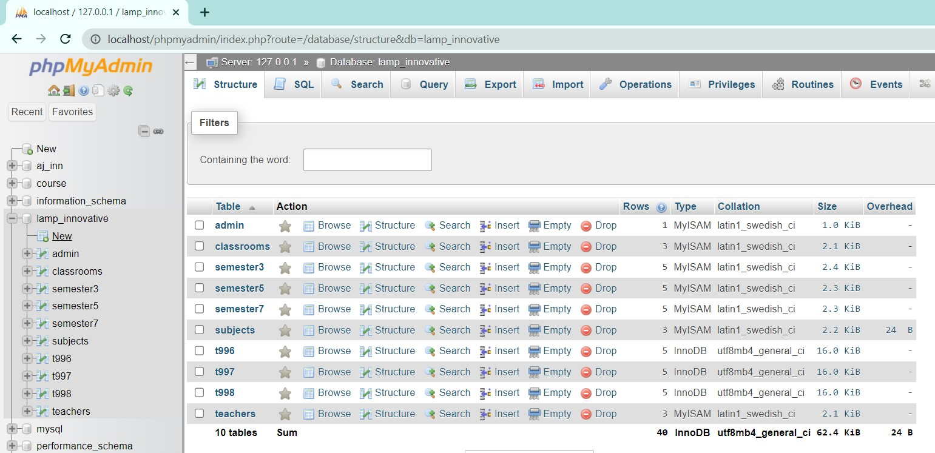

1. ALLOTCLASSES.PHP

<!DOCTYPE html>

<head>

<meta charset="utf-8" />

<meta name="viewport" content="width=device-width, initial-scale=1, maximum-scale=1" />

<meta name="description" content="" />

<meta name="author" content="" />

<title>PROGRAM GENERATOR</title>

<!-- BOOTSTRAP CORE STYLE CSS -->

<link href="./assets/css/bootstrap.css" rel="stylesheet" />

<!-- FONT AWESOME CSS -->

<link href="./assets/css/font-awesome.min.css" rel="stylesheet" />

<!-- FLEXSLIDER CSS -->

<link href="./assets/css/flexslider.css" rel="stylesheet" />

<!-- CUSTOM STYLE CSS -->

<link href="./assets/css/style.css" rel="stylesheet" />

</head>

<body>

<nav class="navbar navbar-inverse navbar-fixed-top" id="menu">

<div class="container">

<ul class="nav navbar-nav">

<li><a href="addteachers.php">ADD TEACHERS</a></li>

<li><a href="addsubjects.php">ADD SUBJECTS</a></li>

<li><a href="addclassrooms.php">ADD CLASSROOMS</a></li>

<li><a href="allotsubjects.php">ALLOTMENT - THEORY</a></li>

<li><a href="allotLab.php">ALLOTMENT - LAB</a></li>

<li><a href="allotclasses.php">ALLOTMENT - CLASSROOMS</a></li>

<li><a href="generatetimetable.php">GENERATE TIMETABLE</a></li>

</ul>

<ul class="nav navbar-nav navbar-right">

<li><a href="index.php">LOGOUT</a></li>

</ul>

</div>

</nav>

<!--navigation bar end-->

<br>

<?php

if (isset($_POST['in_class'])) {

include 'connection.php';

$year = $_POST['course'];

$class = $_POST['in_class'];

$q = mysqli_query(

mysqli_connect("localhost", "root", "", "lamp_innovative"),

"UPDATE classrooms SET status = '$year' WHERE name = '$class'"

);

}

?>

<form action="allotclasses.php" method="post" style="margin-top: 100px">

<div align="center">

<select name="course" class="list-group-item">

<option selected disabled>Select Course</option> <!--pick class-->

';

<option value="2">2nd Year</option>

<option value="3">3rd Year</option>

<option value="4">4rth Year</option>

</select>

</div>

<div align="center" style="margin-top: 5px">

<select name="in_class" class="list-group-item">

<?php

include 'connection.php';

$q = mysqli_query(

mysqli_connect("localhost", "root", "", "lamp_innovative"),

"SELECT * FROM classrooms"

);

$row_count = mysqli_num_rows($q);

if ($row_count) {

$mystring = '

<option selected disabled>Select Classroom</option>'; //pick class

while ($row = mysqli_fetch_assoc($q)) {

if ($row['status'] != 0)

continue;

$mystring .= '<option value="' . $row['name'] . '">' . $row['name'] . '</option>';

}

echo $mystring;

}

?>

</select>

</div>

<div align="center" style="margin-top: 10px;">

<button type="submit" class="btn btn-success btn-lg">Allot</button> <!--allot button-->

</div>

</form>

<script>

function deleteHandlers() {

var table = document.getElementById("allotedsubjectstable");

var rows = table.getElementsByTagName("tr");

for (i = 0; i < rows.length; i++) {

var currentRow = table.rows[i]; //delete function

var createDeleteHandler =

function(row) {

return function() {

var cell = row.getElementsByTagName("td")[0];

var id = cell.innerHTML;

var x;

if (confirm("Are You Sure?") == true) {

window.location.href = "deleteallotment.php?name=" + id;

}

};

};

currentRow.cells[2].onclick = createDeleteHandler(currentRow);

}

}

</script>

<div align="center">

<style>

table {

margin-top: 70px;

margin-bottom: 50px;

font-family: arial, sans-serif;

border-collapse: collapse;

margin-left: 80px;

width: 90%;

}

td,

th {

border: 1px solid #dddddd;

text-align: left;

padding: 8px;

}

tr:nth-child(even) {

background-color: #dddddd;

}

</style>

<table id=allotedclassroomstable>

<caption><strong>CLASSROOMS ALLOTMENT</strong></caption> <!--the table-->

<tr>

<th width="250">Classroom</th>

<th width="400">Alloted To</th>

<th width="60">Action</th>

</tr>

<tbody>

<?php

include 'connection.php';

$q = mysqli_query(

mysqli_connect("localhost", "root", "", "lamp_innovative"),

"SELECT * FROM classrooms "

);

$courses = array('2nd Year', '3rd Year', '4rth Year');

while ($row = mysqli_fetch_assoc($q)) {

if ($row['status'] == 0)

continue;

echo "<tr><td>{$row['name']}</td>

<td>{$courses[$row['status'] - 2]}</td>

<td><button>Delete</button></td>

</tr>\n";

} //delete button

echo "<script>deleteHandlers();</script>";

?>

</tbody>

</table>

</div>

<!--some scripts-->

<script src="./assets/js/jquery-1.10.2.js"></script>

<script src="./assets/js/bootstrap.min.js"></script>

<script src="./assets/js/jquery.flexslider.min.js"></script>

<script src="./assets/js/scrollreveal.min.js"></script>

<script src="./assets/js/jquery.easing.min.js"></script>

<!-- <script src="./assets/js/custom.js"></script> -->

</body>

</html>

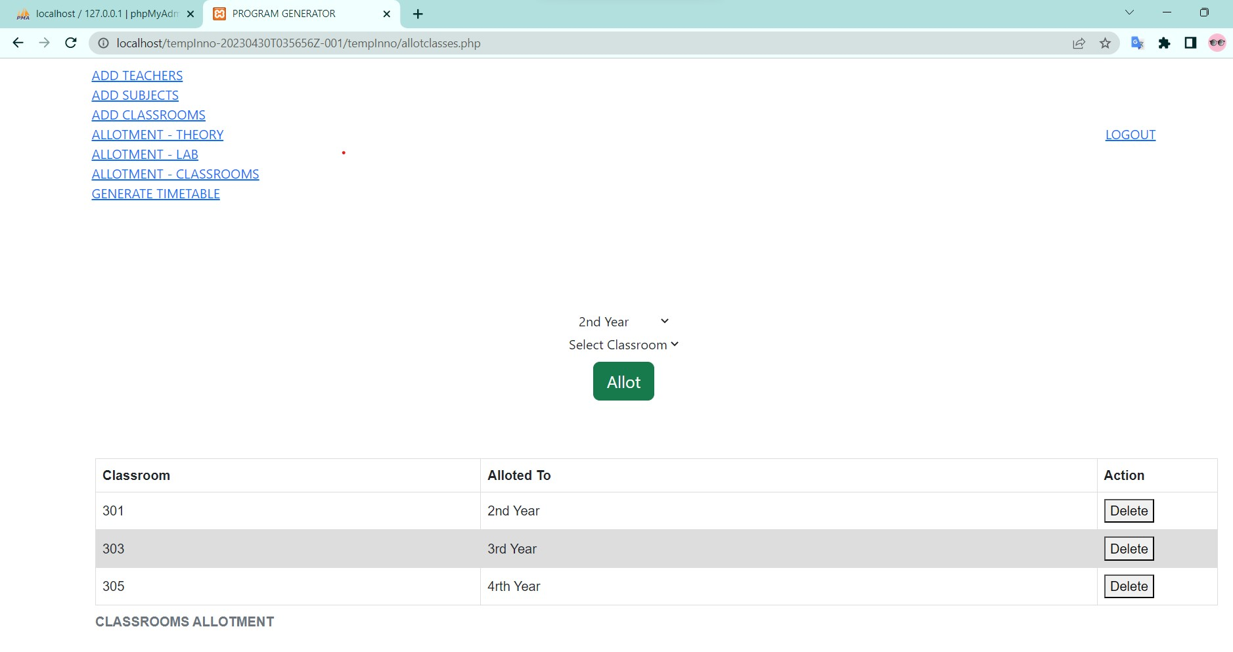

1. ALLOTLAB.PHP

<!DOCTYPE html>

<head>

<meta charset="utf-8" />

<meta name="viewport" content="width=device-width, initial-scale=1, maximum-scale=1" />

<meta name="description" content="" />

<meta name="author" content="" />

<title>PROGRAM GENERATOR</title>

<!-- BOOTSTRAP CORE STYLE CSS -->

<link href="./assets/css/bootstrap.css" rel="stylesheet" />

<!-- FONT AWESOME CSS -->

<link href="./assets/css/font-awesome.min.css" rel="stylesheet" />

<!-- FLEXSLIDER CSS -->

<link href="./assets/css/flexslider.css" rel="stylesheet" />

<!-- CUSTOM STYLE CSS -->

<link href="./assets/css/style.css" rel="stylesheet" />

</head>

<body>

<nav class="navbar navbar-inverse navbar-fixed-top" id="menu">

<div class="container">

<ul class="nav navbar-nav">

<li><a href="addteachers.php">ADD TEACHERS</a></li>

<li><a href="addsubjects.php">ADD SUBJECTS</a></li>

<li><a href="addclassrooms.php">ADD CLASSROOMS</a></li>

<li><a href="allotsubjects.php">ALLOTMENT - THEORY</a></li>

<li><a href="allotLab.php">ALLOTMENT - LAB</a></li>

<li><a href="allotclasses.php">ALLOTMENT - CLASSROOMS</a></li>

<li><a href="generatetimetable.php">GENERATE TIMETABLE</a></li>

</ul>

<ul class="nav navbar-nav navbar-right">

<li><a href="index.php">LOGOUT</a></li>

</ul>

</div>

</nav>

<!--navigation bar ends-->

<br>

<form action="allotmentLabForm.php" method="post" style="margin-top: 100px">

<div align="center">

<select name="tobealloted" class="list-group-item">

<?php

include 'connection.php';

$q = mysqli_query(

mysqli_connect("localhost", "root", "", "lamp_innovative"),

"SELECT * FROM subjects WHERE course_type = 'LAB'"

);

$row_count = mysqli_num_rows($q);

if ($row_count) {

$mystring = '

<option selected disabled>Select Subject</option>'; //picks the subject

while ($row = mysqli_fetch_assoc($q)) {

if ($row['isAlloted'] == 1)

continue;

$mystring .= '<option value="' . $row['subject_code'] . '">' . $row['subject_name'] . '</option>';

}

echo $mystring;

}

?>

</select>

</div>

<div align="center" style="margin-top: 5px">

<select name="toalloted" class="list-group-item">

<?php

include 'connection.php';

$q = mysqli_query(

mysqli_connect("localhost", "root", "", "lamp_innovative"),

"SELECT * FROM teachers "

);

$row_count = mysqli_num_rows($q);

if ($row_count) {

$mystring = '

<option selected disabled>Select Teacher</option>'; //picks the teacher

while ($row = mysqli_fetch_assoc($q)) {

$mystring .= '<option value="' . $row['faculty_number'] . '">' . $row['name'] . '</option>';

}

echo $mystring;

}

?>

</select>

</div>

</div>

<div align="center" style="margin-top: 10px">

<button type="submit" class="btn btn-success btn-lg">Allot</button> <!--allot button-->

</div>

</form>

<?php

include 'connection.php';

if (isset($_GET['name'])) {

$id = $_GET['name'];

$q = mysqli_query(

mysqli_connect("localhost", "root", "", "lamp_innovative"),

"UPDATE subjects SET isAlloted = '0' , allotedto = '' WHERE subject_code = '$id' "

);

}

?>

<script>

function deleteHandlersForPractical() {

var table = document.getElementById("allotedpracticalstable");

var rows = table.getElementsByTagName("tr");

for (i = 0; i < rows.length; i++) {

var currentRow = table.rows[i]; //delete function

var createDeleteHandler =

function(row) {

return function() {

var cell = row.getElementsByTagName("td")[0];

var id = cell.innerHTML; //pop up window for sure

var x;

if (confirm("Are You Sure?") == true) {

window.location.href = "allotLab.php?name=" + id;

}

};

};

currentRow.cells[4].onclick = createDeleteHandler(currentRow);

}

}

</script>

<style>

table {

margin-top: 70px;

margin-bottom: 50px;

font-family: arial, sans-serif;

border-collapse: collapse;

margin-left: 80px;

width: 90%;

}

td,

th {

border: 1px solid #dddddd;

text-align: left;

padding: 8px;

}

tr:nth-child(even) {

background-color: #dddddd;

}

</style>

<table id=allotedpracticalstable>

<caption><strong>LAB ALLOTMENT</strong></caption>

<tr>

<th width="130">Subject Code</th>

<th width=200>Subject Title</th>

<th width="120">Teacher's ID</th>

<th width="300">Teacher's Name</th>

<th width="40">Action</th>

</tr>

<tbody>

<?php

include 'connection.php';

$q = mysqli_query(

mysqli_connect("localhost", "root", "", "lamp_innovative"), //here becomes the allotation

"SELECT * FROM subjects"

);

while ($row = mysqli_fetch_assoc($q)) {

if ($row['isAlloted'] == 0)

continue;

if (!($row['course_type'] == "LAB"))

continue;

$teacher_id1 = $row['allotedto'];

$t1 = mysqli_query(

mysqli_connect("localhost", "root", "", "lamp_innovative"),

"SELECT name FROM teachers WHERE faculty_number = '$teacher_id1'"

);

$trow1 = mysqli_fetch_assoc($t1);

echo "<tr><td>{$row['subject_code']}</td>

<td>{$row['subject_name']}</td>

<td>{$row['allotedto']}</td>

<td>{$trow1['name']}</td>

<td>

<button>Delete</button></td>

</tr>\n";

}

echo "<script>deleteHandlersForPractical();</script>";

?>

</tbody>

</table>

<!--some scripts-->

<script src="./assets/js/jquery-1.10.2.js"></script>

<script src="./assets/js/bootstrap.min.js"></script>

<script src="./assets/js/jquery.flexslider.min.js"></script>

<script src="./assets/js/scrollreveal.min.js"></script>

<script src="./assets/js/jquery.easing.min.js"></script>

<!-- <script src="./assets/js/custom.js"></script> -->

</body>

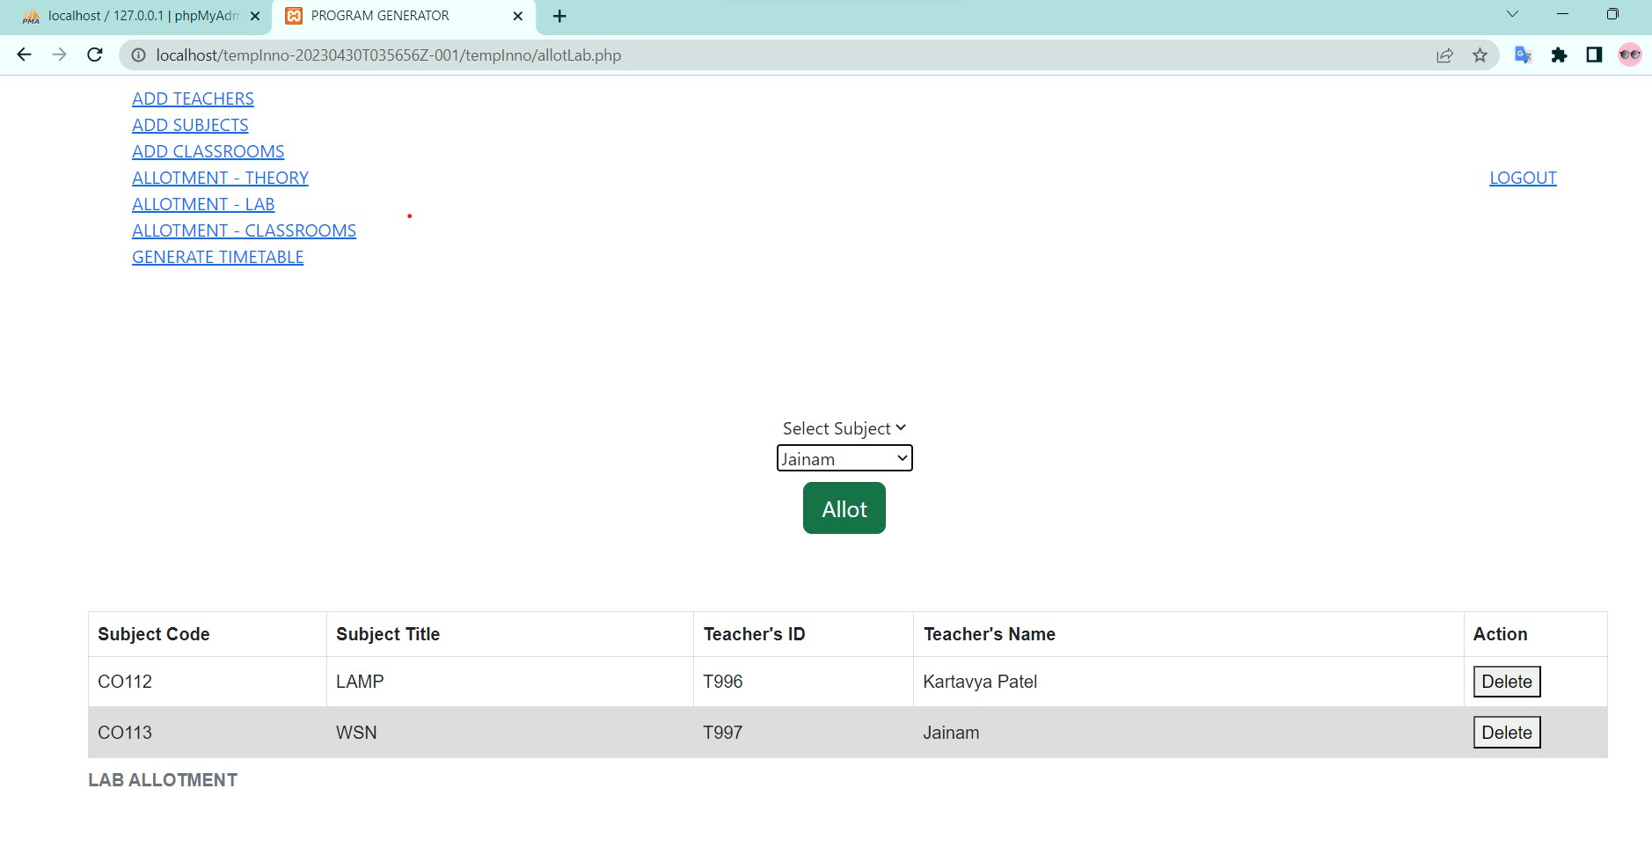

</html>

1. ALLOTMENTFORM.PHP

<?php

include 'connection.php';

if (isset($_POST['tobealloted'])) {

$subject = $_POST['tobealloted'];

$teacher = $_POST['toalloted'];

} else {

$message = "dead.";

echo "<script type='text/javascript'>alert('$message');</script>";

die();

}

$q = mysqli_query(mysqli_connect("localhost", "root", "", "lamp_innovative"), "UPDATE subjects SET isAlloted=1, allotedto='$teacher' WHERE subject_code='$subject'");

if ($q) {

$message = "Done.\\nTry again.";

echo "<script type='text/javascript'>alert('$message');</script>";

header("Location:allotsubjects.php");

} else {

$message = "Username or Password incorrect.\\nTry again.";

$message = $subject;

echo "<script type='text/javascript'>alert('$message');</script>";

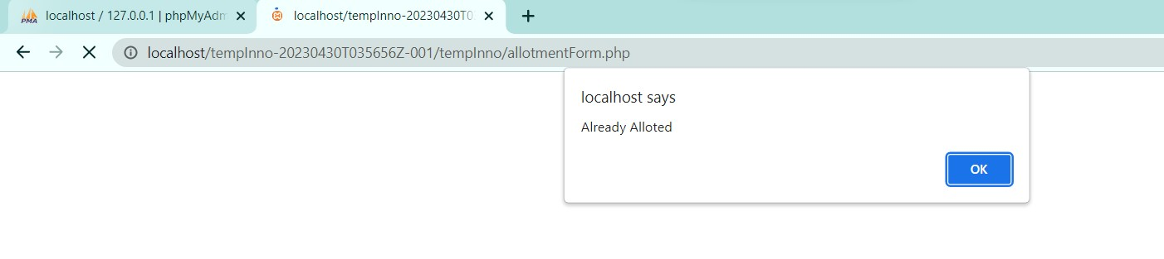

}

?>

1. ALLOTMENTLABFORM.PHP

<?php

include 'connection.php';

if (isset($_POST['tobealloted'])) {

$subject = $_POST['tobealloted'];

$teacher = $_POST['toalloted'];

} else {

$message = "dead.";

echo "<script type='text/javascript'>alert('$message');</script>";

die();

}

$q = mysqli_query(mysqli_connect("localhost", "root", "", "lamp_innovative"), "UPDATE subjects SET isAlloted=1, allotedto='$teacher' WHERE subject_code='$subject'");

if ($q) {

$message = "Done.\\nTry again.";

echo "<script type='text/javascript'>alert('$message');</script>";

header("Location:allotLab.php");

} else {

$message = "Username and Password incorrect.\\nTry again.";

$message = $subject;

echo "<script type='text/javascript'>alert('$message');</script>";

}

?>

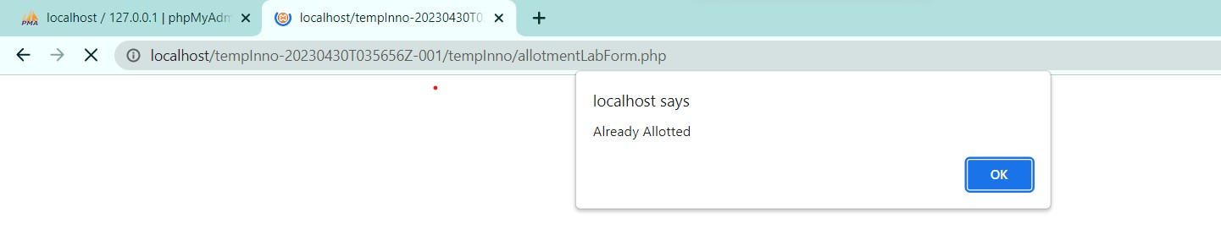

1. ALLOTSUBJECTS.PHP

<!DOCTYPE html>

<head>

<meta charset="utf-8" />

<meta name="viewport" content="width=device-width, initial-scale=1, maximum-scale=1" />

<meta name="description" content="" />

<meta name="author" content="" />

<title>PROGRAM GENERATOR</title>

<!-- BOOTSTRAP CORE STYLE CSS -->

<link href="./assets/css/bootstrap.css" rel="stylesheet" />

<!-- FONT AWESOME CSS -->

<link href="./assets/css/font-awesome.min.css" rel="stylesheet" />

<!-- FLEXSLIDER CSS -->

<link href="./assets/css/flexslider.css" rel="stylesheet" />

<!-- CUSTOM STYLE CSS -->

<link href="./assets/css/style.css" rel="stylesheet" />

</head>

<body>

<nav class="navbar navbar-inverse navbar-fixed-top" id="menu"> <!--navigating through menu bar-->>

<div class="container">

<ul class="nav navbar-nav">

<li><a href="addteachers.php">ADD TEACHERS</a></li>

<li><a href="addsubjects.php">ADD SUBJECTS</a></li>

<li><a href="addclassrooms.php">ADD CLASSROOMS</a></li>

<li><a href="allotsubjects.php">ALLOTMENT - THEORY</a></li>

<li><a href="allotLab.php">ALLOTMENT - LAB</a></li>

<li><a href="allotclasses.php">ALLOTMENT - CLASSROOMS</a></li>

<li><a href="generatetimetable.php">GENERATE TIMETABLE</a></li>

</ul>

<ul class="nav navbar-nav navbar-right">

<li><a href="index.php">LOGOUT</a></li>

</ul>

</div>

</nav>

<!--navigation bar ends-->

<br>

<div align="center">

<form action="allotmentForm.php" method="post" style="margin-top: 100px">

<div style="margin-top: 5px">

<select name="tobealloted" class="list-group-item">

<?php

include 'connection.php'; //connecting to database

$q = mysqli_query(

mysqli_connect("localhost", "root", "", "lamp_innovative"),

"SELECT * FROM subjects"

);

$row_count = mysqli_num_rows($q);

if ($row_count) {

$mystring = '

<option selected disabled>Select Subject</option>'; //select subject

while ($row = mysqli_fetch_assoc($q)) {

if ($row['isAlloted'] == 1 || $row['course_type'] == "LAB") //if already alloted then skip

continue;

$mystring .= '<option value="' . $row['subject_code'] . '">' . $row['subject_name'] . '</option>';

} //otherwise allocate

echo $mystring;

}

?>

</select>

</div>

<div>

<select name="toalloted" class="list-group-item">

<?php

include 'connection.php';

$q = mysqli_query(

mysqli_connect("localhost", "root", "", "lamp_innovative"),

"SELECT * FROM teachers "

);

$row_count = mysqli_num_rows($q);

if ($row_count) {

$mystring = '

<option selected disabled>Select Teacher</option>'; //select teacher

while ($row = mysqli_fetch_assoc($q)) {

$mystring .= '<option value="' . $row['faculty_number'] . '">' . $row['name'] . '</option>';

}

echo $mystring;

}

?>

</select>

</div>

<div style="margin-top: 10px">

<button type="submit" class="btn btn-success btn-lg">Allot</button> <!-- button allot-- allot to php form-->

</div>

</form>

</div>

<script>

function deleteHandlers() {

var table = document.getElementById("allotedsubjectstable"); //delete function

var rows = table.getElementsByTagName("tr");

for (i = 0; i < rows.length; i++) {

var currentRow = table.rows[i];

var createDeleteHandler =

function(row) {

return function() {

var cell = row.getElementsByTagName("td")[0];

var id = cell.innerHTML;

var x;

if (confirm("Are You Sure?") == true) {

window.location.href = "deleteallotment.php?name=" + id; //display window to show delete alloted subject

}

};

};

currentRow.cells[4].onclick = createDeleteHandler(currentRow);

}

}

</script>

<style>

table {

margin-top: 80px;

margin-bottom: 50px;

font-family: arial, sans-serif;

border-collapse: collapse;

margin-left: 80px;

width: 90%;

}

td,

th {

border: 1px solid #dddddd;

text-align: left;

padding: 8px;

}

tr:nth-child(even) {

background-color: #dddddd;

}

</style>

<table id=allotedsubjectstable>

<caption><strong>THEORY ALLOTMENT</strong></caption> <!--table-->

<tr>

<th width="150">Subject Code</th>

<th width=420>Subject Title</th>

<th width="170">Teacher's ID</th>

<th width="330">Teacher's Name</th>

<th width="40">Action</th>

</tr>

<tbody>

<?php

include 'connection.php';

$q = mysqli_query(

mysqli_connect("localhost", "root", "", "lamp_innovative"),

"SELECT * FROM subjects "

);

while ($row = mysqli_fetch_assoc($q)) {

if ($row['isAlloted'] == 0 || $row['course_type'] == 'LAB')

continue;

$teacher_id = $row['allotedto'];

$t = mysqli_query(

mysqli_connect("localhost", "root", "", "lamp_innovative"),

"SELECT name FROM teachers WHERE faculty_number = '$teacher_id'"

);

$trow = mysqli_fetch_assoc($t);

echo "<tr><td>{$row['subject_code']}</td>

<td>{$row['subject_name']}</td>

<td>{$row['allotedto']}</td>

<td>{$trow['name']}</td>

<td>

<button>Delete</button></td>

</tr>\n";

}

echo "<script>deleteHandlers();</script>";

?>

</tbody>

</table>

<!--some scripts-->

<script src="./assets/js/jquery-1.10.2.js"></script>

<script src="./assets/js/bootstrap.min.js"></script>

<script src="./assets/js/jquery.flexslider.min.js"></script>

<script src="./assets/js/scrollreveal.min.js"></script>

<script src="./assets/js/jquery.easing.min.js"></script>

<!-- <script src="./assets/js/custom.js"></script> -->

</body>

</html>

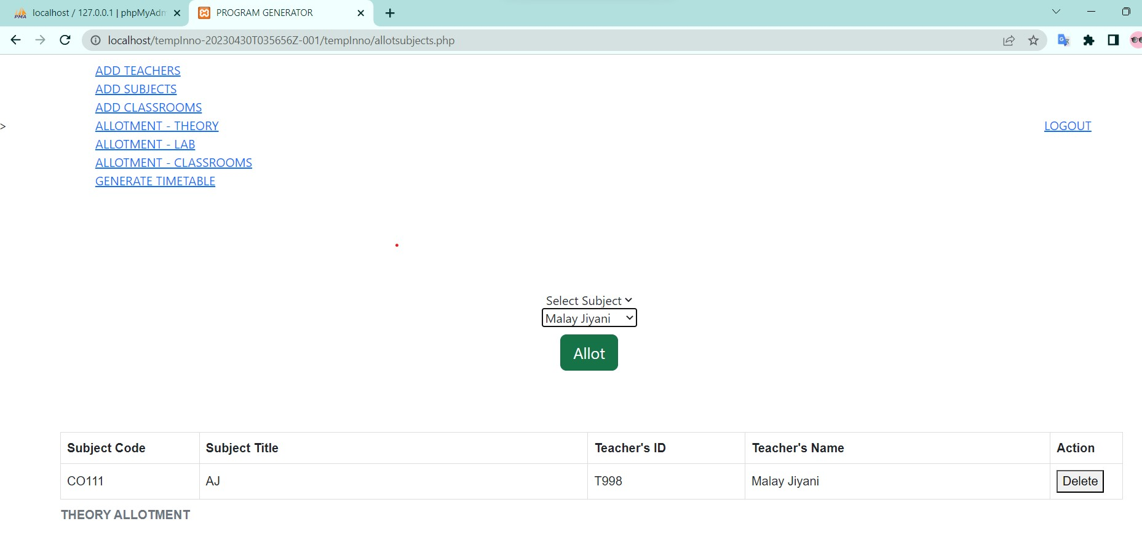

1. DELETEALLOTMENT.PHP

<?php

include 'connection.php';

$id = $_GET['name'];

$q = mysqli_query(mysqli_connect("localhost", "root", "", "lamp_innovative"),

"UPDATE subjects SET isAlloted = '0' , allotedto = '' WHERE subject_code = '$id' ");

if ($q) {

header("Location:allotsubjects.php");

} else {

echo 'Error';

}

?>

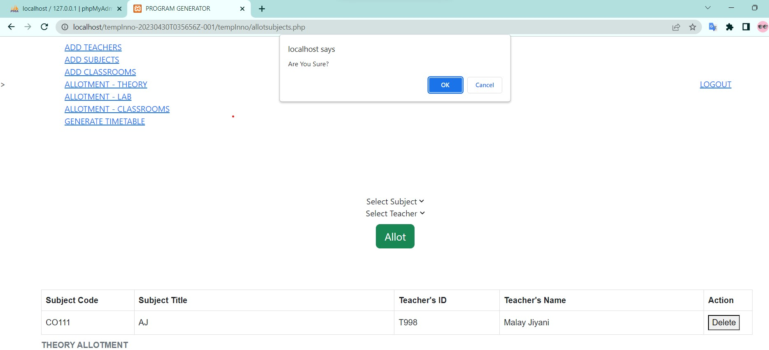

1. DELETESUBJECTS.PHP

<?php

include 'connection.php';

$id = $_GET['name'];

$q = mysqli_query(mysqli_connect("localhost", "root", "", "lamp_innovative"),

"DELETE FROM subjects WHERE subject_code = '$id' ");

if ($q) {

header("Location:addsubjects.php");

} else {

echo 'Error';

}

?>

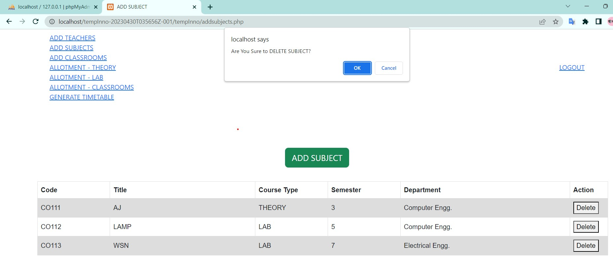

1. DELETETEACHER.PHP

<?php

include 'connection.php';

$id = $_GET['name'];

$q = mysqli_query(mysqli_connect("localhost", "root", "", "lamp_innovative"),

"DELETE FROM teachers WHERE faculty_number = '$id' ");

$drop = "DROP TABLE " . $id;

$q = mysqli_query(mysqli_connect("localhost", "root", "", "lamp_innovative"), $drop);

if ($drop) {

header("Location:addteachers.php");

} else {

echo 'Error';

}

?>

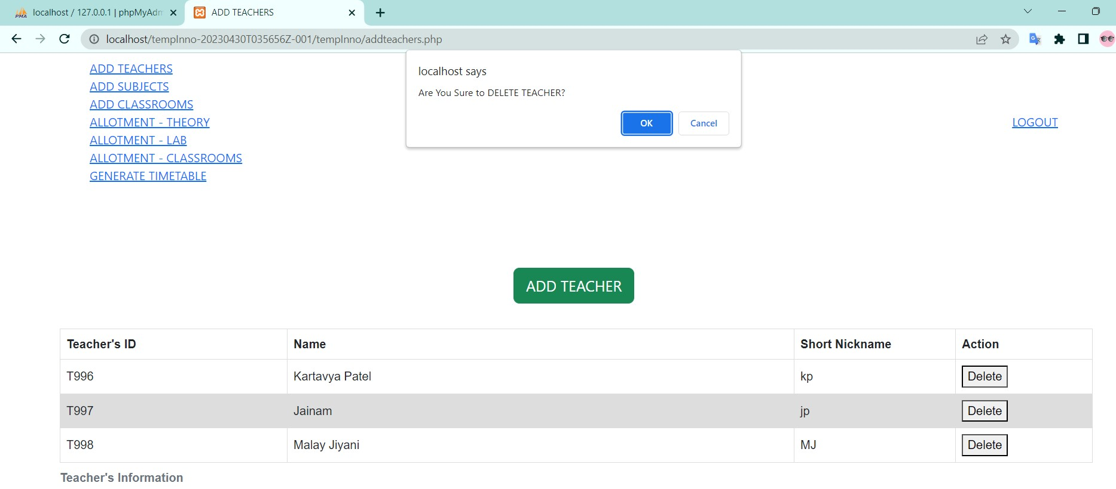

1. DELETECLASSROOM.PHP

<?php

include 'connection.php';

$id = $_GET['name'];

$q = mysqli_query(mysqli_connect("localhost", "root", "", "lamp_innovative"),

"DELETE FROM classrooms WHERE name = '$id' ");

if ($q) {

header("Location:addclassrooms.php");

} else {

echo 'Error';

}

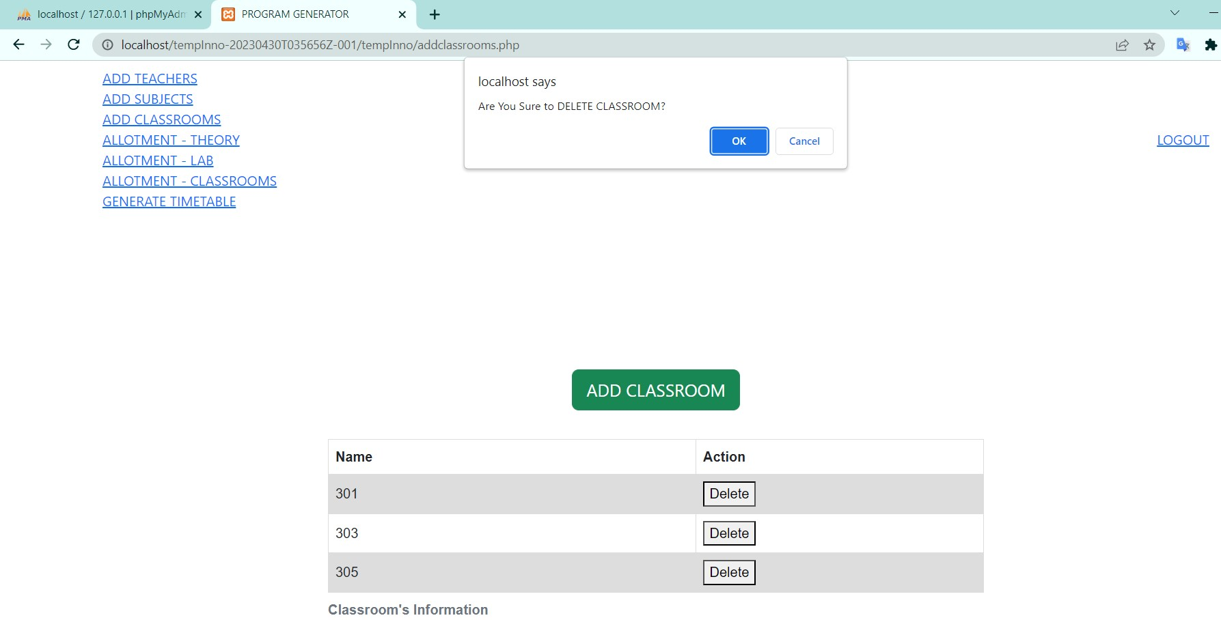

1. **addclassroomsForm.php**

<?php

// Include the file that contains the database connection information

include 'connection.php';

// Check if the CN (Classroom Name) variable was passed via a POST request

if (isset($_POST['CN'])) {

// If it was, assign its value to the $name variable

$name = $_POST['CN'];

} else {

// If it wasn't, set a message variable and display an alert to the user

$message = "dead.";

echo "<script type='text/javascript'>alert('$message');</script>";

// Exit the script

die();

}

// Create a new query to insert the classroom name and an initial count of 0 into the database

$q = mysqli_query(mysqli_connect("localhost", "root", "", "lamp_innovative"), "INSERT INTO classrooms VALUES ('$name',0)");

// If the query was successful, set a success message and redirect to the addclassrooms.php page

if ($q) {

$message = "Classroom added.";

echo "<script type='text/javascript'>alert('$message');</script>";

header("Location:addclassrooms.php");

} else {

// If the query was unsuccessful, set an error message and display an alert to the user

$message = "This Classroom exists.\\nTry again.";

echo "<script type='text/javascript'>alert('$message');</script>";

}

1. **addclassrooms.php**

<!DOCTYPE html>

<head>

<meta charset="utf-8" />

<meta name="viewport" content="width=device-width, initial-scale=1, maximum-scale=1" />

<meta name="description" content="" />

<meta name="author" content="" />

<title>PROGRAM GENERATOR</title>

<link href="./assets/css/bootstrap.css" rel="stylesheet" />

<link href="./assets/css/font-awesome.min.css" rel="stylesheet" />

<link href="./assets/css/flexslider.css" rel="stylesheet" />

</head>

<body>

<nav class="navbar navbar-inverse navbar-fixed-top" id="menu">

<div class="container">

<ul class="nav navbar-nav">

<li><a href="addteachers.php">ADD TEACHERS</a></li>

<li><a href="addsubjects.php">ADD SUBJECTS</a></li>

<li><a href="addclassrooms.php">ADD CLASSROOMS</a></li>

<li><a href="allotsubjects.php">ALLOTMENT - THEORY</a></li>

<li><a href="allotLab.php">ALLOTMENT - LAB</a></li>

<li><a href="allotclasses.php">ALLOTMENT - CLASSROOMS</a></li>

<li><a href="generatetimetable.php">GENERATE TIMETABLE</a></li>

</ul>

<ul class="nav navbar-nav navbar-right">

<li><a href="index.php">LOGOUT</a></li>

</ul>

</div>

</nav>

<br>

<div *align*="center" style="margin-top:10%">

<button id="classroommanual" class="btn btn-success btn-lg">ADD CLASSROOM

</button>

</div>

<div id="myModal" class="modal">

<div class="modal-content">

<div class="modal-header">

<span class="close">&times</span>

<h2 id="popupHead">Add Classroom</h2>

</div>

<div class="modal-body" id="EnterClassroom">

<div style="display:none" id="addClassroomForm">

<form action="addclassroomForm.php" method="POST">

<div class="form-group">

<label for="classroomname">Name</label>

<input type="text" class="form-control" id="classroomname" name="CN">

</div>

<div *align*="right">

<input type="submit" class="btn btn-default" name="ADD" value="ADD">

</div>

</form>

</div>

</div>

<div class="modal-footer">

</div>

</div>

</div>

<script>

// Get the modal element

var modal = document.getElementById('myModal');

// Get the button that opens the modal

var addclassroomBtn = document.getElementById("classroommanual");

// Get the heading element inside the modal

var heading = document.getElementById("popupHead");

// Get the form element inside the modal

var classroomForm = document.getElementById("addClassroomForm");

// Get the close button element inside the modal

var span = document.getElementsByClassName("close")[0];

// When the "Add Classroom" button is clicked, open the modal and display the form

addclassroomBtn.onclick = function() {

modal.style.display = "block";

classroomForm.style.display = "block";

}

// When the user clicks on the close button, close the modal and hide the form

span.onclick = function() {

modal.style.display = "none";

classroomForm.style.display = "none";

}

</script>

<script>

function deleteHandlers() {

// Get the table element by its ID

var table = document.getElementById("classroomstable");

// Get all the rows in the table

var rows = table.getElementsByTagName("tr");

// Loop through each row

for (i = 0; i < rows.length; i++) {

// Get the current row

var currentRow = table.rows[i];

// Create a new function to handle the delete button click for this row

var createDeleteHandler = function(row) {

return function() {

// Get the ID of the classroom from the first cell in the row

var cell = row.getElementsByTagName("td")[0];

var id = cell.innerHTML;

// Ask the user to confirm the delete action

var x;

if (confirm("Are You Sure?") == true) {

// If the user confirms, redirect to the deleteclassroom.php script with the ID as a parameter

window.location.href = "deleteclassroom.php?name=" + id;

}

};

};

// Attach the delete handler to the second cell in the row (which contains the delete button)

currentRow.cells[1].onclick = createDeleteHandler(currentRow);

}

}

</script>

<div *align*="center">

<br>

<style>

table {

margin-top: 10px;

font-family: arial, sans-serif;

border-collapse: collapse;

width: 50%;

}

td,

th {

border: 1px solid #dddddd;

text-align: left;

padding: 8px;

}

tr:nth-child(even) {

background-color: #dddddd;

}

</style>

<table id=classroomstable>

<caption><strong>Classroom's Information</strong></caption>

<tr>

<th width="100">Name</th>

<th width="60">Action</th>

</tr>

<?php

// Include the database connection file

include 'connection.php';

// Query the classrooms table to fetch all data

$q = mysqli_query(

mysqli_connect("localhost", "root", "", "lamp_innovative"),

"SELECT * FROM classrooms "

);

// Loop through all rows of the result set and display them in an HTML table

while ($row = mysqli_fetch_assoc($q)) {

echo "<tr><td>{$row['name']}</td><td><button>Delete</button></td></tr>\n";

}

// Attach a JavaScript function to the delete button to handle deleting the corresponding row from the database

echo "<script>deleteHandlers();</script>";

?>

</table>

</div>

<script src="./assets/js/jquery-1.10.2.js"></script>

<script src="./assets/js/bootstrap.min.js"></script>

<script src="./assets/js/jquery.flexslider.min.js"></script>

<script src="./assets/js/scrollreveal.min.js"></script>

<script src="./assets/js/jquery.easing.min.js"></script>

</body>

</html>

1. **addsubjectForm.php**

<?php

// Including the connection.php file to connect to the database

include 'connection.php';

// Checking if the form fields for subject name, code, semester, and department are set or not

if (isset($_POST['SN']) && isset($_POST['SC']) && isset($_POST['SS']) && isset($_POST['SD'])) {

// Assigning form field values to variables

$name = $_POST['SN'];

$code = $_POST['SC'];

$sem = $_POST['SS'];

$course = $_POST['ST'];

$dept = $_POST['SD'];

} else {

// If the form fields are not set, display a message and redirect to the addsubjects.php page

$message = "dead.";

echo "<script type='text/javascript'>alert('$message');</script>";

header("Location:addsubjects.php");

}

// Inserting the subject details into the 'subjects' table

$q = mysqli_query(mysqli_connect("localhost", "root", "", "lamp_innovative"), "INSERT INTO subjects VALUES ('$code','$name','$course','$sem','$dept',0,'')");

// Checking if the query was successful or not

if (!$q) {

// If the query was not successful, display an error message and redirect to the addsubjects.php page

$message = "Username and/or Password incorrect.\\nTry again.";

echo "<script type='text/javascript'>alert('$message');</script>";

header("Location:addsubjects.php");

}

1. **addsubjects.php**

<!DOCTYPE html>

<head>

<meta charset="utf-8" />

<meta name="viewport" content="width=device-width, initial-scale=1, maximum-scale=1" />

<meta name="description" content="" />

<meta name="author" content="" />

<title>ADD SUBJECT</title>

<link href="./assets/css/bootstrap.css" rel="stylesheet" />

<link href="./assets/css/font-awesome.min.css" rel="stylesheet" />

<link href="./assets/css/flexslider.css" rel="stylesheet" />

</head>

<body>

<nav class="navbar navbar-inverse navbar-fixed-top" id="menu">

<div class="container">

<ul class="nav navbar-nav">

<li><a href="addteachers.php">ADD TEACHERS</a></li>

<li><a href="addsubjects.php">ADD SUBJECTS</a></li>

<li><a href="addclassrooms.php">ADD CLASSROOMS</a></li>

<li><a href="allotsubjects.php">ALLOTMENT - THEORY</a></li>

<li><a href="allotLab.php">ALLOTMENT - LAB</a></li>

<li><a href="allotclasses.php">ALLOTMENT - CLASSROOMS</a></li>

<li><a href="generatetimetable.php">GENERATE TIMETABLE</a></li>

</ul>

<ul class="nav navbar-nav navbar-right">

<li><a href="index.php">LOGOUT</a></li>

</ul>

</div>

</nav>

<br>

<div *align*="center" style="margin-top:80px">

<button id="subjectmanual" class="btn btn-success btn-lg">ADD SUBJECT</button>

</div>

<div id="myModal" class="modal">

<div class="modal-content">

<div class="modal-header">

<span class="close">&times</span>

<h2 id="popupHead">Add Subject</h2>

</div>

<div class="modal-body" id="EnterSubject">

<div style="display:none" id="addSubjectForm">

<form action="addsubjectForm.php" method="POST">

<div class="form-group">

<label for="subjectname">Subject Name</label>

<input type="text" class="form-control" id="subjectname" name="SN">

</div>

<div class="form-group">

<label for="subjectcode">Subject Code</label>

<input type="text" class="form-control" id="subjectcode" name="SC" placeholder="CO...">

</div>

<div class="form-group">

<label for="subjecttype">Type</label>

<select class="form-control" id="subjecttype" name="ST">

<option selected disabled>Select</option>

<option value="THEORY">THEORY</option>

<option value="LAB">LAB</option>

</select>

</div>

<div class="form-group">

<label for="subjectsemester">Semester</label>

<select class="form-control" id="subjectsemester" name="SS">

<option selected disabled>Select</option>

<option value="3">3</option>

<option value="4">4</option>

<option value="5">5</option>

<option value="6">6</option>

<option value="7">7</option>

<option value="8">8</option>

</select>

</div>

<div class="form-group">

<label for="subjectdepartment">Department</label>

<select class="form-control" id="subjectdepartment" name="SD">

<option selected disabled>Select</option>

<option value="Computer Engg.">Computer Engg.</option>

<option value="Electronics Engg.">Biomedical Engg.</option>

<option value="Electrical Engg.">Electrical Engg.</option>

<option value="Mechanical Engg.">Mechanical Engg.</option>

</select>

</div>

<div *align*="right" class="form-group">

<input type="submit" class="btn btn-default" name="ADD" value="ADD">

</div>

</form>

</div>

</div>

<div class="modal-footer">

</div>

</div>

</div>

<script>

// Get the modal element

var modal = document.getElementById('myModal');

// Get the button that opens the modal

var addsubjectBtn = document.getElementById("subjectmanual");

// Get the heading element inside the modal

var heading = document.getElementById("popupHead");

// Get the subject form element inside the modal

var subjectForm = document.getElementById("addSubjectForm");

// Get the <span> element that closes the modal

var span = document.getElementsByClassName("close")[0];

// When the user clicks the "Add Subject" button, display the modal and the subject form

addsubjectBtn.onclick = function() {

modal.style.display = "block";

subjectForm.style.display = "block";

}

// When the user clicks on the <span> (x) inside the modal, close the modal and the subject form

span.onclick = function() {

modal.style.display = "none";

subjectForm.style.display = "none";

}

</script>

<div>

<br>

<style>

table {

margin-top: 10px;

font-family: arial, sans-serif;

border-collapse: collapse;

margin-left: 50px;

width: 90%;

}

td,

th {

border: 1px solid #dddddd;

text-align: left;

padding: 8px;

}

tr:nth-child(even) {

background-color: #dddddd;

}

</style>

<script>

function deleteHandlers() {

// Get the table element

var table = document.getElementById("subjectstable");

// Get all the rows in the table

var rows = table.getElementsByTagName("tr");

// Loop through all the rows in the table

for (i = 0; i < rows.length; i++) {

// Get the current row

var currentRow = table.rows[i];

// Create a function that will handle the delete action for the current row

var createDeleteHandler =

function(row) {

return function() {

// Get the value of the first cell (i.e., subject code) in the current row

var cell = row.getElementsByTagName("td")[0];

var id = cell.innerHTML;

// Ask the user for confirmation before proceeding with the delete action

if (confirm("Are You Sure?") == true) {

window.location.href = "deletesubject.php?name=" + id;

}

};

};

// Set the onclick event handler for the "Delete" button in the current row

currentRow.cells[5].onclick = createDeleteHandler(currentRow);

}

}

</script>

<table id=subjectstable style="margin-left: 90px">

<caption><strong> Subject's Information</strong></caption>

<tr>

<th width="150">Code</th>

<th width=300>Title</th>

<th width=150>Course Type</th>

<th width="150">Semester</th>

<th width="350">Department</th>

<th width="40">Action</th>

</tr>

<?php

// Include the database connection file

include 'connection.php';

// Execute a SELECT query to retrieve all the subjects from the database and order them by subject code

$q = mysqli_query(

mysqli_connect("localhost", "root", "", "lamp_innovative"),

"SELECT * FROM subjects ORDER BY subject_code ASC "

);

// Loop through the result set and output each subject as a row in an HTML table

while ($row = mysqli_fetch_assoc($q)) {

echo "<tr><td>{$row['subject_code']}</td>

<td>{$row['subject_name']}</td>

<td>{$row['course_type']}</td>

<td>{$row['semester']}</td>

<td>{$row['department']}</td>

<td><button>Delete</button></td>

</tr>\n";

}

// Output a JavaScript function call to set up the delete action handlers for the "Delete" buttons in the table

echo "<script>deleteHandlers();</script>";

?>

</table>

</div>

<script src="./assets/js/jquery-1.10.2.js"></script>

<script src="./assets/js/bootstrap.min.js"></script>

<script src="./assets/js/jquery.flexslider.min.js"></script>

<script src="./assets/js/scrollreveal.min.js"></script>

<script src="./assets/js/jquery.easing.min.js"></script>

</body>

</html>

1. **addteacherForm.php**

<?php

// include the connection.php file to connect to the database

include 'connection.php';

// Check if TN, TF, and AL are set in the POST request

if (isset($_POST['TN']) && isset($_POST['TF']) && isset($_POST['AL'])) {

// if set, assign them to variables

$name = $_POST['TN'];

$facno = $_POST['TF'];

$alias = $_POST['AL'];

} else {

// if not set, display an error message and terminate the script

$message = "dead.";

echo "<script type='text/javascript'>alert('$message');</script>";

die();

}

// insert the teacher's details into the 'teachers' table

$q = mysqli_query(mysqli_connect("localhost", "root", "", "lamp_innovative"), "INSERT INTO teachers VALUES ('$facno','$name','$alias')");

// create a new table for the teacher with the name of their faculty number

$sql = "CREATE TABLE " . $facno . " (

day VARCHAR(10) PRIMARY KEY,

period1 VARCHAR(30),

period2 VARCHAR(30),

period3 VARCHAR(30),

period4 VARCHAR(30),

period5 VARCHAR(30),

period6 VARCHAR(30)

)";

mysqli_query(mysqli_connect("localhost", "root", "", "lamp_innovative"), $sql);

// create a row for each day of the week in the new table

$days = array('monday', 'tuesday', 'wednesday', 'thursday', 'friday');

for ($i = 0; $i < 5; $i++) {

$day = $days[$i];

$sql = "INSERT into " . $facno . " VALUES('$day','','','','','','')";

mysqli_query(mysqli_connect("localhost", "root", "", "lamp_innovative"), $sql);

}

// if the query was unsuccessful, display an error message

if (!$q) {

$message = "Username or ID incorrect.\\nTry again.";

echo "<script type='text/javascript'>alert('$message');</script>";

}

1. **addteachers.php**

<!DOCTYPE html>

<html lang="en">

<head>

<meta charset="utf-8" />

<meta name="viewport" content="width=device-width, initial-scale=1, maximum-scale=1" />

<meta name="description" content="" />

<meta name="author" content="" />

<title>ADD TEACHERS</title>

<link href="./assets/css/bootstrap.css" rel="stylesheet" />

<link href="./assets/css/font-awesome.min.css" rel="stylesheet" />

<link href="./assets/css/flexslider.css" rel="stylesheet" />

</head>

<body>

<nav class="navbar navbar-inverse navbar-fixed-top" id="menu">

<div class="container">

<ul class="nav navbar-nav">

<li><a href="addteachers.php">ADD TEACHERS</a></li>

<li><a href="addsubjects.php">ADD SUBJECTS</a></li>

<li><a href="addclassrooms.php">ADD CLASSROOMS</a></li>

<li><a href="allotsubjects.php">ALLOTMENT - THEORY</a></li>

<li><a href="allotLab.php">ALLOTMENT - LAB</a></li>

<li>

<a href="allotclasses.php">ALLOTMENT - CLASSROOMS</a>

</li>

<li>

<a href="generatetimetable.php">GENERATE TIMETABLE</a>

</li>

</ul>

<ul class="nav navbar-nav navbar-right">

<li><a href="index.php">LOGOUT</a></li>

</ul>

</div>

</nav>

<br />

<div *align*="center" style="margin-top: 80px"></div>

<div *align*="center" style="margin-top: 20px">

<button id="teachermanual" class="btn btn-success btn-lg">

ADD TEACHER

</button>

</div>

<div id="myModal" class="modal">

<div class="modal-content" style="margin-top: -60px">

<div class="modal-header">

<span class="close">&times</span>

<h2 id="popupHead">Add Teacher</h2>

</div>

<div class="modal-body" id="EnterTeacher">

<div style="display: none" id="addTeacherForm">

<form action="addteacherForm.php" method="POST">

<div class="form-group">

<label for="teachername">Teacher's Name</label>

<input type="text" class="form-control" id="teachername" name="TN" />

</div>

<div class="form-group">

<label for="TF">Teacher's ID</label>

<input type="text" class="form-control" id="facultyno" name="TF" placeholder="T..." />

</div>

<div class="form-group">

<label for="TF">Short Nickname</label>

<input type="text" class="form-control" id="alias_name" name="AL" placeholder="brief" />

</div>

<div *align*="right">

<input type="submit" class="btn btn-default" name="ADD" value="ADD" />

</div>

</form>

</div>

</div>

<div class="modal-footer"></div>

</div>

</div>

<script>

// Get the modal element

var modal = document.getElementById("myModal");

// Get the button that opens the modal

var addteacherBtn = document.getElementById("teachermanual");

// Get the heading element of the modal

var heading = document.getElementById("popupHead");

// Get the form element for adding teacher details

var facultyForm = document.getElementById("addTeacherForm");

// Get the close button for the modal

var span = document.getElementsByClassName("close")[0];

// When the user clicks the add teacher button, display the modal and the faculty form

addteacherBtn.onclick = function() {

modal.style.display = "block";

facultyForm.style.display = "block";

};

// When the user clicks the close button, hide the modal and the faculty form

span.onclick = function() {

modal.style.display = "none";

facultyForm.style.display = "none";

};

</script>

<div>

<br />

<style>

table {

margin-top: 10px;

font-family: arial, sans-serif;

border-collapse: collapse;

margin-left: 30px;

width: 90%;

}

td,

th {

border: 1px solid #dddddd;

text-align: left;

padding: 8px;

}

tr:nth-child(even) {

background-color: #dddddd;

}

</style>

<script>

// Define a function to set up delete handlers for each row in a table

function deleteHandlers() {

// Get the table element

var table = document.getElementById("teacherstable");

// Get all the rows in the table

var rows = table.getElementsByTagName("tr");

// For each row, set up a delete handler

for (i = 0; i < rows.length; i++) {

var currentRow = table.rows[i];

// Define a function that returns a delete handler for the given row

var createDeleteHandler = function(row) {

return function() {

// Get the first cell in the row (which contains the teacher's ID)

var cell = row.getElementsByTagName("td")[0];

var id = cell.innerHTML;

// Ask for confirmation before deleting the teacher

if (confirm("Are You Sure?") == true) {

// If confirmed, navigate to the "deleteteacher.php" page with the teacher's ID in the query string

window.location.href = "deleteteacher.php?name=" + id;

}

};

};

// Attach the delete handler to the "Delete" button in the row

currentRow.cells[3].onclick = createDeleteHandler(currentRow);

}

}

</script>

<table id="teacherstable" style="margin-left: 80px">

<caption>

<strong>Teacher's Information </strong>

</caption>

<tr>

<th width="130">Teacher's ID</th>

<th width="290">Name</th>

<th width="50">Short Nickname</th>

<th width="40">Action</th>

</tr>

<tbody>

<?php

// Include the "connection.php" file to connect to the database

include 'connection.php';

// Query the "teachers" table and sort the results by faculty number in ascending order

$q = mysqli_query(mysqli_connect("localhost", "root", "", "lamp_innovative"), "SELECT * FROM teachers ORDER BY faculty_number ASC");

// Loop through each row in the query results and display the data in a table row

while ($row = mysqli_fetch_assoc($q)) {

echo "<tr><td>{$row['faculty_number']}</td><td>{$row['name']}</td><td>{$row['alias']}</td><td><button>Delete</button></td></tr>\n";

}

// After displaying all the rows, include a script to set up delete handlers for each row

echo "<script>deleteHandlers();</script>";

?>

</tbody>

</table>

</div>

<script src="./assets/js/jquery-1.10.2.js"></script>

<script src="./assets/js/bootstrap.min.js"></script>

<script src="./assets/js/jquery.flexslider.min.js"></script>

<script src="./assets/js/scrollreveal.min.js"></script>

<script src="./assets/js/jquery.easing.min.js"></script>

</body>

</html>