-----------------------------------------------------------PART-A----------------------------------------------------------

1. Create a new database named “Darshan”.

use database Darshan

switched to db database

2. Create another new database named “DIET”.

use database DIET

already on db database

3. List all databases.

show databases

admin 40.00 KiB

config 108.00 KiB

local 168.00 KiB

todo 72.00 KiB

4. Check the current database.

use database Darshan

already on db database

db

Darshan

5. Drop “DIET” database.

db.dropDatabase("DIET")

{ ok: 1, dropped: 'database' }

6. Create a collection named “Student” in the “Darshan” database.

db.createCollection("Student")

{ ok: 1 }

7. Create a collection named “Department” in the “Darshan” database.

db.createCollection("Department")

{ ok: 1 }

8. List all collections in the “Darshan” database

show collections

Department

Student

9. Insert a single document using insertOne into “Department” collection. (Dname:’CE’, HOD:’Patel’)

db.Department.insertOne({Dname:"CE", HOD:"Patel"})

{

acknowledged: true,

insertedId: ObjectId('67567d79eec5005c5008830d')

}

10. Insert two document using insertMany into “Department” collection. (Dname:’IT’ and Dname:’ICT’)

db.Department.insertMany([{Dname:"IT"},{Dname:"ICT"}])

{

acknowledged: true,

insertedIds: {

'0': ObjectId('67567db4eec5005c5008830e'),

'1': ObjectId('67567db4eec5005c5008830f')

}

}

11. Drop a collection named “Department” from the “Darshan” database

db.Department.drop()

true

12. Insert a single document using insertOne into “Student” collection.

(Fields are Name, City, Branch, Semester, Age) Insert your own data

db.Student.insertOne({Name:"Malay",City:"Jamnagar",Branch:"CSE",Semester:"4",Age:"19"})

{

acknowledged: true,

insertedId: ObjectId('67567f98eec5005c50088310')

}

13. Insert three documents using insertMany into “Student” collection.

(Fields are Name, City, Branch, Semester, Age) Insert your three friend’s data.

db.Student.insertMany([{Name:"Kavyam",City:"Rajkot",Branch:"CSE",Semester:"4",Age:"19"},{Name:"Dhairya",City:"Rajkot",Branch:"CSE",Semester:"4",Age:"4"},{Name:"Kalp",City:"Jamnagar",Branch:"CSE",Semester:"4",Age:"19"}])

{

acknowledged: true,

insertedIds: {

'0': ObjectId('67568045eec5005c50088311'),

'1': ObjectId('67568045eec5005c50088312'),

'2': ObjectId('67568045eec5005c50088313')

}

}

14. Check whether “Student” collection exists or not.

show collections

Student

15. Check the stats of “Student” collection.

db.Student.stats

[Function: stats] AsyncFunction {

apiVersions: [ 0, 0 ],

returnsPromise: true,

serverVersions: [ '0.0.0', '999.999.999' ],

topologies: [ 'ReplSet', 'Sharded', 'LoadBalanced', 'Standalone' ],

returnType: { type: 'unknown', attributes: {} },

deprecated: false,

platforms: [ 'Compass', 'Browser', 'CLI' ],

isDirectShellCommand: false,

acceptsRawInput: false,

shellCommandCompleter: undefined,

help: [Function (anonymous)] Help

}

16. Drop the “Student” collection.

db.Student.drop()

true

17. Create a collection named “Deposit”

db.createCollection("Deposit")

{ ok: 1 }

18. Insert following data in to “Deposit” collection.

db.Deposit.insertMany([{ACTNO:"101",CNAME:"ANIL",BNAME:"VRCE",AMOUNT:"1000.00",CITY:"Rajkot"},{ACTNO:"102",CNAME:"SUNIL",BNAME:"AJNI",AMOUNT:"5000.00",CITY:"SURAT"},{ACTNO:"103",CNAME:"MEHUL",BNAME:"KAROLBAGH",AMOUNT:"3500.00",CITY:"BARODA"},{ACTNO:"104",CNAME:"MADHURI",BNAME:"CHANDI",AMOUNT:"1200.00",CITY:"AHMEDABAD"},{ACTNO:"105",CNAME:"PRMOD",BNAME:"M.G. ROAD",AMOUNT:"3000.00",CITY:"SURAT"},{ACTNO:"106",CNAME:"SANDIP",BNAME:"ANDHERI",AMOUNT:"2000.00",CITY:"RAJKOT"},{ACTNO:"107",CNAME:"SHIVANI",BNAME:"VIRAR",AMOUNT:"1000.00",CITY:"SURAT"},{ACTNO:"108",CNAME:"KRANTI",BNAME:"NEHRU PLACE",AMOUNT:"5000.00",CITY:"RAJKOT"}])

{

acknowledged: true,

insertedIds: {

'0': ObjectId('6756c7790bf081afc586f61a'),

'1': ObjectId('6756c7790bf081afc586f61b'),

'2': ObjectId('6756c7790bf081afc586f61c'),

'3': ObjectId('6756c7790bf081afc586f61d'),

'4': ObjectId('6756c7790bf081afc586f61e'),

'5': ObjectId('6756c7790bf081afc586f61f'),

'6': ObjectId('6756c7790bf081afc586f620'),

'7': ObjectId('6756c7790bf081afc586f621')

}

}

19. Display all the documents of “Deposit” collection.

db.Deposit.find()

{

_id: ObjectId('6756c7790bf081afc586f61a'),

ACTNO: '101',

CNAME: 'ANIL',

BNAME: 'VRCE',

AMOUNT: '1000.00',

CITY: 'Rajkot'

}

{

_id: ObjectId('6756c7790bf081afc586f61b'),

ACTNO: '102',

CNAME: 'SUNIL',

BNAME: 'AJNI',

AMOUNT: '5000.00',

CITY: 'SURAT'

}

{

_id: ObjectId('6756c7790bf081afc586f61c'),

ACTNO: '103',

CNAME: 'MEHUL',

BNAME: 'KAROLBAGH',

AMOUNT: '3500.00',

CITY: 'BARODA'

}

{

_id: ObjectId('6756c7790bf081afc586f61d'),

ACTNO: '104',

CNAME: 'MADHURI',

BNAME: 'CHANDI',

AMOUNT: '1200.00',

CITY: 'AHMEDABAD'

}

{

_id: ObjectId('6756c7790bf081afc586f61e'),

ACTNO: '105',

CNAME: 'PRMOD',

BNAME: 'M.G. ROAD',

AMOUNT: '3000.00',

CITY: 'SURAT'

}

{

_id: ObjectId('6756c7790bf081afc586f61f'),

ACTNO: '106',

CNAME: 'SANDIP',

BNAME: 'ANDHERI',

AMOUNT: '2000.00',

CITY: 'RAJKOT'

}

{

_id: ObjectId('6756c7790bf081afc586f620'),

ACTNO: '107',

CNAME: 'SHIVANI',

BNAME: 'VIRAR',

AMOUNT: '1000.00',

CITY: 'SURAT'

}

20. Drop the “Deposit” collection.

db.Deposit.drop()

true

-----------------------------------------------------------PART-B----------------------------------------------------------

1. Create a new database named “Computer”

use database Computer

switched to db database

2. Create a collection named “Faculty” in the “Computer” database

db.createCollection("Faculty")

{ ok: 1 }

3. Insert a below document using insertOne into “Faculty” collection.

db.Faculty.insertOne({FID:"1",FNAME:"ANIL",BNAME:"CE",AMOUNT:10000,JDATE:"01-03-1995"})

{

acknowledged: true,

insertedId: ObjectId('675867c28a75535f96ea3630')

}

4. Insert below documents using insertMany into “Faculty” collection.

db.Faculty.insertMany([{FID:"2",FNAME:"SUNIL",BNAME:"CE",AMOUNT:50000,JDATE:"04-01-1996"},{FID:3,FNAME:"MEHUL",BNAME:"IT",SALARY:35000,JDATE:"17-11-1995"},{FID:4,FNAME:"MADHURI",BNAME:"IT",SALARY:12000,JDATE:"17-12-1995"},{FID:5,FNAME:"PRMOD",BNAME:"CE",SALARY:30000,JDATE:"27-03-1996"},{FID:6,FNAME:"SANDIP",BNAME:"CE",SALARY:20000,JDATE:"31-03-1996"},{FID:7,FNAME:"SHIVANI",BNAME:"CE",SALARY:10000,JDATE:"05-09-1995"},{FID:8,FNAME:"KRANTI",BNAME:"IT",SALARY:50000,JDATE:"02-07-1995"}])

{

acknowledged: true,

insertedIds: {

'0': ObjectId('67586af78a75535f96ea3638'),

'1': ObjectId('67586af78a75535f96ea3639'),

'2': ObjectId('67586af78a75535f96ea363a'),

'3': ObjectId('67586af78a75535f96ea363b'),

'4': ObjectId('67586af78a75535f96ea363c'),

'5': ObjectId('67586af78a75535f96ea363d'),

'6': ObjectId('67586af78a75535f96ea363e')

}

}

5. Display all the documents of “Faculty” collection.

db.Faculty.find()

{

_id: ObjectId('675867c28a75535f96ea3630'),

FID: 1,

FNAME: 'ANIL',

BNAME: 'CE',

SALARY: 10000,

JDATE: '01-03-1995'

}

{

_id: ObjectId('67586af78a75535f96ea3638'),

FID: '2',

FNAME: 'SUNIL',

BNAME: 'CE',

AMOUNT: 50000,

JDATE: '04-01-1996'

}

{

_id: ObjectId('67586af78a75535f96ea3639'),

FID: 3,

FNAME: 'MEHUL',

BNAME: 'IT',

SALARY: 35000,

JDATE: '17-11-1995'

}

{

_id: ObjectId('67586af78a75535f96ea363a'),

FID: 4,

FNAME: 'MADHURI',

BNAME: 'IT',

SALARY: 12000,

JDATE: '17-12-1995'

}

{

_id: ObjectId('67586af78a75535f96ea363b'),

FID: 5,

FNAME: 'PRMOD',

BNAME: 'CE',

SALARY: 30000,

JDATE: '27-03-1996'

}

{

_id: ObjectId('67586af78a75535f96ea363c'),

FID: 6,

FNAME: 'SANDIP',

BNAME: 'CE',

SALARY: 20000,

JDATE: '31-03-1996'

}

{

_id: ObjectId('67586af78a75535f96ea363d'),

FID: 7,

FNAME: 'SHIVANI',

BNAME: 'CE',

SALARY: 10000,

JDATE: '05-09-1995'

}

{

_id: ObjectId('67586af78a75535f96ea363e'),

FID: 8,

FNAME: 'KRANTI',

BNAME: 'IT',

SALARY: 50000,

JDATE: '02-07-1995'

}

6. Drop the “Faculty” collection.

db.Faculty.drop()

true

7. Drop the “Computer” database.

db.dropDatabase("Computer")

{ ok: 1, dropped: 'database' }

-----------------------------------------------------------PART-C----------------------------------------------------------

1. Create a new database named “Computer”.

2. Create a collection named “Faculty” in the “Computer” database.

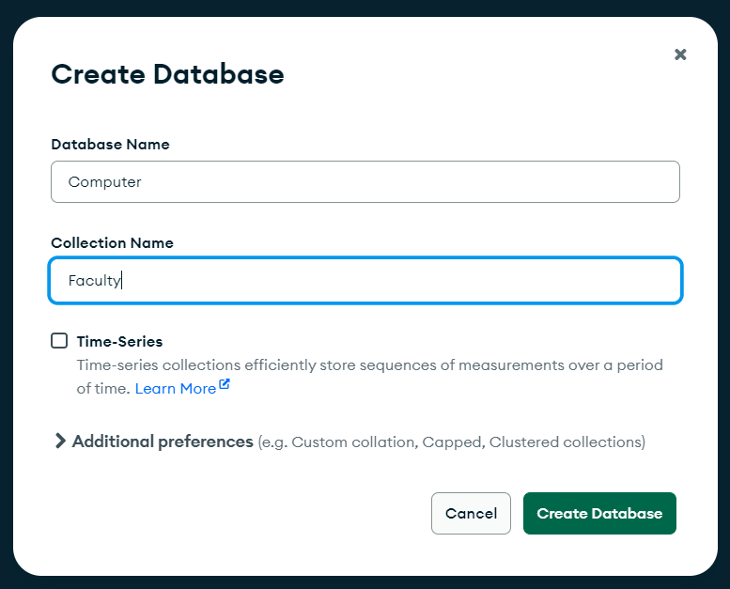

3. Insert a below documents into “Faculty” collection.

[

{

"FID":1,"FNAME":"ANIL","BNAME":"CE","SALARY":10000,"JDATE":"01-03-1995"

},

{

"FID":2,"FNAME":"SUNIL","BNAME":"CE","SALARY":50000,"JDATE":"04-01-1996"

},

{

"FID":3,"FNAME":"MEHUL","BNAME":"IT","SALARY":35000,"JDATE":"17-11-1995"

},

{

"FID":4,"FNAME":"MADHURI","BNAME":"IT","SALARY":12000,"JDATE":"17-12-1995"

},

{

"FID":5,"FNAME":"PRMOD","BNAME":"CE","SALARY":30000,"JDATE":"27-03-1996"

},

{

"FID":6,"FNAME":"SANDIP","BNAME":"CE","SALARY":20000,"JDATE":"31-03-1996"

},

{

"FID":7,"FNAME":"SHIVANI","BNAME":"CE","SALARY":10000,"JDATE":"05-09-1995"

},

{

"FID":8,"FNAME":"KRANTI","BNAME":"IT","SALARY":50000,"JDATE":"02-07-1995"

}

]

4. Display all the documents of “Faculty” collection.

5. Drop the “Faculty” collection.

6. Drop the “Computer” database.