**Lab Practical #01:**

Study of basic networking commands and IP configuration.

**Practical Assignment #01:**

1. Perform and explain various networking commands listed below:
   1. ipconfig
   2. ping
   3. getmac
   4. systeminfo
   5. traceroute / tracert
   6. netstat
   7. nslookup
   8. hostname
   9. pathping
   10. arp

## ipconfig

### Description:

**Displays all current TCP/IP network configuration values and refreshes DHCP and DNS settings.**

|  |  |  |
| --- | --- | --- |
| No. | Option | Description |
| 1 | /all | Displays full configuration information. |
| 2 | /release | Releases the IP address for the specified adapter. |
| 3 | /renew | Renews the IP address for the specified adapter. |
| 4 | /flushdns | Clears the DNS Resolver cache. |
| 5 | /displaydns | Displays the contents of the DNS Resolver cache. |

### Implementation:

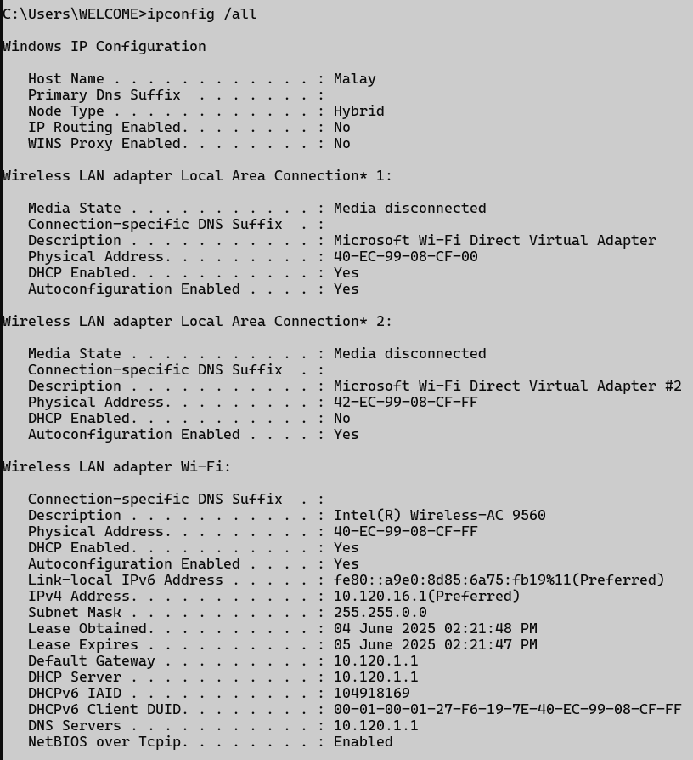

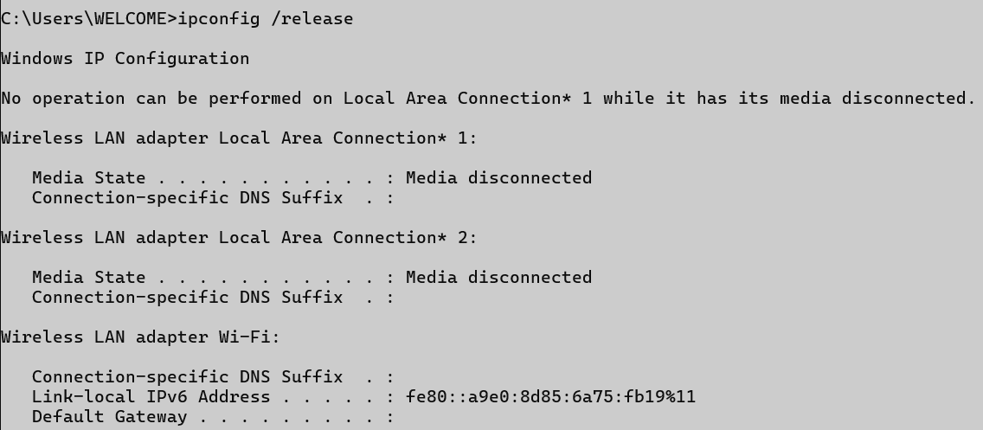

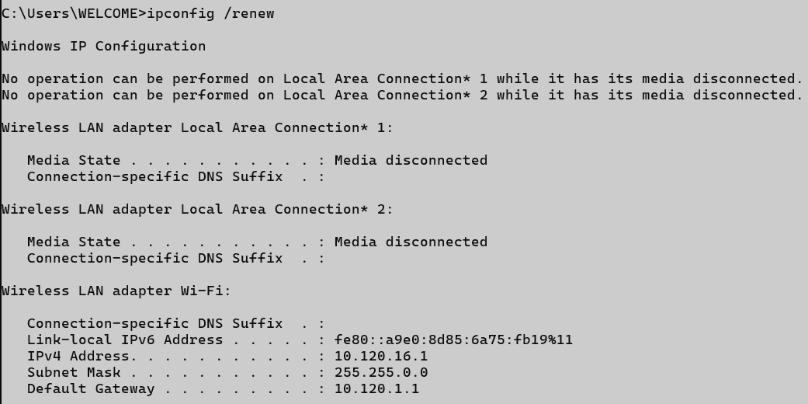

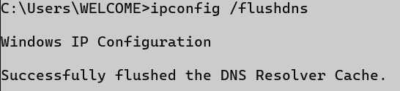

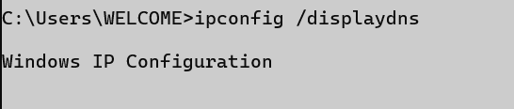

## ping

### Description:

**Sends ICMP Echo Request messages to verify if a host is reachable over the network.**

|  |  |  |
| --- | --- | --- |
| No. | Option | Description |
| 1 | -t | Pings the target until stopped manually. |
| 2 | -n count | Specifies the number of Echo Request messages to send. |
| 3 | -l size | Sends packets with a custom byte size. |
| 4 | -4 | Forces using IPv4. |
| 5 | -a | Resolve addresses to hostnames. |

### Implementation:

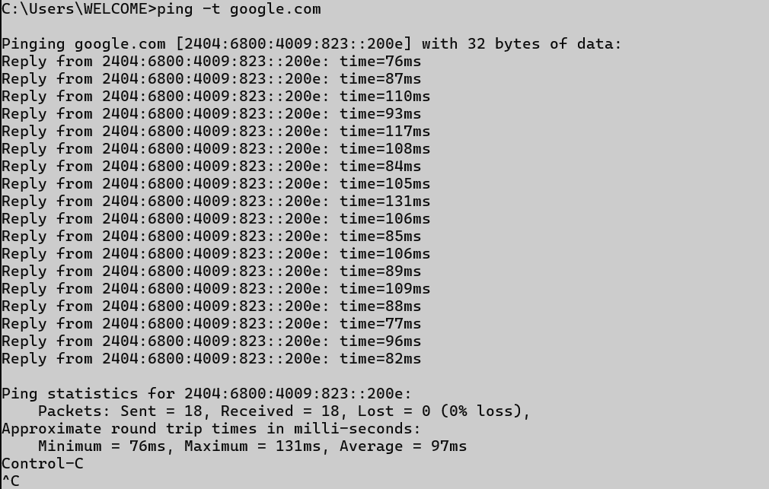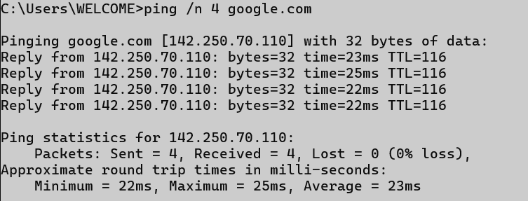

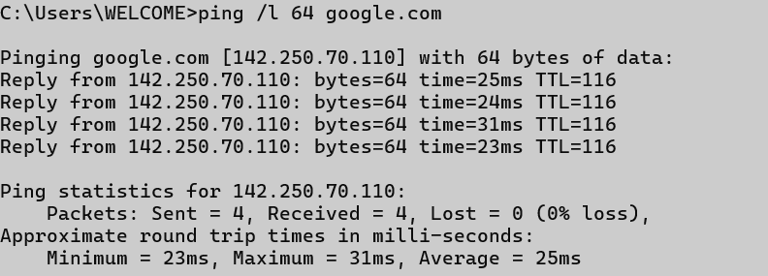

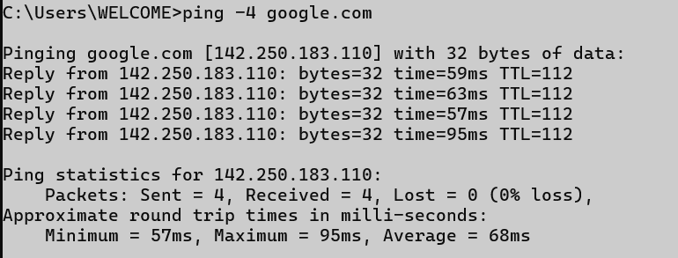

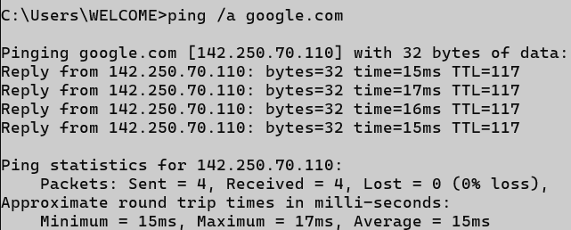

## getmac

### Description:

**Displays the MAC address of the system’s network interfaces.**

|  |  |  |
| --- | --- | --- |
| No. | Option | Description |
| 1 | /v | Shows verbose output with more details. |
| 2 | /fo table | Displays output in table format. |
| 3 | /fo list | Displays output in list format. |
| 4 | /fo csv | Displays output in CSV format. |
| 5 | /nh | Hides the column headers in the output. |

### Implementation:

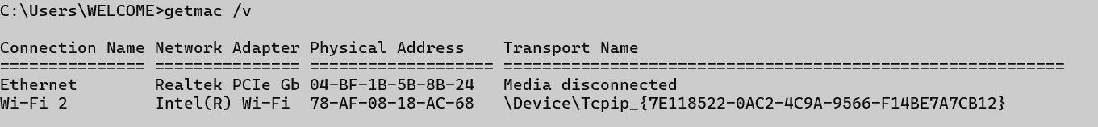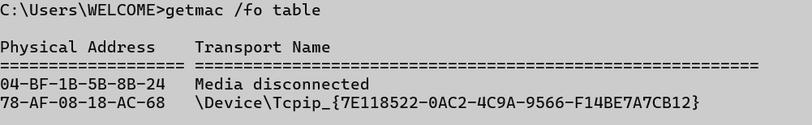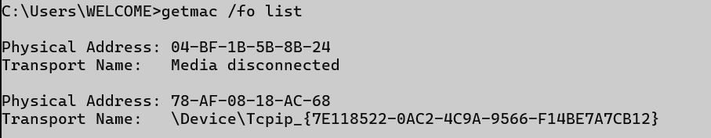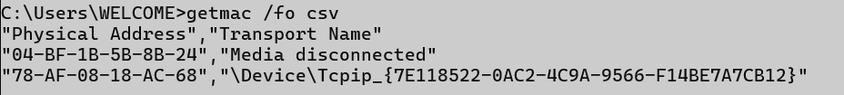



## systeminfo

### Description:

**Provides detailed configuration information about the computer and its OS.**

|  |  |  |
| --- | --- | --- |
| No. | Option | Description |
| 1 | (no option) | Shows all system information. |
| 2 |  |  |
| 3 |  |  |
| 4 |  |  |
| 5 |  |  |

### Implementation:

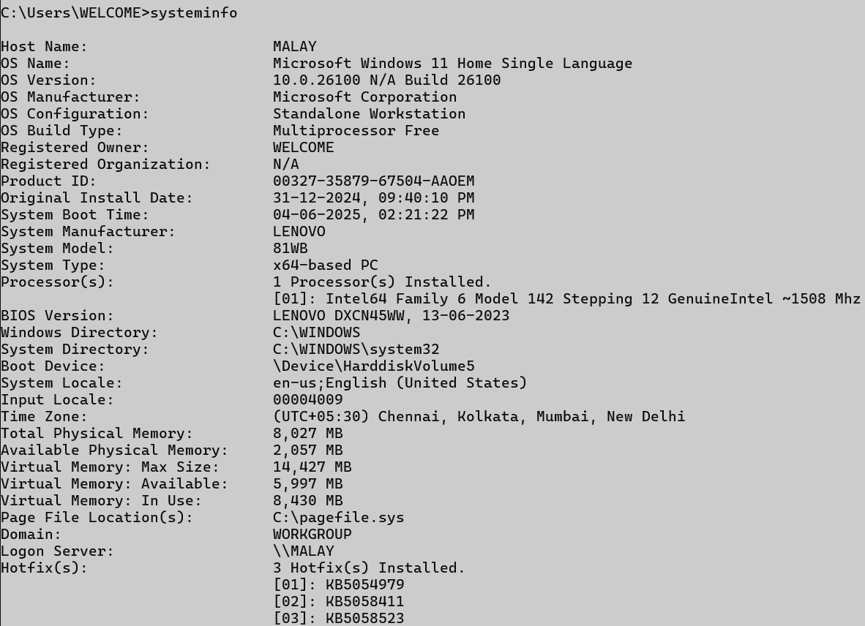

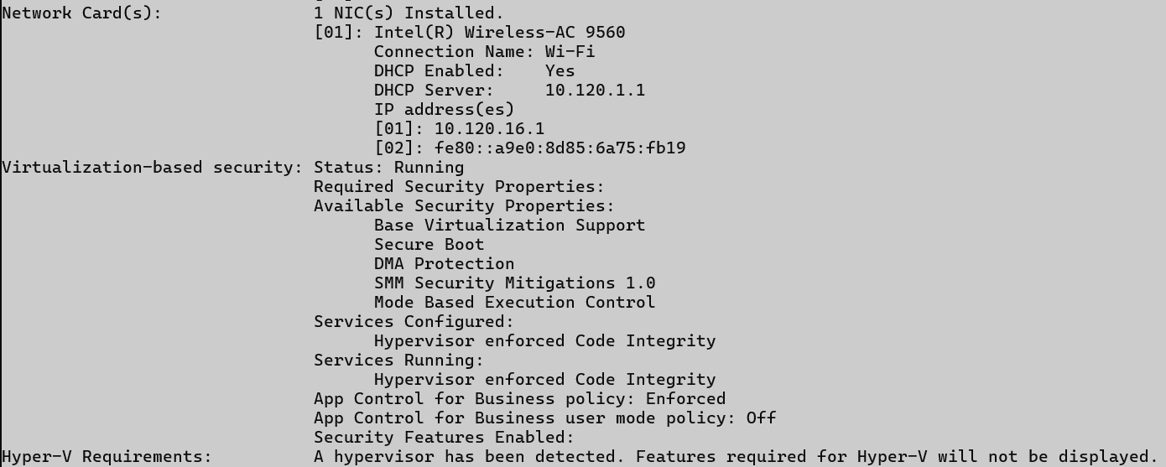

## traceroute / tracert

### Description:

**Traces the path that packets take to reach a network host.**

|  |  |  |
| --- | --- | --- |
| No. | Option | Description |
| 1 | -d | Prevents resolving IPs to hostnames. |
| 2 | -h <max> | Sets the maximum number of hops. |
| 3 | -w <timeout> | Sets the timeout in milliseconds. |
| 4 | -4 | Forces using IPv4. |
| 5 | -6 | Forces using IPv6. |

### Implementation:

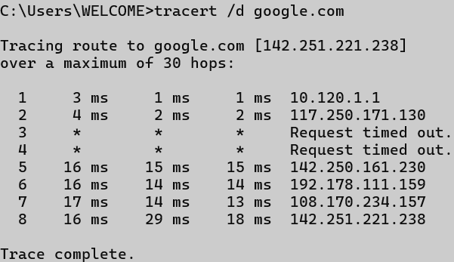

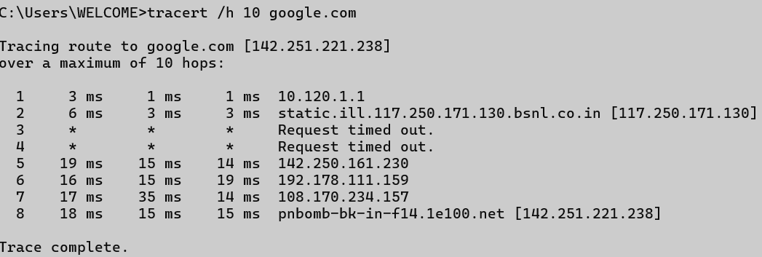

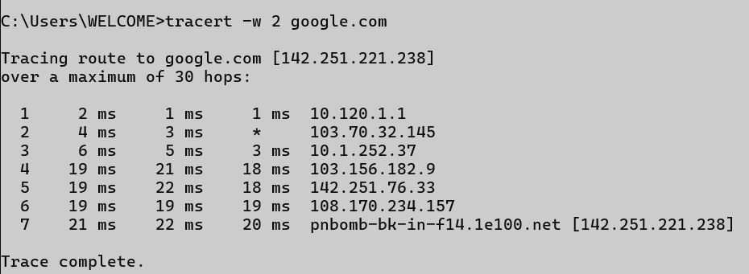

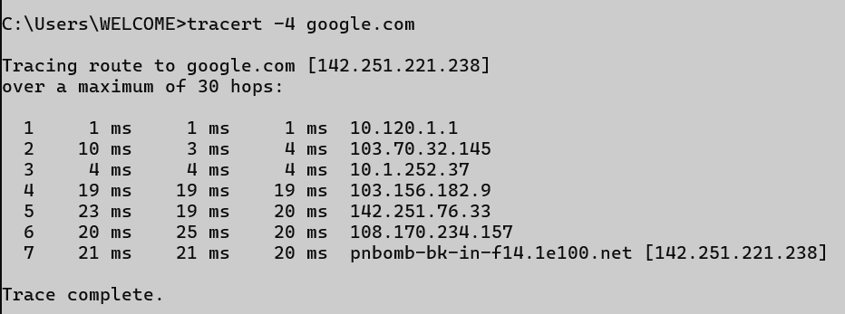

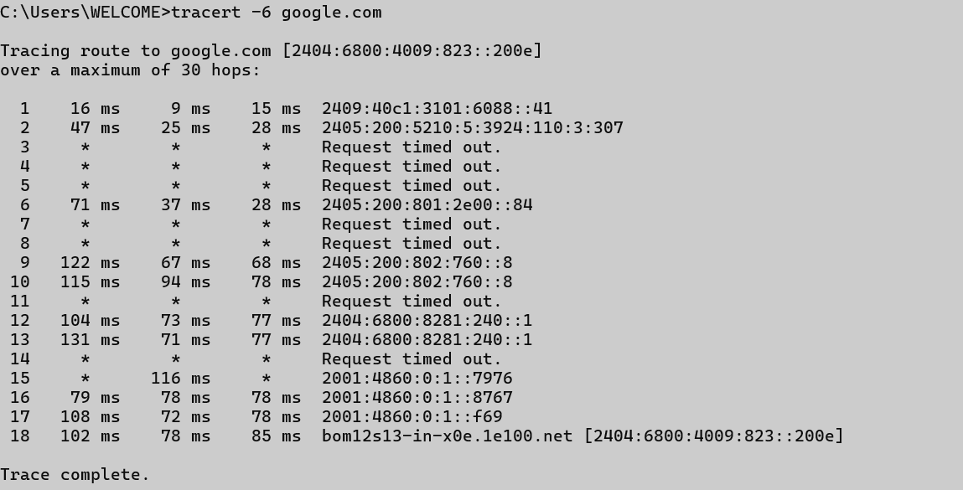

## netstat

### Description:

**Displays network connections, routing tables, interface stats, etc.**

|  |  |  |
| --- | --- | --- |
| No. | Option | Description |
| 1 | -a | Displays all connections and listening ports. |
| 2 | -n | Displays addresses and port numbers numerically. |
| 3 | -o | Displays owning process ID associated with each connection. |
| 4 | -e | Displays Ethernet statistics. |
| 5 | -s | Displays per-protocol statistics. |

### Implementation:

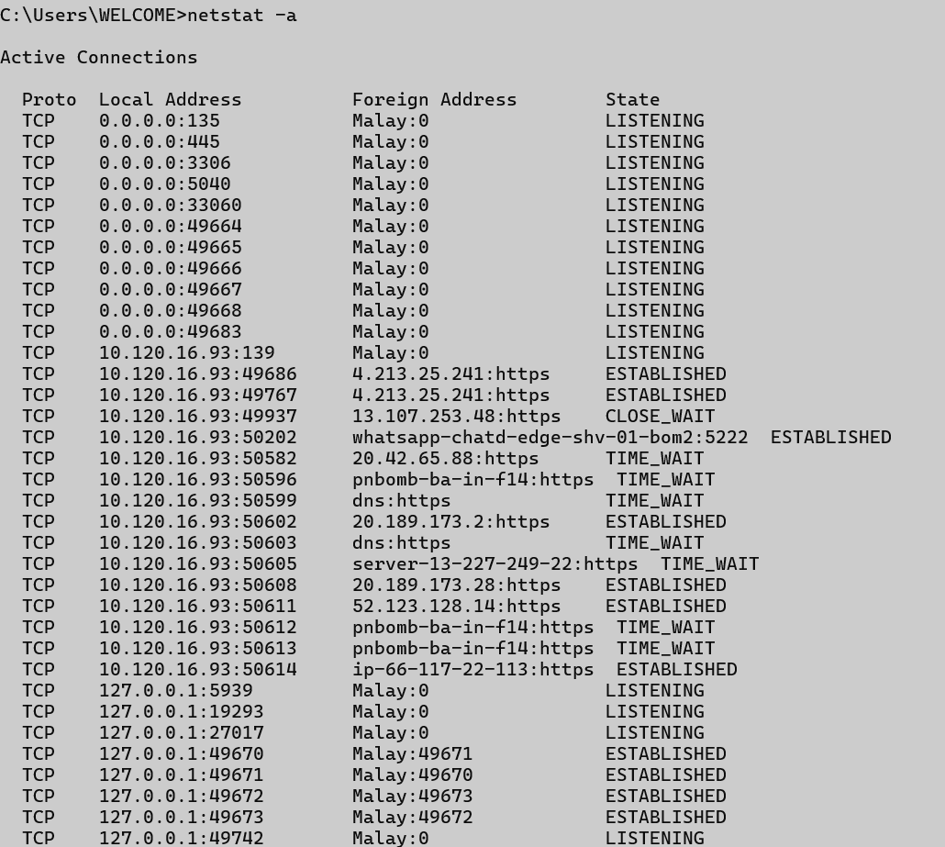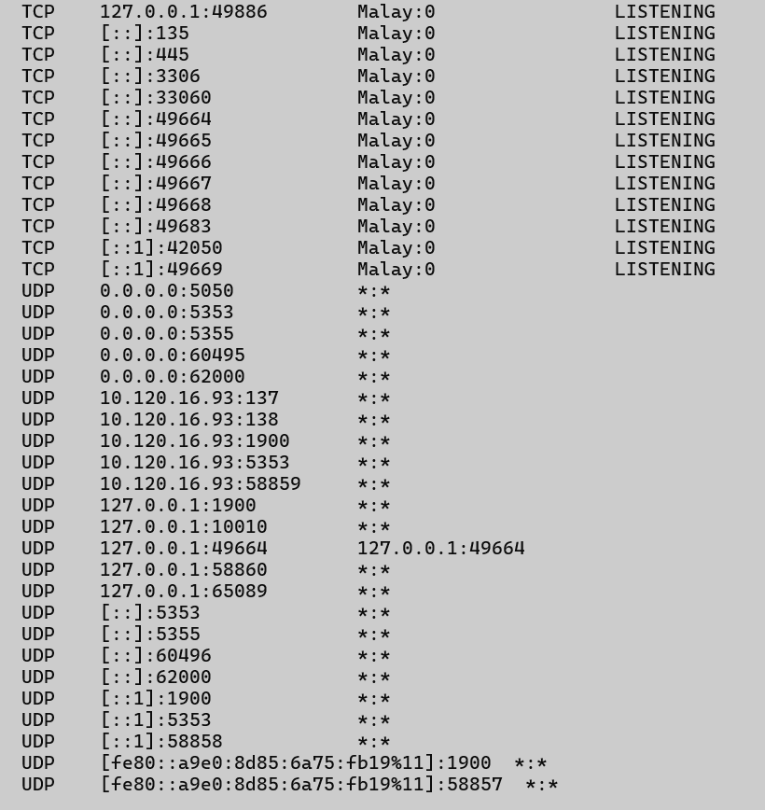

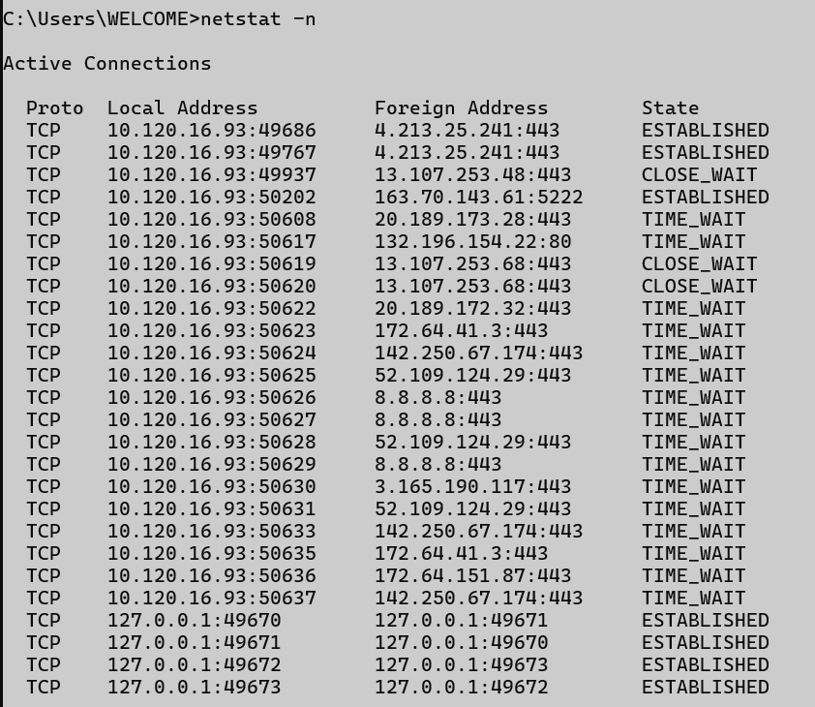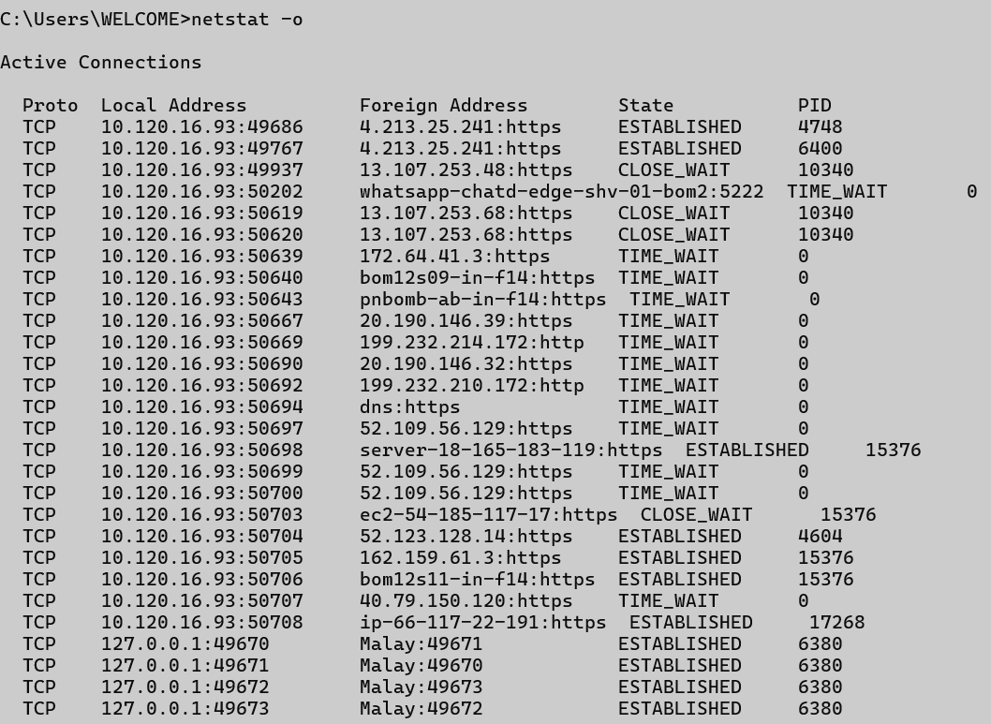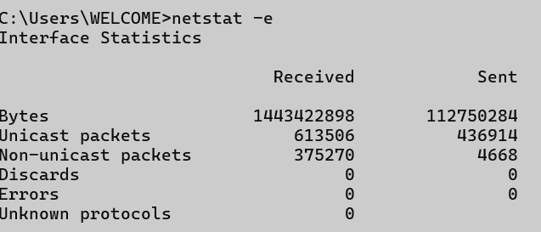

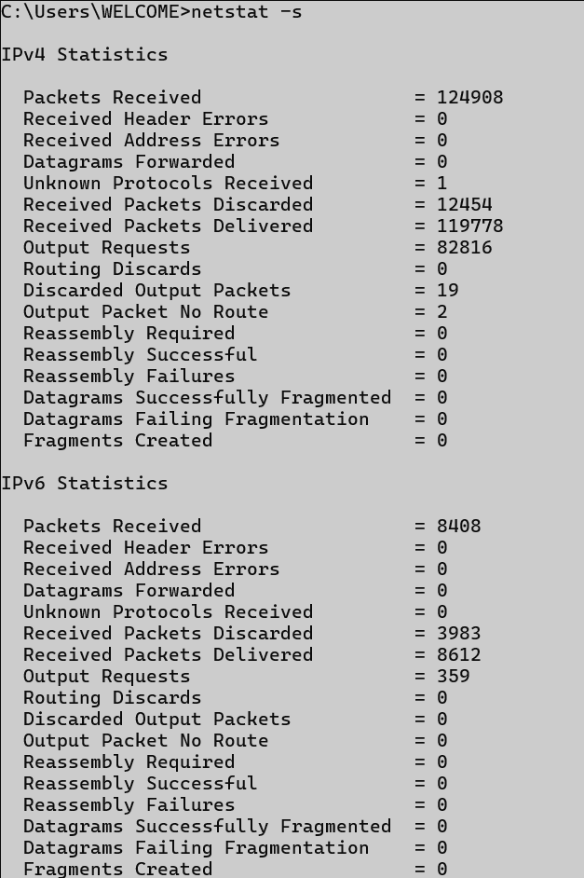

## nslookup

### Description:

**Queries the DNS to obtain domain name or IP address mapping.**

|  |  |  |
| --- | --- | --- |
| No. | Option | Description |
| 1 | <domain> | Retrieves IP address for the domain. |
| 2 | <IP> | Retrieves domain name for the given IP (reverse lookup). |
| 3 | set type=MX | Retrieves Mail Exchange records. |
| 4 | set type=NS | Retrieves Name Server records. |
| 5 | server <IP> | Specifies DNS server for the query. |

### Implementation:

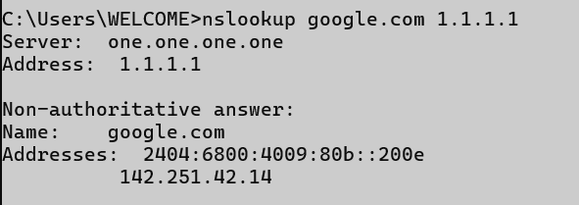

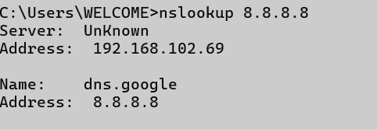

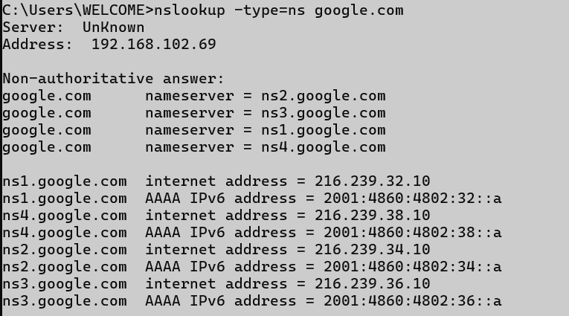

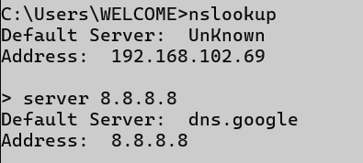

## hostname

### Description:

**Displays the current name of the computer.**

|  |  |  |
| --- | --- | --- |
| No. | Option | Description |
| 1 | (no option) | Prints current hostname. |
| 2 |  |  |
| 3 |  |  |
| 4 |  |  |
| 5 |  |  |

### Implementation:



## pathping

### Description:

**Combines the functions of ping and tracert to provide information on packet loss at each hop.**

|  |  |  |
| --- | --- | --- |
| No. | Option | Description |
| 1 | -n | Prevents resolving hostnames. |
| 2 | -h <max> | Sets maximum number of hops. |
| 3 | -g <host-list> | Specifies loose source route along host list. |
| 4 | -p <ms> | Wait time between pings. |
| 5 | -q <num> | Number of queries per hop. |

### Implementation:

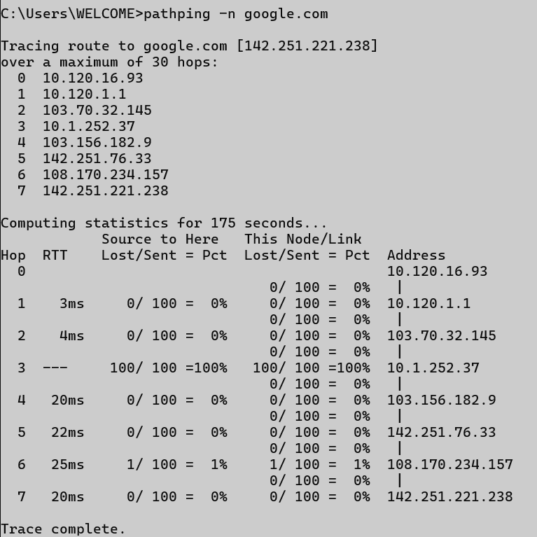

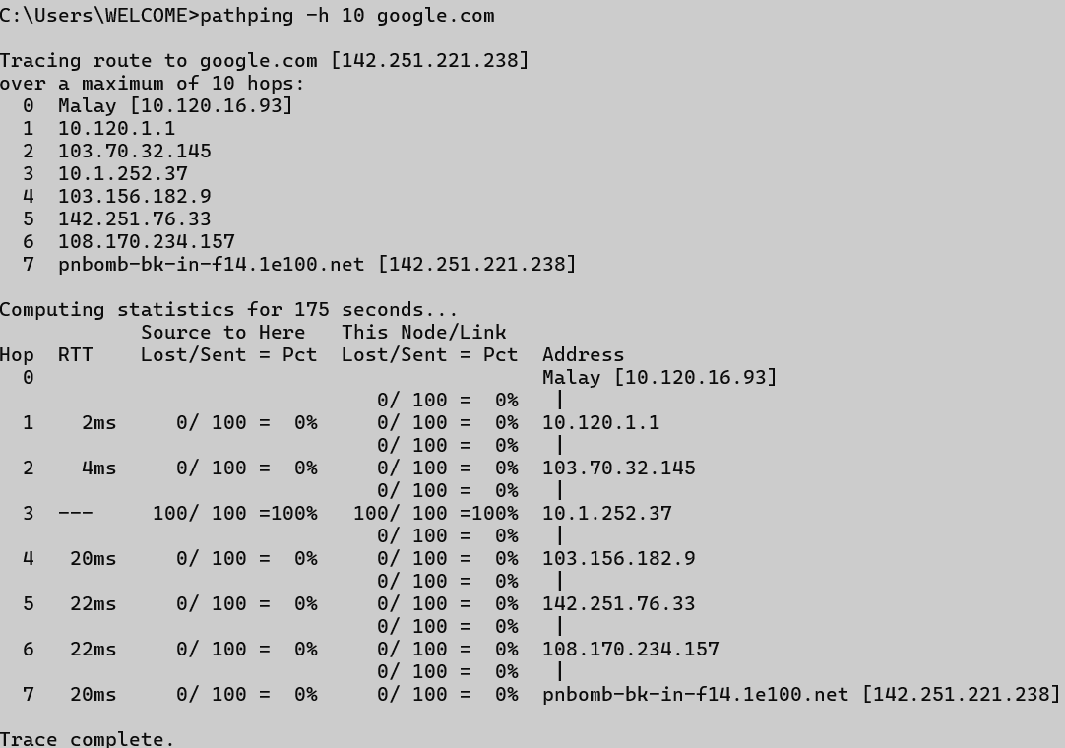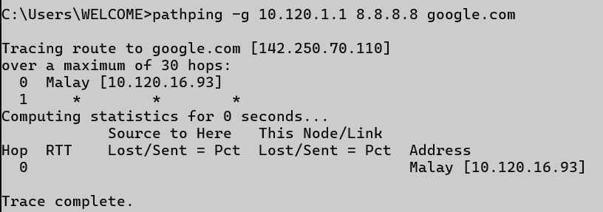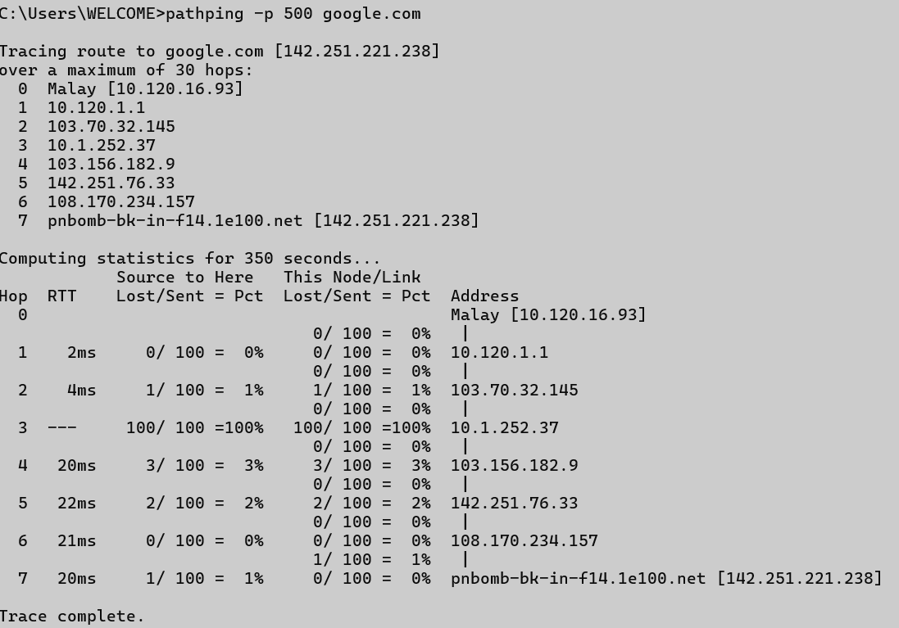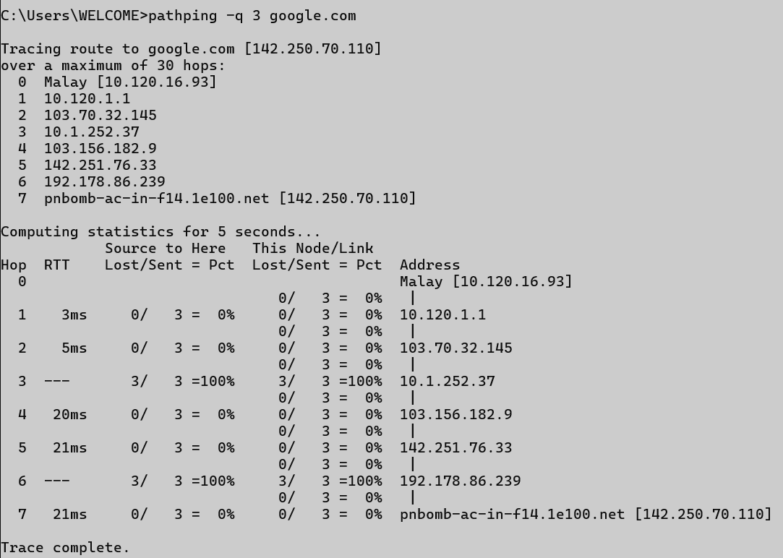

## arp

### Description:

**Displays and modifies the ARP (Address Resolution Protocol) cache.**

|  |  |  |
| --- | --- | --- |
| No. | Option | Description |
| 1 | -a | Displays current ARP entries. |
| 2 | -g | Displays current ARP entries (same as -a). |
| 3 | -d <IP> | Deletes ARP entry for the specified IP address. |
| 4 | -s <IP> <MAC> | Adds a static ARP entry. |
| 5 | -v | Shows verbose output. |

### Implementation:

