Lab Practical #11:
Study the concept of routing using packet tracer. (Dynamic Routing)
Practical Assignment #11:
- Connect the two different networks based on the calculated IP addresses and subnet using a packet tracer.
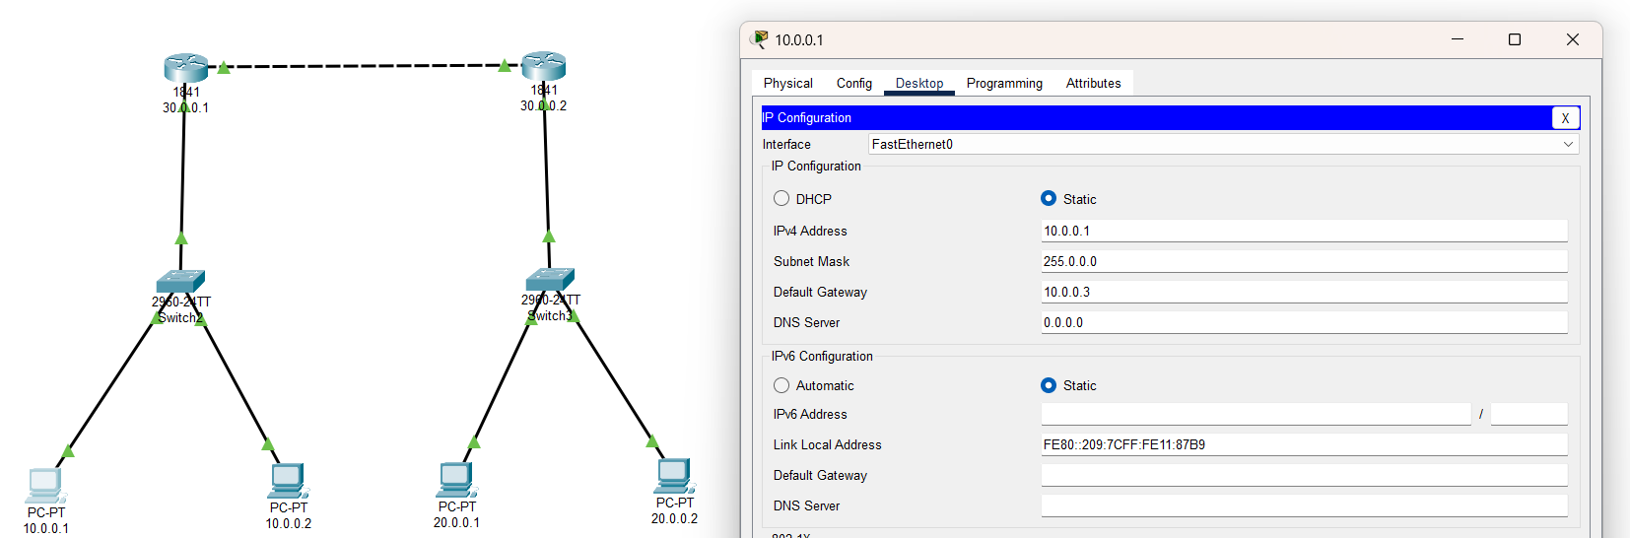

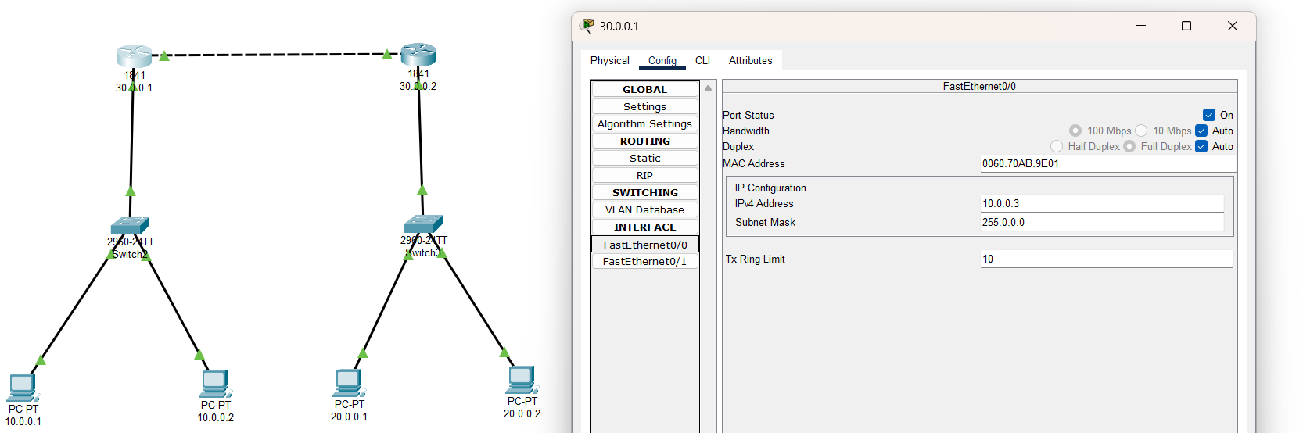

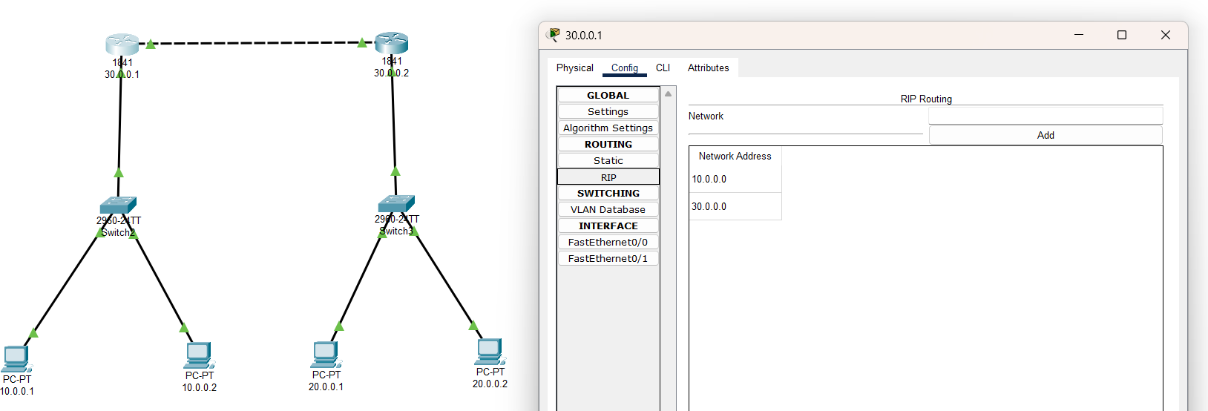
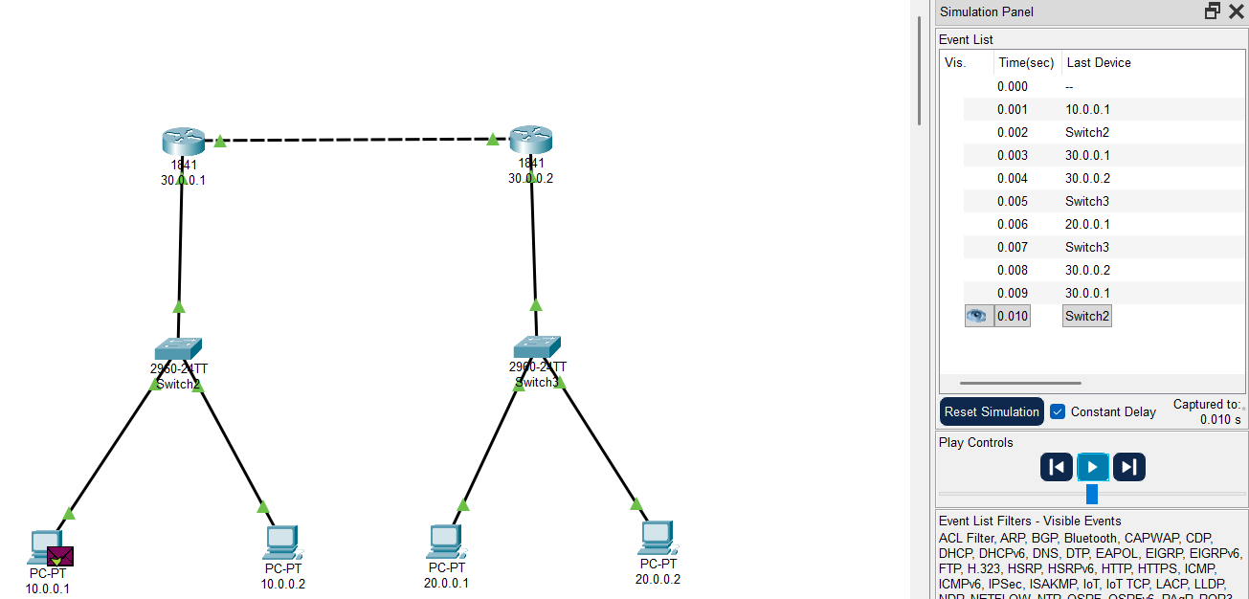

- Connect the three different networks based on the calculated IP addresses and subnet using a packet tracer.

