SkyWeave
Aviation Route Visualization & ATS Route Management Platform
Software Requirements Specification
INT – 221
Web Development
Kartavya Shrivastav, Malay Shikhar Soni, Kumar Mayank
12326205

Prepared for
Continuous Assessment 2
Submitted To – Ms. Sakshi Sharma

Table of Contents
1. Introduction
1.1 Purpose
1.2 Scope
1.3 Definitions, Acronyms, and Abbreviations
1.4 References
1.5 Overview
2. General Description
2.1 Product Perspective
2.2 Product Functions
2.3 User Characteristics
2.4 General Constraints
2.5 Assumptions and Dependencies
3. Specific Requirements
3.1 External Interface Requirements
3.1.1 User Interfaces
3.1.2 Hardware Interfaces
3.1.3 Software Interfaces
3.1.4 Communications Interfaces
3.2 Functional Requirements
3.2.1 Waypoint Management
3.2.2 NAVAID Management
3.2.3 ATS Route Builder
3.2.4 Interactive Map
3.2.5 User Authentication
3.3 Non-Functional Requirements
3.3.1 Performance
3.3.2 Reliability
3.3.3 Availability
3.3.4 Security
3.3.5 Maintainability
3.3.6 Portability
3.4 Design Constraints
4. Analysis Models
4.1 Data Flow Diagrams
4.2 ER Diagram
5. Project Snapshots
6. GitHub Link
7. Deployed Link
A. Appendices

1. Introduction
This Software Requirements Specification (SRS) document provides a comprehensive description of SkyWeave, an aviation route visualization and ATS (Air Traffic Service) route management web application. SkyWeave is designed to serve aviation professionals, trainees, dispatch operators, and navigation analysts who require an efficient platform for geographical visualization and structured route planning. This document outlines the functional and non-functional requirements, system architecture, design constraints, and interface specifications for the SkyWeave platform. The intended audience includes the development team, project evaluators, and stakeholders who need to understand the scope and technical implementation of the system.

1.1 Purpose
The purpose of this SRS document is to define the requirements for the SkyWeave aviation navigation platform. It serves as a reference for developers to implement the system and for evaluators to validate that the software meets its intended specifications. This document is intended for the development team (Kartavya Shrivastav, Malay Shikhar Soni, Kumar Mayank), course faculty (Ms. Monika Sharma), and any stakeholders involved in assessing the project.

1.2 Scope
SkyWeave is a web-based aviation navigation management platform. The software will:
(1) Provide CRUD operations for aviation waypoints with precise latitude/longitude coordinates
(2) Support NAVAID (Navigation Aid) management with type classification (VOR, DME, VOR/DME, NDB, TACAN) and frequency data
(3) Enable ATS route construction by sequencing waypoints with automatic distance calculation using the Haversine formula
(4) Render an interactive aeronautical map using Leaflet.js for geospatial visualization of waypoints, NAVAIDs, and routes
(5) Provide user authentication and role-based access control using Laravel Breeze
The platform explicitly avoids gamification, achievement systems, social engagement mechanics, and habit tracking. SkyWeave is intended to function as a serious operational and educational aviation utility.

1.3 Definitions, Acronyms, and Abbreviations
Acronym | Definition
ATS | Air Traffic Service
VOR | VHF Omnidirectional Range – a type of radio navigation system
DME | Distance Measuring Equipment
NDB | Non-Directional Beacon
TACAN | Tactical Air Navigation System
NAVAID | Navigation Aid – any facility used in aerial navigation
FIX | A geographical position determined by reference to navigation aids
CRUD | Create, Read, Update, Delete
MVC | Model-View-Controller architectural pattern
ORM | Object-Relational Mapping
SRS | Software Requirements Specification
CSRF | Cross-Site Request Forgery
API | Application Programming Interface
FIR | Flight Information Region
ICAO | International Civil Aviation Organization

1.4 References
(1) Laravel 12.x Official Documentation – https://laravel.com/docs
(2) Leaflet.js Documentation – https://leafletjs.com/reference.html
(3) TailwindCSS Documentation – https://tailwindcss.com/docs
(4) Alpine.js Documentation – https://alpinejs.dev
(5) Laravel Breeze Documentation – https://laravel.com/docs/starter-kits#breeze
(6) IEEE 830-1998 – IEEE Recommended Practice for Software Requirements Specifications

1.5 Overview
(1) Section 2 provides a general description of the product, its functions, user characteristics, constraints, and assumptions.
(2) Section 3 details the specific functional and non-functional requirements, including external interface requirements, feature specifications, performance targets, and security constraints.
(3) Section 4 presents analysis models including data flow diagrams and entity-relationship diagrams.
(4) Sections 5-7 provide project snapshots, GitHub repository link, and deployed link.

2. General Description
This section describes the general factors that affect the SkyWeave product and its requirements. It provides context for the specific requirements detailed in Section 3.

2.1 Product Perspective
SkyWeave is a standalone web application that operates independently without integration into an existing system. It is built on the Laravel 12 framework using the MVC architecture pattern. The system consists of three primary components:
(1) Frontend Layer – Laravel Blade templates styled with TailwindCSS, providing a professional dark-themed aviation UI with glassmorphism effects. Alpine.js handles lightweight interactivity and Vite bundles assets.
(2) Backend Layer – PHP 8.2+ with Laravel framework handling routing, controllers, Eloquent ORM for database operations, authentication via Laravel Breeze, session management, and API endpoints.
(3) Data Layer – SQLite/MySQL/PostgreSQL database storing users, waypoints, NAVAIDs, ATS routes, and route-waypoint pivot records with referential integrity.
Technology Stack:
Layer | Technology
Backend Framework | Laravel 12
Architecture Pattern | MVC
Frontend Templating | Laravel Blade
Styling | TailwindCSS v3
Interactive JS | Alpine.js
Asset Bundler | Vite 7
Mapping Library | Leaflet.js
Database | SQLite / MySQL / PostgreSQL
ORM | Laravel Eloquent
Authentication | Laravel Breeze
API Format | JSON
Session Management | Laravel Sessions (database driver)

2.2 Product Functions
SkyWeave provides the following core functions:
• User registration, login, and profile management with secure authentication
• Waypoint CRUD – Create, view, update, and delete aviation waypoints with identifier, latitude, longitude, region, and type
• NAVAID management – Register and manage navigation aids (VOR, DME, VOR/DME, NDB, TACAN) with frequency data
• ATS Route Builder – Construct routes by sequencing waypoints, with automatic distance calculation using the Haversine formula
• Interactive Map – Leaflet.js-powered aeronautical map with waypoint plotting, polyline route rendering, clustering, and filtering
• Dashboard – Command Center with statistics overview (waypoint count, NAVAID count, route count) and quick actions
• API endpoints – JSON APIs for map data retrieval (/api/map/waypoints, /api/map/navaids, /api/map/routes)

2.3 User Characteristics
The target users of SkyWeave include aviation professionals, flight dispatch operators, navigation analysts, and aviation students/trainees. Users are expected to have basic familiarity with aviation terminology (waypoints, NAVAIDs, ATS routes) and web application usage. The system provides an intuitive UI that minimizes the learning curve while maintaining professional-grade functionality.

2.4 General Constraints
The following constraints apply to SkyWeave development:
• The application must run on PHP 8.2 or higher
• The frontend must be responsive across desktop and mobile devices
• The system must use Laravel’s built-in CSRF protection for all form submissions
• Coordinate validation must enforce latitude range [-90, 90] and longitude range [-180, 180]
• ATS routes must contain a minimum of 2 waypoints
• All NAVAID identifiers and waypoint identifiers must be unique
• The application follows the MVC pattern as enforced by the Laravel framework

2.5 Assumptions and Dependencies
The following assumptions and dependencies affect the SkyWeave system:
• Users have a modern web browser (Chrome, Firefox, Edge, Safari) with JavaScript enabled
• The server environment supports PHP 8.2+, Composer, Node.js, and npm
• Internet connectivity is required for loading map tiles from Leaflet.js tile providers
• The database server (SQLite/MySQL/PostgreSQL) is available and properly configured
• Google Fonts (Inter, JetBrains Mono) are accessible for typography rendering

3. Specific Requirements
This section provides detailed functional and non-functional requirements for the SkyWeave platform. Each requirement is designed to be verifiable, unambiguous, and traceable.

3.1 External Interface Requirements

3.1.1 User Interfaces
SkyWeave provides a dark-themed aviation UI built with TailwindCSS featuring glassmorphism design elements. The interface includes:
• Sticky navigation bar with logo, navigation links (Dashboard, Waypoints, NAVAIDs, ATS Routes), and user dropdown
• Responsive dashboard (Command Center) with stat cards, welcome banner, and quick action cards
• Form-based CRUD interfaces for waypoints, NAVAIDs, and routes
• Interactive Leaflet.js map with zoom, pan, polyline rendering, and coordinate popups
• Mobile-responsive layout with hamburger menu navigation
• Authentication pages (Login, Register, Forgot Password, Profile Settings)

3.1.2 Hardware Interfaces
SkyWeave is a web application and does not directly interface with hardware. It requires a standard web server capable of running PHP 8.2+ and a database server. Client devices require a modern web browser and internet connectivity.

3.1.3 Software Interfaces
The system interfaces with the following software components:
Software | Interface Description
Laravel 12 | Backend framework providing routing, ORM, authentication, and session management
Leaflet.js | JavaScript mapping library for rendering interactive aeronautical maps
TailwindCSS v3 | Utility-first CSS framework for styling the aviation-themed dark UI
Alpine.js | Lightweight JavaScript framework for dropdown menus and interactive components
Vite 7 | Frontend build tool for asset bundling and hot module replacement
SQLite/MySQL/PostgreSQL | Relational database for persistent data storage

3.1.4 Communications Interfaces
SkyWeave communicates over HTTP/HTTPS protocols. The backend exposes JSON API endpoints for map data retrieval:
Endpoint | Description
GET /api/map/waypoints | Returns all waypoints as JSON for map rendering
GET /api/map/navaids | Returns all NAVAIDs as JSON for map rendering
GET /api/map/routes | Returns all ATS routes with waypoint sequences as JSON

3.2 Functional Requirements
The following subsections describe the specific functional features of SkyWeave.

3.2.1 Waypoint Management
3.2.1.1 Introduction
The waypoint management module allows users to create, view, update, and delete aviation waypoints. Each waypoint is identified by a unique identifier and has precise geographic coordinates.
3.2.1.2 Inputs
• Identifier (unique string, e.g., 'DPN')
• Latitude (decimal, -90 to 90, 7 decimal places)
• Longitude (decimal, -180 to 180, 7 decimal places)
• Region (optional string)
• Type (default: 'FIX')
3.2.1.3 Processing
The system validates coordinate ranges, enforces unique identifiers, and stores waypoint data via Eloquent ORM. Waypoints are retrievable via web views and JSON API.
3.2.1.4 Outputs
Waypoint list view, individual waypoint detail, map marker on Leaflet.js map, JSON API response.
3.2.1.5 Error Handling
Validation errors for duplicate identifiers, out-of-range coordinates, and missing required fields are displayed inline on the form.

3.2.2 NAVAID Management
3.2.2.1 Introduction
The NAVAID module manages navigation aids used in aviation. It supports five types: VOR, DME, VOR/DME, NDB, and TACAN.
3.2.2.2 Inputs
• Identifier (unique string)
• Name (string)
• Type (enum: VOR, DME, VOR_DME, NDB, TACAN)
• Frequency (decimal, 6 digits, 2 decimal places, optional)
• Latitude and Longitude (same constraints as waypoints)
3.2.2.3 Processing
NAVAIDs are validated, stored via Eloquent, and rendered on the map with type-specific color-coded badges (VOR: green, DME: indigo, NDB: orange, TACAN: pink, FIX: gray).
3.2.2.4 Outputs
NAVAID list with type badges, map markers with tooltips, JSON API response.
3.2.2.5 Error Handling
Validation errors for invalid type, duplicate identifier, and coordinate range violations.

3.2.3 ATS Route Builder
3.2.3.1 Introduction
The ATS Route Builder allows users to construct air traffic service routes by connecting waypoints in a defined sequence.
3.2.3.2 Inputs
• Route Name (unique string)
• Description (optional text)
• Waypoint sequence (array of waypoint IDs, minimum 2)
3.2.3.3 Processing
The system stores routes in the ats_routes table with a created_by foreign key to users. Waypoints are linked via the route_waypoint pivot table with sequence_order. Total route distance is calculated using the Haversine formula (Earth radius = 3440.065 nautical miles). Draft routes are managed via Laravel session state.
3.2.3.4 Outputs
Route list view, route detail with ordered waypoints, polyline rendering on map, calculated distance in nautical miles.
3.2.3.5 Error Handling
Validation for minimum 2 waypoints, unique route name, and valid waypoint references.

3.2.4 Interactive Map
3.2.4.1 Introduction
The interactive map provides geospatial visualization of all aviation data using Leaflet.js.
3.2.4.2 Inputs
Map data fetched from JSON API endpoints (/api/map/waypoints, /api/map/navaids, /api/map/routes).
3.2.4.3 Processing
Data is fetched asynchronously and rendered as markers, polylines, and clusters on the map.
3.2.4.4 Outputs
Interactive map with zoom/pan, waypoint markers, NAVAID markers with type badges, route polylines, coordinate popups, tooltip overlays, and dynamic filtering.

3.2.5 User Authentication
3.2.5.1 Introduction
User authentication is handled by Laravel Breeze, providing registration, login, password reset, and profile management.
3.2.5.2 Inputs
• Name, Email, Password (registration)
• Email, Password (login)
3.2.5.3 Processing
Passwords are hashed using bcrypt (12 rounds). Sessions are stored in the database. All authenticated routes are protected by auth middleware.
3.2.5.4 Outputs
Authenticated session, redirect to dashboard, profile settings page.

3.3 Non-Functional Requirements

3.3.1 Performance
Requirement | Target
Dashboard Load | < 3 seconds
API Response | < 500 ms
Map Rendering | < 2 seconds
Waypoint Search | < 300 ms

3.3.2 Reliability
The system uses database transactions for data integrity. Eloquent ORM prevents SQL injection. Laravel’s error handling provides graceful failure with user-friendly error pages.

3.3.3 Availability
The application is designed for continuous availability on a standard web server. Session data persists across server restarts via database-backed sessions.

3.3.4 Security
• CSRF protection on all form submissions via Laravel middleware
• SQL injection prevention through Eloquent ORM parameterized queries
• Input sanitization and validation on all user inputs
• Rate limiting on API endpoints
• Authorization middleware protecting all authenticated routes
• Password hashing with bcrypt (12 rounds)

3.3.5 Maintainability
The codebase follows Laravel MVC conventions with clear separation of concerns: Models (User, Waypoint, Navaid, ATSRoute), Controllers (DashboardController, WaypointController, NavaidController, ATSRouteController, MapApiController, DraftRouteController), and Blade Views organized by feature. TailwindCSS utility classes and custom component styles (glass-card, elevated-card, stat-card, etc.) ensure consistent styling.

3.3.6 Portability
SkyWeave is portable across any platform supporting PHP 8.2+. The application supports SQLite, MySQL, and PostgreSQL databases. Frontend assets are compiled by Vite and are compatible with all modern browsers.

3.4 Design Constraints
The following design constraints are imposed on SkyWeave:
• Must follow Laravel MVC architecture pattern
• Must use Laravel Eloquent ORM for all database operations (no raw SQL)
• Must use Laravel Blade for server-side templating
• All coordinates must support 7 decimal places of precision (decimal(10,7))
• Route-waypoint relationships must use a pivot table with sequence ordering
• Frontend must use the established dark aviation theme with TailwindCSS

4. Analysis Models
This section presents the analysis models used in developing SkyWeave, including data flow and entity-relationship representations.

4.1 Data Flow Diagrams
The SkyWeave data flow follows this pattern:
User → Browser → Laravel Router → Controller → Eloquent Model → Database
Database → Eloquent Model → Controller → Blade View / JSON API → Browser → User

Web Routes (web.php):
Route | Controller | Description
GET /dashboard | DashboardController | Dashboard view
GET,POST,PUT,DELETE /waypoints/* | WaypointController | Waypoint CRUD
GET,POST,PUT,DELETE /navaids/* | NavaidController | NAVAID CRUD
GET,POST,PUT,DELETE /routes/* | ATSRouteController | ATS Route CRUD
POST /routes/draft/add | DraftRouteController | Add waypoint to draft
POST /routes/draft/remove | DraftRouteController | Remove waypoint from draft

API Routes (api.php):
Endpoint | Controller Method | Response
GET /api/map/waypoints | MapApiController@waypoints | JSON waypoint data
GET /api/map/navaids | MapApiController@navaids | JSON NAVAID data
GET /api/map/routes | MapApiController@routes | JSON route data

4.2 Entity-Relationship Diagram
The database schema consists of the following entities and their relationships:
Users Table:
Column | Type | Description
id | BIGINT | Primary Key, Auto Increment
name | VARCHAR | User full name
email | VARCHAR | Unique email address
password | VARCHAR | Hashed password (bcrypt)
timestamps | TIMESTAMP | created_at, updated_at

Waypoints Table:
Column | Type | Description
id | BIGINT | Primary Key
identifier | VARCHAR | Unique waypoint identifier
latitude | DECIMAL(10,7) | Geographic latitude
longitude | DECIMAL(10,7) | Geographic longitude
region | VARCHAR (nullable) | Geographic region
type | VARCHAR | Default: 'FIX'
timestamps | TIMESTAMP | created_at, updated_at

Navaids Table:
Column | Type | Description
id | BIGINT | Primary Key
identifier | VARCHAR | Unique NAVAID identifier
name | VARCHAR | NAVAID name
type | ENUM | VOR, DME, VOR_DME, NDB, TACAN
frequency | DECIMAL(6,2) | Radio frequency (nullable)
latitude | DECIMAL(10,7) | Geographic latitude
longitude | DECIMAL(10,7) | Geographic longitude
timestamps | TIMESTAMP | created_at, updated_at

ATS Routes Table:
Column | Type | Description
id | BIGINT | Primary Key
route_name | VARCHAR | Unique route name
description | TEXT (nullable) | Route description
created_by | BIGINT (FK) | Foreign key to users.id (CASCADE)
timestamps | TIMESTAMP | created_at, updated_at

Route-Waypoint Pivot Table:
Column | Type | Description
id | BIGINT | Primary Key
ats_route_id | BIGINT (FK) | Foreign key to ats_routes.id (CASCADE)
waypoint_id | BIGINT (FK) | Foreign key to waypoints.id (CASCADE)
sequence_order | INTEGER | Order of waypoint in route
timestamps | TIMESTAMP | created_at, updated_at
Unique constraint: (ats_route_id, sequence_order)

Relationships:
• User hasMany ATSRoute (via created_by)
• ATSRoute belongsTo User
• ATSRoute belongsToMany Waypoint (via route_waypoint pivot)
• Waypoint belongsToMany ATSRoute (via route_waypoint pivot)

5. Project Snapshots
Login Page:
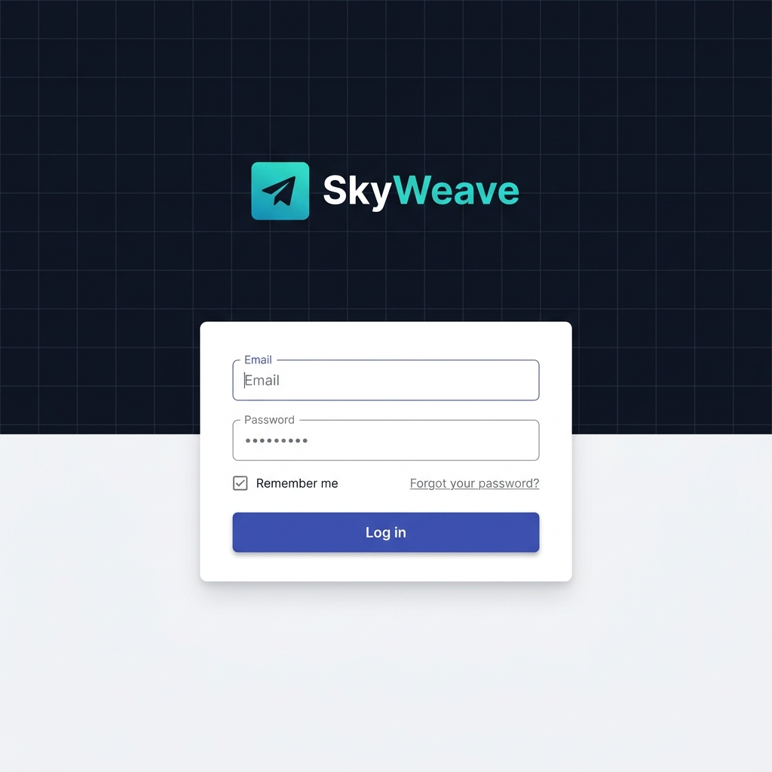
Sign Up / Register Page:
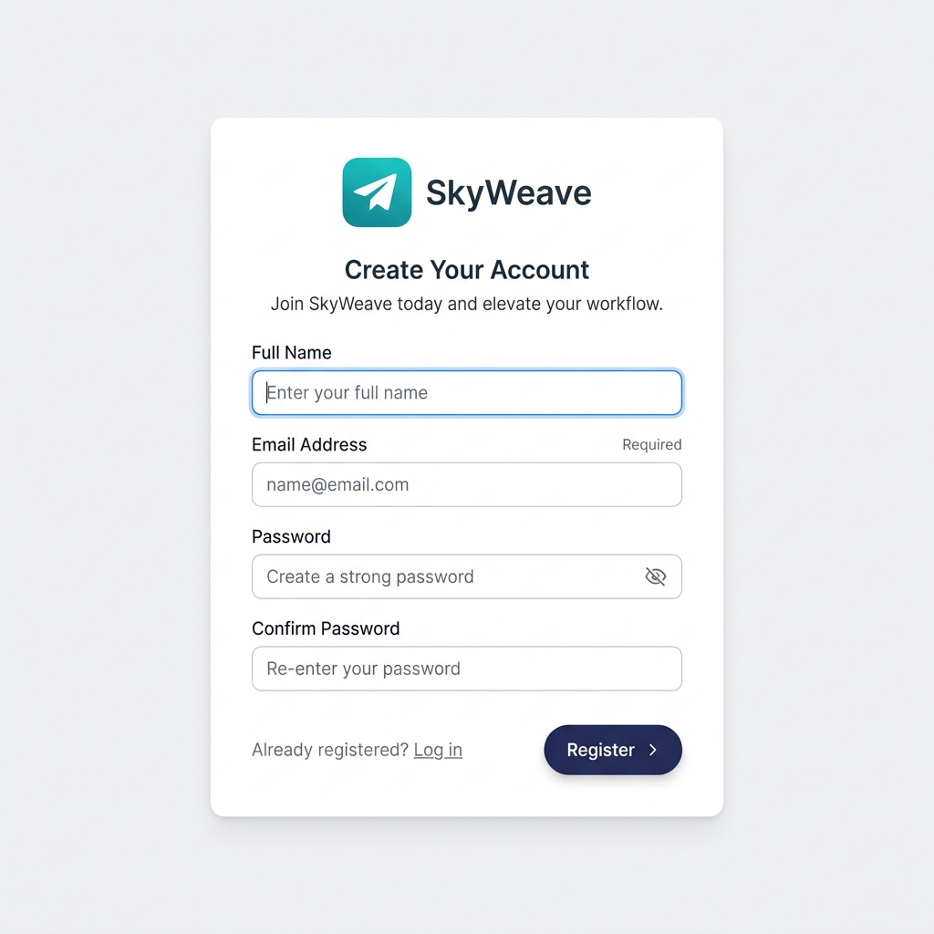
Dashboard (Command Center):
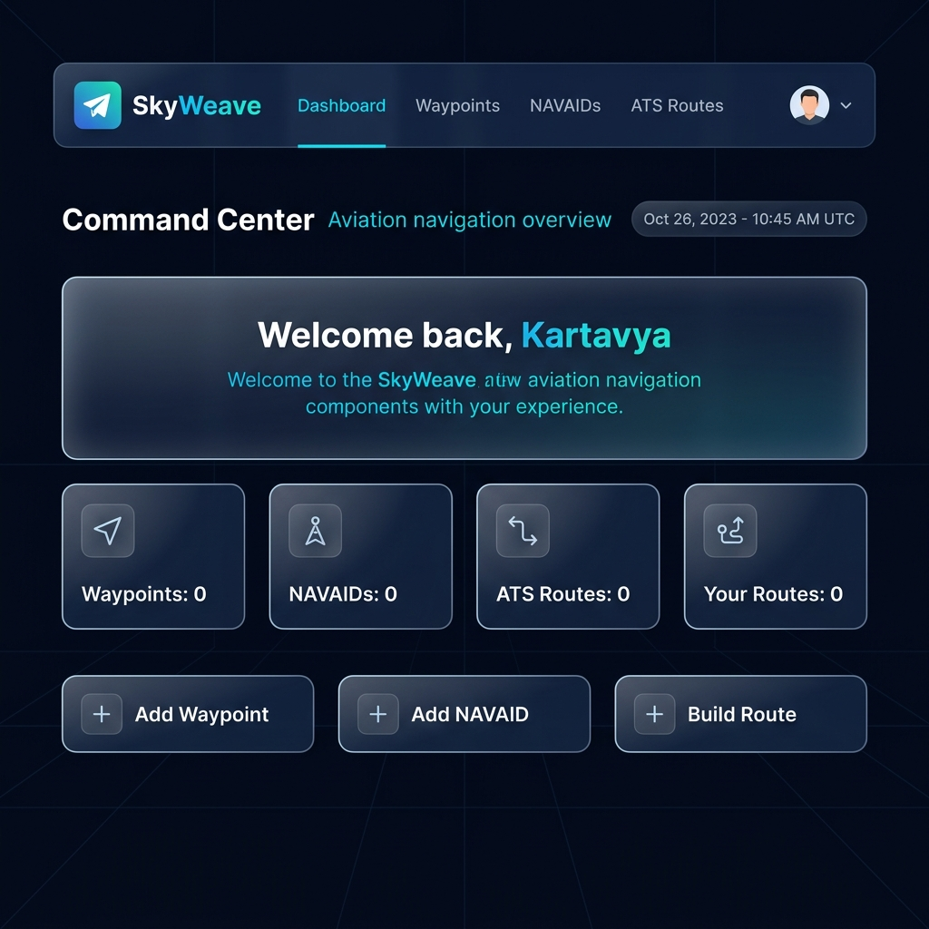
Navigation Bar with User Dropdown:
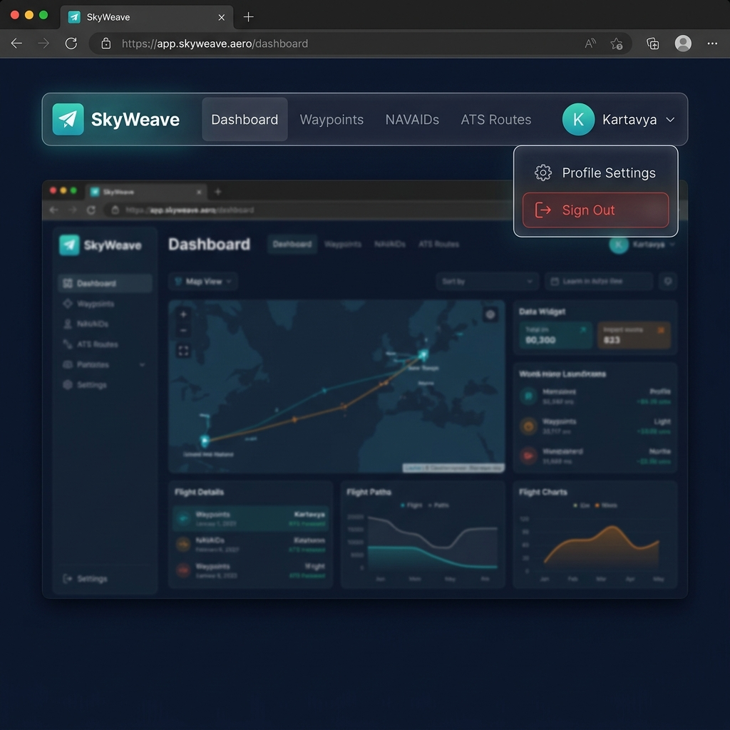
Waypoints Management Page:
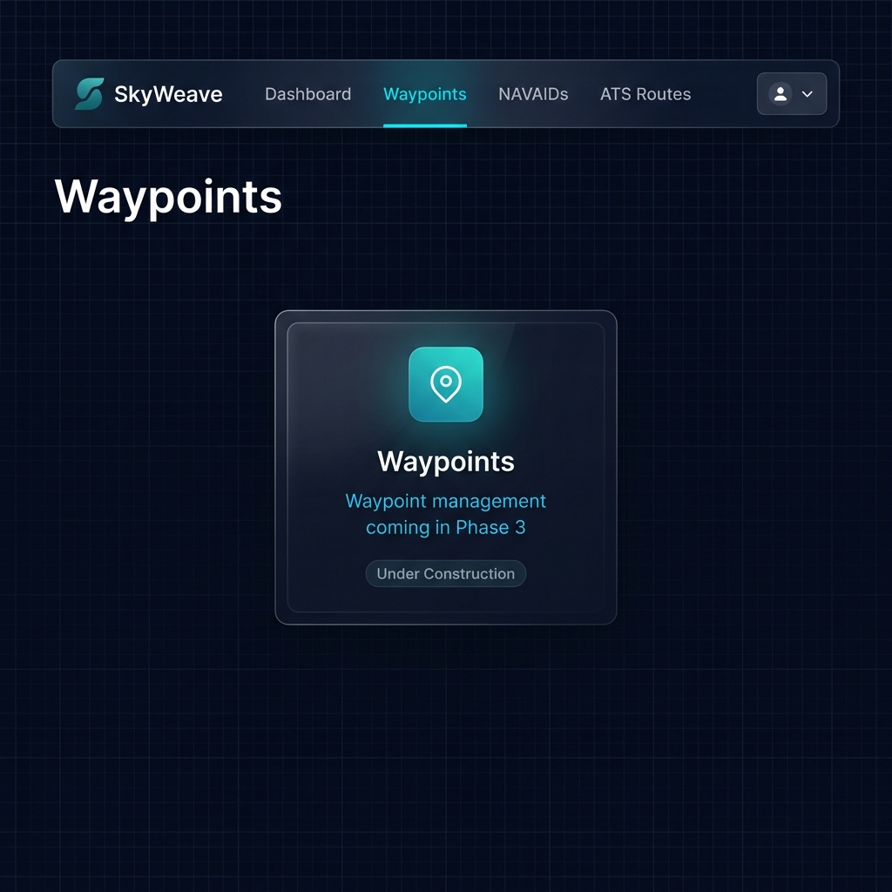
NAVAIDs Management Page:
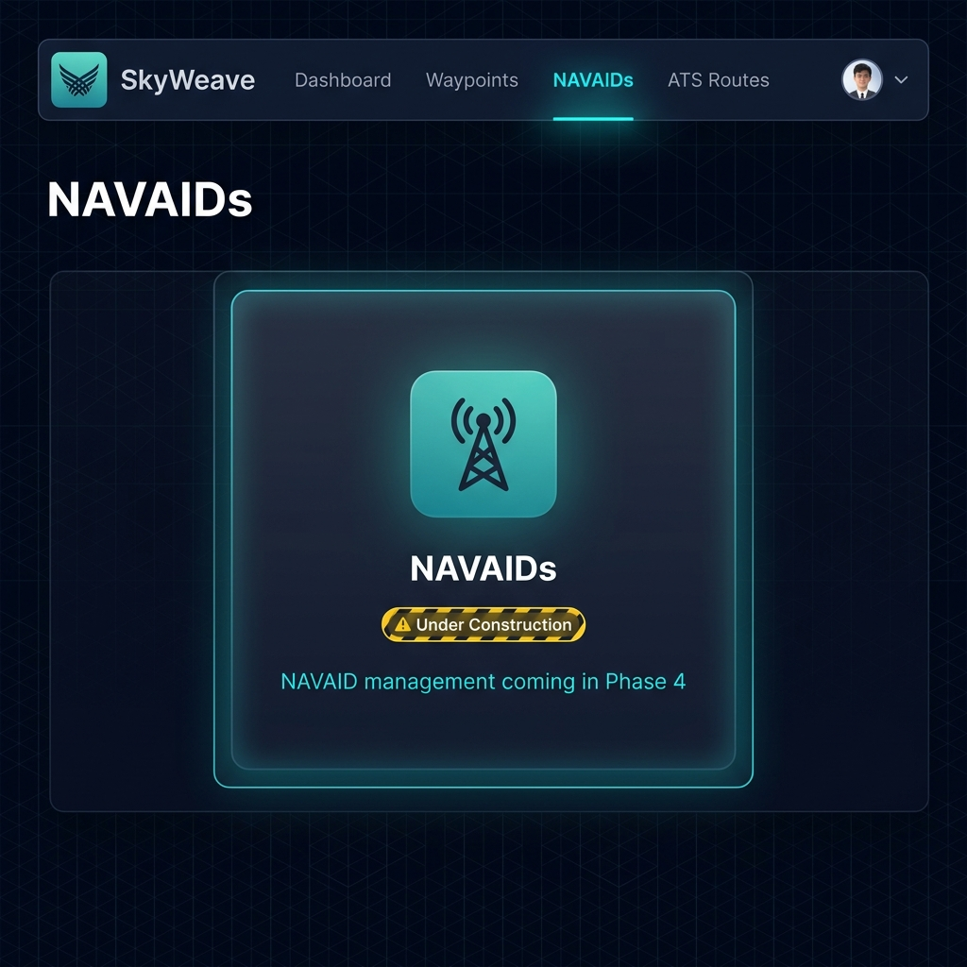
ATS Routes Management Page:
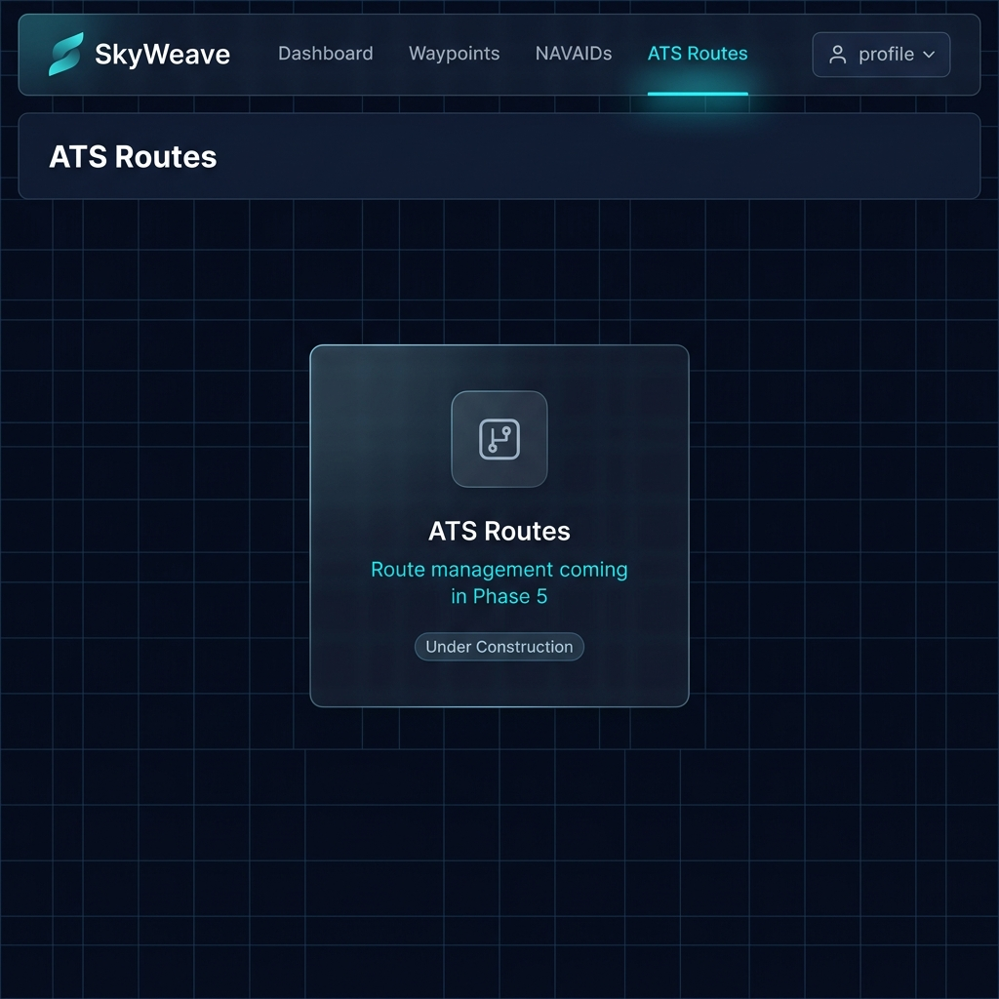
Profile Settings Page:
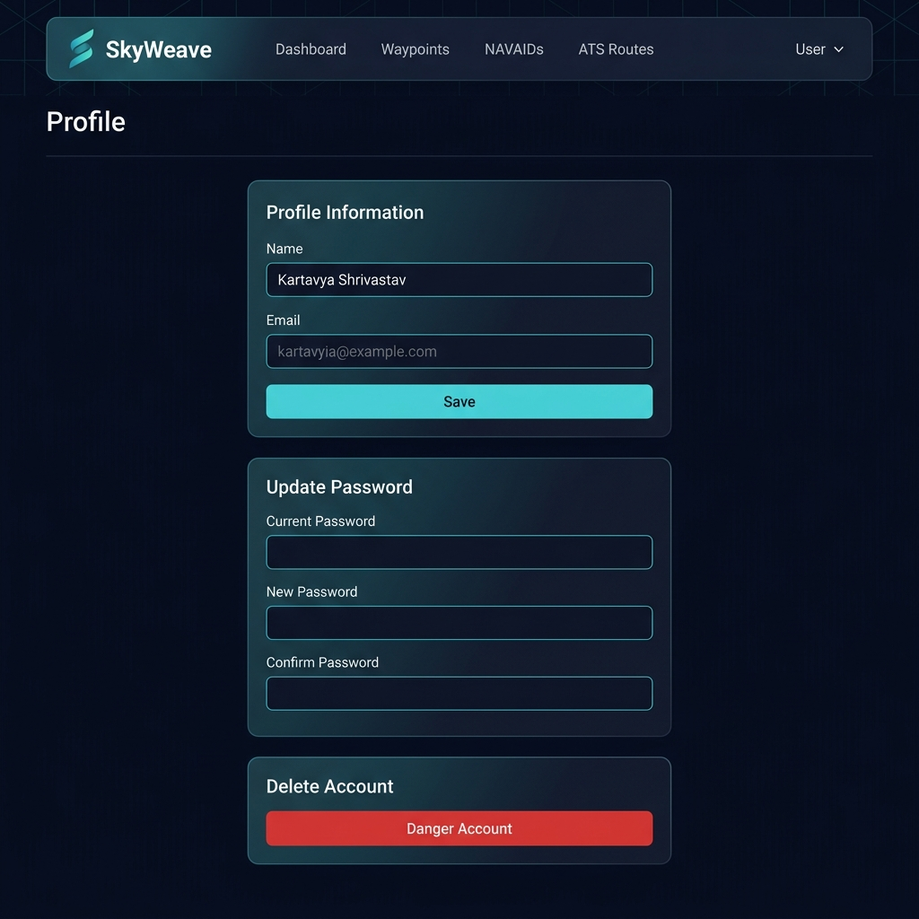
Mobile Responsive View:
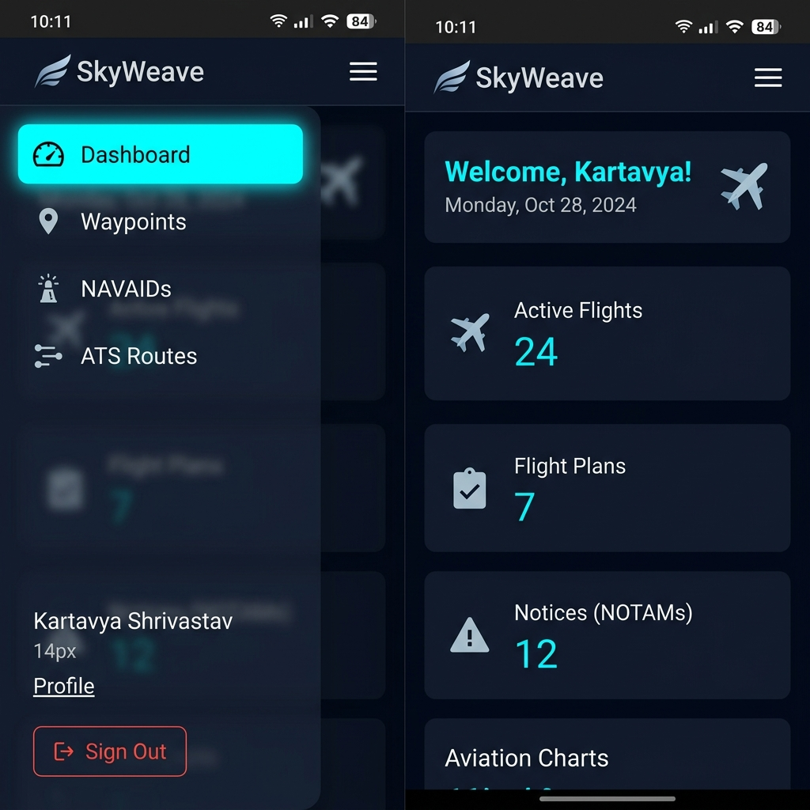

6. GitHub Link
GitHub Repository: https://github.com/MalayShikharSoni/SkyWeave

7. Deployed Link
The application is deployed locally for development and testing purposes.
Local URL: http://localhost:8000

A. Appendices

A.1 Validation Rules
Latitude Validation:
'latitude' => ['required', 'numeric', 'between:-90,90']
Longitude Validation:
'longitude' => ['required', 'numeric', 'between:-180,180']
Route Waypoints Validation:
'waypoints' => ['required', 'array', 'min:2']

A.2 Session Draft Route Structure
session(['draft_route' => ['waypoints' => [...], 'metadata' => [...]]])

A.3 Haversine Distance Calculation
The Haversine formula is used to calculate the great-circle distance between two points on the Earth’s surface. The ATSRoute model implements this with Earth radius = 3440.065 nautical miles, returning the total route distance by summing distances between sequential waypoints.

A.4 Future Enhancements
• FIR (Flight Information Region) overlays
• Weather layer integration
• NOTAM (Notice to Airmen) integration
• GeoJSON import/export functionality
• ICAO route format export
• Real-time aircraft visualization

