**CIME**

BHUBANESWAR

**उद्यमेन हि सिध्यन्ति**

A PROJECT ON

CONVERSATIONAL

NEWS APPLICATION

SUBMITTED BY:

MALAYA KUMAR SWAIN

REG NO -1805107017

Under the Guidance of

SOURAV KABIRAJ

FOR THE DEGREE OF

Master in Computer Application

AT

Department of MCA.

College of IT and management Education

(A Constituent college of Biju Patnaik University of Technology)

Bhubaneswar - 751010

2021-22

**Table Of Contents**

DECLARATION 4

ACKNOWLEDGEMENT 5

ABSTRACT 6

Title of the project 6

Problem statement 6

Why we chosen this topic 6

Objective 6

Method 6

Software we used 7

Testing technology 7

What contribution would the project make 7

Team members 7

Theoretical Background 8

ReactJS 8

Alan API 8

News API 9

Weather API 9

Material UI 10

Features of Material UI: 10

VS code (IDE) 10

GIT (version control) 10

Jest Technology 11

11

Requirement Analysis and Specification 12

Functional and Non-functional requirements 12

Implementation 13

API 13

CONTEXT DIGRAM 15

For News For Weather 15

DFD (Data Flow Diagram) 16

Software Design 17

Basic Architecture diagram 17

User Interface Design 17

Homepage 17

After Processing of voice command 18

Source code and Snapshots: 19

Source code 19

Snapshots 19

Responsive Snapshots 20

Conclusion 21

References 21

# **DECLARATION**

I the undersigned solemnly declare that the project report is based on my own work carried out during the course of our study under the supervision of Sourav Kabiraj. I assert the statements made and conclusions drawn are outcome of my project work.

I further certify that, the work contained in the report is original and has been done by me under the guidance of my supervisor. The work has not been submitted to any other Institution for any other degree/diploma/certificate in this university or any other University of India or abroad to the best of my knowledge and belief.

Malaya Kumar Swain

Regn No- 1805107017

# **ACKNOWLEDGEMENT**

I would like to express my sincere gratitude to my project guide Mr. P.K. Thakur for his invaluable guidance, comments and suggestions throughout the course of the project. I would take this opportunity to thank all the teachers of Dept of MCA, College of It and Management Education for all their supports during the training period. I also thank my roommates for their moral support and encouragement to complete the project in time.

Malaya Kumar Swain

# **ABSTRACT**

## **Title of the project**

Conversational Voice Control News App using ReactJS and Alan AI.

## **Problem statement**

People nowadays prefer digital news over the traditional newspapers. It will be more beneficial if such an app is developed which can read news for people according to their own taste. Through this, users will have news of their own choice and that too within the command of their own voice.

## **Why we chosen this topic**

Users will be able to get news from various sources in one place. An app with voiceassistant aids hands-free operation with the use of only own voice. It frees up humantime and resources. It is an effort to make news reading more fun.

## **Objective**

In today’s tech world people want everything to be faster and in a simpler way. From early childhood we develop a pattern of consuming news from different sources and in today’s mobile era, that mostly boils down to a smartphone. So gradually it becomes a need to have quality digital sources from where people can consume news. Most of the sources that are present are either lacking in simplicity or quality. With this everchanging generations of people there is a constant need to maintain the balance of the above two aspects. This project aims to address this equilibrium for the smartphone generation.

## **Method**

To balance the above aspect, we are going to blend AI along with conventional news, and the way we will be using AI is through voice integration, so that the users can do less work and can still consume the quality content at a faster rate. So basically, it will be a news app that can operate through voice. The news engine will be powered by News API and the front end will be built on top of ReactJS and the voice functionality will be integrated using Alan AI.

## **Software we used**

We are using React JS, Alan AI, Material UI, NEWS API Module, Weather API module, VS code-editor as IDE, GIT (for version control).

## **Testing technology**

We are using JEST technology for testing.

## **What contribution would the project make**

Attaining the above equilibrium for this millennial generation requires reiteration of the product and our first iteration will be the steppingstone towards that bigger goal.

## **Team members**

Malaya Kumar Swain - ReactJS module [1805107017]

Abhinash Nayak - Alan AI module [1805107001]

Madhusmita Nayak - News API module [1805107015]

Subhashree Parhi - Material UI module [1805107031]

# **Theoretical Background**

## **ReactJS**

React is a declarative, efficient, and flexible JavaScript library for building user interfaces. It’s ‘V’ in MVC. ReactJS is an open-source, component-based front-end library responsible only for the view layer of the application. It is maintained by Facebook.

React uses a declarative paradigm that makes it easier to reason about your application and aims to be both efficient and flexible. It designs simple views for each state in your application, and React will efficiently update and render just the right component when your data changes. The declarative view makes your code more predictable and easier to debug.  
A React application is made of multiple components, each responsible for rendering a small, reusable piece of HTML. Components can be nested within other components to allow complex applications to be built out of simple building blocks. A component may also maintain an internal state – for example, a Tab-List component may store a variable corresponding to the currently open tab.

## **Alan API**

*“Alan is one of the most advanced Conversational Voice AI Platform, giving the ability to add a voice assistant to any existing application.”*

Alan is an advanced Voice AI Platform that allows you to add a voice interface to your app without overhead.

Alan provides a complete serverless environment to build robust and reliable in-app voice assistants and chatbots. There is no need to create spoken language models, train the speech recognition software, deploy and host voice components — the Alan AI backend does the bulk of work. The voice experience for your app can be built and developed by a single developer, rather than a team of Machine Learning and Dev Ops experts.

With Alan, you can go beyond the capabilities of touch and type interfaces and voice enable any complex workflow or function in your app. Voice scripts are written in JavaScript, which makes them highly customizable and flexible.

Voice interfaces created with Alan are built once and deployed anywhere — you will not have to rebuild them for specific platforms. Alan offers simple SDKs to integrate with:

* Web
* iOS
* Android
* Flutter
* Ionic
* Apache Cordova
* React Native
* Microsoft Power Apps

And if you need to make changes to the voice interface, you can push these changes without having to release a new app version. Due to Alan’s serverless environment, any change to the voice interface is made available to users instantly.

Using Alan, information can be gathered from applications by users with the use of voice commands. Unlike several other voice assistants, Alan allows companies to build their own voice experiences in their applications.

## **News API**

News API is a simple HTTP REST API for searching and retrieving live articles from all over the web. It can help you answer questions like:

* What top stories is TechCrunch running right now?
* What new articles were published about the next iPhone today?
* Has my company or product been mentioned or reviewed by any blogs recently?

You can search for articles with any combination of the following criteria:

* **Keyword or phrase**. Eg: find all articles containing the word 'Microsoft'.
* **Date published**. Eg: find all articles published yesterday.
* **Source domain name**. Eg: find all articles published on thenextweb.com.
* **Language**. Eg: find all articles written in English.

You can sort the results in the following orders:

* Date published
* Relevancy to search keyword
* Popularity of source

You need an API key to use the API - this is a unique key that identifies your requests. They're free while you're in development.

## **Weather API**

OpenWeatherMap-API weather products are accessible via fast, reliable [APIs](https://openweathermap.org/api) that follow industry standards and compatible with different kind of enterprise systems. All our products content essential climate variables for any location. Besides that, we have some special products that helpful for industries that are affected by weather condition. Amongst them are Road Risk and national weather alerts.

## **Material UI**

**Material UI**is the most powerful and efficient tool to build an Application by adding Designs and Animations and use it with technical and scientific innovation. It is basically a design language that was developed by Google in 2014. It uses more Design and Animations, grid-system and provides shadows and lightning effects.

It can be used with all the JavaScript frameworks like [**AngularJS**](https://www.geeksforgeeks.org/introduction-to-angularjs/), **[VueJS](https://www.geeksforgeeks.org/vue-js-introduction-installation/)**, and libraries like [ReactJS](https://www.geeksforgeeks.org/react-js-introduction-working/), to make the Application more amazing and responsive. With over 35,000 stars on the GitHub, Material UI is one of the top User Interface libraries for React.

### **Features of Material UI:**

1. Material UI provides low-level utility functions called **“style functions”**for building powerful design systems.
2. Access the theme values directly from the component props.
3. Encourage UI consistency.
4. Write responsive style effortlessly.
5. Work with any theme object.
6. Less than KB g zipped.
7. Fast enough to execute.

## **VS code (IDE)**

Visual Studio is an **Integrated Development Environment (IDE)** developed by Microsoft to develop GUI (Graphical User Interface), console, Web applications, web apps, mobile apps, cloud, and web services, etc. With the help of this IDE, you can create managed code as well as native code. It uses the various platforms of Microsoft software development software like Windows store, Microsoft Silverlight, and Windows API, etc. It is not a language-specific IDE as you can use this to write code in C#, C++, VB (Visual Basic), Python, JavaScript, and many more languages. It provides support for 36 different programming languages. It is available for Windows as well as for macOS.

## **GIT (version control)**

Git is a distributed version control system. A version Control system is a system that maintains different versions of your project when we work in a team or as an individual. (system managing changes to files) As the project progresses, new features get added to it.  
So a version control system maintains all your different versions of your project for you and you can rollback to any version you want without causing any trouble to you for maintaining different versions by giving names to it like MyProject, MyProjectWithFeature1, etc.

Distributed Version control system means every collaborator (any developer working on a team project) has a local repository of the project in his/her local machine unlike central where team members should have an internet connection to every time update their work to the main.

## **Jest Technology**

Jest is the most popular testing framework with more than **16M**downloads a week. It is created and maintained by **Facebook**. The team uses it to test all the JavaScript codes including React applications. It is also adopted by Airbnb, Uber, Intuit, and other teams as well. Jest comes with its test runner and assertion functions. This framework is also good for beginners who want to try incredibly fast JavaScript codes.

1. Very fast performance. Airbnb saw a decrease in the total test runtime from **12 minutes to only 4.5 minutes** when they switched from Mocha to Jest.
2. It conduct snapshot, parallelization, and async method tests.
3. Mock your functions, including third-party node_module libraries
4. Possible to manage tests with larger objects using live snapshots.
5. Standard syntax with report guide.
6. Compatible with React, VueJS, Angular and many projects.

# 

**NEWS API**

**REACT JS**

**API**

**MATERIAL UI**

**ALAN STUDIO BACK END**

**API CONNECTIONS**

**FRONT END DEVELOPMENT**

# **Requirement Analysis and Specification**

## **Functional and Non-functional requirements**

There are no functional requirements in this project and the non-functional requirements are:

1. You need a pc or laptop or a mobile device with internet connection to access this app.
2. After opening this App, you need to click once to the mic icon present at the bottom right corner of this app.
3. Then you have to give some command to the application.
4. After getting your command this app will show you the top 10-20 news headlines in card form.
5. Then it will ask you to whether it will read the headlines or not?
6. If you tell yes then it will start reading the head-lines else if you say no then it will not.
7. When the App is listening to your voice if you tell it to open a particular card or article the it will open it in another tab where it has no control because this app can’t access the source website directly.
8. It is able to provide the news by source, keywords, or by specific terms.
9. This app can tell you the weather information of a particular location it includes humidity, moisture, temperature …. Etc.
10. It is able to forecast the weather information of a particular location and with a particular date.
11. But it can forecast only for upcoming five days.
12. At any point if you tell the app to go back it will redirect to you to the entry point of this app.
13. The processing of each request should be done within 10 seconds

## **Implementation**

With great advancements in AI, we have offered an approach for development in the field of news technology. In this project, we have used Alan AI to help get the user some news that they desire to know about. When a user asks Alan about a topic, the AI synthesizes their speech into commands that can then be used to gather information from various applications. We have used ReactJS to develop the front-end of this application and JavaScript for behind-the-scenes operations. Visual Studio Code was our editor of preference. Adding all these technologies together, we progressed to building a hands-on project.

The project implementation can be divided into three parts which are Frontend development, API connections with frontend, and ALAN AI Studio Backend programming.

The front-end part of the project was implemented using ReactJS [1] and Material UI [2]. As mentioned above, ReactJS is an Open-Source JavaScript library maintained and developed by Facebook, it is used for the development purpose of User Interface Components. The components can be reused as many times as a developer desire. React can be used with various frameworks on the server-side and as well as the client-side. The main reason for choosing React for frontend was that it allows us to create a web application with large data and also the changing of data doesn’t require us to reload the page. The rendering process of React is done by using the Virtual DOM which is fast. This fast rendering was required in a project like this where the user is interacting with the web app using the actual voice. Material UI on the other hand is a popular React UI framework. It allows the developer for quick development by providing various components. Some of the components [3] used for this project were Card, CardActions, CardActionArea, CardContent, CardMedia, Button, and Typography.

The Application Programming Interface, API is a messenger that takes requests and tells a system what the user wants and then returns the response. Hence it is a software that provides a foundation for connection between two applications. This connection is then used to send requests from one application to another and get a response in return. An API is the real backend connectivity engine between various other applications.

******API Architecture**

**API RESPONSE**

**SERVER**

**API REQUEST**

**APPLICATION**

API

API

In this project, we have used two APIs. Every application has its API key to connect with your application. The two keys were from NewsAPI and Alan AI. Using the NewsAPI [4], one can search and retrieve accurate and current on-going news across the globe. A lot of query sets are available, one can search and retrieve news by terms, category, or by any news sources. The developer can customize the query for the particular regions for the news. This HTTP REST API allows the developer to access quick news as per the request. The frontend was developed according to the features of this API as there are cards according to the news by terms, category, or by any news sources. Some query set available in the project are:

1. **News by terms**

`https://newsapi.org/v2/everything?apiKey=${API_KEY}`

2. **News by sources**

`https://newsapi.org/v2/top-headlines?apiKey=${API_KEY}`

3**. News by category**

`https://newsapi.org/v2/top-headlines?country=in&apiKey=${API_KEY}&category=${YOUR-VALUE}`

Alan Conversational Platform lends strong support for your app by providing it’s easy to integrate SDK, JavaScript scripting Alan Studio to customize Alan according to our application. The Alan Studio provides a testing tool where the developer can debug the JavaScript commands. The Alan button doesn’t interfere with the User Interface of the application and can be placed anywhere dynamically just by swiping or moving it using the mouse. The cloud handling makes it even more powerful as it is managed by Alan Studio itself. The developer doesn’t need to work on the data security and isolation as the cloud handles it with ease. The simple integration of Alan SDK lets the developer use it with various technologies such as Web, iOS, Android, Ionic, Flutter, Electron, Angular, React, Vue, Ember, and Vanilla JS. The scripting for this project was based on the news requirement. Commands like “Give me the latest news from BBC'', “What’s up with COVID 19”, and more were scripted. The voice assistant is completely scripted to read out all the headlines of the news that the user searched for. While reading the article headlines, the frontend of the project highlights the article by a blue bar below it. The user can ask to open any article to read in depth about that article. The project redirects to the news article when the user asks to open an article of their choice.

## **CONTEXT DIGRAM**

### **For News For Weather**

## **DFD (Data Flow Diagram)**



Application

Backend

Application with

ALAN SDK



**VIRTUAL MACHINE ALAN AI CLOUD**



Alan Studio

# **Software Design**

## **Basic Architecture diagram**

## 

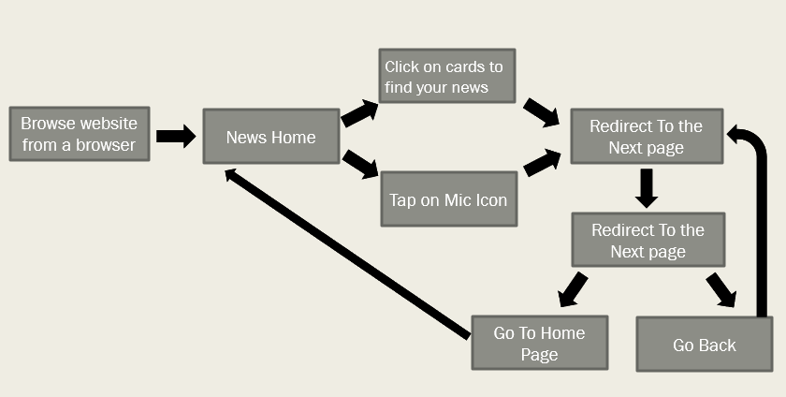

## **User Interface Design**

### **Homepage**

### **After Processing of voice command**

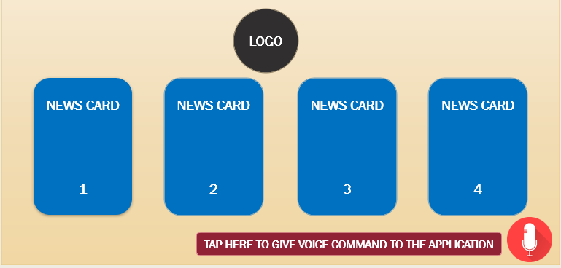

# **Source code and Snapshots:**

## **Source code**

<https://github.com/Malaya2184/JS100/tree/master/conversational_news_app>

## **Snapshots**

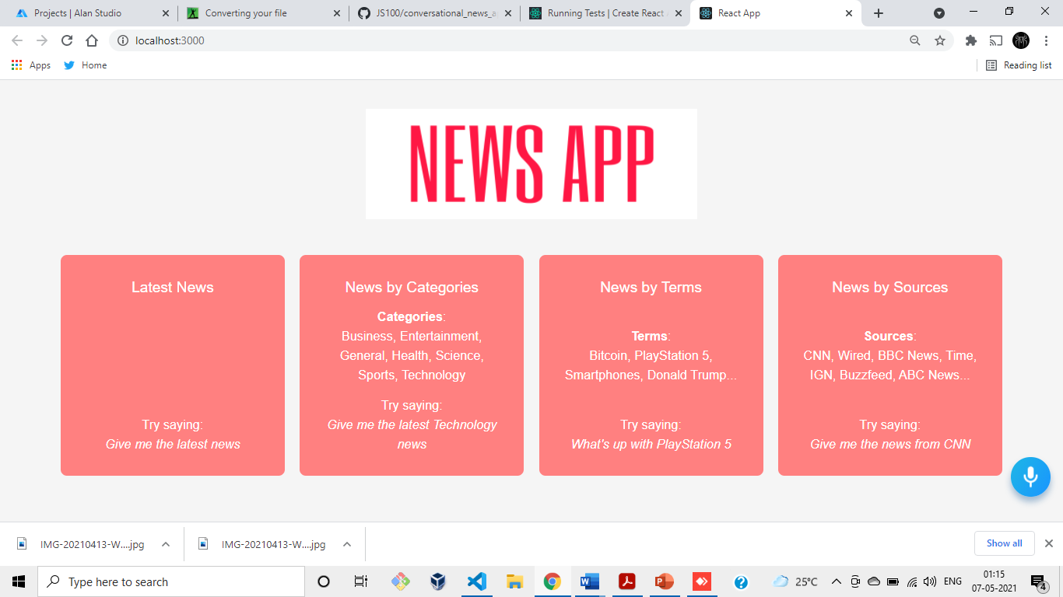

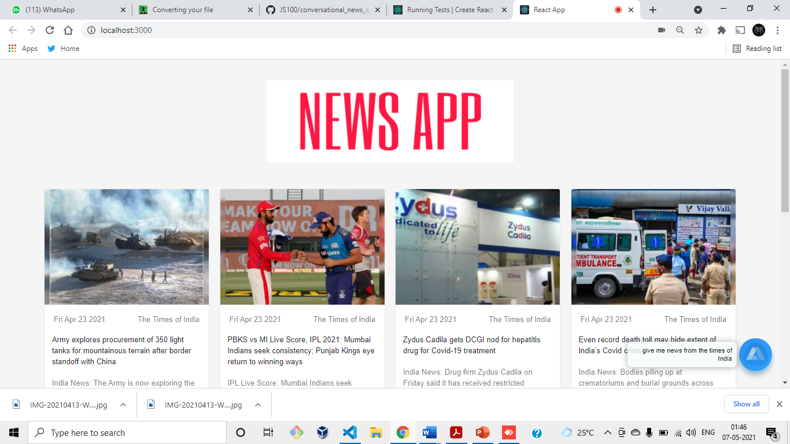

## **Responsive Snapshots**

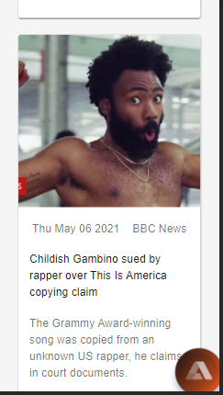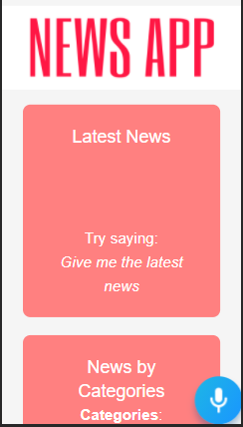

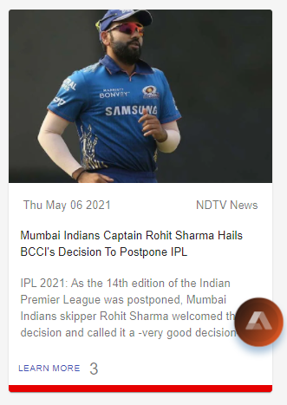

# **Conclusion**

Reading newspapers takes up a lot of time and the reader usually spends reading about articles in which they are not interested. By using this project, the user can get to hear about all the important headlines of their chosen topic on the go, in just 5 minutes. The project is capable of reading all the headlines of the news articles and can open the source article for more in-depth reading if required by the user. Alan voice assistant can be integrated into many more applications in the field of health-care, business, banking, and e-commerce applications. As far as news applications are concerned, we suggest that the integration of voice assistants in news applications will not only enhance the user experience but also make news more engaging in the near future. We hereby have successfully completed our project and conclude our research.

# **References**

[1] "React – A JavaScript library for building user interfaces", Reactjs.org. [Online]. Available: <https://reactjs.org/>.

[2] "Material-UI: A popular React UI framework", Material-ui.com. [Online]. Available: <https://material-ui.com/>.

[3] "React Card component - Material-UI", Material-ui.com. [Online]. Available: <https://material-ui.com/components/cards/>.

[4] "Documentation - News API", Newsapi.org. [Online]. Available: https://newsapi.org/docs.

[5] "6 Major Branches of Artificial Intelligence (AI) | Analytics Steps", Analyticssteps.com. [Online]. Available: <https://www.analyticssteps.com/blogs/6-major-branches-artificial-intelligence-ai>.

[6] [Online]. Available: <https://www.linkedin.com/company/alanvoiceai/>.

[7] "This Person Does Not Exist", Thispersondoesnotexist.com. [Online]. Available: <https://thispersondoesnotexist.com/>.

[8] "Alan AI | Conversational Voice AI Platform", Alan. [Online]. Available: <https://alan.app>.