CHAPTER 4

AEROSOL SENSITIVITY TO POLARIZATION

# 4.1 Introduction

Stratospheric aerosols, which are micron-sized spherical liquid droplets of sulfuric acid, cause a cooling effect by scattering the incoming solar irradiance and therefore have an important radiative effect on climate. This effect depends strongly on the aerosol concentration and also the particle size distribution (*Kiehl and Briegleb, 1993*; *Stocker et al., 2013*). Recent studies have proposed a link between the so-called global warming hiatus and an increase in the stratospheric sulfate aerosol layer. (*Solomon et al., 2011*; *Haywood et al., 2014*; *Fyfe et al., 2013*). The increase in stratospheric aerosol over the last decade is believed to be caused by a series of somewhat minor, mostly tropical volcanic eruptions (*Vernier et al., 2011b*).

Stratospheric aerosol distributions have been monitored on a global scale since the 1970s with satellite instruments using a variety of remote sensing techniques. The first satellite aerosol extinction profile retrievals were from limb sounding solar occultation measurements, most notably from the NASA SAGE missions (*Russell and McCormick, 1989*; *Thomason and Taha, 2003*). The solar occultation technique has provided a robust and reliable method to retrieve aerosol by directly measuring the atmospheric optical depth. However, the global sampling of occultation measurements is somewhat limited due the necessity of a sunrise or sunset and typically requires months to cover a large range of latitudes. Limb scatter measurements, such as from OSIRIS (*Llewellyn et al., 2004*), SCIAMACHY (*Bovensmann et al., 1999*), and OMPS (*Rault and Loughman, 2013*), have better coverage by only requiring the sunlit conditions at the tangent point, but the retrieval of aerosol is more complex requiring computationally heavy forward modelling and inversion compared to occultation. It is worthwhile to note that the combination of the SAGE II and OSIRIS datasets have recently been used to successfully create a single long term merged time series depicting the evolution of the stratospheric aerosol layer (*Rieger et al., 2015*).

OSIRIS, SCIAMACHY, and OMPS measure the spectral radiance of the scattered sunlight from the limb and use non-linear inversion techniques to retrieve aerosol extinction profiles (*Bourassa et al., 2012b*; *Ernst et al., 2012*, *Rault and Loughman, 2013*). For these retrievals, assumptions regarding particle size distributions and/or composition are typically required in the forward model. Most importantly for this study, currently none of these retrievals account for any polarization sensitivity in their respective measurements. However, these instruments have been specifically designed to measure the total radiance by minimizing the instrument sensitivity to polarization. Recently proposed new instruments with the capability to measure aerosol using limb scattering include the Belgium instrument Atmospheric Limb Tracker for the Investigation of the Upcoming Stratosphere (ALTIUS) (*Dekemper et al., 2012*) and the Aerosol Limb Imager (ALI), a Canadian endeavour. Both instruments image the limb and use acousto-optic tunable filters to select the measured wavelength. The use of the acousto-optic filter inherently means that the measured image is linearly polarized. Although it has been previously shown that the retrieval of stratospheric aerosol extinction profiles from polarized scattered sunlight measurements are possible (*McLinden et al., 1999*), the full impact of the polarized measurement has not been systematically studied. In this work we perform an analysis with simulated polarized measurements to determine first if there are any clear advantages or disadvantages to making the linearly polarized measurement. Further, we investigate which linear polarization and viewing geometries have the largest sensitivities to aerosol, and how the polarized measurements affect the accuracy and precision of the retrieved aerosol product.

# 4.2 Background and Forward Model

In order to investigate the effect of polarization on the sensitivity to aerosol, an accurate model of the polarized limb radiance must be employed. Additionally, a large number of scenarios, including various atmospheric states and viewing geometries, are required to fully probe the solution space. In this section, the basic background describing the polarization state of the limb signal is developed and the SASKTRAN-HR model and the various model scenarios used for the analysis are described.

## 4.2.1 Polarized Scattered Sunlight and Stratospheric Aerosols

All full description of scattering interactions within the atmosphere can be found in section 2.4.2 to 2.4.4. This section will briefly cover the theory and then use it to analyze the polarization state of earth’s atmosphere in regards to look direction.

The polarization state of electromagnetic waves can be fully defined by the Stokes vector formulation. The Stokes vector is given by a column matrix

|  |  |
| --- | --- |
|  | (4.1) |

where the terms of the Stokes vector, defined in a reference frame, are measures of the total radiance, , the difference between horizontal polarization to vertical polarization, , the difference between +45o diagonal polarization to -45o polarization, , and the difference between the counter clockwise circular polarization to clockwise polarization, . Using a reference frame where the x-axis is defined to be the horizontal polarization leads to the following definition for the Stokes parameters

|  |  |
| --- | --- |
|  | (4.2) |

To model the scattering for an incident ray propagating in a given direction the ray undergoes a rotation into the Stokes reference frame and is then is multiplied by the phase matrix for the scattering process. After the multiplication the resulting ray is then rotated back into the ray’s initial coordinate system through the following

|  |  |
| --- | --- |
|  | (4.3) |

The outgoing, or scattered, and incoming radiances are represented 4 by 1 matrices, *i.e.* Stokes column vectors, given by and , the rotation matrices are given by and rotate the incoming ray and scattered ray by rotation angles and . The phase matrix is a 4 by 4 represented by and is related to the probability that an incoming ray will be scattered at a scattering angle, . It also describes the change in polarization state through the elements of the matrix.

For this work, two primary scattering interactions induce and/or modify the polarization state of the light propagating in the atmosphere. These are scattering by the molecular air density and by stratospheric sulfate aerosols. The molecular atmosphere interaction is referred to as Rayleigh scattering, and has a phase matrix that is determined from the Rayleigh-Gains approximation (*Mishchenko et al., 2002*) given by

|  |  |
| --- | --- |
|  | (4.4) |

where is the scattering angle.

For randomly orientated or spherical particles, such as stratospheric aerosol, only six elements of the phase matrix are required (*van de Hulst, 1957*) which are the following

|  |  |
| --- | --- |
|  | (4.5) |

Additionally, for spherical particles like stratospheric aerosol only four unique terms are required since and . Spherical aerosol scattering is fully described by Mie theory (*Mie, 1908*), for which several standard codes have been developed to calculate scattering cross sections and phase matrices based on the particle size distribution and index of refraction (e.g. *Wiscombe, 1980*). A full derivation can be found in *van de Hulst (1957)*.

The basic polarization state of the scattered light in the earth’s atmosphere can be understood by first considering a single scattering event of the randomly polarized incoming sunlight in a molecular atmosphere. It can be easily seen from the form of the Rayleigh phase matrix (Equation 4.4) that a single scattering event causes the sky to develop a distinct polarization at a scattering angle of 90 degrees from the incoming solar beam. The scattered sunlight is linearly polarized in the horizontal orientation, which is parallel to the horizon, and gradually becomes fully randomly polarized at scattering angles of 0 and 180 degrees, *i.e.* forward and back scatter respectively. If multiple scattering events are taken into account, the degree of polarization is decreased at 90 degrees scattering angle, and does not become completely randomly polarized at forward and backscatter. Simulations with the SASKTRAN-HR forward model, which is described in section 2.4.5, show that at 90 degrees scattering angle, the degree of linear polarization is approximately 95% for a wavelength of 750 nm. Furthermore, this polarized effect is strongest at longer wavelengths (1500 nm) and decreases, on average by 10%, as the wavelength become shorter (500 nm). This is directly related to the greater contribution from multiple scattering at shorter wavelengths. As the scattering angle decreases or increases from 90 degrees, the degree of linear polarization decreases. It is approximately 20% for a backscatter geometry, and 30% for a scattering angle of 45 degrees.

For an atmosphere that contains both the molecular air density as well as a typical background state of stratospheric sulfate aerosol, both Rayleigh and Mie scattering occur in a weighted fraction according to the optical depth of air and aerosol. Compared to the pure Rayleigh scattering case, a decrease in the degree of linear horizontal polarization occurs for wavelengths from approximately 500 to 1200 nm, and interestingly, for wavelengths longer than approximately 1200 nm, the opposite occurs. This is due to the changing fraction of scattering from the molecular air density and aerosol because the Rayleigh scattering cross section falls off much more quickly with wavelength than the aerosol cross section. These changes are similarly present for all scattering angles. The observed change in linear polarization from a pure Rayleigh atmosphere is approximately 5-10% for typical background aerosol, but it obviously varies depending on aerosol loading and the microphysical parameters of the aerosol.

## 4.2.2 SASKTRAN-HR Model

The model used for this work is the SASKTRAN-HR radiative transfer model discussed in section 2.4.5 and a brief overview will follow. The radiative transfer model SASKTRAN-HR (High-spatial Resolution) (*Bourassa et al., 2007*; *Zawada et al., 2015*) was used in this study. The SASTRAN-HR model provides flexible user specified atmospheric species and concentrations, and uses a fully 3D spherical geometry to solve the radiative transfer equation using a successive orders of scattering technique. SASKTRAN-HR also has the capability to calculate the polarized, or vector, radiances exactly for the first three scattering events, which contribute to most of the signal in limb scatter. The polarization states of higher orders of scattering are approximated with minimal impact on the final solution (*Dueck et al., 2016*). All calculations performed with SASKTRAN-HR in this study assume randomly polarized sunlight, and Rayleigh and Mie scattering events only to model the interaction with the molecular air density and stratospheric aerosol, respectively. Scattering events from the Earth’s surface are assumed to be Lambertian and fully depolarizing.

## 4.2.3 Model Scenarios

The impact of a polarized measurement on stratospheric aerosol retrievals is systematically studied by exploring a set of distinct cases that approximately cover the expected range of aerosol parameters, including both particle size and concentration (or extinction) profiles, and viewing geometries. Viewing geometry is an important parameter as even in the case of the total radiance measurements, the geometry can have a substantial effect on the sensitivity of the measurement to aerosol due to asymmetry of the Mie scattering phase function. (*Rieger et al., 2014*). This is due to strong aerosol scattering in the forward direction and results in a weaker relative aerosol signal in the backscatter direction. To probe a large portion of this parameter space, a series of scenarios were developed.

To probe the aerosol space, two extinction coefficient profiles and four particle size distributions were used. The two extinction profiles, nominally at 750 nm, correspond to a background aerosol case, typical of the volcanically quiet period of the early 2000’s (*Deshler et al., 2003*), and a volcanically enhanced case which was taken from OSIRIS measurements two months after the Nabro eruption in 2012. Both profiles are shown in Figure 4‑1. For the simulations at other wavelengths, these extinction profiles were converted to an equivalent aerosol number density concentration using an assumed size distribution. This number density was then kept constant and the extinction scaled by the Mie scattering cross section corresponding to the selected wavelength and same assumed particle size distribution. The four particle size distributions were also chosen to represent typical background and volcanically enhanced cases. The background cases are both single mode lognormal distributions with somewhat different, but still typically observed, size parameters. A bi-modal lognormal particle size distribution was used for the volcanically enhanced cases, with one fine mode and one coarse mode, each comprising an equal fraction of the total extinction. All of the parameters of the size distributions are detailed in Table 4-1. These selected distributions are based on in-situ balloon particle counter measurements from Laramie, Wyoming (*Deshler et al., 2003*).

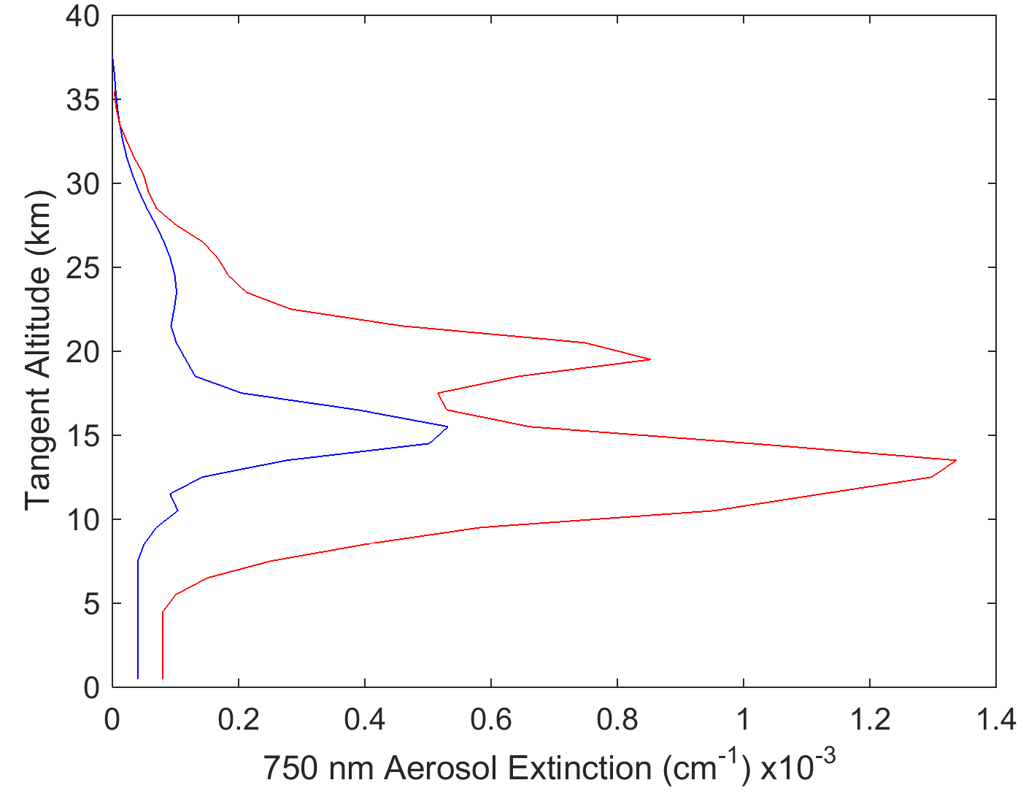

**Figure 4-1:** The two aerosol profiles used in this study. The blue is a background aerosol extinction levels, and the red curve is a representative aerosol profile after the Nabro eruption.

**Table 4-1:** Different particle size distributions used to test the sensitivity of the aerosol retrieval.

|  |  |  |  |  |  |
| --- | --- | --- | --- | --- | --- |
| Particle size distributions | Fine mode radius (µm) | Fine mode width | Coarse mode radius (µm) | Coarse mode width | Percent extinction coarse mode (%) |
| 1 | 0.04 | 1.8 | -- | -- | 0 |
| 2 | 0.12 | 1.25 | -- | -- | 0 |
| 3 | 0.04 | 1.8 | 0.30 | 1.15 | 50 |
| 4 | 0.12 | 1.25 | 0.30 | 1.15 | 50 |

To probe the range of possible viewing geometries, a range of Solar Zenith Angles (SZAs) and Solar Scattering Angles (SSA) were selected. The ranges give representative selections of the possible geometries of a limb scatter instrument in low earth orbit. The selected values for SZA are 15o, 45o, and 75o and for SSA of 30o, 60o, 90o, 120o, 150o, and 180o. The simulations were performed at wavelengths of 500, 750, 1000, 1250, 1500 nm, which approximately cover for the spectral range commonly used for aerosol retrievals from limb instruments. For example, OSIRIS and SCHIAMACHY aerosol products use the ratio of 750 nm to 470 nm for the aerosol retrieval (*Bourassa et al., 2012b*; *Ernst et al., 2012*). Further near infrared wavelengths have been shown to provide particle size information from limb scatter measurements (*Rieger et al., 2014*) and so the 1000-1500 nm wavelength range was also important to include in this study. The other important input parameter is the albedo of the Earth’s surface and for this study we use both values of 0 and 1 in order to cover the full range of potential impact.

# 4.3 Methodology

For the purposes of this study, we have assumed an instrument capable of measuring only the linear polarization with either a vertical or horizontal orientation. This was chosen since upcoming instruments like ALTIUS (*Dekemper et al. 2012*) and ALI use an AOTF for a spectral filter and these instruments by nature only measure one orientation of linear polarization. We want to answer the question: if the linear polarization is measured, is this an advantage or a disadvantage over a measurement of the total radiance for aerosol retrievals? Further, is there a preferred orientation of linear polarization?

The polarization states used here are defined as the following: the linearly polarized radiance aligned with the horizon is referred to as the horizontal polarization, and the linearly polarized radiance that is perpendicular to the horizon is referred to as the vertical polarization. We also use the total radiance, or alternatively the scalar radiance, as the reference case. (Note that the scalar radiance is not precisely equal to the total radiance as explained below.) Using the Stokes parameters, the total radiance is defined as I, the horizontal polarization is given by $0.5(I+Q)$ and the vertical polarization is given by .

Our study looks at the problem in three sections. First, how does the fraction of the limb scatter signal, scalar and polarized, that is due to aerosol vary for a range of geometries and aerosol profiles? Secondly, how does the polarized measurement affect the ability to retrieve aerosol using an assumed particle size distribution, as is the case in the OSIRIS and SCIAMACHY retrieval algorithms? And finally, how does the polarized measurement effect the uncertainty estimate of the retrieved profile? Within this section the methodology for each question is described.

First, the modeled radiance is presented for a set of geometries, wavelengths, and altitudes to determine the approximate fraction of the limb signal that is due to aerosol. The model is run with a nominal atmosphere that consists of molecular air, ozone, and NO2 which is kept constant, and with a variable aerosol amount and albedo. The aerosol fraction was determined by calculating the nominal radiance without aerosol in the model, $I_{nom}$, and the total radiance including the aerosol, $I_{tot}$, and using the difference between the total radiance and nominal radiance to find the approximate fraction of the signal due to aerosol. Thus to determine the percent of the signal that is attributed to aerosol, the following formulation is used

|  |  |
| --- | --- |
|  | (4.6) |

Due to non-linearities from multiple scattering, this is not strictly true; however at most stratospheric tangent altitudes, the wavelengths under study are quite optically thin and this simple percent difference will provide an intuitive approximation of the fraction of the signal due to aerosol. Furthermore, polarized measurements of radiance will be smaller in magnitude than the scalar counterpart and the percent loss will be used to estimate the increase in instrument sensitivity, or, for example, image exposure time, needed to compensate.

To determine the effect of polarization on the retrieval, a retrieval method is used that is essentially similar to that developed by *Bourassa et al. (2012b)* for OSIRIS. A minor change to the algorithm is made where the measurement vector for this study is not normalized by a shorter wavelength. We have made this change as the results from *Rieger et al. (2014)* show this actually decreases sensitivity to particle size distributions. Although it is advantageous to limit sensitivity to particle size, it is advantageous to explore the worst case scenario under possible limitations of future technology, especially given that not all instruments may cover a wide spectral range. For the retrievals, a simulated radiance profile is calculated using the SASKTRAN-HR model with nominal ozone and NO2 profiles for each of the aerosol parameter scenarios listed in section 4.2.3. This is taken as a simulated measurement and is then used to retrieve aerosol extinction profiles using the *Bourassa et al., (2012b)* technique. This is done similarly for all three polarization states. Additionally, a retrieval is performed with the scalar SASKTRAN-HR model to see if there is any substantial difference between using the scalar and the total radiance from the vector model. For each aerosol retrieval, the ozone, NO2, and albedo are fixed to the values used in the simulation of the measurement. All four particle size distributions from Table 4-1 are used in the simulations, but following *Bourassa et al., 2012b*, the aerosol particle size is fixed in the retrieval to a single mode log-normal with 0.08 µm mode radius and mode width of 1.6. The assumption of a fixed particle size distribution is very common in current limb scatter retrievals and this is used to explore sensitivity of the polarized measurements to particle size distributions, and test if the uncertainty in this assumption greatly effects the retrieved extinction.

Lastly, an uncertainty estimate is performed in order to check the precision of the retrieved aerosol profile. The method used for this analysis is one presented by *Bourassa et al. (2012a)* in which it is assumed that the Jacobian, , calculated for the retrieved state, times the Gain matrix, $G$, is approximately equal to the identity matrix such that

|  |  |
| --- | --- |
|  | (4.7) |

With an assumed covariance on the aerosol retrieval, $S_{ϵ}$, the covariance on the aerosol profiles can be found by

|  |  |
| --- | --- |
|  | (4.8) |

Finally, the square root of the diagonal of the aerosol covariance is taken as the final uncertainty profile. Using the results from all the cases, statistics are used to determine any trends in the obtained precision across the input parameters.

# 4.4 Analysis

## 4.4.1 Aerosol Sensitivity

First, the contribution to the total limb radiance from aerosol was analyzed across the spectral range and over a series of tangent altitudes for the background aerosol profile and the particle size distribution 1, given in Table 4-1. Figure 4-2 shows the difference between the fraction of the limb radiance due to aerosol for a linearly polarized measurement and the fraction due to aerosol for the scalar measurement given a typical geometry of SZA=45o and SSA=60o with an albedo of 0. Note that the fraction of the signal due to aerosol increases as wavelengths become longer as expected due to the rapidly decreasing Rayleigh cross section. However, the fraction of the signal due to aerosol increases with wavelength for the vertical polarization as it does in the scalar case, whereas the horizontal polarization has decreasing sensitivity to aerosol.

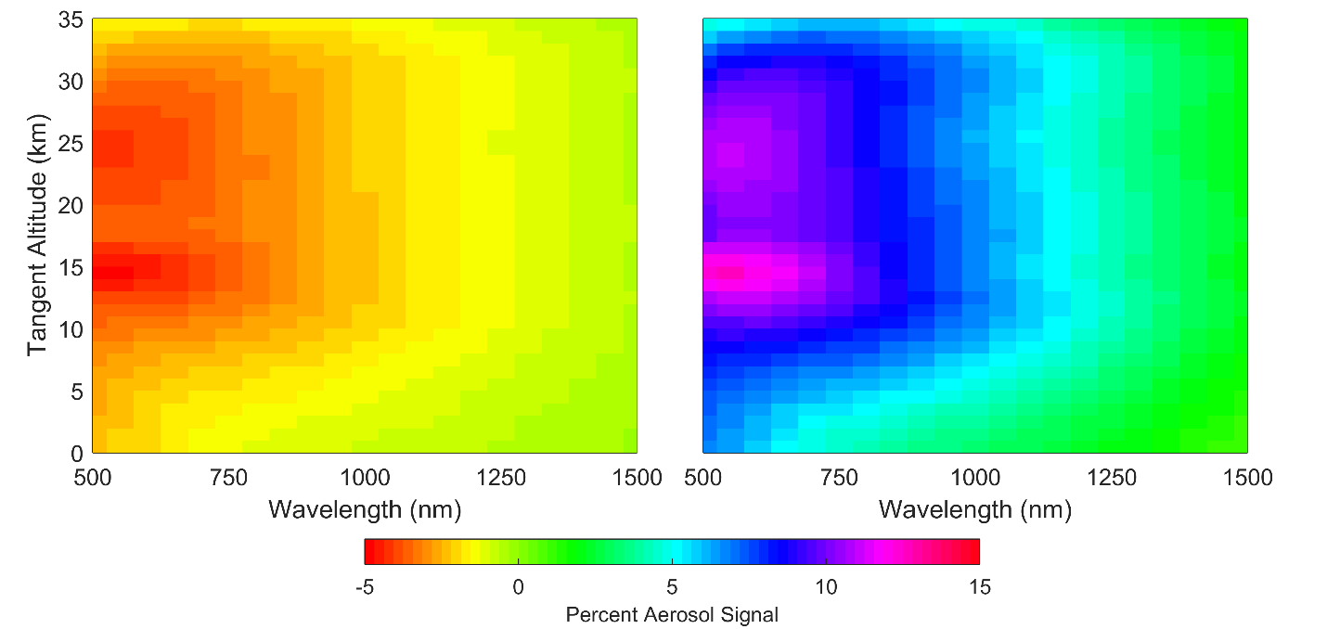

**Figure 4-2:** A computation of the percentage of aerosol signal change in the horizontal and vertical polarizations compared to the scalar. The top, and bottom figures are the horizontal, and vertical polarization respectively. The geometry for the simulation is set up with SZA of 45o and SSA of 60o with an Albedo of 0 and using the background aerosol profile.

A similar analysis was performed for the range of viewing geometries. The left half of Figure 4-3 shows the fraction of aerosol signal for 15 km tangent altitude, with the background aerosol profile and an albedo of 0 and size distribution 1. An important difference is noted between the forward and backward scattering geometries. The scalar and horizontal polarization cases have a similar dependence on geometry, with the strongest aerosol signal from long wavelengths in the forward scatter direction. For the vertical polarization, we see that it has a strong aerosol signal contribution for all forward scattering directions, especially at visible wavelengths, in comparison to the scalar and horizontal polarization cases. For backward scattering, slightly less aerosol signal is observed, but the shape is similar to the scalar and horizontal cases. The magnitude of the limb radiance in each case is shown in the right hand column of Figure 4-3. It is important to note that the vertical polarization has a very low magnitude at scattering angles near 90 degrees, as shown in Figure 4-3. This makes this geometry very difficult to use reliably. We performed these same calculations for the full range of SZAs and found that the SZA only effects the fraction of the signal due to aerosol by less than 1%. Lastly, when the albedo is changed from 0 to 1, the aerosol signal degreases for all polarizations and wavelengths thus reducing overall sensitivity to aerosol as albedo increases.

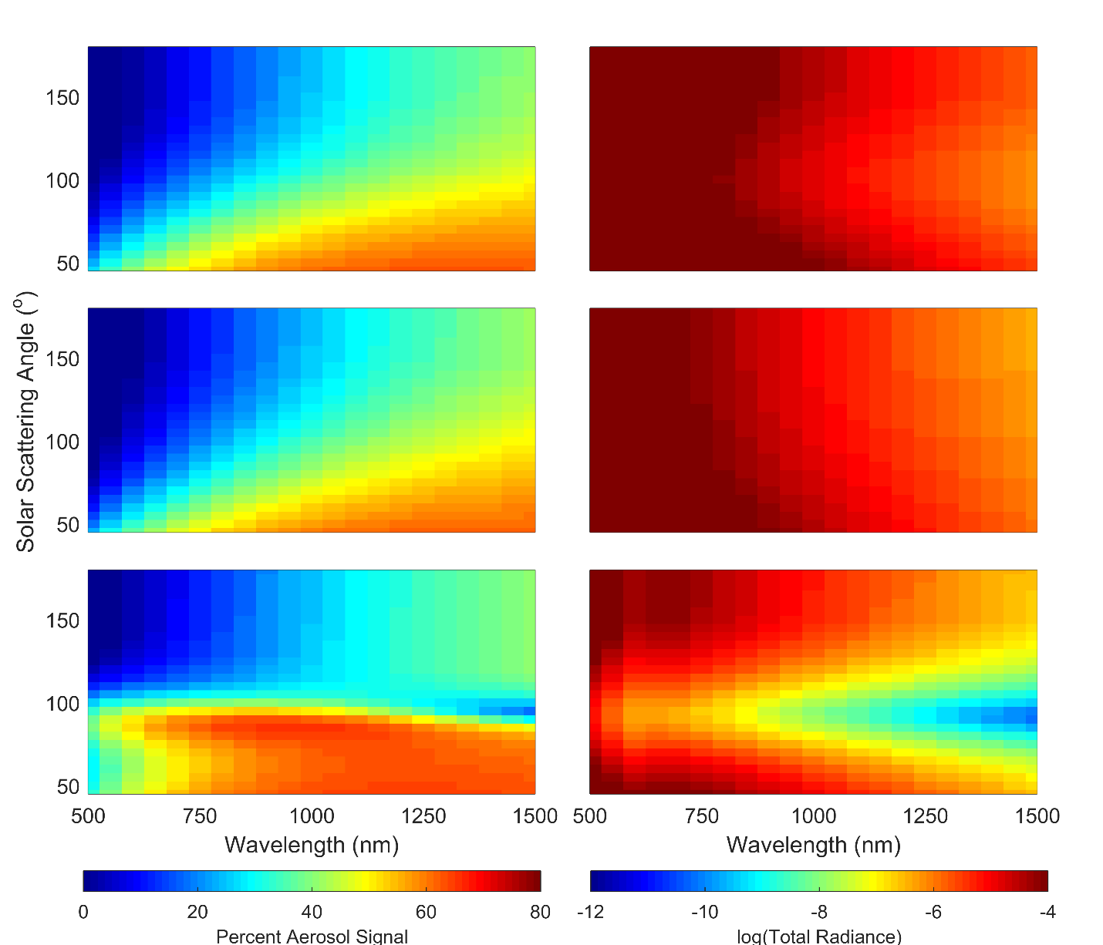

**Figure 4-3:** Left: A computation of the percentage of aerosol signal over the total radiance for a three polarizations. The top, middle, and bottom figures are the scalar, horizontal, and vertical polarization respectively. The geometry for the simulation is set up with SZA of 45o and at an altitude 15.5 km with an Albedo of 0 and using the background aerosol profile. Right: The same geometry as the left column except the log of the total radiance for each polarization is shown.

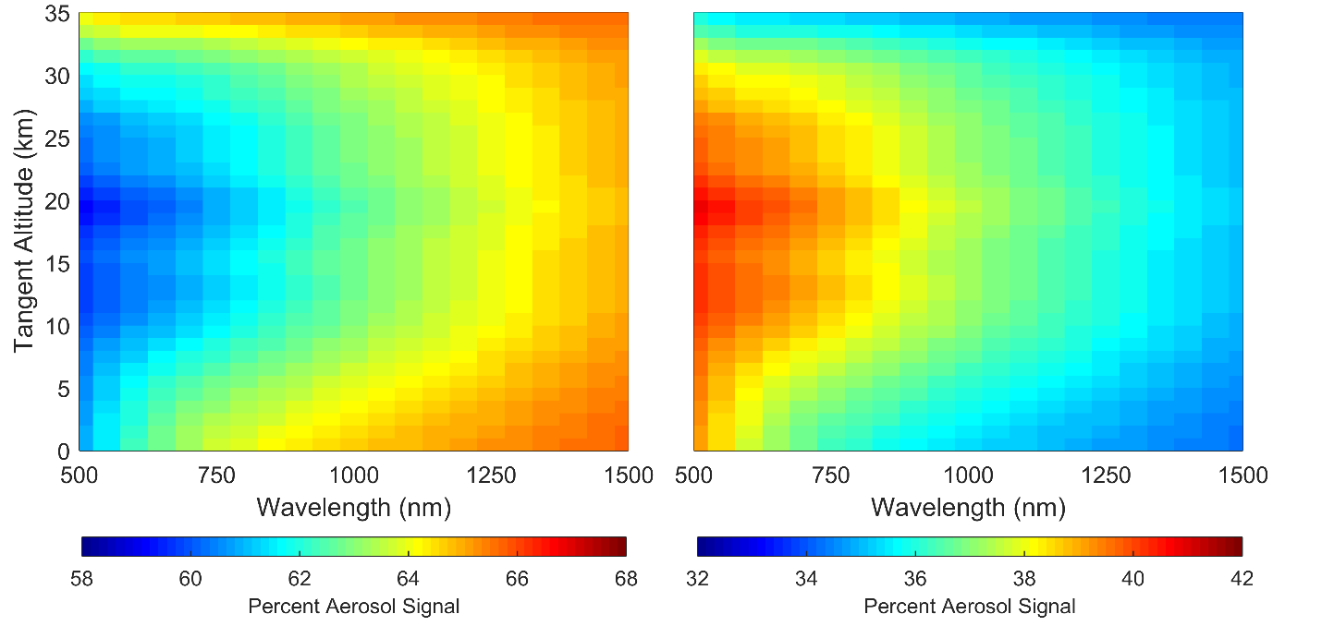

**Figure 4-4:** A percent of the linear polarized radiances over the scalar radiance, the top and bottom figures are the horizontal and vertical polarizations respectively. The radiances were calculated with a geometry of 60o SZA and 45o SSA with an albedo of 0 and using the background aerosol profile. Note that the scale for each plot are different.

As we can see from these results, the sensitivity of the limb radiance to aerosol for the horizontally polarized and scalar cases is approximately the same, and the vertical polarization has better sensitivity in the forward scattering case. However, only measuring the linear polarization results in a loss of overall signal. In Figure 4-4, the ratio of the total polarized radiance over the total scalar radiance is shown for a SZA of 45o and SSA of 60o, in this case using the volcanic aerosol extinction profile. Measuring the horizontal polarization would result in only observing approximately 58% of the signal for shorter wavelengths compared to the scalar case, and at longer wavelengths this increases but only to approximately 66%. For the back scatter case, the observed signal decreases slightly to 52% at short wavelength and 56% at long wavelengths. Finally for SSA near 90o the observed signal increases to 83% at short wavelengths and 95% for long wavelengths. This loss of signal, on average about 30%, would need to be accounted for by a corresponding increase in instrument sensitivity to maintain an equivalent signal to noise ratio in the measurement. For the vertical polarizations, however, the increased aerosol fractional signal in the forward scatter case is compensated with a larger loss of overall signal. For forward scatter only 38% and 34% of the signal are observed for 500 nm and 1500 nm respectively. Similarly for back scatter 48% and 44% of the signal is observed when compared to the scalar case. At SSA near 90o the signal decreases to 15% overall. This is a significant loss of signal that would result in increasing the instrument sensitivity by approximately 60-70%.

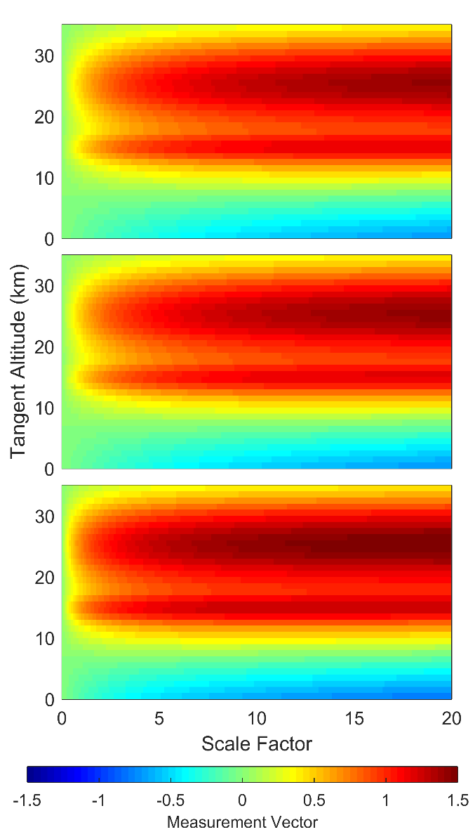

**Figure 4-5:** The background aerosol profile scaled by a factor used to calculate aerosol measurement vectors for 750 nm with a SZA of 60o and SSA of 45o with an albedo of 0. The three panels are the measurement vectors for the scalar, horizontal, and vertical polarizations from top to bottom.

As the amount of aerosol in the atmosphere increases, obviously so does the percent of the signal which is attributed to aerosol. Eventually, an increase in aerosol will result in little change or negative change to the aerosol measurement vectors typically used in aerosol retrievals. These measurement vectors are a similar quantity to the percentage fraction of aerosol signal, except the fraction is performed in log-space. The measurement vectors shown in Figure 4-5 are similar to the measurement vectors used by *Bourassa et al. (2007)* except the short wavelength normalization has been removed. In Figure 4-5, the background aerosol profile is successively scaled to higher values and the aerosol measurement vector is calculated for each scaled valued. These simulations are performed with a SZA of 60o and SSA of 45o and with an albedo of 0. In all cases the measurement vector increases as the aerosol load is increased until a maximum value is reached. For example, for the scalar, horizontal, and vertical polarization this occurs at a scale factor of approximately 10, 11, and 8, respectively, at 25 km tangent altitude. As the aerosol loading is further increased from this point the measurement vector starts to decrease in value representing the maximum aerosol extinction for which that each polarization has sensitivity. Furthermore, a negative measurement vector is noted for lower altitudes. The loss of signal is due to the larger fraction of attenuation of the solar radiance over the increased aerosol scattering as the extinction coefficient approaches these large values (see *Bourassa et al., 2007* for a more detailed explanation). This eventually leads to an aerosol loading limit beyond which retrievals are not possible. At shorter wavelengths, the best range of aerosol loading sensitivities is found for the horizontal polarization, followed by the scalar case. However, for longer wavelengths (*i.e.* 1500 nm) the measurement vectors do not reach a peak value even at a scaling factor of 20 for all three polarization cases.

When considering the orientation of linear polarization for an instrument design there is no clear choice when it comes to sensitivity. Both the horizontal and vertical linear polarization are valid choices depending on the instrument and orbit of the mission in question. The vertical polarization provides the best sensitivity to aerosol in the forward and backward scattering cases but should be avoided if any substantial fraction of the measurements are to be made near scattering angle of 90o for the proposed orbit. In terms of sensitivity, the horizontal polarization is preferable since overall signal levels are higher and generally a larger range of aerosol loading is detectable.

## 4.4.2 Retrievals

Retrievals were performed for all of the wavelengths listed in section 4.2.3, however due to similarities between the retrievals of different wavelengths only the 750 nm wavelength will be presented, with comments on the other wavelengths when significant deviations from the 750 nm case occur.

Retrievals with current limb scatter instruments use a scalar radiative transfer model but accounting for the vector component alters the overall total radiance from the scalar solution due to multiple scattering of the vector radiance contributing to the overall radiance though the phase matrix interactions between the various polarization states. A brief study was performed to determine if using a scalar model for these retrievals instead of the total radiance from the vector model would result in biases in the retrieved aerosol profiles. A comparison between the retrieved extinctions for the scalar and vector model were performed using a percentage difference in the form

|  |  |
| --- | --- |
|  | (4.9) |

Across all wavelengths, the mean percent difference is less than 2% from 15 to 37 km. However, at shorter wavelengths, shown in Figure 4-6, a few outliers occur where the difference between the retrievals is greater than 7%. All of these retrievals occur in the backscatter condition, *i.e.* where the SSA is greater than 90o. The reason for this discrepancy is not well understood, but arises from the differences between the scalar and total radiance due to polarization interactions from a larger contribution of multiply scattered light, but further investigation is required. However, overall the differences between the retrievals using the scalar and vector models are negligible and any form of discrepancy vanishes for wavelengths past 1000 nm. Since the use of the vector model can increase calculation times by a factor of at least two, it is beneficial to be able to use the scalar model and can be used reliably for essentially all cases.

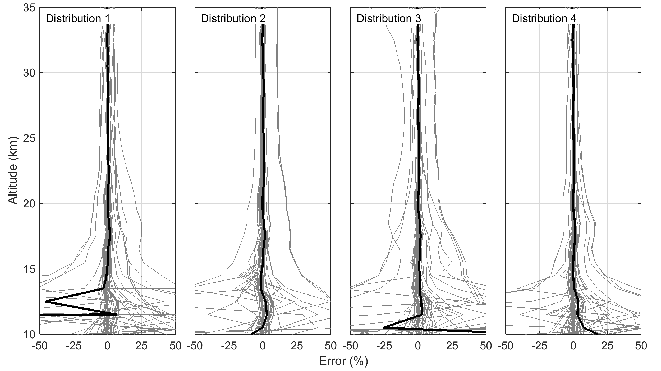

**Figure 4-6:** Percent differences of the retrieved aerosol profiles for the scalar retrieval versus the vector retrieval. Each column represents a different particle size distribution and the labels can be cross referenced in Table 4-1.

Aerosol profiles were retrieved using an assumed particle size distribution, in this case a log-normal with a mode radius and width of 0.08 µm and 1.6 respectively, which was different in all case than the “true” state used to simulate the measurements. The comparison between the retrieval results at 750 nm for simulations of all three polarization states is shown in Figure 4-7. It should be noted that geometries with SSA of 90o have been removed for the vertical polarization due to the low values of overall signal, which creates a large dependency on the particle size distribution and a biased retrieval. However, geometries with a SSA of 85o or 95o almost eliminates the bias seen at the 90o scattering angle and it is completely eliminated once the scattering angle is less than 80o or greater than 100o.

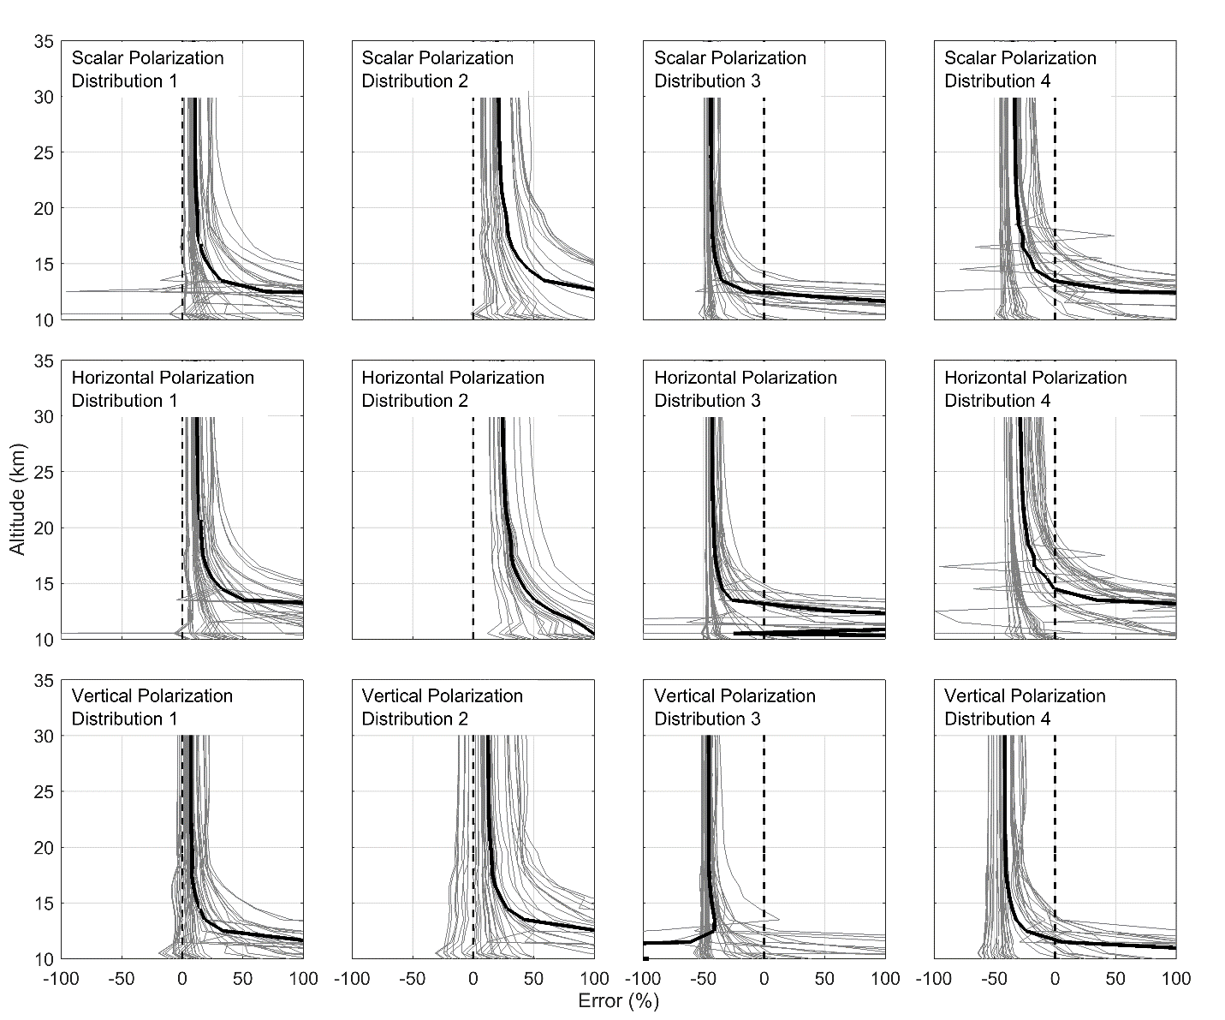

**Figure 4-7:** The retrieved aerosol profiles for each unique combination of geometry and aerosol profile are compared again the known original states. The plots are separated into 12 cases. The four columns represent the four particle size distributions used for the analysis as listed in Table 4-1. From the top to bottom row are the scalar, horizontal, and the vertical polarization.

Each of the four size distributions were used to simulate the measurements for the retrieval in order to test for any persistent biases in the various polarization cases. Recall that in all cases, the retrieval assumes a constant size single mode size distribution that does not match any of the four size distributions used to simulate the measurements. For particle size distribution 1 (see Table 4-1), retrieved aerosol extinction profiles are too large. For scalar, horizontal, and vertical polarizations had mean offsets of 9-13%, 12-17%, and 6-8% respectively from 17 to 35 km. Particle size distribution 2 shows a larger mean offset that also has a higher variance. The mean offset for distribution two are 20-28%, 24-31%, and 12-16% for the same polarizations from 17 to 35 km. For distributions 3 and 4, similar variances are noted between the similar fine modes but the aerosol extinction retrieved is now much smaller than that true extinction state for all three polarizations. For distributions 3 and 4, the mean offsets were -42-44%, -40-43%, and -45-46% and -26-33%, -22-29%, and -38-42% respectively for the same polarization ordering. Furthermore, as wavelength increases an approximately 3-5% decrease in offset is observed for the retrieved aerosol profiles for each polarization. Current satellite instruments only agree to each other within 20-30% and using the above trends, accurate aerosol retrievals could be obtained for atmospheric states where only a fine mode exists. However, when a coarse mode is present in the true state, the retrieval significantly underestimates the amount of aerosol in the atmosphere.

Overall, both horizontal and vertical linear polarizations retrieve similarly accurate aerosol profiles when compared to the scalar case using an assumed particle size distribution. For fine mode cases the extinction retrievals are generally too large but only differ from the true state on average by 12-30% for the horizontal polarization and 12-17% for the vertical polarization. For a volcanic particle size distributions (case 3 and 4) the aerosol extinction retrieved is much too small, up to approximately 45% for both polarizations. However these result are similar to the scalar case.

## 4.4.3 Precision analysis

Using SASKTRAN-HR, the Jacobians for all the retrieved aerosol profiles were calculated and inverted to determine the gain matrices. These were used as shown in in Equation 4.8 to determine the retrieval precision. It should be noted that not all of the Jacobians could be inverted due to negative sensitivity of the lower tangent altitudes (*Bourassa et al., 2007*) and these were removed from the data set (approximately 9% of total cases).

A value of 1% was chosen for uncertainty in the measurement vector. This is similar to the measurement uncertainty of the OSIRIS instrument at the aerosol retrieval wavelengths and tangent altitudes. The same uncertainty was selected no matter the polarization or geometry. This allows for the determination of the absolute change in precision for an instrument with the same measurement uncertainty no matter the polarization state measured or the instrument sensitivities have been compensated for each polarization to observe the same quantity of incoming radiance. The measurement vector used in the aerosol extinction retrieval uses the logarithmic ratio of the retrieval altitude or tangent altitude over a high altitude reference radiance where there is little aerosol contribution. This leads to the diagonal values of the covariance matrix, , of 0.2% since they consist of the uncertainty in the tangent altitude radiance of the measurement and the uncertainty of the high altitude reference radiance. The cross terms of the covariance matrix are 0.1%, which represents the uncertainty in the normalization altitude. For each parameter listed in section 4.2.3, the uncertainty in the retrieved radiance was determined. This uncertainty, stated as a percent error, was used to determine the standard deviation and mean for each polarization and input parameter. However, the 500 nm wavelength was removed from the analysis since the addition of noise to the measurement resulted in reducing the aerosol sensitivity to a point where aerosol cannot be reliably determined. This is not surprising as the sensitivity to aerosol at this short wavelength is very small (*Bourassa et al., 2007*). The remaining profiles were used to determine the percent error at each altitude and each linear polarization was compared to the scalar case. The analysis was performed for the SSA, SZA, albedo, extinction type, fine mode type, percentage of coarse mode, and wavelength.

Two primary results were noted. First, the vertical polarization shows a an improvement in uncertainty of on average 5-10% for forward scattering cases across altitudes from 15 to 29 km that decreases as altitude increases. For backscatter cases the linear polarizations yields the same percent error as the scalar case with a maximum relative percent difference of 2%. This can be seen in Figure 4-8. The other major note is the change of relative error with wavelength. At 750 nm the vertical polarization sees a 30% relative improvement over the base case at 16 km and gradually decreases to a 20% improvement at 28 km. For 1000 and 1250 nm the vertical polarizations and scalar once again have very similar percent errors and at 1500 nm about a 5% worse relative uncertainty is seen at the lower altitudes but reaches par with the scalar case at approximately 20 km. For the horizontal case the same magnitude but opposite effects occurs for the precision and can be seen in Figure 4-9. The other parameters tested (i.e. albedo, SZA, etc.) do not show a significance difference between the different polarizations and do not appear to have a large effect on the precision of the profiles.

As a final note if it is assumed that a constant instrument sensitivity is selected no matter the polarization, the increase in overall radiance from the horizontal polarization would result in a higher precision measurement compared to the vertical case. However, in this scenario the horizontal polarization would have a percent error on the aerosol profile of approximately half compared to the vertical polarization which would vary depending on the aerosol extinction profile and the viewing geometry.

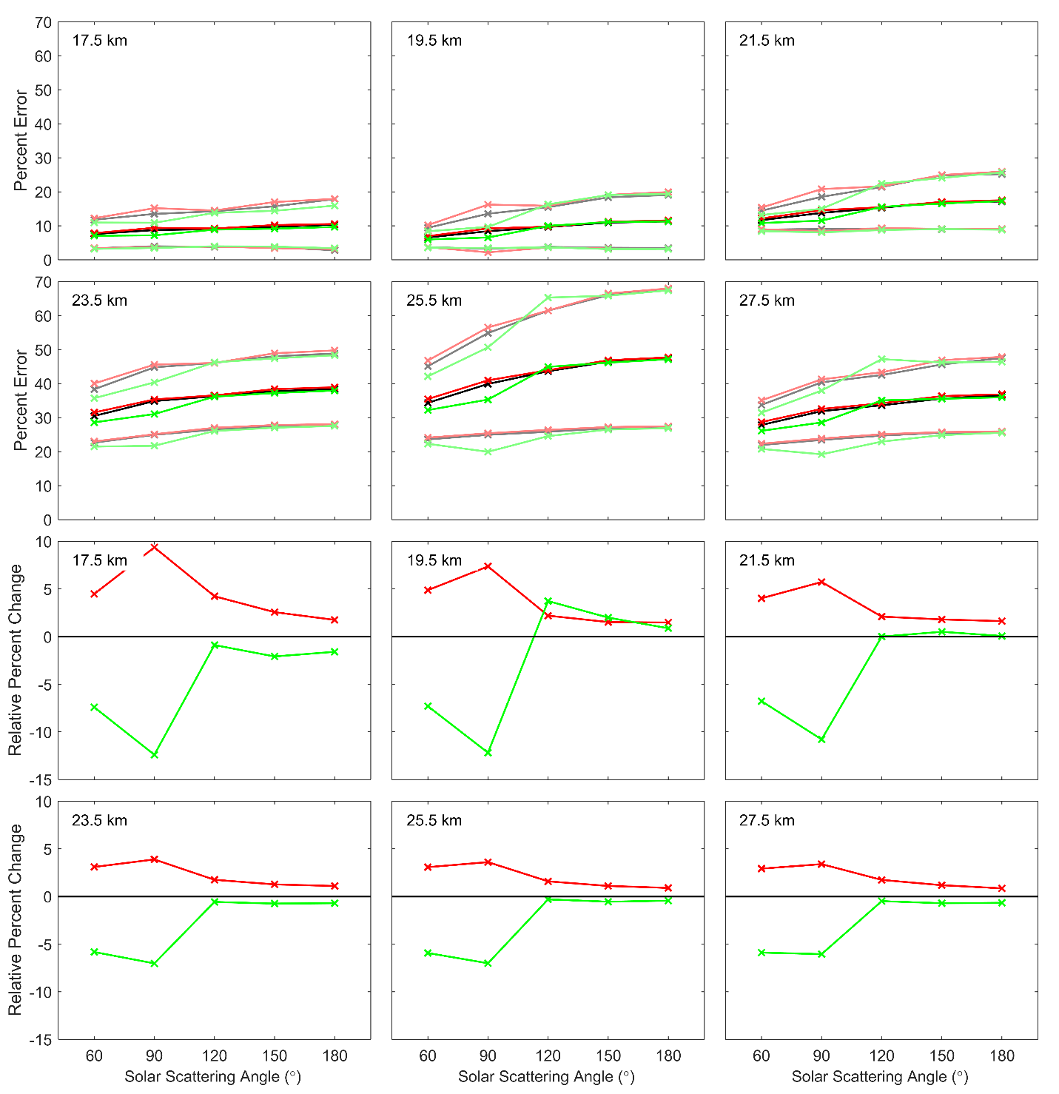

**Figure 4-8:** The top six panels show the mean percent error with the standard deviation for each polarization depending on the SSA. The bottom six panels show the relative change is the percent error from the scalar case. The black, red, and green curves represent the scalar, horizontal and vertical polarization respectively.

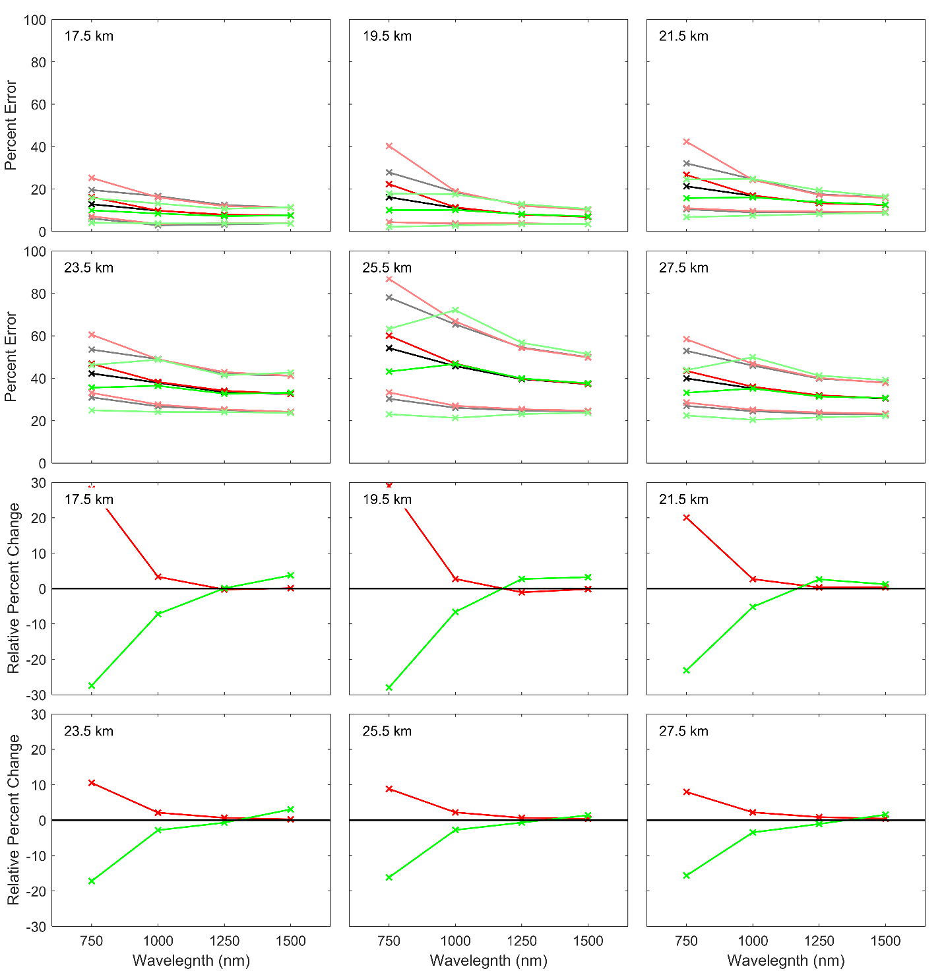

**Figure 4-9:** Similar to Figure 4-8 except the comparison is to wavelength instead of SSA.

# 4.5 Conclusions

Overall choice for a polarized instrument that can only measure one polarization focused at retrieving high quality aerosol products is not a simple answer and depends on several parameters. The overall best situation would be an instrument that measures forward scattered light with vertical polarization with compensated instrument sensitivities. Recall that the vertical polarization is defined as the polarization normal to the horizon. In this orientation, the radiance measurement has good sensitivity to aerosol across all altitudes greater than 13 km. However, the increased sensitivity, especially at the shorter wavelengths, falls off quite rapidly as a SSA of 90o is reached and then increases again for SSA to 180o. This instrument would also yield the best precision possible but it has two disadvantages. First, assuming a particle size distribution scattering angles close to 90o contain a large bias in the retrieved aerosol extinction compared to the scalar case and true state. Second, a large loss of the overall signal occurs from measuring the vertical polarization, up to 70% which would require a large increase in instrument sensitivity compared to the scalar case. Depending on instrument specifications, the required increase in sensitivity may result in unacceptably instrument parameters.

If more signal is required or the orbit will result in a high percent of measurements around SSAs of 90o, the horizontal polarization should be used. However, the preference would be for forward scatter at the longer wavelengths since a loss of aerosol signal occurs at shorter wavelengths. This would result in the highest possible aerosol signal in the radiance. Furthermore, a maximum of loss of signal would only be 42% which is considerably better than the vertical polarized case.

As a final note, the agreement between the scalar and vector SASKTRAN-HR model are generally within 2% of each other for the aerosol retrievals. It is promising that the inclusion of polarization in the model does not cause a large change to the retrieved profiles since the use of the vector model would result in an approximate doubling in processing time.