CHAPTER 2

BACKGROUND

# 2.1 Stratospheric Aerosol

The atmosphere of earth is a complex and complicated system and is effected by the human activities. In the late 18th century it was known that atmospheric temperature decreased with altitude and a theory had been raised that at specific certain altitude the temperature must eventually go to absolute zero. This lead to a series of balloon campaigns to discover this mysterious altitude in the atmosphere which were noisy unreliable due to the technology available. However in the late 19th the technology used in these sounding balloon had improved to a point where the atmospheric temperature could be accurately measured and it was found that at approximately 12 km an inversion point was discovered where the temperature started to increase and thus the tropopause, which separates troposphere and the stratosphere, was discovered (*Hoinka*, 1997). The stratosphere is the region of the atmosphere above the temperature inversion of the troposphere, where atmospheric temperature increases and the lower bound of the stratosphere is in-between 10 and 16 km from the high latitude to the tropics (*Andrews*, 1987). The stratosphere which extends up to approximately 50 km is thermodynamically stable and fairly dry (*Boucher*, 2015). The characteristic stability of the region limits vertical transport of the stratosphere results in long lifetimes, spanning from months to years, for non-volatile species (*Volk et al,* 1997; *Brasseur and Solomon*, 2005)

The stratosphere undergoes exchange of air with the troposphere though a series of dynamical processes including tropical convection, the polar vortex, and tropopause folding (*Holton et al.,* 1995) and circulation within the stratosphere is dominated by the slow Brewer-Dobson circulation (*Plumb and Eluszkiewicz*, 1999). Some chemicals can cross the tropopause thermal barrier into the stratosphere which allows for chemicals reactions to occur. One such reaction forms stratospheric sulfate aerosol, discovered by *Junge et al* (1961) though stratospheric balloon sondes, which are droplets hydrated sulfuric acid (H­2­SO­4) formed from the oxidation of sulfate compounds, primary OCS and SO2 (*Brock et al.*, 1995). This aerosol layer stability exists in the stratosphere from altitude from the tropopause to approximately 30 km.

## 2.1.1 Aerosol Sources and Microphysics

The sources for sulfate aerosol are primarily produced in the troposphere and formed though both natural and anthropogenic processes. One primary source of this sulfur is OCS which originates from marine processes, biomass burnings, and industry (*Kettle et al.*, 2002; *Notholt et al.*, 2003). OCS has a long lifetimes in the troposphere and low solubility allowing for significant portion of to reach there stratosphere and there some of it oxidizes and hydrates to form sulfate aerosol (H2SO4) and form add to the background aerosol layer (*Crutzen*, 1976).

Another source of sulfur is SO2 and one source originates in the troposphere though industry form the burning of fossil fuels. Sulfur dioxide (SO2) has a short lifetime and its concentration various regionally (*Thomason and Peter*, 2006) which also hydrates into sulfate aerosol. A second source of SO2 is from volcanic eruptions which is highly variable in location and time and can insert a large amount of sulfur directly into the atmosphere. The sulfur amounts that can be injected by volcanos can be so large they in fact dominate the stratospheric aerosol layer perturbing from the background levels. Examples of this perturbation of the aerosol layer were noted during the volcanic eruptions of El Chichon in 1982 (12-20 Tg of sulfur) (*McCormick and Swissler*, 1983; *Hofmann and Rosen*, 1983) or Mount Pinatubo in 1991 (20-30 Tg of sulfur) (*McCormick and Veiga*, 1992). However, after the Mount Pinatubo eruption a volcanically quiescent period occurred where aerosol layers returned to background. Following a series of smaller volcanic eruptions have increased the background aerosol layer in the amount of 4-7% per year from 2000 to 2009 (*Vernier et al.*, 2011).

These sulfur sources undergo a series of reactions to be conversion into H2SO­4 and have been found to form droplets of aerosol that consists of approximately 25% H2O and 75% H2SO4 (*Rossen*, 1971; Wang *et al.*, 1989). These aerosol particles form droplets of various sizes that undergo that grow to various sizes on the order of 0.05 to 1.0 µm depending on the processes of nucleation, evaporation and condensation that is underwent (*Junge et al.* 1961; *Brock et al.*, 1995; *Bingen et al.*, 2004). A log-normal distribution generally describes the particle size of aerosol in the form of

|  |  |
| --- | --- |
| $$\frac{dn\left(r\right)}{dr}=\frac{n_{0}}{rln\left(σ_{g}\right){\left(2π\right)}^{1/2}}exp\left(-\frac{\ln^{2}{(r/r_{g})}}{2\ln^{2}{(σ_{g})}} \right)$$ | (2.1) |

where $n_{0}$ is the aerosol number density, $r_{g}$ is the mode radius, and $σ_{g}$ is the mode width (*Jäger and Hofmann,* 1991; *Hamill et al.* 1997). The particles are distributed in a normally over the logarithm of the radius. To fully describe aerosol for a single log-normal distribution the number density, mode radius and mode width is required and for a non-volcanic background aerosol layer an approximate mode radius and mode width of 0.08 µm and 1.6 respectively have been determined (*Thomason*, 1991).

Optical particle counter have been used on board Laramie, Wyoming over the past 40 years to measure particle sizes in bin in between 0.15 to 2.0 µm. The composition of the particle size distributions have been primarily unimodal, known as a fine mode, over non-volcanic periods and can be used as an acceptable distribution approximation during background periods. But during volcanic episodes a bimodal log-normal distribution of aerosol particles is more representative of the stratospheric aerosols with the addition of a coarse mode (*Deshler et al.*, 2003; 2008; *Kovilakam et al.*, 2015). The coarse mode has larger particles than the fine mode and complicates determining full aerosol microphysical parameters since the number of required has increased to five: a number density, two mode radii, and two mode widths.

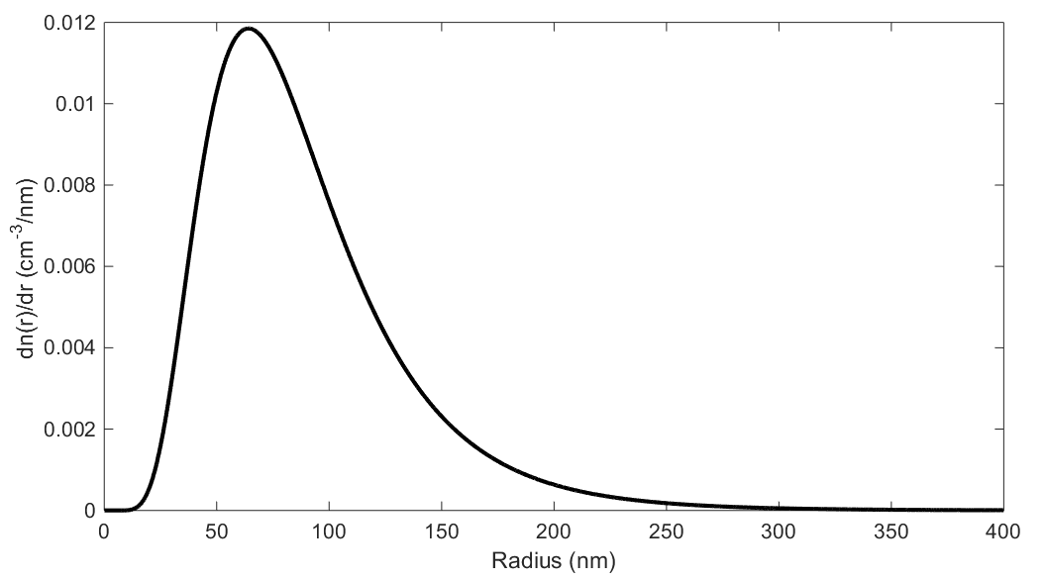

**Figure 2-1**: Log-normal distribution for non-volcanic background aerosol layer.

## 2.1.2 Climate Effects

Test

# 2.2 Aerosol Measurements

Test

## 2.2.1 Ground based and in-situ

Test

## 2.2.2 Occultation

Test

## 2.2.3 Lidar

Test

## 2.2.4 Limb Scatter

Test

# 2.3 Requirement for Higher Spatial Resolution

Test

# 2.4 ALI Prototype and Stratospheric Balloon Flight

Test.