CHAPTER 3

Optical Design and Calibration

This chapter will discuss ALI from the initial planning to a completed system then calibration and testing of the system. First a discussion of the Acousto-Optical Tunable Filter (AOTF) will be discussed with theory and then calibration with the specific AOTF used in ALI. With the completed characterization of AOTF discussion will occur of the two primary optical layout considered for the instrument with the final design and optical specifications. Finally the system will be tested as a whole and an outline of addition component and will be address as well as a full system test.

# 3.1 AOTF

The fundamental piece of technology that allows for the building of ALI is an Acousto-Optical Tunable Filter (AOTF) which allows a signal to be passed through a band gap wavelength filter. The use of AOTF technology for space based initiatives is only recently possible due the recent advances in creating AOTFs with the ability to maintain imaging qualities over a wide acceptance angles. This section will discuss the theory behind the AOTF as well as the calibration and testing of the specific AOTF used for the ALI instrument.

## 3.1.1 Background and Theory

An AOTF is a device that through phonon-phonon interactions and Bragg diffraction allows a broadband light source to be filtered into a spectral image. Two primary types of AOTF's exists, a collinear (*i.e.* the acoustic wave is aligned with the incident beam, (*Harris and Wallace*, 1969)) and a non-collinear (*i.e.* the acoustic wave and the optical beam do not propagate collinearly in the crystal, (*Chang*, 1977)) configurations and both use an optically anisotropic medium (*Saito and Yano*, 1976). An anisotropic medium is a material that is transparent and has a different index of refraction based upon the polarization of the incoming light and its propagation direction, commonly called birefringence. In order to fully understand the principles behind an AOTF two methods shall be used, first a stress analysis through the acousto-wave and a second by the required diffraction momentum matching criteria. A piezo-electric transducer is attached to a face of the anisotropic crystal that allows a Radio Frequency (RF) to be passed into the crystal which affects permittivity. This causes an acoustic wave to be formed within the crystal, essentially forming a pressure wave throughout the entire crystal. If we assume that the pressure wave causes a stress throughout the crystal then a modulation of the permittivity or dielectric constant will occur as,

|  |  |
| --- | --- |
|  | (3.1) |

Where is the new permittivity due to the the pressure wave, is the original permittivity, and is the perturbation component of the permittivity due to the stress wave. The frequency and wave vector of the acoustic wave are and respectively. The primary terms in the acoustic waves are related as follows

|  |  |
| --- | --- |
|  | (3.2) |

where is the wavelength of the acoustic wave and is the frequency with being the respective velocity in the birefringent material. Since the permittivity is now a function of time and space an analysis must be done by Maxwell's equations to determine the form of the interacted electric field, to determine if a plane wave can still be assumed.

|  |  |
| --- | --- |
|  | (3.3) |
|  | (3.4) |

The curl of the equation 3.3 and equation 3.4 can be combined with the fact that the AOTF crystal is non-conductive; therefore which gives the simplified form

|  |  |
| --- | --- |
|  | (3.5) |

Given that the divergence of the dielectric displacement is zero and the permittivity varies with space, the following relation can be found for the divergence of the electric field.

|  |  |
| --- | --- |
|  | (3.6) |

The above can be inserted into equation 3.5 to give the following relation

|  |  |
| --- | --- |
|  | (3.7) |

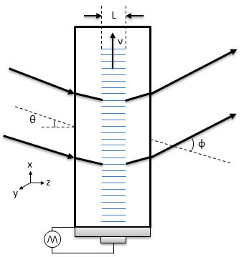

**Figure 3-2**: A standard non-collinear AOTF experiential set up. The crystal is assumed to infinitely long in the y direction. Figure recreated after *Guenther* (1990) number 14B-1.

However, the simplified divergence term can be shown to be on the order of which is small and therefore can be neglected leaving the following differential equation:

|  |  |
| --- | --- |
|  | (3.8) |

The above differential equation allows for a plane wave to be used for the outgoing light as the interaction does not greatly affect the form of the outbound electric field. A standard acousto-optical experiment is shown in Figure 3-1. The acoustic wave is propagating in the x direction of the crystal causing the described stress which leads to the modulation of the index of refraction within the acoustic region of the crystal denoted by . The light is incident at an angle with respect to the normal of the crystal surface and the electric field entering the device will be a plane wave described by

|  |  |
| --- | --- |
|  | (3.9) |

The incoming electric field is modulated by the acoustic wave propagating through the crystal. Since the acoustic wave is periodic, it can expanded into the following Fourier series of a plane wave though the acoustic interaction, which gives the diffracted electric field .

|  |  |
| --- | --- |
|  | (3.10) |

It should be noted that the frequency of the th order diffracted light is now Doppler shifted and has become , however for an AOTF experiencing Bragg diffraction only the first term of the acousto interaction diffracts causing to be small compared to so a negligible shift in the wavelength of the diffracted beam occurs. Bragg Diffraction occurs when the active region of the acoustic wave, , is much larger than the diffracted wavelength, causing the stress wave in the crystal to act as a thick diffraction grating. The above also tells us the x component of the wave vector for the th order is

|  |  |
| --- | --- |
|  | (3.11) |

where is the wave vector of the th order of diffracted beam, the angle is between the incident beam and the diffracted beam. The magnitude of the diffracted wave vector is

|  |  |
| --- | --- |
|  | (3.12) |

and combining the results from equation 3.11 and equation 3.12 the angular deviation of the diffracted source is

|  |  |
| --- | --- |
|  | (3.13) |

Now it can be seen that the diffracted light will leave the AOTF at a different angle depending on the RF frequency which in turn alters the wavelength of light that leaves the device. In order for the device to be usable in an imaging optical system the diffracted light must always leave the device following the same path no matter what wavelength is being filter. Thus a crystal wedge or compensator is attached to the back of the device to compensate for this effect causing the diffracted beam to always leave at the same angle. A general optical layout with the deflection in the optical path and an attached compensating wedge is shown in Figure 3-2.

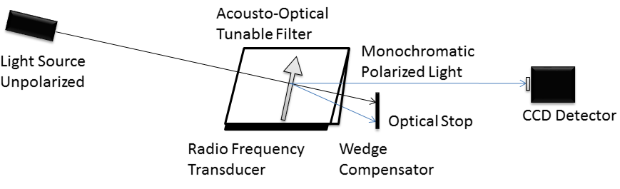

**Figure 3-3**: General Layout of an Acousto-Optical Tunable Filter. A randomly polarized incoming light source hits the front surface of the birefringent crystal. The black bar below the crystal is the piezo-electric transducer that produces the RF signal and forms the acousto wave represented by the grey arrow. The momentum matching Bragg diffraction occurs and monochromatic polarized light (+1 order) exits the AOTF at a constant angle with the 0th order and -1 order being blocked by an optical stop.

In order for the AOTF to allow the filtering of a specific wavelength a momentum matching criteria must be held where the wave vectors of the acoustic wave match the difference of the incoming and diffracted light wave vectors. This condition is described by

|  |  |
| --- | --- |
|  | (3.14) |

where and are the wave vectors for the incoming and diffracted light and is the acoustic wave vector. These wave vectors can be described by

|  |  |
| --- | --- |
|  | (3.15) |
|  | (3.16) |
|  | (3.17) |

where and are the indices of refraction of incoming and diffracted light. Finally is the wavelength of light in a vacuum. It will be assumed that the extraordinary light is undergoes the momentum matching through the device. This causes the above refractive indices defined above to be

|  |  |
| --- | --- |
|  | (3.18) |
|  | (3.19) |

where and are the indices of refraction for the extraordinary and ordinary polarizations of the incoming light and is the cut angle relative to the piezoelectric transducer and the optical axis. For a crystal, like TeO2, the difference in the index of refraction is small and can be approximated as (*Voloshinov et al*., 2007)

|  |  |
| --- | --- |
|  | (3.20) |

where is the difference between the extraordinary and ordinary indices of refraction (*i.e.* ). The wave vectors, seen in Figure 3-3, of the system need to follow the momentum matching criteria from equation 3.14. Separating the wave vectors into their directional components with respect to the cut angle, , the tangential and perpendicular directions respectively are

|  |  |
| --- | --- |
|  | (3.21) |
|  | (3.22) |

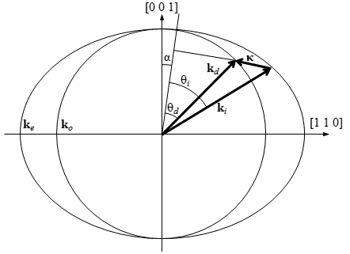

**Figure 3-4**: The wave vectors generated by the AOTF experiment set up in Figure 3-1. From the above figure and are the wave vectors of the extraordinary and ordinary axis of the AOTF crystal. The cut angel, , is the cut angle form the optional axis to the piezoelectric transducer.

The tangential direction of the wave vector does not give any helpful information however the wavelength and RF relation can be determined by the perpendicular component of the wave vector by combining equation 3.22 and the vector diagram seen in Figure 3-3 to get

|  |  |
| --- | --- |
|  | (3.23) |

It should be noted that for the geometry defined the incident angle is the same as the Bragg angle. The above can be written as

|  |  |
| --- | --- |
|  | (3.24) |

assuming difference in indices of refraction is small and the Taylor expansion approximation of the square root is used (*Voloshinov and Mosquera*, 2006). Also, through the described interaction the diffracted light goes though a 90o rotation in polarization (*Voloshinov*, 1996). Lastly, a wide aperture is required for an AOTF used for imaging purposes. These devices have been developed (*Gass and Sambles*, 1991) and are currently readily available for imaging purposes.

## 3.1.2 Calibration and Testing

Test Test Test