CHAPTER 4

AEROSOL SENSITIVITY TO POLARIZATION

# 4.1 Introduction

Recent studies have proposed a so called global warming hiatus due to an increase in the background stratospheric sulfate aerosol layer. (*Solomon et al.*, 2011; *Haywood et al.*, 2014; *Fyfe et al.*, 2013). The increase in stratospheric aerosol over the last decade is believed to be caused by a series of small-scale tropical volcanos (*Hofmann et al.*, 2009). Stratospheric aerosols cause a cooling effect by scattering incoming irradiance and has an important radiative effect on the climate of the planet which depends on the concentration and particle size distribution (*Kiehl and Briegleb*, 1993; *Stocker et al.*, 2013).

Aerosols have been monitored on a global scale for decades from instruments on satellites such as the SAGE missions (*Russell and McCormick*, 1989; *Thomason and Taha*, 2003), OSIRIS (*Llewellyn et al.*, 2004), SCIAMACHY (*Bovensmann et al.*, 1999), and CALIPSO (*Winker et al.*, 2007). The results have been used to create long merge time series depicting the evolution of the stratospheric aerosol layer (*Rieger et al.*, 2015; *Ridley et al.*, 2014).

OSIRIS and SCIAMACHY measure radiance from the limb and use inversion techniques to determine aerosol profiles (*Bourassa et al.*, 2012b; *Ernst et al.*, 2012). Future instruments with the capability to measure aerosol from the limb have been proposed including the Belgium instrument Atmospheric Limb Tracker for the Investigation of the Upcoming Stratosphere (ALTIUS) (*Dekemper et al.*, 2012) and the Aerosol Limb Imager (ALI), a Canadian endeavour (Elash et al., 2015 TODO: THIS NEEDS TO CHANGE). Both instruments use acousto-optic tunable filters to select the measured wavelength but can only measure a linear polarized signal, whereas previous limb scatter instruments have used scalar measurements to perform the inversion. This work will perform an analysis on simulated polarized measurements and determine which linear polarization and geometries have the largest sensitivities to aerosol, and how those polarized measurements affect the accuracy and precision of the retrieved aerosol product. Furthermore, a brief comparison between the scalar and vector models will be performed for verification of the use of the scalar model for scalar retrievals.

# 4.2 Model and Scenarios and Aerosol Sensitivity

In order to compare the effect of polarization on the sensitivity to aerosol, one must be able to accurately model polarized radiance. Additionally, a large number of scenarios are required with different atmospheric states and geometries to fully probe the solution space. In this section, the SASKTRAN-HR model used for the analysis with be discussed as well as aerosol scenarios used for the study.

## 4.2.1 SASKTRAN-HR model

TODO: Change this. I figured I would ask Seth to write this portion as they know the details better than I do.

## 4.2.2 Aerosol Scenarios

The variety of plausible aerosol profiles within the atmosphere are vast and cannot be completely covered due to the vast range of particle size distributions and possible concentrations which affect their importance in radiative forcing. Furthermore, with the limb scatter technique, the geometry of the measurement also can have a large effect on the sensitivity of the measurement to aerosol. To probe a large portion of this space, a series of scenarios were derived.

**Table 4-1:** Different particle size distributions used to test the sensitivity of the aerosol retrieval.

|  |  |  |  |  |  |
| --- | --- | --- | --- | --- | --- |
| Particle size distributions | Fine mode radius (µm) | Fine mode width | Coarse mode radius (µm) | Coarse mode width | Percent extinction coarse mode (%) |
| 1 | 0.04 | 1.8 | -- | -- | 0 |
| 2 | 0.12 | 1.25 | -- | -- | 0 |
| 3 | 0.04 | 1.8 | 0.30 | 1.15 | 50 |
| 4 | 0.12 | 1.25 | 0.30 | 1.15 | 50 |

To probe the aerosol space, two profiles and four particle size distributions were used. The two profiles are a background aerosol extinction profile, typical used during the volcanically quiet period starting in 1997, and the second profile, which is a representative volcanic profile after the Nabro eruption in 2012 with a higher sulfur injection from the eruption at approximately 20 km. Both profiles can be observed in Figure 4-1. A log-normal particle size distribution was selected with two fine modes and one coarse mode, which can be seen in Table 4-1. The aerosol profile could either completely consist of only one of the fine mode or a mix of 50% fine mode and 50% coarse mode. The fine modes are representations of two background aerosol particle size distributions and the coarse mode is a representation of the effect of a volcanic eruption on the size of the aerosol droplets (Deshler et al, 2003). For the albedo, a value of 0 and 1 were used to determine how ground reflectance effects aerosol sensitivity on polarization measurements.

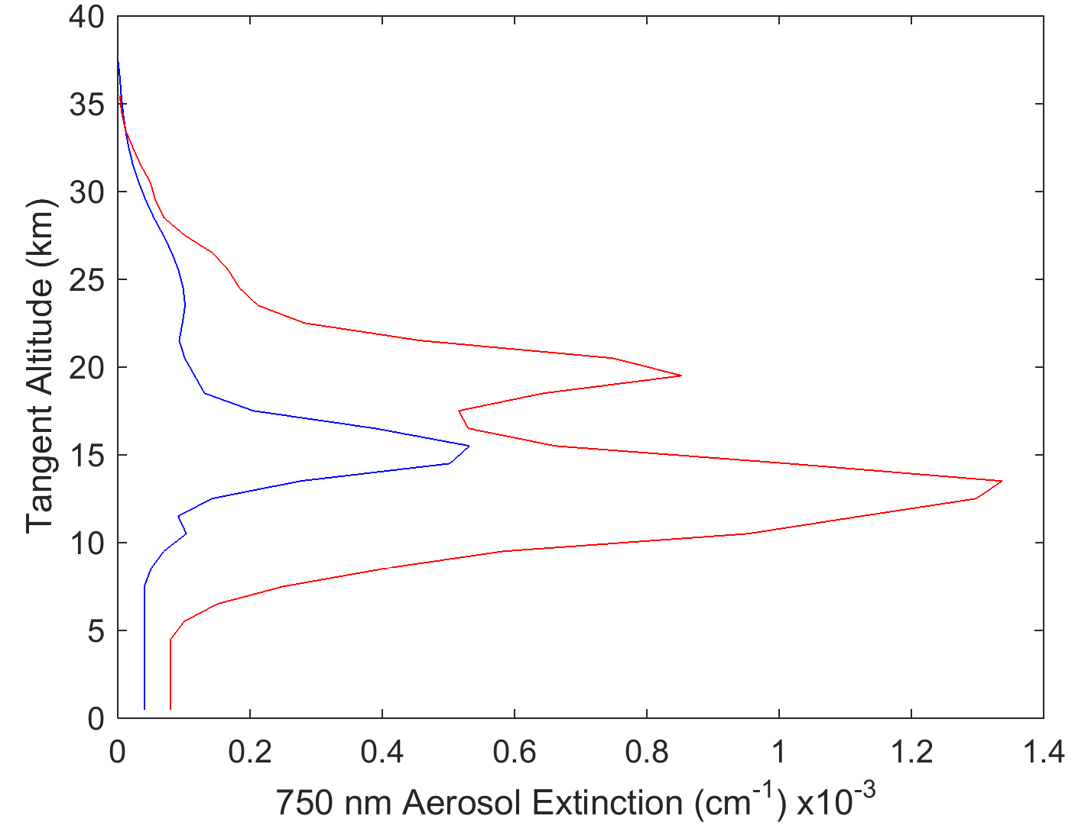

**Figure 4-1:** The two aerosol profiles used in this study. The blue is a background aerosol extinction levels, and the red curve is a representative aerosol profile after the Nabro eruption.

To probe the entire geometry, a range of Solar Zenith Angles (SZAs) and Solar Scattering Angles (SSA) were selected. The ranges were selected to give representative selections of all the possible geometries of a limb scatter instrument. The ranges for SZA are 15 o, 45 o, and 75o and for SSA of 30o, 60o, 90o, 120o, 150o, and 180o. And the wavelengths chosen were 500, 750, 1000, 1250, 1500 nm to cover the effect of polarized measurements for wavelengths commonly used by instruments to achieve aerosol profiles from limb instruments (i.e. OSIRIS and SCHIAMACHY aerosol products used 750 nm (*Bourassa et al.*, 2012b; *Ernst et al.*, 2012)) Furthermore, near infrared wavelengths are required to discern particle size information from limb scatter measurements so the 1000-1500 nm wavelength were also chosen (*Rieger et al.*, 2014).

## 4.2.3 Methodology

In order to limit the polarization space of this study, a linear polarized instrument will be assumed that either measures the vertical or horizontal linear polarizations. This was chosen since upcoming instruments like ALTIUS (*Dekemper et al.*, 2012) and ALI (TODO: Elash et al., 2015) use an acousto-optic tunable filter for a spectral filter which can only measure linear polarizations. So if only one linear polarization must be used to retrieve aerosol, which is the best option and how do the polarized measurements compare to the sensitivity of an instrument that measures scalar radiance. The three polarizations used will be define as the following: radiance that aligned with the horizon will be known as the horizontal polarization and radiance that is perpendicular to the horizon will be known as the vertical polarization. The third polarization used the total radiance which will be known as the scalar or unpolarised radiance; it is used as the reference case. Using the Stokes parameters, the scalar radiance is defined as I, the horizontal polarization is given by 0.5(I+Q) and the vertical polarization is given by 0.5(I-Q).

The study looks at the problem in three sections. How does the percent of the aerosol signal compare to the overall radiance for a variety geometries and aerosol profiles? How does the polarization affect the ability to retrieve aerosol from a simulated measurement using a consistent assumed particle size distribution? And how does the sensitivity effect the error on the retrieved profile? Within this section the methodology for each question will be described.

First, the modeled radiance will be compared for a series of geometries, wavelengths, and altitudes to determine the percent of the radiance that is inherent to aerosol signal. The model is run using a polarization mode that accurately models the polarized radiance for the first three orders of scatter, then the scattering events are assumed to be scalar in nature. The model is run with a nominal atmosphere that consists of molecular air, ozone, and NO2 which is kept constant, and with a variable altitude and albedo. The sensitivity was determined by calculating the nominal radiance without aerosol in the model, I_nom, and the radiance including the aerosol known as the total radiance, I_tot, and using the difference between the total radiance and nominal radiance would yield the aerosol radiance. To determine the percent of the signal that is attributed, the following formulation is used

|  |  |
| --- | --- |
| $$Percent Aerosol=\frac{I_{tot}-I_{nom}}{I_{tot}}*100\%.$$ | (4.1) |

From the percentage of aerosol parameter, it can be determined where the aerosol contributes the largest percentage of the signal. On the other hand, the loss of overall radiance will be looked at when using a polarized measurement compared to a scalar measurement to determine the required increase in exposure time for the polarized measurements.

To determine the effect of polarization on the retrieval, a retrieval method will be used similar to aerosol extinction retrieval by *Bourassa et al.* (2012b). A minor change to the algorithm is made where the measurement vector will not be normalized by a shorter wavelength since work by *Rieger et al.* (2014) has shown this decreases sensitivity to particle size distributions. For the retrievals, a simulated measurement radiance profile will be calculated using the SASKTRAN-HR model with nominal Ozone and NO2 profiles for each of the scenarios listed in section 4.2.2. The simulated measurements will be used to retrieve aerosol profiles using the multiplicative algebra reconstruction technique for all three polarization states. Additionally, a retrieval will be performed with the scalar SASKTRAN-HR model to see if there is a large discrepancy between using the scalar and the polarized model to retrieve aerosol profiles from a scalar measurement. For each aerosol retrieval, the Ozone, NO2, and albedo are set the same as in the simulated radiance except the aerosol particle size is to be set to 0.08 µm mode radius and 1.6 mode width. The assumption of an incorrect particle size is very common in current limb scatter instruments and will be used to see how the different polarizations are sensitive to particle size distributions and if this incorrect assumption greatly affects the retrieved extinctions for any of the polarizations.

Lastly, an error analysis of the revivals will be performed in order to check the precision of the retrieved aerosol profile. The method used for this analysis is one presented by *Bourassa et al.* (2012a) in which it is assumed that the Jacobian, K, times the Gain matrix, G, is approximately equal to the identity matrix so

|  |  |
| --- | --- |
| $$G≅K^{-1}.$$ | (4.2) |

With an assumed covariance on the aerosol retrieval, S_ϵ, the covariance on the aerosol profiles can be found by

|  |  |
| --- | --- |
| $$S_{aero}=GS_{ϵ}G^{T}$$ | (4.3) |

Finally, the square root of the diagonal of the aerosol covariance is taken as the final error profile. Using the results from all the cases, statistics will be used to determine trends across the input parameters to find a range of geometries which the instrument should be orientated to achieve aerosol profiles with the highest precision possible.

# 4.3 Analysis

## 4.3.1 Aerosol Sensitivity

The SASKTRAN-HR model was run for many different geometries, both aerosol profiles and all four particle size distributions. An analysis of the aerosol signal from the different cases will be analyzed in this section. The percent of the radiance that is composed of aerosol allows for larger measurement vectors in the retrievals process which generally lead to a higher sensitivity to aerosols during retrievals. Determining the geometries and polarization where the greatest aerosol signal composes the radiance can make future polarized instruments highly sensitive to aerosol.

First, contribution from aerosol was analyzed across wavelength and over a series of altitudes. The aerosol profile demonstrated in Figure 4-2 is the background aerosol profile with particle size distribution one. As expected, the percent aerosol increased as wavelengths become longer. However, as seen in Figure 4-2, which is a foreword scattering case (SZA of 45o, SSA of 60o), the percentage of the signal that is caused by the aerosol has increased in the vertical polarization whereas the horizontal polarization has less sensitivity to aerosol. It should be noted that the opposite effect is seen for a backscatter case. Another interesting feature to note is the vertical polarization reached a maximum of 70% aerosol contribution at approximately 1200 nm at 25 km then falls off as wavelengths get longer. The aerosol signal becomes monotonically stronger as wavelength increases for scalar and horizontal polarizations.

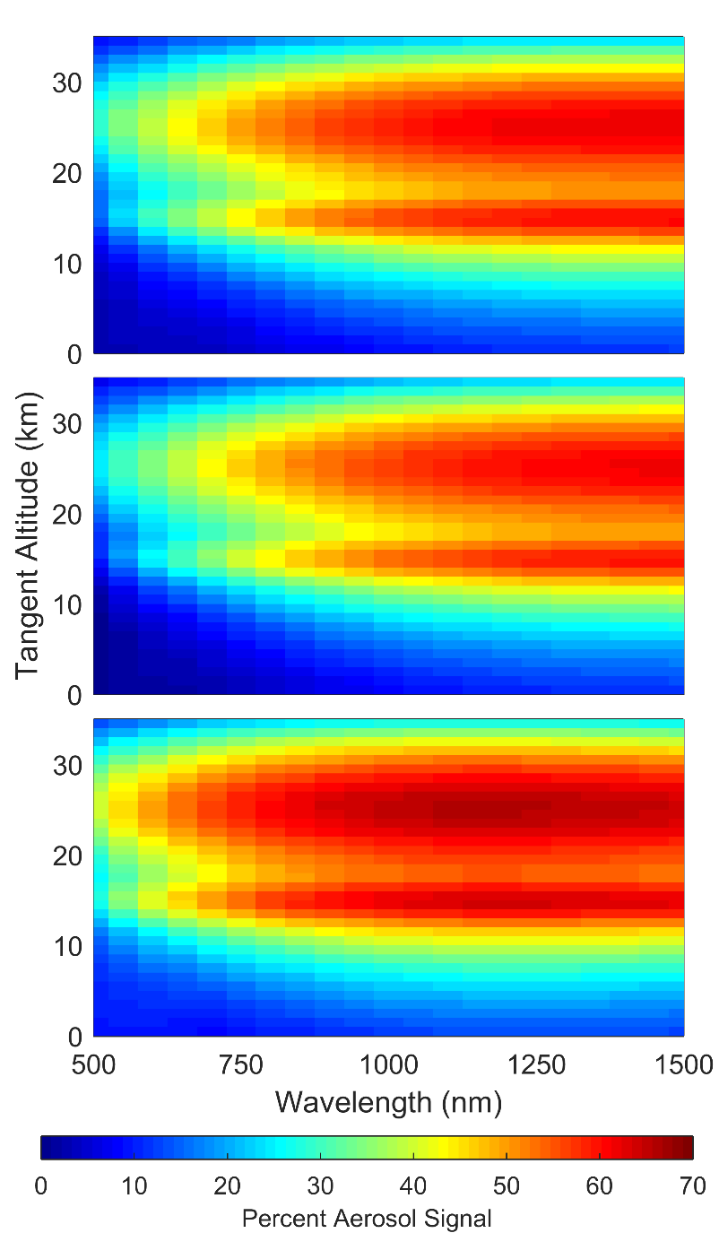

**Figure 4-2:** A computation of the percentage of aerosol signal over the total radiance for a three polarizations. The top, middle, and bottom figures are the unpolarised, horizontal, and vertical polarization respectively. The geometry for the simulation is set up with SZA of 45o and SSA of 60o with an Albedo of 0 and using the background aerosol profile.

A similar analysis was performed using a variety of geometries at a range of altitudes to assess the aerosol signal strength from different look orientations. Figure 4-3 demonstrates the percent aerosol signal for 15.5 km tangent altitude with the background aerosol loading and an albedo of zero. A sharp difference is noted between the forward and backward scattering geometries. The scar and horizontal polarization case follow a similar signal dependence, with the strongest aerosol signal composting from long wavelengths in the forward scatter direction. For the vertical polarization we see that is has a strong aerosol signal contribution for all forward scattering directions even short wavelengths, and slightly less, approximately 2-4%, but similar aerosol signal as the scalar and horizontal cases. With the vertical polarization it should be noted that modeling the radiance at a SSA of 90o is very sensitive to particle size distribution, which may make this geometry difficult to preform accurate retrievals. Finally the SZA only effects the percent of the aerosol signal by less than 0.5% no matter the geometry and is not an important consideration.

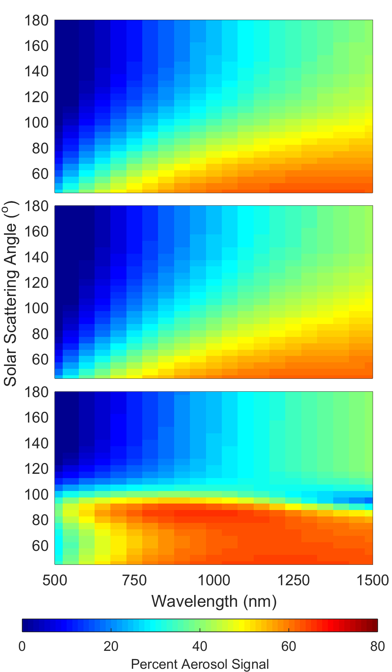

**Figure 4-3:** Similar to Figure 4-2 except the 15.5 km altitude is selected across a range of SSA.

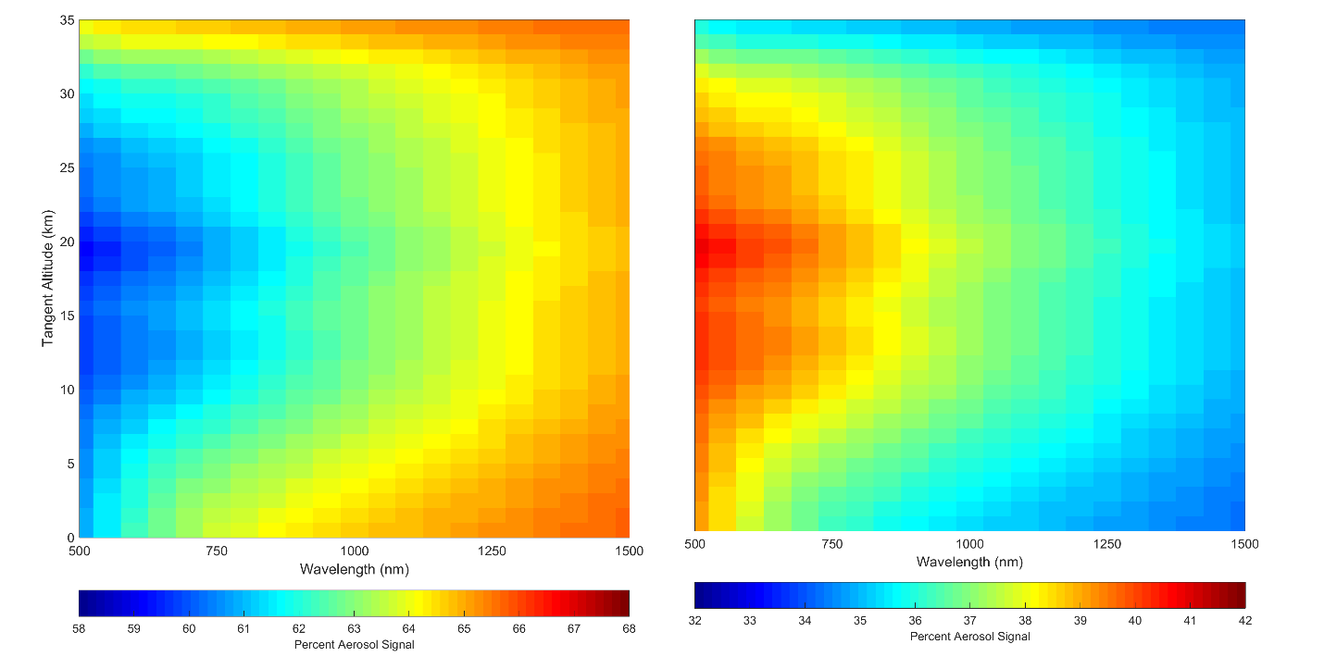

**Figure 4-4:** A percent of the linear polarized radiances over the scalar radiance, the top and bottom figures are the horizontal and vertical polarizations respectively. The radiances were calculated with a geometry of 60o SZA and 45o SSA with an albedo of 0 and using the background aerosol profile. Note that the scale for each plot are different.

The sensitivity of aerosol between horizontal and scalar radiances is approximately the same and the vertical polarization has better sensitivity in the forward scattering case than the backscatter case. However, only measuring a linear polarization results in a loss of overall radiance or signal. In Figure 4-4, the ratio of the total polarized radiance over the total scalar radiance is shown as a percentage for a SZA of 45o and SSA of 60o with a background aerosol profile. When using a horizontal polarization would result in shorter wavelengths only observing approximately 58% of the signal compared to the scalar case and at longer wavelengths this increases to approximately 66%. For the back scatter case the percentage of the measured signal increases slightly to 74% at short wavelength and 80% at long wavelengths. The loss of signal would need to be accounted for by a small increase to exposure times, a mean of approximately 30%. For the vertical polarizations however, the increased aerosol signal in the foreword scatter case is met with a loss in overall signal of up to 70% compared to the scalar case and for the backscatter case a decrease of up to 85% is observed. This is a significant loss of signal that will essentially close to double the exposure time. Depending on the expected exposure times for an optical instrument this may lead to a situation where the increases results in unacceptably times despite the increase in aerosol sensitivity.

Lastly, as the amount of aerosol in the atmosphere increases so does the percent of the signal which is attributed to aerosol. Eventually, an increase in aerosol will result in little change to the aerosol signal which limits the highest aerosol concentration that can be retrieved from a measurement. In Figure 4-5 the background aerosol profile is scaled and the percentage of aerosol signal is calculated for each scaled valued with a SZA of 45o and SSA of 60o with an albedo of zero. For the all polarizations the rate of increase of aerosol signal increases substantially until approximately 90% of the radiance signal is from aerosol where it considerably slows. At this point it is considered to be saturated which corresponds to a 0.1% increase in aerosol signal for a 0.1 increase of scale factor. For scalar and horizontal cases saturation first occurs at 25 km when the background aerosol layer is scaled by 9.4. For the vertical polarization, which had higher sensitivity to aerosol in the foreword scatter geometry we see a cap of aerosol sensitivity at 4.4 times the background aerosol layer. For a large volcanic eruptions this would limit the aerosol concentration profiles that could be retrieved from limb scatter instrument.

The vertical polarization yields significantly more aerosol signal in the foreword scattering case when compared to the horizontal polarization. However this increase in aerosol signal would result in exposure times that would be 70-85% longer than the horizontal polarization and would be not as effective as measuring aerosol during large volcanic eruptions.

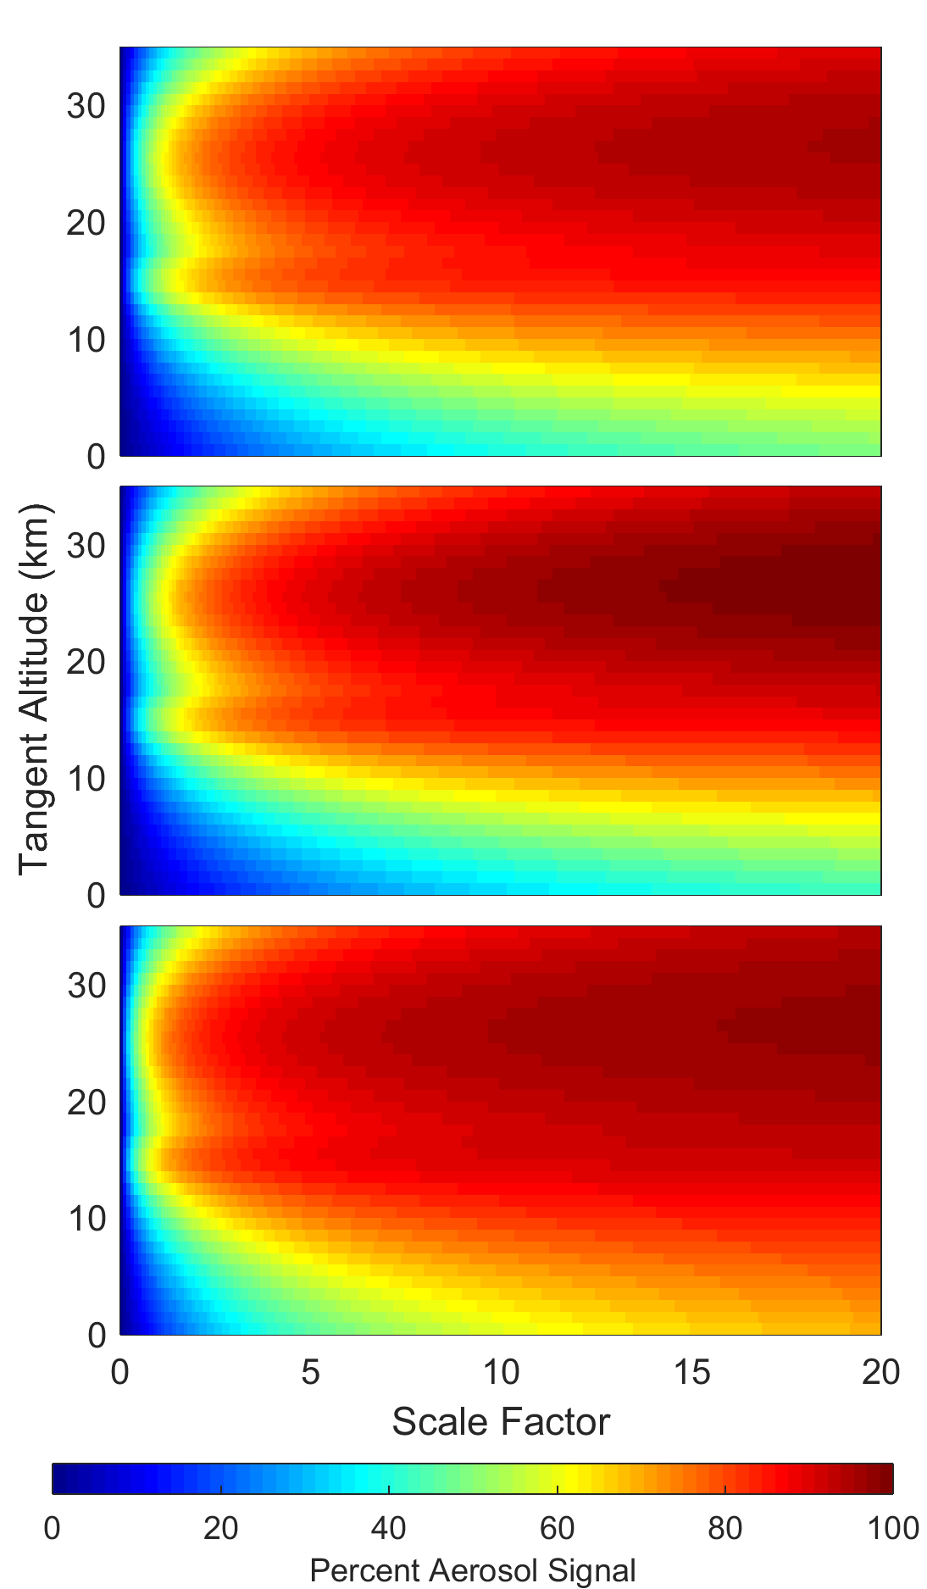

**Figure 4-5:** Similar to Figure 2 except only 750 nm wavelength is observed and the aerosol concentration has been scaled to determine where the signal saturated with aerosol.

## 4.3.2 Retrievals

Retrievals were performed for all of the wavelengths listed in section 4.2.2, however due to similarities between the retrievals of different wavelengths only the 750 nm wavelength will be focused on with comments on the other wavelengths necessary when deviations from the 750 nm case occur.

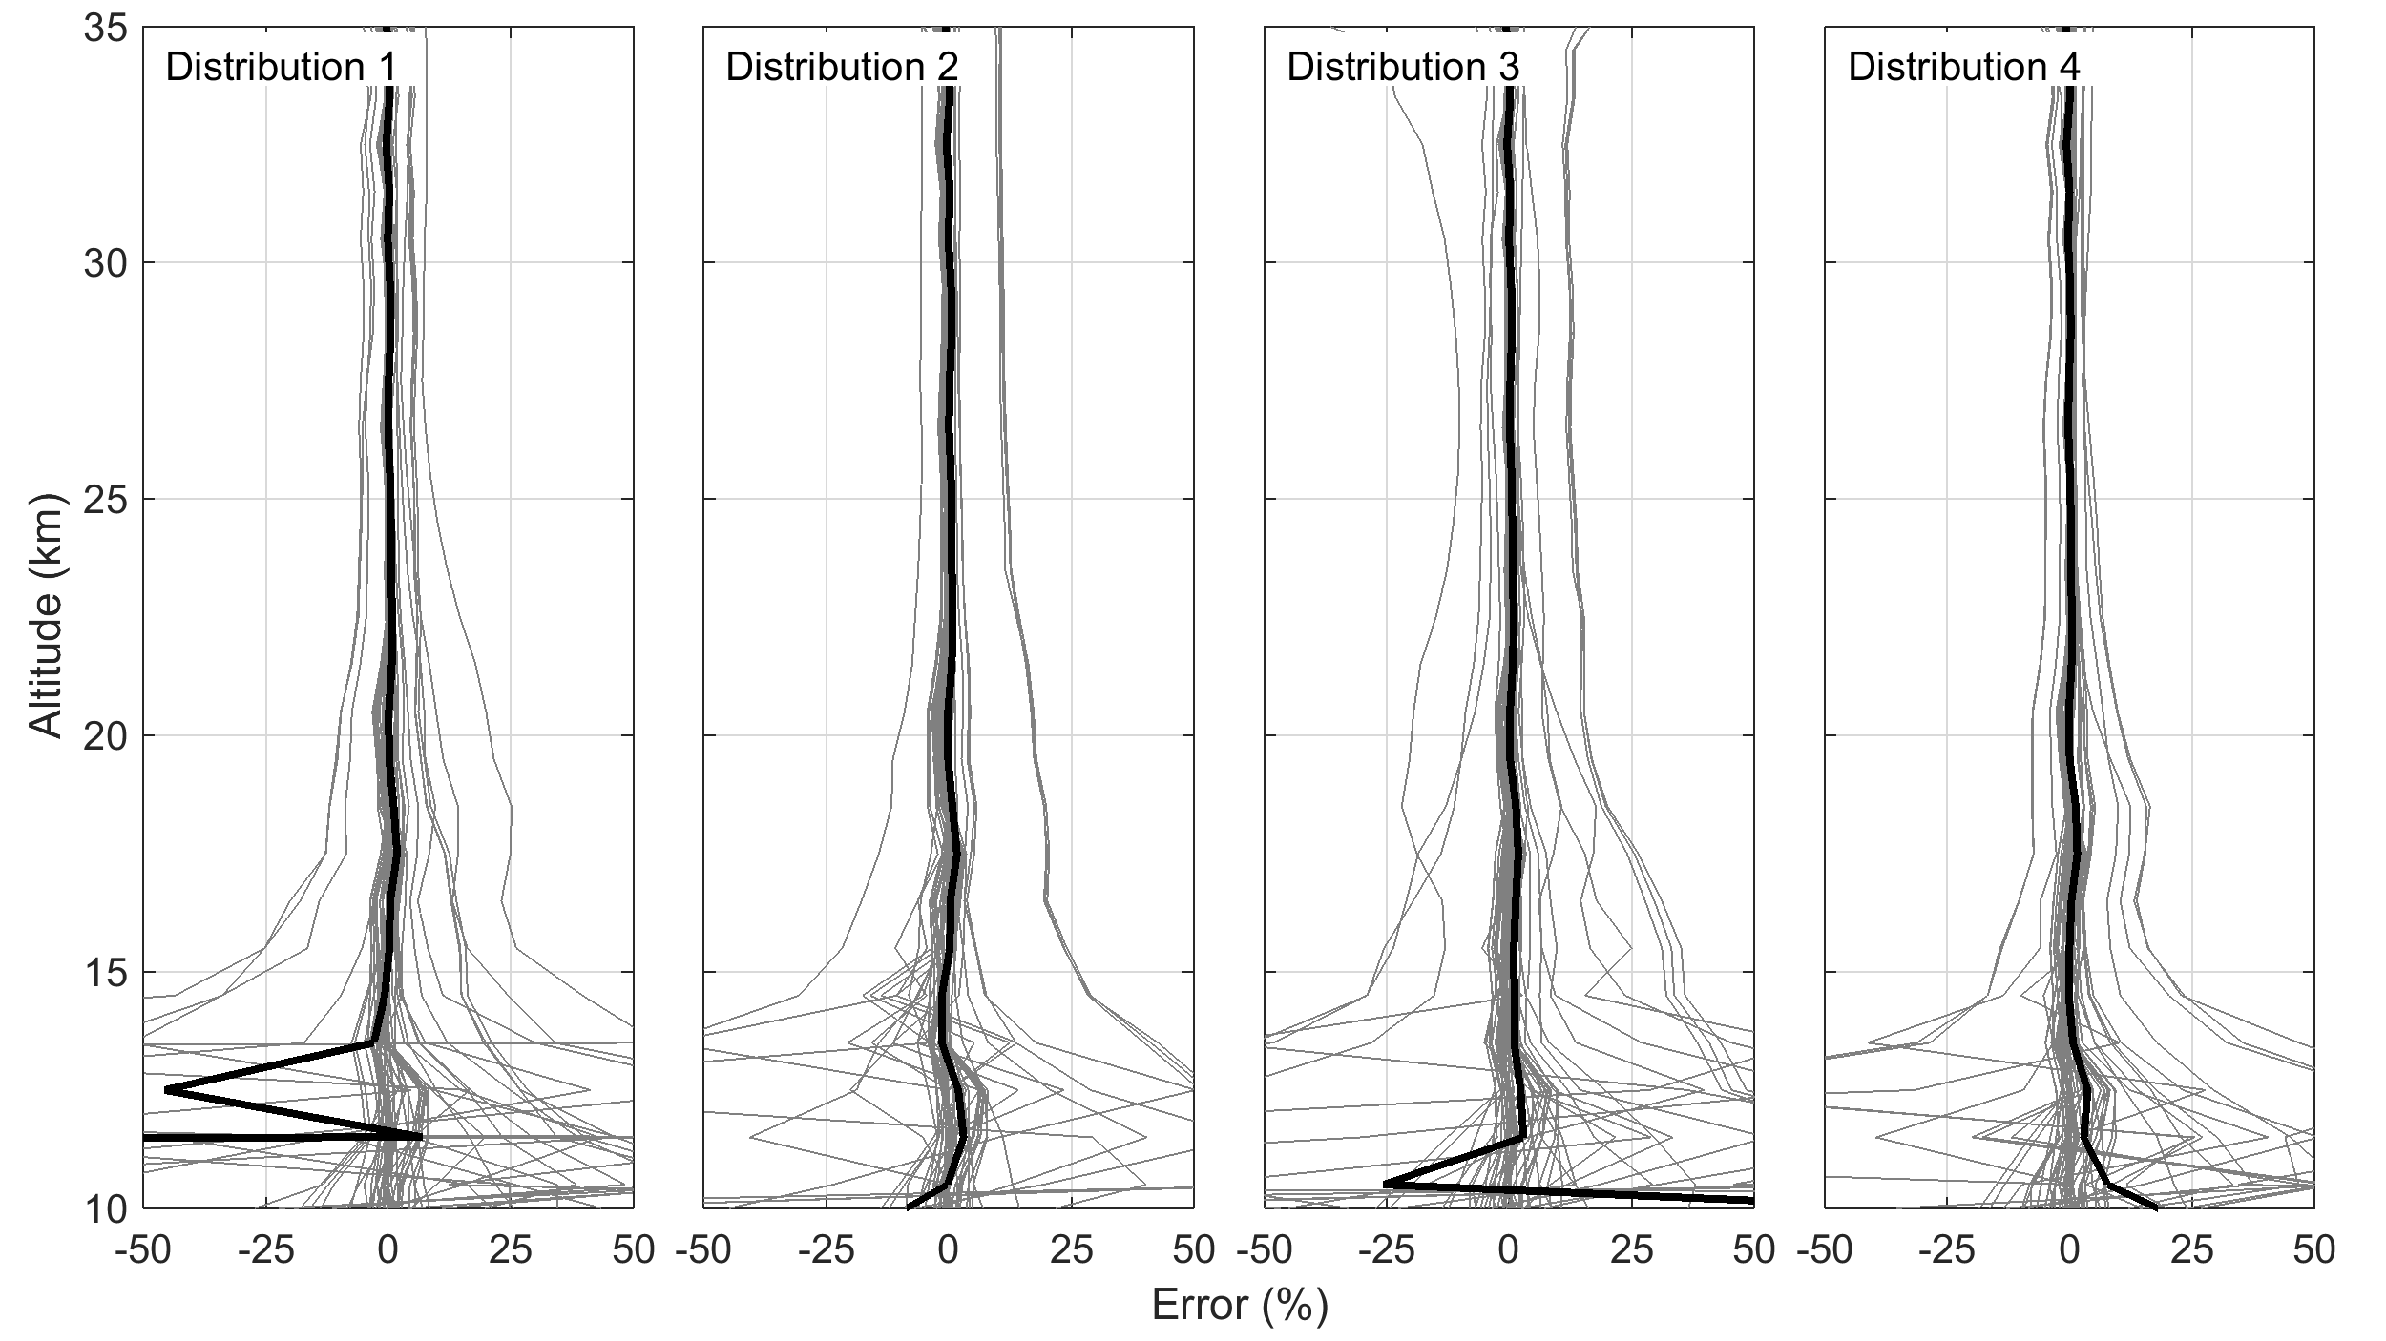

**Figure 4-6:** Percent differences of the retrieved aerosol profiles for the scalar retrieval versus the vector retrieval. Each column represents a different particle size distribution and the labels can be cross referenced in Table 1.

For the reference case, the scalar radiance, aerosol profiles can be retrieved using either the scalar or vector SASKTRAN-HR mode. As such aerosol retrievals were processed with both model modes using the same input radiances. A compression between the retrieved extinctions for the scalar and vector model were performed using a percentage difference in the form

|  |  |
| --- | --- |
| $$Percent Difference=\frac{{k_{vector}-k}_{scalar}}{k_{vector}}*100\%.$$ | (4.4) |

Across all wavelengths the mean percent difference is less than 2% from 15 to 37 km. However, at shorter wavelengths, for example 750 nm shown in Figure 4-6, a few outliers occur where the difference between the reveals is greater than 7%. All of these retrievals occur in the backscatter condition where the SSA is greater than 90o. The reason for this discrepancy is not known at shorter wavelengths, and may be due to changes in the scalar radiance due to polarization interactions but further investigation is required. However, overall the agreement between the retrievals using the scalar and vector models are minuscule and any form of discrepancy vanished for wavelengths past 1000 nm. Since the use of the vector model can increase calculation times by a factor of two for the retrievals it is beneficial to be able to use the scalar model for scalar radiance retrievals and can be performed for most cases.

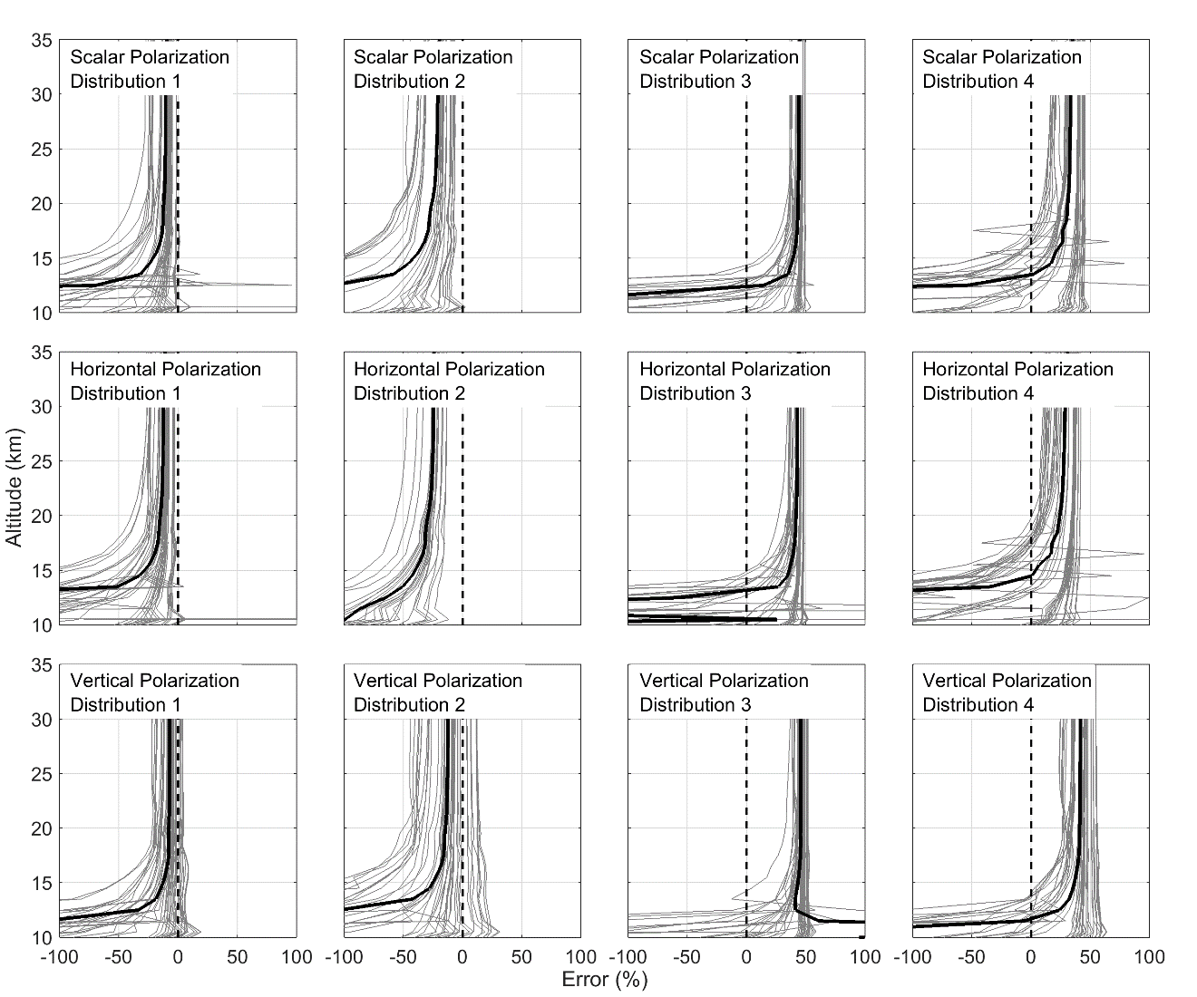

**Figure 4-7:** The retrieved aerosol profiles for each unique combination of geometry and aerosol profile are compared again the known original sates. The plot are separated into 12 cases. The four columns represent the four particle size distributions used for the analysis as listed in Table 1. From the top to bottom row are the unpolarised, horizontal, and the vertical polarization.

Aerosol profiles were retrieved using an assumed particle size distribution, in this case a log-normal with a mode radius and width of 0.08 µm and 1.6 respectively, which was different then the true state. For the three tested polarization states, aerosol profiles were retrieved and separated by particle size distributions and compared again the true aerosol extinction state. The 750 nm aerosol comparisons separated by polarizations states and particle size distributions can be seen in Figure 4-7. It should be noted that geometries with SSA of 90o have been removed for the vertical polarization due to the small phase function contribution of aerosol to the overall radiance causing a strong bias in the results. To remove this bias from the results these retrievals were removed from the analysis. However, using a geometry with a SSA of 85o or 95o almost eliminates the bias seen at the 90o scattering angle and is completely eliminated once the scattering angle is less than 80o or 100o.

Now each of distributions will be examined to notice any noticed offsets from the true aerosol state. For particle size distribution one (see Table 4-1), retrieved aerosol extinction profiles are too large. For scalar, horizontal, and vertical polarizations had mean offsets of -9-13%, -12-17%, and -6-8% respectively from 17 to 35 km. Particle size distribution two shows a different mean offset, larger, and a higher variance is observed. The mean offset for distribution two are -20-28%, -24-31%, and -12-16% for the same polarizations from 17 to 35 km. For distributions three and four similar variances are noted between the similar fine modes but the aerosol extinction retrieved is now much smaller than that true extinction state for all three polarizations. For distributions three and four the mean offsets were 42-44%, 40-43%, and 45-46% for and 26-33%, 22-29%, and 40-42% respectively for the same polarization ordering. Furthermore, as wavelength increases an approximately 3-5% increase in offset is observed for the retrieved aerosol profiles for each polarization. Using the method proposed here, decent aerosol profiles can be retrieved when only a fine mode or background aerosol layer period, since current instruments only agree to each other within 20-30%. However, when a coarse mode is present in the true state, the retrieval significantly underestimates the amount of aerosol in the atmosphere. Volcanic eruptions are the main cause for a perturbation in the size distribution and this would lead to an underestimation of aerosol extinction after a significant eruption which can miss a noticeable climate forcing effect.

Using the spectral variance of the aerosol profiles an Angström exponent (*Angström*, 1964) was attempted to be determine. The Angström exponent is method of determining particle size information due to a sensitivity of the scattering cross section from wavelength and should result in a linear trend in log-extinction log-wavelength space. Using retrieved aerosol profiles with identical geometries and particle size distribution an Angström exponent was attempted but resulting in values that were either much too large or small for a reasonable value. Addition work is required to determine if retrieving accurate particle size distributions is possible from linear polarized radiance measures for aerosol.

## 4.3.3 Precision analysis

Using SASKTRAN-HR the Jacobians for all the retrieved aerosol profiles were calculated, which were then inverted to determine the gain matrix which were used in Equation 4.3 to determine the precision. It should be noted that not all of the Jacobians could be stability inverted which caused them to be removed from the data set. Unfortunately, this resulted in a large portion of the SSA 30o cases not to invert properly and left too few for accurate statistics and were removed. Overall, these led to a loss of 12% of all of the retrieved scans for the precision analysis.

A value of 0.2% was chosen for the covariance at each altitude of the of the measurement vector. The diagonal of the covariance matrix, S_ϵ, was 0.4% since it consisted of the altitude measure and the error in the reference altitude. The cross terms of the covariance matrix was 0.2% to represent the error in the normalization altitude. The 500 nm wavelength resulted in precision estimates that were large and noisy. This lead to forming a bias in the results for the tested input parameters and was removed when doing the trend analysis. The remaining profiles were used to determine the percent error at each altitude and how the precision changed based on the true state input parameters. The analysis was performed for the SSA, SZA, albedo, extinction type, fine mode type, percentage of coarse mode, and wavelength. The numeric value of the parameters can be looked up in Table 4-2.

**Table 4-2:** Parameters used in precision study.

|  |  |  |  |  |
| --- | --- | --- | --- | --- |
| Extinction Type Number | Extinction Loading | Fine mode Type | Fine Mode Radius (µm) | Fine Mode Width |
| 0 | Background | 0 | 0.04 | 1.8 |
| 1 | Nabro | 1 | 0.12 | 1.25 |

The results from this analysis can be seen for the 19.5 km altitude in Figure 8. When comparing the three different polarization, a similar trend occurs. On average, the scalar, horizontal and vertical polarization have similar percent error ranges for each parameter and generally differ by a few tenths of the percent. The scalar trends can be seen in Figure 4-8a-g, horizontal polarization trends in Figure 4-8h-n, and vertical polarization trends in Fig. 8o-u. Any major difference between the polarizations and altitudes will be noted when looking at each independence parameter.

For the SSA across all altitudes where the retrieval was performed an increase in uncertainty is observed as SSA is increases. At 14.5 km the mean uncertainty ranges from 0.8% at a SSA of 60o to 1.5% at a SSA of 180o, similarly for retrieval altitudes of 19.5 and 24.5 km ranges of 1.4-2.8% and 6.8-10.1% are noted. The 19.5 km case can be viewed in Figure 4-8a,h,o. The standard deviation of the also increases as the SSA increases. There is a dependence on the uncertainty of the retrievals to the SSA and forward scatter observations are preferred to reduce the uncertainty.

There is close to no dependence on the SZA when it come to the precision for all three polarizations. The mean and standard deviation remain mostly constant across the SZA angle. For the 14.5, 19.5 and 24.5 km altitudes mean ranges were observed of 1.2-1.6%, 2.0-2.5%, and 8.4-9.3% respectively for SZA from 15o to 75o. The 19.5 km altitude can be seen in Figure 4-8b,I,p.

For the albedo, from a change from zero to one resulted in a general decrease of mean uncertainties and standard deviation for all polarizations, however some altitudes of the horizontal polarization did not appear to have any trends with respect to albedo epically near the 18-22 km altitude regions. For the 19.5 km altitude (Figure 4-8c,j,q) the mean uncertainties for all three polarization cases varied between 2.3-2.7% for an albedo of zero and 1.8-2.2% for an albedo of one. With regards to polarization, the mean uncertainty of the vertical orientation for albedo was always a few tenths of a percent less than the other two polarizations. However, a full probe of this space has not been performed and it is unknown if the trend is linear with albedo as no other points were sampled.

Two extinction loads were used consisting of a background and a representative Nabro volcanic loading. The indices used in Figure 4-8d,k,r for the 19.5 km altitude can be looked up in Table 2. The mean uncertainty ranges are from background to Nabro loading for the 14.5, 19.5, and 24.5 km altitudes are 1.5-1.3%, 3.6-1.2%, and 9.8-8.4% respectively. When going from a background to a volcanic loading the increased extinction causes the mean percent error to become smaller due to the larger retrieved extinction. However this magnitude of the error on the two types of extinction level are approximately the same. This results in a trend that larger extinction loading yields smaller mean uncertainty and standard deviations but similar absolute errors.

Across the two fine modes which can be referenced in Table 4-2, there is a small dependence to the uncertainty from the two modes, but is mostly constant. It should be noted that the scans with a coarse mode were not filtered out from this specific parameter analysis and the full data set was used. For the fine mode dependence all three polarization were within a few tens of a percent of each other with the scalar radiance generally on the larger end and the vertical polarization retrievals on the smaller end. The 19.5 km altitude can be seen in Figure 4-8e,l,s.

With the existence of the strong coarse mode in the stratosphere a change in the precision occurs which is dependent on height. For the lower altitudes, for example 14.5 km altitude, the mean uncertainty changes by only a couple tenths of percent and increases when a coarse mode is added. However the effect of the standard deviations is dependent on polarizations. In the scalar and vertical polarizations cases the standard deviations decreases by 0.3% whereas the standard deviation of the horizontal polarization increases by 1.2%. At middle retriavls altitudes, for example 19.5 km, all three polarizations follow the same trend with an increase in the mean of the uncertainty with the addition of the coarse mode. The increase in the uncertainty is 0.9%, 1.0%, and 0.5% for the scalar, horizontal, and vertical polarizations. As well an increase in standard deviation is noted across all three cases, and can be observed in Figure 4-8f,m,t. The same is noted with higher altitude except with even a greater increase of the mean by approximately 3% at 24.5 km.

For wavelength the same trend occurs for all retrieved altitudes, as the wavelength increases the uncertainty in the aerosol retrieval decreases quite substantially for all three polarization cases. This can be seen Figure 4-8g,n,u.

For a precise aerosol retrieval, an instrument should primarily orientated to capture forward scatter signal (SSA less than 90o) at longer wavelengths into the NIR. These measurements would result in the highest precision possible. For the aerosol profile itself it is preferred to have a volcanic loading with only a fine mode and no coarse mode. In reality a volcanic eruption inherently forms a coarse mode and the volcanic loading with no coarse mode is not physically realistic. Choice of polarization does not have a great effect on the precision of the retrievals with the overall uncertainty generally varying by only a few tenths of the percent to at worse a couple of percent between the polarization cases.

# 4.4 Conclusions

Overall choice for a polarized instrument that can only measure one polarization focused at retrieving high quality aerosol products is not a simple answer and depends several parameters. The overall best situation would be an instrument that measures forward scattered light in with vertical polarization or the polarization normal to the horizon. In this orientation the radiance measurement has good sensitivity to aerosol across all altitudes greater than 13 km. However, the increased sensitivity especially at the shorter wavelengths fall off quite rapidly once a SSA of 90o is surpassed. This instrument would also yield the best precision possible but it has two disadvantages. First, without correct knowledge of particle size information scattering angles at 90o contain a bias to the retrieved aerosol extinction. Second, a large loss of the overall signal is lost from measuring the vertical polarization, up to 68% which would increase exposure times. Depending on instrument specifications, the required increase in exposure time may result in unacceptable high values.

If more signal is required the horizontal polarization should be used. However, the preference would be for forward scatter at the longer wavelengths since a loss of aerosol signal occurs at shorter wavelengths. This would result in the highest possible aerosol signal in the radiance. Furthermore, a maximum of loss of signal would only be 42% which is considerable better than the vertical polarized case.

Further work is needed to be able to determine if the systematic differences between the retrieved aerosol extinction offsets and the original profile can be corrected through the use of some particle size retrieval’s method. As an Angström exponent fit does not yield accurate particle size information from the direct retrievals.

As a final note the agreement between the scalar and vector SASKTRAN-HR model are generally within 2% of each other with the aerosol retrievals are promising in that the inclusion of polarization in the model does not cause a large change to the retrieved aerosol profiles. As requiring the use of the vector model could result in a doubling in processing time.

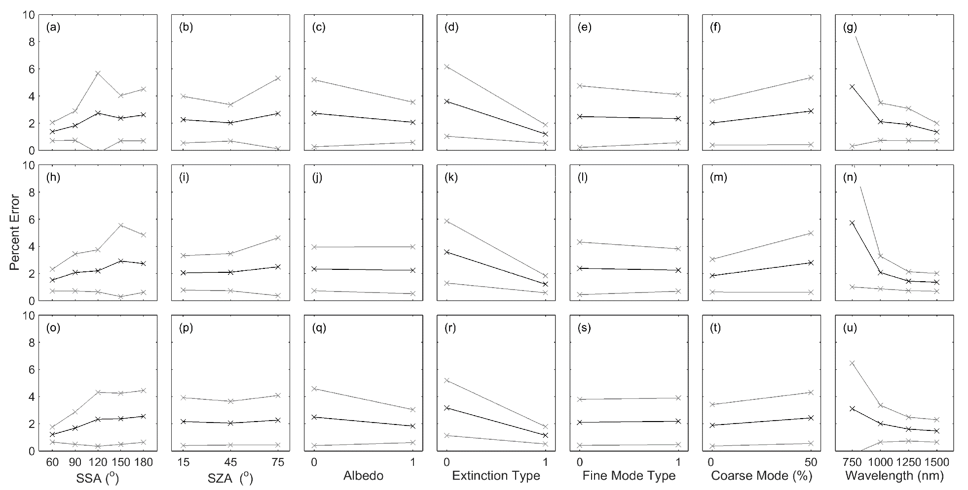

**Figure 4-8:** Trend analysis for the 19.5 km retrieval altitude. Then black points are the mean precision value for the bin, and the grey point is one standard deviation from the mean. Panels (a) through (g) are for the scalar radiance, (h) through (n) is the horizontal polarization, and (o) through (u) are for the vertical polarization.