CHAPTER 5

STRATOSPHERIC BALLOON FLIGHT AND AEROSOL RETRIVALS

# 5.1 Stratospheric Balloon Flight

After the completion of the ALI system tests on August 18, 2014, the instrument was transported to Timmins, Ontario and preparations were underwent for the balloon launch from August 25, 2014 until September 19, 2014. During this balloon campaign, there were seven balloon launches with ALI being a part of the seventh balloon. The flight of ALI took place on September 20, 2014.

## 5.1.1 Preflight Preparations

The Canadian Space Agency (CSA) balloon launch facility in Timmins, Ontario is located at the Victor M. Power Airport (48.47oN 81.33oW). ALI arrived at the base on August 25, 2014 with a launch window from September 8 to 14, 2014. In between the arrival of ALI and the balloon launch, ALI had to be verified to have survived transportation, a seal within the CCD needed to be removed, thermal insulation needed to be added, and finally, ALI needed to be integrated onto the Centre National d'Etudes Spatiales (CNES) CARMEN-2 gondola.

ALI was unpacked and set up on a test bench at the launch facility. A visual inspection occurred to verify that no obvious damage occurred to the instrument during transportation. Once completed, ALI was connected to its electronics and power boxes and ALI was powered on. A ground station computer was used to connect to ALI and preform a system check, including verification of automated startup, establishment of telemetry connection, ensuring that the system powered on correctly with no error and that the science operation program functioned. With this test it was verified that no functional problems occurred to the device during transportation, and all temperature and voltage sensors, GPS module, and CCD camera were reporting valid diagnostic values.

Once the ALI system was verified to be operational, an imaging check was performed to check that no optical components suffered damage or slippage during transportation. An EIA 1956 resolution target was illuminated by a 250 W tungsten halogen light source and was imaged by ALI to verify the optical layout. The recorded images were very similar to the one taken in the laboratory before leaving Saskatoon.

Following the successful test of ALI, the final preparations were needed prior to beginning integration with CARMEN-2 were performed. First, the CCD used by ALI had a sealed chamber that was in a vacuum state designed to be at atmospheric pressure and would be required to be unsealed before the flight. The unsealing is done in order to not develop a strong pressure gradient between the CCD chamber and the low pressure of a 35 km environment causing permanent catastrophic damage to the CCD detector. At the launch facility, ALI was taken to a semi-clean area to unseal the CCD chamber. A panel was removed on the side of the camera and the seal to be removed can be seen in Figure 5-1. The orange o-ring was removed with associated sealing components and the vacuum seal was broken. The chamber panel was replaced and ALI was moved back to the integration hall and another set of test resolution targets were taken to verify the correct operation of ALI. All resolution targets were similar with the set before the chamber was unsealed except there was approximately a 5% drop in counts which may have been caused by unsealing the chamber or a change in the lighting conditions of the resolution target.

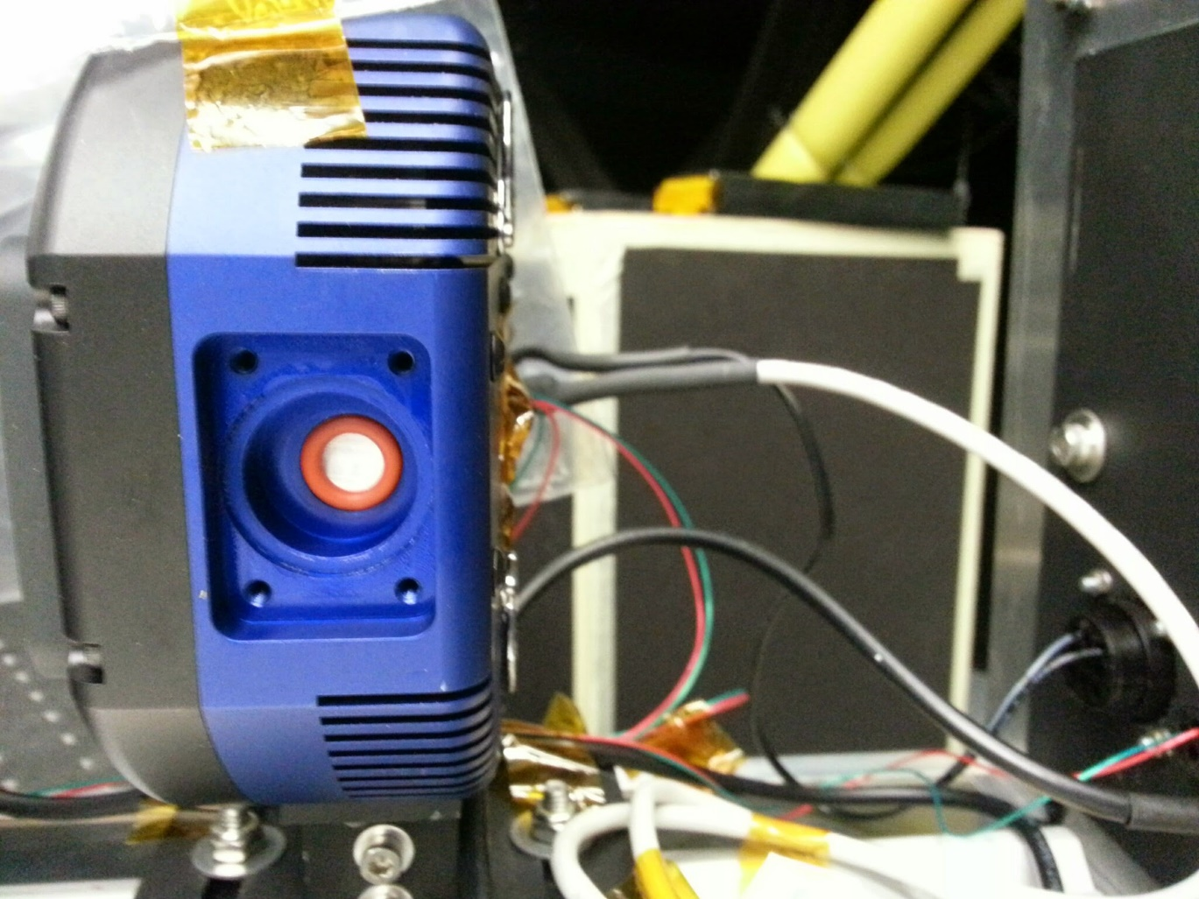

**Figure 5-1:** Side of the QSI CCD with the panel that contains the vacuum seal opened. The orange o-ring seen in the cavity is removed from the chamber to open the vacuum seal to the camera's CCD chip.

The next step before ALI could be integrated was to add thermal shielding in order to protect ALI from the thermal environment at approximately 35 km. The first thermal concern was the instrument falling to a temperature were the electronics were too cold to function. The instrument would have to be in complete darkness during the assent which would result in little to no solar heating. Furthermore, ALI will pass through the tropopause where temperatures can be as cold as -70oC. Insulation, in the form of foam, was added around the exterior of the instrument to give ALI thermal isolation from the cold environment. The second concern was once CARMEN-2 was at float altitude, ALI would have to be able to survive the direct heating from the sun's radiation which could cause overheating. The impact of the sun's energy was reduced on ALI by adding a thermal reflector to the outside of the thermal insulation which would reflect a portion of the incoming solar radiation away from ALI.

With the completion of the thermal management, ALI was ready to be mounted onto the CARMEN-2 gondola. ALI can be seen mounted on the CARMEN-2 gondola in Figure 5-2 and ALI used the power and communication subsystems of CARMEN-2. Testing was performed with collaboration from the CARMEN-2 team to check that there were no issues between ALI and CARMEN-2’ systems. A problem was found in the communication module, named Siren, between ALI and the ground station computer. With assistance from the CARMEN-2 team, the correct Ethernet setting were determined and a correction to the ALI operation code was applied.

During the integration phase, it should be noted that several instruments were also being verified with the CARMEN-2 systems for integration onto the gondola including four other Canadian instruments, such as the OSRIS development model (*Kozun*, 2015; *Taylor*, 2015) and SHOW which measures water vapour.

The CNES gondola is an actively pointed gondola with azimuthal pointing precision better than 1’ with the use of an onboard star tracker. ALI was orientated so it would be maintained at 90o from the azimuthal direction of the sun, with an overall southern field of view during the mission.

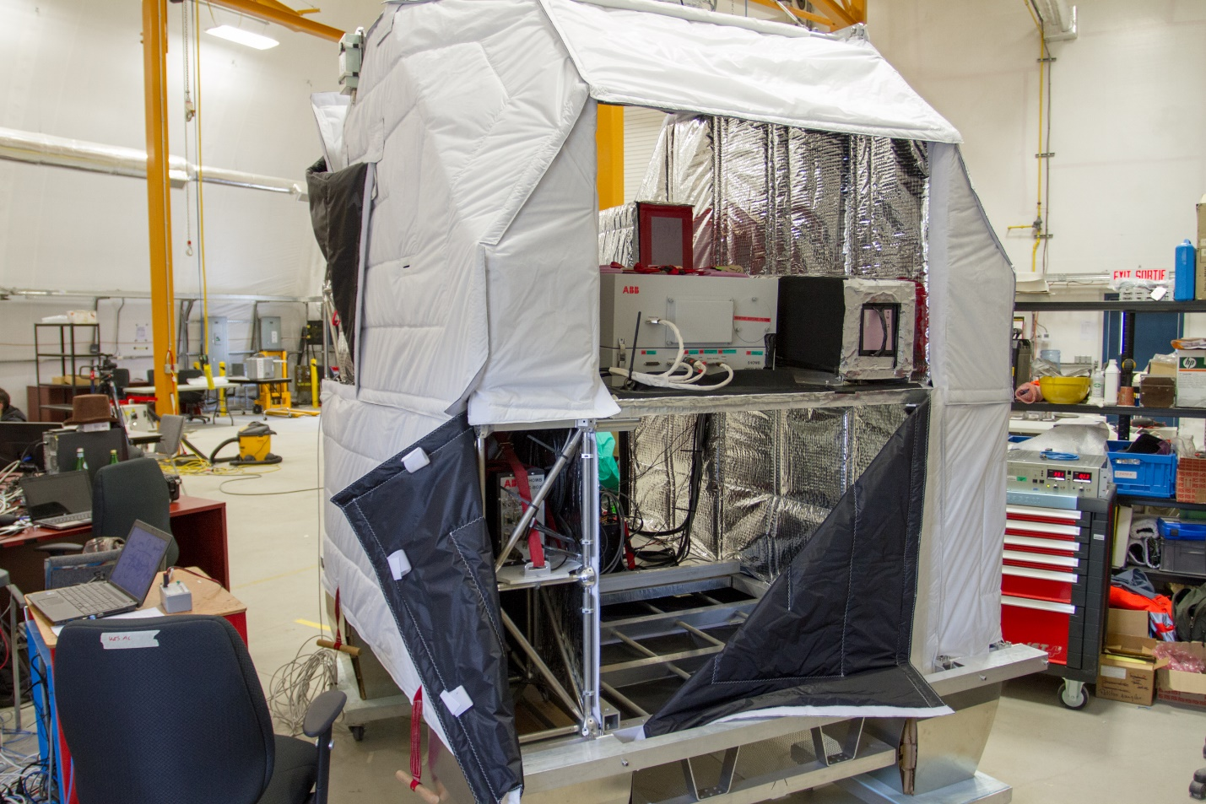

**Figure 5-2:** The ALI instrument is mounted on board the CARMEN-2 gondola (top shelf on the right). ALI located next to SHOW, another Canadian instrument with collaboration between ABB, York University, and the University of Saskatchewan. ALI has its red tag cover over the optical entrance to protect the instrument from dust and other contaminates. Thermal insulation has been added to the instrument and during the flight sun side will be on the side of SHOW. Some of the reflective layer was blacked out to not cause additional stray light into SHOW optical path.

## 5.1.2 Balloon Flight

The flight plan for the CARMEN-2 gondola was once float altitude was reached and the sun had risen ALI, OSIRIS, and SHOW would perform their operational missions for the first four hours of the campaign. The operation objectives for ALI included a dark imaging suite for calibration purposes and an aerosol imaging suite for aerosol measurements. A secondary goal was to test the sensitivity to aerosol of ALI with respect to SSA by recording images at various azimuth directions. After the end of the ALI mission, the instrument was to be powered off and other instruments on CARMEN-2 were to gather measurements.

The flight of CARMEN-2 was delayed past it launch window of September 8 to 14, 2014 due to poor weather conditions. On September 19, 2014 at 05:35 UTC (01:35 local time) ALI was launched as part of the Nimbus 7 mission from the CSA Timmins balloon launch facility. During the launch, the sky was clear with light winds allowing for a safe and uneventful launch. The ascent of the gondola occurred in darkness and reached its flight altitude of 36.5 km at 8:17 UTC. First light was observed by ALI at 9:39 UTC and spectral images were recorded until 14:42 UTC. ALI was powered off at 17:15 UTC.

A visualization of the flight path with major landmarks noted can be found in Figure 5-3a. Temperature profiles for the ambient atmosphere and instrument are shown in Figure 5-3b. The black curve is the ambient atmospheric temperature at the gondola altitude and location during the flight as obtained from ECMWF reanalysis (*Dee et al.*, 2011). The blue, green, and red are from temperature sensors onboard ALI located on the baffle, camera, and RF driver respectively. The baffle temperature sensor was attached just on the inside of ALI right by the entrance aperture for the system and monitors the temperature at the front of the system. The camera sensor is attached to the back of the CCD camera and the RF driver sensors measure the surface temperature of the RF driver. ALI was thermally insulated to keep the system warm whereas the baffle temperature sensor is relatively uninsulated from the extreme cold of the tropopause. The effect of the cold tropopause can be seen on the gondola at approximately 6:00 UTC. The cooling effect can even be seen on the interior CCD and RF driver sensors which are isolated from the exterior temperature. After the internal temperature drop, the system reaches an equilibrium temperature until the sun rises and solar radiation comes into contact on the instrument at approximately 10:00 UTC at which point there is an increases in the system’s temperature. The temperature of the system are kept within operating range with the aid of the reflective material during the flight.

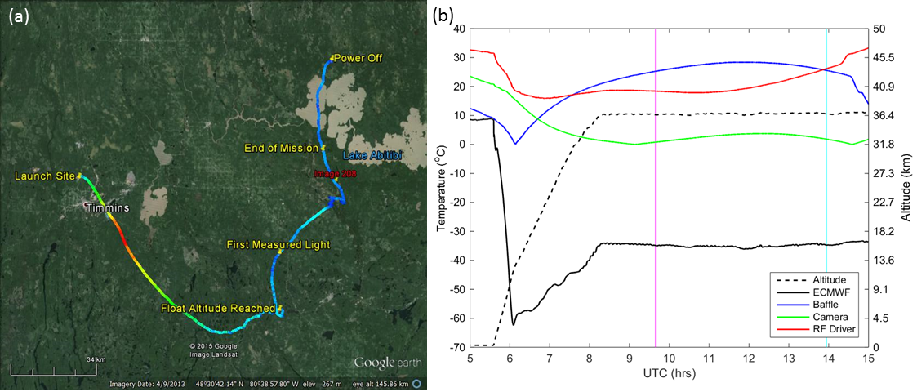

**Figure 5-3:** (a) The GPS data from ALI during the Nimbus 7 mission generated via Google Earth. The colour of the line represents the absolute speed of the gondola during the mission. Important landmarks are noted on the image. The end of mission represents the end of the primary aerosol mission. No GPS data was collected from ALI after power down. The location of image 208 is the red label. (b) The temperature and altitude profiles from the Nimbus 7 flight. The time of image 208 is shown by the cyan vertical line and first light measured by ALI is occurs at the magenta vertical line.

During the mission, ALI operated in two primary acquisition modes, a calibration mode and an aerosol imaging mode. The first mode, the calibration mode, was primarily used during ascent when the gondola was in darkness and intermittently between the aerosol mode during sunlit conditions. During this mode, the filtering of the AOTF was not enabled and the system imaged essentially only dark current during the ascent in darkness and stray light during sunlit conditions. Eight exposures are taken in the calibration mode with 0.05, 0.1, 0.5, 1, 2, 3, 5, 10 second exposure times.

The second operational mode, the aerosol mode, recorded measurements in a cycle that contained 13 pairs of images across the spectral range (650-950 nm every 25 nm), the pairs being a calibration image with the “AOTF-off” and an image of the limb. Each cycle took approximately 10 minutes with each measurement set taking approximately 40 seconds to acquire with initial exposure times shown in Figure 5-4 in blue, which were the exposure times determined during the roof testing of ALI (see section 3.6.1). However, during the flight it was determined that the calculated exposure times were not long enough and the images were underexposed. The underexposure is believed to be caused by the initial exposure time calibration curves being calculated with simulated scaler radiance since the SASKTRAN-HR polarization module had not yet completed development. So the exposure time curve was recalibrated during the flight using the image statics that were sent down with the house keeping. A comparison of the two exposure time curves with the percent increase can be seen in Figure 5-4. The percent increase is given by

|  |  |
| --- | --- |
|  | (5.1) |

where is the exposure time for the original calibration and are the updated exposure times calculated from the flight.

The Nimbus 7 flight lasted for 16 hours 19 minutes with a successful landing at 21:54 UTC. During the flight, ALI successfully gathering 216 aerosol images. The gondola landed 70 km from Amos, Quebec or approximately 250 km from the launch facility. CARMEN-2 was recovered by the balloon recovery team and was returned to base on September 21, 2015. ALI was removed from the gondola, repacked and transported back to Saskatoon, Saskatchewan were the data could be processed.

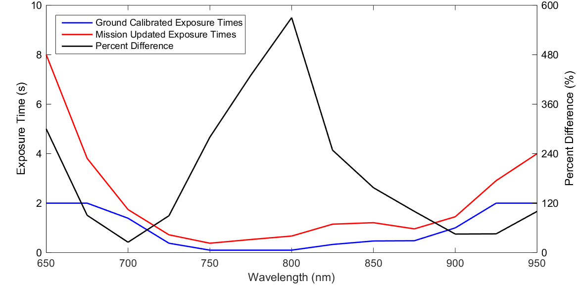

**Figure 5-4:** During the flight the calibrated exposure times was updated. The blue curve represents the exposure times from the ground calibration and the red curve is the recalibration during the flight. The black curve is the percent change in between the pre-flight calibrated results and the during flight calibration.

# 5.2 Limb Measurements

After the successful post-flight recovery, ALI was unpacked and check for any damages in Saskatoon, SK on September 25, 2014. No obvious damage had occurred to ALI from the flight and the instrument was functioning correctly. 216 raw aerosol mode images were obtained from the flight and calibration was performed including pointing alignment and the calibrations as detailed in section 3.3.

The images needed to have complete pointing information added since the raw images only had position and altitude information from the onboard GPS. The azimuth and zenith directional information needed to be added to the images as they are needed to determine the line of sight of each pixel on the CCD. The CNES team supplied the SAA information from the flight and was correlated to the images using GPS time. However, no information was supplied about the zenith direction of the gondola, we were just notified that the gondola was zenithally stable throughout the entire flight. So some manual calibration of the zenith angle occurred. ALI was tilted at 3o so the zenith as assumed to be 93o for ALI. This starting guess was not accurate enough since features in the radiance profiles did not retain the same altitude over the course of a few images. To determine a more precise zenith angle, the zenith angle was varied from 92o to 94o in 0.1o intervals and the tangent altitude was calculated for each case. Then the radiance profiles for each zenith angle was compared to find zeniths where the features were aligned. The zenith angle with the optimal alignment was determined to be 92.55o with an uncertainty of 0.10o.

The calibration techniques discussed in section 3.3 were then applied to the raw images to find the final radiances. As an example, image number 208 is used to demonstrate the steps in the calibration on a flight image. Image 208 is recorded with a wavelength of 750 nm and taken at 13:57 UTC with a solar zenith angle and solar scattering angle of 63o and 98o respectively. The dark current and DC offset have been removed from image 208 using the Equation 3.42. Next, the stray light is removed by using the AOTF-off or calibration image and removing it from the AOTF-on or measurement image. The result of this procedure can be seen in Figure 5-5. In the first panel, abnormal bright spots are noticed in the right side and the top right of the measurement. These same features are noticed in the stray light image. By subtracting the AOTF-off image from the measurement image, a final smooth measurement image is seen. Finally, a flat fielding calibration is performed (see section 3.6.5) and a final calibrated image can be seen in Figure 5-6a. Remember that no absolute calibration was performed on ALI, so the radiance are relative radiance in arbitrary units to the 775 nm laboratory calibration. The error, , on a given pixel for the radiance measurements were given by

|  |  |
| --- | --- |
|  | (5.2) |

where is the readout uncertainty from the CCD, which is 15 counts, is the error in the DC offset calibration, is the error from the dark current in the CCD, is the error in the stray light calibration, and is the error in the flat field corrections.

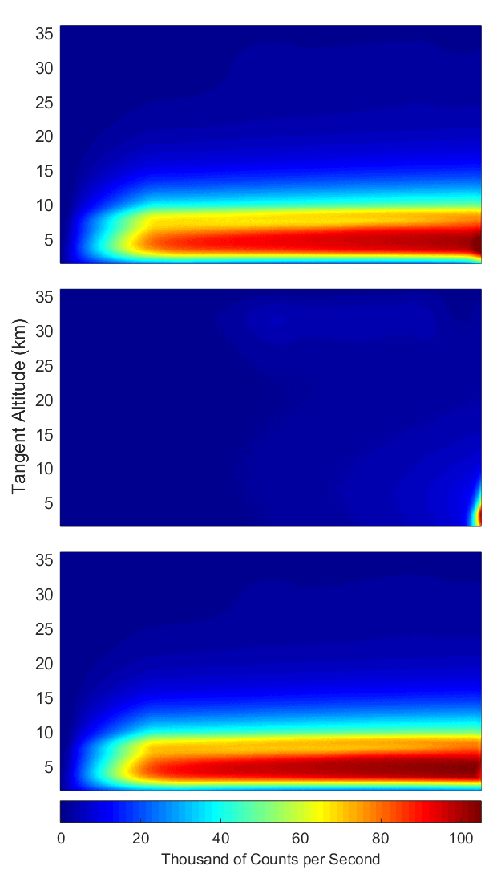

**Figure 5-5:** Stray light removal technique is performed using image 208 which is a 750~nm measurement. The top panel is the image after the DC offset has been removed from the measurement. The middle panel is the associated AOTF-off image and stray light features are seen in the upper right of the image as well as light being registered in the entire right side of the image. The final panel is the first panel minus the second panel and the abnormal gradient has been removed from the final image, leaving a cleaner radiance profile.

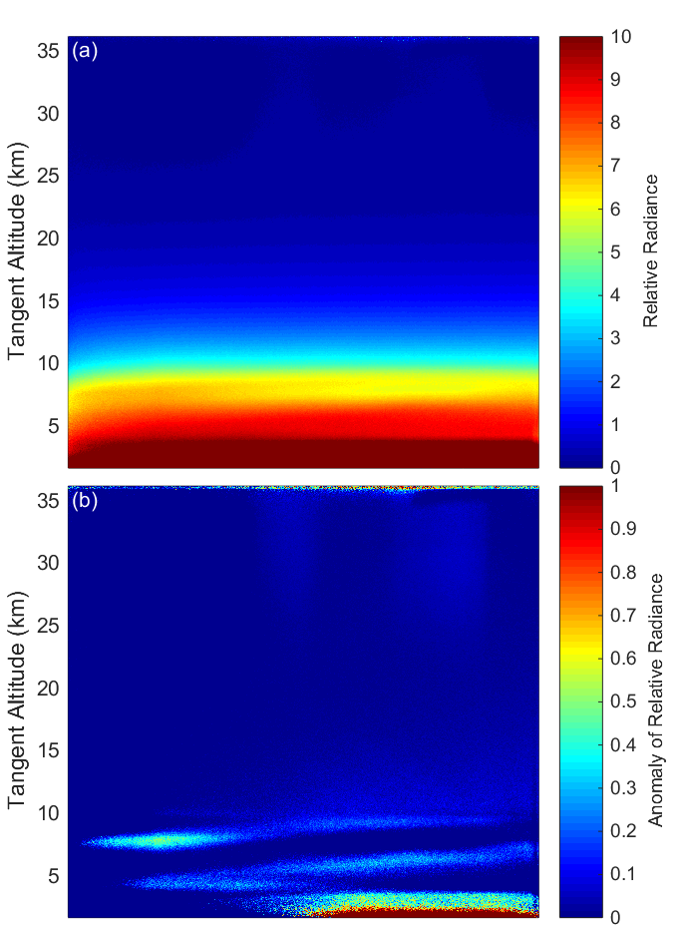

**Figure 5-6:** (a) Final calibrated 750 nm image, taken at 13:57 UTC located at 48.55oN, 80.00oW with a solar zenith angle and solar scattering angle of 63o and 98o respectively. (b) The same 750 nm image with the mean of the profile removed from the image leaving the residual signal that shows thin clouds in the troposphere.

From image 208 the horizontal structure across the image is nicely revealed by calculating the mean radiance profile across the image and then removing it from each profile. This is shown in Figure 5-6b, where thin clouds (2 km vertical extent or less) are clearly seen near and below the tropopause level, with substantial variation in tangent altitude across the horizontal field of view. These clouds were also observed from other instruments on board the gondola during the mission (B. Solheim, private communication). A brief check on the CALIPSO quick-look plots also shows clouds at a maximum height of approximately 13 km from measurements taken at 08:40 UTC at 47.24oN, 95.25oW, the nearest measurement point to the ALI location and time. Although these images only have a 35 km extent in the horizontal direction, there is also some indication of horizontal variation in radiance significantly above the cloud level, possibly due to real atmospheric variability in the aerosol layer. It should also be noted that some high altitude stray light is also visible in this mean residual image that was not observed in the laboratory tests. This may be due to contamination from scattering from a baffle vein or a nearby component of the gondola, although the true cause is unknown at this point.

For ease of further analysis, and to increase the precision of the measurements to a minimum of 0.6 MTF the images were averaged into cells of 25 pixels horizontally, and average vertically onto a 1 km tangent altitude grid. The errors for the averaged radiances, , is given by

|  |  |
| --- | --- |
|  | (5.3) |

where the errors for each pixel, , are summed in vertical, , and horizontal, , directions from the starting pixel, for the vertical and for the horizontal, to the final pixel in the average, for the vertical and for the horizontal. The radiance profiles from the center column of the images for all measurements obtained during the flight are shown in Figure 5-7. The first set of profiles, the dashed lines, which start near zero and move toward larger values, are the measurements that were recorded near and during sunrise so the gradual increase is therefore expected. Measurements obtained for solar zenith angles less than 90o are represented by the solid lines. These radiance profiles follow a similar, and expected exponential shape, with some variability at tangent altitudes below 12 km corresponding largely to changing cloud conditions.

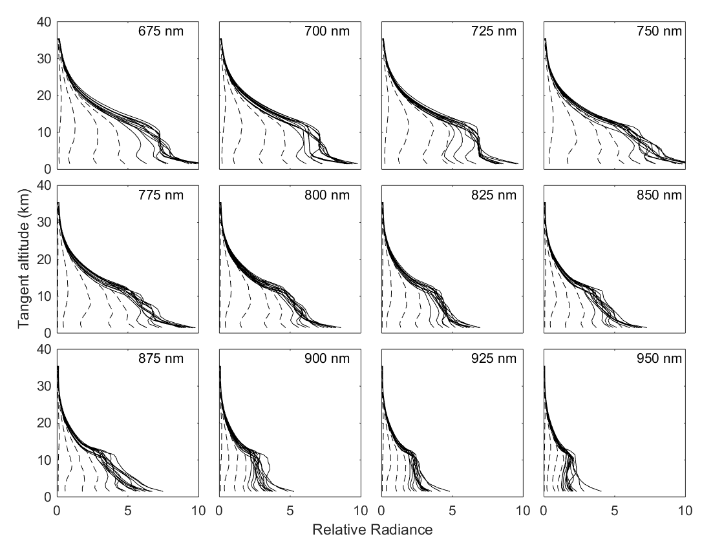

**Figure 5-7:** Averaged ALI relative radiance vectors from 12 of the 13 wavelengths from the Nimbus 7 flight. Each panel presents the radiance vectors from a different wavelength measured which is denoted in the top right corner. The dashed lines are radiance profiles where the solar zenith angle is greater than 90o and solid lines are profile where the solar zenith angle is less than 90o.

A full cycle of 13 spectral images (numbers 204-216) were used in Figure 5-8 to show the spectrum of relative calibrated radiances at selected tangent altitudes. The estimated uncertainty in the radiance is represented by the shading has calculated using Equations 5.2 and 5.3. The uncertainty is approximately five percent from 5 to 20 km and increases up to eight percent from 20 to 35 km. The spectra display the expected and relatively smooth fall off in intensity with increasing wavelength with Chappuis ozone absorption seen at the lower wavelengths; however, the reason for the peak in the spectra at 875 nm is not known and may be due to an inconsistency in the pre-flight calibration.

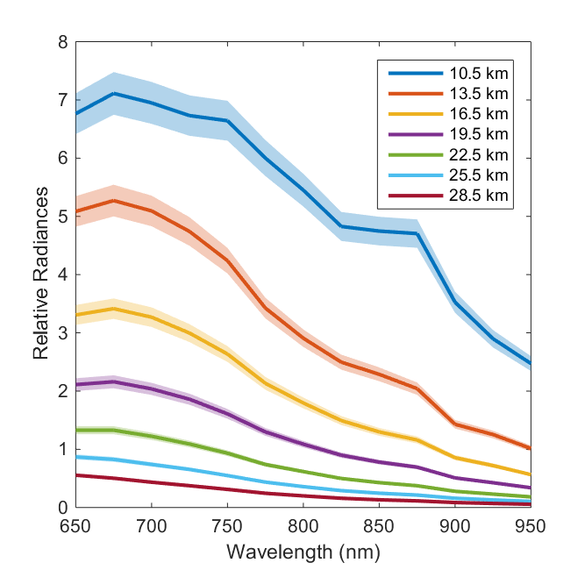

**Figure 5-8**: Relative radiances spectrally from 650 nm to 950 nm as measured from ALI at approximately 14:20 UTC consisting of images number 204 to 216 looking 90o in the azimuth from the sun facing southwards. These spectral profiles are presented at several tangent altitudes with a horizontal look direction of 0o. The shading represents the error on the radiances.

# 5.3 Aerosol Retrievals

From the successful mission, radiance measurements from ALI needed to be used to determine aerosol atmospheric parameters. The following sections will describe the MART retrieval method used to determine aerosol. The retrieved aerosol profile from ALI using the MART method will be presented and will be compared to the OSIRIS version 5.07 aerosol extinction product. Following a cycle of aerosol measurements will be used to determine a particle size distribution estimate and will be contrasted with particle size parameters from other instruments.

## 5.3.1 Aerosol Extinction Retrieval Methodology

A measurement inversion technique is a method used on a measured value can be converted into a wanted usable physical quantity via an iterative method. A measurement vector, , is constructed that has sensitivity to a desired physical state and is computed with a forward model, **,** with an input state, , and a wanted physical parameter . The measurement vector is then calculated with the model and is yielded by

|  |  |
| --- | --- |
|  | (5.4) |

where is the noise on the measurement vector.

The inversion of the ALI radiances used a Multiplicative Algebraic Reconstruction Technique (MART), specifically we have applied a slightly modified version of the standard OSIRIS stratospheric aerosol extinction retrieval (*Bourassa et al.*, 2007; 2012b). This inversion algorithm, which is applied from the tropopause to 30 km altitude, assumes log-normally distributed hydrated sulphuric acid droplets (see Equation 2.1) in order to calculate the aerosol scattering cross sections from the Mie scattering solution. The modeled radiances for the nonlinear inversion were computed with the SASKTRAN-HR radiative transfer engine using the newly developed vector module for polarization (*Bourassa et al.*, 2008; *Zawada et al.*, 2015; *Dueck et al.*, 2015). The output of SASKTRAN-HR gives the Stokes vectors for the radiance on the model reference frame, which are then rotated into the instrument's coordinate system (see section 2.4.5). Once rotated, the polarization signal required to match the ALI measurement is the vertical polarization given by

|  |  |
| --- | --- |
|  | (5.5) |

where and are Stokes parameters defined by and . The variables and are the horizontal and vertical component of the electric field in the instrument reference frame.

The relative radiance measurements from ALI are used to create measurement vectors, , as specified in *Bourassa et al.* (2012b) in the form,

|  |  |
| --- | --- |
|  | (5.6) |

where is the measured relative radiance from ALI and is the relative radiance at a high reference tangent altitude where there is little aerosol contribution. For the ALI measurements, the highest possible tangent altitude where the signal is above the noise threshold is approximately 30 km tangent height. The second term in Equation 5.6 uses modeled radiances from SASKTRAN-HR with only the molecular atmosphere to approximately remove the Rayleigh signal. This is done to improve the speed of the convergence of the retrieval (*Bourassa et al.*, 2012b). Figure 5-9a shows the measurement vector from a 750 nm image (number 208) from the center of the CCD. The final measurement vector, **,** is shown in the black, with the first term of Equation 5.6 is in blue and the second term is in red. Removing the Rayleigh component of the signal from the measurement vectors increases the sensitivity to aerosol which increases the speed of convergence of the solution. All of the measurement vectors for the 750 nm images from the mission can be seen in Figure 5-9b.

An initial guess state, , for the aerosol extinction and an assumed particle size distribution profile are set in the SASKTRAN-HR model. The forward model vector is then constructed similarly to the measurement vector, and used in combination with the measurement vector to update the aerosol extinction coefficient profile using the MART algorithm,

|  |  |
| --- | --- |
|  | (5.7) |

where is the aerosol extinction at each model altitude, and denotes a tangent altitude from the measurements. is the weighting matrix that relates the importance of each element of the measurement vector to each shell altitude. It should be noted that this inversion technique is computationally efficient as it allows for the updating of the atmospheric state without calculating the Jacobian (*Degenstein et al.*, 2009). This iterative process is run until the solution have converged and the value of the summation is approximately one the final aerosol state is determined.

In order to determine the precision on the retrieved aerosol profiles an error estimate on the measurement vector is performed. To yield the error on the measurement vector at a specific tangent altitude, , Equation 5.6 is differentiated giving and summed in quadrature yielding the following result

|  |  |
| --- | --- |
|  | (5.8) |

However, the only error that is considered is due to the instrument measurement and calibrations, errors in the SASKTRAN-HR model are ignored. Since the Rayleigh component are modeled they are dropped from the error, simplifying the above result to

|  |  |
| --- | --- |
|  | (5.9) |

An example of the error on a measurement vector for image 208 is located on Figure 5-9c.

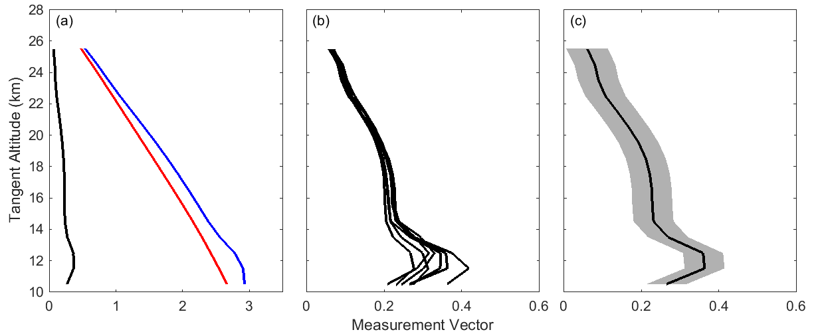

**Figure 5-9**: (a) The measurement vector and the two contributions terms of Equation 5.6 from image 208 using the center line of sight horizontally. The black, blue, red curves represent the measurement vector, first term of Equation 5.6, and second term of Equation 5.6. (b) A collection of all of the measurement vectors at 750 nm during the mission with a SZA greater than 90o. (c) Image 208 measurement vector with associated error represented by the shading.

The error on the measurement vector is used to determine the error on the retrieved aerosol profile. Once a retrieval has been completed for a measured radiance profile, the result is then used to estimate the error in the retrieved extinction. For each altitude, a gain matrix is defined as

|  |  |
| --- | --- |
|  | (5.10) |

where is the change in the retrieved aerosol extinction and is the change in the measurement vector. The gain matrix is calculated through successive numerical perturbation of the measurement vector and re-retrieval (*Rodgers*, 2000). A much faster method to use the Jacobian to determine the error has been performed (*Bourassa et al.*, 2012a), as used in the analysis for chapter 4, but makes an assumption that the gain matrix is equal to the inverse of the Jacobian, as typically the averaging kernel is close to the identity matrix. However, this method adds additional uncertainty to the error estimate and with a limited set of balloon data, it is possible to calculate the gain matrix directly. The error at each retrieved altitude is then given by

|  |  |
| --- | --- |
|  | (5.11) |

where is the covariance matrix of the measurement vector and is the covariance of the retrieved aerosol profile (*Rodgers*, 2000). The covariance matrix is given by

|  |  |
| --- | --- |
|  | (5.12) |

where the individual terms are given by

|  |  |
| --- | --- |
|  | (5.13) |

The reported precision for ALI aerosol extinction retrievals is the square root of the diagonal of .

Ideally, the ALI measurements would be used independently to also retrieve ozone in the Chappuis band (600-700 nm range for ALI). However, due to the spectral range of the prototype, only a small fraction of the long wavelength side of the absorption band was captured. For this analysis, we have not retrieved the ozone profile but have set the ozone profile in SASKTRAN-HR to an average of the five closest coincident ozone profiles measured by OSIRIS at the ALI location and time. The ozone cross sections were determined by *Burrows et al.* (1999). The surface albedo used is also from the OSIRIS scans since the two instruments share a similar measurement method and should determine a similar albedo for the cloudy conditions. Preferably albedo would be determined from the ALI following the method of *Bourassa et al.*, 2012b, however due to the lack of an absolute calibration this was not possible.

## 5.3.2 Aerosol Extinction Retrievals

The complete mission consisted of 216 images that were recorded in illuminated conditions. The MART retrieval method was run on a select complete cycle for the purpose of the analysis, specifically the set of images from 650 to 950 nm consisting of images 204-216. For the purpose of the retrieval an *a priori* for particle was used with a mode radius of 0.08 µm and a mode width of 1.6 (*Thomason*, 1991). A sample of the retrievals can be observed in Figure 5-10 which highlights the 750, 850, and 950 nm retrievals. The left panels shows the measurement vector from ALI in black with the forward model radiance profile from SASKTRAN-HR in blue. For each of the wavelengths, the algorithm determines altitudes where the value of the measurement vector is less than the known noise and does not allow aerosol to be retrieved in those regions. Instead the scaling factor, given by is scaled to the aerosol profile above and below the last retrieved point to keep the aerosol profile smooth, as discontinuities are nonphysical and can lead to a nonphysical results in the MART algorithm. The middle panel shows the convergence between the measurement vector and the forward model result. The right column of Figure 5-10 is the received aerosol profiles in blue with the associated error calculated using the method described in the previous section.

The retrieved aerosol extinction profiles for the analysis cycle can be seen in the left panel of Figure 5-11. Note the log scale. For the full range of the wavelengths a difference of less than 2% between the measurement vector and forward model is seen throughout the retrieval altitude from approximately 13 to 29 km. Note the behavior of decreasing extinction with increasing wavelength as expected due to the dependence of the cross section with respect to particle size.

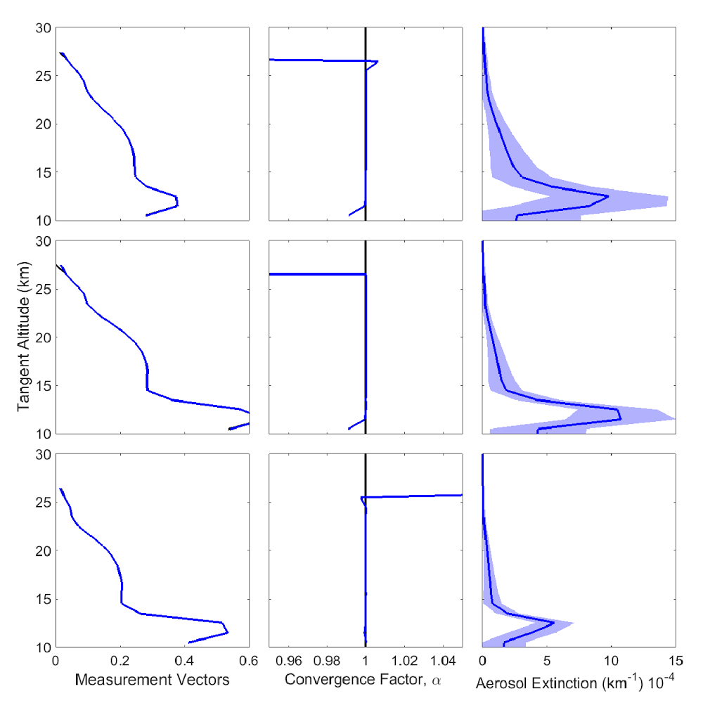

**Figure 5-10:** An example of three aerosol retrievals from images 206, 208, and 214, with center wavelengths of 750, 850, and 950 nm respectively vertically displayed in the figure from top to bottom. The left column shows the measurement vector, , in black with the retrieved forward model, , in blue. The center column shows the ratio of the measurement vector over forward model known as and is the convergence factor between the ALI measurement and the forward model. For both the first two columns the black line is barely viable due to the very good agreement of the forward model. The final column is ALI aerosol extinction in blue with the associated error represented by the light blue shading.

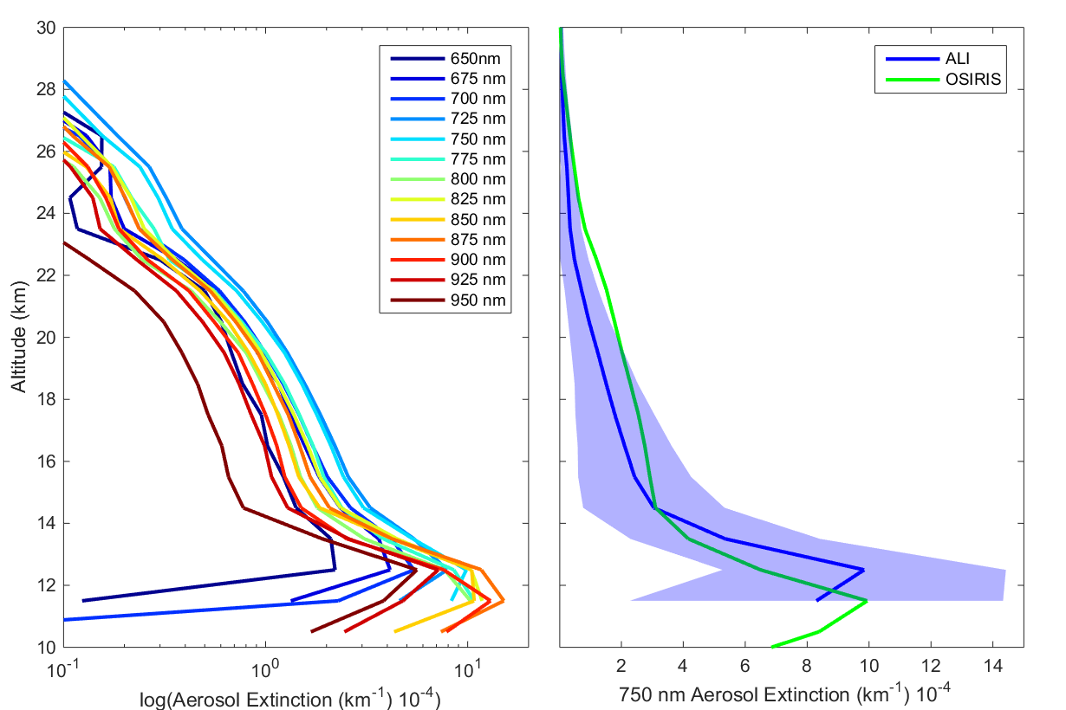

**Figure 5-11:** Left is the retrieved aerosol extinction profiles from the last complete imaging cycle consisting of images 205 to 216 from the 0.0o horizontal line-of-sight. Right is the 750 nm ALI aerosol extinction in blue with its error represented by the shading compared to the 750 nm extinction measured by OSIRIS in green.

The ALI 750 nm aerosol extinction profile is shown in the right panel of Figure 5-11 in blue with the shading representing the precision of the retrieval. The error is strictly based on measurement error and neglects any model and atmospheric state errors as previously stated. The green curve is the average 750  nm aerosol extinction profiles of the same five coincident OSIRIS scans used for the ozone profile. The retrieved extinction profiles from ALI and OSIRIS are within with the total retrieval uncertainty below 20 km. It is encouraging, however, that the instruments follow the same overall profile shape including the stratospheric layer and the steep increase below 15 km. However, the OSIRIS and ALI extinctions do not agree within error between 20 to 25 km. Aerosol is notoriously difficult to validate in remote sensing with various technique and instrument geometries, and yet the SAGE II, SAGE III and OSIRIS differences are generally below 20-30% up to 30 km (*Bourassa et al.*, 2012b; *Rieger et al.*, 2015) so the disagreement between OSIRIS and ALI from 20 to 25 km found here is somewhat puzzling. However, given the retrieved uncertainty, the OSIRIS profile is only outside the upper error bound of ALI by less than 10%. There are also several possible systematic errors not accounted for in the inversion including the choice of retrieval altitude ranges, particle size composition and distributions, stray light, and the high altitude aerosol load.

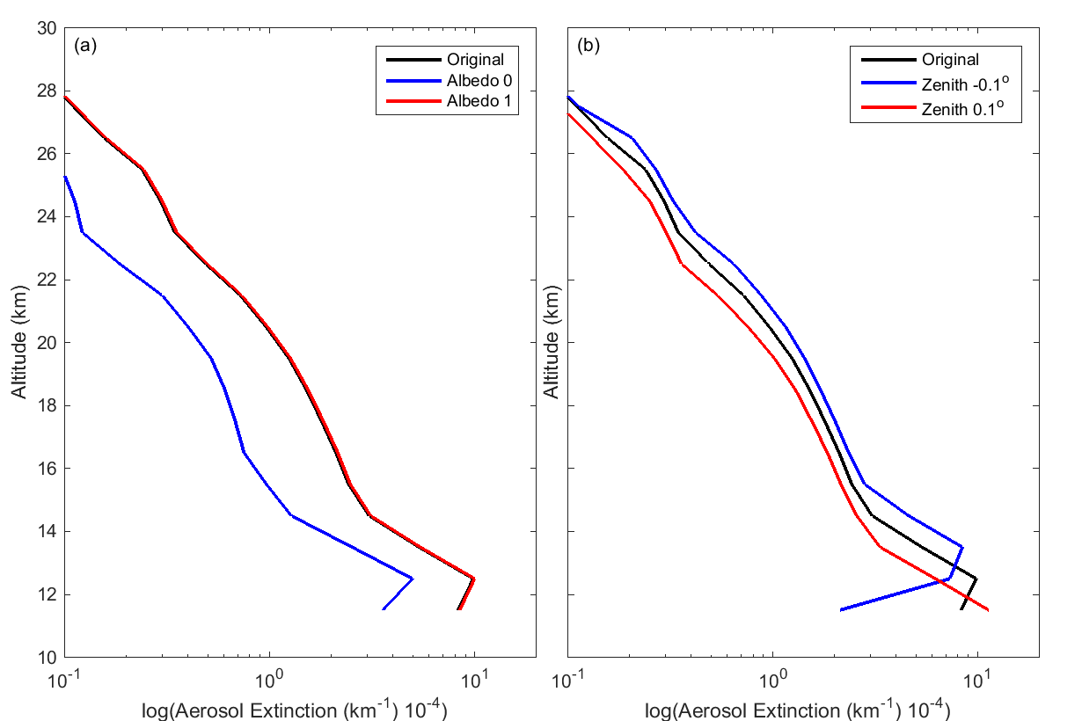

**Figure 5-12:** (a) Image 208 (750 nm) re-retrieved using an albedo of 0 and 1 compared to the original albedo used from OSIRIS. (b) Using the determined zenith pointing error from section 5.2, image 208 is retrieved again using the maximum possible pointing error compared to the original.

As a further note to other issues may have resulted in the disagreement between OSIRIS and ALI, mainly the estimation of the albedo and the pointing inaccuracies. For the albedo, as noted in TODO: ADD SECTION, linear polarized aerosol retrievals have a much larger sensitivity to albedo. For a scalar retrieval changing the albedo of zero to one result is approximately a 30% increase in the aerosol extinction but for a linear polarized measurement this change in albedo can be a s large as a 100% increase. Image 208 from the ALI campaign was rerun using an albedo of zero and one and the outcome of the retrieval can be seen in Figure 5-12a. Once again note the log scale the albedo used from OSIRIS was 0.79. It should be noted that increasing the albedo higher than the OSIRIS values does not greatly increase the aerosol extinction. A similar rerun was performed using the error is the zenith pointing discussed in section 5.2. The results of the alteration of the pointing can be seen in Figure 5-12b. From decreasing the zenith angle the aerosol extinction is increased which could account for the discrepancies between the OSIRIS and ALI results at the 20 km range but moves the aerosol peak to a higher altitude causing a further discrepancy with OSIRIS. However, do to a lack of pointing information from the gondola this is the best estimation that could be performed. Furthermore, this is also the first polarized limb scatter retrieval to our knowledge and so there may be further issues to explore with the polarized measurement and forward model. Regardless, the results are encouraging.

## 5.3.3 Particle Size Retrieval Methodology

Work done by *Rieger et al.* (2014) has shown that different particle size distributions can affect the aerosol measurement vector to yield some sensitivity. In his study he uses an OSIRIS geometry and calculates the respective measurement vectors for a series of particle sizes which can be seen in Figure 5-13. In panel A three different log-normal distributions are used which give a near identical measurement vector at 750 nm with simulation of the atmosphere with SASKTRAN. The three profiles are, in blue is a single fine mode particle size distribution with a mode radius and width of 0.08 µm and 1.6 respectively, black is a bimodal particle size distribution the simulates volcanic conditions with the mode radius and width of 0.08 µm and 1.6 for the fine mode and 0.4 µm and 1.2 for the coarse mode, lastly red is a representative size distribution with mode radius and width of 77 µm and 1.75. Panel B shows the measurement vectors calculated with the three distributions across a series of wavelengths. The third panel, panel C, shows the difference of the measurement vectors compared to the bimodal distribution. Sensitivity to particle size is only seen past 800 nm measurements but great sensitivity does not occur until measurement is recorded out to 1200 nm. Furthermore, a 1% error in the radiance yields a relative error in the bimodal distribution measurement vector shown by the gray shading.

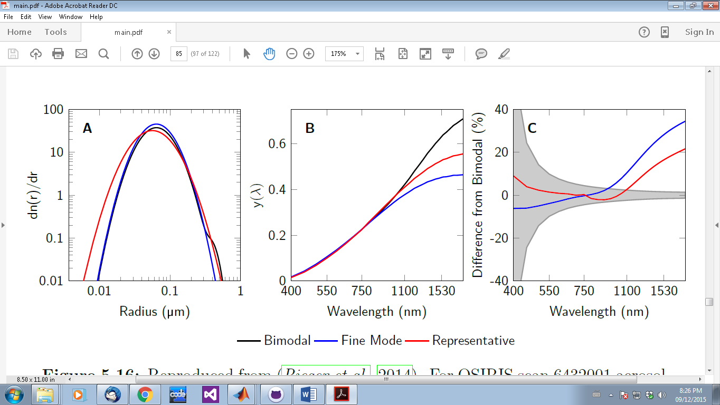

**Figure 5-13:** Reproduced from Figure 4 of *Rieger et al.* (2014). For OSIRIS scan 6432001 aerosol measurement vectors were calculated at 22.5 km. (A) The three size distributions used in the study. (B) The measurement vectors calculated via the SASKTRAN simulation (C) The relative percent difference of the fine and representative distributions with respect to the bimodal distribution. A 1% error is the radiance yields an uncertainty in the bimodal measurement vector shown by the grey shading.

For ALI measurements were only gathered between 650 and 950 nm in wavelength, due to the low sensitivity of the CCD camera in the NIR. As such ALI only has some sensitivity to particle size form the longer wavelengths and only a small amount. As such it will not possible to determine both the mode radius and mode width. Instead the data from ALI will be used to determine an Angström exponent. The Angström exponent is an approximation to Mie scattering since the value of the Angström exponent, , is an analogy to particle size. The scattering cross section for aerosol is dependent on the particle size distribution since the number density must be a constant across wavelength, as such the extinction value changes with a change in cross section. From

|  |  |
| --- | --- |
|  | (5.14) |

the particle size profile from a series wavelengths can be determined from the Angström exponent. Lower Angström exponents correspond to larger particle sizes and vice versa for small particle sizes. Since the measurements observe relatively the same atmosphere over the time of one complete aerosol cycle; the differences between extinction ratios at the different wavelengths can be used to gather a understanding of aerosol particle size in the form of Equation 5.14 where is the aerosol concentration, and is the scattering cross section. For the 750 nm wavelength, the Mie scattering cross section was calculated for a variety of mode radii and widths and a change in the cross section can be observed in Figure 5-14.

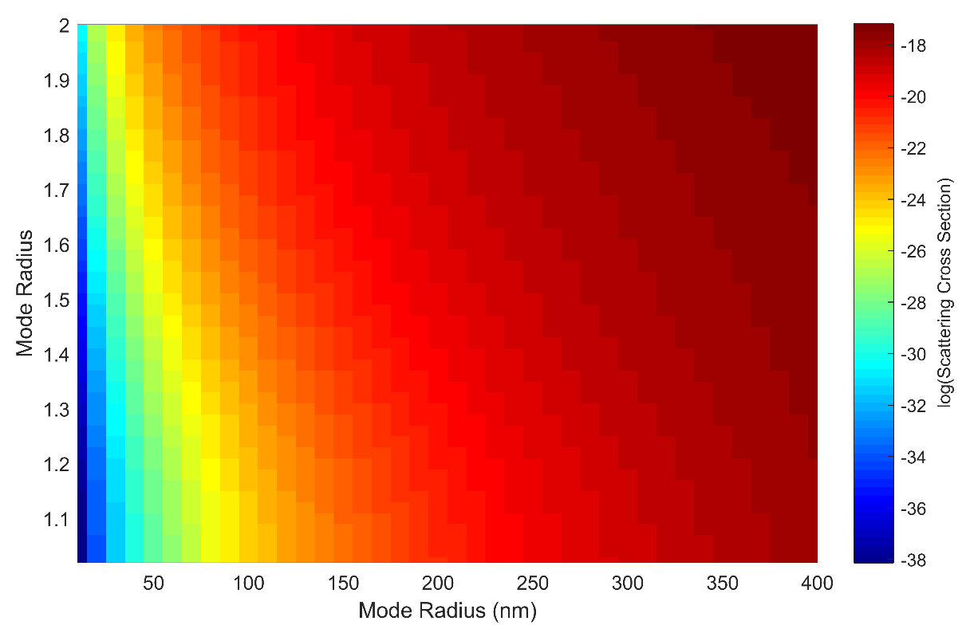

**Figure 5-14:** Computed with the optical properties of the SASKTRAN engine. This variation of the cross section with respect to the mode radius and width allows for some determination of the particle size distribution through the Angström exponent.

The Angström exponent can be determine by fitting a line through a series of spectral points by rearranging Equation 5.14 into the following

|  |  |
| --- | --- |
|  | (5.15) |

The rearranging demonstrates that the Angström exponent in the simple the slope of the log of the extinction over the log of the wavelengths.

Using the retrieved extinction profiles for the complete spectral range, we have attempted a determination of the Angström exponent using a method similar to that outlined by *Rault and Loughman* (2013) for the OMPS-LP analysis. In this method, the independently retrieved extinction profiles at each wavelength and altitude are fit with a straight line in log-wavelength, log-extinction space using least squares. The slope of this line corresponds to the Angström exponent. This is then used to find the best match to the spectral dependence of the Mie scattering cross section in order to update the particle size distribution. With only one piece of information, the mode-width of the log-normal distribution is fixed to 1.6 and the mode radius is updated. The extinction retrievals are then performed again at each wavelength and the process is iterated until the Angström exponent, corresponding to the determined mode radius, converges.

A percision estimate as also required and since a least squares fit was used to determine the Angström exponent, the method to determine the error from fit was used. Assuming no uncertainity in the measurement points the error in the slope is given by

|  |  |
| --- | --- |
|  | (5.16) |

where is

|  |  |
| --- | --- |
|  | (5.17) |

and , , and are the sum of squares of the wavelength, aerosol extinction, and cross term between the wavelength and aerosol extinction and is the number of points. However, there is an associated error with each aerosol extinction profile as outlined in section 5.3.1. So to determine the precision on the Angström exponent accounting for the uncertainty in the aerosol extinction a Monte Carlo was used. The uncertainty of the Angström exponent was calculated millions of times and for each calculation a random amount of the error from the known range was added to the extinction. Finally, the mean from the all the uncertainty calculations of all of the least squares fits was used as the precision estimate on the Angström exponent.

## 5.3.4 A Sample Particle Size Retrieval

The particle size method outlined above was also applied to this measurement set consisting of images 204 to 216. The retrieved extinction at a given altitude was rejected from the straight line fit if the converged forward model radiance at that altitude was not within 2% of the measurement vector. In the case shown in Figure 5-15, at the 14.5 km altitude point, only 10 of the 13 possible wavelengths contributed to the determination of the Angström exponent. The first panel of Figure 5-15 shows the median Angström exponent that was determined after each iteration and convergence can be seen after a couple iterations. The results are shown in the second panel of Figure 13, where the Angström exponent is between 2 and 3 throughout the altitude range from 13 to 22 km. Assuming a mode width of 1.6 yields a median mode radius of 0.077 µm. In comparison to typical levels of background aerosol from the Laramie, Wyoming OPC data (*Deshler et al.*, 2003) the retrieved particle size parameters are certainly within an expected range, although there is a relatively large error bar on the retrieved value, limiting the usefulness of the retrieved particle size information for background aerosol. However, with these error bars, even this limited spectral range would have the sensitivity to detected particle size changes as seen by OSIRIS and SAGE II over recent decades due to small volcanic perturbations (*Rieger et al.*, 2014).

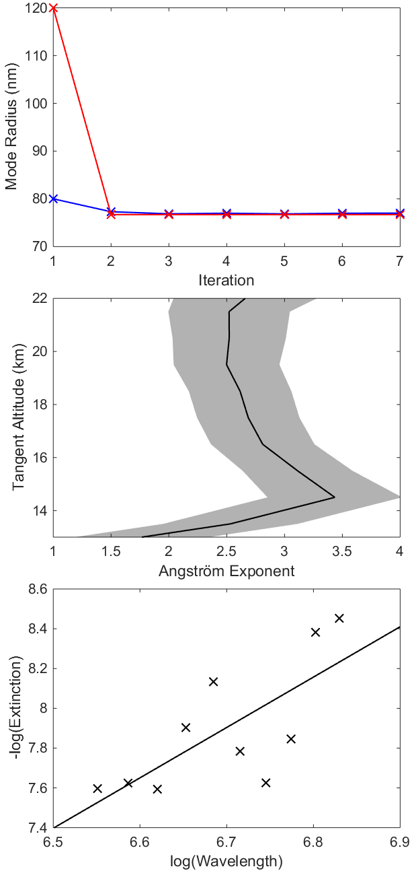

**Figure 5-15:** The top panel shows the convergence of two sample particle size retrievals, blue and red represent an initial state of 0.08 and 0.12 µm mode radius respectively. Both initial states converge to the same value over approximately 3 iterations in the particle size retrieval method. The middle panel shows the final Angström exponents determined from images 204-216. The shading represents the error associated with the least squares fit. The bottom panel shows a typical least squares fit of the retrieved extinction values over wavelength to determine the Angström exponent at model altitude of 14.5 km.

# 5.4 Results

The ALI prototype, which is telescopic acousto-optic imager, has been used to successfully measure two dimensional spectral images of the atmospheric limb from stratospheric balloon. The observed radiances appear to be of high quality and show both vertical and horizontal features of the cloud and aerosol layers. Aerosol extinction coefficient profiles were retrieved from the ALI data that show reasonable agreement with OSIRIS satellite measurements.

No large scale issues were found with the instrument performance; however, some future changes would be recommended. First, an absolute calibration of the instrument would allow ALI to determine the effect albedo directly, as is done with OSIRIS. This would remove some the uncertainly in the model inputs and likely yield higher quality results. This is simply a matter of having access to the calibration equipment. Also, even with the baffle and the robust method of removing stray light with the cycling of the AOTF, some stray light was still observed in the obtained images. Impact and mitigation of this should be tacked in future iterations of the instrument.