APPENDIX A

ALI HARDWARE COMPONENTS

The section will list and give specifications for all of the major ALI hardware components. Each section will have a brief description followed by a table of the specifications.

# A.1 Optical Components

## A.1.1 Optical Lenses

All lenses used in the ALI system were purchased from Newport and were coated with anti-reflective coating AR.16 which covers 650-1000 nm range with an average reflectance of 0.5% and a maximum of 1.5%. All the lens in the system were made from N-BK7 glass and the specification and model number of each lens is located in Table A-1.

**Table A-1:** Lens used in ALI and their specifications.

|  |  |  |  |  |  |
| --- | --- | --- | --- | --- | --- |
| Model Number | Effective Focal Length (mm) | Diameter (mm) | Center Thickness (mm) | Radius (mm) | Type of Lens |
| KPX100AR.16 | 150.0±1.5 | 25.4+0/-0.1 | 4.0±0.1 | 77.520 | Plano-Convex |
| KPX187AR.16 | 100.0±1.0 | 50.2+0/-0.1 | 9.7±0.1 | 51.680 | Plano-Convex |
| KBX052AR.16 | 50.2±0.5 | 25.4+0/-0.1 | 6.2±0.1 | 50.806 | Bi-Convex |

## A.1.2 Polarizers

ALI needed two linear polarizers to help remove unwanted signal and reduce stray light in the system. These polarizers required a high extinction ratio over the range of the CCD sensitivities. The polarizers chosen were model number LPVIS100 from Thorlabs. The extinction ratios and transmission of the device can be seen in Figure A-1.

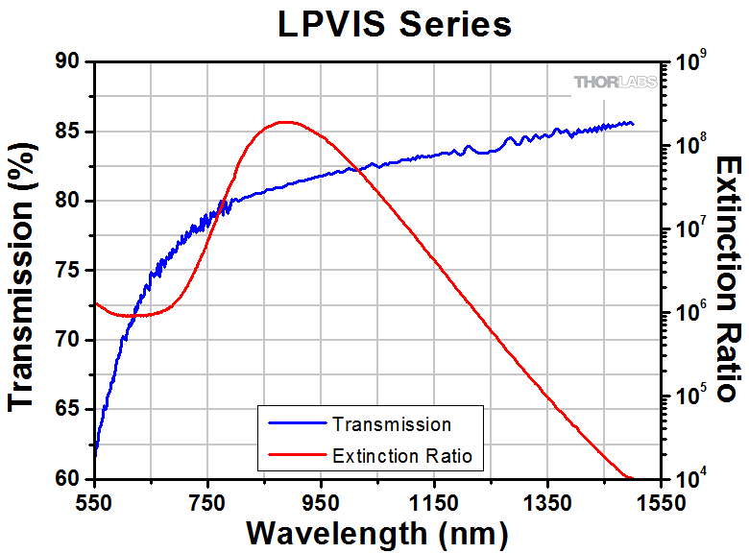

**Figure A-1:** The transmission and extinction ratios of the LPVIS100 used in ALI.

## A.1.3 AOTF

The AOTF in ALI is made by Brimrose of America (model number TEAFI10-0.6-1.0-MSD). The specifications of the device can be seen in Table A-2. The separation angle is defined as the angle between the input source and the desired refracted polarization and the acceptance angle is measured from the normal of the face of the crystal.

**Table A-2:** AOTF Specifications.

|  |  |  |  |
| --- | --- | --- | --- |
| Parameter | Value | Parameter | Value |
| Material | TeO­2 | Polarization | Linear vertical |
| RF Range (Mhz) | 75-156 | Tunable Range (nm) | 600-1200 |
| Optical Aperture (mm) | 10x10 | Angular Aperture (o) | 5-6 |
| Acceptance Angle (o) | 3.0 | Separation Angle (o) | 2.7 |
| RF Power (W) | 2.0 | Damage Threshold (W) | 5.0 |

# A.2 Opto-Mechanical and Electrical Components

## A.2.1 RF Driver

The driver for ALI is made by Gooch and Housego (model number 64020-200-2ADMDFS-A). It had no internal control mechanism and required additional control hardware to operate the device. In order to pick the frequency, a 30-bit digital value is inputted into the device to pick a frequency as well as manage several control lines to the device. The control word is used to determine a specific frequency which is given by

|  |  |
| --- | --- |
| $$K_{10}=\frac{F2^{n+1}}{F_{clk}}$$ | (A.1) |

where $K_{10}$ is the 30-bit control word in base 10 rounded to the nearest integer, $F$ is the desired RF to be outputted by the driver, $F_{clk}$ is the internal clock of the driver which is 1000.059 MHz for ALI, and $n$ is the number of bits in the control word for ALI (*i.e. $n=30$* ). The control word is converted to binary and sent to the device to get the desired RF.

## A.2.2 QSI CCD Camera

The CCD camera was a QSI 616s with a Kodak KAP-1603ME sensor with a mechanical shutter and a 16-bit digital readout. The spectral response of the device can be seen in Figure 3-10 and the camera specification can be seen in Table A-3.

**Table A-3:** QSI CCD camera specifications.

|  |  |  |  |
| --- | --- | --- | --- |
| Parameter | Value | Parameter | Value |
| Imager Size (mm) | 13.8 x 9.2 | Imager Size (pixels) | 1536 x 1024 |
| Pixel Size (µm) | 9 x 9 | Read Noise RMS (electrons) | 15 |
| Mass (kg) | 0.95 | Power Consumption (W) | 24 |
| Operating Temperature (oC) | -20 to 30 | Full Well Depth (electrons) | 100,000 |

## A.2.3 OCELOT Computer

The on board computer for the ALI instrument was the Ocelot VL-EPMs-21 computer made by VersaLogic. Its architecture is based on the Intel Atom Z5 processor and had 2 GB of DDR2 memory. It had low power draw and fanless operation. It had a temperature range of -40 to 85 oC. The system run a bare-bone version of Debian Linux.

## A.2.4 Opto-Mechanical Pieces

In this section is a brief list of all the opto-mechanical components used within the final version of ALI. Listed is the model number of the components and the quantity in the design with a short description. All components were purchased from Thorlabs.

**Table A-4:** Opto-mechanical components used in ALI

|  |  |  |
| --- | --- | --- |
| Model Number | Quantity | Description |
| XT95SP-1000 | 1 | 1000 mm length optical rail, 95 mm width |
| XT95P11/M | 4 | 95 mm width optical rail drop-on carriage |
| RS2P4M | 2 | Pedestal post, 50 mm long, 25.4 mm width, metric, M4 |
| RS2P/M | 2 | Pedestal post, 50 mm long, 25.4 mm width, metric, M6 |
| RS2M | 2 | Pedestal post spacer, 2 mm long, 25.4 mm width |
| RS7M | 2 | Pedestal post spacer, 7 mm long, 25.4 mm width |
| LCP01B | 2 | 60 mm cage clamp |
| CP02T/M | 1 | 30 mm cage plate, 1” lens holder, square, metric |
| CP07 | 3 | 60 mm cage plate, 1” lens holder, round, metric |
| LCP01/M | 1 | 60 mm cage plate, 2” lens holder, square, metric |
| LCP02/M | 4 | 30 mm to 60 mm cage converter, metric |
| ER1-P4 | 3 | Cage assembly rod, 1” long, 4 pack |
| ER2-P4 | 2 | Cage assembly rod, 2” long, 4 pack |
| ER4-P4 | 1 | Cage assembly rod, 4” long, 4 pack |
| ER8-P4 | 2 | Cage assembly rod, 8” long, 4 pack |
| LC1A/M | 1 | Swivel mount, 60 |