Team Meetings & Sprint 2 Completion
Meeting 1:  We reviewed the Sprint 2 requirements and discussed the main information CareerUp needs to store, including users, companies, portfolio posts, and job applications.  Meeting 2:  We worked on the ER diagram and checked how the tables connect. We reviewed the main business rules and organized the design into seven chapter diagrams to make it easier to explain.  Meeting 3:  We reviewed the three competition use cases: creating a portfolio post, verifying company collaboration, and applying for a job. We also worked on the presentation flow and simple explanations of the database. |  | 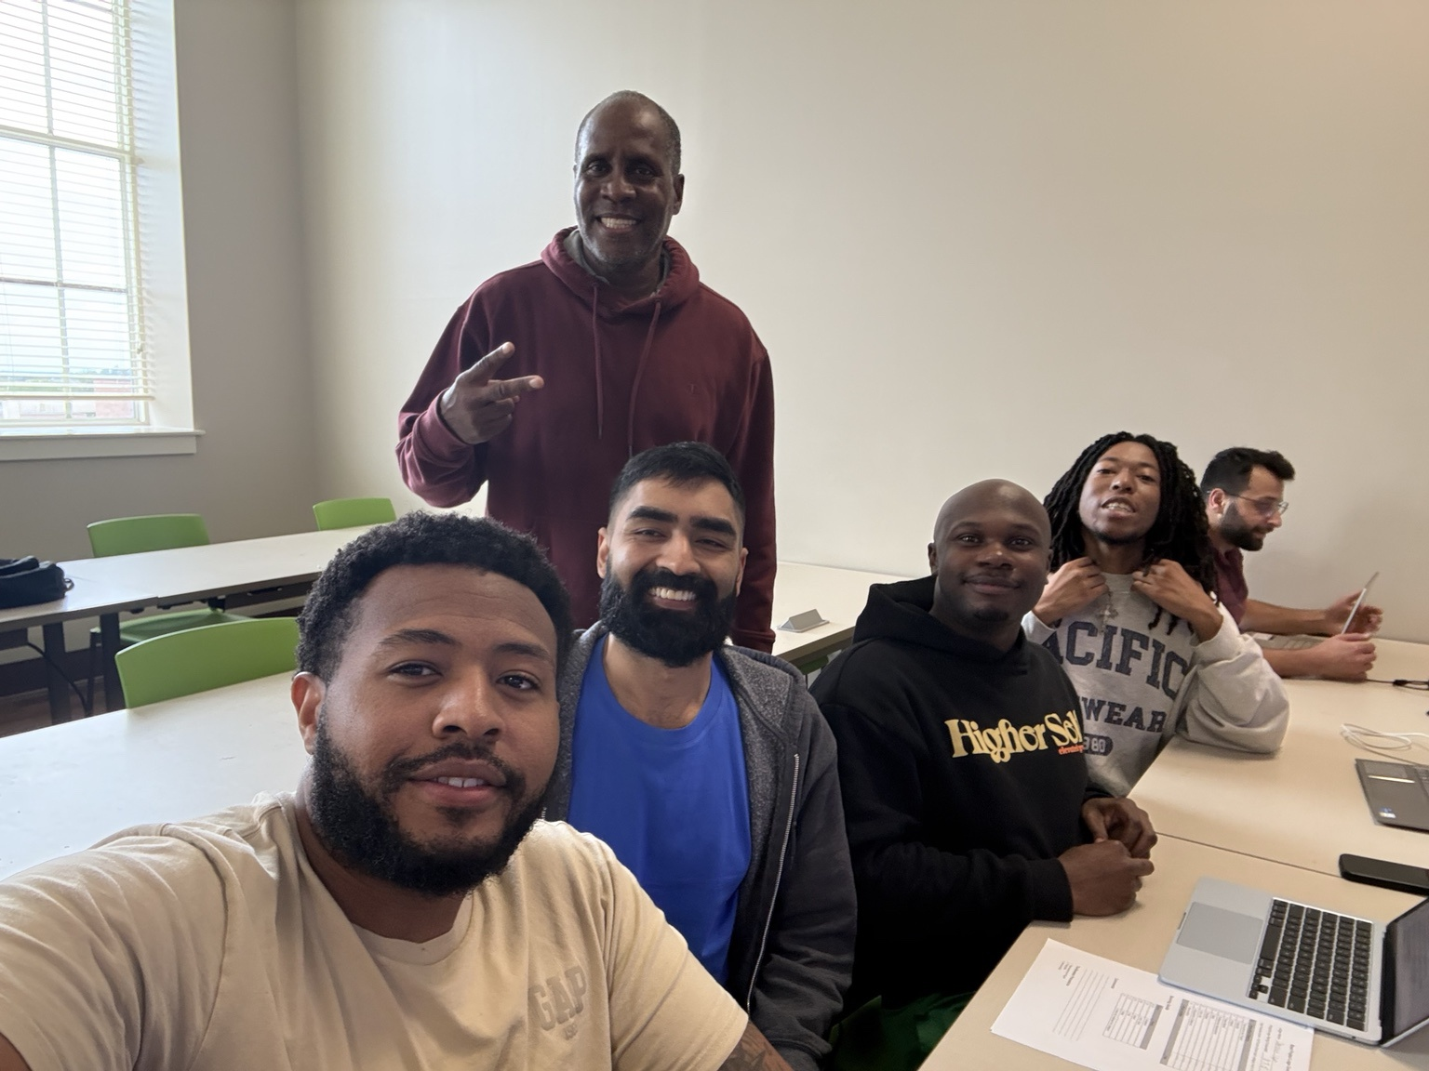
  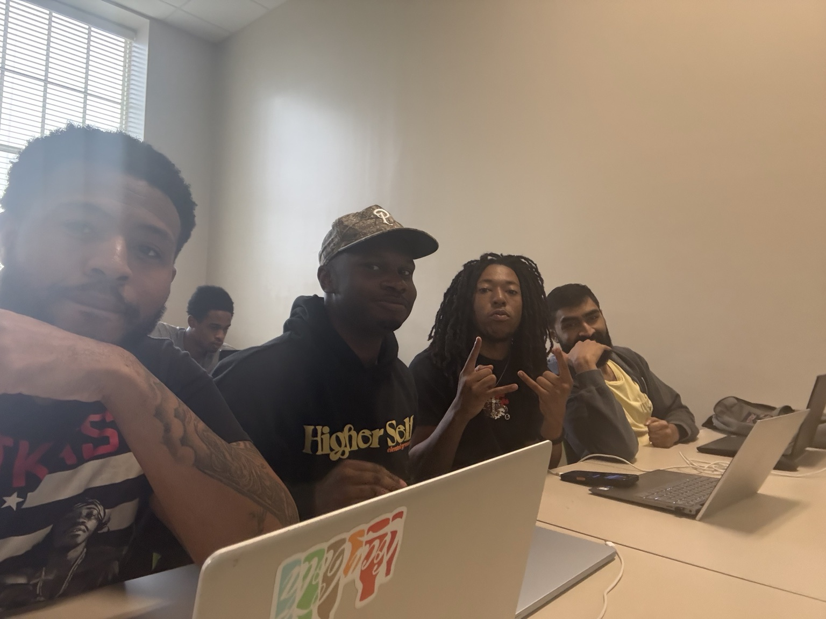 |  | 