An Introduction to the Source Code of the Pyrrho DBMS

Malcolm Crowe, University of Paisley
www.pyrrhodb.com



January 2007

© 2007 Malcolm Crowe and University of Paisley, UK

1. Introduction
For a general introduction to the Pyrrho DBMS, including its aims and objectives, see the manual that forms part of the distribution of Pyrrho DBMS (this is referred to below as “the Manual”).
From Version 1.3 of the Pyrrho DBMS, an Open Source Edition is being maintained alongside the production editions. The Open Source Edition has functionality equivalent to the Professional edition of Pyrrho DBMS, but has different encryption algorithms for the security features. It remains intellectual property of the University of Paisley, and while you are at liberty to view and test the code and incorporate it into your own software which you can use on a royalty-free basis, the terms of the license prohibit you from creating a competing product or from reverse engineering the production editions.
I am proud to let the community examine this code: I am conscious about how strongly programmers tend to feel about programming design principles, and the particular set of programming principles adopted here will please no one. But, perhaps surprisingly, the results of this code are robust and efficient, and the task of this document is to try to exoplain how and why.
Much of the structure and functionality of the Pyrrho DBMS is documented in the Manual. The details provided there include the syntax of the languages used (SQL2003, Java Persistence Query Language, and SPARQL), and the structure of the binary database files. Usage details from the manual will not be repeated here. In some cases some paragraphs from the user manual provide an introduction to sections of this document.
This document aims to provide a gentle introduction for the enthusiast who wishes to explored the source code, and see how it works. The topics covered include the workings of all levels of the DBMS (the server) and the structure of the client library OSPLink.dll. Many people will find the sections on the implementation of SPARQL and the Java Persistence Query Language particularly interesting.
The reader of this document is assumed to be a database expert and competent programmer. The DBMS itself has over 450 C# classes, spread over 98 source files in 6 namepsaces. The Excel worksheet Classes.xls lists all of the classes together with their location, superclass, and a brief description. The code itself is intended to be quite readable, and has “Intellisense” comments for all classes, methods, fields, and properties.
This document avoids having a section for each class, or for each source file. Either of those designs for this document would result in tedious repetition of what is in the source. Instead, the structure of this document reflects the themes of design, with chapters addressing the role in the DBMS of particular groupings of related classes or methods.

2. Overall structure of the DBMS
The following diagram, from the Manual, shows the DBMS as a layered design. There is basically a namespace for each of four of the layers, and two other namepsaces, Pyrrho and Pyrrho.Common:
Namespace | Title in the diagram | Description
Pyrrho |  | The top level contains only the protocol management files Start.cs, HttpService.cs, Sparql.cs and Crypt.cs
Pyrrho.Common |  | Basic data structures: Integer, StringCollatioon, BTree, and the lexical analyzer for SQL.
Pyrrho.Level1 | Database File, Database File Segments | Binary file management. Caching and buffering
Pyrrho.Level2 | Physical Records | The Physical Database layer: PhysBase.cs and classes for physical records.
Pyrrho.Level3 | Logical Database | Database.cs, LocalTransaction.cs and classes for database objects.
Pyrrho.Level4 | SQL processing | Connection.cs, Transaction.cs, Query.cs, Parser.cs etc

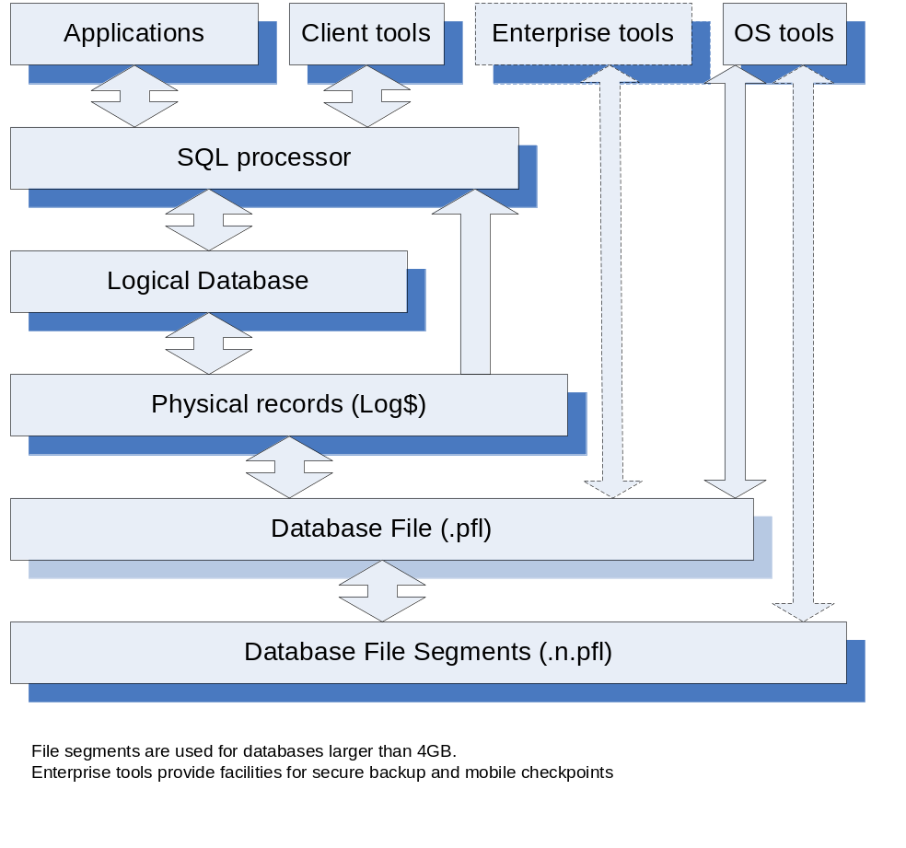

2.1 Key Features of the Design
- Transaction commits correspond one-to-one to disk operations: completion of a transaction is accompanied by a force-write of a database record to the disk. There is a 5-byte end-of-file marker which is overwritten on each record, but otherwise the physical records once written are immutable. Deletion of records or database objects is a matter for the logical database, not the physical database. This makes the database fully auditable: the records for each transaction can always be recovered along with details about the transaction (the user, the timestamp, the role of the transaction).
- Because data is immutable once recorded, the physical position of a record in the data file (its “defining position”) can be used to identify database objects and records for all future time (as names can change). Needless to say, the current structure of the database object, or the current values of a record, may well depend on subsequent data, which should be examined for relevant alterations and updates (or even drops and deletes). Pyrrho threads together the physical records that refer to the same defining position to facilitate backward searching in the database file and forward searching in the corresponding memory structures.
- Data structures in the higher levels of the database are frequently built from immutable elements. For example, if an entry in a list is to be changed, what happens at the data structure level is that a replacement element for the list is constructed and a new list descriptor which accesses the modified data, while the old list remains accessible from the old list descriptor. In this way creating a local copy or snapshot of the database (which occurs at the start of every transaction) consists merely to making a new header for accessing the lists of database objects etc. As the local transaction progresses, this header will point to new headers for these lists (as they are modified). If the transaction aborts or is rolled back, all of this data can be simply forgotten, leaving the database unchanged. With this design total separation of concurrent transactions is achieved, and local transactions always see consistent states of the database.
- When a local transaction commits, however, the database cannot simply be replaced by the local transaction object, because other transactions may have been committed in the meantime. If any of these changes conflict with data that this transaction has read (read constraints) or plans to modify (transaction conflict), then the transaction cannot be committed. If there is no conflict, the physical records proposed in the local transaction are relocated onto the end of the database. Thus the defining positions of any new data will be different from those created in memory for the local transaction: the entire local transaction structure is therefore forgotten even in the case of a successful commit. Instead, the database is updated by reading the new records back from the disk (or disk cache). Thus all changes are applied twice – once in the local transaction and then after transaction commit – but the first can be usefully seen as a validation step, and involves many operations that do not need to be repeated at the commit stage: evaluation of expressions, check constraints, execution of stored procedures etc.
- These approaches to the design have some strange effects. For example, any data structures that are not transaction-specific must avoid maintaining pointers to the logical level structures such as Table, TableColumn, since these may no longer be current for the next transaction. The current versions must be obtained afresh from the Database data structure, either by name or by defining position as appropriate.
- Because of transaction separation, checking for transaction conflicts cannot be done at the level of the logical database (Level 3). It is done at the physical level (Level 2), with the help of a set of rules for what constitutes a conflict. Data relating to read constraints needs to be passed down to level 2 in a special data structure since these do not correspond to proposed changes to the database.
- Data recorded in the database is intended to be non-localised (e.g. it uses Unicode with explicit character set and collation sequence information, universal time and date formats), and machine-independent (e.g. no built-in limitations as to machine data precision such as 32-bit). Default value expressions, check constraints, views, stored procedures etc are stored in the database in SQL2003 source form and reparsed when required. This has the advantage that changes consequential on renaming of objects can be supported at the logical database level, where the edits can be applied to the source forms in memory.
- The database implementation uses B-Trees throughout (note: B-Trees are not binary trees). Lazy traversal of B-Tree structures (enumeration) is used throughout the query processing part of the database. This brings dramatic advantages where search conditions can be propagated down to the level of B-Tree traversal. It also results in extensive use of partial evaluation, so that for example parameterless Column value expressions (e.g. col.Value) or Search conditions (e.g. where.Match) are affected by movement of an enumerator (e.g. enu.MoveNext()). The effect of this relatively unusual programming technique is to mimic the behaviour of SQL expressions: thus a RowSet is a Row (a set of Columns) and an Enumerator (which modifies the values of the row columns as it moves).
- The aim of SQL query processing is to bridge the gap between bottom-up knowledge of traversable data in tables and joins (e.g. columns in the above sense) and top-down analysis of value expressions. Analysis of any kind of query goes through a set of stages: (a) source analysis to establish where the data is coming from, (b) selects analysis to match up references in value expressions with the correct columns in the sources, (c) conditions analysis which examines which search and join conditions can be handled in table enumeration, (d) ordering analysis which looks not only at the ordering requirements coming from explicit ORDER BY requests from the client but also at the ordering required during join evaluation and aggregation, and finally (e) RowSet construction, which in many cases can choose the best enumeration method to meet all the above requirements.

2.2 Plan of this booklet
- Introduction
- Overview (this chapter)
- Basic data structures: B-Tree, Integer, Decimal, StringCollation, Physical, DBObject, Database
- Locks,. integrity constraints and transaction conflicts
- Parsing, renaming
- Query processing
- Transactions and multiple database connections
- Permissions and the security model
- The client library, and Java client
- XML, RDF and Sparql
- The Java Persistence Query Language
- Checkpoints and operations

3. Basic Data Structures
In this chapter we discuss some of the fundamental data structures used in the DBMS. The data structures in this chapter have been selected because they are sufficiently complex or unusual to require a discussion.

3.1 B-Trees
Almost all indexing and cataloguing tasks in the database are done by BTrees. These are basically sorted lists of pairs (key,value), where key is comparable. In addition, sets and partial orderings use a degenerate sort of catalogue in which the values are not used (and are all the single value true).
There are several subclasses of BTree used in the database: Some of these implement multilevel indexes. BTree itself is a subclass of an abstract class called ATree. The BTree class provides the main implementation.

3.1.1 B-Tree structure
The B-Tree is a standard, fully scalable mechanism for maintaining indexes. B-Trees as described in textbooks vary in detail, so the following account is given here to explain the code.
A B-Tree is formed of nodes called Buckets. Each Bucket is either a Leaf bucket or an Inner Bucket. A Leaf contains up to N pairs (called Slots in the code). An Inner Bucket contains Slots whose values are pointers to Buckets, and a further pointer to a Bucket, so that an Inner Bucket contains pointers to N+1 Buckets altogether (“at the next level”). In each Bucket the Slots are kept in order of their key values, and the Slots in Inner buckets contain the first key value for the next lower-level Bucket, so that the extra Bucket is for all values bigger than the last key.
The value of N in Pyrrho is currently 32: the performance of the database does not change much for values of N between 4 and 32. For ease of drawing, the illustrations in this section show N=4.
The BTree itself contains a root Bucket and some other data we discuss later.
6
6

Root (inner)
The BTree dynamically reorganizes its structure so that (apart from the root) all Buckets have at least N/2 Slots, and at each level in the tree, Buckets are either all Inner or all Leaf buckets, so that the depth of the tree is the same at all values.
1
3
4
6
8
Leaves
3.2 Integer
3.3 Decimal
3.4 StringCollation
3.5 Physical
3.6 DBObject
3.7 Database

